Supplementary Material
Table S1a. Artificial seawater test solution/media composition supplemented with 1000 mg L⁻¹ of yeast extract. Yeast extract has a protein content of about 50%, of which about 20% is glutathione, 6% is nucleic acid. It is rich in 18 kinds of amino acids, functional peptides glutathione, dextran, mannan, trehalose, flavouring nucleotide, B vitamins, biotin, trace elements and volatile aromatic compounds and other components. Calcium, phosphorus, and trace element contents (μg g⁻¹) in yeast extract: Calcium 1120, Phosphorus 18020, Zinc 190, Iron 162, Chromium 5, Potassium 9300, Cobalt 1.2, Manganese 15, Strontium 3.5, Magnesium 2150.
Major Ion | % Total Weight | Concentration (mg L⁻¹)
Chloride, Cl- | 47.47 | 18.74
Sodium, Na+ | 26.28 | 10.454
Sulfate, SO42- | 6.6 | 2631
Magnesium, Mg2+ | 3.23 | 1256
Calcium, Ca2+ | 1.013 | 400
Potassium, K | 1.015 | 401
Bicarbonate, HCO3- | 0.491 | 194
Boron, B3+ | 0.015 | 6
Strontium, Sr2+ | 0.001 | 7.5
Solids Total | 86.11% | 34.09
Water | 13.88
Total | 99.99%

Table S2. Environmental conditions on the day the marine sediment was collected on September 14, 2022.
Date & Time | 14/09/2021 07:32 | 14/09/2021 07:47 | 14/09/2021 08:02 | 14/09/2021 08:17 | 14/09/2021 08:32 | 14/09/2021 08:47 | 14/09/2021 09:02 | 14/09/2021 09:17 | 14/09/2021 09:32
pH units (pH/ORP) | 7.99 | 7.99 | 7.99 | 7.98 | 7.98 | 8 | 8.01 | 8 | 8.01
Specific Conductivity mS/cm (Conductivity) | 40.982 | 39.918 | 39.798 | 40.598 | 40.859 | 39.9 | 39.561 | 39.803 | 38.604
Turbidity NTU (Turbidity/Brush) | 265.1 | 233 | 663 | 170.8 | 205.9 | 244.6 | 317.4 | 610 | 586
Barometric Pressure mmHg (Necessary Input) | 766.7 | 766.7 | 766.7 | 766.7 | 766.7 | 766.7 | 766.7 | 766.7 | 766.7
DO mg/L (Hach LDO) | 7.41 | 7.34 | 7.43 | 7.25 | 7.37 | 7.41 | 7.45 | 7.4 | 7.43
Depth meters (Depth 25 meter) | 0.197 | 0.203 | 0.199 | 0.194 | 0.196 | 0.194 | 0.192 | 0.202 | 0.194
Turbidity mV (Turbidity/Brush) | 256.553 | 228.405 | 605.772 | 173.86 | 204.651 | 238.627 | 302.424 | 558.721 | 538.339
DO %SAT (Hach LDO) | 91.7 | 90.5 | 91.5 | 89.6 | 91.3 | 91.5 | 91.9 | 91.4 | 91.2
ORPAgCl mV (pH/ORP) | 220 | 222 | 220 | 216 | 219 | 216 | 220 | 220 | 218
Temperature °C (Temperature) | 18.5 | 18.53 | 18.51 | 18.55 | 18.57 | 18.61 | 18.63 | 18.62 | 18.55
Total Dissolved Solids g/L (Conductivity) | 26.228 | 25.548 | 25.471 | 25.983 | 26.149 | 25.536 | 25.319 | 25.474 | 24.706
Specific Gravity (Depth 25 meter) | 1.019 | 1.018 | 1.018 | 1.018 | 1.018 | 1.018 | 1.018 | 1.018 | 1.017
Density kg/m3 (Depth 25 meter) | 1018.52 | 1017.94 | 1017.88 | 1018.3 | 1018.44 | 1017.91 | 1017.72 | 1017.85 | 1017.23
Salinity psu (Conductivity) | 26.32 | 25.56 | 25.48 | 26.05 | 26.23 | 25.55 | 25.31 | 25.48 | 24.63
Chlorophyll a µg/L (Chlorophyll a) | 5.99 | 6.2 | 2.41 | 2.26 | 9.23 | 2.25 | 2.4 | 2.47 | 2.14

Abiotic Coupons
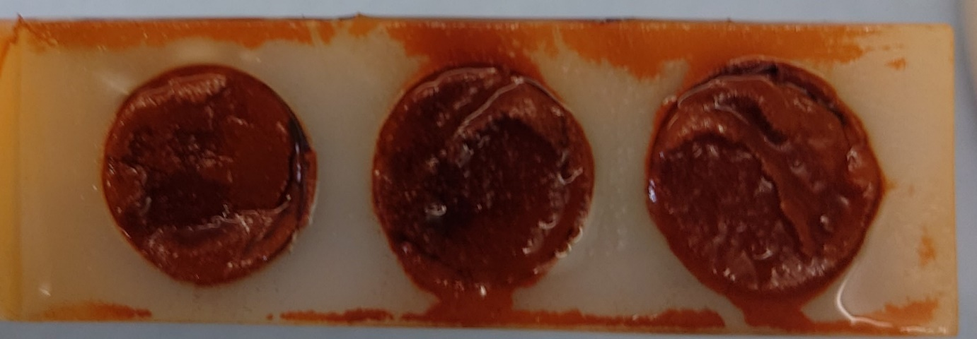
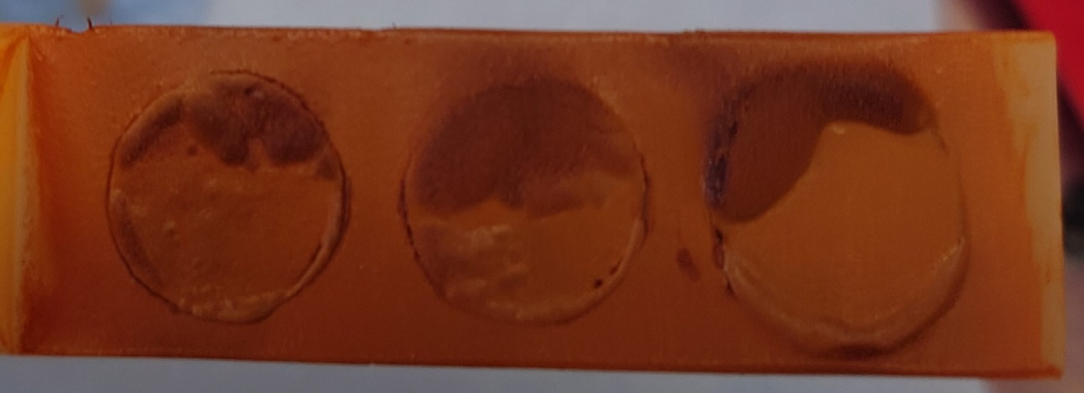
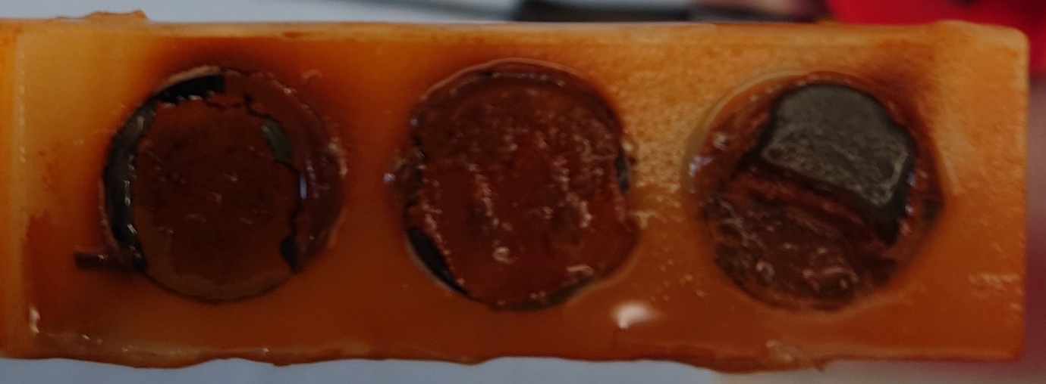
Figure S3a. Photographs taken of the coupon rods taken from the abiotic condition on Day 28, on dismantling the reactor, after exposure to anaerobic nutrient-enriched ASW media for 28 days.

Biotic Coupons
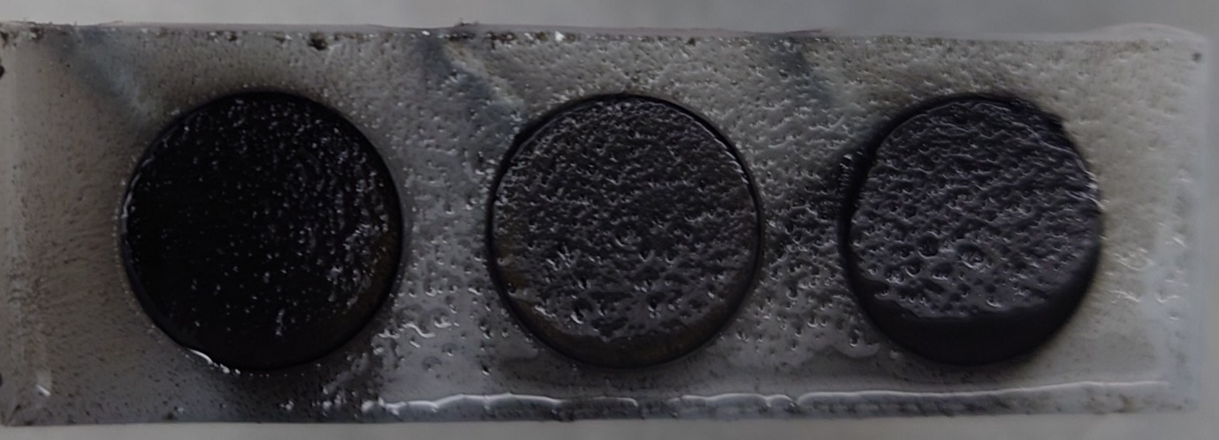
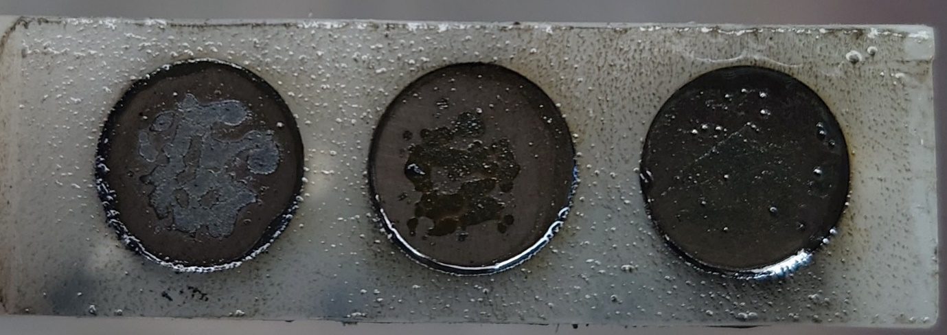
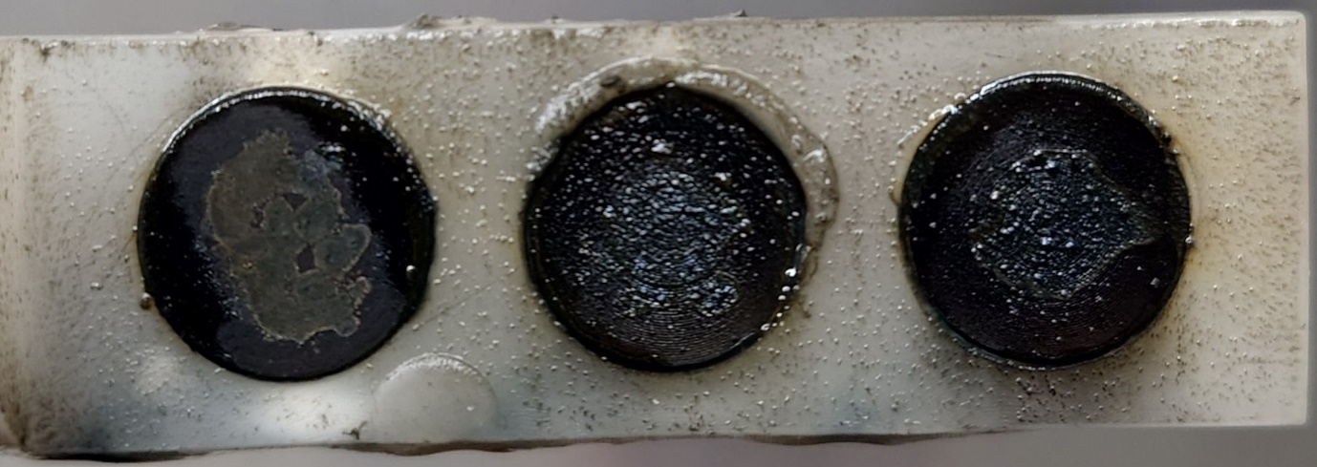
Figure S3b. Photographs taken of the coupon rods taken from the biotic condition on Day 28, on dismantling the reactor, after exposure to anaerobic nutrient-enriched ASW media for 28 days.

(a)  542 µm  715 µm | (b)  542 µm  715 µm
(c)  542 µm  715 µm | (d)  542 µm  715 µm
Figure S4. Three-dimensional optical surface profilometry of UNS G10180 surfaces at day 0. AR coupons for: (a) abiotic and (b) biotic conditions; and P coupons for: (c) abiotic and (d) biotic conditions, prior to exposure to anaerobic nutrient-enriched ASW media for 28 days.

Table S5a. Quantitative surface roughness profiles for as-received (AR) coupon samples on day 0 and day 28. R_{a} average roughness of profile, R_{t} maximum peak to valley height of roughness, R_{z} mean peak to valley height, R_{p} maximum peak height, R_{v} maximum valley height, R_{c} mean height of profile irregularities, R_{sm} mean spacing of profile irregularities, R_{t}/R_{z} extreme scratch/peak value of roughness profile (higher values (>=1) represent larger scratches/peaks).
Day | Reactor | R_{a} (µm) | R_{t} (µm) | R_{z} (µm) | R_{p} (µm) | R_{v} (µm) | R_{c} (µm) | R_{sm} (µm) | R_{t}/R_{z} (µm)
0 | Abiotic | 1.3±0.7 | 19.5±11.5 | 10.3±4.8 | 12.1±7.3 | 7.4±7.9 | 9.1±7.6 | 193±202 | 1.8±0.6
0 | Biotic | 1.4±0.8 | 12.4±6.9 | 8.3±3.6 | 8.1±5.2 | 4.3±2.5 | 6.5±3.8 | 156±128 | 1.5±0.4
28 | Abiotic | 2.2±0.7 | 33.6±16.0 | 17.2±6.8 | 10.7±5.2 | 22.9±12.0 | 18.4±12.5 | 248±167 | 1.9±0.5
28 | Biotic | 3.5±1.2 | 48.3±19.0 | 26.0±8.7 | 15.4±5.1 | 32.9±15.1 | 27.6±11.7 | 328±235 | 1.9±0.4
Table S5b. Quantitative surface roughness profiles for polished (P) coupon samples on day 0 and day 28.
Day | Reactor | R_{a} (µm) | R_{t} (µm) | R_{z} (µm) | R_{p} (µm) | R_{v} (µm) | R_{c} (µm) | R_{sm} (µm) | R_{t}/R_{z} (µm)
0 | Abiotic | 0.4±0.03 | 4.6±0.8 | 3.5±0.3 | 2.5±0.5 | 2.1±0.5 | 1.9±0.2 | 38±5 | 1.3±0.1
0 | Biotic | 0.4±0.03 | 4.2±0.5 | 3.4±0.2 | 2.3±0.3 | 1.9±0.4 | 1.9±0.2 | 36±5 | 1.3±0.1
28 | Abiotic | 2.1±0.8 | 40.6±18.7 | 18.6±7.0 | 9.2±3.6 | 31.4±15.2 | 24.8±18.8 | 304±180 | 2.1±0.5
28 | Biotic | 2.9±0.9 | 51.8±11.7 | 26.1±7.0 | 14.1±3.2 | 37.8±11.6 | 34.5±11.1 | 350±239 | 2.1±0.4

Figure S6. Equivalent circuit model used to generate EIS parameters shown in Table S7.
① R1+(Q1/Q2+R2)
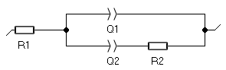
② R1+(Q1+R2)
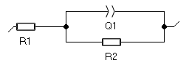
③ R1+Q1/(R2+Q2/R3)
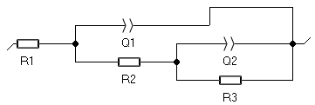
④ R1+Q1+(Q2/R3)
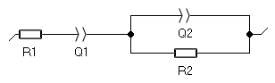

Table S7a. EIS parameters of the carbon steel coupons immersed in ASW+YE media for the abiotic control reactors on days 1, 7, 14, 21 and 28. Equivalent circuit: – R_{s}+(Q₁/Q₂+R_{ct}); – R_{s}+(Q₁/R_{ct}); – R_{s}+Q₁/(R_{film}+Q₂/R_{ct}).
Day | Coupon | R_{s} / Ω cm² | Q₁ / mΩ^{–1} cm^{–2} s^{n} | n₁ | R_{film} / Ω cm² | Q₂ / mΩ^{–1} cm^{–2} s^{n} | n₂ | R_{ct} / Ω cm² | χ² ×10⁻⁴
1 | AR | 3.9±0.5 | 0.2±0.03 | 0.85±0.01 | – | 0.8±0.9 | 0.45±0.03 | 304±52 | 14
1 | P | 4.0±0.2 | 0.1±0.01 | 0.87±0.01 | – | 0.6±0.3 | 0.45±0.07 | 612±179 | 18
7 | AR | 6.7±0.1 | 2.2±0.1 | 0.78±0.04 | – | – | – | 417±24 | 8.5
7 | P | 6.6±0.1 | 1.2±0.1 | 0.81±0.01 | – | – | – | 374±14 | 3.4
14 | AR | 13.0±1.7 | 5.3±0.9 | 0.40±0.03 | – | 4.0±0.1 | 0.58±0.03 | 23±374 | 2.9
14 | P | 13.0±0.6 | 3.6±2.1 | 0.42±0.08 | 28±11 | 3.4±0.9 | 0.60±0.04 | 903±409 | 2.9
21 | AR | 13.0±8.5 | 4.3±4.0 | 0.51±0.21 | 46±43 | 4.6±1.3 | 0.56±0.05 | 1454±485 | 3.2
21 | P | 18.0±1.5 | 3.6±1.7 | 0.42±0.06 | 39±0.1 | 8.0±2.1 | 0.52±0.09 | 775±287 | 4.8
28 | AR | 13.6±5.8 | 3.2±5.6 | 0.59±0.22 | – | 4.2±6.7 | 0.59±0.28 | 84±124 | 3.7
28 | P | 19.9±1.4 | 11.0±6.6 | 0.48±0.10 | 243±178 | 9.3±3.7 | 0.42±0.16 | 123±162 | 4.8

Table S7b. EIS parameters of the carbon steel coupons immersed in ASW+YE media for the biotic test reactors on days 1, 7, 14, 21 and 28. Equivalent circuit: – R_{s}+Q₁+(Q₂/R_{ct}).
Day | Coupon | R_{s} / Ω cm² | Q₁ / mΩ^{–1} cm^{–2} s^{n} | n₁ | Q₂ / mΩ^{–1} cm^{–2} s^{n} | n₂ | R_{ct} / Ω cm² | χ² ×10⁻⁴
1 | AR | 4.0±0.1 | 0.6±0.2 | 0.85±0.02 | 1.4±0.6 | 0.77±0.01 | 2509±1497 | 41
1 | P | 3.7±0.9 | 0.4±0.3 | 0.93±0.06 | 0.9±0.1 | 0.69±0.20 | 1342±1251 | 41
7 | AR | 5.0±0.4 | 1.7±0.8 | 0.86±0.02 | 2.3±0.4 | 1.02±0.06 | 616±79 | 21
7 | P | 5.3±0.2 | 1.5±0.3 | 0.94±0.07 | 2.0±1.0 | 0.92±0.09 | 939±465 | 21
14 | AR | 7.7±0.6 | 3.0±0.6 | 0.84±0.02 | 5.4±1.8 | 0.98±0.04 | 164±109 | 13
14 | P | 8.2±0.2 | 3.3±0.6 | 0.88±0.03 | 3.7±0.5 | 0.85±0.02 | 206±66 | 15
21 | AR | 9.3±0.7 | 6.5±6.7 | 0.80±0.03 | 7.1±6.1 | 1.01±0.06 | 1506±2474 | 4.8
21 | P | 10.0±0.3 | 2.5±0.4 | 0.87±0.04 | 8.1±3.8 | 0.91±0.09 | 97±105 | 5.0
28 | AR | 10.0±0.3 | 2.9±0.4 | 0.84±0.01 | 8.5±4.4 | 1.02±0.06 | 156±106 | 3.5
28 | P | 10.8±0.3 | 3.1±1.2 | 0.87±0.04 | 6.6±4.3 | 0.91±0.13 | 163±161 | 4.2

(a)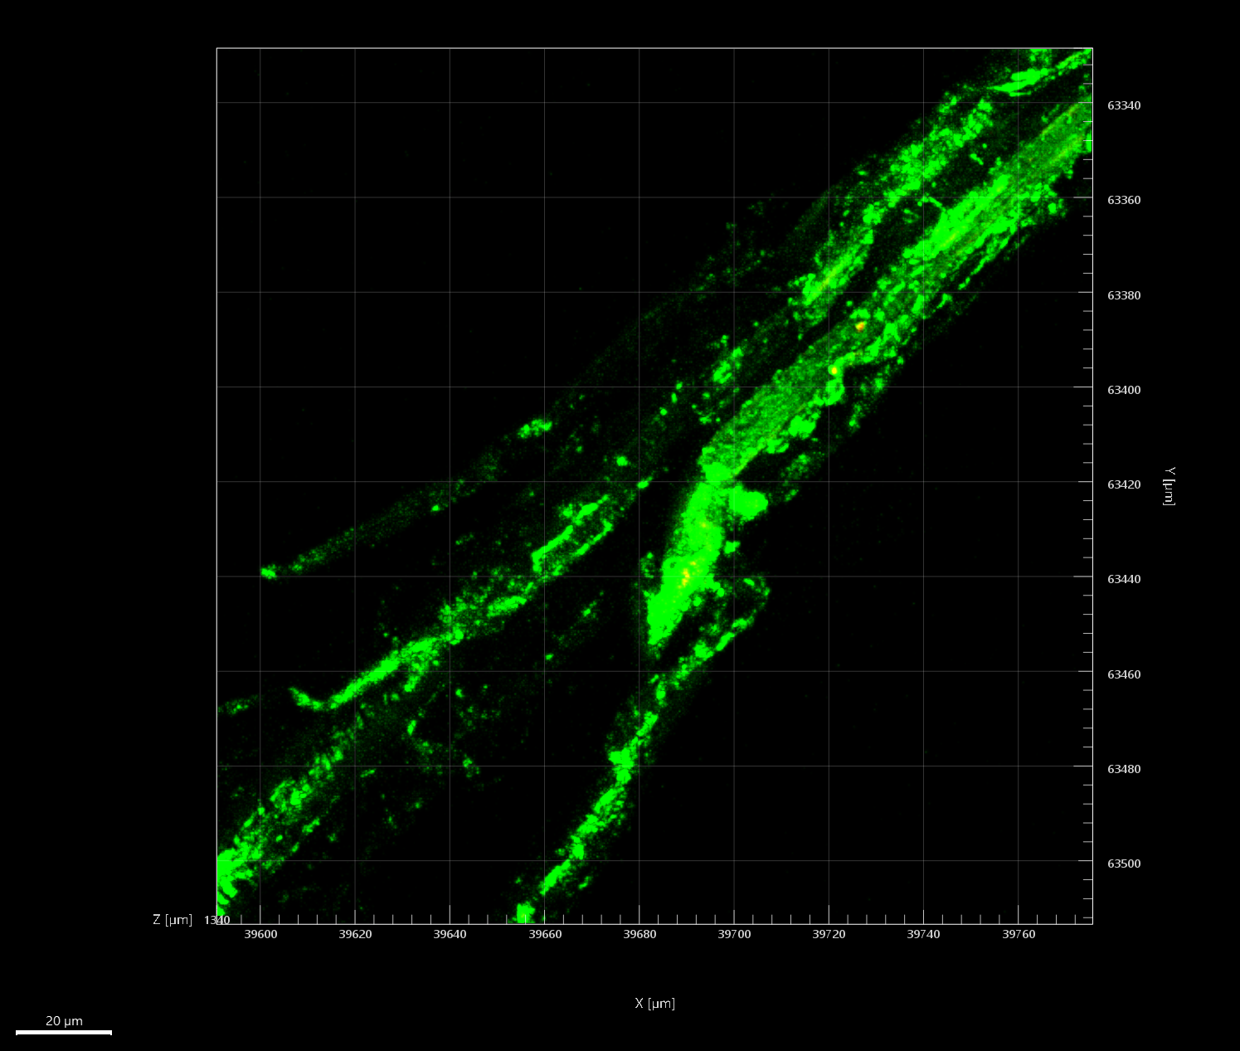 | (b)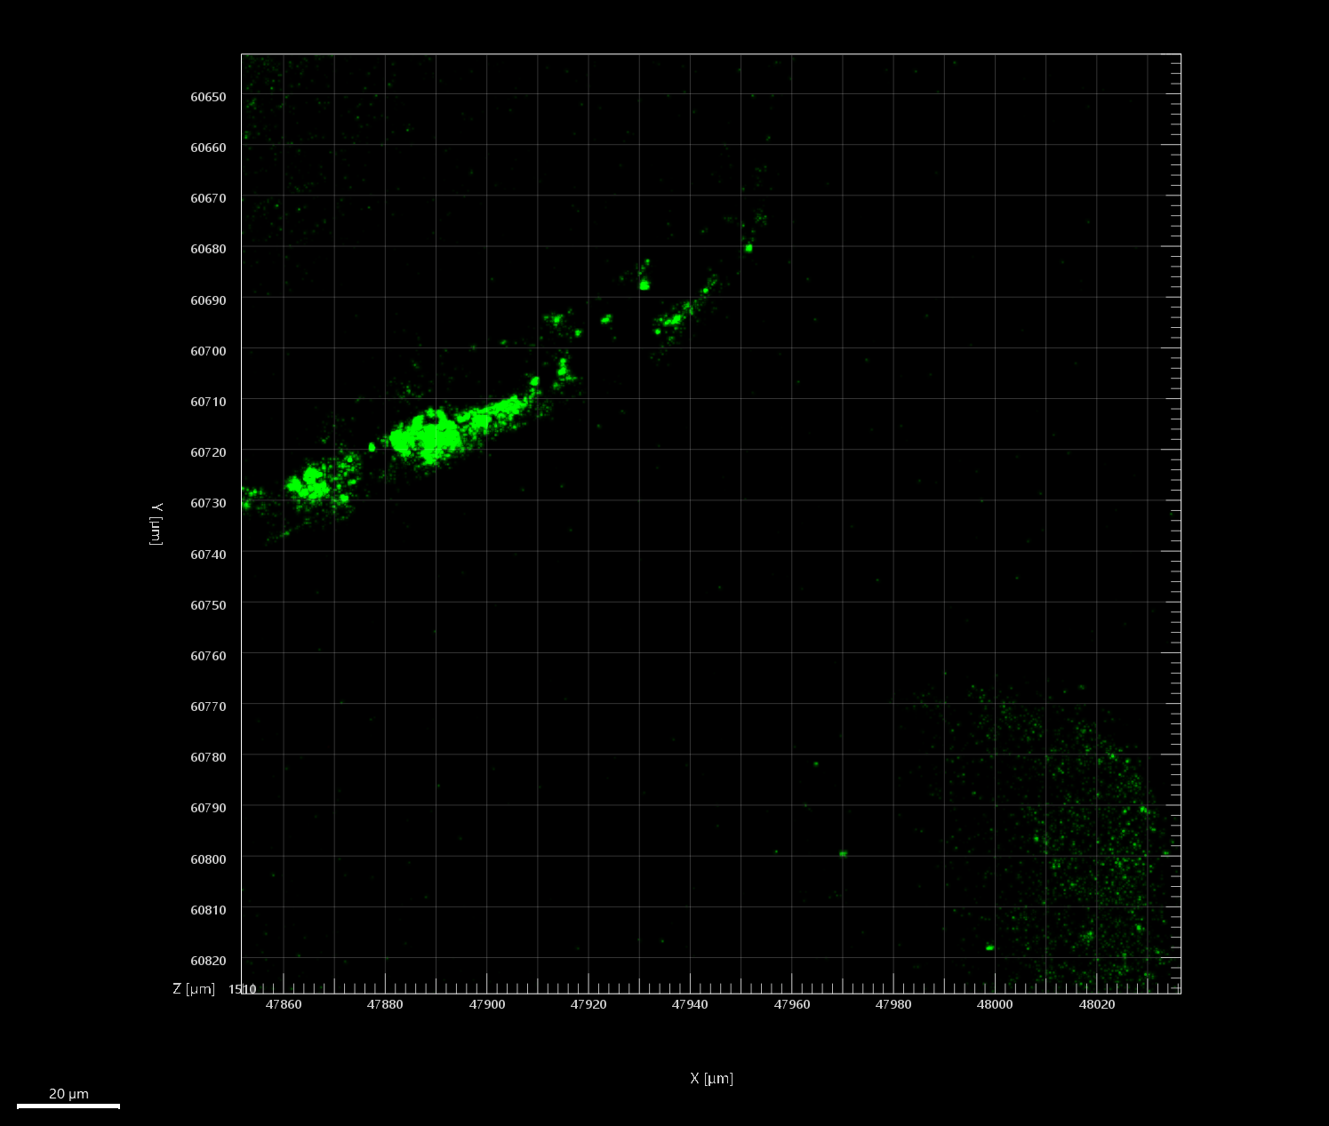
Figure S8. Confocal images of biofilms formed over UNS G10180 carbon steel surfaces for (a) AR and (b) P biofilms, after exposure to anaerobic nutrient-enriched ASW media for 28 days.

Table S9. List of top 25 microbial genera identified through 16S rRNA amplicon sequencing with two target region, V3-4 for bacteria and archaea.
Name | Sediment | Day0 | Day28 | AR | 25M
Malaciobacter | 0.002629 | 0.000723 | 51.51 | 30.96 | 31.06
Vibrio | 0.1229 | 44.44 | 18.57 | 3.456 | 5.58
Oceanicoccus | 0.02797 | 13.6 | 0.2062 | 0.3402 | 0.1696
Draconibacterium | 0.0827 | 0.4161 | 12.77 | 3.469 | 3.492
Crassaminicella | 0.006454 | 0.8045 | 6.202 | 10.68 | 10.35
Maridesulfovibrio | 0.02844 | 2.335 | 3.183 | 10.64 | 6.391
Serpentinicella | 0.004303 | 10.18 | 0.2291 | 1.389 | 3.472
Sulfurovum | 8.113 | 0.002169 | NA | 0.000522 | 0.000689
Desulfomicrobium | 0.06956 | 0.06236 | 0.5023 | 7.878 | 5.54
Halarcobacter | 0.001434 | NA | 0.2581 | 3.965 | 7.52
Methanococcoides | 0.08151 | 7.294 | NA | NA | NA
Shewanella | 0.01864 | 0.0103 | 1.287 | 5.786 | 6.979
Candidatus Prometheoarchaeum | 6.812 | 0.015 | NA | NA | NA
Candidatus Methanoplasma | 6.768 | 0.03362 | NA | NA | NA
Desulfosarcina | 6.685 | 0.003615 | NA | 0.008087 | 0.003102
Desulfuromonas | 5.615 | 0.001446 | 0.3122 | 5.735 | 5.274
Fusobacterium | 0.001195 | 4.787 | 0.001397 | 0.00287 | 0.008271
Thiohalobacter | 3.865 | 0.001084 | NA | NA | NA
Sedimentibacter | NA | 0.06091 | 1.74 | 3.18 | 2.776
Anaerotignum | 0.001195 | 2.691 | 0.01886 | 0.1283 | 0.3395
Kineobactrum | 2.52 | 0.000904 | NA | NA | NA
Pseudodesulfovibrio | 2.237 | 0.188 | 0.03544 | 0.4844 | 0.3563
Methanomassiliicoccus | 2.058 | 0.003976 | NA | NA | NA
Desulforapulum | 0.2462 | 0.003796 | 0.000524 | 1.978 | 1.161
Woeseia | 1.962 | 0.000362 | NA | NA | 0.000345

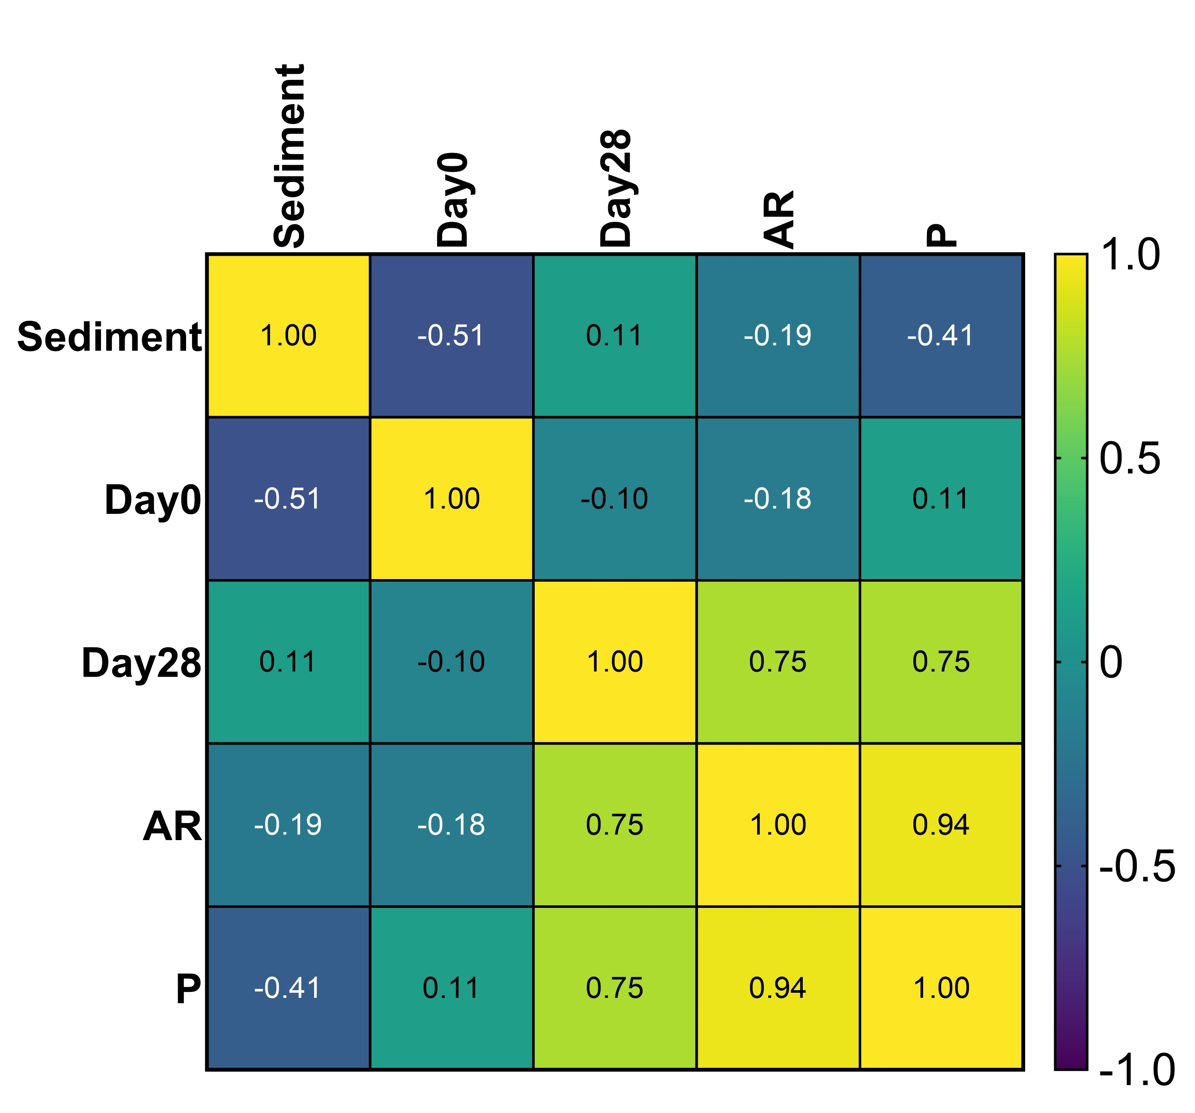
Figure S10. Spearman correlation coefficients for environmental marine sediment, Day 0, and Day 28 planktonic samples, AR and P biofilms, after exposure to anaerobic nutrient-enriched ASW media for 28 days.

(a)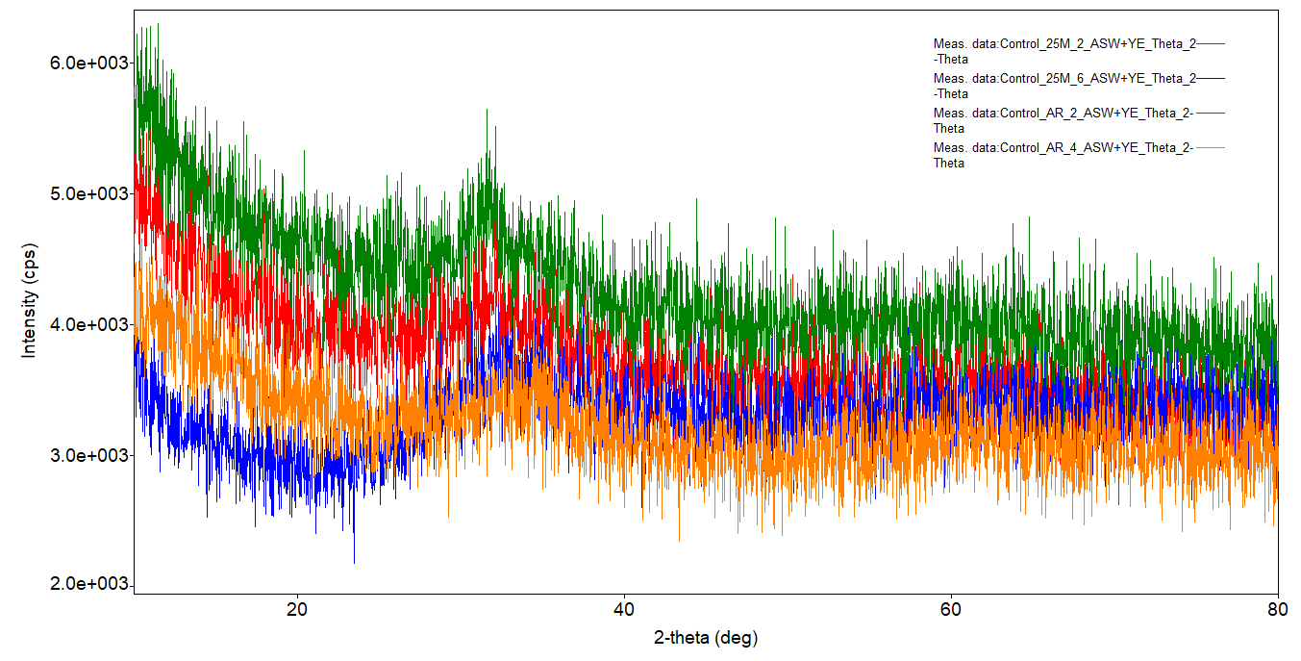
(b)
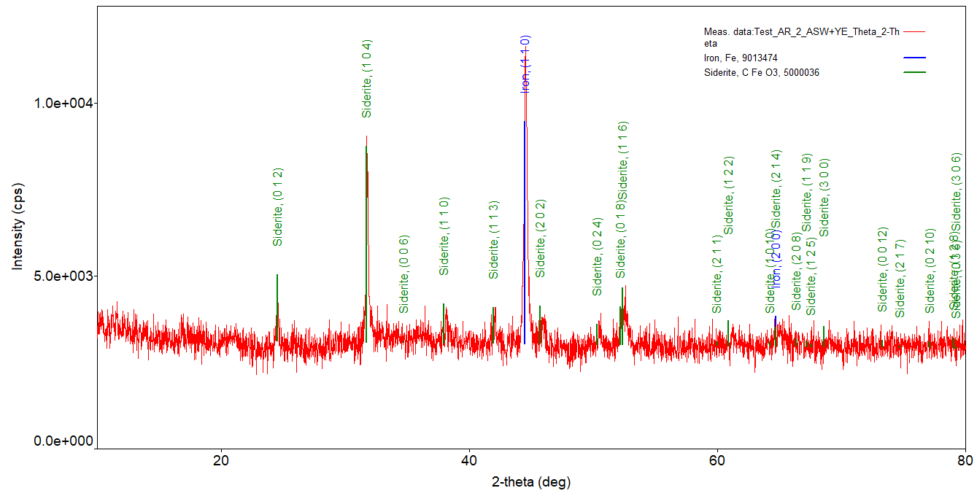
(c)
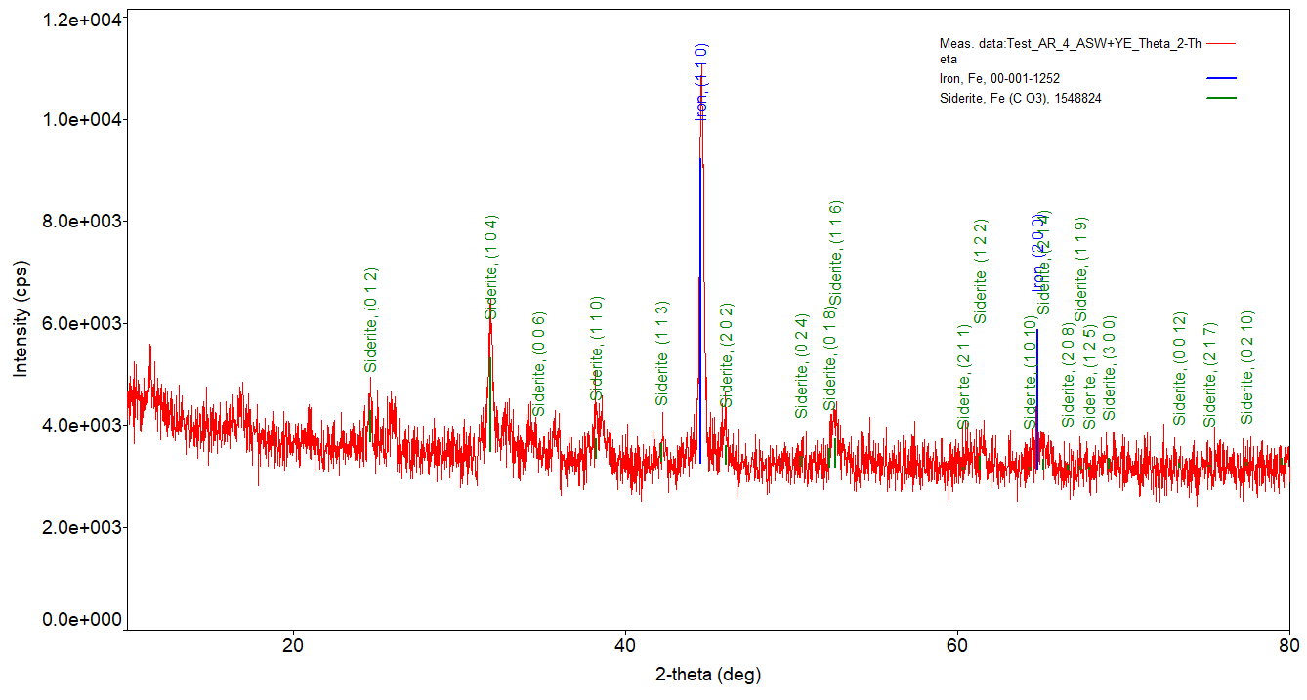
Figure S11. XRD patterns for corrosion products formed on carbon steel for abiotic (a), and biotic coupons (b, c), after exposure to anaerobic nutrient-enriched ASW media for 28 days.

