Supplementary Materials

TNFRSF18+ Tregs Impair Immunotherapy Efficacy in Immunosuppressed Colon Cancer Patients

Figure S1.HLA expression and cellular infiltration in different immunophenotypes 2
Figure S2.Survival analysis 3
Figure S3.Single cell annotation marker 4

Figure S1. HLA expression and cellular infiltration in different immunophenotypes. A. Schematic illustration of the differences in HLA expression between the two Immunophenotypes; B. Schematic illustration of the differences in immune cellular infiltration patterns between the two Immunophenotypes.
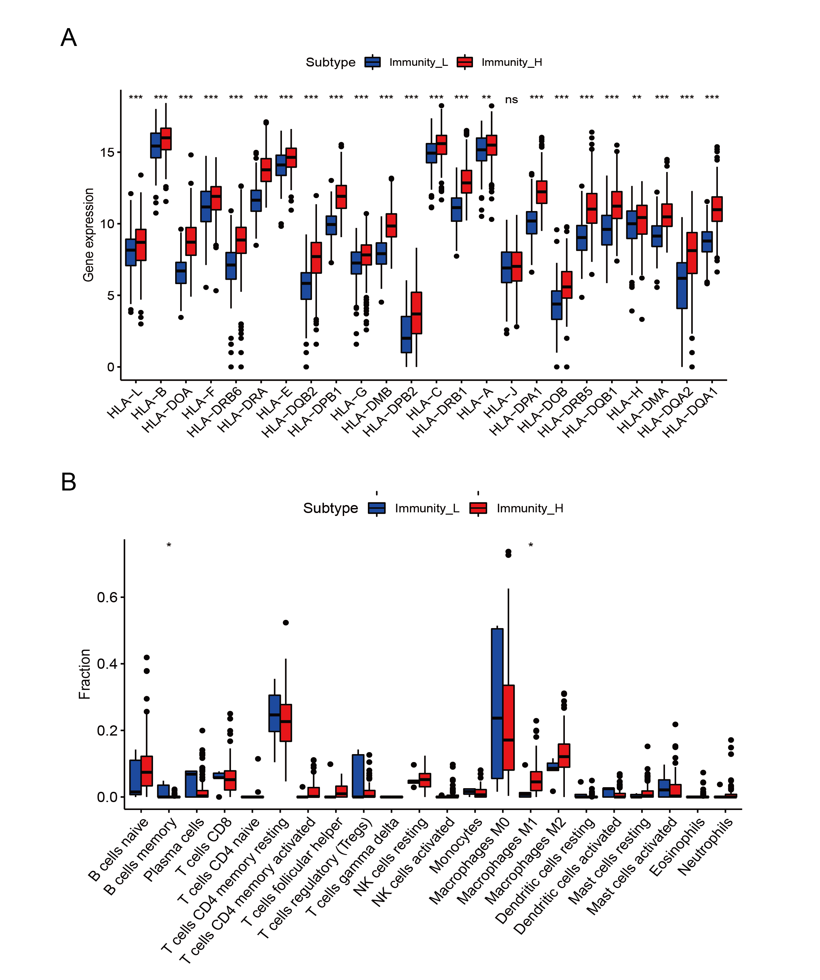

Figure S2. Survival analysis. Immunity-Low group of gene survival curves significantly associated with prognosis.
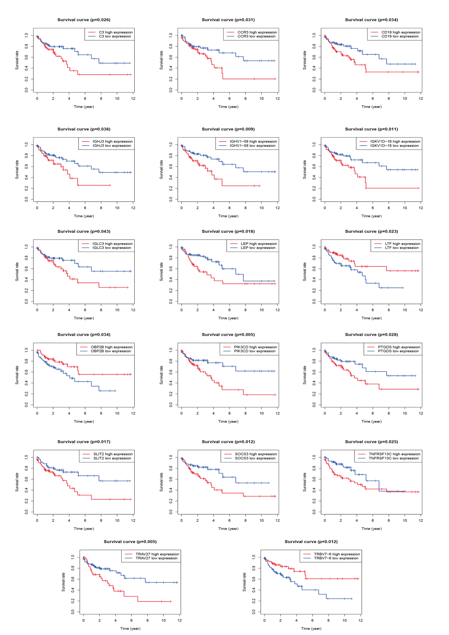
Figure S3. Single cell annotation marker. A. Schematic diagram of the overall cell data annotation marker. B. Schematic diagram of the CD4T cell annotation marker.
