Supplementary Information

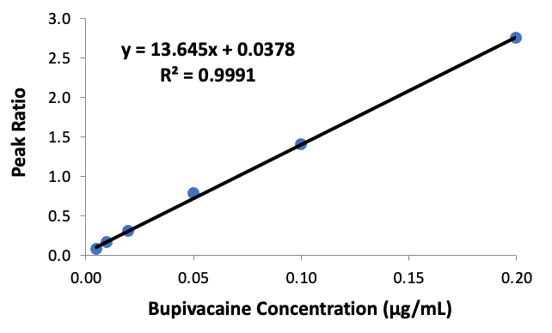
Fig. S-1 Standard curve of bupivacaine from 5 ng/mL to 200 ng/mL. Peak ratio represents the peak area of standard (i.e., bupivacaine) to internal standard (i.e., ropivacaine).

