Supplementary methods
IDH1 and IDH2 mutations identification
In order to specifically select those patients with primary glioblastoma, the presence of isocitrate dehydrogenase 1 (IDH1) and/or isocitrate dehydrogenase 2 (IDH2) mutations were studied. In the case of the TCGA group, the mutational annotation for both genes were analyzed and those patients with any kind of mutation in these genes (7 patients with IDH1 mutation and 1 patient with IDH2 mutation) were excluded. In the case of the local cohort of patients, the most common mutation in IDH1 (R132H) and IDH2 (R172K) were tested by PCR amplification and pyrosequencing.

MGMT methylation analysis in TCGA patients
Methylation probes were available for 117 patients in the cohort of TCGA patients included in the present study. In 67 of them the methylation status was tested using the HumanMethylation27 (HM27) platform and the rest of the patients were tested with the HumanMethylation (M450) platform. Some patients presented data from both platforms. Thus, the absence of significant differences between those samples on the two Infinium platforms was confirmed by calculating the p-value using a student-t test [1]. Data was then merged by averaging the beta-values of the CpG probes of interest. The methylation status of MGMT was determined as explained in other reports [2]. In brief, the beta values were transformed in m-values using the following formula:
# M = log2(Beta/(1-Beta))
The logit(y) was then calculated using the model proposed by Bady et al (2012), where only the M-value of two MGMT CpG islands is considered (cg12434587 and cg12981137):

#logit(y) = 4,3215+0,5271*cg12434587+0,9265*cg12981137

As proposed by Bady et al. (2012) a probability cutoff of 0.358 was used which empirically maximized the sum of sensitivity and specificity [2].

MGMT methylation analysis in local patients
The methylation status of the four most informative CpG islands in the MGMT promoter was studied in DNA purified from glioblastoma areas dissected from PPFE tissue sections using a commercial kit for pyrosequencing (Qiagen).

RNAseq data from TCGA patients
FOXP2 RNA expression data were extracted as explained above and they did not have a normal distribution, and thus were transformed by using base 2 logarithm (Log2 (x+1)), where x is the expression of FOXP2. This new variable (Log2FOXP2) was included in the univariate Cox regression analysis. Furthermore, FOXP2 RNA expression was also dichotomized (using different cutoffs: p25, p50 and p75) and this variable was used for the Kaplan-Meier curves and the Log-Rank test analysis.
Apart from FOXP2 RNA expression data, other gene expression profiles were also extracted to perform a molecular classification. As is widely described in previous reports, there are differences in gene expression in glioblastoma that allow their classification in proneural, neural, classical and mesenchymal transcriptomic subtypes [3,4]. Using the list of input genes that are highly expressed in each subtype (http://tcga-data.nci.nih.gov/docs/publications/gbm_exp/), an unsupervised hierarchical cluster analysis was performed (MORPHEUS, Broad Institute, http://software.broadinstitute.org/morpheus/) and each patient was assigned to a molecular subgroup by cutting the resulted dendogram (supplementary figure 1).

MicroRNA expression data from TCGA patients
Bearing in mind that protein translation of FOXP2 mRNA is intensively regulated by miRNA [5], a number of these were selected to analyze their prognostic value. Firstly, miRNA public databases (mirDB [http://www.mirdb.org/] and mirANDA [http://www.microrna.org/microrna/home.do]) were used to identify the miRNA that target FOXP2. Secondly, from this list of miRNA (supplementary table 2), those with a proven role in glioblastoma pathogenesis acting as oncogenic or tumor suppressor miRNA were selected [6]. Finally, the expression of the miRNA from this list that was available in the TCGA data was analyzed (supplementary table 3).
As most of the miRNA expression did not show a normal distribution, a dichotomization of each one was performed by using the median as cutoff. These variables were included in a stratified survival analysis with FOXP2 expression groups (supplementary table 4).

DNA Copy-Number Variation and DNA mutations
Copy number variation and mutation annotation files were downloaded as indicated above. After excluding those patients whose RNAseq data was not available, the ten-most-common cancer related genes showing copy number alteration (CNA) and/or mutation were studied. These genes (supplementary tables 5 and 6) were identified from the whole TCGA glioblastoma cohort whose analysis is available at cBioPortal (https://www.cbioportal.org/). A comparative analysis of the distribution of these genetic events between the two groups of FOXP2 expression was performed.

References
1 Brennan CW, Verhaak RGW, McKenna A, Campos B, Noushmehr H, Salama SR, et al. The somatic genomic landscape of glioblastoma. Cell. 2013 Oct;155(2):462–77.
2 Bady P, Sciuscio D, Diserens A-C, Bloch J, van den Bent MJ, Marosi C, et al. MGMT methylation analysis of glioblastoma on the Infinium methylation BeadChip identifies two distinct CpG regions associated with gene silencing and outcome, yielding a prediction model for comparisons across datasets, tumor grades, and CIMP-status. Acta Neuropathol. 2012 Oct;124(4):547–60.
3 Phillips HS, Kharbanda S, Chen R, Forrest WF, Soriano RH, Wu TD, et al. Molecular subclasses of high-grade glioma predict prognosis, delineate a pattern of disease progression, and resemble stages in neurogenesis. Cancer Cell. 2006 Mar;9(3):157–73.
4 Verhaak RGW, Hoadley KA, Purdom E, Wang V, Qi Y, Wilkerson MD, et al. Integrated genomic analysis identifies clinically relevant subtypes of glioblastoma characterized by abnormalities in PDGFRA, IDH1, EGFR, and NF1. Cancer Cell. 2010 Jan;17(1):98–110.
5 Herrero MJ, Gitton Y. The untold stories of the speech gene, the FOXP2 cancer gene. Genes Cancer. 2018 Jan;9(1–2):11–38.
6 Ahir BK, Ozer H, Engelhard HH, Lakka SS. MicroRNAs in glioblastoma pathogenesis and therapy: A comprehensive review. Crit Rev Oncol Hematol. 2017 Dec;120:22–33.

Supplementary table 1.
Supplementary table 1. Clinical and molecular features of patients included in the study.
 | Local Patients  (n=62) | TCGA Patients  (n=144)
Age | 62.93 (SD=9.9) | 61.01 (SD=12.5)
Gender (female:male) | 26:36 | 50:93
Neurological deficit at diagnosis | 46 (74.2%) | NA
Epilepsy | 9 (14.5%) | NA
Resection
Total | 12 (19.4%) | NA
Subtotal | 26 (41.9%) | NA
Partial/Biopsy | 24 (38.7%) | NA
Subventricular zone involvement | 46 (74.2%) | NA
MRI gadolinium enhancement
Heterogeneous | 28 (45.2%) | NA
Ring | 34 (54.8%) | NA
Ki-67 expression (ICH) (mean %) | 24.79 (SD=15.1) | NA
MGMT promoter methylation | 34 (54.8%) | 47 (32.6%)
Molecular subtype
Classic | NA | 42 (29.2%)
Mesenchymal | NA | 43 (29.9%)
Proneural | NA | 31 (21.5%)
Neural | NA | 28 (19.4%)
FOXP2 expression (ICH) (mean %) | 24.79 (SD=32.1) | NA
FOXP2 expression (RNAseq) | NA | 25.91 (SD=52.53)
Progression free survival (months) | 8.5 (95% CI: 4.9-12.0) | NA
Overall survival (months) | 15.17 (95% CI: 8.4-21.9) | 13.13 (95% CI: 11.0-15.2)
Treatment (TMZ+RT) | 62 (100%) | 78 (54.2%)
NA: Not Available
SD: Standard Deviation
MRI: Magnetic Resonance Imaging
MGMT: O⁶ Methylguanine-DNA methyl-transferase
TMZ: Temozolamide
RT: Radiotherapy

Supplementary figure 1.

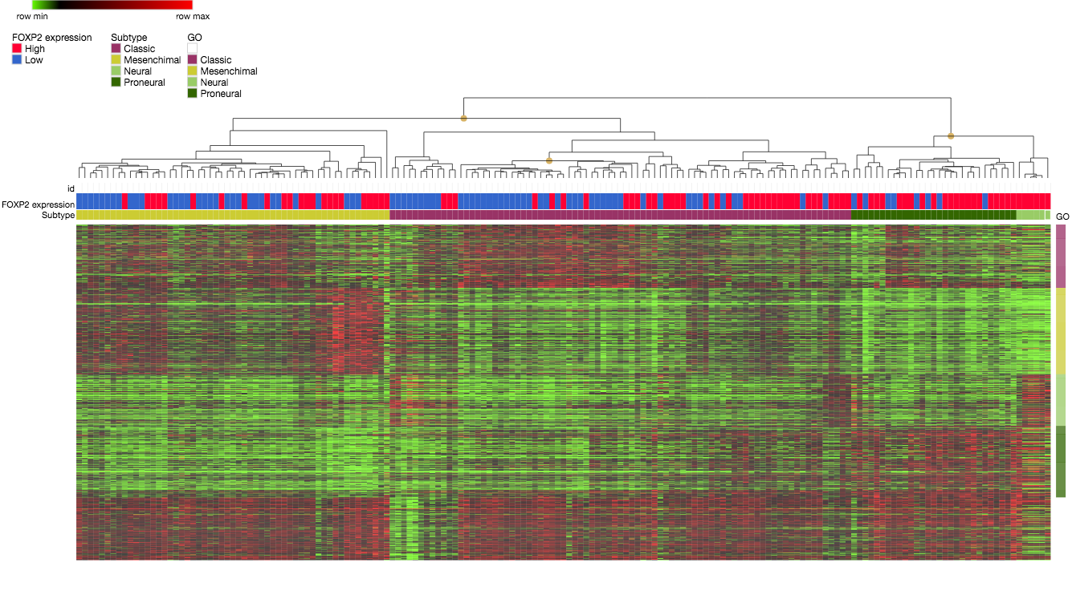
Supplementary figure 1. Unsupervised hierarchical cluster analysis to identidy molecular subgroups in glioblastoma, according to Verhaak et al., 2010.

Supplementary table 2. List of miRNAs that target FOXP2 according with the databases MirDB and mirANDA. Colored cells indicate those miRNAs with a role in glioblastoma pathogenesis acting as oncogenic or tumor suppressor (Ahir BK et al, 2017).

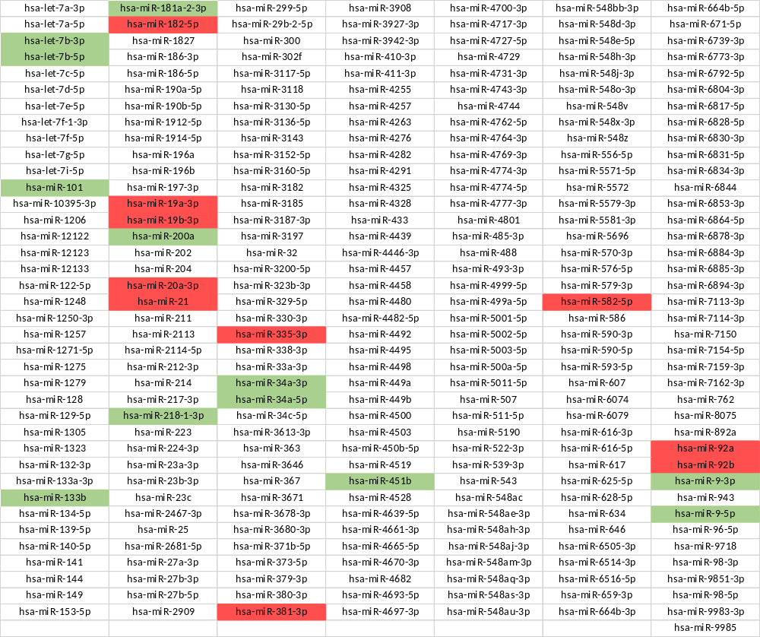

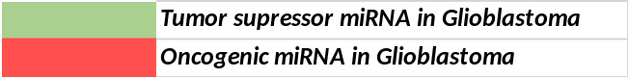

Supplementary table 3. List of miRNAs that target FOXP2, involved in glioblastoma pathogenesis and available in TCGA database.
miRNA | TCGA name | Mean Expression | SD | Median
hsa-let-7b-3p | hsa_let_7b | 14.03 | 0.56 | 14.06
hsa-let-7b-5p | hsa_let_7b | 14.03 | 0.56 | 14.06
hsa-miR-101 | hsa_miR_101 | 10.31 | 0.57 | 10.31
hsa-miR-133b | hsa-miR-133b | 6.21 | 0.29 | 6.17
hsa-miR-181a-2-3p | hsa-miR-181a* | 6.93 | 0.48 | 6.87
hsa-miR-182-5p | hsa_miR_182 | 7.74 | 1.49 | 7.25
hsa-miR-19a-3p | hsa_miR_19a | 9.12 | 0.62 | 9.06
hsa-miR-19b-3p | hsa_miR_19b | 10.63 | 0.61 | 10.61
hsa-miR-200a | hsa-miR-200a | 6.06 | 0.21 | 6.01
hsa-miR-20a-3p | hsa-miR-20a | 10.00 | 0.78 | 9.99
hsa-miR-21 | hsa_miR_21 | 14.29 | 1.07 | 14.41
hsa-miR-218-1-3p | hsa-miR-218 | 6.59 | 0.69 | 6.55
hsa-miR-335-3p | hsa-miR-335 | 7.77 | 0.76 | 7.71
hsa-miR-34a-3p | hsa_miR_34a | 10.18 | 0.95 | 10.26
hsa-miR-34a-5p | hsa_miR_34a | 10.18 | 0.95 | 10.26
hsa-miR-381-3p | hsa_miR_381 | 6.42 | 0.37 | 6.37
hsa-miR-582-5p | hsa-miR-582 | 5.99 | 0.18 | 5.97
hsa-miR-92a | hsa-miR-92 | 10.15 | 0.52 | 10.12
hsa-miR-92b | hsa_miR_92b | 8.27 | 0.61 | 8.31
hsa-miR-9-3p | hsa-miR-9* | 13.70 | 1.16 | 13.89
hsa-miR-9-5p | hsa-miR-9 | 12.08 | 1.23 | 12.21

Supplementary table 4. Survival analysis (high vs. low FOXP2 expression) in low miRNA subtype expression

miRNA | TCGA name | Log-Rank | p-value
hsa-let-7b-3p | hsa_let_7b | 0.433 | 0.511
hsa-let-7b-5p | hsa_let_7b | 0.433 | 0.511
hsa-miR-101 | hsa_miR_101 | 2.407 | 0.121
hsa-miR-133b | hsa-miR-133b | 0.000 | 0.998
hsa-miR-181a-2-3p | hsa-miR-181a* | 4.847 | 0.028
hsa-miR-182-5p | hsa_miR_182 | 0.007 | 0.932
hsa-miR-19a-3p | hsa_miR_19a | 1.231 | 0.267
hsa-miR-19b-3p | hsa_miR_19b | 0.108 | 0.742
hsa-miR-200a | hsa-miR-200a | 1.146 | 0.284
hsa-miR-20a-3p | hsa-miR-20a | 5.454 | 0.020
hsa-miR-21 | hsa_miR_21 | 0.069 | 0.792
hsa-miR-218-1-3p | hsa-miR-218 | 0.169 | 0.681
hsa-miR-335-3p | hsa-miR-335 | 0.389 | 0.533
hsa-miR-34a-3p | hsa_miR_34a | 0.017 | 0.895
hsa-miR-34a-5p | hsa_miR_34a | 0.017 | 0.895
hsa-miR-381-3p | hsa_miR_381 | 3.082 | 0.079
hsa-miR-582-5p | hsa-miR-582 | 0.068 | 0.794
hsa-miR-92a | hsa-miR-92 | 1.248 | 0.264
hsa-miR-92b | hsa_miR_92b | 1.752 | 0.186
hsa-miR-9-3p | hsa-miR-9* | 3.673 | 0.055
hsa-miR-9-5p | hsa-miR-9 | 0.929 | 0.335

Supplementary table 5. Top-10 cancer-related mutated genes in the TCGA whole cohort (290 profiled samples).

 | Number of mutations | Number of samples with one or more mutations | Frequency | MutSig(Q-value)
PTEN | 93 | 90 | 31.0% | 3.02E-12
TP53 | 101 | 84 | 29.0% | 3.02E-12
EGFR | 95 | 77 | 26.6% | 3.02E-12
PIK3R1 | 34 | 33 | 11.4% | 0
NF1 | 40 | 32 | 11.0% | 1.40E-10
PIK3CA | 35 | 32 | 11.0% | 4.53E-12
PCLO | 29 | 28 | 9.7%
RB1 | 27 | 25 | 8.6% | 4.53E-12
ATRX | 17 | 17 | 5.9% | 1.53E-02
KEL | 15 | 15 | 5.2% | 1.55E-06

Supplementary table 6. Top-10 cancer-related genes with Copy Number Alteration in the TCGA whole cohort (577 profiled samples).

 | Cytoband | CNA | Number of samples with one or more CNA | Frequency | Gistic(Q-value)
CDKN2A | 9p21.3 | DEL | 331 | 57.4% | 0
CDKN2B | 9p21.3 | DEL | 323 | 56.0% | 0
MTAP | 9p21.3 | DEL | 303 | 52.5% | 0
EGFR | 7p11.2 | AMP | 253 | 43.8%
CDK4 | 12q14.1 | AMP | 83 | 14.4% | 0
MLLT3 | 9p21.3 | DEL | 77 | 13.3%
FIP1L1 | 4q12 | AMP | 75 | 13.0% | 0
PDGFRA | 4q12 | AMP | 74 | 12.8% | 0
CHIC2 | 4q12 | AMP | 69 | 12.0%
PTEN | 10q23.31 | DEL | 56 | 9.7% | 0

Supplementary figure 2. FOXP2 expression level in each molecular subgroup. Statistical differences were identified using Kruskal-Wallis with Dunn’s correction for multiple comparisons.

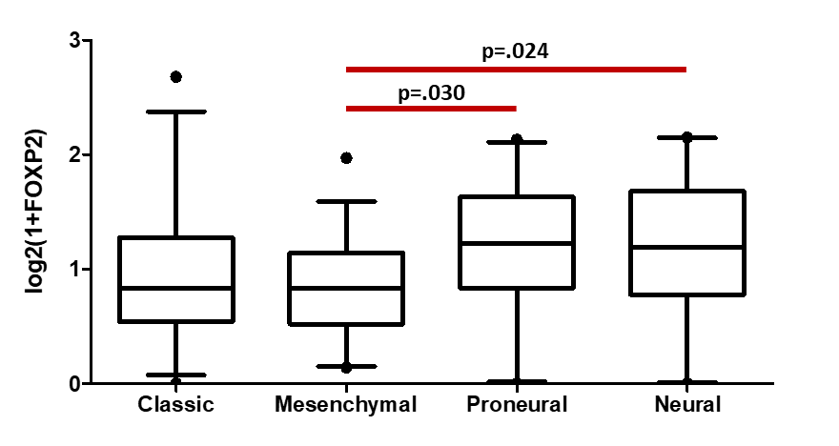

Supplementary table 7. Arm-level somatic copy number aberrations in low and high FOXP2 RNA expression groups.
Supplementary table X. Arm-level somatic copy number aberrations in low and high FOXP2 RNA expression groups.
 |  | FOXP2 RNA expression
 |  | Low |  | High
 |  | Count | % | Count | % | p-value | FDR
1p Status | Not called | 54 | 85.7% | 61 | 95.3% | 0.1 | 0.573
1p Status | Gained | 7 | 11.1% | 1 | 1.6% | 0.1 | 0.573
1p Status | Lost | 1 | 1.6% | 2 | 3.1% | 0.1 | 0.573
1p Status | Mixed | 1 | 1.6% | 0 | 0.0% | 0.1 | 0.573
1q Status | Not called | 56 | 87.5% | 60 | 90.9% | 0.486 | 0.758
1q Status | Gained | 7 | 10.9% | 5 | 7.6% | 0.486 | 0.758
1q Status | Lost | 0 | 0.0% | 1 | 1.5% | 0.486 | 0.758
1q Status | Mixed | 1 | 1.6% | 0 | 0.0% | 0.486 | 0.758
2p Status | Not called | 64 | 95.5% | 66 | 95.7% | 0.716 | 0.759
2p Status | Gained | 1 | 1.5% | 2 | 2.9% | 0.716 | 0.759
2p Status | Lost | 2 | 3.0% | 1 | 1.4% | 0.716 | 0.759
2p Status | Mixed | 0 | 0.0% | 0 | 0.0% | 0.716 | 0.759
2q Status | Not called | 65 | 95.6% | 66 | 97.1% | 0.843 | 0.843
2q Status | Gained | 1 | 1.5% | 1 | 1.5% | 0.843 | 0.843
2q Status | Lost | 2 | 2.9% | 1 | 1.5% | 0.843 | 0.843
2q Status | Mixed | 0 | 0.0% | 0 | 0.0% | 0.843 | 0.843
3p Status | Not called | 61 | 91.0% | 61 | 93.8% | 0.162 | 0.575
3p Status | Gained | 5 | 7.5% | 1 | 1.5% | 0.162 | 0.575
3p Status | Lost | 1 | 1.5% | 3 | 4.6% | 0.162 | 0.575
3p Status | Mixed | 0 | 0.0% | 0 | 0.0% | 0.162 | 0.575
3q Status | Not called | 58 | 89.2% | 63 | 95.5% | 0.128 | 0.575
3q Status | Gained | 6 | 9.2% | 1 | 1.5% | 0.128 | 0.575
3q Status | Lost | 1 | 1.5% | 2 | 3.0% | 0.128 | 0.575
3q Status | Mixed | 0 | 0.0% | 0 | 0.0% | 0.128 | 0.575
4p Status | Not called | 62 | 91.2% | 65 | 95.6% | 0.215 | 0.575
4p Status | Gained | 1 | 1.5% | 2 | 2.9% | 0.215 | 0.575
4p Status | Lost | 5 | 7.4% | 1 | 1.5% | 0.215 | 0.575
4p Status | Mixed | 0 | 0.0% | 0 | 0.0% | 0.215 | 0.575
4q Status | Not called | 63 | 94.0% | 63 | 94.0% | 0.721 | 0.759
4q Status | Gained | 1 | 1.5% | 2 | 3.0% | 0.721 | 0.759
4q Status | Lost | 2 | 3.0% | 2 | 3.0% | 0.721 | 0.759
4q Status | Mixed | 1 | 1.5% | 0 | 0.0% | 0.721 | 0.759
5p Status | Not called | 61 | 92.4% | 67 | 97.1% | 0.103 | 0.573
5p Status | Gained | 4 | 6.1% | 0 | 0.0% | 0.103 | 0.573
5p Status | Lost | 1 | 1.5% | 2 | 2.9% | 0.103 | 0.573
5p Status | Mixed | 0 | 0.0% | 0 | 0.0% | 0.103 | 0.573
5q Status | Not called | 63 | 94.0% | 62 | 95.4% | 0.137 | 0.575
5q Status | Gained | 3 | 4.5% | 0 | 0.0% | 0.137 | 0.575
5q Status | Lost | 1 | 1.5% | 3 | 4.6% | 0.137 | 0.575
5q Status | Mixed | 0 | 0.0% | 0 | 0.0% | 0.137 | 0.575
6p Status | Not called | 58 | 85.3% | 57 | 85.1% | 0.663 | 0.759
6p Status | Gained | 1 | 1.5% | 2 | 3.0% | 0.663 | 0.759
6p Status | Lost | 9 | 13.2% | 7 | 10.4% | 0.663 | 0.759
6p Status | Mixed | 0 | 0.0% | 1 | 1.5% | 0.663 | 0.759
6q Status | Not called | 39 | 68.4% | 51 | 76.1% | 0.341 | 0.659
6q Status | Gained | 0 | 0.0% | 2 | 3.0% | 0.341 | 0.659
6q Status | Lost | 17 | 29.8% | 13 | 19.4% | 0.341 | 0.659
6q Status | Mixed | 1 | 1.8% | 1 | 1.5% | 0.341 | 0.659
7p Status | Not called | 11 | 18.0% | 14 | 21.2% | 0.824 | 0.843
7p Status | Gained | 50 | 82.0% | 52 | 78.8% | 0.824 | 0.843
7p Status | Lost | 0 | 0.0% | 0 | 0.0% | 0.824 | 0.843
7p Status | Mixed | 0 | 0.0% | 0 | 0.0% | 0.824 | 0.843
7q Status | Not called | 9 | 14.3% | 14 | 21.2% | 0.361 | 0.659
7q Status | Gained | 54 | 85.7% | 52 | 78.8% | 0.361 | 0.659
7q Status | Lost | 0 | 0.0% | 0 | 0.0% | 0.361 | 0.659
7q Status | Mixed | 0 | 0.0% | 0 | 0.0% | 0.361 | 0.659
8p Status | Not called | 60 | 89.6% | 59 | 88.1% | 0.675 | 0.759
8p Status | Gained | 2 | 3.0% | 4 | 6.0% | 0.675 | 0.759
8p Status | Lost | 5 | 7.5% | 4 | 6.0% | 0.675 | 0.759
8p Status | Mixed | 0 | 0.0% | 0 | 0.0% | 0.675 | 0.759
8q Status | Not called | 61 | 91.0% | 59 | 89.4% | 0.372 | 0.659
8q Status | Gained | 2 | 3.0% | 5 | 7.6% | 0.372 | 0.659
8q Status | Lost | 4 | 6.0% | 2 | 3.0% | 0.372 | 0.659
8q Status | Mixed | 0 | 0.0% | 0 | 0.0% | 0.372 | 0.659
9p Status | Not called | 21 | 45.7% | 32 | 62.7% | 0.226 | 0.575
9p Status | Gained | 2 | 4.3% | 1 | 2.0% | 0.226 | 0.575
9p Status | Lost | 23 | 50.0% | 18 | 35.3% | 0.226 | 0.575
9p Status | Mixed | 0 | 0.0% | 0 | 0.0% | 0.226 | 0.575
9q Status | Not called | 53 | 80.3% | 55 | 83.3% | 0.699 | 0.759
9q Status | Gained | 4 | 6.1% | 3 | 4.5% | 0.699 | 0.759
9q Status | Lost | 9 | 13.6% | 7 | 10.6% | 0.699 | 0.759
9q Status | Mixed | 0 | 0.0% | 1 | 1.5% | 0.699 | 0.759
10p Status | Not called | 5 | 7.6% | 4 | 6.1% | 0.548 | 0.759
10p Status | Gained | 0 | 0.0% | 1 | 1.5% | 0.548 | 0.759
10p Status | Lost | 61 | 92.4% | 60 | 90.9% | 0.548 | 0.759
10p Status | Mixed | 0 | 0.0% | 1 | 1.5% | 0.548 | 0.759
10q Status | Not called | 3 | 4.5% | 4 | 6.0% | 0.556 | 0.759
10q Status | Gained | 0 | 0.0% | 0 | 0.0% | 0.556 | 0.759
10q Status | Lost | 64 | 95.5% | 62 | 92.5% | 0.556 | 0.759
10q Status | Mixed | 0 | 0.0% | 1 | 1.5% | 0.556 | 0.759
11p Status | Not called | 60 | 88.2% | 54 | 85.7% | 0.482 | 0.758
11p Status | Gained | 3 | 4.4% | 1 | 1.6% | 0.482 | 0.758
11p Status | Lost | 5 | 7.4% | 7 | 11.1% | 0.482 | 0.758
11p Status | Mixed | 0 | 0.0% | 1 | 1.6% | 0.482 | 0.758
11q Status | Not called | 61 | 92.4% | 59 | 85.5% | 0.512 | 0.759
11q Status | Gained | 1 | 1.5% | 1 | 1.4% | 0.512 | 0.759
11q Status | Lost | 4 | 6.1% | 8 | 11.6% | 0.512 | 0.759
11q Status | Mixed | 0 | 0.0% | 1 | 1.4% | 0.512 | 0.759
12p Status | Not called | 56 | 84.8% | 56 | 83.6% | 0.228 | 0.575
12p Status | Gained | 8 | 12.1% | 4 | 6.0% | 0.228 | 0.575
12p Status | Lost | 2 | 3.0% | 6 | 9.0% | 0.228 | 0.575
12p Status | Mixed | 0 | 0.0% | 1 | 1.5% | 0.228 | 0.575
12q Status | Not called | 55 | 84.6% | 57 | 87.7% | 0.251 | 0.575
12q Status | Gained | 7 | 10.8% | 2 | 3.1% | 0.251 | 0.575
12q Status | Lost | 2 | 3.1% | 5 | 7.7% | 0.251 | 0.575
12q Status | Mixed | 1 | 1.5% | 1 | 1.5% | 0.251 | 0.575
13q Status | Not called | 44 | 78.6% | 42 | 70.0% | 0.412 | 0.698
13q Status | Gained | 0 | 0.0% | 1 | 1.7% | 0.412 | 0.698
13q Status | Lost | 12 | 21.4% | 17 | 28.3% | 0.412 | 0.698
13q Status | Mixed | 0 | 0.0% | 0 | 0.0% | 0.412 | 0.698
14q Status | Not called | 45 | 76.3% | 36 | 60.0% | 0.189 | 0.575
14q Status | Gained | 0 | 0.0% | 1 | 1.7% | 0.189 | 0.575
14q Status | Lost | 14 | 23.7% | 22 | 36.7% | 0.189 | 0.575
14q Status | Mixed | 0 | 0.0% | 1 | 1.7% | 0.189 | 0.575
15q Status | Not called | 59 | 89.4% | 46 | 75.4% | 0.038 | 0.573
15q Status | Gained | 3 | 4.5% | 1 | 1.6% | 0.038 | 0.573
15q Status | Lost | 4 | 6.1% | 12 | 19.7% | 0.038 | 0.573
15q Status | Mixed | 0 | 0.0% | 2 | 3.3% | 0.038 | 0.573
16p Status | Not called | 61 | 91.0% | 58 | 92.1% | 0.693 | 0.759
16p Status | Gained | 1 | 1.5% | 1 | 1.6% | 0.693 | 0.759
16p Status | Lost | 5 | 7.5% | 3 | 4.8% | 0.693 | 0.759
16p Status | Mixed | 0 | 0.0% | 1 | 1.6% | 0.693 | 0.759
16q Status | Not called | 55 | 85.9% | 55 | 84.6% | 0.707 | 0.759
16q Status | Gained | 1 | 1.6% | 2 | 3.1% | 0.707 | 0.759
16q Status | Lost | 8 | 12.5% | 7 | 10.8% | 0.707 | 0.759
16q Status | Mixed | 0 | 0.0% | 1 | 1.5% | 0.707 | 0.759
17p Status | Not called | 59 | 88.1% | 57 | 86.4% | 0.598 | 0.759
17p Status | Gained | 0 | 0.0% | 1 | 1.5% | 0.598 | 0.759
17p Status | Lost | 8 | 11.9% | 8 | 12.1% | 0.598 | 0.759
17p Status | Mixed | 0 | 0.0% | 0 | 0.0% | 0.598 | 0.759
17q Status | Not called | 60 | 90.9% | 61 | 95.3% | 0.062 | 0.573
17q Status | Gained | 0 | 0.0% | 2 | 3.1% | 0.062 | 0.573
17q Status | Lost | 6 | 9.1% | 1 | 1.6% | 0.062 | 0.573
17q Status | Mixed | 0 | 0.0% | 0 | 0.0% | 0.062 | 0.573
18p Status | Not called | 58 | 86.6% | 53 | 82.8% | 0.287 | 0.589
18p Status | Gained | 5 | 7.5% | 2 | 3.1% | 0.287 | 0.589
18p Status | Lost | 4 | 6.0% | 8 | 12.5% | 0.287 | 0.589
18p Status | Mixed | 0 | 0.0% | 1 | 1.6% | 0.287 | 0.589
18q Status | Not called | 57 | 85.1% | 55 | 84.6% | 0.66 | 0.759
18q Status | Gained | 5 | 7.5% | 3 | 4.6% | 0.66 | 0.759
18q Status | Lost | 5 | 7.5% | 6 | 9.2% | 0.66 | 0.759
18q Status | Mixed | 0 | 0.0% | 1 | 1.5% | 0.66 | 0.759
19p Status | Not called | 40 | 61.5% | 48 | 71.6% | 0.066 | 0.573
19p Status | Gained | 25 | 38.5% | 15 | 22.4% | 0.066 | 0.573
19p Status | Lost | 0 | 0.0% | 2 | 3.0% | 0.066 | 0.573
19p Status | Mixed | 0 | 0.0% | 2 | 3.0% | 0.066 | 0.573
19q Status | Not called | 42 | 66.7% | 43 | 71.7% | 0.101 | 0.573
19q Status | Gained | 20 | 31.7% | 11 | 18.3% | 0.101 | 0.573
19q Status | Lost | 1 | 1.6% | 5 | 8.3% | 0.101 | 0.573
19q Status | Mixed | 0 | 0.0% | 1 | 1.7% | 0.101 | 0.573
20p Status | Not called | 45 | 67.2% | 53 | 76.8% | 0.229 | 0.575
20p Status | Gained | 22 | 32.8% | 15 | 21.7% | 0.229 | 0.575
20p Status | Lost | 0 | 0.0% | 1 | 1.4% | 0.229 | 0.575
20p Status | Mixed | 0 | 0.0% | 0 | 0.0% | 0.229 | 0.575
20q Status | Not called | 46 | 67.6% | 52 | 76.5% | 0.246 | 0.575
20q Status | Gained | 22 | 32.4% | 14 | 20.6% | 0.246 | 0.575
20q Status | Lost | 0 | 0.0% | 1 | 1.5% | 0.246 | 0.575
20q Status | Mixed | 0 | 0.0% | 1 | 1.5% | 0.246 | 0.575
21q Status | Not called | 59 | 86.8% | 61 | 95.3% | 0.271 | 0.587
21q Status | Gained | 6 | 8.8% | 2 | 3.1% | 0.271 | 0.587
21q Status | Lost | 2 | 2.9% | 0 | 0.0% | 0.271 | 0.587
21q Status | Mixed | 1 | 1.5% | 1 | 1.6% | 0.271 | 0.587
22q Status | Not called | 48 | 75.0% | 35 | 55.6% | 0.073 | 0.573
22q Status | Gained | 2 | 3.1% | 1 | 1.6% | 0.073 | 0.573
22q Status | Lost | 14 | 21.9% | 26 | 41.3% | 0.073 | 0.573
22q Status | Mixed | 0 | 0.0% | 1 | 1.6% | 0.073 | 0.573

Supplementary table 8. GISTIC analysis of the glioblastoma top-10 most common focal amplifications and deletions in cancer-related genes for low and high FOXP2 RNA expression groups.

 |  | FOXP2 RNA expression
 |  | Low |  | High
 |  | Count | % | Count | % | p-value | FDR
CDKN2A | Deep Deletion | 44 | 62.0% | 34 | 46.6% | 0.069 | 0.173
CDKN2A | Amplification | 0 | 0.0% | 0 | 0.0% | 0.069 | 0.173
CDKN2A | Normal | 27 | 38.0% | 39 | 53.4% | 0.069 | 0.173
CDKN2B | Deep Deletion | 42 | 59.2% | 31 | 42.5% | 0.048 | 0.160
CDKN2B | Amplification | 0 | 0.0% | 0 | 0.0% | 0.048 | 0.160
CDKN2B | Normal | 29 | 40.8% | 42 | 57.5% | 0.048 | 0.160
MTAP | Deep Deletion | 42 | 59.2% | 30 | 41.1% | 0.045 | 0.160
MTAP | Amplification | 0 | 0.0% | 0 | 0.0% | 0.045 | 0.160
MTAP | Normal | 29 | 40.8% | 43 | 58.9% | 0.045 | 0.160
EGFR | Deep Deletion | 0 | 0.0% | 0 | 0.0% | 0.243 | 0.389
EGFR | Amplification | 39 | 54.9% | 32 | 43.8% | 0.243 | 0.389
EGFR | Normal | 32 | 45.1% | 41 | 56.2% | 0.243 | 0.389
CDK4 | Deep Deletion | 0 | 0.0% | 0 | 0.0% | 0.027 | 0.160
CDK4 | Amplification | 7 | 9.9% | 18 | 24.7% | 0.027 | 0.160
CDK4 | Normal | 64 | 90.1% | 55 | 75.3% | 0.027 | 0.160
MLLT3 | Deep Deletion | 9 | 12.7% | 5 | 6.8% | 0.272 | 0.389
MLLT3 | Amplification | 0 | 0.0% | 0 | 0.0% | 0.272 | 0.389
MLLT3 | Normal | 62 | 87.3% | 68 | 93.2% | 0.272 | 0.389
FIP1L1 | Deep Deletion | 0 | 0.0% | 0 | 0.0% | 0.638 | 0.638
FIP1L1 | Amplification | 9 | 12.7% | 12 | 16.4% | 0.638 | 0.638
FIP1L1 | Normal | 62 | 87.3% | 61 | 83.6% | 0.638 | 0.638
PDGFRA | Deep Deletion | 0 | 0.0% | 0 | 0.0% | 0.638 | 0.638
PDGFRA | Amplification | 9 | 12.7% | 12 | 16.4% | 0.638 | 0.638
PDGFRA | Normal | 62 | 87.3% | 61 | 83.6% | 0.638 | 0.638
CHIC2 | Deep Deletion | 0 | 0.0% | 0 | 0.0% | 0.624 | 0.638
CHIC2 | Amplification | 8 | 11.3% | 11 | 15.1% | 0.624 | 0.638
CHIC2 | Normal | 63 | 88.7% | 62 | 84.9% | 0.624 | 0.638
PTEN | Deep Deletion | 10 | 14.1% | 5 | 6.8% | 0.181 | 0.362
PTEN | Amplification | 0 | 0.0% | 0 | 0.0% | 0.181 | 0.362
PTEN | Normal | 61 | 85.9% | 68 | 93.2% | 0.181 | 0.362

Supplementary table 9. Mutational signature of the glioblastoma top-10 most common cancer-related mutated genes for low and high FOXP2 RNA expression groups.

 |  | FOXP2 expression
 |  | Low |  | High
 |  | Count | % | Count | % | p-value | FDR
PTEN | Missense Mutation (putative driver) | 9 | 12.7% | 10 | 13.7% | 0.699 | 0.699
PTEN | Truncating Mutation (putative driver) | 14 | 19.7% | 11 | 15.1% | 0.699 | 0.699
PTEN | Inframe Mutation (putative driver) | 0 | 0.0% | 0 | 0.0% | 0.699 | 0.699
PTEN | Missense Mutation (putative passenger) | 1 | 1.4% | 3 | 4.1% | 0.699 | 0.699
PTEN | Truncating Mutation (putative passenger) | 0 | 0.0% | 0 | 0.0% | 0.699 | 0.699
PTEN | Inframe Mutation (putative passenger) | 0 | 0.0% | 0 | 0.0% | 0.699 | 0.699
PTEN | No mutation | 47 | 66.2% | 49 | 67.1% | 0.699 | 0.699
TP53 | Missense Mutation (putative driver) | 13 | 18.3% | 19 | 26.0% | 0.16 | 0.476
TP53 | Truncating Mutation (putative driver) | 2 | 2.8% | 5 | 6.8% | 0.16 | 0.476
TP53 | Inframe Mutation (putative driver) | 0 | 0.0% | 2 | 2.7% | 0.16 | 0.476
TP53 | Missense Mutation (putative passenger) | 0 | 0.0% | 0 | 0.0% | 0.16 | 0.476
TP53 | Truncating Mutation (putative passenger) | 0 | 0.0% | 0 | 0.0% | 0.16 | 0.476
TP53 | Inframe Mutation (putative passenger) | 0 | 0.0% | 0 | 0.0% | 0.16 | 0.476
TP53 | No mutation | 56 | 78.9% | 47 | 64.4% | 0.16 | 0.476
EGFR | Missense Mutation (putative driver) | 27 | 38.0% | 12 | 16.4% | 0.042 | 0.21
EGFR | Truncating Mutation (putative driver) | 0 | 0.0% | 0 | 0.0% | 0.042 | 0.21
EGFR | Inframe Mutation (putative driver) | 0 | 0.0% | 1 | 1.4% | 0.042 | 0.21
EGFR | Missense Mutation (putative passenger) | 3 | 4.2% | 4 | 5.5% | 0.042 | 0.21
EGFR | Truncating Mutation (putative passenger) | 0 | 0.0% | 1 | 1.4% | 0.042 | 0.21
EGFR | Inframe Mutation (putative passenger) | 0 | 0.0% | 0 | 0.0% | 0.042 | 0.21
EGFR | No mutation | 41 | 57.7% | 55 | 75.3% | 0.042 | 0.21
PIK3R1 | Missense Mutation (putative driver) | 1 | 1.4% | 1 | 1.4% | 0.561 | 0.623
PIK3R1 | Truncating Mutation (putative driver) | 3 | 4.2% | 3 | 4.1% | 0.561 | 0.623
PIK3R1 | Inframe Mutation (putative driver) | 0 | 0.0% | 1 | 1.4% | 0.561 | 0.623
PIK3R1 | Missense Mutation (putative passenger) | 0 | 0.0% | 2 | 2.7% | 0.561 | 0.623
PIK3R1 | Truncating Mutation (putative passenger) | 0 | 0.0% | 0 | 0.0% | 0.561 | 0.623
PIK3R1 | Inframe Mutation (putative passenger) | 0 | 0.0% | 0 | 0.0% | 0.561 | 0.623
PIK3R1 | No mutation | 67 | 94.4% | 66 | 90.4% | 0.561 | 0.623
NF1 | Missense Mutation (putative driver) | 0 | 0.0% | 0 | 0.0% | 0.221 | 0.476
NF1 | Truncating Mutation (putative driver) | 4 | 5.6% | 9 | 12.3% | 0.221 | 0.476
NF1 | Inframe Mutation (putative driver) | 0 | 0.0% | 0 | 0.0% | 0.221 | 0.476
NF1 | Missense Mutation (putative passenger) | 0 | 0.0% | 1 | 1.4% | 0.221 | 0.476
NF1 | Truncating Mutation (putative passenger) | 0 | 0.0% | 0 | 0.0% | 0.221 | 0.476
NF1 | Inframe Mutation (putative passenger) | 0 | 0.0% | 0 | 0.0% | 0.221 | 0.476
NF1 | No mutation | 67 | 94.4% | 63 | 86.3% | 0.221 | 0.476
PIK3CA | Missense Mutation (putative driver) | 3 | 4.2% | 4 | 5.5% | 0.534 | 0.623
PIK3CA | Truncating Mutation (putative driver) | 0 | 0.0% | 0 | 0.0% | 0.534 | 0.623
PIK3CA | Inframe Mutation (putative driver) | 0 | 0.0% | 0 | 0.0% | 0.534 | 0.623
PIK3CA | Missense Mutation (putative passenger) | 1 | 1.4% | 0 | 0.0% | 0.534 | 0.623
PIK3CA | Truncating Mutation (putative passenger) | 0 | 0.0% | 1 | 1.4% | 0.534 | 0.623
PIK3CA | Inframe Mutation (putative passenger) | 1 | 1.4% | 0 | 0.0% | 0.534 | 0.623
PIK3CA | No mutation | 66 | 93.0% | 68 | 93.2% | 0.534 | 0.623
PCLO | Missense Mutation (putative driver) | 0 | 0.0% | 0 | 0.0% | 0.016 | 0.16
PCLO | Truncating Mutation (putative driver) | 0 | 0.0% | 0 | 0.0% | 0.016 | 0.16
PCLO | Inframe Mutation (putative driver) | 0 | 0.0% | 0 | 0.0% | 0.016 | 0.16
PCLO | Missense Mutation (putative passenger) | 10 | 14.1% | 1 | 1.4% | 0.016 | 0.16
PCLO | Truncating Mutation (putative passenger) | 1 | 1.4% | 1 | 1.4% | 0.016 | 0.16
PCLO | Inframe Mutation (putative passenger) | 0 | 0.0% | 0 | 0.0% | 0.016 | 0.16
PCLO | No mutation | 60 | 84.5% | 71 | 97.3% | 0.016 | 0.16
RB1 | Missense Mutation (putative driver) | 0 | 0.0% | 1 | 1.4% | 0.251 | 0.476
RB1 | Truncating Mutation (putative driver) | 7 | 9.9% | 3 | 4.1% | 0.251 | 0.476
RB1 | Inframe Mutation (putative driver) | 0 | 0.0% | 0 | 0.0% | 0.251 | 0.476
RB1 | Missense Mutation (putative passenger) | 0 | 0.0% | 0 | 0.0% | 0.251 | 0.476
RB1 | Truncating Mutation (putative passenger) | 0 | 0.0% | 0 | 0.0% | 0.251 | 0.476
RB1 | Inframe Mutation (putative passenger) | 0 | 0.0% | 0 | 0.0% | 0.251 | 0.476
RB1 | No mutation | 64 | 90.1% | 69 | 94.5% | 0.251 | 0.476
ATRX | Missense Mutation (putative driver) | 0 | 0.0% | 0 | 0.0% | 0.373 | 0.532
ATRX | Truncating Mutation (putative driver) | 0 | 0.0% | 1 | 1.4% | 0.373 | 0.532
ATRX | Inframe Mutation (putative driver) | 0 | 0.0% | 0 | 0.0% | 0.373 | 0.532
ATRX | Missense Mutation (putative passenger) | 0 | 0.0% | 1 | 1.4% | 0.373 | 0.532
ATRX | Truncating Mutation (putative passenger) | 0 | 0.0% | 0 | 0.0% | 0.373 | 0.532
ATRX | Inframe Mutation (putative passenger) | 0 | 0.0% | 0 | 0.0% | 0.373 | 0.532
ATRX | No mutation | 71 | 100.0% | 71 | 97.3% | 0.373 | 0.532
KEL | Missense Mutation (putative driver) | 0 | 0.0% | 0 | 0.0% | 0.286 | 0.476
KEL | Truncating Mutation (putative driver) | 0 | 0.0% | 0 | 0.0% | 0.286 | 0.476
KEL | Inframe Mutation (putative driver) | 0 | 0.0% | 0 | 0.0% | 0.286 | 0.476
KEL | Missense Mutation (putative passenger) | 3 | 4.2% | 5 | 6.8% | 0.286 | 0.476
KEL | Truncating Mutation (putative passenger) | 2 | 2.8% | 0 | 0.0% | 0.286 | 0.476
KEL | Inframe Mutation (putative passenger) | 0 | 0.0% | 0 | 0.0% | 0.286 | 0.476
KEL | No mutation | 66 | 93.0% | 68 | 93.2% | 0.286 | 0.476

