Supplementary Tables

S1 Table. Egg measurement (in µm) of LT experimental and control lines for ten generations of An. stephensi (LT, low temperature; ER, egg-float ridge; EL, length of egg; EW, width of egg; EFL, length of egg-float; EFW, width of egg-float).
Generation | Control | LT | Control | LT | Control | LT | Control | LT | Control | LT
 | EL (µm) | EL (µm) | EW (µm) | EW (µm) | EFL (µm) | EFL (µm) | EFW (µm) | EFW (µm) | ER | ER
1 | 450 | 440 | 170 | 150 | 220 | 220 | 60 | 50 | 21 | 20
2 | 460 | 450 | 170 | 160 | 230 | 230 | 70 | 60 | 21 | 20
3 | 450 | 480 | 130 | 170 | 210 | 220 | 50 | 60 | 20 | 21
4 | 450 | 470 | 150 | 160 | 220 | 250 | 70 | 60 | 21 | 19
5 | 460 | 480 | 150 | 170 | 220 | 240 | 60 | 60 | 21 | 20
6 | 450 | 470 | 140 | 160 | 220 | 250 | 70 | 70 | 21 | 21
7 | 460 | 480 | 150 | 170 | 220 | 240 | 70 | 60 | 21 | 21
8 | 460 | 480 | 160 | 170 | 230 | 250 | 60 | 70 | 21 | 21
9 | 460 | 470 | 140 | 160 | 210 | 250 | 60 | 70 | 21 | 21
10 | 450 | 480 | 160 | 170 | 220 | 250 | 70 | 70 | 19 | 20
Mean | 450 | 475 | 152 | 164 | 220 | 240 | 64 | 63 | 20.7 | 20.4

S2 Table. Egg measurement (in µm) of HT experimental and control lines for ten generations of An. stephensi (HT, high temperature; ER, egg-float ridge; EL, length of egg; EW, width of egg; EFL, length of egg-float; EFW, width of egg-float).

Generation | Control | HT | Control | HT | Control | HT | Control | HT | Control | HT
 | EL (µm) | EL (µm) | EW (µm) | EW (µm) | EFL (µm) | EFL (µm) | EFW (µm) | EFW (µm) | ER | ER
1 | 470 | 430 | 170 | 140 | 220 | 210 | 70 | 30 | 21 | 20
2 | 450 | 420 | 170 | 140 | 230 | 210 | 80 | 30 | 21 | 19
3 | 460 | 400 | 130 | 140 | 230 | 200 | 80 | 30 | 20 | 19
4 | 450 | 410 | 150 | 150 | 220 | 200 | 70 | 40 | 21 | 20
5 | 460 | 410 | 150 | 140 | 240 | 210 | 80 | 30 | 21 | 18
6 | 460 | 400 | 140 | 130 | 240 | 200 | 70 | 30 | 21 | 20
7 | 470 | 380 | 150 | 140 | 220 | 210 | 60 | 40 | 21 | 21
8 | 450 | 410 | 160 | 140 | 220 | 200 | 70 | 30 | 21 | 18
9 | 450 | 400 | 140 | 150 | 240 | 200 | 60 | 40 | 21 | 19
10 | 460 | 390 | 160 | 130 | 240 | 210 | 80 | 30 | 19 | 19
Mean | 458 | 405 | 152 | 140 | 230 | 205 | 72 | 33 | 20.7 | 19.3

S3 Table. Egg measurement (in µm) of NT experimental and control lines for ten generations of An. stephensi (NT, nutritional stress; ER, ridge number of egg-float; EL, egg length; EW, egg width; EFL, length of egg-float; EFW, width of egg-float).

Generation | Control | NT | Control | NT | Control | NT | Control | NT | Control | NT
 | EL (µm) | EL (µm) | EW (µm) | EW (µm) | EFL (µm) | EFL (µm) | EFW (µm) | EFW (µm) | ER | ER
1 | 410 | 360 | 140 | 120 | 190 | 160 | 80 | 40 | 17 | 16
2 | 420 | 370 | 130 | 110 | 210 | 140 | 80 | 30 | 18 | 15
3 | 390 | 370 | 130 | 100 | 200 | 130 | 70 | 30 | 17 | 16
4 | 460 | 370 | 140 | 120 | 210 | 130 | 90 | 30 | 17 | 16
5 | 430 | 360 | 130 | 130 | 210 | 150 | 80 | 40 | 18 | 16
6 | 390 | 370 | 130 | 100 | 200 | 160 | 90 | 30 | 17 | 16
7 | 400 | 370 | 130 | 100 | 210 | 150 | 70 | 30 | 17 | 15
8 | 420 | 360 | 130 | 120 | 210 | 140 | 90 | 30 | 17 | 16
9 | 420 | 390 | 130 | 110 | 210 | 160 | 80 | 30 | 17 | 16
10 | 430 | 380 | 120 | 110 | 210 | 130 | 90 | 30 | 18 | 16
Mean | 417 | 370 | 131 | 112 | 206 | 145 | 82 | 32 | 17.3 | 15.8

S4 Table. Comparative statistics of egg measurements (in µm) of NT, HT and LT experimental lines of An. stephensi (LT, low temperature; HT, high temperature; NT, nutritional stress; ER, ridge number of egg-float; EL, egg length; EW, egg width; EFL, length of egg-float; EFW, width of egg-float).

Parameters | NT |  | HT |  | LT
Parameters | SEM | SD | SEM | SD | SEM | SD
ER | 15.8±0.133 | 0.421 | 19±0.375 | 0.992 | 20±0.221 | 0.663
EL | 370±2.981 | 9.428 | 407±5.261 | 13.91 | 455±1.666 | 5
EW | 112±3.266 | 10.328 | 140±1.889 | 5 | 164±2.211 | 6.633
EFL | 145±4.013 | 12.693 | 206±1.829 | 4.841 | 240±3.944 | 11.832
EFW | 32±1.333 | 4.216 | 32±1.636 | 4.33 | 63±2.134 | 6.749

S5 Table. Wing measurement (in mm) of male and female adults of LT experimental and control strains for eight generations of An. stephensi (LT, low temperature).

Generation | Male |  |  |  | Female
Generation | Length (control) | Length (LT) | Width (control) | Width (LT) | Length (control) | Length (LT) | Width (control) |  | Width (LT)
1 | 3.102 | 2.701 | 0.662 | 0.627 | 3.802 | 3.655 | 0.798 |  | 0.791
2 | 3.405 | 2.928 | 0.532 | 0.731 | 3.533 | 3.134 | 0.795 |  | 0.816
3 | 3.426 | 2.933 | 0.672 | 0.602 | 3.726 | 3.587 | 0.785 |  | 0.873
4 | 3.16 | 2.816 | 0.601 | 0.714 | 3.638 | 3.446 | 0.771 |  | 0.941
5 | 2.832 | 2.811 | 0.652 | 0.824 | 3.345 | 3.245 | 0.782 |  | 0.926
6 | 3.204 | 2.724 | 0.674 | 0.746 | 3.234 | 3.335 | 0.748 |  | 0.874
7 | 3.149 | 2.806 | 0.672 | 0.697 | 3.276 | 3.212 | 0.817 |  | 0.865
8 | 3.142 | 2.714 | 0.654 | 0.816 | 3.42 | 2.992 | 0.767 |  | 0.953
SEM | 3.1775±0.0657 | 2.8041±0.032 | 0.6399±0.0175 | 0.7196±0.028 | 3.4967±0.0748 | 3.3258±0.08 | 0.7829±0.0075 |  | 0.8799±0.0205
Mean | 2.9908 |  | 0.6798 |  | 3.411 |  | 0.831
Value | p=0.0384; F=4.22 |  | p=0.119; F=2.55 |  | p=0.4336; F=1.14 |  | p=0.0083; F=7.45

S6 Table. Wing measurement (in mm) of male and female adults of HT experimental and control lines for eight generations of An. stephensi (HT, high temperature).

Generation | Male |  |  |  | Female
Generation | Length (control) | Length (HT) | Width (control) | Width (HT) | Length (control) | Length (HT) | Width (control) | Width (HT)
1 | 3.104 | 3.021 | 0.652 | 0.567 | 3.302 | 3.135 | 0.798 | 0.612
2 | 3.005 | 2.821 | 0.632 | 0.511 | 3.333 | 3.013 | 0.795 | 0.624
3 | 2.826 | 2.613 | 0.652 | 0.512 | 3.37 | 2.727 | 0.785 | 0.613
4 | 3.06 | 2.456 | 0.611 | 0.501 | 3.418 | 2.954 | 0.771 | 0.701
5 | 2.932 | 2.391 | 0.622 | 0.547 | 3.245 | 2.821 | 0.782 | 0.702
6 | 3.014 | 2.454 | 0.663 | 0.506 | 3.164 | 2.624 | 0.748 | 0.682
7 | 3.059 | 2.816 | 0.661 | 0.617 | 3.176 | 2.413 | 0.817 | 0.615
8 | 3 | 2.748 | 0.624 | 0.609 | 3.313 | 2.928 | 0.767 | 0.712
SEM | 3±0.0308 | 2.665±0.0787 | 0.6396±0.007 | 0.5463±0.0166 | 3.2901±0.0317 | 2.8269±0.0822 | 0.7829±0.0075 | 0.6576±0.016
Mean | 2.8325 |  | 0.5929 |  | 3.058 |  | 0.7203
Value | p=0.0120; F=6.54 |  | p=0.0181; F=5.64 |  | p=0.0111; F=6.73 |  | p=0.0314; F=4.57

S7 Table. Wing measurement (in mm) of male and female adults of NT experimental and control lines of An. stephensi for eight generations (NT, nutritional stress).

Generation | Male |  |  |  | Female
Generation | Length (control) | Length (NT) | Width (control) | Width (NT) | Length (control) | Length (NT) | Width (control) | Width (NT)
1 | 2.953 | 2.411 | 0.513 | 0.567 | 3.282 | 2.555 | 0.84 | 0.606
2 | 2.964 | 2.401 | 0.524 | 0.431 | 2.931 | 2.595 | 0.589 | 0.616
3 | 3 | 2.43 | 0.754 | 0.422 | 3.121 | 2.487 | 0.778 | 0.513
4 | 3.016 | 2.41 | 0.656 | 0.441 | 3.41 | 2.349 | 0.848 | 0.507
5 | 2.537 | 2.501 | 0.708 | 0.427 | 3.081 | 2.425 | 0.781 | 0.526
6 | 2.82 | 2.404 | 0.689 | 0.406 | 2.898 | 2.225 | 0.683 | 0.574
7 | 2.967 | 2.416 | 0.621 | 0.437 | 2.703 | 2.322 | 0.727 | 0.595
8 | 3.131 | 2.408 | 0.735 | 0.429 | 3.412 | 2.492 | 0.815 | 0.522
SEM | 2.9235±0.063 | 2.4226±0.0116 | 0.65±0.0323 | 0.445±0.0178 | 3.1047±0.0901 | 2.4313±0.0444 | 0.7576±0.0311 | 0.5574±0.0159
Mean | 2.673 |  | 0.547 |  | 2.768 |  | 0.657
Value | p=0.0001, F=29.35 |  | p=0.0694; F=3.29 |  | p=0.0407; F=4.12 |  | p=0.0495; F=3.8

S8 Table. Wing measurements (in mm) of NT, HT and LT lines of An. stephensi (NT, nutritional stress; HT, high temperature; LT, low temperature).

An. stephensi | Male |  | Female
 | Length | Width | Length | Width
NT
Range (mm) | 2.401–2.501 | 0.406–0.567 | 2.225–2.595 | 0.507–0.616
SEM | 2.422±0.011 | 0.445±0.017 | 2.431±0.044 | 0.557±0.016
SD | 0.033 | 0.0504 | 0.125 | 0.045
HT
Range (mm) | 2.391–3.021 | 0.501–0.617 | 2.413–3.135 | 0.612–0.712
SEM | 2.665±0.0787 | 0.546±0.016 | 2.827±0.082 | 0.657±0.016
SD | 0.223 | 0.047 | 0.232 | 0.045
LT
Range (mm) | 2.701–2.933 | 0.602–0.824 | 2.992–3.655 | 0.791–0.953
SEM | 2.804±0.032 | 0.719±0.028 | 3.325±0.08 | 0.879±0.02
SD | 0.0905 | 0.0793 | 0.2264 | 0.0579

S9 Table. Pupal body mass (in mg) of LT, HT and NT-stressed and control lines for eight generations of An. stephensi (LT, low temperature; HT, high temperature, and NT, nutritional stress).

 | LT |  | HT |  | NT
Generation | Expt | Control | Expt | Control | Expt | Control
1 | 57.2 | 62.2 | 52.5 | 62.1 | 51.2 | 62.7
2 | 59.6 | 62.2 | 51.2 | 62.1 | 48.3 | 62.3
3 | 57.1 | 62.6 | 53.1 | 62.5 | 50.7 | 63.2
4 | 57.3 | 61.4 | 51.1 | 63.2 | 47.12 | 64.1
5 | 57.1 | 62.2 | 52 | 62.5 | 49.8 | 62.4
6 | 57 | 61.6 | 52.1 | 61.9 | 50.2 | 63.1
7 | 56.8 | 61.7 | 52.1 | 62.1 | 49.3 | 62.2
8 | 57.5 | 62.2 | 52.2 | 63.1 | 58.1 | 61.7
Mean | 57.45 | 62.01 | 52.03 | 62.44 | 50.59 | 62.71
SEM | 57.45±0.315 | 62.01±0.125 | 52.03±0.229 | 62.44±0.172 | 50.59±1.168 | 62.71±0.262
SD | 0.892 | 0.375 | 0.650 | 0.486 | 3.306 | 0.743
 | p=0.0257; F=4.94; M=59.731 |  | p=0.2322; F=1.78; M=57.237 |  | p=0.0004; F=19.78; M=56.651

S10 Table. Baseline assay of eggs of LT lines for fixing the optimal lower temperature of An. stephensi (LT, low temperature).

Temperature (4°C)
Strains | T₂ | T₂ | T₂
Duration (hour) | 24 h (day 1) | 48 h (day 2)* | 72 h (day 3)
%H (1st replicate) | 89–90 | 70–75 | 57–60
%H (2nd replicate) | 85–89 | 75–77 | 52–54
%H (3rd replicate) | 92–93 | 78–81 | 45–50
*Considered as optimal duration (h).

S11 Table. Baseline assay for fixing the optimal higher temperature for HT lines of An. stephensi (HT, high temperature).

High temperature (30–40°C)
Temp. | Strain | No. of eggs | % Hatchability | No. of Larvae | No. of dead larvae | No. of pupae | No. of dead pupae | Adults |  |  | Adult longevity  (day)
 |  |  |  |  |  |  |  | No. of males | No. of females | Total no. | Adult longevity  (day)
30°C | T₂ | 237 | 80.16% | 190 | 63 | 127 | 10 | 73 | 44 | 117 | 50–55
32.5°C | T₂ | 260 | 63.46% | 165 | 23 | 142 | 13 | 78 | 51 | 129 | 40–45
34.5°C | T₂ | 232 | 61.20% | 142 | 36 | 125 | 17 | 65 | 43 | 108 | 31–35
35.5°C* | T₂ | 224 | 59.37% | 133 | 39 | 94 | 21 | 38 | 35 | 73 | 15–25
37.5°C | T₂ | 175 | 42.28% | 74 | 42 | 32 | 29 | 1 | 2 | 3 | 5–10
40°C | T₂ | 70 | 37.14% | 26 | 17 | 9 | 9 | 0 | 0 | 0 | 0
*Considered as optimal temperature.

S12 Table. Baseline study for fixing the optimal amount of larval food for NT lines of An. stephensi (NT, nutritional stress).

NT-strain | Batch | Food (mg) | Mortality (%) | Survivability (%)
T₆ | 1 | 75 | 5 | 95
T₆ | 2 | 46 | 13 | 87
T₆ | 3 | 33* | 35 | 65
T₆ | 4 | 23 | 70 | 30
T₆ | 5 | 15 | 82 | 18
T₆ | 6 | 10 | 98 | 2
*Considered as the optimal amount of food.

S13 Table. LT, HT and NT stress data at G₀ generation of An. stephensi (LT, low temperature; HT, high temperature; NT, nutritional stress).

Stress | Generation | Strain | No. of eggs | Eggs laid (day) | Duration of egg (day) | %H | No. of larvae | Duration of larvae (day) | No. of pupae | Pupal duration (day) | Male | Female | No. of adults | Adult longevity (day)
LT | G₀ | T₂ | 335 | 3 | 2 | 94.02 | 315 | 10 | 308 | 2 | 179 | 108 | 287 | 40
HT | G₀ | T₂ | 329 | 3 | 2 | 92.7 | 305 | 10 | 300 | 2 | 171 | 113 | 284 | 35
NT | G₀ | T₆ | 315 | 3 | 2 | 93.01 | 293 | 10 | 280 | 2 | 165 | 110 | 275 | 5

S14 Table. Life-cycle data of LT stress lines of An. stephensi for eight generations (LT, low temperature).

Generation | Strain | No. of eggs | Egg laid (day) | Duration (day) | % H | No. of larvae | Larval duration (day) | No. of pupae | Pupal duration (day) | No. of Male | No. of Female | No. of total adults | Adult longevity (day)
1 | T₂ | 213 | 4 | 4 | 80 | 172 | 17 | 130 | 3.5 | 55 | 35 | 90 | 30
2 | T₂ | 236 | 4 | 4 | 82 | 195 | 17 | 154 | 3.5 | 75 | 48 | 123 | 30
3 | T₂ | 228 | 4 | 4 | 80 | 183 | 17 | 137 | 3.5 | 63 | 42 | 105 | 30
4 | T₂ | 232 | 4 | 4 | 78 | 181 | 17 | 139 | 3.5 | 77 | 33 | 110 | 30
5 | T₂ | 242 | 4 | 4 | 81 | 198 | 17 | 146 | 3.5 | 68 | 36 | 104 | 30
6 | T₂ | 322 | 4 | 4 | 82 | 265 | 19 | 232 | 3.5 | 117 | 75 | 192 | 30
7 | T₂ | 327 | 4 | 4 | 81 | 266 | 19 | 243 | 3.5 | 114 | 89 | 203 | 30
8 | T₂ | 301 | 4 | 4 | 82 | 247 | 19 | 228 | 3.5 | 115 | 84 | 199 | 30
Mean |  | 262.625 | 4 | 4 | 80.75 | 213.375 | 17.75 | 176.125 | 3.5 | 85.5 | 55.25 | 140.75 | 30
SEM |  | 262.625±16.299 |  |  |  | 213.375±13.901 |  | 176.125±17.279 |  | Ratio=1.54:1 |  | 140.75±17.092
SD |  | 46.099 |  |  |  | 39.319 |  | 48.871 |  |  |  | 48.343

S15 Table. Life-cycle data of control lines for corresponding LT lines for eight generations of An. stephensi. (LT, low temperature).
Generation | Strain | No. of eggs | Egg laid (day) | Duration (day) | % H | No. of larvae | Larval duration (day) | No. of pupae | Pupal duration (day) | No. of Male | No. of Female | No. of total adults | Adult longevity (day)
1 | T₂ | 323 | 3 | 2 | 93 | 301 | 10 | 298 | 2 | 181 | 115 | 296 | 40
2 | T₂ | 328 | 3 | 2 | 94 | 309 | 10 | 307 | 2 | 171 | 135 | 306 | 40
3 | T₂ | 334 | 3 | 2 | 95 | 319 | 10 | 317 | 2 | 182 | 132 | 314 | 40
4 | T₂ | 345 | 3 | 2 | 93 | 321 | 10 | 318 | 2 | 187 | 129 | 316 | 40
5 | T₂ | 349 | 3 | 2 | 91 | 318 | 10 | 314 | 2 | 192 | 120 | 312 | 40
6 | T₂ | 376 | 3 | 2 | 90 | 339 | 10 | 337 | 2 | 194 | 141 | 335 | 40
7 | T₂ | 385 | 3 | 2 | 92 | 355 | 10 | 354 | 2 | 202 | 149 | 351 | 40
8 | T₂ | 356 | 3 | 2 | 94 | 335 | 10 | 332 | 2 | 208 | 122 | 330 | 40
Mean |  | 349.5 | 3 | 2 | 92.75 | 324.625 | 10 | 322.125 | 2 | 189.625 | 130.375 | 320 | 40
SEM |  | 349.5±7.826 |  |  | 92.75±0.59 | 324.625±6.164 |  | 322.125±6.345 |  | Ratio=1.4:1
SD |  | 22.135 |  |  | 1.66 | 17.435 |  | 17.947

S16 Table. Life-cycle data of HT stress lines for eight generations of An. stephensi (HT, high temperature).

Generation | Strain | No. of eggs | Egg laid (day) | Duration (day) | % H | No. of larvae | Larval duration (day) | No. of pupae | Pupal duration (day) | No. of Male | No. of Female |  | No. of total adults | Adult longevity (day)
1 | T₂ | 204 | 2 | 1.5 | 72 | 147 | 5 | 137 | 1 | 78 | 44 |  | 122 | 25
2 | T₂ | 192 | 2 | 1.5 | 74 | 143 | 5 | 129 | 1 | 60 | 35 |  | 95 | 25
3 | T₂ | 216 | 2 | 1.5 | 72 | 157 | 5 | 148 | 1 | 72 | 61 |  | 133 | 25
4 | T₂ | 213 | 2 | 1.5 | 69 | 149 | 5 | 137 | 1 | 69 | 43 |  | 112 | 25
5 | T₂ | 208 | 2 | 1.5 | 67 | 141 | 5 | 134 | 1 | 69 | 45 |  | 114 | 25
6 | T₂ | 235 | 2 | 1.5 | 77 | 181 | 5 | 170 | 1 | 98 | 61 |  | 159 | 25
7 | T₂ | 240 | 2 | 1.5 | 79 | 190 | 5 | 176 | 1 | 82 | 75 |  | 157 | 25
8 | T₂ | 238 | 2 | 1.5 | 88 | 210 | 5 | 195 | 1 | 74 | 59 |  | 133 | 25
Mean |  | 218.25 | 2 | 1.5 | 74.75 | 164.75 | 5 | 153.25 | 1 | 75.25 | 52.875 |  | 128.125 | 25
SEM |  | 218.25±6.23 |  |  |  | 164.75±9.07 |  | 153.25±8.51 |  | Ratio=1.44:1 |  |  | 128.125±7.825
SD |  | 17.621 |  |  |  | 25.661 |  | 24.069 |  |  |  |  | 22.132

S17 Table. Life-cycle data of control strains for corresponding HT strains of all the life stages for eight generations of An. stephensi (HT, high temperature).

Generation | Strain | No. of eggs | Egg laid (day) | Duration (day) | % H | No. of larvae | Larval duration (day) | No. of pupae | Pupal duration (day) | No. of male | No. of female | No. of total adults | Adult longevity (day)
1 | T₂ | 339 | 3 | 2 | 91 | 309 | 10 | 305 | 2 | 185 | 120 | 304 | 40
2 | T₂ | 342 | 3 | 2 | 89 | 305 | 10 | 299 | 2 | 172 | 125 | 297 | 40
3 | T₂ | 337 | 3 | 2 | 90 | 304 | 10 | 301 | 2 | 168 | 131 | 299 | 40
4 | T₂ | 347 | 3 | 2 | 92 | 320 | 10 | 317 | 2 | 201 | 115 | 316 | 40
5 | T₂ | 355 | 3 | 2 | 93 | 331 | 10 | 326 | 2 | 196 | 128 | 324 | 40
6 | T₂ | 350 | 3 | 2 | 96 | 337 | 10 | 334 | 2 | 198 | 133 | 331 | 40
7 | T₂ | 359 | 3 | 2 | 93 | 334 | 10 | 331 | 2 | 205 | 124 | 329 | 40
8 | T₂ | 342 | 3 | 2 | 94 | 322 | 10 | 319 | 2 | 181 | 136 | 317 | 40
Mean |  | 346.375 | 3 | 2 | 92.25 | 320.25 | 10 | 316.5 | 2 | 188.25 | 126.5 | 314.625 | 40
SEM |  | 346.375±2.764 |  |  |  | 320.25±4.651 |  | 316.5±4.803 |  | Ratio=1.49:1 |  | 314.625±4.702
SD |  | 7.818 |  |  |  | 13.156 |  | 13.586 |  |  |  | 13.298

S18 Table. Life-cycle data of NT stress lines for eight generations of An. stephensi (NT, nutrition stress).

Generation | Strain | No. of eggs | Egg laid (day) | Duration | % H | No. of larvae | Larval duration (day) | No. of pupae | Pupal duration (day) | No. of males | No. of females | No. of total adults | Adult longevity (without food) 3rd day 4th day 5th day
1 | T₆ | 79 | 2 | 1.5 | 69.62 | 55 | 8 | 45 | 1.5 | 25 | 14 | 39 | 14 | 20 | 5
2 | T₆ | 83 | 2 | 1.5 | 62.65 | 52 | 8 | 46 | 1.5 | 11 | 26 | 37 | 12 | 18 | 7
3 | T₆ | 92 | 2 | 1.5 | 67.39 | 62 | 8 | 58 | 1.5 | 15 | 34 | 49 | 16 | 30 | 3
4 | T₆ | 102 | 2 | 1.5 | 68.62 | 70 | 8 | 63 | 1.5 | 29 | 21 | 50 | 15 | 31 | 4
5 | T₆ | 121 | 2 | 1.5 | 64.46 | 78 | 8 | 72 | 1.5 | 35 | 27 | 62 | 16 | 42 | 4
6 | T₆ | 129 | 2 | 1.5 | 65.89 | 85 | 8 | 68 | 1.5 | 31 | 22 | 53 | 14 | 34 | 5
7 | T₆ | 125 | 2 | 1.5 | 63.20 | 79 | 8 | 74 | 1.5 | 33 | 29 | 62 | 26 | 30 | 6
8 | T₆ | 110 | 2 | 1.5 | 68.18 | 75 | 8 | 61 | 1.5 | 25 | 23 | 48 | 19 | 22 | 7
Mean |  | 105.125 | 2 | 1.5 | 66.251 | 69.5 | 8 | 60.875 | 1.5 | 25.5 | 24.5 | 50 | 16.5 | 28.375 | 5.125
SEM |  | 105.125±6.807 |  |  |  | 69.5±4.238 |  | 60.875±3.856 | 1.5 | Ratio=1.04 |  | 50±3.251
SD |  | 19.253 |  |  |  | 11.988 |  | 10.907 |  |  |  | 9.196

S19 Table. Life-cycle data of control strains for corresponding NT strains for eight generations of An. stephensi (NT, nutritional stress).
Generation | Strain | No. of eggs | Egg laid (day) | Duration (day) | % H | No. of larvae | Larval duration (day) | No. of pupae | Pupal duration (day) | No. of males | No. of females | No. of total adults | Adult longevity (days)
1 | T₆ | 330 | 3 | 3 | 93 | 308 | 10 | 306 | 2 | 171 | 134 | 305 | 40
2 | T₆ | 322 | 3 | 3 | 94.4 | 304 | 10 | 303 | 2 | 175 | 126 | 301 | 40
3 | T₆ | 329 | 3 | 3 | 95.44 | 314 | 10 | 311 | 2 | 181 | 128 | 309 | 40
4 | T₆ | 315 | 3 | 3 | 93.33 | 294 | 10 | 292 | 2 | 170 | 120 | 290 | 40
5 | T₆ | 339 | 3 | 3 | 91 | 309 | 10 | 307 | 2 | 197 | 109 | 306 | 40
6 | T₆ | 326 | 3 | 3 | 95.09 | 310 | 10 | 309 | 2 | 189 | 119 | 308 | 40
7 | T₆ | 330 | 3 | 3 | 94.84 | 313 | 10 | 312 | 2 | 166 | 145 | 311 | 40
8 | T₆ | 344 | 3 | 3 | 96.51 | 332 | 10 | 329 | 2 | 198 | 129 | 327 | 40
Mean |  | 329.38 | 3 | 3 | 94.201 | 310.5 | 10 | 308.63 | 2 | 180.87 | 126.25 | 307.13 | 40
SEM |  | 329.38±3.25 |  |  | 310.5±3.789 |  |  | 308.63±3.6593 |  | Ratio=1.42:1 |  | 307.13±3.6618
SD |  | 9.101 |  |  | 10.72 |  |  | 10.35 |  |  |  | 10.357

S20 Table. Comparative p values of eggs, larvae, pupae and adults among LT, HT, and NT strains with the control strains of An. stephensi [LT, low-temperature stress; HT, high-temperature stress; NT, nutritional stress; non-significant (p>0.05)].

 | LT |  |  | HT |  |  | NT
 | M | p | F | M | p | F | M | p | F
Eggs | 306.06 | p=0.0001 | 4.34 | 282.31 | p=0.0001 | 5.08 | 217.25 | p=0.033 | 4.47
Larvae | 269 | p<0.0001 | 5.09 | 242.5 | p<0.0001 | 3.8 | 190 | p<0.0001 | 1.25
Pupae | 249.12 | p<0.0001 | 7.41 | 234.87 | p<0.0001 | 3.14 | 184.75 | p<0.0001 | 1.11
Adults | 230.37 | p<0.0001 | 7.53 | 221.37 | p<0.0001 | 2.77 | 178.56 | p<0.0001 | 1.27

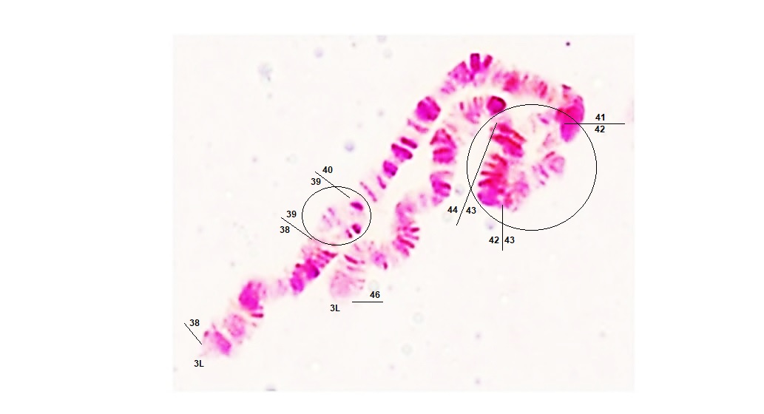

S1 Fig. Photomap of the polytene chromosome from An. stephensi ovarian nurse cells: Chromosomal inversions show breakpoints at two locations, i.e. 39A–39C and 42A–44C, on the 3L arm of NT-stressed lines (NT, nutritional stress).

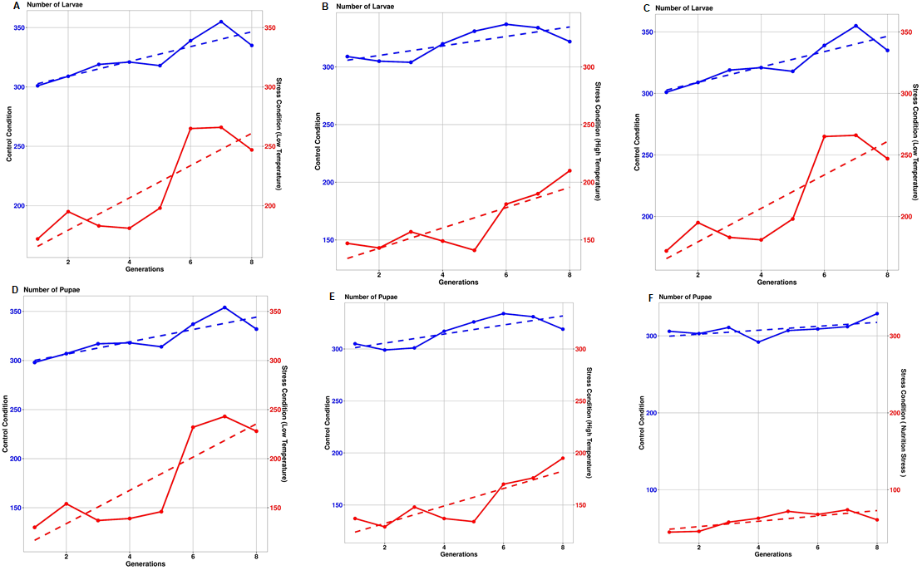

S2 Fig. Plots show the transgenerational changes in the larval and pupal stages of An. stephensi under stress and control conditions: (A, D) low-temperature (LT) stress, (B, E) high-temperature (HT) stress, and (C, F) nutritional (NT) stress.

