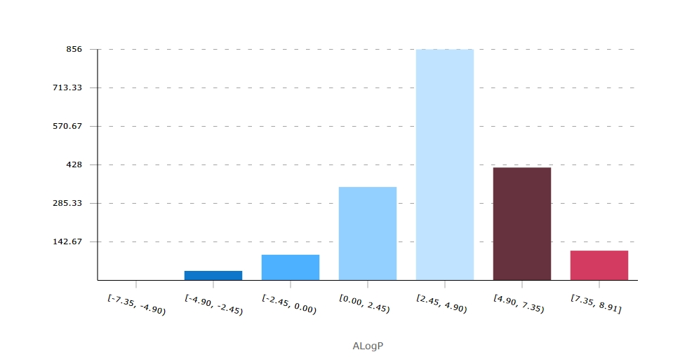
SI Fig.S1. Hist profile of AlogP value of STAT3 inhibitors obtained from ChEMBL database. This result implied that the drug like pre-set of zinc selection is suitable for further library generation.

SI Fig.S2. Profile of Loss function with 200,000 iterations for training process.

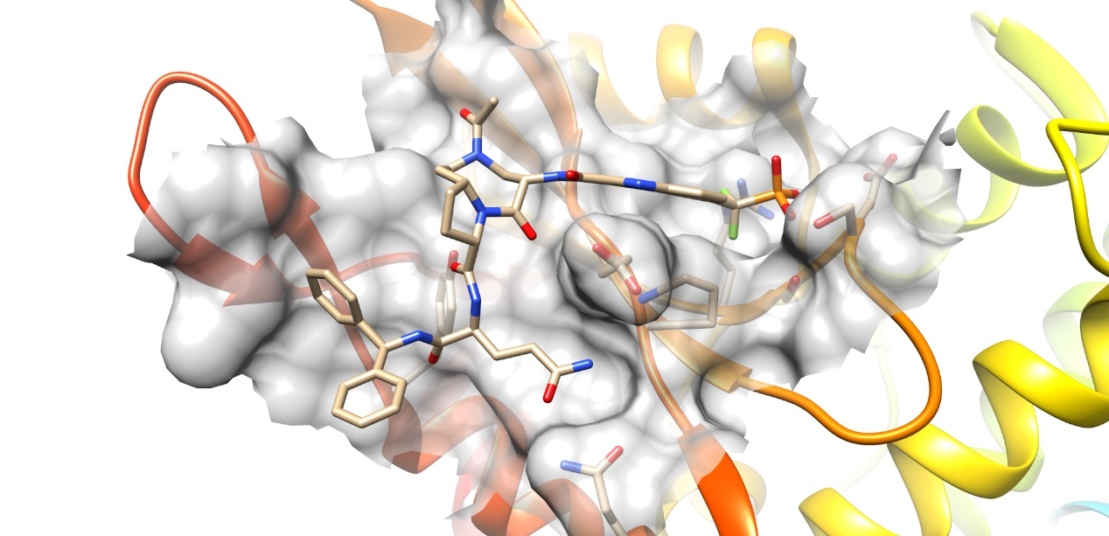
SI Fig.S3. Crystal structure of STAT3 with inhibitor SI109 (PDB ID: 6NUQ). Pocket surface was presented as gray color, and molecular structure of SI109 was presented as stick.

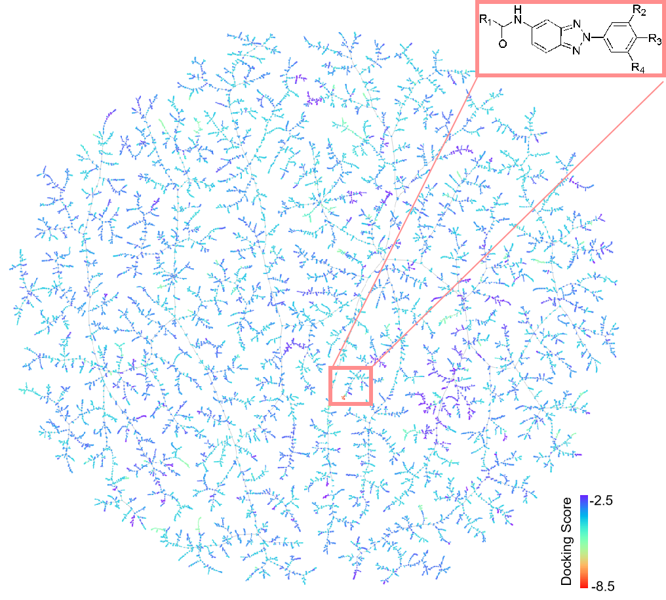
SI Fig.S4 Location of selected molecules for further experimental validation in the TMAP of the filtered molecules. Center: overview of the TMAP colored by the number of RECAP fragments. Surrounding boxes: the zoom-in versions of their corresponding field with molecules colored by the docking score (red–yellow–blue). Molecules with docking scores: selected molecules pointing to their position in the TMAP.

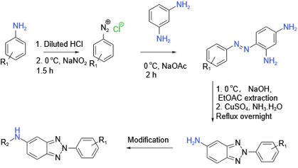
SI Fig.5. Synthetic routine of benzotriazole scaffold entities.
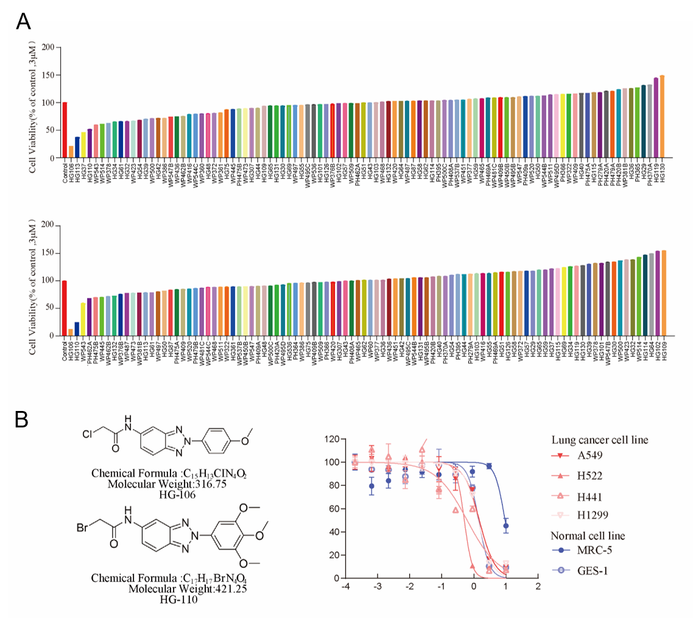
SI Fig.6. A. Prelimentary screening of molecular activities from given molecular library at 3 uM for 48 h. B. Molecular structure of HG106 and HG110. The IC50 was determined by dose-manner cell viability curve. Three replicates per group.

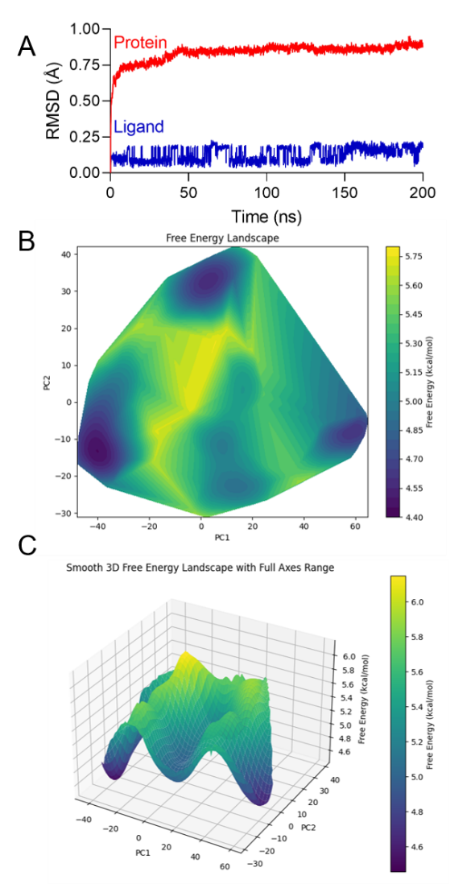
SI Fig.S.7. A. The RMSD plot for STAT3-HG106 complex during the 200 ns simulation. B. Two-dimensional free energy surface (2D-FES) of STAT3-ligand complex after 200 ns simulation.
C. Three-dimensional free energy landscapes (FEL) of STAT3-ligand complex during 200 ns MD simulations
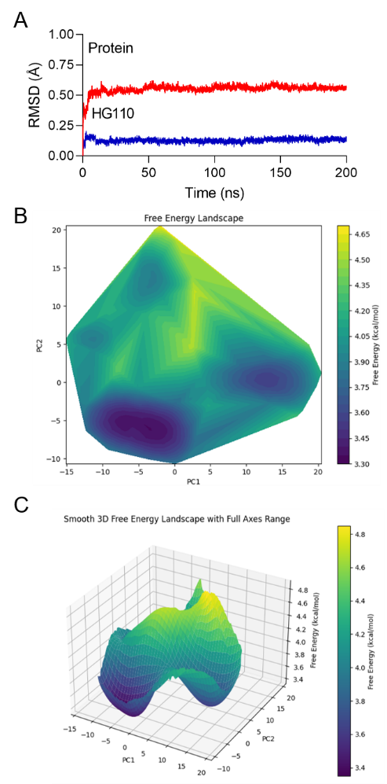
SI Fig.S8. A. The RMSD plot for STAT3-HG110 complex during the 200 ns simulation. B. Two-dimensional free energy surface (2D-FES) of STAT3-ligand complex after 200 ns simulation.
C. Three-dimensional free energy landscapes (FEL) of STAT3-ligand complex during 200 ns MD simulations

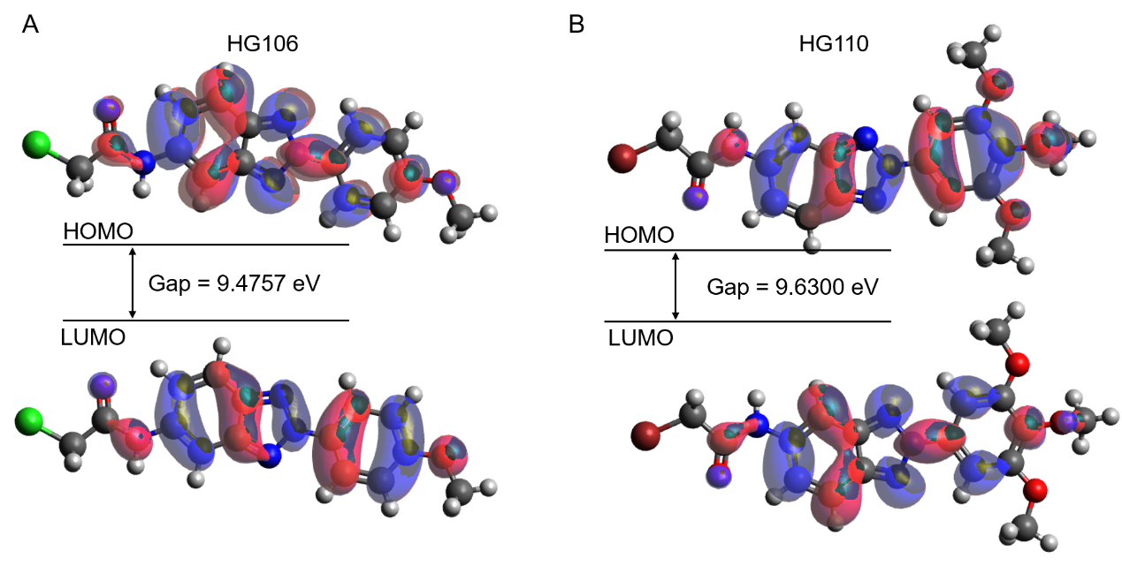
SI Fig.S9. A. Calculated HOMO-LUMO plots of HG106 using DFT/B3LYP/6-31G. B. Calculated HOMO-LUMO plots of HG110 using DFT/B3LYP/6-31G

