Supplementary Materials
Table S1. The mean, standard deviation, and standard error are shown for fuel bed height.
Fuel bed height (cm)
Species | Mean | SD | Std.error
Andropogon glomeratus | 5.78 | 2.51 | 0.79
Andropogon ternarius | 12.71 | 2.96 | 0.93
Andropogon virginicus | 10.58 | 2.86 | 0.90
Aristida beyrichiana | 8.071 | 0.99 | 0.31
Eragrostis spectabilis | 11.46 | 1.79 | 0.56
Eustachys petraea | 7.73 | 1.52 | 0.47
Schizachyrium stoloniferum | 10.65 | 1.69 | 0.56
Sorghastrum secundum | 6.23 | 2.45 | 0.77
Sprobulus juncus | 8.51 | 1.47 | 0.46

Table S2. Pearson’s correlation coefficients with p-vales showed across fuel bed height along with flammability metrics that include max flame height, flame duration, smoldering duration, mass loss, and mass loss rate.
 |  | Pearson correlation coefficient | p-value (0.05)
Fuel Bed Height | Max Flame Height | 0.64 | 8.16E-12
Fuel Bed Height | Flame Duration | -0.45 | 8.26E-06
Max Flame Height | Flame Duration | -0.60 | 4.73E-10
Fuel Bed Height | Smoldering Duration | -0.02 | 0.884157
Max Flame Height | Smoldering Duration | 0.01 | 0.902355
Flame Duration | Smoldering Duration | -0.17 | 0.107496
Fuel Bed Height | Mass Loss | 0.20 | 0.063747
Max Flame Height | Mass Loss | 0.24 | 0.020909
Flame Duration | Mass Loss | -0.32 | 0.002108
Smoldering Duration | Mass Loss | -0.23 | 0.032282
Fuel Bed Height | Mass Loss Rate | 0.38 | 0.000222
Max Flame Height | Mass Loss Rate | 0.43 | 2.70E-05
Flame Duration | Mass Loss Rate | -0.59 | 7.84E-10
Smoldering Duration | Mass Loss Rate | -0.58 | 1.80E-09
Mass Loss | Mass Loss Rate | 0.58 | 3.00E-09

Table S3. Loadings from the principal components analysis featuring five flammability metrics.
Flammability Metric | PC1 | PC2
Flame Duration | -1.54 | 1.10
Smolder Duration | -0.77 | -1.76
Flame Height | 1.40 | -0.95
Mass Loss % | 1.42 | 0.41
Mass Rate | 1.88 | 0.58

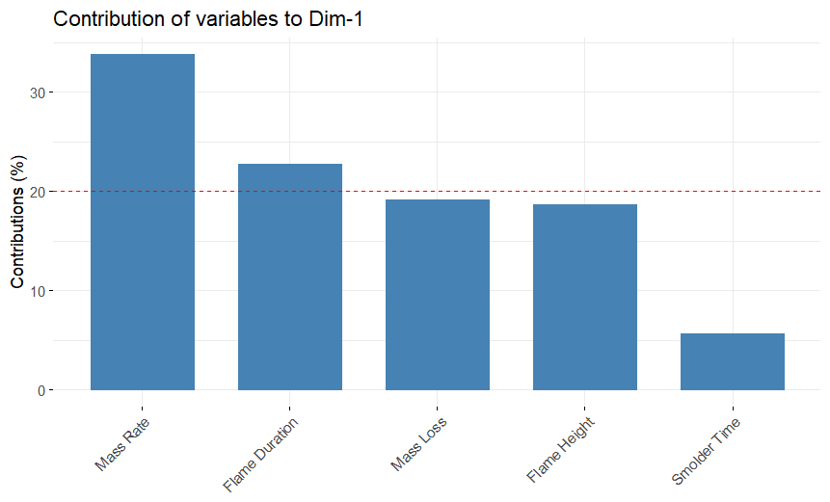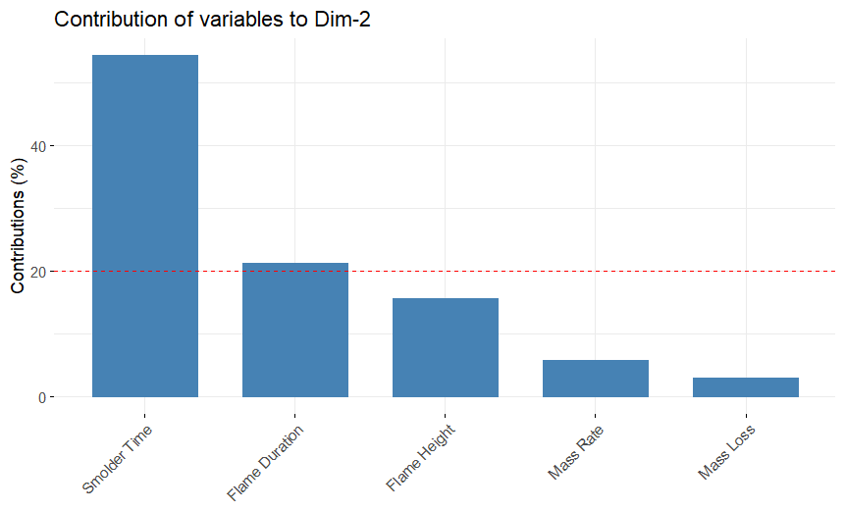
Figure S1. Bar graph showing total contributions of variables to dimensions one (left image) and dimensions two (right image) of the principal components analysis.

