Supplementary Tables and Figures
Manuscript title: Unraveling the transcriptional response mechanisms to Fusarium wilt disease (Foc6) in two contrasting chickpea cultivars
Authors: Aliakbar Faramarzpour^{1,2}, Sara Dezhsetan*¹, Hamid Hassaneian Khoshro³, Raheleh Mirdar Mansuri², Hamid Reza Pouralibaba³, Zahra-Sadat Shobbar*²

Table S1 Primers for qRT-PCR. Gene identifiers, annotation NCBI, primer sequences, amplicon size and chromosome position. Primer PCR efficiency and PCR product Tm data represent mean values. PCR efficiencies (E) calculated according to the equation (1 + E) = 10^{slope}.
ID Gene | Annotation | Primer Sequence (5‘-3’) | PCR product  size (bp) | Chr position | PCR E | PCR product  Tm(˚C)
LOC101498889 | carbonic anhydrase 1 | F-CTTTGTCCTCTGCCAAAACTTC | 140 | Ca2:  2190241..2193896 | 2.2 | 60
LOC101498889 | carbonic anhydrase 1 | R-GAAAACCGGCTTGTCTTGAATC
LOC101507324 | putative protein TPRXL | F-GAACTTTAGGCAGCAACTCCT | 83 | Ca6: 50702624..50703264 | 1.87 | 60
LOC101507324 | putative protein TPRXL | R-CAAGCTATTGTCCCCTAGCA
LOC101495793 | MATH and LRR domain-containing protein PFE0570w | F-CCAGAAGCAATTCAAGGACTC | 105 | Ca5: 30905134..30907624 | 2.04 | 60
LOC101495793 | MATH and LRR domain-containing protein PFE0570w | R-CACCTTCTCTTCTACGATGAC
LOC101497118 | transcription factor MYB41 | F-ACGTCACCTTCACCTTCTAG | 96 | Ca1: 16391425..16394227 | 1.94 | 60
LOC101497118 | transcription factor MYB41 | R-GTCATAAGTGTATCTCTCACCT
LOC101510034 | basic 7S globulin-like | F-GGCAACTCCTCCCATATCCAT | 140 | Ca4: 2179311..2181111 | 1.95 | 60
LOC101510034 | basic 7S globulin-like | R-GGGTGCAATGAAGAACAGTAGG
LOC101513347 | spermidine hydroxycinnamoyl transferase-like | F-CTTGTTGTGGCGATTTGTTTG | 122 | Ca3: 26823706..26825488 | 1.88 | 60
LOC101513347 | spermidine hydroxycinnamoyl transferase-like | R-CCCTTTAACCACTTAACATTGC
LOC101489892 | expansin-like B1 | F-CTCATTAAGCCTTCTCTTGAGC | 175 | Ca8: 2678285..2680891 | 2.02 | 60
LOC101489892 | expansin-like B1 | R-GGTACACAGGGCAGGTAAGAA
LOC101491624 | linoleate 9S-lipoxygenase-like | F-CCTTCTCCTGCTATGTATGGTC | 113 | Ca7: 32157827..32162937 | 1.93 | 60
LOC101491624 | linoleate 9S-lipoxygenase-like | R-GCTCCATCACAATACAAGGTACA
LOC101501931 | heat shock cognate 70 kDa protein 2 | F-GGCTGGAAAAGGTGAAGGTC | 120 | Ca6: 26638762..26641344 | 2.03 | 60
LOC101501931 | heat shock cognate 70 kDa protein 2 | R-GTAGTTCTGTTCCCTTGGTCG
LOC101495891 | 1-aminocyclopropane-1-carboxylate oxidase | F-GAGCAAGCAACCTGCAATAAAC | 101 | Ca5: 41656988..41659172 | 1.92 | 60
LOC101495891 | 1-aminocyclopropane-1-carboxylate oxidase | R-CTGGGAAGTTCTCCATATCTCT
LOC101513977 | serine/threonine-protein kinase-like | F-AGCTGTAGACCTTTATCCTATCC | 121 | Ca1: 47140415..47152696 | 1.93 | 60
LOC101513977 | serine/threonine-protein kinase-like | R-CATCACATGACATAGTTGCAGG
LOC101493121 | protein ENHANCED PSEUDOMONAS SUSCEPTIBILTY 1 | F-CAACAAGTAGTGTGAGTGAAACC | 114 | Ca6: 48162598.. 48164521 | 1.99 | 60
LOC101493121 | protein ENHANCED PSEUDOMONAS SUSCEPTIBILTY 1 | R-CGACACCCAAATCCAATCCAC

Table S2 List of important DEGs based on their responses to Fusarium wilt (Foc6) disease in both Ana (resistance) and Hashem (susceptible) chickpea cultivars.
Gene | Description | ID Genes |  | Fold Change (Log2): Ana&Hashem | Subcellular Location | Function | Reference
CaNLR-RPM1 | disease resistance protein RPM1 (Pseudomonas syringae pv. maculicola 1) | LOC101504665 |  | A: 1.3 H: - | Cytoplasm | Sensing | Martin et al. 2003; Baggs et al. 2017; Yuan et al. 2019
CaLYK5-RLK  CaPR5-RLK  CaLRR-RLK  CaLRR-RLK  CaRLP-EIX2 | receptor-like kinase | LOC101494861  LOC101493461  LOC101489235  LOC101513977  LOC101498360 |  | A: 1.8 H: -  A: 1.3 H: -  A: 2.3 H: -  A: 2 H: 1.6  A: 1.7 H: - | Membrane & Nucleus | Sensing | Tang et al. 2017; Yadav et al. 2023; Cao et al. 2014
CaPP7 | serine/threonine-protein phosphatase 7 long form homolog | LOC105852653 |  | A: 10 H: - | Nucleus | Signaling | Luan 1998
CaHSC70 | heat shock cognate 70 kDa protein 2 | LOC101501931 |  | A: 2.3 H: 1.9 | Endoplasmic reticulum | Signaling | Wang et al. 2020; Garg et al. 2023; Stanley et al. 2005; Xing et al. 2016
CaEPS1 | enhanced Pseudomonas susceptibility 1 | LOC101493121 |  | A: 1.8 H: - | Cytoplasm | Signaling | Khan et al. 2022
CaPR-1 | pathogenesis-related protein 1-like | LOC101503659 |  | A: 1.5 H: - | Membrane & Vacuole | Signaling | Patil et al. 2021
CaPR-4 | thaumatin-like pathogenesis-related protein 4-like | LOC101511048 |  | A: 5.7 H: 4.1 | Membrane & Vacuole | Signaling | Patil et al. 2021
CaSTY13 | serine/threonine-protein kinase STY13-like | LOC101511109 |  | A: 10 H: - | Nucleus & Membrane | Signaling | Gupta et al. 2017; Garg et al. 2023; Kim et al. 2011
CaSTY-OXI1 | serine/threonine-protein kinase OXI1-like  (OXI1: Oxidative Signal-Inducible1) | LOC101501979 |  | A: 3.1 H: 1.4 | Nucleus & Membrane | Signaling | Gupta et al. 2017; Garg et al. 2023; Kim et al. 2011
CaTLP1b | Thaumatin-like protein 1b | LOC101495985 |  | A: 5.6 H: 4.3 | Cytoplasm | Signaling | Petre et al. 2011; Yadav et al., 2023
CansLTP-like | non-specific lipid-transfer protein 1-like | LOC101503860 |  | A: 5.5 H: 2.3 | Cell wall | Signaling | Petre et al. 2011; Yadav et al., 2023
CaMYB41 | transcription factor MYB41 | LOC101497118 |  | A: 4.7 H: - | Nucleus | Transcription regulation | Kosma et al. 2014; Li et al. 2015
CaMYB108 | transcription factor MYB108 | LOC101490747  LOC101492267 |  | A: 3 H: -  A: 2.6 H: - | Nucleus | Transcription regulation | Mengiste et al. 2003; Zhang et al. 2012
CaMYB-related | probable transcription factor At5g61620 | LOC101507725 |  | A: 10 H: - | Nucleus | Transcription regulation | Mengiste et al. 2003; Li et al. 2015
CaGLK | uncharacterized LOC101491042 | LOC101491042 |  | A: 10 H: - | Nucleus | Transcription regulation | Riechmann et al. 2000; Han et al. 2016
CaERF9  CaERF113  CaERF113-like | ethylene-responsive transcription factor | LOC101502158  LOC101515629  LOC101513362 |  | A: 1.3 H: -  A: 1.3 H: -  A: 2.1 H: - | Nucleus | Transcription regulation | Sakuma et al. 2002; Dong et al. 2020; Yadav et al. 2023
CaZAT11-like | zinc finger protein ZAT11-like | LOC101498044  LOC101492538 |  | A: 10 H: -  A:1.5 H: - | Nucleus | Transcription regulation | Gechev et al. 2005; Qureshi et al. 2013
CaNAC6 | NAC domain-containing protein | LOC101514169 |  | A: 2.2 H: - | Nucleus | Transcription regulation | Jensen et al. 2007; Nakashima et al. 2007; Chen et al. 2013
CaPGI2-like | polygalacturonase inhibitor 2-like | LOC105852278 |  | A: 3.9 H: - | Cell wall & Cytoplasm | Cell wall | De Lorenzo and Ferrari 2002; Martin et al. 2003; Yadav et al. 2023;
CaPE2 | pectinesterase 2-like | LOC101508209 |  | A: 4.3 H: 2.3 | Cell wall | Cell wall | Shu et al. 2021
CaPME7 | probable pectinesterase/pectinesterase inhibitor 7 | LOC101489717 |  | A: 3.5 H: 2.5 | Cell wall | Cell wall | Shu et al. 2021
CaEXLB1  CaEXLB1  CaEXLA2 | expansin-like B1  expansin-like B1  expansin-like A2 | LOC101489892  LOC101507544  LOC101514490 |  | A: 3.6 H: -  A: 3.8 H: 2.1  A: 2 H: 1.2 | Cell wall | Cell wall integrity | Abuqamar et al. 2013; Chen et al. 2016; Muthusamy et al. 2022; Guo et al. 2024;
CaCSLD | cellulose synthase | LOC101509896  LOC101488214  LOC101499287 |  | A: 1.2 H: -  A: 1.8 H: -  A: -2 H: - | Membrane & Chloroplast | Cell wall integrity | Malinovsky et al. 2014; Gupta et al. 2017
CaCYP73A100-like | cytochrome P450 CYP73A100-like | LOC101503511 |  | A: 3.9 H: - | Endoplasmic reticulum & Membrane | Cell wall integrity | Pandian et al. 2020; Yadav et al. 2023; Gan et al. 2024
CaXTH23 | probable xyloglucan endotransglucosylase/hydrolase protein 23 | LOC101489989  LOC101490102 |  | A: 4.6 H: -  A: 2.9 H: - | Cell wall & Cytoplasm | Cell wall | Shu et al. 2021
CaNR/NADH | nitrate reductase [NADH]-like | LOC101498580 |  | A: -1.7 H: - | Peroxisome | Transport-related genes | Gupta et al. 2017
CaCa²⁺-ATPase | calcium-transporting ATPase, endoplasmic reticulum-type | LOC101512366 |  | A: 1.5 H: - | Endoplasmic reticulum | Transport-related genes | Upasani et al. 2017; Yadav et al. 2023
CaSWEET13-like | bidirectional sugar transporter SWEET13-like | LOC101491054 |  | A: -1.8 H: - | Membrane | Transport-related genes | Liu et al. 2022; Yadav et al. 2023
CaSWEET17 | bidirectional sugar transporter SWEET17 | LOC101509872 |  | A: -2.6 H: -1.3 | Membrane | Transport-related genes | Liu et al. 2022; Yadav et al. 2023
CaSWEET1 | bidirectional sugar transporter SWEET1 | LOC101498274 |  | A: -2.1 H: -1.9 | Membrane | Transport-related genes | Liu et al. 2022; Yadav et al. 2023
CaCAT5 | cationic amino acid transporter 5 | LOC101509123 |  | A: 1.5 H: - | Membrane | Transport-related genes | Yang et al. 2014
CaNRAMP5 | metal transporter Nramp5-like  (Nramp: natural resistance-associated macrophage proteins) | LOC101489317 |  | A: -3.5 H: - | Membrane | Transport-related genes | Noor et al. 2023
CaSULTR_{3.5} | probable sulfate transporter 3.5 | LOC101512274 |  | A: 3.4 H: 2.5 | Membrane | Transport-related genes | Leggett and Epstein 1956; Zhou et al. 2017
CaDTX27 | protein DETOXIFICATION 27-like | LOC101503133 |  | A: 2.5 H: - | Membrane | Transport-related genes | Nawrath et al. 2002; Tiwari et al. 2014; Caballo et al. 2019
CaUFGT3 | putative UDP-glucose flavonoid 3-O-glucosyltransferase 3 |  | UGT71S3 | A: 3.3 H: - | Membrane & Nucleus | Metabolism | Morkunas and Ratajczak 2014; Gupta et al. 2017
CaUGT | putative UDP-glucose glucosyltransferase |  | UGT84F2 | A: 1.4 H: - | Membrane & Nucleus | Metabolism | Morkunas and Ratajczak 2014; Gupta et al. 2017
BF-CWI | beta-fructofuranosidase, cell wall isozyme-like | LOC101513089 |  | A: 4.2 H: 3 | Cell wall | Metabolism | Proels and Hückelhoven 2014
CaGSTs | probable glutathione S-transferase | LOC101494465  LOC101506971 |  | A: 3.4 H: 1.4  A: 1.8 H: - | Cytoplasm | Metabolism | Marrs 1996; Taxak et al. 2017; Gupta et al. 2013, 2017
CaASI | alpha-amylase/subtilisin inhibitor-like | LOC101508812 |  | A: 2 H: - | Vacuole | Metabolism | Yamasaki et al. 2006; Yu et al. 2017
CaCA1 | carbonic anhydrase 1 | LOC101498889 |  | A: 10 H: - | Chloroplast | Metabolism | Dreher and Callis 2007; Guangsheng et al. 2012; Taxak et al. 2017
CaSHT-like | spermidine hydroxycinnamoyl transferase-like | LOC101513347 |  | A: 3.4 H: 2.5 | Cytoplasm | Metabolism | Galston et al. 1985; Perrin et al. 2021
CaSAG39-like | senescence-specific cysteine protease SAG39-like | LOC101497435 |  | A: 2.9 H: - | Membrane & Vacuole | Plant–pathogen interaction | Channale et al. 2021
CaBg7S-like | basic 7S globulin-like | LOC101509822 |  | A: 4.4 H: - | Membrane | Plant–pathogen interaction | Hirano 2021
CaMDCP | MATH (Meprin And TRAF Homology) and LRR domain-containing protein PFE0570w | LOC101495793 |  | A: -2.4 H: - | Nucleus | Plant–pathogen interaction | Kushwaha et al. 2016

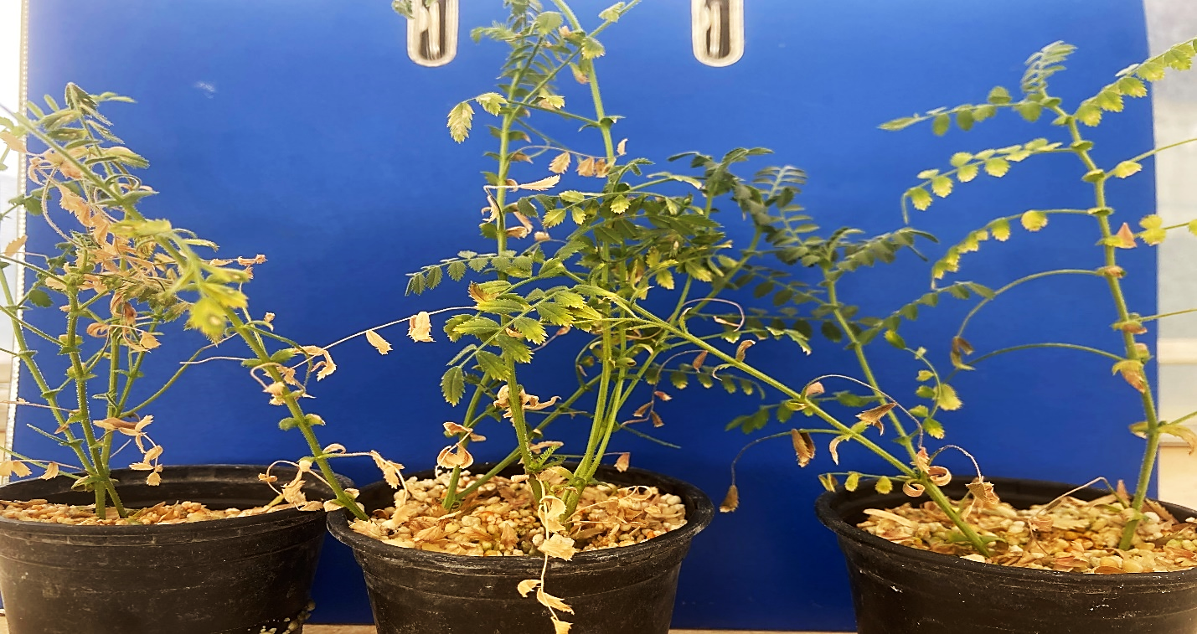
Fig. S1 Ana cultivars were approximately 12 days after inoculation with FOC race 6.

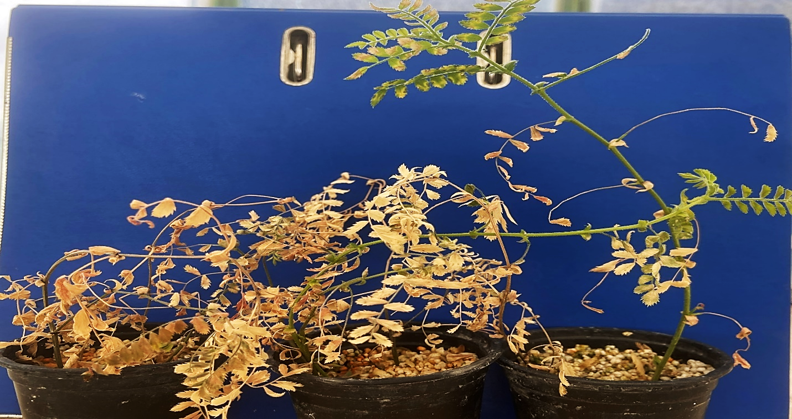
Fig. S2 Hashem cultivars were approximately 12 days after inoculation with FOC race 6.

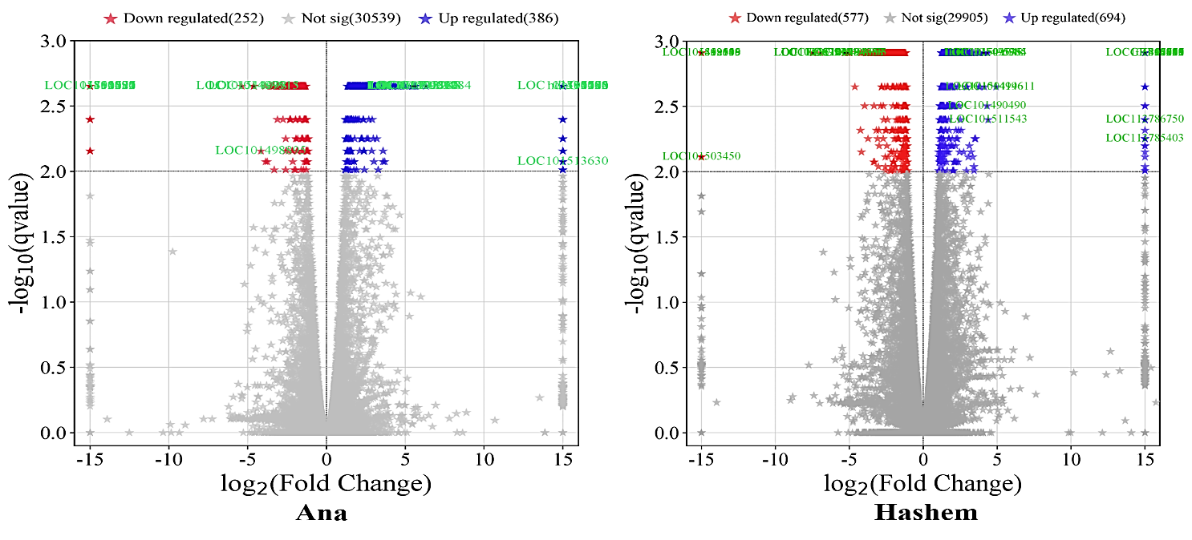 Fig. S3 Volcano plot of DEGs between stress and normal in Ana and Hashem chickpea cultivars. Volcano plot scales significance value at y axis and logFC at x axis (qvalue≤0/01 and −1≤Log2 Fold Change ≥1). Blue stars represent up-regulated genes, red stars represent down-regulated genes and gray stars represent genes that were not differentially expressed.

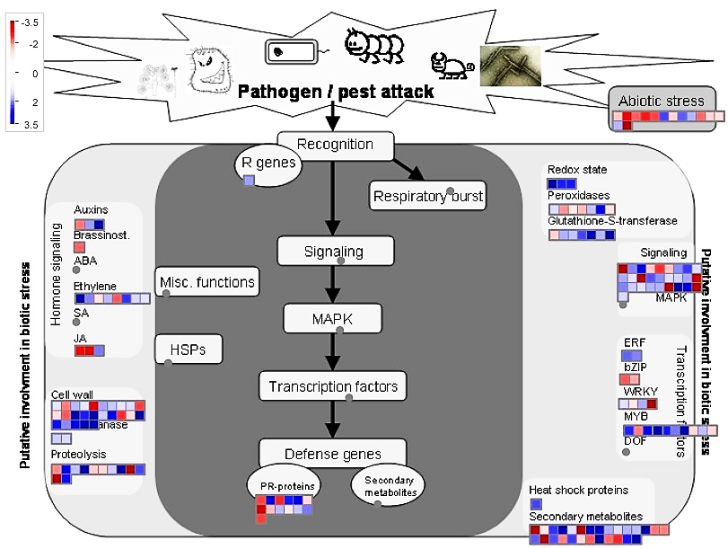
Fig. S4 MapMan presentation of DEGs in Ana chickpea cultivar under Fusarium wilt stress category. The color change from dark blue (+3.5 LogFC) to dark red (-3.5 LogFC) through white (0 LogFC) indicates the differential expression ranging from up-regulation and down-regulation genes.
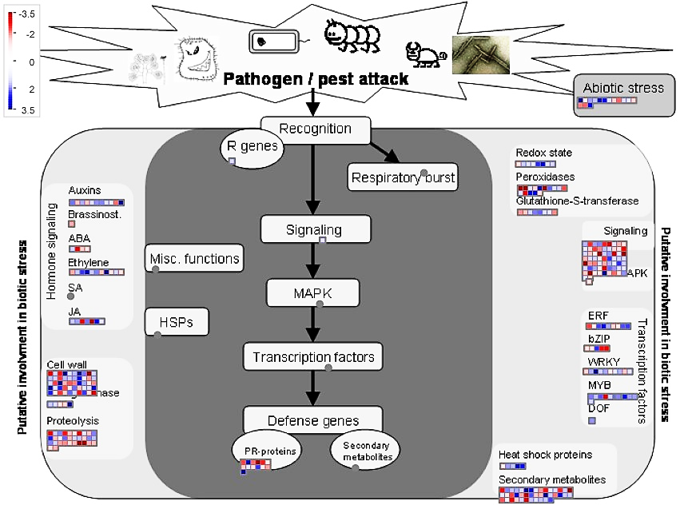
Fig. S5 MapMan presentation of DEGs in Hashem chickpea cultivar under Fusarium wilt stress category. The color change from dark blue (+3.5 LogFC) to dark red (-3.5 LogFC) through white (0 LogFC) indicates the differential expression ranging from up-regulation and down-regulation genes.

