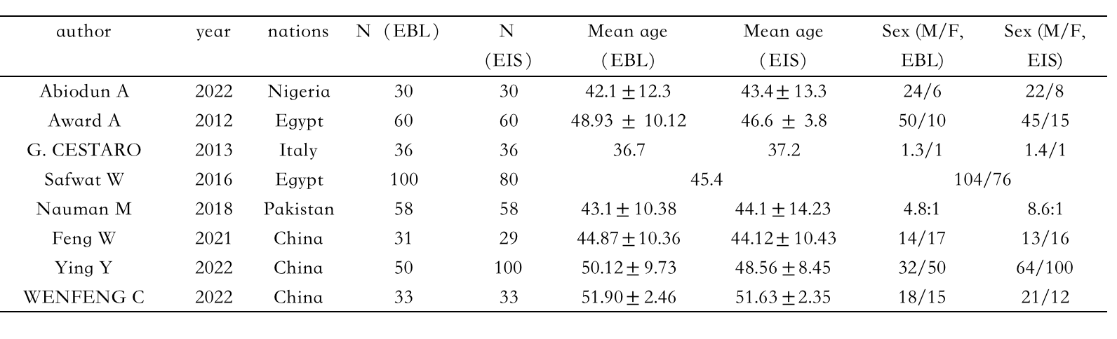
Table.1. Summary of characteristics of the included studies.

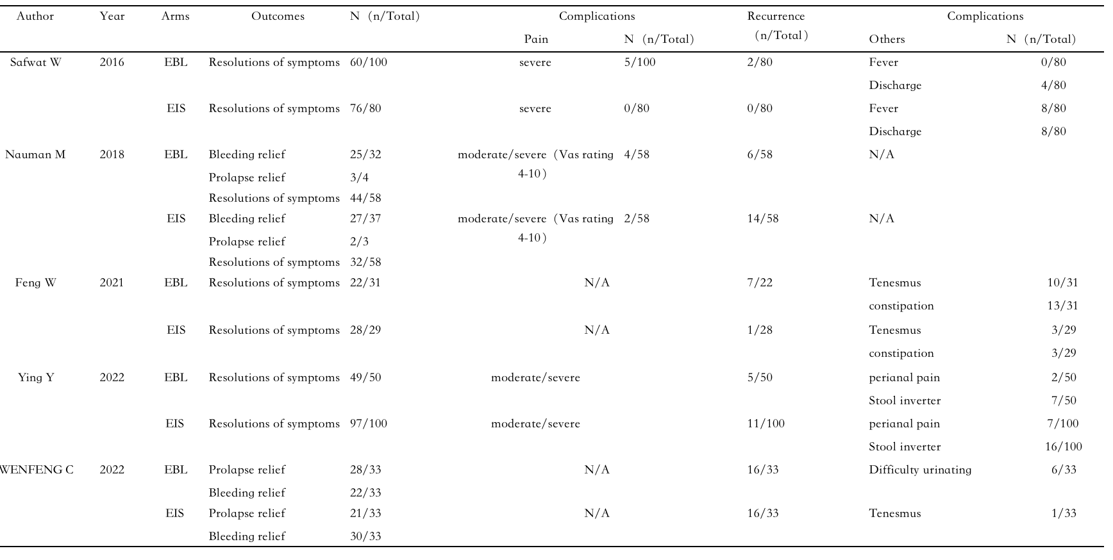
Table. 1. Continued
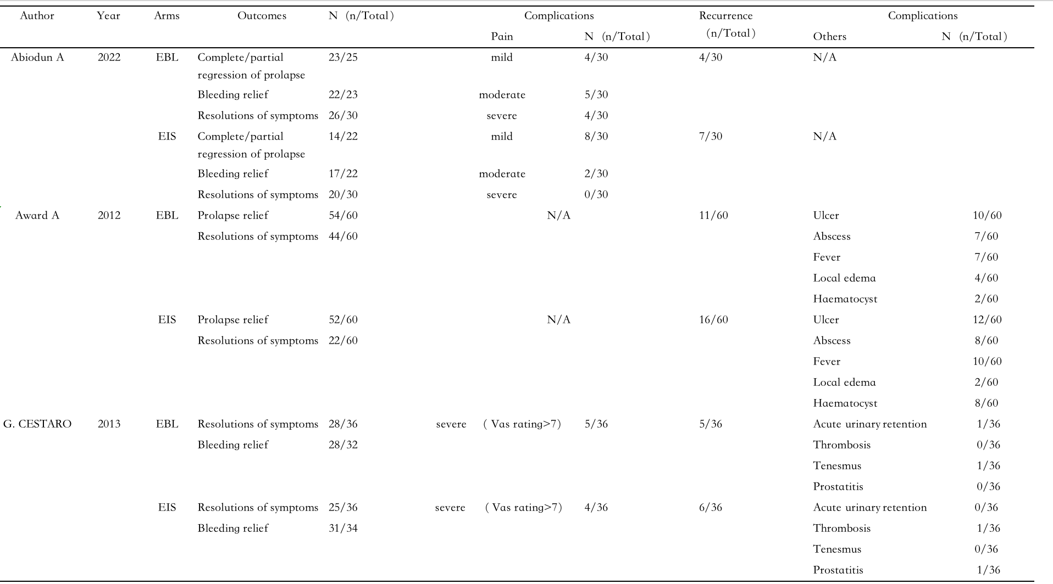

Table. 1. Continued

