Supporting files: Spectra’s: LCMS/GCMS; %Purity; ¹HNMR; IR
- LC-MS SPECTRUM of Compound “C”
Molecular Weight: 273.0g/mol
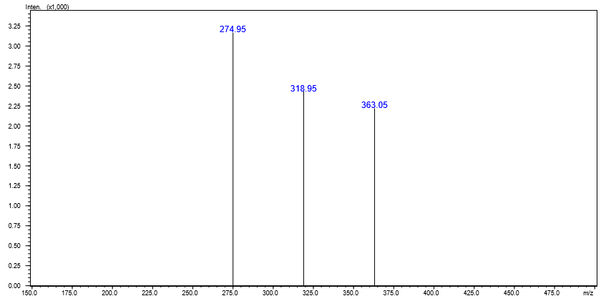

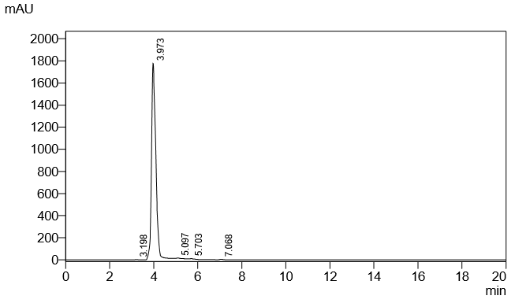

¹H NMR Spectra of Compound “C”
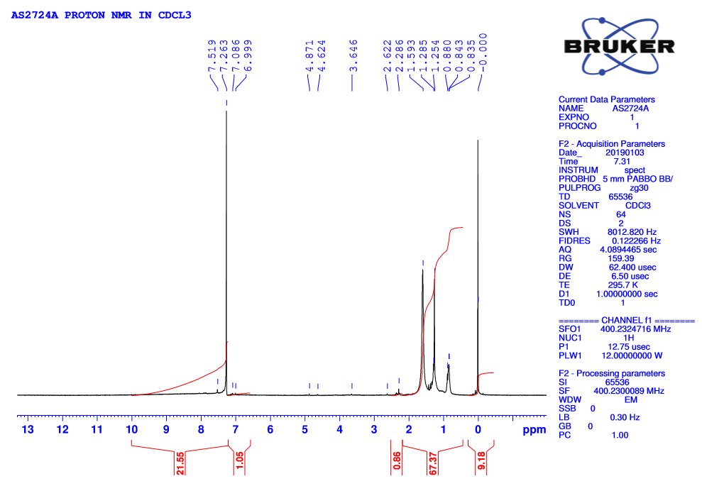
¹H NMR Spectra interpretation
S.NO | δ VALUE | TYPES OF PEAK | NUMBER OF PROTONS
1 | 1.5-2.6 | Multiplet | 1 Proton
2 | 6.9-7.5 | Multiplet | 8 Protons

IR Spectra interpretation
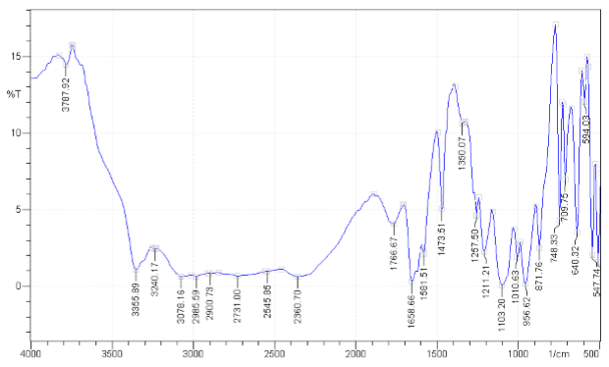

S.NO | WAVE NUMBER  (cm⁻¹) | TYPES OF VIBRATIONS | FUNCTIONAL GROUP
1 | 1658.66 | C=N Stretching | Imine group
2 | 640.32 | C-Cl Stretching | C-Cl group
3 | 2900.73 | C-H Stretching | Alkyl group

- LC-MS SPECTRUM of Compound “D”

Molecular weight: 283.31/mol

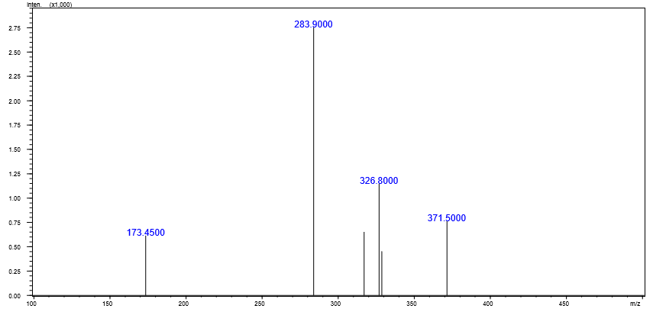

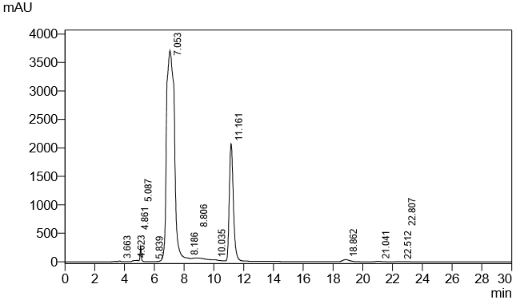

¹H NMR Spectra of Compound “D”

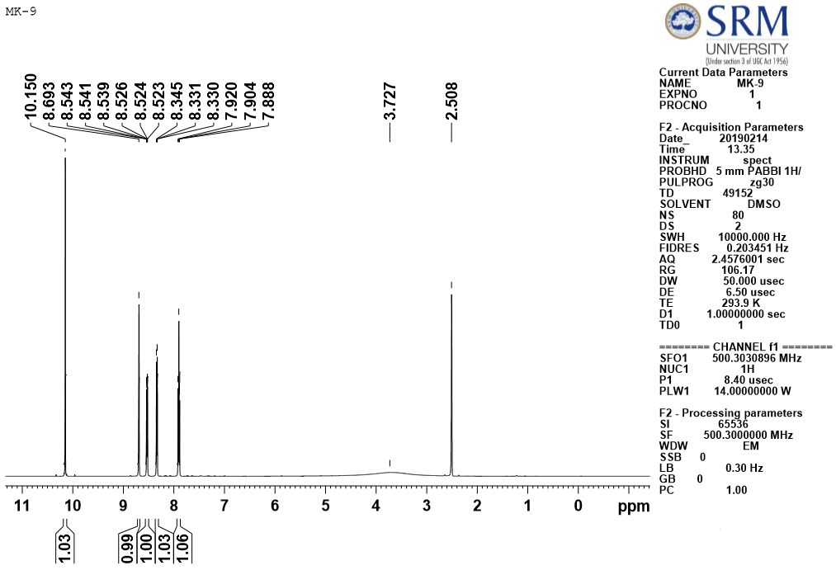

S.NO | δ VALUE | TYPES OF PEAK | NUMBER OF PROTONS
1 | 2.3 | Multiplet | 1 Proton
2 | 7.8-8.6 | Multiplet | 4 Protons
3 | 10.1 | Multiplet | 4 Protons

IR Spectrum of Compound “D”
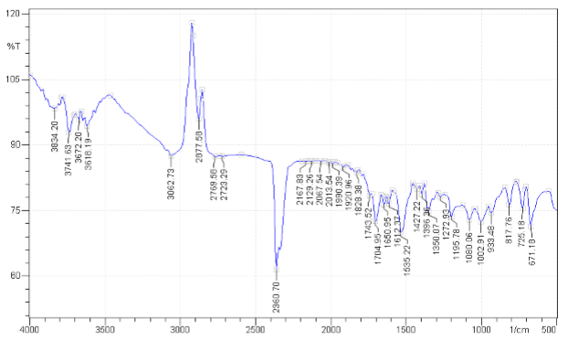

S.NO | WAVE NUMBER  (cm⁻¹) | TYPES OF VIBRATIONS | FUNCTIONAL GROUP
1 | 1535.22 | N=O Stretching | NO₂ group
2 | 2360.70 | C=N Stretching | Imine group
3 | 1650.95 | C=C Stretching | Aromatic C-C group

- LC-MS SPECTRUM of Compound “E”

Molecular weight: 268.33/mol

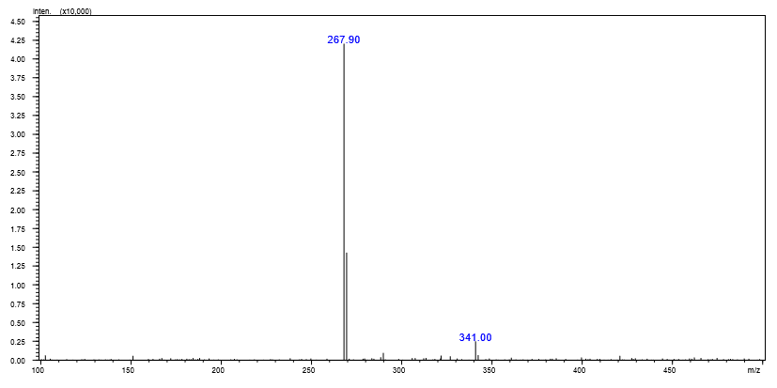
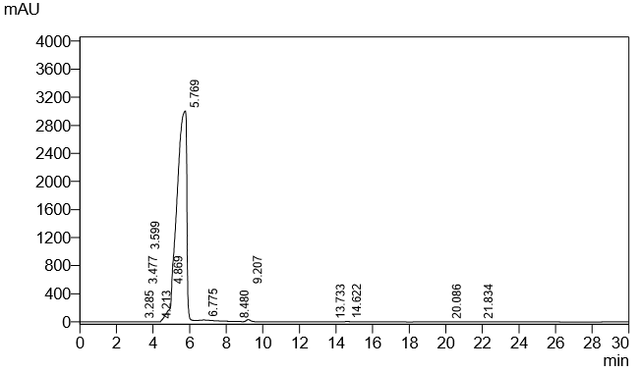

¹H NMR Spectra of Compound “E”
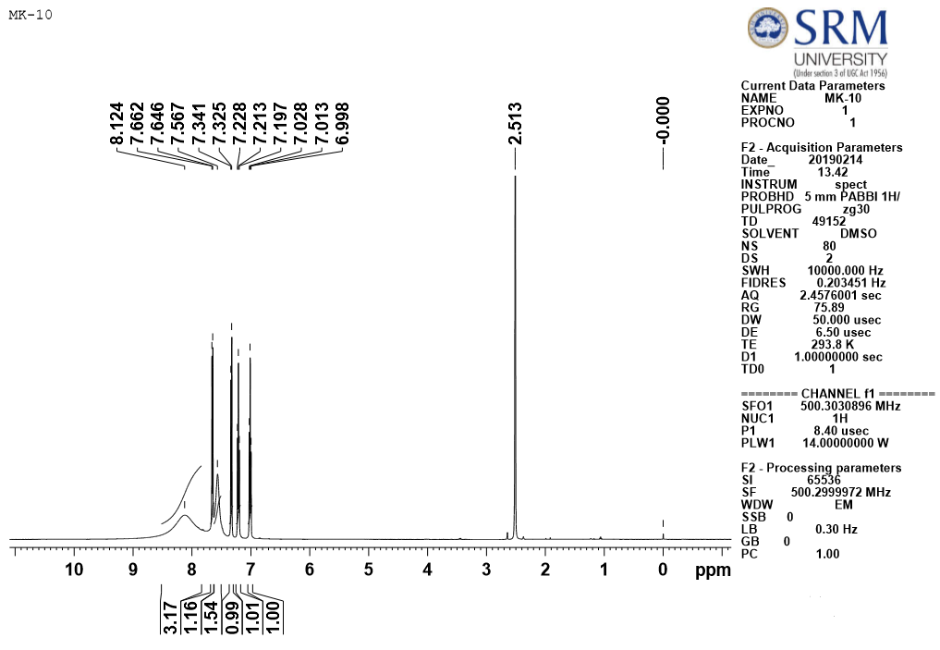
S.NO | δ VALUE | TYPES OF PEAK | NUMBER OF PROTONS
1 | 2.51 | Singlet | 3 Protons
2 | 6.9-7.3 | Multiplet | 8 Protons
3 | 7.6-8.1 | Multiplet | 1 Proton

IR Spectrum of Compound “E”
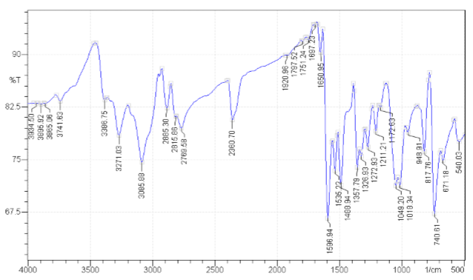

S.NO | WAVE NUMBER  (cm⁻¹) | TYPES OF VIBRATIONS | FUNCTIONAL GROUP
1 | 2885.30 | C-H Stretching | Alkyl group
2 | 1650.95 | C=N Stretching | Imine group
3 | 1357.79 | O-H Stretching | Hydroxyl group

- LC-MS SPECTRUM of Compound “F”

Molecular weight: 327.26/mol
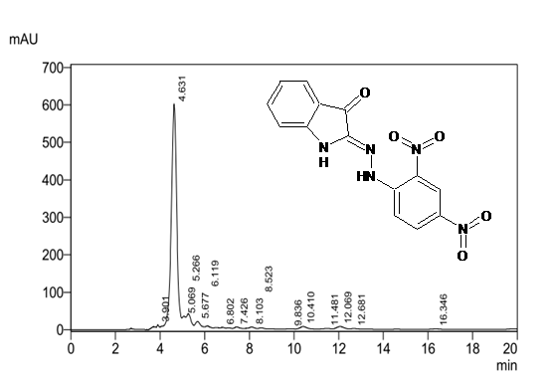

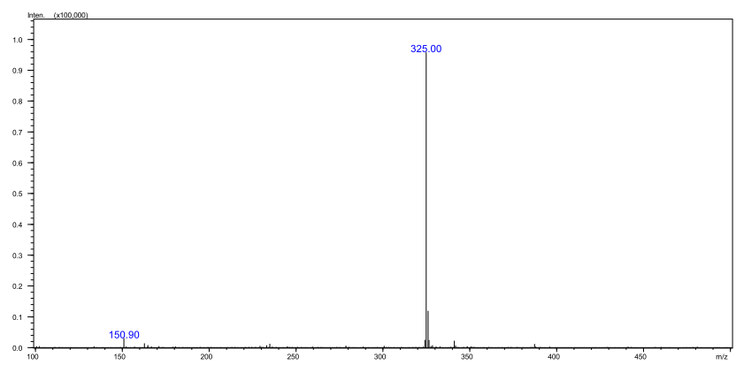

NMR SPECTRUM
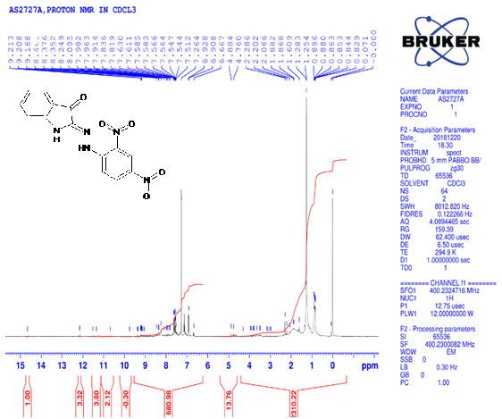

NMR SPECTRUM Interpretation:
S.NO | δ VALUES | TYPES OF PEAK | NUMBER OF PROTONS
1 | 7.6-7.8 | Multiplet | Five protons
2 | 7.9-8.4 | Multiplet | Four protons

- LC-MS SPECTRUM of Compound “G”
Molecular weight: 326.56/mol

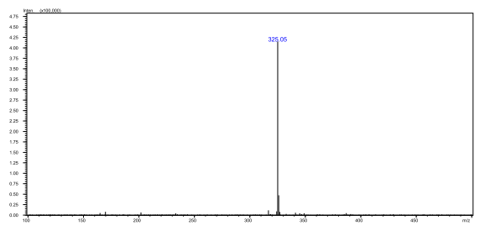
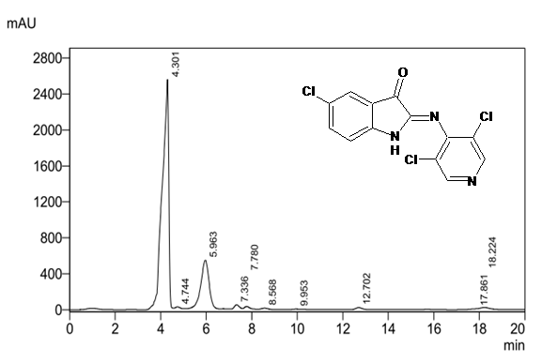

IR SPECTRA
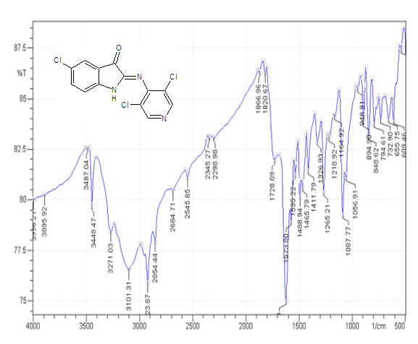
INTERPRETATION: IR SPECTRA
S.NO | WAVE NUMBER | TYPES OF VIBRATIONS | FUNCTIONAL GROUP
1 | 2854.44 | C-H stretching | Alkyl group
2 | 794.61 | C-Cl stretching | Presence of C-Cl group
3 | 1728.09 | C=O Stretching | Presence of keto group

NMR Spectra
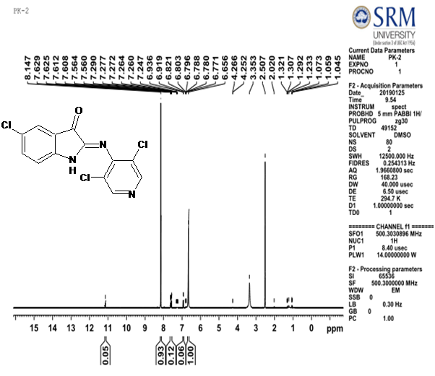

S.NO | δ VALUES | TYPES OF PEAK | NUMBER OF PROTONS
1 | 6.8-7.5 | Multiplet | Two protons
2 | 3.3-4.2 | Triplet | Four protons

- LC-MS SPECTRUM of Compound “H”
Molecular weight: 262.32/mol

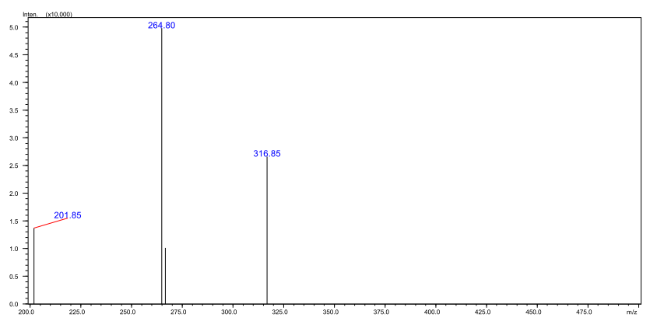

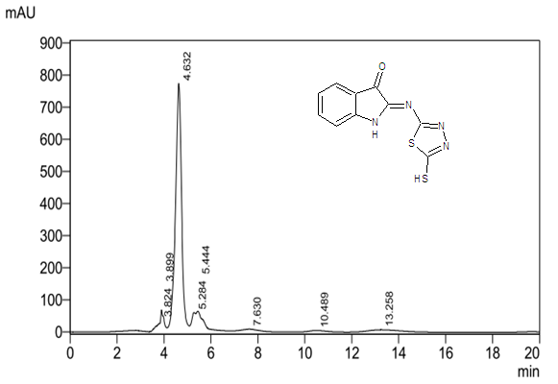

NMR SPECTRUM OF THE COMPOUND “H”
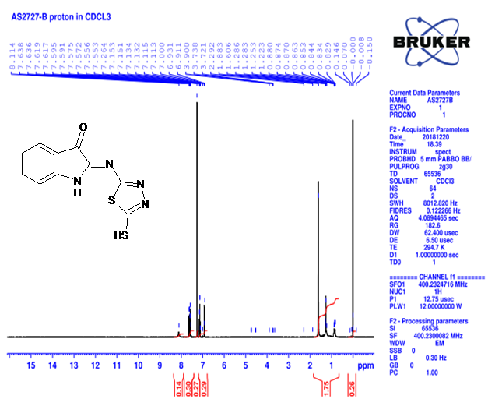
NMR interpretation of the compound “H”
S.NO | δ VALUES | TYPES OF PEAK | NUMBER OF PROTONS
1 | 6.9-7.5 | Doublet | Five protons
2 | 7.6-8.1 | Multiplet | One proton

IR SPECTRA of compound “H”
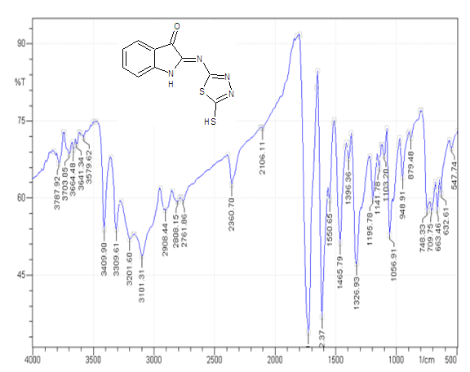

IR interpretation of the compound “H”

S.NO | WAVE NUMBER | TYPES OF VIBRATIONS | FUNCTIONAL GROUP
1 | 2908.44 | C-H stretching | Alkyl group
2 | 1612.37 | C=N stretching | Imine group
3 | 748.33 | C-S stretching | Thiol group

- LC-MS SPECTRUM of Compound “I”
Molecular weight: 237.25/mol
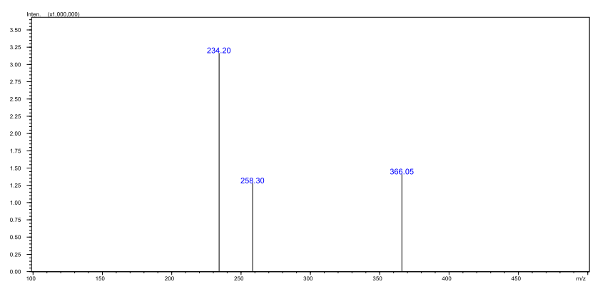
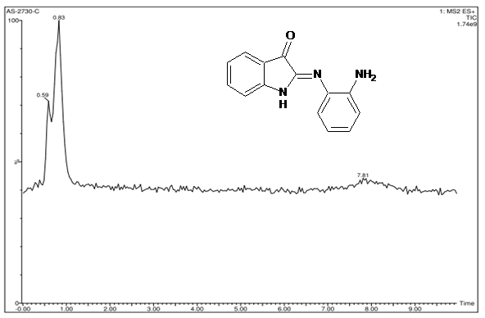

NMR SPECTRUM OF COMPOUND “I”
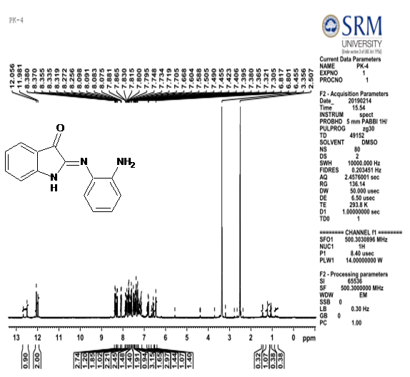
NMR interpretation of the compound “I”
S.NO | δ VALUES | TYPES OF PEAK | NUMBER OF PROTONS
1 | 6.8-8.3 | Triplet | Nine protons
2 | 2.5-3.3 | Multiplet | Two protons

IR Spectrum of Compound “I”
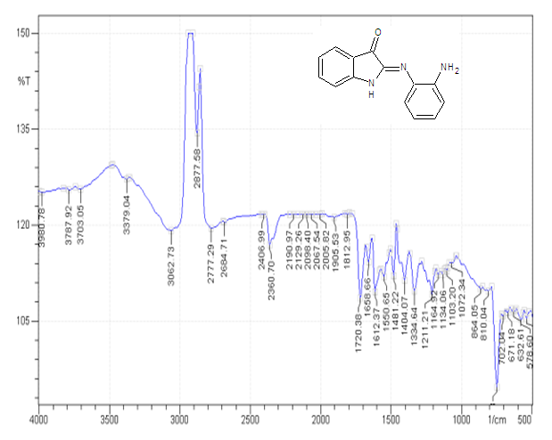
IR interpretation of the compound “I”
S.NO | WAVE NUMBER | TYPES OF VIBRATIONS | FUNCTIONAL GROUP
1 | 3062.73 | C-H stretching | Alkene group
2 | 1612.37 | C=N stretching | Imine group
3 | 1720.38 | C=O Stretching | Presence of keto group

- LC-MS SPECTRUM of Compound “J”
Molecular weight: 257.67/mol
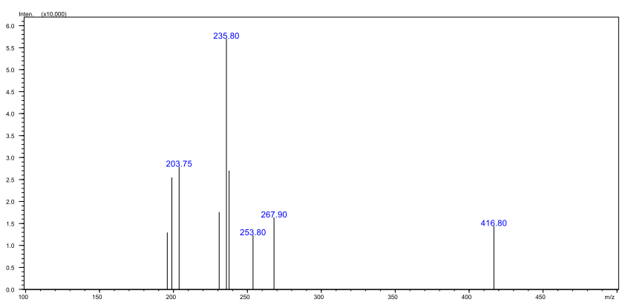
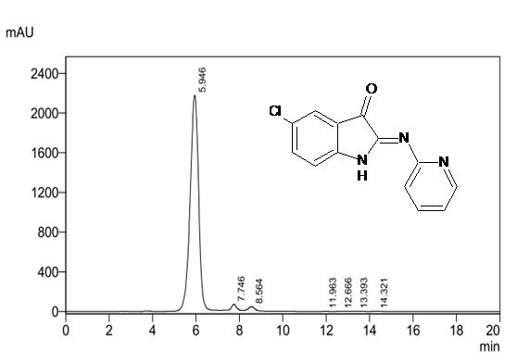

NMR SPECTRUM OF COMPOUND “J”
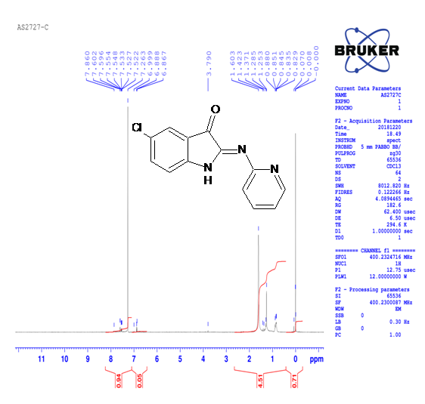
NMR interpretation of the compound “J”
S.NO | δ VALUES | TYPES OF PEAK | NUMBER OF PROTONS
1 | 6.8-7.8 | Triplet | Six protons
2 | 3.7 | Multiplet | Two protons

IR SPECTRUM OF COMPOUND “J”
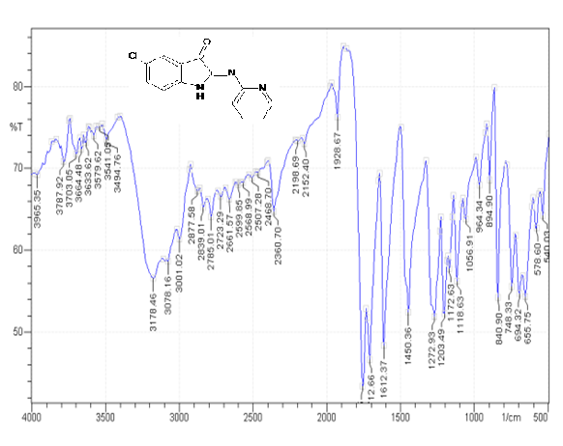
IR interpretation of the compound “J”
S.NO | WAVE NUMBER | TYPES OF VIBRATIONS | FUNCTIONAL GROUP
1 | 2877.58 | C-H stretching | Alkyl group
2 | 1612.37 | C=N stretching | Imine group
3 | 748.39 | C-Cl stretching | Presence of C-Cl group

- LC-MS SPECTRUM of Compound “K”
Molecular weight: 284.28g/mol

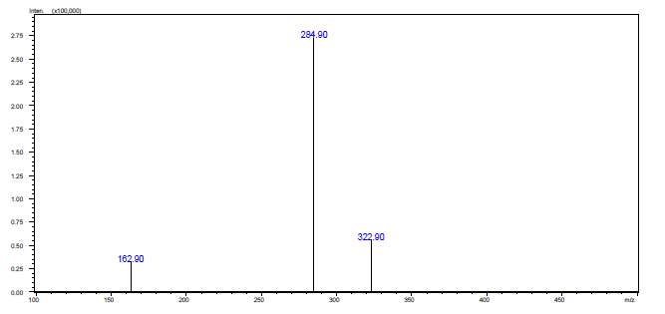

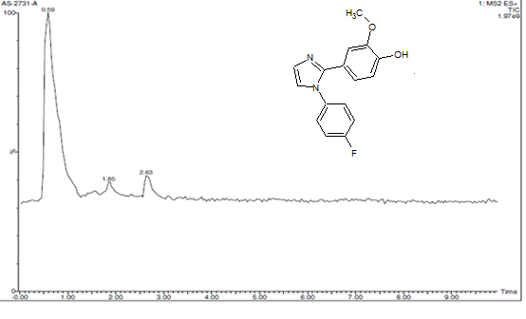

H¹ NMR Spectrum of sample “K”
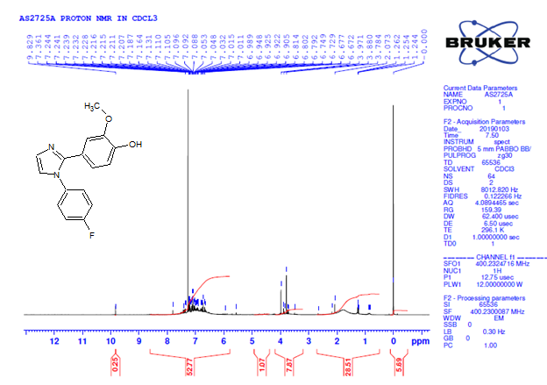
S.NO | δ VALUE | TYPES OF PEAK | NUMBER OF PROTONS
1. | 3.8-3.9 | MULTIPLET | 2 Protons
2. | 6.6-7.1 | MULTIPLET | 4 Protons
3. | 7.2-9.8 | MULTIPLET | 7 Protons

IR Spectrum of sample “K “
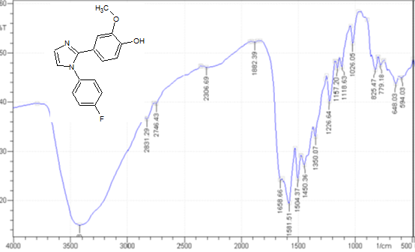

S.No. | WAVE NUMBER cm⁻¹ | TYPES OF VIBRATIONS
1 | 1226.64 | ArOH Stretching
2 | 1350.07 | C-F Stretching
3 | 1504.37 | C=N Stretching
4 | 1118.63 | -C-O- Stretching

- LC-MS SPECTRUM of Compound “L”
Molecular weight: 359.25g/mol

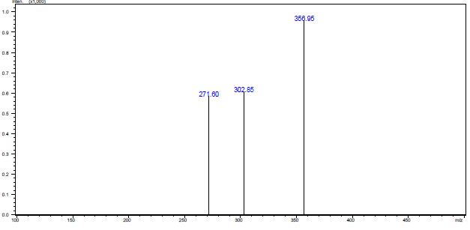

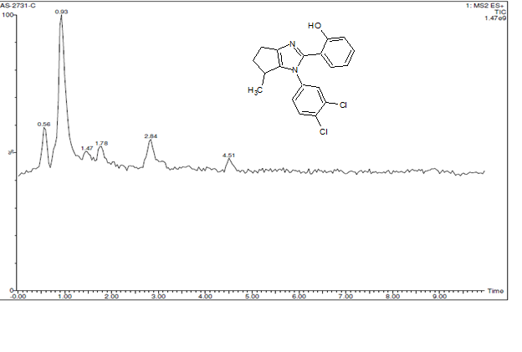

H1 NMR Spectrum of sample “L”
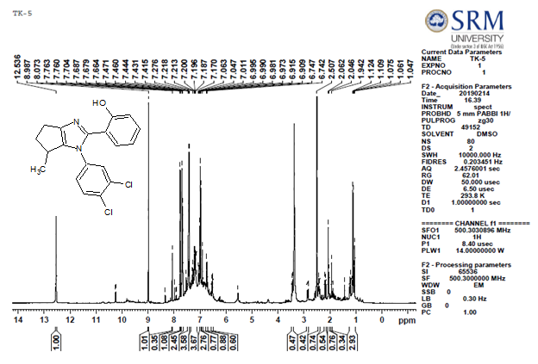

S.NO | δ VALUE | TYPES OF PEAK | NUMBER OF PROTONS
1. | 1.1-2.5 | MULTIPLET | 3 Protons
2. | 6.7-6.9 | MULTIPLET | 5 Protons
3. | 7.4-8.9 | MULTIPLET | 8 Protons

IR Spectrum of sample “L”
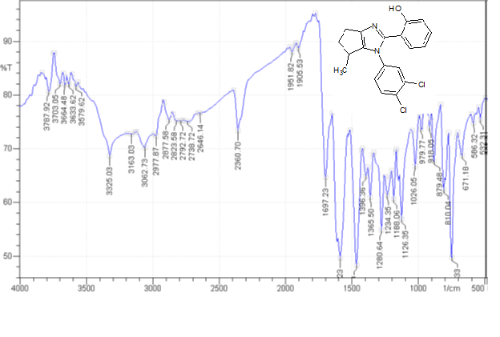

S.No. | WAVE NUMBER cm⁻¹ | TYPES OF VIBRATIONS
1 | 671.18 | C-Cl Stretching
2 | 1234.35 | ArOH Stretching
3 | 1396.30 | C=N Stretching
4 | 3062.73 | Ar-H Stretching

- LC-MS SPECTRUM of Compound “M”
Molecular weight: 268.29g/mol

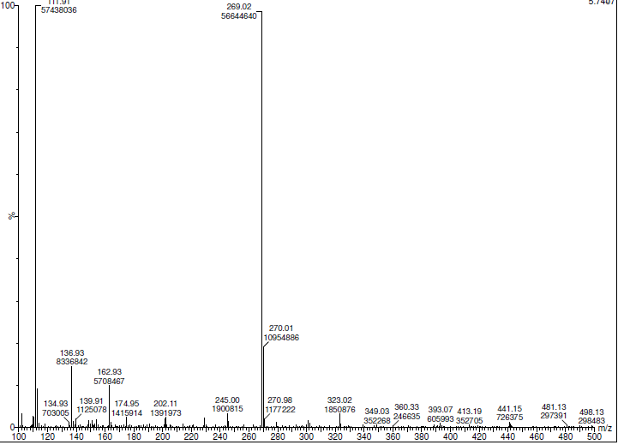

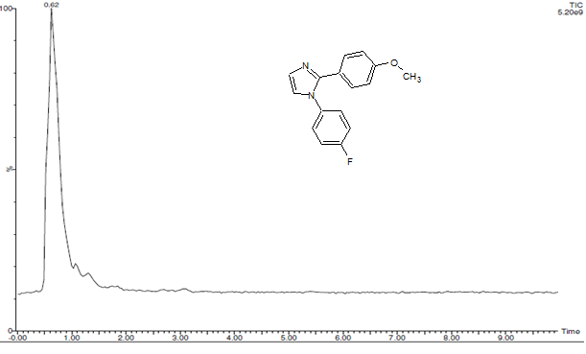

H1 NMR Spectrum of sample “M”
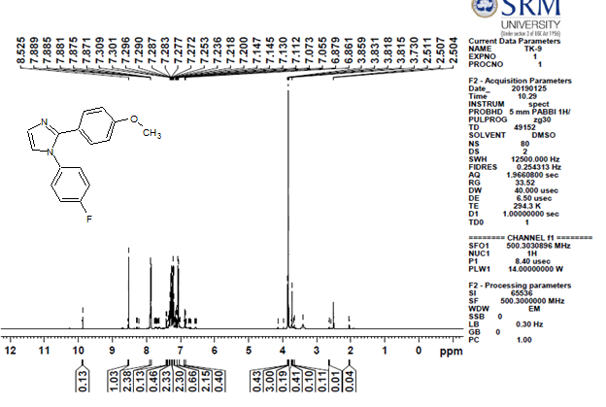

S.NO | δ VALUE | TYPES OF PEAK | NUMBER OF PROTONS
1. | 3.7-3.8 | MULTIPLET | 3 Protons
2. | 6.4-7.7 | MULTIPLET | 8 Protons
3. | 7.8-8.6 | MULTIPLET | 2 Protons

IR Spectrum of sample “M”

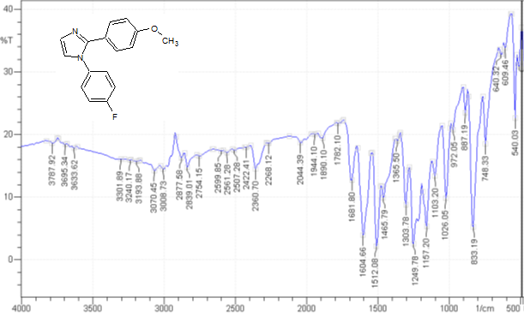

S.No. | WAVE NUMBER cm⁻¹ | TYPES OF VIBRATIONS
1 | 1157.20 | C-F Stretching
2 | 1512.06 | C=N Stretching
3 | 1249.78 | C-O Stretching
4 | 3006.73 | Ar-H Stretching

- LC-MS SPECTRUM of Compound “N”
Molecular weight: 267.11g/mol

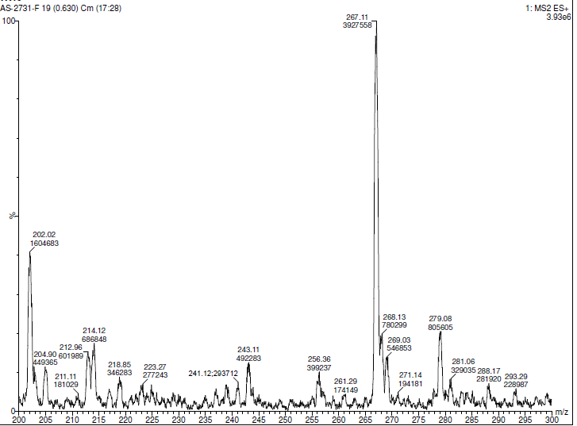

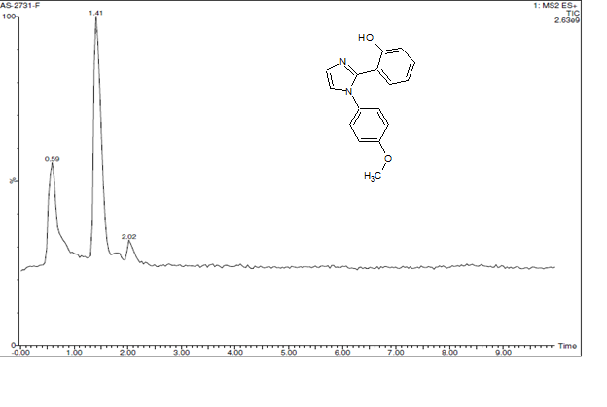

H1 NMR Spectrum of sample “N”
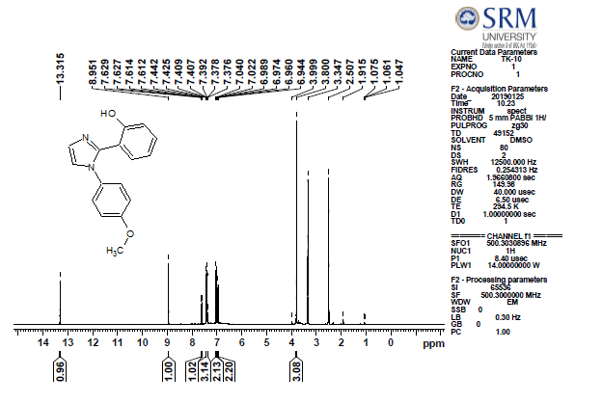

S.NO | δ VALUE | TYPES OF PEAK | NUMBER OF PROTONS
1. | 3.8-3.9 | MULTIPLET | 3 Protons
2. | 6.9-7 | MULTIPLET | 5 Protons
3. | 7-8.9 | MULTIPLET | 6 Protons

IR Spectrum of sample “N”

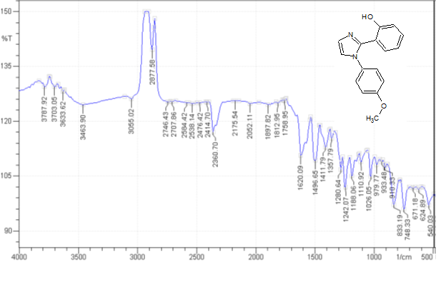
S.No. | WAVE NUMBER cm⁻¹ | TYPES OF VIBRATIONS
1 | 1357.79 | ArOH Stretching
2 | 1496.65 | C=N Stretching
3 | 1242.07 | C-O Stretching
4 | 3055.02 | Ar-H Stretching

- LC-MS SPECTRUM of Compound “O”
Molecular weight: 280.33g/mol

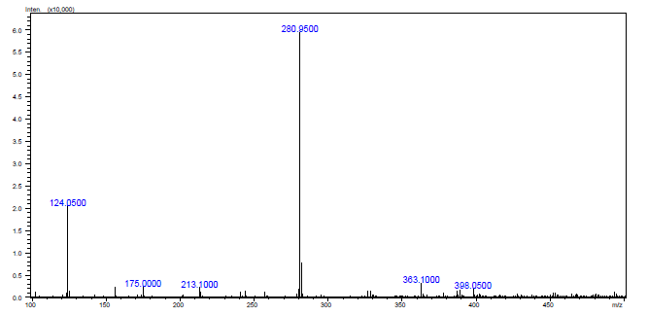

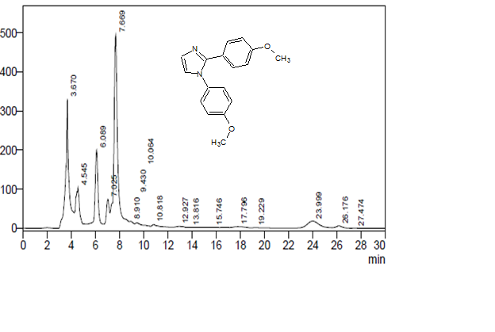

H1 NMR Spectrum of sample “O”

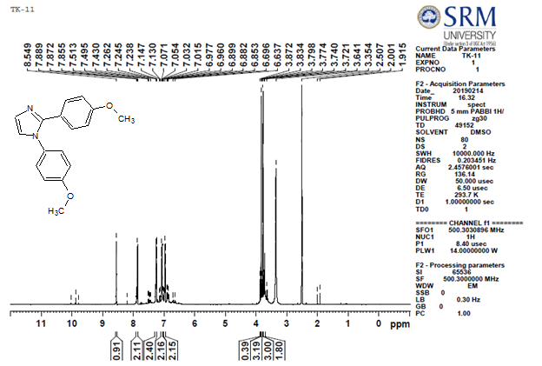

S.NO | δ VALUE | TYPES OF PEAK | NUMBER OF PROTONS
1. | 3.3-3.8 | MULTIPLET | 6 Protons
2. | 6.6-7.2 | MULTIPLET | 8 Protons
3. | 7.4-8.5 | MULTIPLET | 2 Protons

IR Spectrum of sample “O”

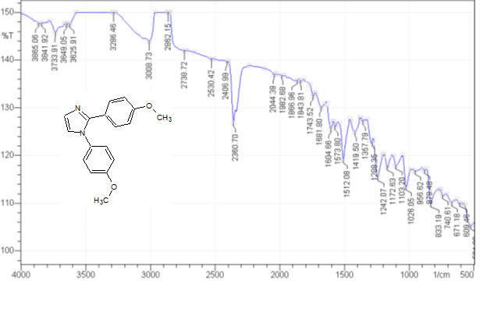

S.No. | WAVE NUMBER cm⁻¹ | TYPES OF VIBRATIONS
1 | 1512.08 | C=N Stretching
2 | 1026.05 | C-O Stretching
3 | 3008.73 | Ar-H Stretching

