Supplementary Materials for

Prediction of enhancer-promoter interactions using the cross-cell information and domain adversarial neural network

Fang Jing¹, Shao-Wu Zhang^{1,*} and Shihua Zhang^{2,3,4*}
¹Key Laboratory of Information Fusion Technology of Ministry of Education, School of Automation, Northwestern Polytechnical University, Xi’an 710072, China
²NCMIS, CEMS, RCSDS, Academy of Mathematics and Systems Science, Chinese Academy of Sciences, Beijing 100190, China
³School of Mathematical Sciences, University of Chinese Academy of Sciences, Beijing 100049, China
⁴Center for Excellence in Animal Evolution and Genetics, Chinese Academy of Sciences, Kunming 650223, China
*To whom correspondence should be addressed.

Table S1. Models, hidden layers and hyper-parameters. 2×{layer} means double layers, 1 CNN means a CNN layer, 1 bidirectional LSTM means a bidirectional LSTM layer, 1 Dense means a Dense layer. The grid search strategy is used to optimize the hyperparameters.

Model | Hidden layers |  |  | Hyper-parameters
 | Feature learning pahse | Domain adversarial learning phase | Predictor phase | Number of kernels (32,100,300)  Learning Rate (1e-03,1e-05)  Reversal Rate (0.5, 1)
SEPT | 2×{ CNN, Maxpooling },  1 bidirectional LSTM; | 1 Gradient reversal,  1 Dense; | 1 Dense layer
BASE+LSTM | 1 CNN, 1 Maxpooling,  1 bidirectional LSTM; | 1 Gradient reversal,  1 Dense; | 1 Dense layer
BASE | 1 CNN, 1 Maxpooling; | 1 Gradient reversal,  1 Dense; | 1 Dense layer
BASE+FC | 1 CNN, 1 Maxpooling,  1 Dense; | 1 Gradient reversal,  1 Dense; | 1 Dense layer | Number of kernels (32,100,300)  Learning Rate (1e-03,1e-05)  Reversal Rate (0.5, 1)  Number of Dense units (20,200)
Table S2. Top 5 potentially important TFs identified by the first convolution layer of SEPT and SEP.
Cell line | Element | Methods | Potentially important TFs involved in EPIs
K562 | Promoter | In both SEPT and SEP | ZNF563, RXRA, ZNF554, SP3, THAP1
K562 | Promoter | Only in SEPT | ZBTB6, EBF1, SALL4, ZNF320, MAFB
K562 | Enhancer | In both SEPT and SEP | T, ZNF563, RARG, MAF, LYL1
K562 | Enhancer | Only in SEPT | TCF4, NR3C1, ETV4, FOXM1, CUX1
GM12878 | Promoter | In both SEPT and SEP | ZNF563, THAP1, RXRA, OSR2, ZNF341
GM12878 | Promoter | Only in SEPT | TEAD4, ELF1, GABPA, ELF3, MYOD1
GM12878 | Enhancer | In both SEPT and SEP | T, MAF, LYL1, NFIA, ZNF563
GM12878 | Enhancer | Only in SEPT | NR2F2, NKX3-1, NR1I3, ETV4, NR4A1
HeLa-S3 | Promoter | In both SEPT and SEP | THAP1, SP3, ZNF563, PATZ1, RXRA
HeLa-S3 | Promoter | Only in SEPT | NR1I3, BATF3, ZIC3, ZEB1, CTCFL
HeLa-S3 | Enhancer | In both SEPT and SEP | NR1D1, ZNF563, MAF, GATA2, NKX6-1
HeLa-S3 | Enhancer | Only in SEPT | ZN547, SOX9, NFIA, FOXK1, RBPJ
HUVEC | Promoter | In both SEPT and SEP | THAP1, ZNF563, SP3, RXRA, NR1D1
HUVEC | Promoter | Only in SEPT | TEAD4, ZBTB6, PGR, ZNF354A, ELF2
HUVEC | Enhancer | In both SEPT and SEP | MAF, ZNF563, T, ZNF335, ZNF214
HUVEC | Enhancer | Only in SEPT | ESR2, NKX3-1, FEZF1, SMAD4, SMAD2
IMR90 | Promoter | In both SEPT and SEP | THAP1, RXRA, SP2, ZNF563, SP3
IMR90 | Promoter | Only in SEPT | NKX2-5, RBPJ, TEAD4, TCF4, NR2F2
IMR90 | Enhancer | In both SEPT and SEP | MAF, ZNF563, OLIG2, T, RXRA
IMR90 | Enhancer | Only in SEPT | TFAP2A, ZNF85, NR1I3, NKX3-1, SOX9
NHEK | Promoter | In both SEPT and SEP | THAP1, SP2, ZNF563, SP3, PATZ1
NHEK | Promoter | Only in SEPT | TFAP2C, RBPJ, ETV4, EBF1, MYOD1
NHEK | Enhancer | In both SEPT and SEP | ZNF563, NR1H3, CLOCK, NR1D1, GATA1
NHEK | Enhancer | Only in SEPT | SMAD2, SMAD4, ETV4, FEZF1, FOXM1
HMEC | Promoter | In both SEPT and SEP | THAP1, ZNF563, SP3, PATZ1, RXRA
HMEC | Promoter | Only in SEPT | NFYC, RBPJ, ZBTB6, SOX10, EHF
HMEC | Enhancer | In both SEPT and SEP | NR1H3, ZNF563, RXRA, MAFF, THRA
HMEC | Enhancer | Only in SEPT | ASCL1, ZNF317, ZEB1, TFDP1, REL

Table S3. Potentially important TFs identified by both SEPT and SPEID.
Cell line | Element | Potentially important TFs involved in SEPT and SPEID
K562 | Promoter | ZIC1, SP3, VDR, TFDP1, IRF8, CLOCK, KLF6
K562 | Enhancer | E2F6, FOXK1, TCF7L1, E2F3
GM12878 | Promoter | SP3, ELF2, CLOCK, EHF
GM12878 | Enhancer | FOXK1, FOXO1, SREBF2, IRF4, SREBF1
HeLa-S3 | Promoter | SP2, SP3, TFAP2B, CLOCK
HeLa-S3 | Enhancer | FOXK1, FOXO1, EHF
HUVEC | Promoter | THAP1, SP4, IRF1, SP2, SP3, ELF2
HUVEC | Enhancer | CLOCK, KLF15, TFDP1, TCF7L1, IRF4
IMR90 | Promoter | CLOCK, KLF6, THAP1, SP2, SP3, ELF2, VDR
IMR90 | Enhancer | CLOCK, VDR, KLF15
NHEK | Promoter | CLOCK, MZF1, THAP1, SP2, SP3, ELF2
NHEK | Enhancer | MZF1, CLOCK, VDR
* Only the top 50 TFs of SPEID were used to compare.

Table S4. Overlap number of EPIs between any two cell lines.
Cell line | IMR90 | NHEK | HUVEC | HeLa-S3 | K562 | GM12878 | HMEC
#EPIs | 1254 | 1291 | 1524 | 1740 | 1977 | 2113 | 1342
IMR90 | * | 11 | 0 | 0 | 0 | 0 | 19
NHEK | 11 | * | 0 | 0 | 0 | 0 | 22
HUVEC | 0 | 0 | * | 0 | 0 | 0 | 0
HeLa-S3 | 0 | 0 | 0 | * | 0 | 0 | 0
K562 | 0 | 0 | 0 | 0 | * | 0 | 0
GM12878 | 0 | 0 | 0 | 0 | 0 | * | 0
HMEC | 19 | 22 | 0 | 0 | 0 | 0 | *

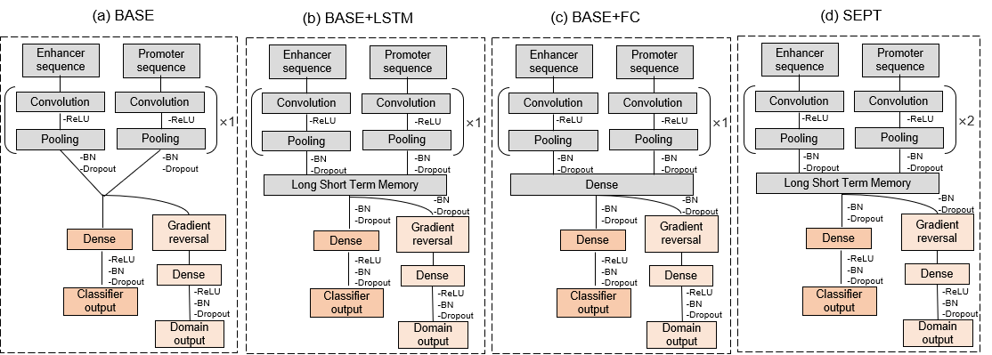
Fig.S1. Computational network architectures in feature learning phase. The first network architecture (namely BASE) includes only one convolutional layer. The second network architecture (namely BASE+LSTM) includes one convolutional layer and one LSTM layer. The third network architecture (namely BASE+FC) include one convolutional layer and one full connection layer. SEPT includes two convolutional layers and one LSTM layer.

