Table S1. PDB entries with Oseltamivir bound to Neuraminidase for Influenza Virus, including interaction data (IC50 values, inhibition constants) and relevant mutations.
Entry ID | Value (nM) | Type | N Series | Subtype | Mutations
5NZN | 0.1 | IC50 | N1 | H1N1 | H275Y/S247N
4K1I | 0.11 | IC50 | N2 | H2N2 | -
4HZX | 0.5 | IC50 | N3 | H2N3 | -
4B7R | 1 | IC50 | N1 | H1N1 | I223R
5NWE | 1.1 | IC50 | N1 | H1N1 | H275Y
3CL0 | 1.1 | Ki | N1 | H5N1 | H274Y
4GZP | 1.6 | IC50 | N2 | H3N2 | -
2HU4 | 1.8 | IC50 | N1 | H5N1 | -
2QWK | 2 | IC50 | N9 | H11N9 | -
4CPY | 3 | IC50
4CPM | 3 | IC50
4K1J | 4.5 | IC50 | N2 | H2N2 | -
5NZE | 6.5 | IC50 | N1 | H1N1 | S247N
4K1K | 7 | IC50 | N2 | H2N2 | -
4HZZ | 8.31 | IC50 | N3 | H2N3 | H274Y
2HT7 | 8.9 | IC50 | N8 | H3N8 | -
2HT8 | 8.9 | IC50 | N8 | H3N8 | -
4WA4 | 8.9 | IC50 | N8 | H3N8 | -
4B7J | 11.1 | Ki | N1 | H1N1 | I223R
4GZT | 17 | Ki | N2 | H3N2 | D151G
5NZF | 20 | IC50 | N1 | H1N1 | H275Y/I223V
3TI6 | 20 | IC50 | N1 | H1N1 | -
2HU0 | 23 | IC50 | N1 | H5N1 | -
3CL2 | 49 | IC50 | N1 | H5N1 | N294S
3K3A | 61 | IC50
5NZ4 | 520 | Kd | N1 | H1N1 | I223V
7CM1
7FGD
7XVU
6HG5 |  |  | N6
4QN7 |  |  | N7
2QWH |  |  | N9
4MWQ |  |  | N9
4MWW |  |  | N9
5L15 |  |  | N9
6HEB |  |  | N9

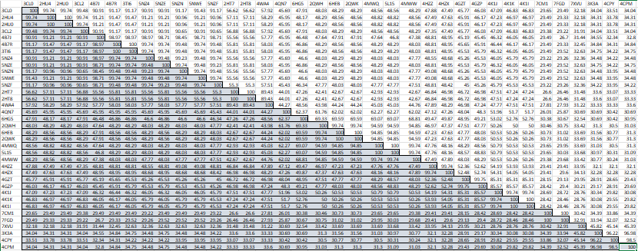
Figure S1. Identity Matrix for all the sequences of the Neuraminidase series

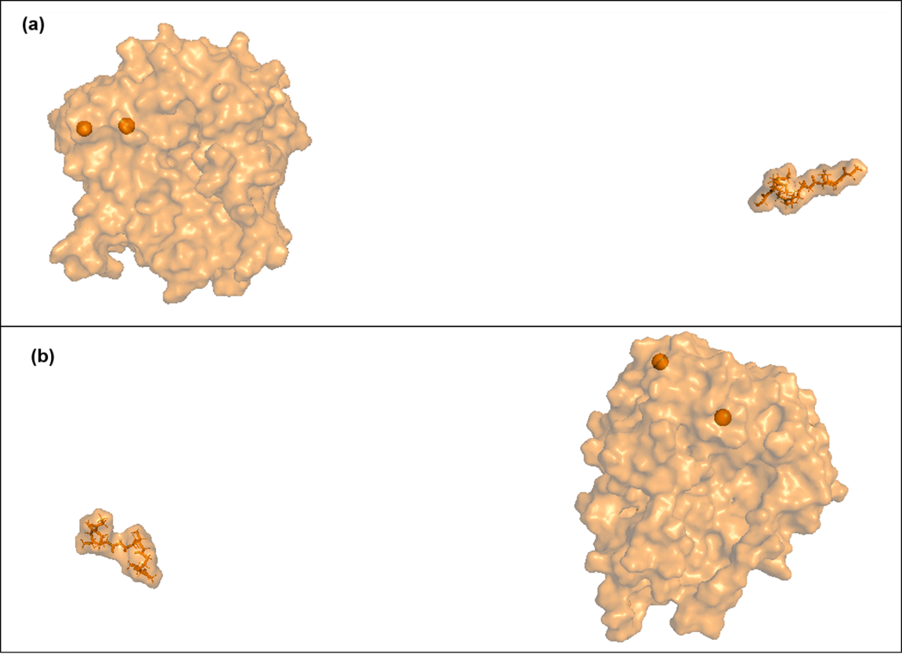
Figure S2. Conformation of the initial (0 ns) and final (100 ns) pose for the (a) compounds_106-597 and (b) compounds_375-597.

Figure S3: Interaction networks for the top hit compounds and oseltamivir with neuraminidase binding site residues. The networks display key interactions such as hydrogen bonds, hydrophobic contacts, and π-π stacking. (a) compound_106, (b) compound_375, (c) compound_440, (d) compound_539, (e) compound_597, (f) compound_601, (g) compound_705, (h) compound_747, (i) compound_867, and (j) oseltamivir (native ligand). Binding residues involved in hydrogen bonding are indicated in red, while residues involved in hydrophobic and aromatic interactions are highlighted in green, orange, and purple, respectively.
Figure S4: Interaction networks for the combined compounds and neuraminidase binding site residues. The networks display key interactions such as hydrogen bonds, hydrophobic contacts, and alkyl interactions. (a) compound_106-375, (b) compound_106-597, and (c) compound_375-597. Binding residues involved in hydrogen bonding are indicated in green, alkyl interactions in purple, and van der Waals interactions in light blue. These interactions highlight the key residues stabilizing the ligand-protein complex and contributing to the compounds’ inhibitory potential.

