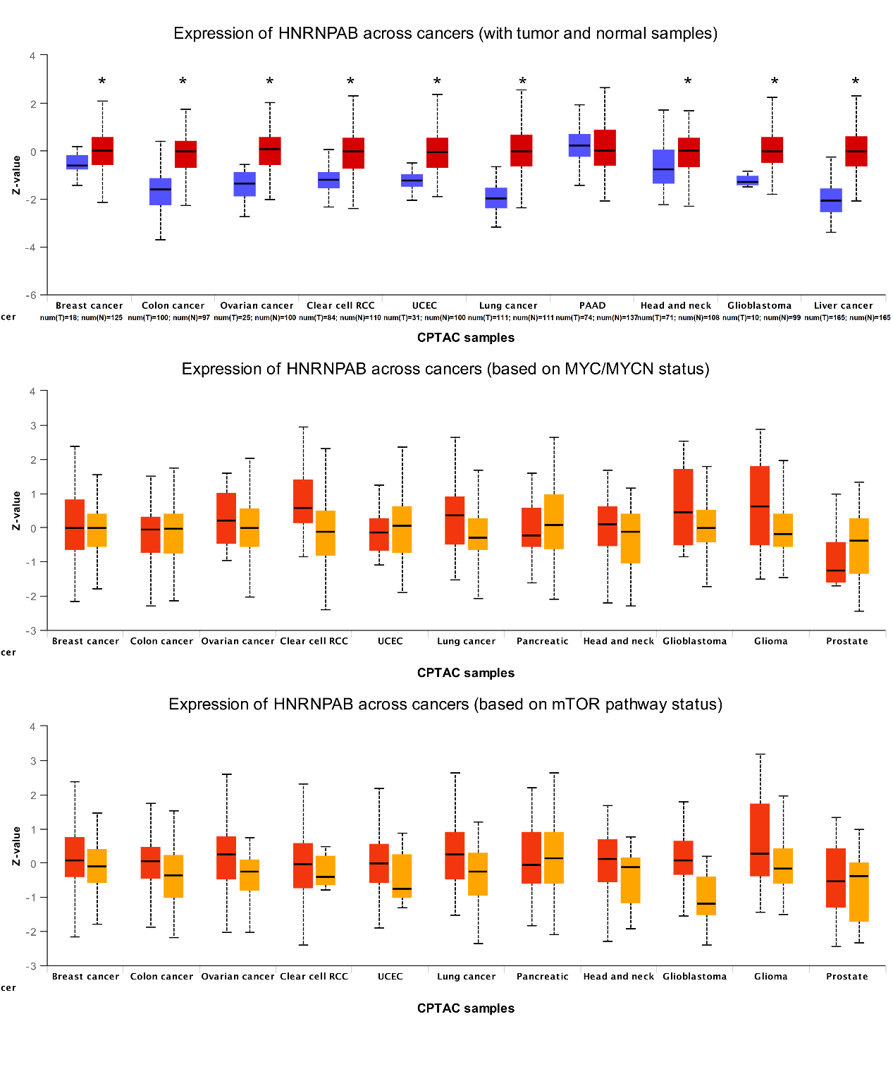Supplementary Figure S1: Protein level analysis of hnRNPAB between normal and tumor tissues using CPTAC proteomics data.*p < 0.05, **p < 0.01, ***p < 0.001, *****p < 0.0001.
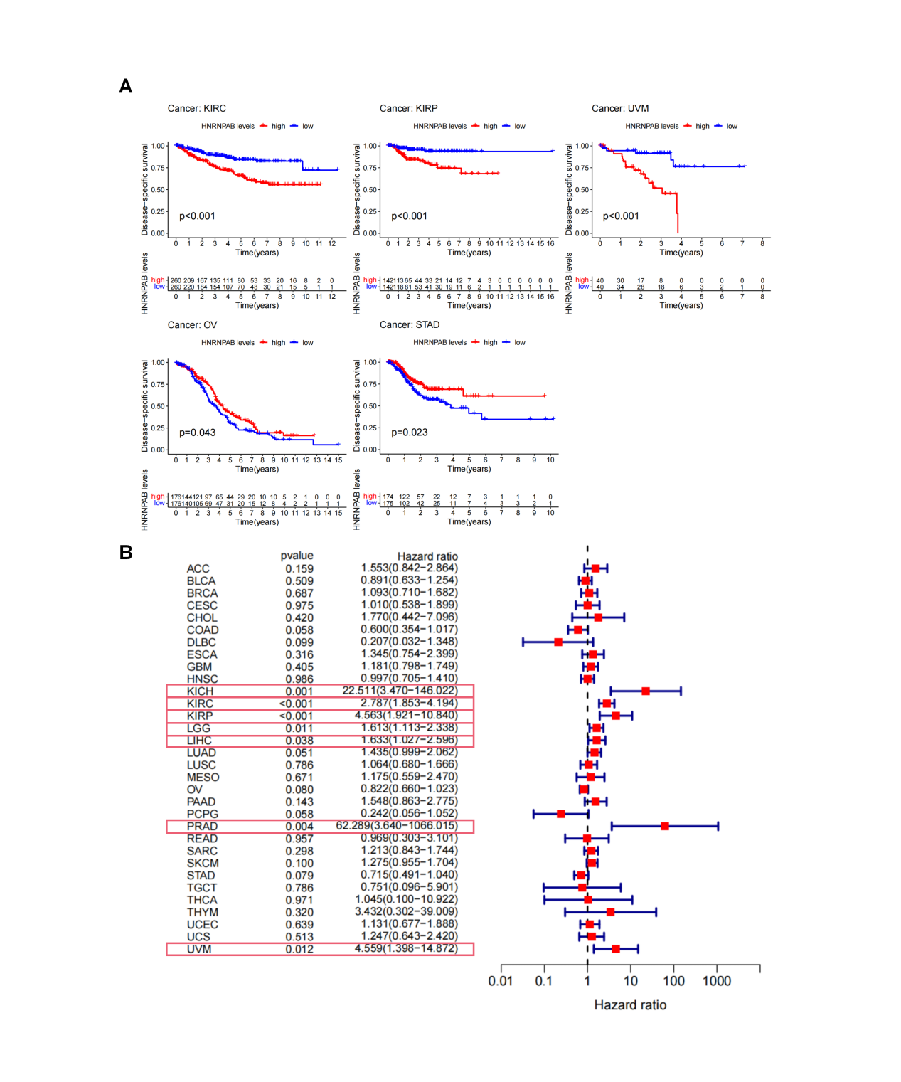Supplementary Figure S2: Correlation between hnRNPAB expression and disease-specific survival (DSS). (A) Kaplan-Meier analysis of hnRNPAB expression and DSS. (B) Forest plot of the correlation between hnRNPAB expression and DSS in 33 cancer types.
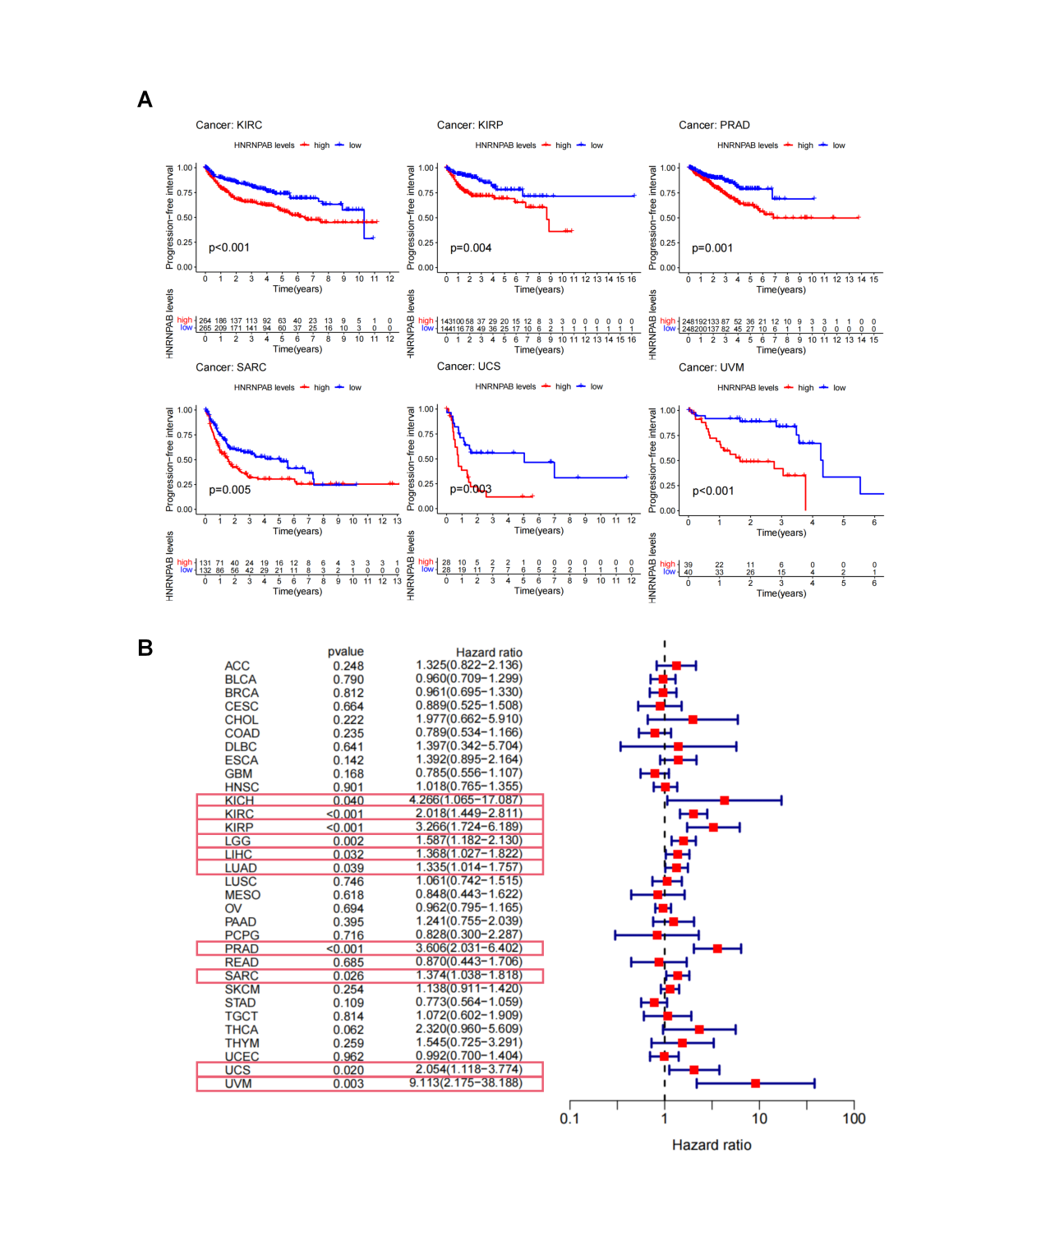Supplementary Figure S3: Correlation between hnRNPAB expression and progression-free survival (PFS). (A) Kaplan-Meier analysis of hnRNPAB expression and PFS. (B) Forest plot of the correlation between hnRNPAB expression and PFS in 33 cancer types.
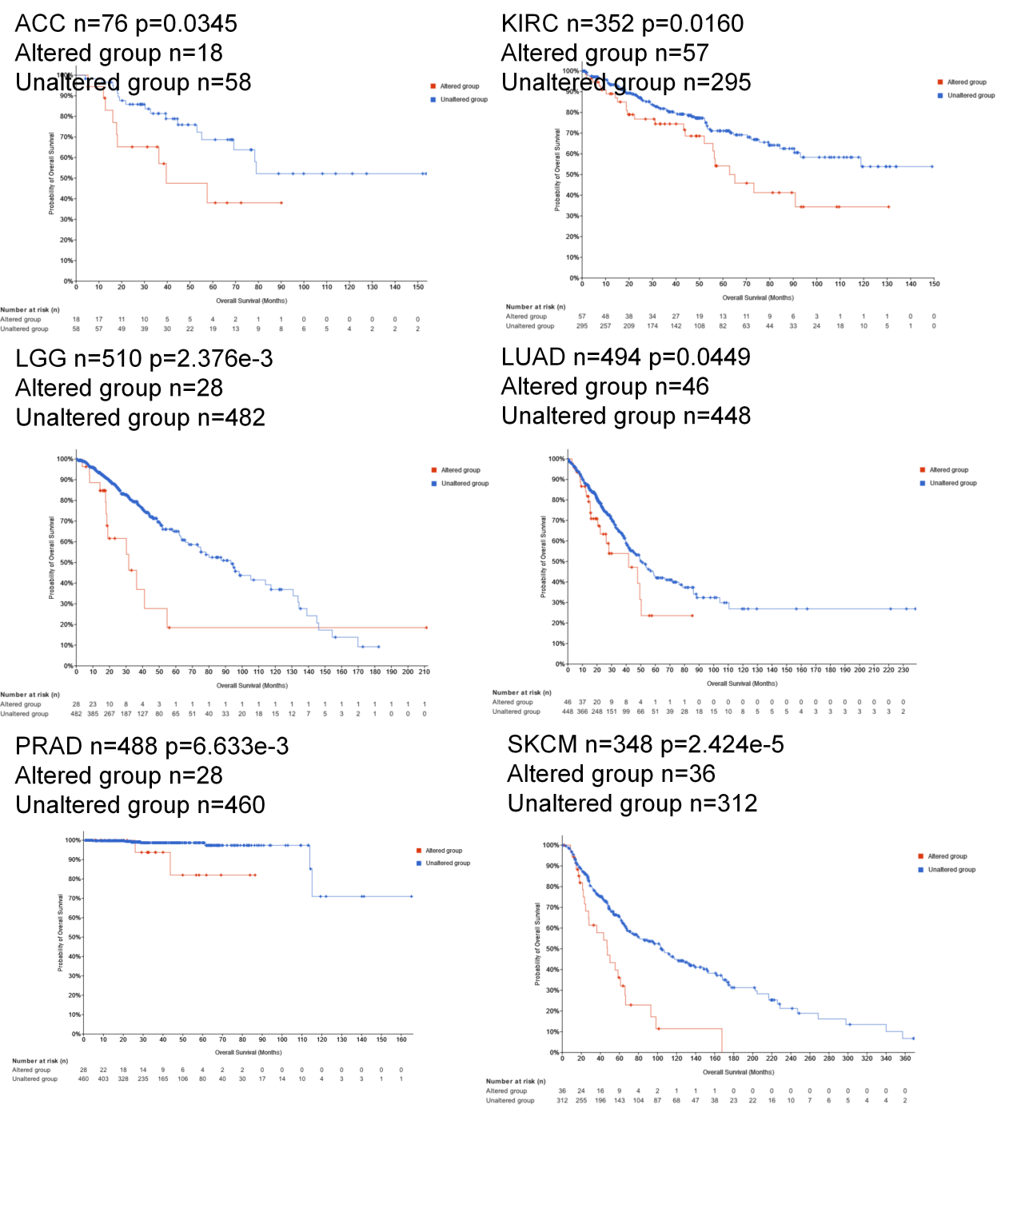Supplementary Figure S4: Comparison of OS between patients with hnRNPAB alterations and without alterations in ACC, KIRC, LGG, LUAD, PRAD, and SKCM.
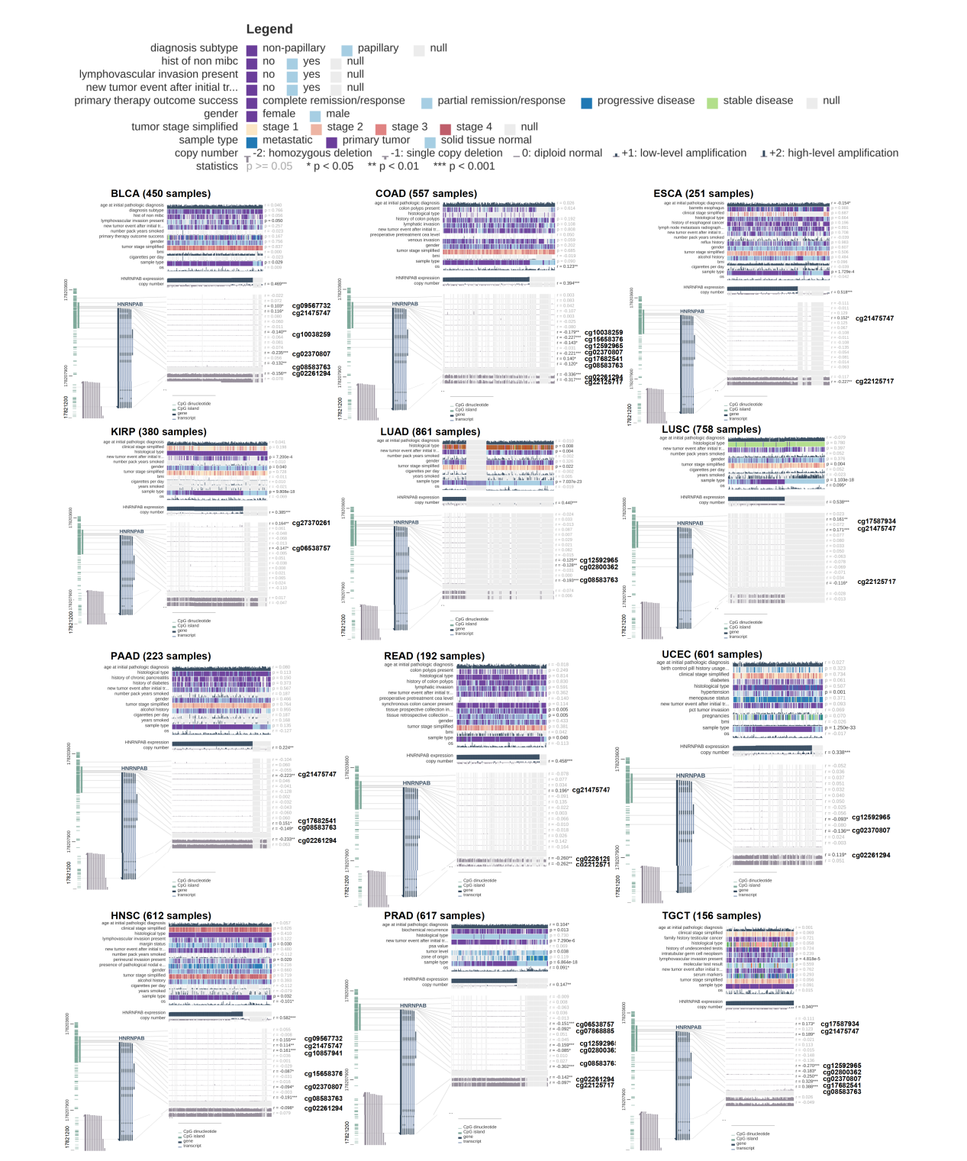Supplementary Figure S5: Correlation analysis of hnRNPAB methylation levels and copy number variations using the MEXPRESS database.
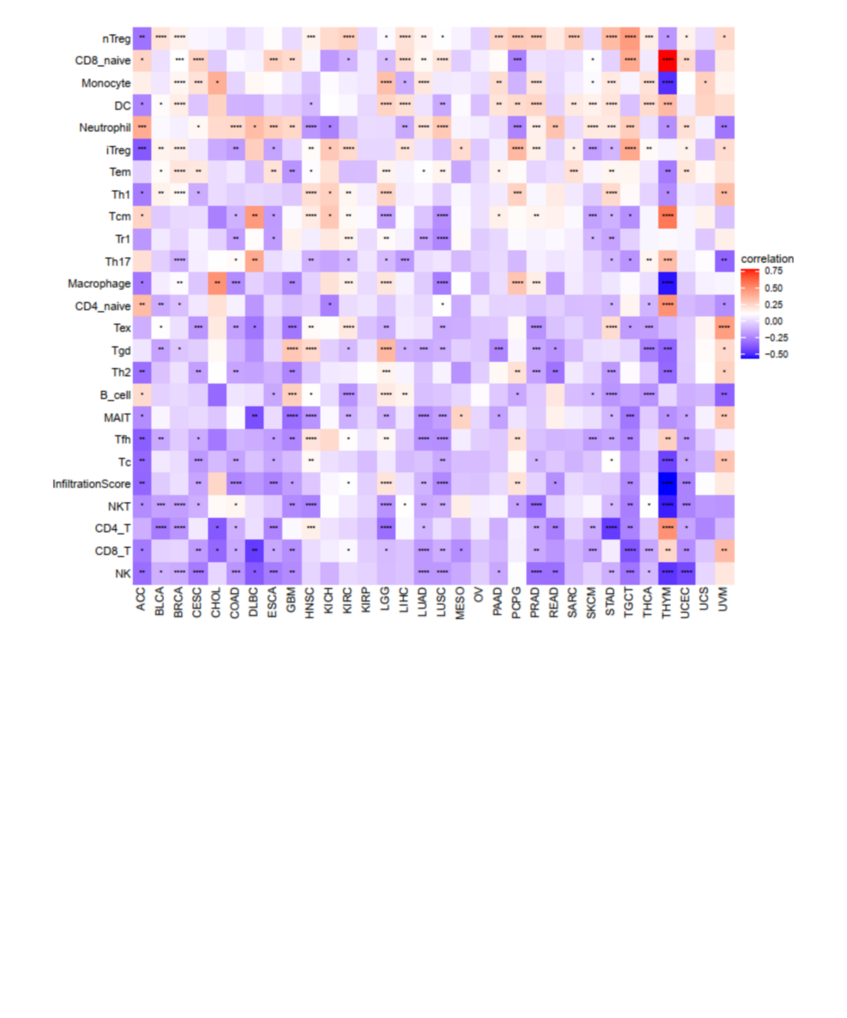Supplementary Figure S6: Correlation between hnRNPAB expression and immune cell infiltration in various cancer tissues. *p < 0.05, **p < 0.01, ***p < 0.001, ****p < 0.0001.
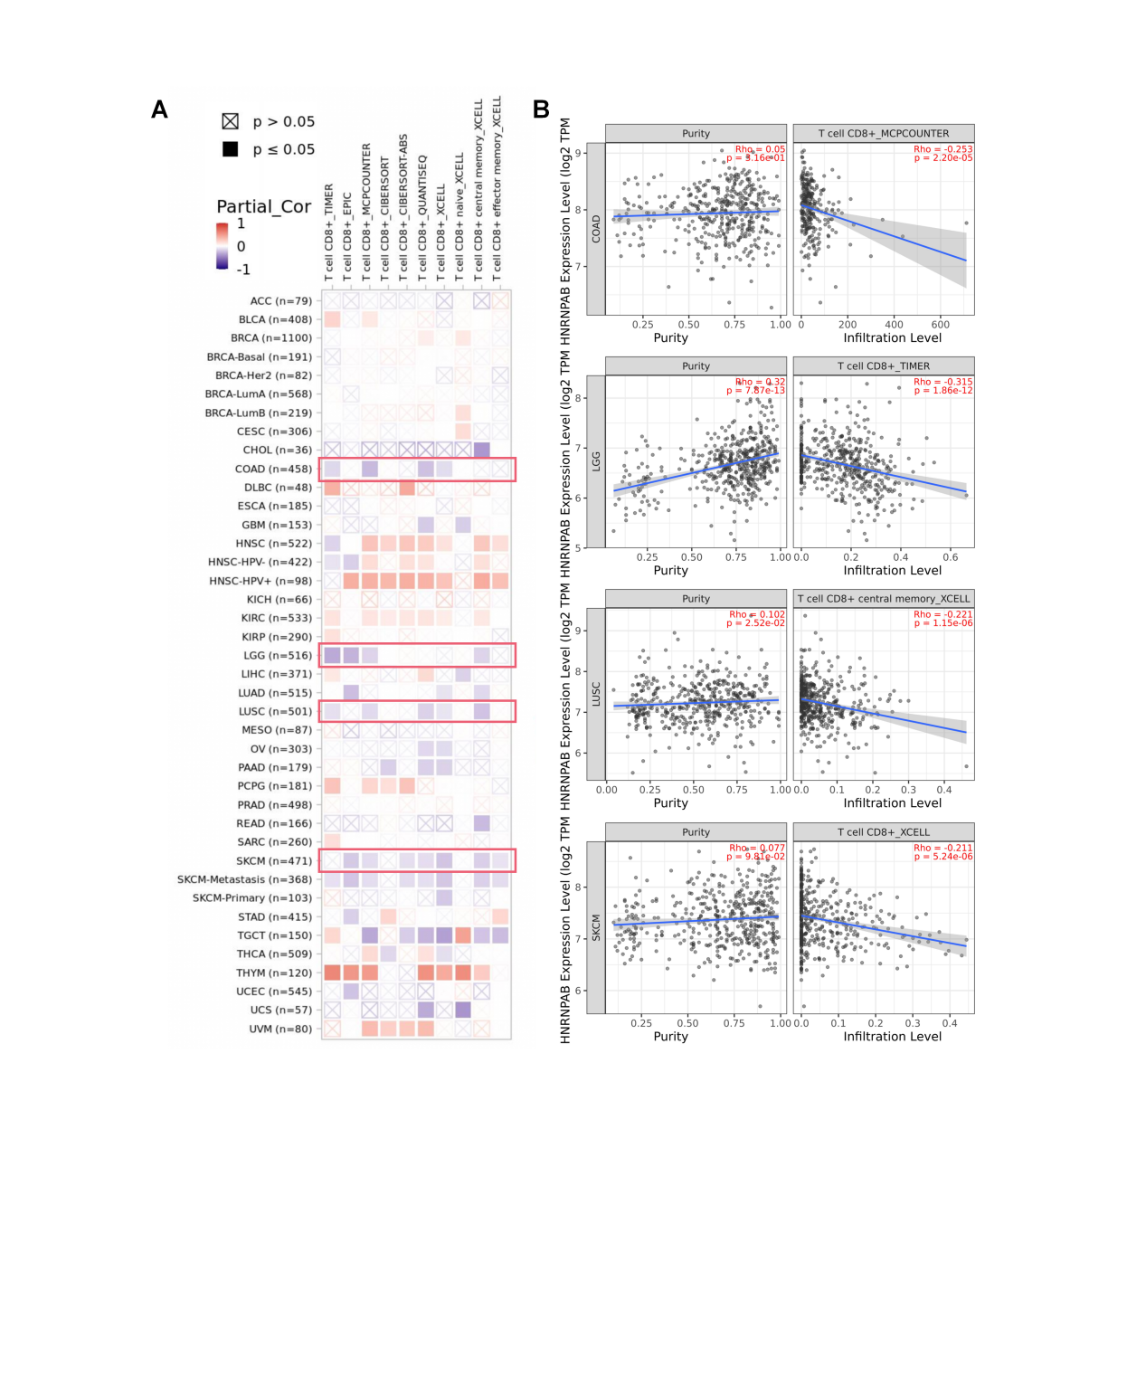Supplementary Figure S7: Correlation between hnRNPAB expression and immune cell infiltration in different cancer tissues. (A) Heatmap showing the relationship between hnRNPAB and immune cells. (B) Scatter plot showing correlations between hnRNPAB and COAD, LGG, LUSC, and SKCM.
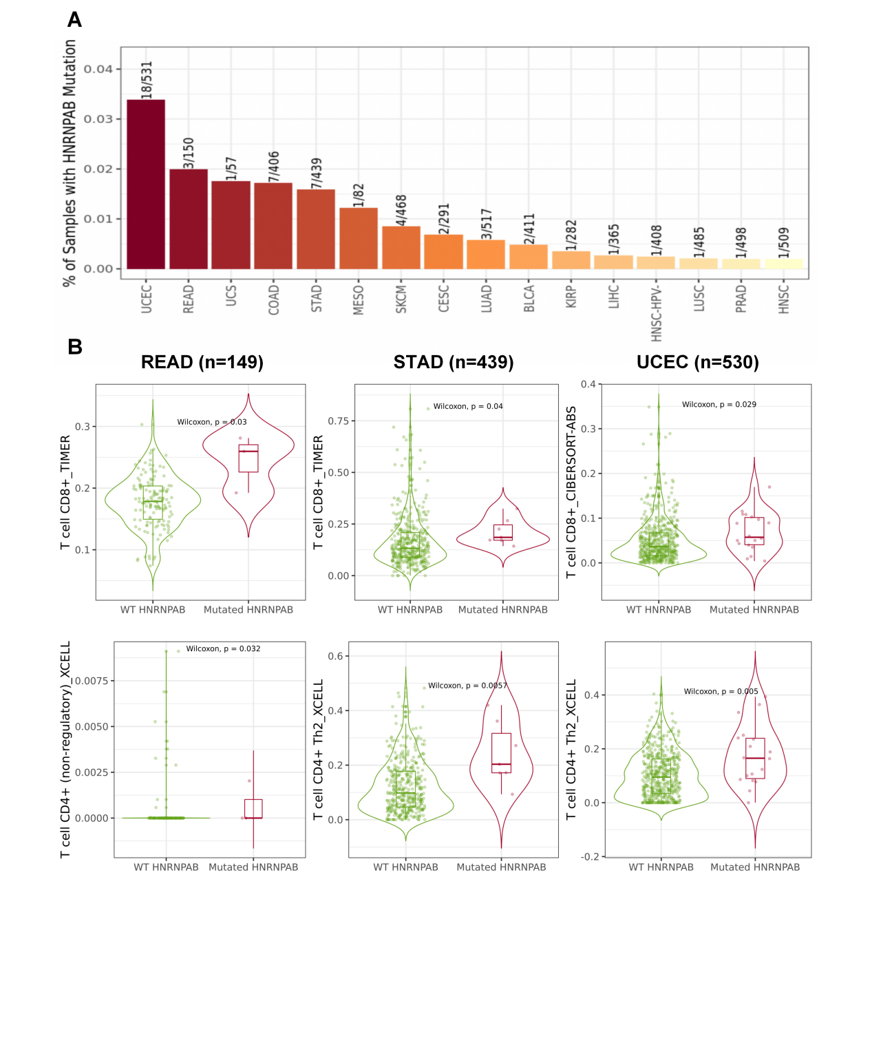Supplementary Figure S8: Immune infiltration mutation analysis related to hnRNPAB in different cancer tissues. (A) Distribution of immune infiltration in hnRNPAB-mutant and wild-type tumors across pan-cancer. (B) Organ plot showing immune infiltration levels in hnRNPAB-mutant and wild-type tumors in READ, STAD, and UCEC.
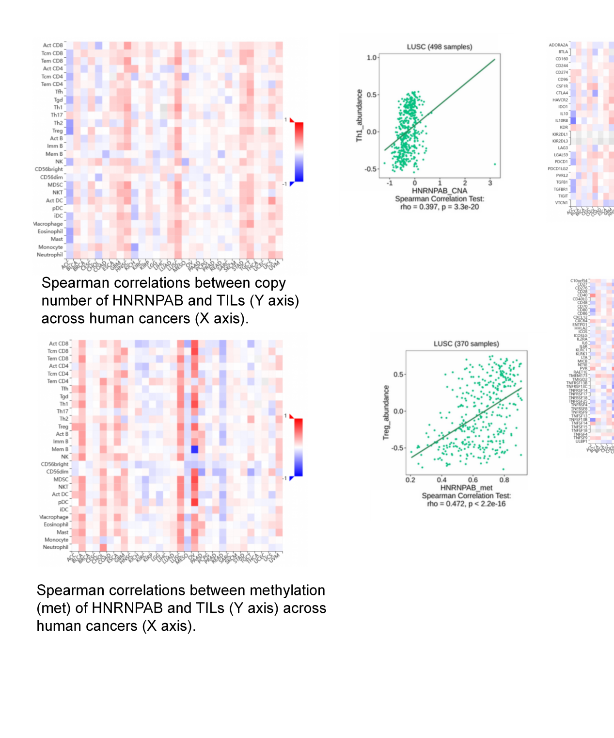Supplementary Figure S9: Heatmap and scatter plot showing the correlation between tumor-infiltrating lymphocytes (TILs) and hnRNPAB copy number or methylation.
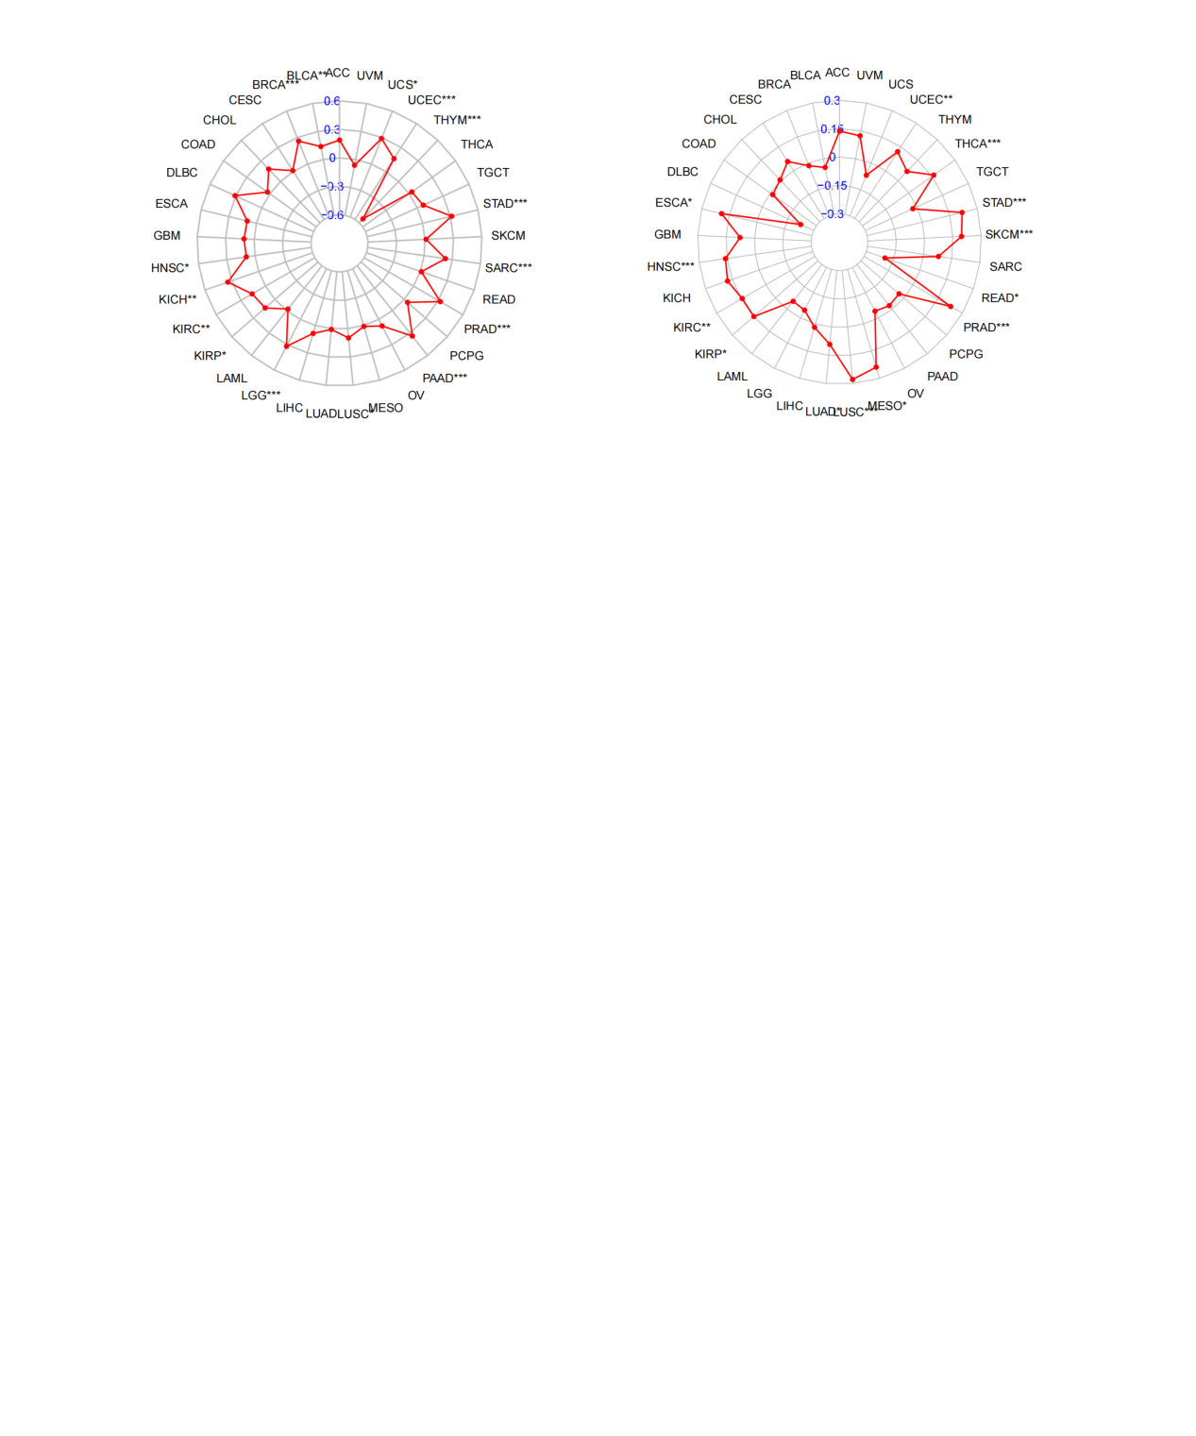Supplementary Figure S10: Radar plot showing the relationship between hnRNPAB expression, tumor mutational burden (TMB), and microsatellite instability (MSI) across different tumors.
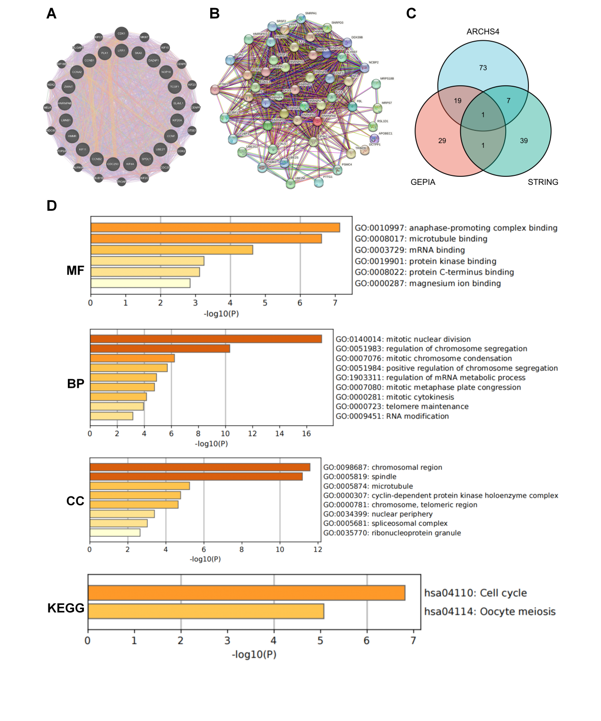Supplementary Figure S11: Gene expression analysis of hnRNPAB in different cancer tissues. (A) Genes with similar expression patterns to hnRNPAB. (B) STRING network of genes with similar expression to hnRNPAB. (C) Venn diagram of similar genes. (D) KEGG pathway enrichment clustering of similar genes.
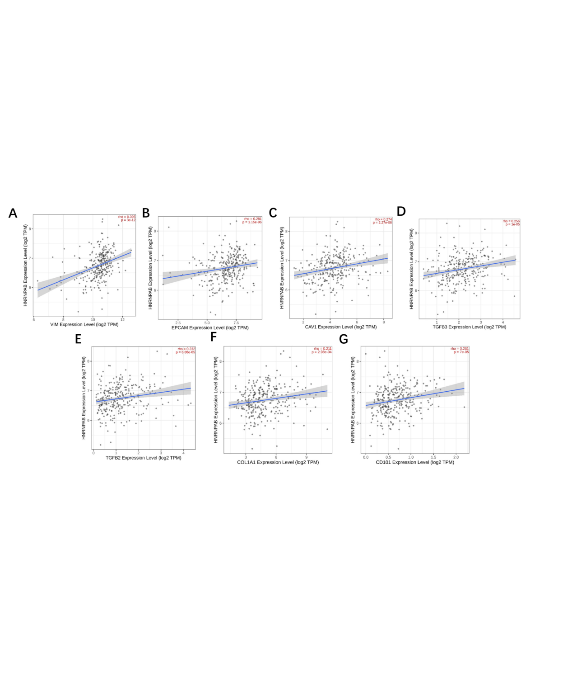Supplementary Figure S12: Correlation analysis between hnRNPAB expression and cancer-associated fibroblast marker genes in KIRP. (A-G) Scatter plots showing the correlation of hnRNPAB expression with CAV1, CD101, COL1A1, COL1A2, FAP, TGF-β3, and VIM.

