Supplementary Information

Keto-enol tautomerism as transformative electron/hole traps to promote charge carrier separation for record-high hydrogen peroxide photosynthesis in real world

Fang Ma,^{a,†} Xiaodong Sun,^{b,c,†} Liqun Ye^{a,*} Chunqiu Han,ª Yongye Wang,ª Anqiang Jiang,^{d} Ying Zhou,^{d} Guijie Liang,^{e} Huiqing Wang,ª Li Wang,ª Binbin Jia,ª Yingping Huang,ª Hongwei Huang,^{f} Xin Ying Kong,^{g} Hui Li,^{c,h} Niu Huang,^{a*} Tianyi Ma,^{c,h*}

ª College of Materials and Chemical Engineering, Key Laboratory of Inorganic Nonmetallic Crystalline and Energy Conversion Materials, China Three Gorges University, Yichang 443002, China.
^{b} College of Chemistry, Liaoning University, Shenyang 110036, PR China
^{c} Centre for Atomaterials and Nanomanufacturing (CAN), School of Science, RMIT University, Melbourne VIC 3000, Australia
^{d} State Key Laboratory of Oil and Gas Reservoir Geology and Exploitation, School of Oil & Natural Gas Engineering, Southwest Petroleum University, Chengdu 610500, China.e
^{e} Hubei Key Laboratory of Low Dimensional Arts and Science, Hubei University of Arts and Science 441053 Xiangyang, P. R. China
^{f} Beijing Key Laboratory of Materials Utilization of Nonmetallic Minerals and Solid Wastes, School of Materials Science and Technology, China University of Geosciences, Beijing 100083, China.
^{g} School of Chemistry, Chemical Engineering and Biotechnology, Nanyang Technological University, 21 Nanyang Link, Singapore, 637371, Singapore
^{h} ARC Industrial Transformation Research Hub for Intelligent Energy Efficiency in Future Protected Cropping (E2Crop), Melbourne VIC 3000, Australia
†Equal contribution to the work

*E-mail addresses: lqye@ctgu.edu.cn (L. Ye); huangliu.ysxf@163.com (N. Huang); tianyi.ma@rmit.edu.au (T. Ma)
Part 1. Experimental Details
1.1 Materials S6
1.2 Synthesis S6
1.3 Characterization S10
1.4 Detection method for H₂O₂ S11
1.5 Photocatalytic H₂ evolution S11
1.6 Photocatalytic CO₂ Reduction S12
1.7 Photocatalytic aniline oxidation conversion S12
1.8 Photoeletrochemical measurements S12
1.9 Photocatalytic experiments S13
1.10 In-situ Fourier transform infrared spectrometer (in-situ FTIR) analysis S13
1.11 Natural sunlight photocatalytic H₂O₂ generation (Flow reactor) S13
1.12 Natural sunlight photocatalytic H₂O₂ generation (immobilization reactor) S13
1.13 Natural sunlight photocatalytic H₂O₂ generation (Dispersion) S14
1.14 Indoor photocatalytic H₂O₂ generation (Flow reactor) S14
1.15 Solor-to-chemical conversion S14
1.16 The SCC calculation procedure of the outdoor experiment cited article is detailed S15
Part 2. Supplemental Results
Figure S1. Unit configurations of COFs synthesized using Tp and BT monomers S18
Figure S2. XRD pattern and FTIR spectra of BTPa and TpPa S19
Figure S3. TEM images and EDS-mapping of BTPa and TpPa S20
Figure S4. DRS and Kubelka-Munk-transformed reflectance spectra of BTPa and TpPa S21
Figure S5. Mott-Schottky plots and Schematic band structure diagram for BTPa and TpPa S22
Figure S6. Photocurrent curves and EIS spectra of BTPa and TpPa S23
Figure S7. Photocatalytic performances of Pa on H₂O₂ production from water S24
Figure S8. XPS spectra of BTPa and TpPa S25
Figure S9. XRD pattern and FTIR spectra of BT-2F and Tp-2F S26
Figure S10. TEM images and EDS-mapping of BT-2F and Tp-2F S27
Figure S11. DRS and Kubelka-Munk-transformed reflectance spectra of 2F S28
Figure S12. Mott-Schottky and Schematic band structure diagram for BT-2F and Tp-2F S29
Figure S13. Photocurrent curves and EIS spectra of BT-2F and Tp-2F S30
Figure S14. Photocatalytic performances of 2F on H₂O₂ production from water S31
Figure S15. XPS spectra of BT-2F and Tp-2F S32
Figure S16. XRD pattern and FTIR spectra of BT-CH₃ and Tp-CH₃ S33
Figure S17. TEM images and EDS-mapping of BT-CH₃ and Tp-CH₃ S34
Figure S18. DRS and Kubelka-Munk-transformed reflectance spectra of CH₃ S35
Figure S19. Mott-Schottky plots and Schematic band structure diagram for CH₃ S36
Figure S20. Photocurrent curves and EIS spectra of BT-CH₃ and Tp-CH₃ S37
Figure S21. Photocatalytic performance of CH₃ on H₂O₂ production from water S38
Figure S22. XPS spectra of BT-CH₃ and Tp-CH₃ S39
Figure S23. XRD pattern and FTIR spectra of BTDpt and TpDpt S40
Figure S24. TEM images and EDS-mapping of BTDpt and TpDpt S41
Figure S25. DRS and Kubelka-Munk-transformed reflectance spectra of Dpt S42
Figure S26. Mott-Schottky plots and Schematic band structure diagram for Dpt S43
Figure S27. (a) Photocurrent curves and (b) EIS spectra of BTDpt and TpDpt S44
Figure S28. Photocatalytic performance of Dpt on H₂O₂ production from water S45
Figure S29. XPS spectra of BTDpt and TpDpt S46
Figure S30. XRD pattern and FTIR spectra of BTBpy and TpBpy S47
Figure S31. TEM images and EDS-mapping of BTBpy and TpBpy S48
Figure S32. DRS and Kubelka-Munk-transformed reflectance spectra of BTBpy and TpBpy S49
Figure S33. Mott-Schottky plots and Schematic band structure diagram for Bpy S50
Figure S34. Photocatalytic performance of Bpy on H₂O₂ production from water S51
Figure S35. XPS spectra of BTBpy and TpBpy S52
Figure S36. XRD pattern and FTIR spectra of BT-COOH and Tp-COOH S53
Figure S37. TEM images and EDS-mapping of BT-COOH and Tp-COOH S54
Figure S38. DRS and Kubelka-Munk-transformed reflectance spectra of COOH S55
Figure S39. Mott-Schottky plots and Schematic band structure diagram of COOH S56
Figure S40. Photocurrent curves and EIS spectra of BT-COOH and Tp-COOH S57
Figure S41. Photocatalytic performance of COOH samples on H₂O₂ production from water S58
Figure S42. XPS spectra of BT-COOH and Tp-COOH S59
Figure S43. XRD pattern and FTIR spectra of BTTAPT and TpTAPT S60
Figure S44. TEM images and EDS-mapping of BTTAPT and TpTAPT S61
Figure S45. DRS and Kubelka-Munk-transformed reflectance spectra of TAPT S62
Figure S46. Mott-Schottky plots and Schematic band structure diagram for TAPT S63
Figure S47. Photocurrent curves and EIS spectra of BTTAPT and TpTAPT S64
Figure S48. Photocatalytic performance of TAPT for H₂O₂ production from water S65
Figure S49. XPS spectra of BTTAPT and TpTAPT S66
Figure S50. XRD pattern and FTIR spectra of BTTBPT and TpTBPT S67
Figure S51. TEM images and EDS-mapping of BTTBPT and TBTAPT S68
Figure S52. DRS and Kubelka-Munk-transformed reflectance spectra of TBPT S69
Figure S53. Mott-Schottky plots and Schematic band structure diagram for TBPT S70
Figure S54. Photocurrent curves and EIS spectra of BTTBPT and TpTBPT S71
Figure S55. Photocatalytic performance of TBPT on H₂O₂ production from water S72
Figure S56. XPS spectra of BTTBPT and TpTBPT S73
Figure S57. The Photocatalytic performances of TpBpy and BTBpy S74
Figure S58. H₂O₂ photosynthesis performances of TpBpy compared to its control COFs S75
Figure S59. XRD pattern and FTIR spectra of OMe-Bpy S76
Figure S60. TEM images and EDS-mapping of OMe-Bpy S77
Figure S61. DRS and Kubelka-Munk-transformed reflectance spectra of OMe-Bpy S78
Figure S62. Mott-Schottky plots and Schematic band structure diagram for OMe-Bpy S79
Figure S63. Photocurrent curves and EIS spectra of OMe-Bpy and TpBpy S80
Figure S64. Photocatalytic performance of OMe-Bpy on H₂O₂ production from water S81
Figure S65. XPS spectra of OMe-Bpy S82
Figure S66. XRD pattern and FTIR spectra of CN-SP₂ S83
Figure S67. TEM images and EDS-mapping of CN-SP₂ S84
Figure S68. DRS and Kubelka-Munk-transformed reflectance spectra of CN-SP₂ S85
Figure S69. Mott-Schottky plots and Schematic band structure diagram for CN-SP₂ S86
Figure S70. Photocurrent curves and EIS spectra of CN-SP₂ and TpBpy S87
Figure S71. Photocatalytic performance of CN-SP₂ on H₂O₂ production from water S88
Figure S72. XPS spectra of CN-SP₂ S89
Figure S73. XRD pattern and FTIR spectra of S-TpBpy S90
Figure S74. TEM images and EDS-mapping of S-TpBpy S91
Figure S75. DRS and Kubelka-Munk-transformed reflectance spectra of S-TpBpy S92
Figure S76. Mott-Schottky plots and Schematic band structure diagram for S-TpBpy S93
Figure S77. Photocurrent curves and EIS spectra of S-TpBpy and TpBpy S94
Figure S78. Photocatalytic performance of S-TpBpy on H₂O₂ production from water S95
Figure S79. XPS spectra of S-TpBpy S96
Figure S80. TpBpy: N1 s of In situ XPS S97
Figure S81. AFM: the dark condition of BTBpy and TpBpy S98
Figure S82. BTBpy and TpBpy. Fluorescence spectra S99
Figure S83. Detailed diagram of the flow experimental device S100
Figure S84. Picture of the flow-reactor system in laboratory environment. S101
Figure S85. Picture of the flow-reactor system in the open air.. S102
Figure S86. Outdoor diagram of immobilization experiment. S103
Figure S87. Outdoor immobilization test glass plate (40cm×30cm) coating effect S104
Figure S88. Outdoor dispersion picture of SCC (%) S105
Figure S89. H₂O₂ concentration standard curve S106
Figure S90. Standard curve for hydrogen production S107
Part 3. Tables
Table S1 The guide explains that Tp has universal reference collation S108
Table S2 Hydrogen peroxide properties of 8 groups of materials (40 min) S114
Table S3 Comparison of hydrogen peroxide production performance S115
Table S4 Hydrogen peroxide properties of 4 groups of materials (40 min) S118
Table S5 Second order kinetic fitting lifetime of BTBpy S119
Table S6 Second order kinetic fitting lifetime of TpBpy S120
Table S7 Comparison of SCC (%) under natural sunlight S121
Part 4. References

Part 1. Experimental Details
1.1. Materials
2,2′-bipyridine-5,5′-diamine (Bpy, >97%), 2,4,6-trihydroxybenzaldehyde-1,3,5-tricarbaldehyde (Tp, >97%), 4,4′-diamino-2,2′-difluo-biphenyl (2F, >98%), 2,2′-dimethyl-[1,1′-biphenyl]-4,4′-diamine (CH₃, >97%), 2,4,6-tris(4-aminophenyl)-1,3,5-triazine (TAPT, >98%), 4′,4′′′,4′′′′′-(1,3,5-triazine-2,4,6-triyl)tris(([1,1′-biphenyl]-4-amine)) (TBPT, >97%) and 5,5′-bis(cyanomethyl)-2,2′-bipyridine (CN, >97%) were purchased from Shanghai Tensus Biotech Co., Ltd. 1,3,5-benzenetricarboxaldehyde (BT, >99.76%), 4,4′-diamino-p-terphenyl (Dpt, >98.86%) and 2,5-diaminobenzoic acid (COOH, >98%) were purchased from Jilin Yanshen Technology Co., Ltd. Solvents including dichloromethane (DCM, AR), o-dichlorobenzene (o-DCB, 99%), acetic acid (AcOH, ≥99.8%), N, N-dimethylacetamide (DMAC, 99.8%, extra dry, with molecular sieves, water ≤50 ppm), dioxane (spectral pure, ≥99.5%) and p-phenylenediamine (AR, 97%) were purchased from Aladdin. Tetrahydrofuran (AR, 99.0%) and 1,3,5-trimethylbenze (AR, 97%) were purchased from Macklin. 38% HCl was procured from Chengdu Kolon Chemical Co. All reagents were used as received without further purification.
1.2. Synthesis
Synthesis of BTPa. BT (0.3 mmol, 48.6 mg) and Pa (0.45 mmol, 48.6 mg) were mixed in 6 mL n-BuOH, ensuring uniform dispersion through ultrasonication. Subsequently, 0.4 mL of 6 M AcOH aqueous solution was swiftly introduced and sonicated for an additional 30 mins. After degassing with liquid nitrogen through three freeze-thaw cycles, the reaction was conducted at 120 °C for 3 days. The solid was then washed thoroughly with a large amount of DMAC, acetone, n-BuOH, tetrahydrofuran, and dichloromethane, and dried under vacuum. The resulting BTPa COF in yellow color was collected.
Synthesis of TpPa. Tp (0.3 mmol, 63 mg) and Pa (0.45 mmol, 48.6 mg) were mixed with 4.5 mL of DMAC and 1.5 mL of o-DCB, ensuring uniform dispersion through ultrasonication. Subsequently, 0.4 mL of 6 M AcOH aqueous solution was swiftly introduced and sonicated for an additional 30 mins. After degassing with liquid nitrogen via three freeze-thaw cycles, the reaction was conducted at 120 °C for 3 days. The solid was then washed thoroughly with a large amount of DMAC, acetone, n-BuOH, tetrahydrofuran, and dichloromethane, and dried under vacuum. The resulting TpPa COF in yellow color was collected.
Synthesis of BT-2F. BT (0.5 mmol, 81 mg) and 2F (0.75 mmol, 165 mg) were mixed in 8 mL n-BuOH, ensuring uniform dispersion through ultrasonication. Subsequently, 0.6 mL of 6 M AcOH aqueous solution was swiftly introduced and sonicated again over 30 mins. After degassing with liquid nitrogen via three freeze-thaw cycles, the reaction was conducted at 120 °C for 3 days. The solid was then washed away with a large amount of DMAC, acetone, n-BuOH, tetrahydrofuran, and dichloromethane, and dried under vacuum.The resulting Tp-2F COF in yellow color was collected.
Synthesis of Tp-2F. Tp (0.3 mmol, 63 mg) and Bpy (0.45 mmol, 83 mg) were mixed with 4.5 mL DMAC and 1.5 mL o-DCB, ensuring uniform dispersion through ultrasonication. Subsequently, 0.6 mL of 6 M AcOH aqueous solution was swiftly introduced and sonicated again over 30 mins. After degassing with liquid nitrogen via three freeze-thaw cycles, the reaction was conducted at 120 °C for 3 days. The solid was then washed away with a large amount of DMAC, acetone, n-BuOH, tetrahydrofuran, and dichloromethane, and dried under vacuum. The resulting Tp-2F COF was collected.
Synthesis of BT-CH₃. BT (0.6 mmol, 97 mg) and CH₃ (0.9 mmol, 191 mg) were mixed in 8 mL n-BuOH, ensuring uniform dispersion through ultrasonication. Subsequently, 0.6 mL of 6 M AcOH aqueous solution was swiftly introduced and sonicated again over 30 mins. After degassing with liquid nitrogen via three freeze-thaw cycles, the reaction was conducted at 120 °C for 3 days. The solid was then washed away with a large amount of DMAC, acetone, n-BuOH, tetrahydrofuran, and dichloromethane, and dried under vacuum. The resulting BT-CH₃ COF was collected.
Synthesis of Tp-CH₃. Tp (0.6 mmol, 126 mg) and CH₃ (0.9 mmol, 191 mg) were mixed in 8 mL n-BuOH, ensuring uniform dispersion through ultrasonication. Subsequently, 0.6 mL of 6 M AcOH aqueous solution was swiftly introduced and sonicated again over 30 mins. After degassing with liquid nitrogen via three freeze-thaw cycles, the reaction was conducted at 120 °C for 3 days. The solid was then washed away with a large amount of DMAC, acetone, n-BuOH, tetrahydrofuran, and dichloromethane, and dried under vacuum. The resultingTp-CH₃ COF was collected.
Synthesis of BTDpt. BT (0.1 mmol, 16.2 mg) and Dpt (0.15 mmol, 16.4 mg) were mixed in 8 mL n-BuOH, ensuring uniform dispersion through ultrasonication. Subsequently, 0.6 mL of 6 M AcOH aqueous solution was swiftly introduced and sonicated again over 30 mins. After degassing with liquid nitrogen via three freeze-thaw cycles, the reaction was conducted at 120 °C for 3 days. The solid was then washed away with a large amount of DMAC, acetone, n-BuOH, tetrahydrofuran and, dichloromethane, and dried under vacuum. The resulting BTDpt COF was collected.
Synthesis of TpDpt. Tp (0.1 mmol, 21 mg) and Dpt (0.15 mmol, 16.4 mg), were mixed in 6 mL n-BuOH, ensuring uniform dispersion through ultrasonication. Subsequently, 0.6 mL of 6 M AcOH aqueous solution was swiftly introduced and sonicated again over 30 mins. After degassing with liquid nitrogen via three freeze-thaw cycles, the reaction was conducted at 120 °C for 3 days. The solid was then washed away with a large amount of DMAC, acetone, n-BuOH, tetrahydrofuran and, dichloromethane, and dried under vacuum. The resultingTpDpt COF was collected.
Synthesis of BTBpy. BT (0.5 mmol, 81 mg) and Bpy (0.75 mmol, 139.5 mg) were mixed in 8 mL n-BuOH, ensuring uniform dispersion through ultrasonication. Subsequently, 0.6 mL of AcOH aqueous solution was swiftly introduced and sonicated again over 30 mins. After degassing with liquid nitrogen via three freeze-thaw cycles, the reaction was conducted at 120 °C for 3 days. The solid was then washed away with a large amount of DMAC, acetone, n-BuOH, tetrahydrofuran and, dichloromethane, and dried under vacuum. The resulting BTBpy COF was collected.
Synthesis of TpBpy. Tp (0.3 mmol, 63 mg) and Bpy (0.45 mmol, 83 mg) were mixed with 4.5 mL DMAC, 1.5 mL o-DCB, ensuring uniform dispersion through ultrasonication. Subsequently, 0.6 mL of 6 M AcOH aqueous solution was swiftly introduced and sonicated again over 30 mins. After degassing with liquid nitrogen via three freeze-thaw cycles, the reaction was conducted at 120 °C for 3 days. The solid was then washed away with a large amount of DMAC, acetone, n-BuOH, tetrahydrofuran and, dichloromethane, and dried under vacuum. The resulting TpBpy COF was collected.
Synthesis of BT-COOH. BT (0.3 mmol, 48.6 mg) and COOH (0.45 mmol, 16.2 mg) were mixed with 4 mL 1,4-dioxane and 4 mL m-xylene, ensuring uniform dispersion through ultrasonication. Subsequently, 0.6 mL of 6 M AcOH aqueous solution was swiftly introduced and sonicated again over 30 mins. After degassing with liquid nitrogen via three freeze-thaw cycles, the reaction was conducted at 120 °C for 3 days. The solid was then washed away with a large amount of DMAC, acetone, n-BuOH, tetrahydrofuran and, dichloromethane, and dried under vacuum. The resulting BT-COOH COF was collected.
Synthesis of Tp-COOH. Tp (0.3 mmol, 48.6 mg) and COOH (0.45 mmol, 16.2 mg) were mixed with 4 mL 1,4-dioxane and 4 mL m-xylene, ensuring uniform dispersion through ultrasonication. Subsequently, 0.6 mL of 6 M AcOH aqueous solution was swiftly introduced and sonicated again over 30 mins. After degassing with liquid nitrogen via three freeze-thaw cycles, the reaction was conducted at 120 °C for 3 days. The solid was then washed away with a large amount of DMAC, acetone, n-BuOH, tetrahydrofuran and, dichloromethane, and dried under vacuum. The resulting Tp-COOH COF was collected.
Synthesis of BTTAPT. BT (0.1 mmol, 35.4 mg) and TAPT (0.1 mmol, 16.2 mg) were mixed with 1.5 mL 1,4-dioxane and 1.5 mL tetrahydrofuran, ensuring uniform dispersion through ultrasonication. Subsequently, 0.3 mL of 6 M AcOH aqueous solution was swiftly introduced and sonicated again over 30 mins. After degassing with liquid nitrogen via three freeze-thaw cycles, the reaction was conducted at 120 °C for 3 days. The solid was then washed away with a large amount of DMAC, acetone, n-BuOH, tetrahydrofuran and, dichloromethane, and dried under vacuum. The resulting BTTAPT COF was collected.
Synthesis of TpTAPT. Tp (0.15 mmol, 53.2 mg) and TAPT (0.15 mmol, 31.5 mg) were mixed in 3 mL 1,4-dioxane, ensuring uniform dispersion through ultrasonication. Subsequently, 0.3 mL of 6 M AcOH aqueous solution was swiftly introduced and sonicated again over 30 mins. After degassing with liquid nitrogen via three freeze-thaw cycles, the reaction was conducted at 120 °C for 3 days. The solid was then washed away with a large amount of DMAC, acetone, n-BuOH, tetrahydrofuran and, dichloromethane, and dried under vacuum. The resulting TpTAPT COF was collected.
Synthesis of BTTBPT. BT (0.1 mmol, 35.4 mg) and TBPT (0.1 mmol, 16.2 mg) were mixed with 1.5 mL 1,4-dioxane and 1.5 mL tetrahydrofuran, ensuring uniform dispersion through ultrasonication. Subsequently, 0.3 mL of 6 M AcOH aqueous solution was swiftly introduced and sonicated again over 30 mins. After degassing with liquid nitrogen via three freeze-thaw cycles, the reaction was conducted at 120 °C for 3 days. The solid was then washed away with a large amount of DMAC, acetone, n-BuOH, tetrahydrofuran and, dichloromethane, and dried under vacuum. The resulting BTTBPT COF was collected.
Synthesis of TpTBPT. Tp (0.1 mmol, 35.4 mg) and TBPT (0.1 mmol, 16.2 mg) were mixed with 1.5 mL 1,4-dioxane and 1.5 mL tetrahydrofuran, ensuring uniform dispersion through ultrasonication. Subsequently, 0.3 mL of 6 M AcOH aqueous solution was swiftly introduced and sonicated again over 30 mins. After degassing with liquid nitrogen via three freeze-thaw cycles, the reaction was conducted at 120 °C for 3 days. The solid was then washed away with a large amount of DMAC, acetone, n-BuOH, tetrahydrofuran and, dichloromethane, and dried under vacuum. The resulting TpTBPT COF was collected.
Synthesis of OMe-Bpy. OMe (0.3 mmol, 75 mg) and Bpy (0.45 mmol, 83 mg) were mixed with 4.5 mL DMAC and 1.5 mL o-DCB, ensuring uniform dispersion through ultrasonication. Subsequently, 0.6 mL of 6 M AcOH aqueous solution was swiftly introduced and sonicated again over 30 mins. After degassing with liquid nitrogen via three freeze-thaw cycles, the reaction was conducted at 120 °C for 3 days. The solid was then washed away with a large amount of DMAC, acetone, n-BuOH, tetrahydrofuran and, dichloromethane, and dried under vacuum. The resulting OMe-Bpy COF was collected.
Synthesis of CN-SP₂. Tp (0.3 mmol, 63 mg) and CN (0.45 mmol, 105.4 mg) were mixed with 4.5 mL DMAC and 1.5 mL o-DCB, ensuring uniform dispersion through ultrasonication. Subsequently, 0.6 mL of 6 M AcOH aqueous solution was swiftly introduced and sonicated again over 30 mins. After degassing with liquid nitrogen via three freeze-thaw cycles, the reaction was conducted at 120 °C for 3 days. The solid was then washed away with a large amount of DMAC, acetone, n-BuOH, tetrahydrofuran and, dichloromethane, and dried under vacuum. The resulting CN-SP₂ was collected.
Synthesis of S-COF-TpBpy. The synthesized COF-TpBpy was placed in octathiocyclohexane (catalyst to octathione ratio of 1:10) and calcined in a muffle furnace for 16 hours to obtain black solid powder. Following that, the vulcanized powder was then extracted using a tetrahydrofuran Soxhlet extractor for 12 hours and ground to obtain brown-red S-COF-TpBpy.
1.3. Characterization
X-ray powder diffraction (XRD) analysis was conducted using a Rigaku Ultima IV diffractometer equipped with an X-ray generator with a power of 3 KW (Cu-Kα radiation). The microstructures and morphologies of the catalysts were examined through transmission electron microscopy (TEM, FEI JEOL-2100F). The compositions and element states of the catalysts were determined by X-ray photoelectron spectroscopy (XPS, Escalab 250Xi X-ray, Thermo Scientific). UV-vis absorption spectra were acquired using a UH4150 (HITACHI) to analyze diffuse reflectance spectroscopy over the 300-1200 nm range, while time-resolved PL spectra were obtained with an FLS980 multifunctional steady-state and transient fluorescence spectrometer. The electrochemical impedance and photocurrent response of the catalysts were evaluated using an electrochemical workstation (CHI660D, CHI Instruments, Shanghai, China). Fourier transform infrared (FTIR) spectra of the samples were acquired using a Nicolet iS-50 instrument. In situ Fourier transform infrared spectroscopy (in-situ FTIR) was also performed on a Nicolet iS-50 instrument.
1.4. Detection method for H₂O₂
H₂O₂ detection method: Different concentrations of H₂O₂ solutions were prepared using a 30% H₂O₂ standard solution, and the absorbance was measured with a UV-Vis spectrophotometer to obtain the concentration-absorbance standard curve (Figure S89a). In this experiment, 11.935 g of KH₂PO₄ and 2.876 g of K₂HPO₄·3H₂O were dissolved in 200 mL of pure water to prepare a phosphate buffer solution, which was used to adjust the pH of the samples. Then, the DPD and POD stock solutions were prepared (0.1 g of DPD was dissolved in 10 mL of 0.05 M H₂SO₄ solution, and 10 mg of POD was dissolved in 10 mL of pure water). During the experiment, 2.5 mL of the sample solution was added to a quartz tube, and 0.4 mL of phosphate buffer solution, 50 μL of POD solution, and 50 μL of DPD solution were added in sequence and mixed well. The absorbance at 552 nm was measured with a UV-2600 (Shanghai Tianmei Scientific Instruments Co., Ltd.). As shown in Figure S89b, the 30% H₂O₂ stock solution was diluted to calibrate the H₂O₂ concentration, and the H₂O₂ concentration-absorbance standard curve was obtained.
1.5. Photocatalytic H₂ evolution
Photocatalytic hydrogen evolution was carried out in a closed photocatalytic glass system with a reactor volume of 150 mL and a circulating condensate system. The specific experimental procedure is as follows: 20 mg of photocatalyst powder (BTBpy or TpBpy) and 0.1 M ascorbic acid as the sacrificial agent were mixed into a solution consisting of 0.3% Pt colloidal solution (co-catalyst) and 40 mL of deionized water. The reactor was then placed in an ultrasonic water bath until all the catalyst powder was uniformly dispersed. After sonication, the reactor was connected to the closed photocatalytic glass system. The circulating condensate was activated at 5.5°C (±0.1) and the vacuumization process was initiated. Vacuumization was stopped once the system pressure remained stable and unchanged for a duration of 30 minutes. A suitable cut-off filter (to allow the light wavelength ≥ 420 nm to pass through) was attached to a 300 W Xe lamp. After light illumination, the gas produced was analyzed by a gas chromatography equipped with a thermal conductivity detector (TCD) with argon (Ar) as the carrier gas. Figure S90 show the standard curve of photocatalytic hydrogen production.
1.6. Photocatalytic CO₂ Reduction
First, a stock solution was prepared by dispersing 10 mg of finely powdered catalyst (BTBpy or TpBpy) in 40 mL of deionized water, followed by sonication for 10 minutes. Next, highly pure CO₂ gas (99.99%) was purged into the reaction mixture for 30 minutes. The setup was then sealed, leaving 24.5 mL of void space. After sonication, the reactor was connected to a closed photocatalytic glass system. The circulating condensate was activated at 5.5 °C (±0.1), and vacuumization was performed until the system pressure remained stable and unchanged for 30 minutes. A suitable cut-off filter (to allow the light wavelength ≥ 420 nm to pass through) was attached to a 300 W Xe lamp. After light illumination, the gas produced was analyzed by a gas chromatography equipped with a thermal conductivity detector (TCD) with argon (Ar) as the carrier gas. The main gases targeted for detection were CO and CH₄.
1.7. Photocatalytic aniline oxidation conversion
5 mg of catalysts (BTBpy or TpBpy) was added to 2 mL of acetonitrile solvent. Then, 0.5 mmol of benzyl alcohol was added. The reaction was conducted under a blue LED irradiation for 12 hours. Subsequently, the plate was exposed to observe the reaction progress and the conversion rate of benzyl alcohol to benzaldehyde was determined.
1.8. Photoelectrochemical measurements
To prepare working electrodes, 10 mg fully ground sample and 1 mL ethanol were mixed under sonication for 30 min to completely disperse the sample. The resulting slurry was dropped onto a piece of fluorinated tin (FTO) glass substrate, covering an area of 1 cm². Electrochemical impedance spectroscopy (EIS) measurements, photocurrent responses and photoelectrochemical water oxidation reactions were performed using a CHI660E electrochemical workstation (CHI Instruments, Shanghai, China). FTO glass coated with the prepared samples, platinum wires and Ag/AgCl electrodes were used as working, counter and reference electrodes, respectively. A 300 W xenon lamp (λ > 400 nm) served as the light source and Na₂SO₄ (0.5 M, pH = 6.5) aqueous solution was used as the electrolyte throughout the measurements. The working electrode was illuminated by a 300 W Xe lamp (λ > 400 nm) (PLS-SXE300D, Beijing Perfectlight). The potential was calculated using the formula: E(vs. RHE) = E(vs. Ag/AgCl) + 0.197 V + 0.0591*pH.
1.9. Photocatalytic H₂O₂ generation
The catalyst (10 mg) and 10 mL of water were placed in a sealed apparatus consisting of quartz tubes and sealing elements. The suspension was well dispersed by sonication for 15 min. Prior to the photocatalytic experiment, the suspension was stirred, and dry air was bubbled into the suspension for 30 min to reach adsorption-desorption equilibrium. A 300 W Xe lamp (PLS-SXE300D, Beijing Perfectlight) was used as the light source, and the concentration of H₂O₂ was measured with a UV spectrophotometer. For analysis, 1 mL of liquid was sampled with a 0.22 μm filter to remove the photocatalyst. The samples were mixed and reacted with pre-prepared phosphate buffer solution, POD solution and DPD solution, and the concentration of H₂O₂ was determined by UV-vis spectrophotometer.
1.10. In-situ Fourier transform infrared spectrometer (in-situ FTIR) analysis
In-situ Fourier transform infrared spectrometry was performed using a Nicolet iS-50 instrument. The sample was placed into an in-situ FTIR cell, and O₂ and H₂O vapors were introduced into the cell through the CaF₂ window using a fiber source (FX300, Beijing Perfect Light Technology Co., Ltd., Beijing, China). Before measurements, the samples were degassed at 423 K for 4 h. The baseline was obtained before the sample reached O₂ adsorption equilibrium within 1 h.
1.11. Natural sunlight photocatalytic H₂O₂ generation (flow reactor)
Photocatalytic generation of H₂O₂ using natural sunlight and TpBpy was performed on a partially sunny day, specifically from 10:00 to 17:00 hours, on August 8, 9, and 13, 2024. This experiment took place on the fifth floor of the Mechanical building at Three Gorges University, located at a longitude of 111.311539 and a latitude of 30.714216. The light intensity and the hydrogen peroxide concentration of the mobile phase flow reactor at each time of the three days were sampled and measured. The flow rate of peristaltic pump is controlled at 2 mL min⁻¹, and the irradiated area of the flow reactor is 17 cm².
1.12. Natural sunlight photocatalytic H₂O₂ generation (immobilization reactor)
In order to compare with the flow reaction, an immobilization reactor was utilized for the photocatalytic generation of H₂O₂ under natural sunlight. The immobilization reactor, measuring 50 cm × 30 cm × 5 cm, featured TpBpy applied via drop-coating onto a glass slide with an area of 1148 cm², using 5 liters of pure water (illustrated in Figure S86 and S87). The H₂O₂ generation was conducted on September 23, 2024 from 09:30 to 11:30, with Longitude of 111.311539 and latitude of 30.714216. The immobilization reactor utilizing TpBpy achieved a H₂O₂ photosynthesis rate of 207.12 μM h⁻¹ and an SCC of 0.0288 % under an average light intensity of 50.83 mW cm⁻².
1.13. Natural sunlight photocatalytic H₂O₂ generation (Dispersion)
To facilitate comparisons with dispersion methos reported in other studies, we also assessed the SCC values by using TpBpy dispersion solution. The experiment utilized a 50 mL beaker (diameter = 4 cm), 45 mg of catalyst, and 30 mL of deionized water. To ensure precise area measurements, we opted to cover the sides of the beaker with tin foil, thereby minimizing the impact of external experimental variables (Figure S88). Additionally, to prevent the settling of the catalyst, a magnetic stirrer was incorporated into the setup. The SCC test was performed on September 18, 2024, in the Student Building of Three Gorges University, from 14:53 to 16:53, during which the light intensity was recorded at 52.7 mW cm⁻², based on the average of six measurements taken over the two-hour period.
1.14. Indoor photocatalytic H₂O₂ generation (Flow reactor)
To ensure the consistent and stable production of hydrogen peroxide using a flow reactor, we developed a reaction apparatus with a surface area of 17 cm² (illustrated in Figure S83-S85). A 300 W xenon lamp (100 mW cm⁻²) was employed to provide continuous illumination for a duration of 20 hours, during which we conducted real-time monitoring of both light intensity and hydrogen peroxide concentration at every moment. This experiment further demonstrated that the flow reactor is capable of producing hydrogen peroxide in a stable and continuous manner.
1.15. Solar-to-chemical conversion
When calculating the solar conversion efficiency, we choose natural light and record the light intensity with an intensimeter.
Equation:
$$SCC efficiency \left(\%\right)=\frac{\left[∆G for H_{2}O_{2} generation \left(J {mol}^{-1}\right)\right]×\left[H_{2}O_{2} formed \left(mol\right)\right]}{\left[Total input power \left(W\right)\right]\left[Reaction time \left(s\right)\right]}×100\%$$
Where the free energy for H₂O₂ formation is 117 kJ mol⁻¹.
1.16. The SCC calculation procedure of the outdoor experiment of cited articles
COF-2CN:
Outdoor condition: 228 μM in five hours, 3L H₂O.
Average light intensity:
$L_{ave}=\frac{0.0425+0.04+0.039+0.038+0.037}{5}=0$.0393$W {cm}^{-2}$
(We chose the light intensity of each point within 5 h as the reference for calculation)
$$SCC efficiency \left(\%\right)=\frac{\left[117×{10}^{3} \left(J {mol}^{-1}\right)\right]×\left[136.8×{10}^{-6} \left(mol\right)\right]}{0.0393\left(W {cm}^{-2}\right)×1500\left({cm}^{2}\right)×3600\left(s\right)}×100\%=0.0075\%$$
PI-BD-TPB:
Outdoor condition: 34.3 mmol m⁻² in six hours, the outdoor fixed phase area is 0.5 m².
Average light intensity:
$L_{ave}=\frac{79.5+86+87+78+66.5+59}{6}=$76 m$W {cm}^{-2}$
(Here, we also took the average value of the light intensity within 6 h like that of COF-2CN)
$$SCC efficiency \left(\%\right)=\frac{\left[117×{10}^{3} \left(J {mol}^{-1}\right)\right]×\left[2.87×{10}^{-3} \left(mol\right)\right]}{0.076\left(W {cm}^{-2}\right)×5000\left({cm}^{2}\right)×3600\left(s\right)}×100\%=0.024\%$$
CTF-BTT:
Outdoor condition: 1.571 mmol L⁻¹ in four hours, 1 L H₂O.
Average light intensity:
$L_{ave}=\frac{112.25+117.25+116.25+105.25}{4}=$112.75 m$W {cm}^{-2}$
S$\left({cm}^{2}\right)=πr^{2}$+$\left(d×2r\right)$=3.14$×$9$×$9 + (3.932$×$2$×$9) = 325.12 cm²
$d=\frac{1 L}{πr^{2}}=$3.932 cm (Considering that the cylindrical container selected by the author in this paper has a certain height, we have carried out corresponding calculation, and this height cannot be ignored, so the SCC calculation of the subsequent article is calculated as follows:)
$$SCC efficiency \left(\%\right)=\frac{\left[117×{10}^{3} \left(J {mol}^{-1}\right)\right]×\left[393×{10}^{-3} \left(mol\right)\right]}{0.11275\left(W {cm}^{-2}\right)×325.12\left({cm}^{2}\right)×3600\left(s\right)}×100\%=0.035\%$$
COF-N32:
Outdoor condition: 85 $μ$mol in three hours, immobilization of COF-N32 powders (60 mg) onto ITO glass slide (10 cm $×$ 10 cm) for H₂O₂ production in 200 mL of pure water under natural sunlight irradiation.
Average light intensity:
$L_{ave}=\frac{48.6+50+47}{3}=$48.53 m$W {cm}^{-2}$
$$SCC efficiency \left(\%\right)=\frac{\left[117×{10}^{3} \left(J {mol}^{-1}\right)\right]×\left[28.33×{10}^{-6} \left(mol\right)\right]}{0.04853\left(W {cm}^{-2}\right)×100\left({cm}^{2}\right)×3600\left(s\right)}×100\%=0.019\%$$
Hz-Tp-BT-COF:
Outdoor condition: 2.7 mmol g⁻¹ h⁻¹, 50 mL H₂O, 5 mg catalysts. Natural sunlight photocatalytic H₂O₂ generation using Hz-TP-BT-COF was conducted from 12:00 to 13:00 hours. The Hz-TP-BT-COF (5 mg) was dispersed in air-saturated water (50 mL) in a petri dish with diameter of 86 mm and exposed directly to the sun. The light intensity measured was about 85 mW cm⁻²
$SCC efficiency \left(\%\right)=\frac{\left[117×{10}^{3} \left(J {mol}^{-1}\right)\right]×\left[13.5×{10}^{-6} \left(mol\right)\right]}{0.085\left(W {cm}^{-2}\right)×58.0586\left({cm}^{2}\right)×3600\left(s\right)}×100\%=0.0089\%$
TAPT-FTPB (flow reactor-indoor):
Indoor condition: When the concentration of hydrogen peroxide is 0.09 mmol L⁻¹ and the flow rate of water controlled by the peristaltic pump is 1ml/min, the total amount of mobile phase hydrogen peroxide in one hour is 5.4×10⁻⁶ mol, the device area is calculated to be 17 cm², and the light intensity is 100 mW cm⁻².
$$SCC efficiency \left(\%\right)=\frac{\left[117×{10}^{3} \left(J {mol}^{-1}\right)\right]×\left[5.4×{10}^{-6} \left(mol\right)\right]}{0.1\left(W {cm}^{-2}\right)×17\left({cm}^{2}\right)×3600\left(s\right)}×100\%=0.0103\%$$
Tp-DPBD₃₀-COF:
Outdoor condition: 3.4 mmol g⁻¹ h⁻¹, the Tp-DPBD30-COF (2.5 mg) was dispersed in air-saturated water (15 mL) in a Test tube with diameter of 35 mm and exposed directly to the sun. The light intensity measured was about 86.2 mW cm⁻².
$$SCC efficiency \left(\%\right)=\frac{\left[117×{10}^{3} \left(J {mol}^{-1}\right)\right]×\left[8.5×{10}^{-6} \left(mol\right)\right]}{0.0862\left(W {cm}^{-2}\right)×9.61625\left({cm}^{2}\right)×3600\left(s\right)}×100\%=0.033\%$$
Note: The illuminated area in this context is difficult to estimate; we have approximated it using the diameter of the test tube. Consequently, the actual SCC should be significantly lower than 0.0333%.
TpBpy (flow reactor) under natural sunlight:
Condition:Running time: 3 days, totaling 24 hours; flow rate: 2 ml min⁻¹; average hydrogen peroxide concentration: 124 μM.
$${SCC efficiency \left(\%\right)}_{ave}=\frac{0.046\%+0.0453\%+0.0461\%+....+0.0434\%}{24}=0.038\%$$
TpBpy (flow reactor) under simulated sunlight:
Condition: Running time: 20 hours; flow rate: 2 ml min⁻¹; average hydrogen peroxide concentration: 172 μM.
$${SCC efficiency \left(\%\right)}_{ave}=\frac{0.042\%+0.040\%+0.043\%+0.044\%....+0.044\%}{24}=0.042\%$$
TpBpy (dispersion):
Outdoor condition: 797.86 $μ$M in two hours, dispersion of TpBpy powders (45 mg) onto beaker (50 mL) for H₂O₂ production in 30 mL of pure water under natural sunlight irradiation.
Average light intensity:
$L_{ave}=\frac{64.3+48.4+45.5}{3}=$52.7 m$W {cm}^{-2}$
$SCC efficiency \left(\%\right)=\frac{\left[117×{10}^{3} \left(J {mol}^{-1}\right)\right]×\left[23.94×{10}^{-6} \left(mol\right)\right]}{0.0527\left(W {cm}^{-2}\right)×12.56\left({cm}^{2}\right)×7200\left(s\right)}×100\%$ = 0.055%

TpBpy (immobilization):
Outdoor condition: 207.12 $μ$M in two hour in 5 L of pure water under natural sunlight irradiation.
Average light intensity:
$L_{ave}=\frac{44.9+55.4+52.2}{3}=$50.83 m$W {cm}^{-2}$
$$SCC efficiency \left(\%\right)=\frac{\left[117×{10}^{3} \left(J {mol}^{-1}\right)\right]×\left[207.12×{10}^{-6} \left(mol/L\right)\right]×5 (L)}{0.05083 \left(W {cm}^{-2}\right)×1148 \left({cm}^{2}\right)×7200\left(s\right)}×100\%=0.02884\%$$

Part 2. Supplemental Results
Figure S1. Unit configurations of COFs synthesized using Tp and BT monomers.

Figure S2. (a) XRD pattern and (b) FTIR spectra of BTPa and TpPa.

Figure S3. TEM images and EDS-mapping of BTPa and TpPa.

Figure S4. (a) DRS and (b) Kubelka-Munk-transformed reflectance spectra of BTPa and TpPa.

Figure S5. Mott-Schottky plots of (a) BTPa and (b) TpPa, (c) Schematic band structure diagram for BTPa and TpPa.

Figure S6. (a) Photocurrent curves and (b) EIS spectra of BTPa and TpPa.

Figure S7. Photocatalytic performances of BTPa and TpPa on H₂O₂ production from water.

Figure S8. XPS spectra of (a-c) BTPa and (d-f) TpPa.

Figure S9. (a) XRD pattern and (b) FTIR spectra of BT-2F and Tp-2F.

Figure S10. TEM images and EDS-mapping of BT-2F and Tp-2F.

Figure S11. (a) DRS and (b) Kubelka-Munk-transformed reflectance spectra of BT-2F and Tp-2F.

Figure S12. Mott-Schottky plots of (a) BT-2F and (b) Tp-2F, (c) Schematic band structure diagram for BT-2F and Tp-2F.

Figure S13. (a) Photocurrent curves and (b) EIS spectra of BT-2F and Tp-2F.

Figure S14. Photocatalytic performances of BT-2F and Tp-2F on H₂O₂ production from water.

Figure S15. XPS spectra of (a-c) BT-2F and (d-f) Tp-2F.

Figure S16. (a) XRD pattern and (b) FTIR spectra of BT-CH₃ and Tp-CH_{3.}

Figure S17. TEM images and EDS-mapping of BT-CH₃ and Tp-CH₃.

Figure S18. (a) DRS and (b) Kubelka-Munk-transformed reflectance spectra of BT-CH₃ and Tp-CH₃.

Figure S19. Mott-Schottky plots of (a) BT-CH₃ and (b) Tp-CH₃, (c) Schematic band structure diagram for BT-CH₃ and Tp-CH₃.

Figure S20. (a) Photocurrent curves and (b) EIS spectra of BT-CH₃ and Tp-CH₃.

Figure S21. Photocatalytic performance of BT-CH₃ and Tp-CH₃ on H₂O₂ production from water.

Figure S22. XPS spectra of (a-c) BT-CH₃ and (d-f) Tp-CH₃.

Figure S23. (a) XRD pattern and (b) FTIR spectra of BTDpt and TpDpt.

Figure S24. TEM images and EDS-mapping of BTDpt and TpDpt.
.

Figure S25. (a) DRS; (b) Kubelka-Munk-transformed reflectance spectra of BTDpt and TpDpt.

Figure S26. Mott-Schottky plots of (a) BTDpt and (b) TpDpt, (c) Schematic band structure diagram for BTDpt and TpDpt.

Figure S27. (a) Photocurrent curves and (b) EIS spectra of BTDpt and TpDpt.

Figure S28. Photocatalytic performance of BTDpt and TpDpt on H₂O₂ production from water.

Figure S29. XPS spectra of (a-c) BTDpt and (d-f) TpDpt.

Figure S30. (a) XRD pattern and (b) FTIR spectra of BTBpy and TpBpy.

Figure S31. TEM images and EDS-mapping of BTBpy and TpBpy.
.

Figure S32. (a) DRS and (b) Kubelka-Munk-transformed reflectance spectra of BTBpy and TpBpy.

Figure S33. Mott-Schottky plots of (a) BTBpy and (b) TpBpy, (c) Schematic band structure diagram for BTBpy and TpBpy.

Figure S34. Photocatalytic performance of BTBpy and TpBpy on H₂O₂ production from water.

Figure 35. XPS spectra of (a-c) BTBpy and (d-f) TpBpy.

Figure S36. (a) XRD pattern and (b) FTIR spectra of BT-COOH and Tp-COOH.

Figure S37. TEM images and EDS-mapping of BT-COOH and Tp-COOH.
.

Figure S38. (a) DRS and (b) Kubelka-Munk-transformed reflectance spectra of BT-COOH and Tp-COOH.

Figure S39. Mott-Schottky plots of (a) BT-COOH and (b) Tp-COOH, (c) Schematic band structure diagram for BT-COOH and Tp-COOH.

Figure S40. (a) Photocurrent curves and (b) EIS spectra of BT-COOH and Tp-COOH.

Figure S41. Photocatalytic performance of BT-COOH and Tp-COOH on H₂O₂ production from water.

Figure S42. XPS spectra of (a-c) BT-COOH and (d-f) Tp-COOH.

Figure S43. (a) XRD pattern and (b) FTIR spectra of BTTAPT and TpTAPT.

Figure S44. TEM images and EDS-mapping of BTTAPT and TpTAPT.
.

Figure S45. (a) DRS; (b) Kubelka-Munk-transformed reflectance spectra of BTTAPT and TpTAPT..

Figure S46. Mott-Schottky plots of (a) BTTAPT and (b) TpTAPT, (c) Schematic band structure diagram for BTTAPT and TpTAPT.

Figure S47. (a) Photocurrent curves and (b) EIS spectra of BTTAPT and TpTAPT.

Figure S48. Photocatalytic performance of BTTAPT and TpTAPT for H₂O₂ production from water.

Figure S49. XPS spectra of (a-c) BTTAPT and (d-f) TpTAPT.

Figure S50. (a) XRD pattern and (b) FTIR spectra of BTTBPT and TpTBPT.

Figure S51. TEM images and EDS-mapping of BTTBPT and TBTAPT.
.

Figure S52. (a) DRS and (b) Kubelka-Munk-transformed reflectance spectra of BTTBPT and TpTBPT.

Figure S53. Mott-Schottky plots of (a) BTTBPT and (b) TpTBPT, (c) Schematic band structure diagram for BTTBPT and TpTBPT.

Figure S54. (a) Photocurrent curves and (b) EIS spectra of BTTBPT and TpTBPT.

Figure S55. Photocatalytic performance of BTTBPT and TpTBPT on H₂O₂ production from water.

Figure S56. XPS spectra of (a-c) BTTBPT and (d-f) TpTBPT.

Figure S57. (a-c) The Photocatalytic performances of TpBpy and BTBpy on H₂ evolution. Conditions: λ>420 nm (298 K; Xenon lamp, light intensity at 420-700 nm: 40.8 mW cm⁻²), water (40 mL), catalyst (20 mg) and 0.1M TA. Benzoamine conversion. Conditions: Utilize 5 milligrams of catalyst (BTBpy or TpBpy) in 2 milliliters of acetonitrile solvent, introduce 0.5 millimoles of benzyl alcohol, employ a blue LED, and conduct the reaction for approximately 12 hours. and CO₂ reduction. Conditions: λ>420 nm (298 K; xenon lamp, light intensity at 420-700 nm: 40.8 mW cm⁻²), water (40 mL), catalyst (10 mg).

Figure S58. (a) Schematic illustration highlighting the critical roles of enol/keto and imine/amine groups, with "E" representing enol bonds and "K" representing keto bonds. (b) H₂O₂ photosynthesis performances of TpBpy compared to its control COFs.

Figure S59. (a) XRD pattern and (b) FTIR spectra of OMe-Bpy.

Figure S60. TEM images and EDS-mapping of OMe-Bpy.
.

Figure S61. (a) DRS and (b) Kubelka-Munk-transformed reflectance spectra of OMe-Bpy.

Figure S62. Mott-Schottky plots of (a) OMe-Bpy and (b) TpBpy, (c) Schematic band structure diagram for OMe-Bpy and TpBpy.

Figure S63. (a) Photocurrent curves and (b) EIS spectra of OMe-Bpy and TpBpy.

Figure S64. Photocatalytic performance of OMe-Bpy and TpBpy on H₂O₂ production from water.

Figure S65. (a-c) XPS spectra of OMe-Bpy.

Figure S66. (a) XRD pattern and (b) FTIR spectra of CN-SP₂.

Figure S67. TEM images and EDS-mapping of CN-SP₂.
.

Figure S68. (a) DRS and (b) Kubelka-Munk-transformed reflectance spectra of CN-SP₂.

Figure S69. Mott-Schottky plots of (a) CN-SP₂ and (b) TpBpy, (c) Schematic band structure diagram for CN-SP₂ and TpBpy.

Figure S70. (a) Photocurrent curves and (b) EIS spectra of CN-SP₂ and TpBpy.

Figure S71. Photocatalytic performance of CN-SP₂ and TpBpy on H₂O₂ production from water.

Figure S72. XPS spectra of (a-c) CN-SP₂.

Figure S73. (a) XRD pattern and (b) FTIR spectra of S-TpBpy.

Figure S74. TEM images and EDS-mapping of S-TpBpy.

Figure S75. (a) DRS and (b) Kubelka-Munk-transformed reflectance spectra of S-TpBpy.

Figure S76. Mott-Schottky plots of (a) S-TpBpy and (b) TpBpy, (c) Schematic band structure diagram for S-TpBpy and TpBpy.

Figure S77. (a) Photocurrent curves and (b) EIS spectra of S-TpBpy and TpBpy.

Figure S78. Photocatalytic performance of S-TpBpy and TpBpy on H₂O₂ production from water.

Figure S79. (a-d) XPS spectra of S-TpBpy.

Figure S80. N 1s of in-situ XPS of TpBpy.

In-situ XPS: We conducted experiments under three different conditions to investigate the presence of keto-enol tautomerism. Specifically, we analyzed the elemental composition of the TpBpy material before, during, and after exposure to light, as well as assessed whether an electron shift would take place if tautomerism were to occur. The experimental findings reveal a significant shift in the N1s position, suggesting that light conditions facilitate the occurrence of photoisomerism. Additionally, this supports the conclusion that O₂ and H₂O play a role in the photoisomerization of Tp materials, a finding we have confirmed through in situ infrared testing.

Figure S81. AFM of (a-b) BTBpy and (c-d) TpBpy in dark condition.

Figure S82. Fluorescence spectra of BTBpy and TpBpy.

Figure S83. Detailed diagram of the flow experimental device.

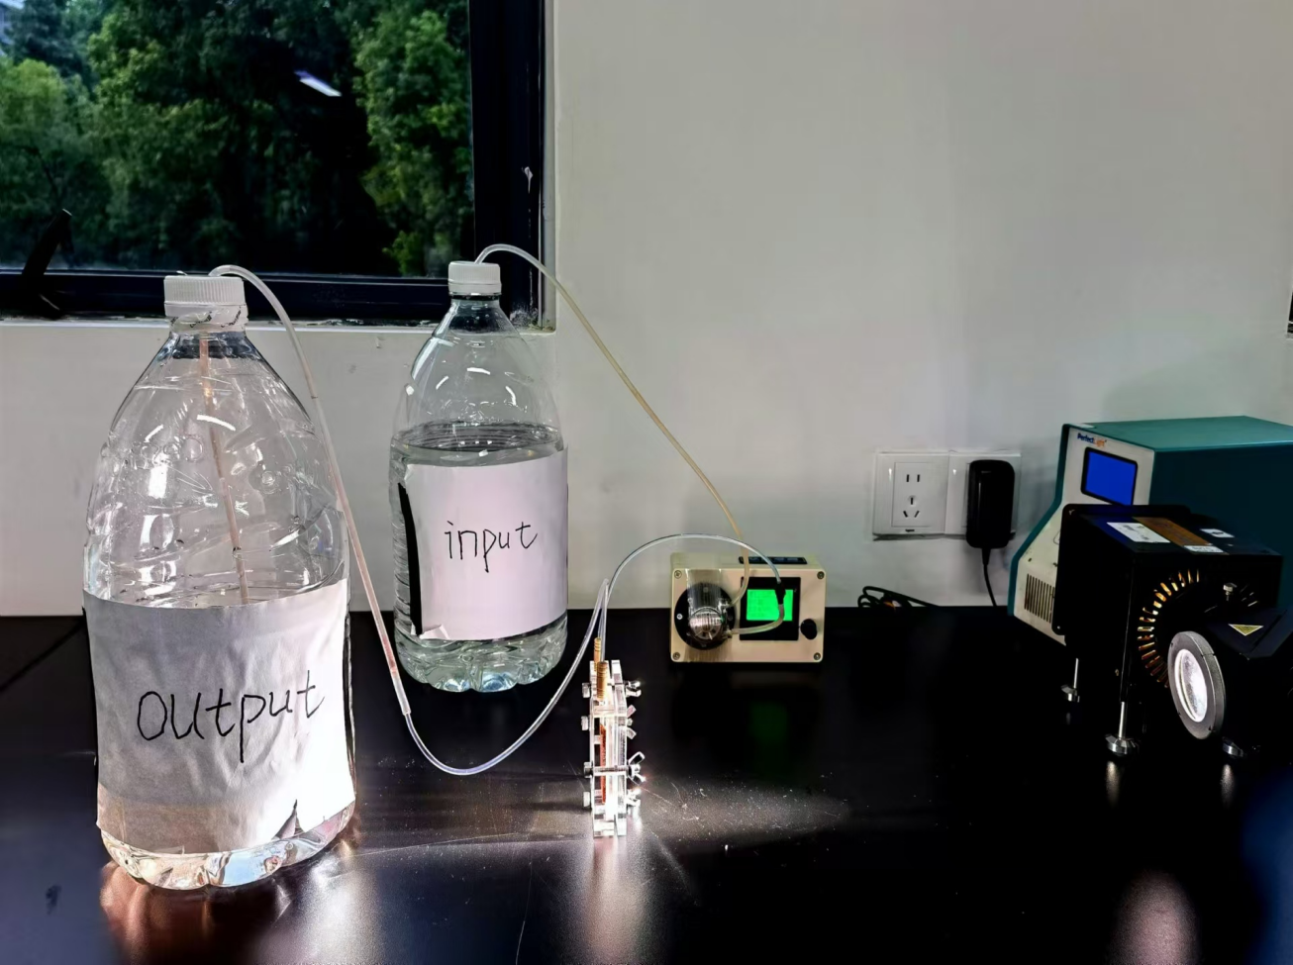
Figure S84. Picture of the flow-reactor system used for H₂O₂ photocatalytic synthesis in laboratory environment under simulated sunlight.

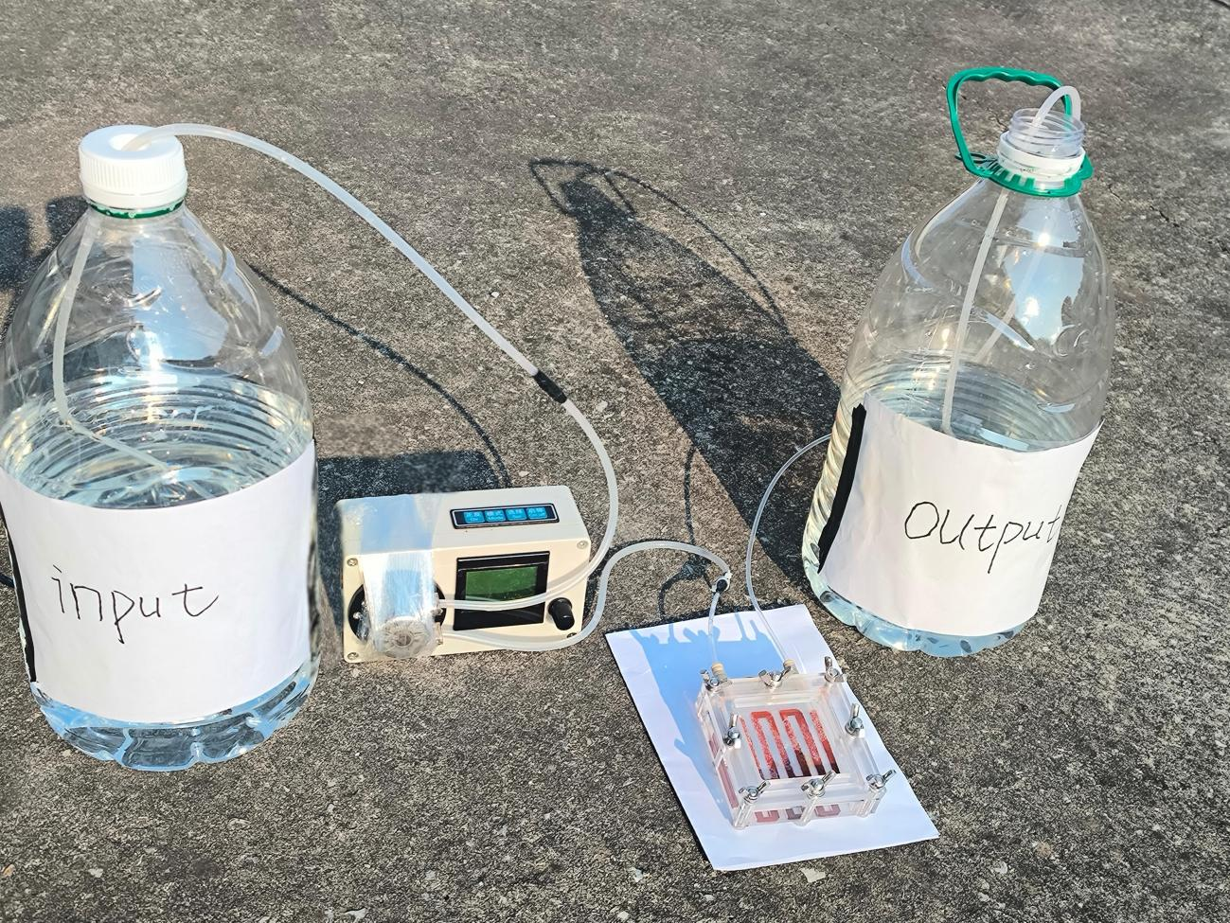
Figure S85. Picture of the flow-reactor system used for H₂O₂ photocatalytic synthesis in the open air under natural sunlight.

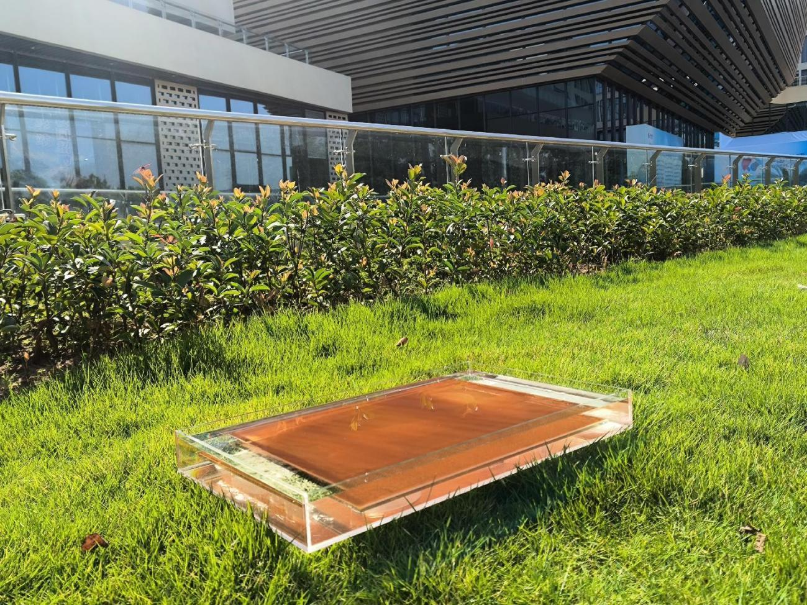
Figure S86. Outdoor diagram of immobilization experiment.

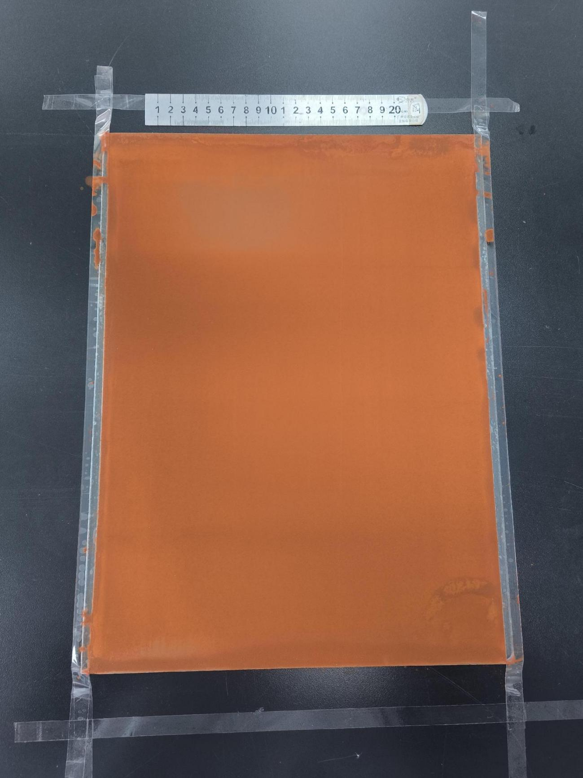
Figure S87. Outdoor immobilization test glass plate (40cm×30cm) coating effect.

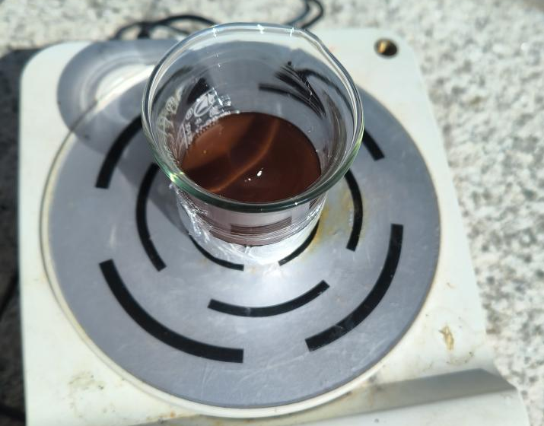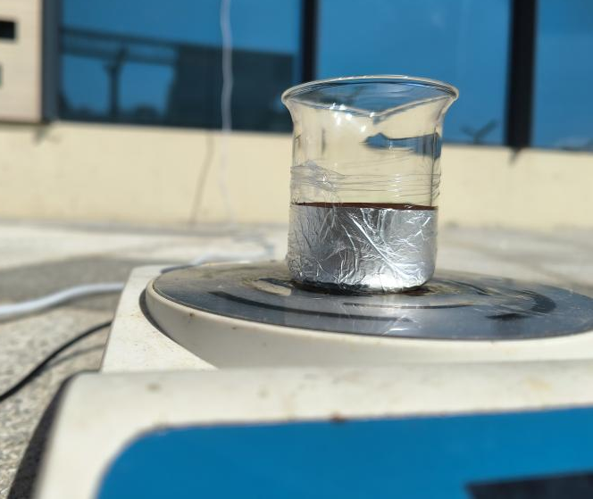
Figure S88. Outdoor dispersion picture of SCC (%).

Figure S89. (a) Absorption spectra of H₂O₂ at different concentrations (0 µM, 2.5 µM, 5 µM, 15 µM, 25 µM, and 50 µM). (b) H₂O₂ concentration standard curve.

Figure S90. Standard curve for hydrogen production.

Table S1 The guide exhibiting the universal reference collation of Tp monomer.
Same momomer | COFs | Catalytic reaction | Activity | Refs
1,3,5-triformylphloroglucinol (Tp) | Tp(BT_{0.05}TP_{0.95})-COFs | H₂ evolution | 9839 μmol g⁻¹ h⁻¹ | [1] Polym. Chem. 2021, 12, 3250−3256
1,3,5-triformylphloroglucinol (Tp) | TpBTCOF | H₂ evolution | 6040 μmol g⁻¹ h⁻¹ | [1] Polym. Chem. 2021, 12, 3250−3256
CdS | CdS@TPPA | H₂ evolution | 194.1 μmol h⁻¹ | [2] Research. 2021, 2021, 2639−5274
CdS | CdS nanosphere | H₂ evolution | 11.92 μmol h⁻¹ | [2] Research. 2021, 2021, 2639−5274
1,3,5-triformylphloroglucinol (Tp) | TP-COFs-1 | H₂ evolution | 0.96 mmol g⁻¹ h⁻¹ | [3] Angew. Chem. Int. Ed. 2023, 62, e202309026.
1,3,5-triformylphloroglucinol (Tp) | BT-COFs-1 | H₂ evolution | 0.3 mmol g⁻¹ h⁻¹ | [3] Angew. Chem. Int. Ed. 2023, 62, e202309026.
TpBD | CdS-1%COF | H₂ evolution | 15.1 mmol g⁻¹ h⁻¹ | [4] Chem. Eng. J. 2023, 476, 146818
TpBD | TpBD | H₂ evolution | 2.4 mmol g⁻¹ h⁻¹ | [4] Chem. Eng. J. 2023, 476, 146818
TpPa-1-COF | NH₂-UiO-66/TpPa-1-  COF(4:6) | H₂ evolution | 23.41 mmol g⁻¹ h⁻¹ | [5] Angew. Chem. Int. Ed. 2018, 57, 12106−12110
TpPa-1-COF | TpPa-1-COF | H₂ evolution | 1.22 mmol g⁻¹ h⁻¹ | [5] Angew. Chem. Int. Ed. 2018, 57, 12106−12110
TpPa-1-COF | WO₃@TpPa-1-COF/rGO (30%) | H₂ evolution | 26.73mmol·g⁻¹·h⁻¹ | [6] Chem. Eng. J. 2022, 431, 133404
TpPa-1-COF | WO₃@TpPa-1-COF | H₂ evolution | 1.6 mmol h⁻¹ g⁻¹ | [6] Chem. Eng. J. 2022, 431, 133404
TpPa-COF | TpPa-COF-(CH₃)₂ | H₂ evolution | 8.33 mmol·g⁻¹·h⁻¹ | [7] ChemCatChem. 2019, 11, 2313–2319
TpPa-COF | TpPa-COF | H₂ evolution | 1.56 mmol·g⁻¹·h⁻¹ | [7] ChemCatChem. 2019, 11, 2313–2319
TFP-BpyD COF | TFP-BpyD-nano-COF | H₂ evolution | 392 mmol·g⁻¹·h⁻¹ | [8] Nat. Commun. 2024, 15, 6482
TFP-BpyD COF | TFP-BpyD COF | H₂ evolution | 0 mmol·g⁻¹·h⁻¹ | [8] Nat. Commun. 2024, 15, 6482
1,3,5-triformylphloroglucinol (Tp) | TpPa-Cl₂ | H₂ evolution | 11.73 μmol m⁻¹ h⁻¹ | [9] Chem. Eng. J. 2021, 419 129984
1,3,5-triformylphloroglucinol (Tp) | TpPa-(CH₃)₂ | H₂ evolution | 3.62 μmol m⁻¹ h⁻¹ | [9] Chem. Eng. J. 2021, 419 129984
1,3,5-triformylphloroglucinol (Tp) | FS-OHOMe-COF | H₂O₂ production | 740 μmol.L⁻¹ | [10] Angew. Chem. Int. Ed. 2024, 63, e202403926
1,3,5-triformylphloroglucinol (Tp) | FS-OH-COF | H₂O₂ production | 390 μmol.L⁻¹ | [10] Angew. Chem. Int. Ed. 2024, 63, e202403926
1,3,5-triformylphloroglucinol (Tp) | FS-COF | H₂ evolution | 10.1 mmol·g⁻¹·h⁻¹ | [11] Nature Chem. 2018, 10, 1180-1189
1,3,5-triformylphloroglucinol (Tp) | Tp-COF | H₂ evolution | 1.6 mmol·g⁻¹·h⁻¹ | [11] Nature Chem. 2018, 10, 1180-1189
4,4’,4’’-boranetriyltris(3,5-dimethylaniline) (TAB) | TAB-TFP-COF | H₂ evolution | 666.4 μmol·g⁻¹·h⁻¹ | [12] J. Mater. Chem. A, 2022, 10, 17691−17698
4,4’,4’’-boranetriyltris(3,5-dimethylaniline) (TAB) | TAB-TFB-COF | H₂ evolution | 8.8 μmol·g⁻¹·h⁻¹ | [12] J. Mater. Chem. A, 2022, 10, 17691−17698
1,3,5-triformylphloroglucinol (Tp) | Tp-BDDA | H₂ evolution | 324.1 μmol·g⁻¹·h⁻¹ | [13] J. Am. Chem. Soc. 2018, 140, 1423-1427
1,3,5-triformylphloroglucinol (Tp) | Tp-EDDA | H₂ evolution | 30.5 μmol·g⁻¹·h⁻¹ | [13] J. Am. Chem. Soc. 2018, 140, 1423-1427
1,3,5-triformylphloroglucinol (Tp) | BtCOF150 | H₂ evolution | 750.25 μmol·g⁻¹·h⁻¹ | [14] J. Am. Chem. Soc. 2020, 142, 9752−9762
1,3,5-triformylphloroglucinol (Tp) | TpCOF150 | H₂ evolution | 50.4 μmol·g⁻¹·h⁻¹ | [14] J. Am. Chem. Soc. 2020, 142, 9752−9762
1,3,5-triformylphloroglucinol (Tp) | TpPa-Cl₂ | H₂ evolution | 99.23 mmol·g⁻¹·h⁻¹ | [15] J. Mater. Chem. A, 2024,12, 11416−11423
1,3,5-triformylphloroglucinol (Tp) | TpPa-CN₂ | H₂ evolution | 76.93 mmol·g⁻¹·h⁻¹ | [15] J. Mater. Chem. A, 2024,12, 11416−11423
2,4,6-Tris(4-aminophenyl)-1,3,5-triazine(TAPT) | COF-OH-3 | H₂ evolution | 9.89 mmol·g⁻¹·h⁻¹ | [16] J. Mater. Chem. A, 2022,10, 24620−24627
2,4,6-Tris(4-aminophenyl)-1,3,5-triazine(TAPT) | COF-OH-0 | H₂ evolution | 0.11 mmol·g⁻¹·h⁻¹ | [16] J. Mater. Chem. A, 2022,10, 24620−24627
BDA-THTA-COF | BDA-THTA-30 | H₂ evolution | 9691.84 μmol·g⁻¹·h⁻¹ | [17] Fuel. 2024, 355, 129470
BDA-THTA-COF | BDA-THTA-COF | H₂ evolution | 950.18 μmol·g⁻¹·h⁻¹ | [17] Fuel. 2024, 355, 129470
1,3,5-triformylphloroglucinol (Tp) | 30%PEG@BT-COF | H₂ evolution | 11.14 mmol g⁻¹ h⁻¹ | [18] Nat. Commun. 2021, 12, 3934
1,3,5-triformylphloroglucinol (Tp) | BT-COF | H₂ evolution | 7.70 mmol g⁻¹ h⁻¹ | [18] Nat. Commun. 2021, 12, 3934
TpBpy-COF | TpBpy-Ni2% | H₂ evolution | 513 μmol h⁻¹ | [19] Angew. Chem. Int. Ed. 2023, 62, e202217527
TpBpy-COF | TpBpy-COF | H₂ evolution | 205.2 μmol h⁻¹ | [19] Angew. Chem. Int. Ed. 2023, 62, e202217527
1,3,5-triformylphloroglucinol (Tp) | TAH-COF | H₂O₂ production | 6003 μmol g⁻¹ h⁻¹ | [20] J. Am. Chem. Soc. 2024, 146, 20107−20115
1,3,5-triformylphloroglucinol (Tp) | TPPA-COF | H₂O₂ production | 925 μmol g⁻¹ h⁻¹ | [20] J. Am. Chem. Soc. 2024, 146, 20107−20115
1,3,5-triformylphloroglucinol (Tp) | TpBpy | H₂ evolution | 25.2 mmol g⁻¹ h⁻¹ | [21] JACS Au. 2023, 3, 3391−3399
1,3,5-triformylphloroglucinol (Tp) | TpPa | H₂ evolution | 3.5 mmol g⁻¹ h⁻¹ | [21] JACS Au. 2023, 3, 3391−3399
Pa | Pt-PVP-Tp-COF | H₂ evolution | 8.42 mmol g⁻¹ h⁻¹ | [22] Angew. Chem. Int. Ed. 2019, 58, 18290−18294
Pa | Pt/BT-COF | H₂ evolution | 76 μmol g⁻¹ h⁻¹ | [22] Angew. Chem. Int. Ed. 2019, 58, 18290−18294
NYU-BDA-THTA | NYU-BDA-THTA/  NH2-Ti3C2T_{8:4} | H₂ evolution | 14228.1 μmol g⁻¹ h⁻¹ | [23] J. Am. Chem. Soc. 2020, 142, 4862−4871
NYU-BDA-THTA | NYU-BDA-THTA | H₂ evolution | 1127.1 μmol g⁻¹ h⁻¹ | [23] J. Am. Chem. Soc. 2020, 142, 4862−4871
Tp-Bpy-COF | Tp-2C/Bpy²⁺-COF | H₂ evolution | 346 μmol h⁻¹ | [24] Angew. Chem. Int. Ed. 2021, 60, 9642– 9649
Tp-Bpy-COF | Tp-Bpy-COF | H₂ evolution | 194 μmol h⁻¹ | [24] Angew. Chem. Int. Ed. 2021, 60, 9642– 9649
1,3,5-triformylphloroglucinol (Tp) | TpDTz-NiME | H₂ evolution | 76.6 μmol g⁻¹ h⁻¹ | [25] J. Am. Chem. Soc. 2019, 141, 11082−11092
1,3,5-triformylphloroglucinol (Tp) | TpDTP-NiME | H₂ evolution | 9.16 μmol g⁻¹ h⁻¹ | [25] J. Am. Chem. Soc. 2019, 141, 11082−11092
4,4’,4”-(1,3,5-triazine-2,4,6-triyl) trianiline (TTA) and 1,3,5-triformylphloroglucinol (Tp) | CN-COF | H₂ evolution | 0.93 mmol g⁻¹ h⁻¹ | [26] Chem. Commun. 2019, 55 (41), 5829−5832
 | COF | H₂ evolution | 0.16 mmol g⁻¹ h⁻¹ | [26] Chem. Commun. 2019, 55 (41), 5829−5832
 | BT-COFs-1 | H₂ evolution | 0 mmol g⁻¹ h⁻¹ | [26] Chem. Commun. 2019, 55 (41), 5829−5832
TpPa | composite 2 | H₂ evolution | 2.796 mmol g⁻¹ h⁻¹ | [27] Angew. Chem. Int. Ed. 2022, 61, e202114071
TpPa | TpPa | H₂ evolution | 1.31 mmol g⁻¹ h⁻¹ | [27] Angew. Chem. Int. Ed. 2022, 61, e202114071
NM-88 | COF_{Tp-TTA} | biological usage | fast | [28] Angew. Chem., Int. Ed. 2021, 60, 3469−3474
NM-88 | NM-88 | biological usage | slow | [28] Angew. Chem., Int. Ed. 2021, 60, 3469−3474
TpPa-1 | 0.5%Pt NPs-TpPa-1 | H₂ evolution | 1.13 mmol h⁻¹ | [29] J. Mater. Chem. A, 2023, 11, 26052−26062
TpPa-1 | TpPa-1 | H₂ evolution | 0.15 mmol h⁻¹ | [29] J. Mater. Chem. A, 2023, 11, 26052−26062
1,3,5-triformylphloroglucinol (Tp) | TpTAPT-COF | conversions of sulfides | 85% | [30] Sustain. Energy Fuels. 2023, 7, 1963−1973
1,3,5-triformylphloroglucinol (Tp) | TpTAPB-COF | conversions of sulfides | lower | [30] Sustain. Energy Fuels. 2023, 7, 1963−1973
1,3,5-triformylphloroglucinol (Tp) | BT-COF(HOAc) | conversions of sulfides | 2.02 mmol g⁻¹ h⁻¹ | [30] Sustain. Energy Fuels. 2023, 7, 1963−1973
1,3,5-triformylphloroglucinol (Tp) | TP- DTP | conversions of sulfides | 20 μmol h^{–1} g^{–1} | [30] Sustain. Energy Fuels. 2023, 7, 1963−1973
1,3,5-triformylphloroglucinol (Tp) | Triethylamine (TEA) | conversions of sulfides | 84 μmol h^{–1} g^{–1} | [30] Sustain. Energy Fuels. 2023, 7, 1963−1973
1,3,5-triformylphloroglucinol (Tp) | TpDz | H₂O₂ production | 7327 μmol h^{–1} g^{–1} | [31] Angew. Chem. Int. Ed. 2023, 62, e202310556
1,3,5-triformylphloroglucinol (Tp) | TpPz | H₂O₂ production | 1418 μmol h^{–1} g^{–1} | [31] Angew. Chem. Int. Ed. 2023, 62, e202310556
1,3,5-triformylphloroglucinol (Tp) | FS-COFs | H₂O₂ production | 1501 μmol h^{–1} g^{–1} | [32] Angew. Chem. Int. Ed. 2023, 62, e202305355
1,3,5-triformylphloroglucinol (Tp) | C-COFs | H₂O₂ production | 487.6 μmol h^{–1} g^{–1} | [32] Angew. Chem. Int. Ed. 2023, 62, e202305355
1,3,5-triformylphloroglucinol (Tp) | COF N32 | H₂O₂ production | 650 μmol h^{–1} g^{–1} | [33] Nat. Commun. 2023, 14, 4344
1,3,5-triformylphloroglucinol (Tp) | COF N33 | H₂O₂ production | 150 μmol h^{–1} g^{–1} | [33] Nat. Commun. 2023, 14, 4344
1,3,5-triformylphloroglucinol (Tp) | BAH-COF | H₂O₂ production | 1297 μmol h^{–1} g^{–1} | [33] Nat. Commun. 2023, 14, 4344
1,3,5-triformylphloroglucinol (Tp) | Kf-AQ pH=13 | H₂O₂ production | 4784 μmol h^{–1} g^{–1} | [34] Nat. Commun. 2024, 15, 2649
1,3,5-triformylphloroglucinol (Tp) | Kf-AQ pH=7 | H₂O₂ production | 2300 μmol h^{–1} g^{–1} | [34] Nat. Commun. 2024, 15, 2649
1,3,5-benzenetricarboxaldehyde  (Tb) | BDOH-Tb-IM | H₂O₂ production | 2490 μmol h^{–1} g^{–1} | [35] ACS. Appl. Mater. Interfaces 2024, 16, 40180−40189
1,3,5-benzenetricarboxaldehyde  (Tb) | BDOH-Tb-BO-a | H₂O₂ production | 1168 μmol h^{–1} g^{–1} | [35] ACS. Appl. Mater. Interfaces 2024, 16, 40180−40189
1,3,5-triformylphloroglucinol (Tp) | COF-2CN | H₂O₂ production | 1587 μmol h^{–1} g^{–1} | [36] Angew. Chem. Int. Ed. 2024, 63, e202318562
1,3,5-triformylphloroglucinol (Tp) | COF-1CN | H₂O₂ production | 500 μmol h^{–1} g^{–1} | [36] Angew. Chem. Int. Ed. 2024, 63, e202318562
TpPa-1-COF | TMPs/TpPa-1-COF | H₂ evolution | 31.6 μmol h^{–1} | [37] Small 2022, 18, 2201340
TpPa-1-COF | TpPa-1-COF | H₂ evolution | 1.65 μmol h^{–1} | [37] Small 2022, 18, 2201340
1,3,5-triformylphloroglucinol (Tp) | o-COFTpPzda | H₂O₂ production | 4396 μmol h^{–1} g^{–1} | [38] Angew. Chem. Int. Ed. 2024, 63, e202404077
1,3,5-triformylphloroglucinol (Tp) | o-COF-TpBda | H₂O₂ production | 1030 μmol h^{–1} g^{–1} | [38] Angew. Chem. Int. Ed. 2024, 63, e202404077

Table S2 Hydrogen peroxide properties of eight groups of materials (40 min).
Photocatalysts | H₂O₂ generation rate (μM)
Photocatalysts | 10 min | 20 min | 30 min | 40 min
TpPa | 37.0 | 105.2 | 148.2 | 202.0
BTPa | 12.8 | 29.0 | 41.0 | 84.2
Tp-2F | 109.4 | 239.2 | 330.0 | 445.4
BT-2F | 20.8 | 40.2 | 45.6 | 62.8
Tp-CH₃ | 64.4 | 174.0 | 293.4 | 402.4
BT-CH₃ | 1.0 | 5.0 | 17.8 | 30.4
TpDpt | 26.8 | 55.2 | 72.6 | 90.4
BTDpt | 10.0 | 28.0 | 38.2 | 43.6
TpBpy | 450.0 | 1024.2 | 1686.2 | 2526.2
BTBpy | 10.0 | 42.0 | 88.8 | 132.4
TpTAPT | 82.8 | 187.8 | 291.4 | 411.4
BTTAPT | 20.0 | 90.8 | 148.6 | 242.8
Tp-COOH | 43.0 | 67.6 | 96.6 | 125.0
BT-COOH | ~0 | 2.2 | 6.4 | 11.8
TpTBPT | 83.8 | 128.2 | 194.8 | 204.2
BTTBPT | 24.0 | 51.2 | 73.0 | 101.4

Table S3 Comparison of hydrogen peroxide production performance over different photocatalysts from pure water and air.
Photocatalysts | Light  source | H₂O₂ concentration  (μM h⁻¹) | Catalyst dosage | Refs
TACOF-1-COOH | λ > 420 nm | 492 | 2.5 mg, 18 mL H₂O | [39] Angew. Chem. Int. Ed. 2024, 63, e202408802
COF-N32 | λ > 420 nm | 121 | 10 mg, 50 mL H₂O | [33] Nat. Commun. 2023, 14, 4344
DETH-COF | λ > 420 nm | 200 | 10 mg, 50 mL H₂O | [40] ACS. Catal. 2022, 12, 14911−14917
DMCR-1NH | λ > 420 nm | 1029 | 10 mg, 22 mL H₂O | [41] J. Am. Chem. Soc. 2023, 145, 2975−2984
TB-COF | λ > 420 nm | 313 | 1 mg, 8 mL H₂O | [42] ACS. Catal. 2024, 14, 4728−4737
CTF-BTT | λ > 420 nm | 686 | 5 mg, 50 mLH₂O | [43] Angew. Chem. Int. Ed. 2024, 63, e202416350
RF523 | λ > 420 nm | 84 | 50 mg, 30 mL H₂O | [44] Nat. Mater. 2019, 18, 985–993
HEP-TAPT-COF | λ > 420 nm | 535 | 6 mg, 20 mL H₂O | [45] ACS. Catal. 2022, 12, 616−623
TpDz | λ > 420 nm | 758 | 3 mg, 18 mL H₂O | [31] Angew. Chem. Int. Ed. 2023, 62, e202310556
H-COF | λ > 420 nm | 284 | 2 mg, 10 mL H₂O | [46] Angew. Chem. Int. Ed. 2024, 63, e202408041
TFPA-TAPT-COF-Q | λ > 420 nm | 409 | 10 mg, 22 mL H₂O | [47] Nat. Commun. 2024, 15, 1267
PEI/g-C₃N₄ | λ > 420 nm | 208 | 20 mg, 20 mL H₂O | [48] ACS. Catal. 2020, 10, 3697−3706
FS-COFs | λ > 420 nm | 975 | 5 mg, 20 mL H₂O | [32] Angew. Chem. Int. Ed. 2023, 62, e202305355
TaptBtt | λ > 420 nm | Ca. 500 | 5 mg, 10 mL H₂O | [49] Nat. Commun. 2023, 14, 5238
TaptBtt | λ > 420 nm | 2111 | 15 mg, 10 mL H₂O | [49] Nat. Commun. 2023, 14, 5238
Kf-AQ | λ > 400 nm | 797 | 5 mg, 30 mL H₂O | [34] Nat. Commun. 2024, 15, 2649
TDB-COF-OH | λ > 420 nm | 661 | 5 mg, 50 mL H₂O | [50] ACS. Catal. 2024, 14, 7736-7745
TBD-COF | λ > 420 nm | 250 | 1 mg, 8 mL H₂O | [51] Angew. Chem. Int. Ed. 2024, 63, e202405763
TAH-COF | λ > 420 nm | 600 | 5 mg, 50 mL H₂O | [20] J. Am. Chem. Soc. 2024, 146, 20107-20115
PI-BD-TPB | λ > 420 nm | 750 | 15 mg, 20 mL H₂O | [52] Nat. Commun. 2024, 15, 5316
Hz-TP-BT-COF | λ > 420 nm | 1140 | 3 mg, 15 mL H₂O | [53] Nat. Catal. 2024, 7, 195-206.
Sb-SAPC | λ > 420 nm | 183 | 100 mg, 50 mL H₂O | [54] Nat. Catal. 2021, 4, 374-384.
SA-TCPP | λ > 420 nm | 55 | 25 mg, 50 mL H₂O | [55] Nat. Energy. 2023, 8, 361-371.
TAPT–FTPB COFs | λ > 420 nm | 3394 | 10 mg, 10 mL H₂O | [56] Nat. Synth. 2024, DOI: 10.1038/s44160-024-00644-z.
TP-DPBD₃₀-COF | λ > 420 nm | 1200 | 2.5 mg, 15 mL H₂O | [57] Nat. Synth. 2024, 3, 998-1010.
CNIO-GaSA | λ > 420 nm | 368 | 2 mg, 2 mL H₂O | [58] Nat. Synth. 2023, 2, 557–563.
TpBpy | λ > 420 nm | 3789 | 10 mg, 10 mL H₂O | This work

Table S4 Hydrogen peroxide properties of 4 groups of materials (40 min).
Photocatalysts | H₂O₂ generation rate (μM)
Photocatalysts | 10 min | 20 min | 30 min | 40 min
BTBpy | 10.0 | 42.0 | 88.8 | 132.4
OMeBpy | 184.4 | 299.8 | 400.0 | 494.2
S-TpBpy | 34.8 | 47.8 | 61.0 | 74.2
CN-SP₂ | 26.8 | 48.4 | 70.8 | 93.8
TpBpy | 450.0 | 1024.2 | 1686.2 | 2526.2

Table S5 Second order kinetic fitting lifetime of BTBpy.
 | t₁ (ps) | t₂ (ps)
BTBpy-475 nm | 0.907 | 252
BTBpy-570 nm | 1.66 | 247
BTBpy-720 nm | 2.37 | 255

Table S6 Second order kinetic fitting lifetime of TpBpy.
 | t₁ (ps) | t₂ (ps)
TpBpy-510 nm | 1.68 | 1080
TpBpy-650 nm | 2.99 | Inf

Table S7 Comparison of SCC (%) under natural sunlight over different photocatalysts from pure water and air.
Method | Sample | Light | mM h⁻¹ | μmol h⁻¹ | mM h⁻¹ m⁻² | mmol h⁻¹ m⁻² | SCC (%) | Ref
Dispersion | Hz-Tp-BT-COF | natural sunlight | 0.27 | 14 | 46.5 | 2.32 | 0.0089 | [53]
Dispersion | CTF-BTT | natural sunlight | 0.39 | 393 | 15.4 | 15.4 | 0.035 | [43]
Dispersion | Tp-DPBD₃₀-COF | natural sunlight | 0.57 | 8.5 | <589 | <8.84 | <0.033 | [57]
Dispersion | TpBpy | natural sunlight | 0.43 | 12.8 | 400 | 10.2 | 0.055 | This work
Immobilization | COF-2CN | natural sunlight | 0.046 | 137 | 0.30 | 0.91 | 0.0075 | [36]
Immobilization | PI-BD-TPB | natural sunlight | 0.29 | 2870 | 0.60 | 5.74 | 0.024 | [52]
Immobilization | COF-N32 | natural sunlight | 0.14 | 28 | 14.2 | 2.83 | 0.019 | [33]
Immobilization | TpBpy | natural sunlight | 0.091 | 455 | 0.79 | 3.96 | 0.029 | This work
Flow | TAPT-FTPB | simulated sunlight  (100 mW cm⁻²) | 0.64 | 5.4 | 376 | 3.30 | 0.010 | [56]
Flow | TpBpy | simulated sunlight  (100 mW cm⁻²) | 2.43 | 20.6 | 1429 | 12.12 | 0.040 | This work
Flow | TpBpy | natural sunlight | 1.75 | 14.9 | 1029 | 8.75 | 0.038 | This work

References
[1] Zhou, T., Huang, X., Mi, Z., Zhu, Y., Wang, R., Wang, C., Guo, J. Multivariate covalent organic frameworks boosting photocatalytic hydrogen evolution. Polym. Chem. 12, 3250-3256 (2021)
[2] Chen, Y., Yang, D., Gao, Y., Li, R., An, K., Wang, W., Zhao, Z., Xin, X., Ren, H., Jiang, Z. On-surface bottom-up construction of COF nanoshells towards photocatalytic H₂ production. Research. 2021, 2639-5274 (2021).
[3] Wu, S., Li, C., Wang, Y., Zhuang, Y., Pan, Y., Wen, N., Wang, S., Zhang, Z., Ding, Z., Yuan, R., Dai, W., Fu, X., Long, J. The keto-switched photocatalysis of reconstructed covalent organic frameworks for efficient hydrogen evolution. Angew. Chem. Int. Ed. 62, e202309026 (2023).
[4] Sun, G., Zhang, J., Cheng, B., Yu, H., Yu, J., Xu, J. Bifunctional CdS/COF S-scheme photocatalyst for enhanced H₂ evolution and organic synthesis. Chem. Eng. J. 476, 146818 (2023).
[5] Zhang, F., Sheng, J., Yang, Z., Sun, X., Tang, H., Lu, M., Dong, H., Shen, F., Liu, J., Lan, Y. Rational design MOF/COF hybrid materials for photocatalytic H₂ evolution in the presence of sacrificial electron donors. Angew. Chem. Int. Ed. 57, 12106−12110 (2018).
[6] Yan, H., Liu, Y., Yang, Y., Zhang, H., Liu, X., Wei, J., Bai, L.,Wang, Y., Zhang, F. Covalent organic framework based WO₃@COF/rGO for efficient visible-light-driven H₂ evolution by two-step separation mode. Chem. Eng. J. 431, 133404 (2022).
[7] Sheng, J., Dong, H., Meng, X., Tang, H., Yao, Y., Liu, D., Bai, L., Zhang, F., Wei, J., Sun, X. Effect of different functional groups on photocatalytic hydrogen evolution in covalent-organic frameworks. ChemCatChem. 11, 2313−2319 (2019).
[8] Zhao, W., Luo, L., Cong, M. Liu, X., Zhang, Z., Bahri, M., Li, B., Yang, J., Yu, M., Liu, L., Xia, Y., Zhu, W., Zhang, W. Nanoscale covalent organic frameworks for enhanced photocatalytic hydrogen production. Nat. Commun. 15, 6482 (2024).
[9] Yin, L., Zhao, Y., Xing, Y., Tan, H., Lang, Z., Ho, W., Wang, Y., Li, Y. Structure-Property relationship in β-keto-enamine-based covalent organic frameworks for highly efficient photocatalytic hydrogen production. Chem. Eng. J. 419 129984 (2021).
[10] Shu, C., Yang, X., Liu, L., Hu, X., Sun, R., Yang, X. Cooper, A. I., Tan, B. Wang, X. Mixed-linker strategy for the construction of sulfone-containing D-A-A covalent organic frameworks for efficient photocatalytic hydrogen peroxide production. Angew. Chem. Int. Ed. 63, e202403926 (2024).
[11] Wang, X., Chen, L., Chong, S.Y., Little, M. A., Wu, Y., Zhu, W., Clowes, R., Yan, Y., Zwijnenburg, M. A., Sprick, R. S., Cooper, A. I. Sulfone-containing covalent organic frameworks for photocatalytic hydrogen evolution from water. Nature Chem 10, 1180–1189 (2018).
[12] Wu, X., Zhang, M., Xia, Y., Ru, C., Chen, P., Zhao, H., Zhou, L., Gong, C., Wu, J., Pan, X. Arylboron functional covalent organic frameworks for synergistic photocatalytic hydrogen evolution J. Mater. Chem. A, 10, 17691-17698 (2022).
[13] Pachfule,P., Acharjya, A., Roeser, Langenhahn, T., Schwarze, M., Schomacker, R., Thomas, A., Schmidt, J. Diacetylene functionalized covalent organic framework (COF) for photocatalytic hydrogen generation. J. Am. Chem. Soc. 140, 1423−1427 (2018).
[14] Ghosh, S., Nakada, A., Springer, M. A., Kawaguchi, T., Suzuki, K., Kaji, H., Baburin, I., Kuc, A., Heine, T., Suzuki, H., Abe, R., Seki, S. Identification of prime factors to maximize the photocatalytic hydrogevolution of covalent organic frameworks. J. Am. Chem. Soc. 142, 9752−9762 (2020).
[15] Jiang, S., Niu, H., Sun, Q., Zhao, R., Li, N., Cai, Y. Significant improvement of photocatalytic hydrogen evolution performance in covalent organic frameworks: substituent fine-tuning. J. Mater. Chem. A. 12, 11416-11423 (2024).
[16] Chen, Y., Luo, X., Zhang, J., Hu, L., Xu, T., Li, W., Chen, L., Shen, M., Ren, S., Han, D., Ning, G., Li, D. Bandgap engineering of covalent organic frameworks for boosting photocatalytic hydrogen evolution from water. J. Mater. Chem. A. 10, 24620-24627 (2022).
[17] Yi, J., Zhang, L., Wang, W., Yi, Q., Wu, H., Li, J., Guo, J. Constructing the covalent organic framework and In₂O₃ composites via covalent bonds towards excellent visible-light photocatalytic hydrogen evolution. Fuel 355, 129470 (2024).
[18] Zhou, T., Wang, L., Huang, X., Unruangsri, J., Zhang, H., Wang, R., Song, Q., Yang, Q., Li, W., Wang, C., Takahashi, K., Xu, H., Guo, J. PEG-stabilized coaxial stacking of two-dimensional covalent organic frameworks for enhanced photocatalytic hydrogen evolution. Nat. Commun. 12, 3934 (2021).
[19] Zhang, H., Lin, Z., Kidkhunthod, P., Guo, J. Stable immobilization of nickel ions on covalent organic frameworks for panchromatic photocatalytic hydrogen evolution. Angew. Chem. Int. Ed. 62, e202217527 (2023).
[20] Xu, T., Wang, Z., Zhang, W., An, S., Wei, L., Guo, S., Huang, Y., Jiang, S., Zhu, M. Zhang, Y., Zhu, W. Constructing photocatalytic covalent organic frameworks with aliphatic linkers. J. Am. Chem. Soc. 146, 20107−20115 (2024).
[21] Weng, W., Lin, Z., Zhang, H., Niu, F., Wang, C., Hu, K., Guo, J. Effect of ESIPT-induced photoisomerization of keto−enamine linkages on the photocatalytic hydrogen evolution performance of covalent organic frameworks. JACS. Au. 3, 3391−3399 (2023).
[22] Ming, J., Liu, A., Zhao, J., Zhang, P., Huang, H., Lin, H., Xu, Z., Zhang, X., Wang, X., Hofkens, J., Roeffaers, M. B. J., Long, J. Hot p-electron tunneling of metal-insulator-COF nanostructures for efficient hydrogen production. Angew. Chem. Int. Ed. 58, 18290–18294 (2019).
[23] Wang, H., Qian, C., Liu, J., Zeng, Y., Wang, D., Zhou, W., Gu, L., Wu, H., Liu, G., Zhao, Y. Integrating suitable linkage of covalent organic frameworks into covalently bridged inorganic/organic hybrids toward efficient photocatalysis. J. Am. Chem. Soc. 142, 4862−4871 (2020).
[24] Mi, Z., Zhou, T., Weng, W., Unruangsri, J., Hu, K., Yang, W., Wang, C., Zhang, K. A. I., Guo, J. Covalent organic frameworks enabling site isolation of viologen-derived electron-transfer mediators for stable photocatalytic hydrogen evolution. Angew. Chem., Int. Ed. 60, 9642−9649 (2021).
[25] Biswal, B. P., Vignolo-Gonzalez, H. A., Banerjee, T., Grunenberg, L., Savasci, G., Gottschling, K., Nuss, J., Ochsenfeld, C., Lotsch, B. V. Sustained solar H₂ evolution from a thiazolo[5,4- d]thiazole-bridged covalent organic framework and nickel-thiolate cluster in water. J. Am. Chem. Soc. 141, 11082−11092 (2019).
[26] Luo, M., Yang, Q., Liu, K., Cao, H., Yan, H. Boosting photocatalytic H₂ evolution on g- C₃N₄ by modifying covalent organic frameworks (COFs). Chem. Commun. 55 (41), 5829−5832 (2019).
[27] Chen, C., Xiong, Y., Zhong, X., Lan, P., Wei, Z., Pan, H., Su, P., Song, Y., Chen, Y., Sirajuddin, A. N., Ma, S. Enhancing photocatalytic hydrogen production via the construction of robust multivariate Ti-MOF/COF composites. Angew. Chem. Int. Ed. 61, e202114071 (2022).
[28] Zhang, L., Liu, Z. W., Deng, Q. Q., Sang, Y. J., Dong, K., Ren, J. S., Qu, X. G. Nature- Inspired Construction of MOF@COF Nanozyme with active sites in tailored microenvironment and pseudopodia-like surface for enhanced bacterial inhibition. Angew. Chem., Int. Ed. 60, 3469−3474 (2021).
[29] Zhao, Z., Chen, W., Zhang, G., Chen, Y. Interface molecular wires induce electron transfer from COFs to Pt for enhanced photocatalytic H₂ Evolution. J. Mater. Chem. A. 11, 26052–26062 (2023).
[30] Miao, X., Zhang, F., Wang, Y., Dong, X., Lang, X. 2D β-ketoenamine-linked triazine covalent organic framework photocatalysis for selective oxidation of sulfides. Sustain. Energy Fuels. 7, 1963-1973 (2023).
[31] Liao, Q., Sun, Q., Xu, H., Wang, Y., Xu, Y., Li, Z., Hu, J., Wang, D., Li, H., Xi, K. Regulating relative nitrogen locations of diazine functionalized covalent organic frameworks for overall H₂O₂ photosynthesis. Angew. Chem. Int. Ed. 62, e202310556 (2023).
[32] Luo, Y., Zhang, B., Liu, C., Xia, D., Ou, X., Cai, Y., Zhou, Y., Jiang, J., Han, B. Sulfone-modified covalent organic frameworks enabling efficient photocatalytic hydrogen peroxide generation via one-step two electron O₂ reduction. Angew. Chem. Int. Ed. 62, e202305355 (2023).
[33] Liu, F., Zhou, P., Hou, Y., Tan, H., Liang, Y., Liang, J., Zhang, Q., Guo, S., Tong, M., Ni, J. Covalent organic frameworks for directphoto synthesis of hydrogen peroxide fromwater, air and sunlight. Nat. Commun. 14, 4344 (2023).
[34] Zhang, X., Cheng, S., Chen, C., Wen, X., Miao, J., Zhou, B., Long, M., Zhang, L. Keto-anthraquinone covalent organic framework for H₂O₂ photosynthesis with oxygen and alkaline water. Nat. Commun. 15, 2649 (2024).
[35] Peng, X.,Tian, Y., Yang, T., Wang, X., Song, C., Kong, A. Changing benzoxazole ring into nonring imine linkages on covalent organic frameworks with tuning H₂O₂ photosynthesis pPerformance. ACS Appl. Mater. Interfaces. 16, 40180−40189 (2024).
[36] Hou, Y., Zhou, P., Liu, F., Lu, Y., Tan, H., Li, Z., Tong, M., Ni, J. Efficient photosynthesis of hydrogen peroxide by cyano-containing covalent organic frameworks from water, air and sunlight. Angew. Chem. Int. Ed. 63, e202318562 (2024).
[37] Yan, G., Sun, X., Zhang, K., Zhang, Y., Li, H., Dou, Y., Yuan, D., Huang, H., Jia, B., Li, H., Ma, T. Integrating covalent organic framework with transition metal phosphide for noble-metal-free visible-light-driven photocatalytic H₂ evolution. Small 18, 2201340 (2022).
[38] Yang, T., Zhang, D., Kong, Ai., Zou, Y., Yuan, L., Liu, C., Luo, S., Wei, G., Yu, C. Robust covalent organic framework photocatalysts for H₂O₂ production: linkage position matters. Angew. Chem. Int. Ed. 63, e202404077 (2024).
[39] Xu, H., Wang, Y., Xu, Y., Wang, Q., Zhuang, M., Liao, Q., Xi., K. Integrating multipolar structures and carboxyl groups in sp²-carbon conjugated covalent organic frameworks for overall photocatalytic hydrogen peroxide production. Angew. Chem. Int. Ed. 63, e202408802 (2024).
[40] Pan, G., Hou, X., Liu, Z., Yang, C., Long, J., Huang, G., Bi, J., Yu, Y., Li, L. The hydration-initiated pathway of water oxidation over photoexcited covalent organic frameworks. ACS. Catal. 12, 14911−14917 (2022).
[41] Das, P., Chakraborty, G., Roeser, J., Vogl, S., Rabeah, J., Thomas, A. Integrating bifunctionality and chemical stability in covalent organic frameworks via one-pot multicomponent reactions for solar-driven H₂O₂ production. J. Am. Chem. Soc. 145, 2975−2984 (2023).
[42] Yue, J., Song, L., Pan, Z., Yang, P., Ma, Y., Xu, Q., Tang, B. Regulating the H₂O₂ photosynthetic activity of covalent organic frameworks through linkage orientation. ACS. Catal. 14, 4728−4737 (2024).
[43] Sun, R., Yang, X.,Hu, X., Guo, Y., Zhang, Y., Shu, C., Yang, X., Gao, H., Wang, X., Hussain, I., Tan, B. Unprecedented photocatalytic hydrogen peroxide production via covalent triazine frameworks constructed from fused building blocks. Angew. Chem. Int. Ed. 63, e202416350 (2024).
[44] Shiraishi, Y., Takii, T., Hagi, T., Mori, S., Kofuji, Y., Kitagawa, Y., Tanaka, S., Ichikawa, S., Hirai, T. Resorcinol-formaldehyde resins as metal-free semiconductor photocatalysts for solar-tohydrogen peroxide energy conversion. Nat. Mater. 18, 985−993 (2019).
[45] Chen, D., Chen, W., Zhang, G., Li, S., Chen, W., Xing, G., Chen, L. N-rich 2D heptazine covalent organic frameworks as efficient metal-free photocatalysts. ACS. Catal. 12, 616-623 (2022).
[46] Zhu, Q., Shi, L., Li, Z., Li, G., Xu, X. Protonation of an imine-linked covalent organic framework for efficient H₂O₂ photosynthesis under visible light up to 700nm. Angew. Chem. Int. Ed. 63, e202408041 (2024).
[47] Wang, J., Song, K., Luan, T., Cheng, K., Wang, Q., Wang, Y., Yu, W. W., Li, P., Zhao, Y. Robust links in photoactive covalent organic frameworks enable effective photocatalytic reactions under harsh conditions. Nat. Commun. 15, 1267 (2024).
[48] Zeng, X., Liu, Y., Kang, Y., Li, Q., Xia, Y., Zhu, Y., Hou, H., Uddin, M. H., Gengenbach, T. R., Xia, D., Sun, C., Mccarthy, D. T., Deletic, A., Yu, J., Zhang, X. Simultaneously tuning charge separation and oxygen reduction pathway on graphitic carbon nitride by polyethylenimine for boosted photocatalytic hydrogen peroxide production. ACS. Catal.10, 3697−3706 (2020).
[49] Qin, C., Wu, X., Tang, L., Chen, X., Li, M., Mou, Y., Su, B., Wang, S., Feng, C., Liu, J., Yuan, X., Zhao, Y., Wang, H. Dual donor-acceptor covalent organic frameworks for hydrogen peroxide photosynthesis. Nat. Commun. 14, 5238 (2023).
[50] Feng, S., Cheng, H., Chen, F., Liu, X., Wang, Z., Xu, H., Hua, J. Rational design of covalent organic frameworks with redox-active catechol moieties for high-performance overall photosynthesis of hydrogen peroxide. ACS. Catal. 14, 7736−7745 (2024).
[51] Yue, J., Luo, J., Pan, Z., Zhang, R., Yang, P., Xu, Q., Tang, B. Regulating the topology of covalent organic frameworks for boosting overall H₂O₂ photogeneration. Angew. Chem. Int. Ed. 63, e202405763 (2024).
[52] Chi, W., Dong, Y., Liu, B., Pan, C., Zhang, J., Zhao, H., Zhu, Y., Liu, Z. A photocatalytic redox cycle over a polyimide catalyst drives efficient solar-to-H₂O₂ conversion. Nat. Commun. 15, 5316 (2024).
[53] Liu, R., Chen, Y., Yu, H., Položij, M., Guo, Y., Sum, T. C., Heine, T., Jiang, D. Linkage-engineered donor-acceptor covalent organic frameworks for optimal photosynthesis of hydrogen peroxide from water and air. Nat. Catal. 7, 195–206 (2024).
[54] Teng, Z., Zhang, Q., Yang, H., Kato, K., Yang, W., Lu, Y., Liu, S., Wang, C., Yamakata, A., Su, C., Liu, B., Ohno, T. Atomically dispersed antimony on carbon nitride for the artificial photosynthesis of hydrogen peroxide. Nat. Catal. 4, 374–384 (2021).
[55] Zhang, Y., Pan, C., Bian, G., Xu, J., Dong, Y., Zhang, Y., Lou,Y., Liu, W., Zhu, Y. H₂O₂ generation from O₂ and H₂O on a near-infrared absorbing porphyrin supramolecular photocatalyst Nat. Energy. 8, 361-371 (2023).
[56] Liu, Y., Li, L., Sang, Z.,Tan, H., Ye, N. Chenglong Sun, Zongqiang Sun, Mingchuan Luo, & Shaojun Guo , Enhanced hydrogen peroxide photosynthesis in covalent organic frameworks through induced asymmetric electron distribution, Nat. Synth. 2024, DOI: 10.1038/s44160-024-00644-z.
[57] Chen, Y., Liu, R., Guo, Y., Wu, G., Sum, T. C., Yang, S., Jiang, D. Hierarchical assembly of donor–acceptor covalent organic frameworks for photosynthesis of hydrogen peroxide from water and air. Nat. Synth. 3, 998–1010 (2024).
[58] Tan, H., Zhou, P., Liu, M., Zhang, Q., Liu, F., Guo, H., Zhou, Y., Chen, Y., Zeng, L., Gu, L., Zheng, Z., Tong, M., Guo, S., Photocatalysis of water into hydrogen peroxide over an atomic Ga-N5 site, Nat. Synth. 2, 557-563, (2023).

