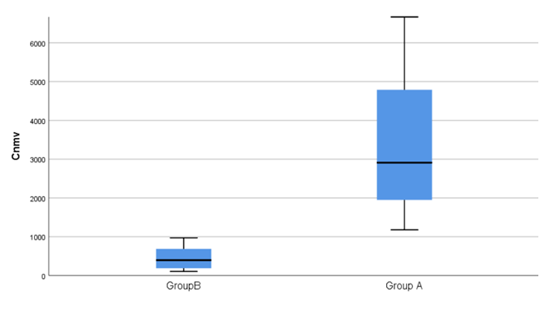
Fig.1
Comparison of NMV/RTV concentration distributions
The drug concentration was compared between the two groups and the difference was statistically significant (P<0.05).

Table.2
The scores and diagnostic grades of the two groups were compared.There was no significant difference in the severity of the disease between the standard group and the failure group (P > 0.05).
Score | Group A(74) | Group B(40) | χ² | P
CURB-65 (%) |  |  | 0.045 | 0.964
Low risk | 37(50) | 19(47.5)
Moderate risk | 24(32.4) | 16 (40)
High risk | 13(17.6) | 5(12.5)
Diagnosticclassification (%) |  |  | 0.247 | 0.805
Light weight | 13 (17.6) | 8(20)
Medium size | 36(48.6) | 17( 42.5)
Heavy duty | 19(25.7) | 10(25)
Critical illness type | 6(8.1) | 5 (12.5)

