Extended Data Table 1. A list of experiments conducted in this study by the GFDL-AM2.5 and GFDL-CM2.5-FLOR family.
Model | Experiment name | Experiment description
AM2.5 | CTL1990s | 10-year atmosphere-only integration with sea surface temperatures and sea ice concentrations fixed at the 1990s climatology as well as the forcing conditions of 1990.
AM2.5 | CTL1990s-0p5TgStratBC | Same as CTL1990s, except that 0.5 Tg¹ BC aerosols are horizontal-uniformly prescribed at each of the highest 7 sigma levels of aerosol inputs², respectively.
AM2.5 | CTL1990s-0p5TgStratSO4 | Same as CTL1990s, except that 0.5 Tg SO₄ aerosols are horizontal-uniformly prescribed at each of the highest 7 sigma levels of aerosol inputs, respectively.
AM2.5 | CTL1990s-5TgStratSO4 | Same as CTL1990s, except that 5.0 Tg SO₄ aerosols are horizontal-uniformly prescribed at each of the highest 7 sigma levels of aerosol inputs, respectively.
FLOR | CTL1860 | Coupled simulations with non-evolving pre-industrial conditions. Conditions chosen to be representative of the period prior to the onset of large-scale industrialization, with 1860 being the reference year.
FLOR | CTL1860-0p5TgStratBC | 150-year coupled integration with 0.5 Tg BC aerosols are horizontal-uniformly prescribed at the second highest sigma level of aerosol inputs.
FLOR | CTL1860-5TgStratSO4 | 150-year coupled integration with 5.0 Tg SO₄ aerosols are horizontal-uniformly prescribed at the second highest sigma level of aerosol inputs.
¹ One teragram (Tg) is equal to one million metric tons (t).
² Identical aerosol inputs are used for the two model families.

Extended Data Table 2. An identical list of experiments conducted in this study by the GFDL-AM2.1 and GFDL-CM2.1 family.
Model | Experiment name | Experiment description
AM2.1 | CTL1990s | Same as the CTL1990s of AM2.5 in Extended Data Table 1, except for 30-year integration.
AM2.1 | CTL1990s-0p5TgStratBC | Same as the CTL1990s-0p5TgStratBC of AM2.5, except for 30-year integrations.
AM2.1 | CTL1990s-5TgStratSO4 | Same as the CTL1990s-5TgStratSO₄ of AM2.5, except for 30-year integrations.
CM2.1 | CTL1860 | Same as the CTL1860 of FLOR in Extended Data Table 1.
CM2.1 | CTL1860-0p5TgStratBC | Same as the CTL1860-0p5TgStratBC of FLOR, except there are 3 ensemble members branching from year 1, 101, 201 of the CTL1860 simulation.
CM2.1 | CTL1860-5TgStratSO4 | Same as the CTL1860-5TgStratSO₄ of FLOR, except there are 3 ensemble members branching from year 1, 101, 201 of the CTL1860 simulation.

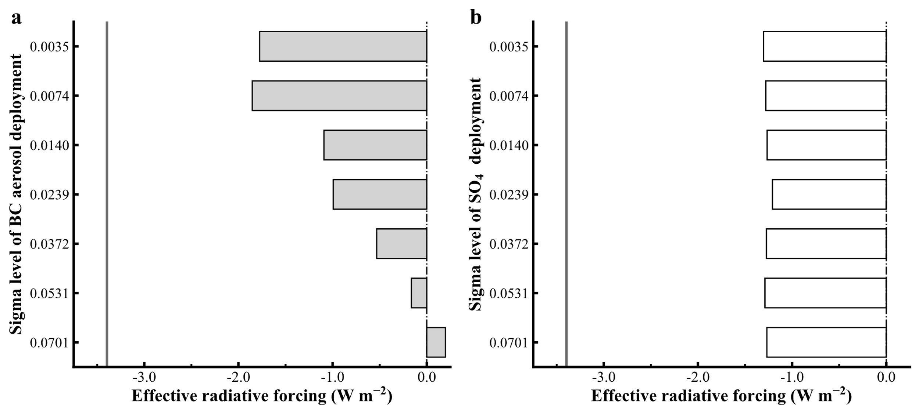
Extended Data Fig. 1. Same as Fig. 2, except for the GFDL-AM2.1 model and without the effective radiative forcing results from 0.5 Tg SO₄ aerosols in (b).

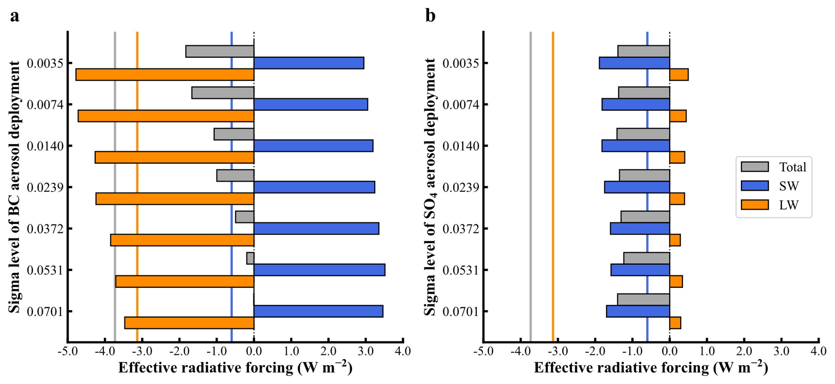
Extended Data Fig. 2. Decompositions of effective radiative forcing of horizontal-uniformly prescribed (a) 0.5 Tg BC aerosols and (b) 5.0 Tg SO₄ aerosols at each of the highest 7 sigma levels of aerosol inputs, respectively, simulated by GFDL-AM2.5 model, into the shortwave and longwave components. The vertical lines represent the corresponding flipped components of doubling CO₂.

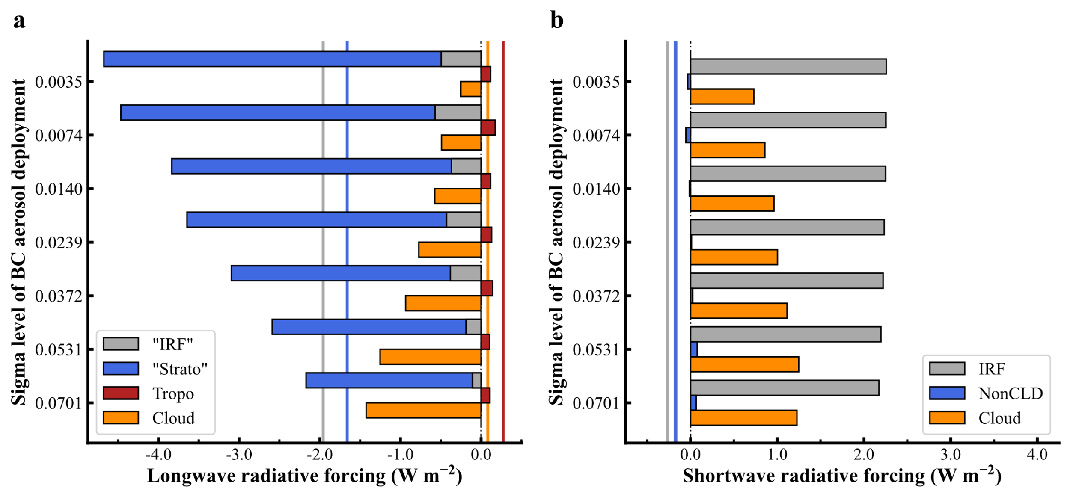
Extended Data Fig. 3. Decomposition of (a) longwave and (b) shortwave effective radiative forcing of horizontal-uniformly prescribed 0.5 Tg BC aerosols at each of the highest 7 sigma levels of aerosol inputs, respectively, simulated by GFDL-AM2.5 model, into the instantaneous radiative forcing (IRF) and individual rapid adjustment components. The solid vertical lines represent the corresponding flipped components of doubling CO₂.

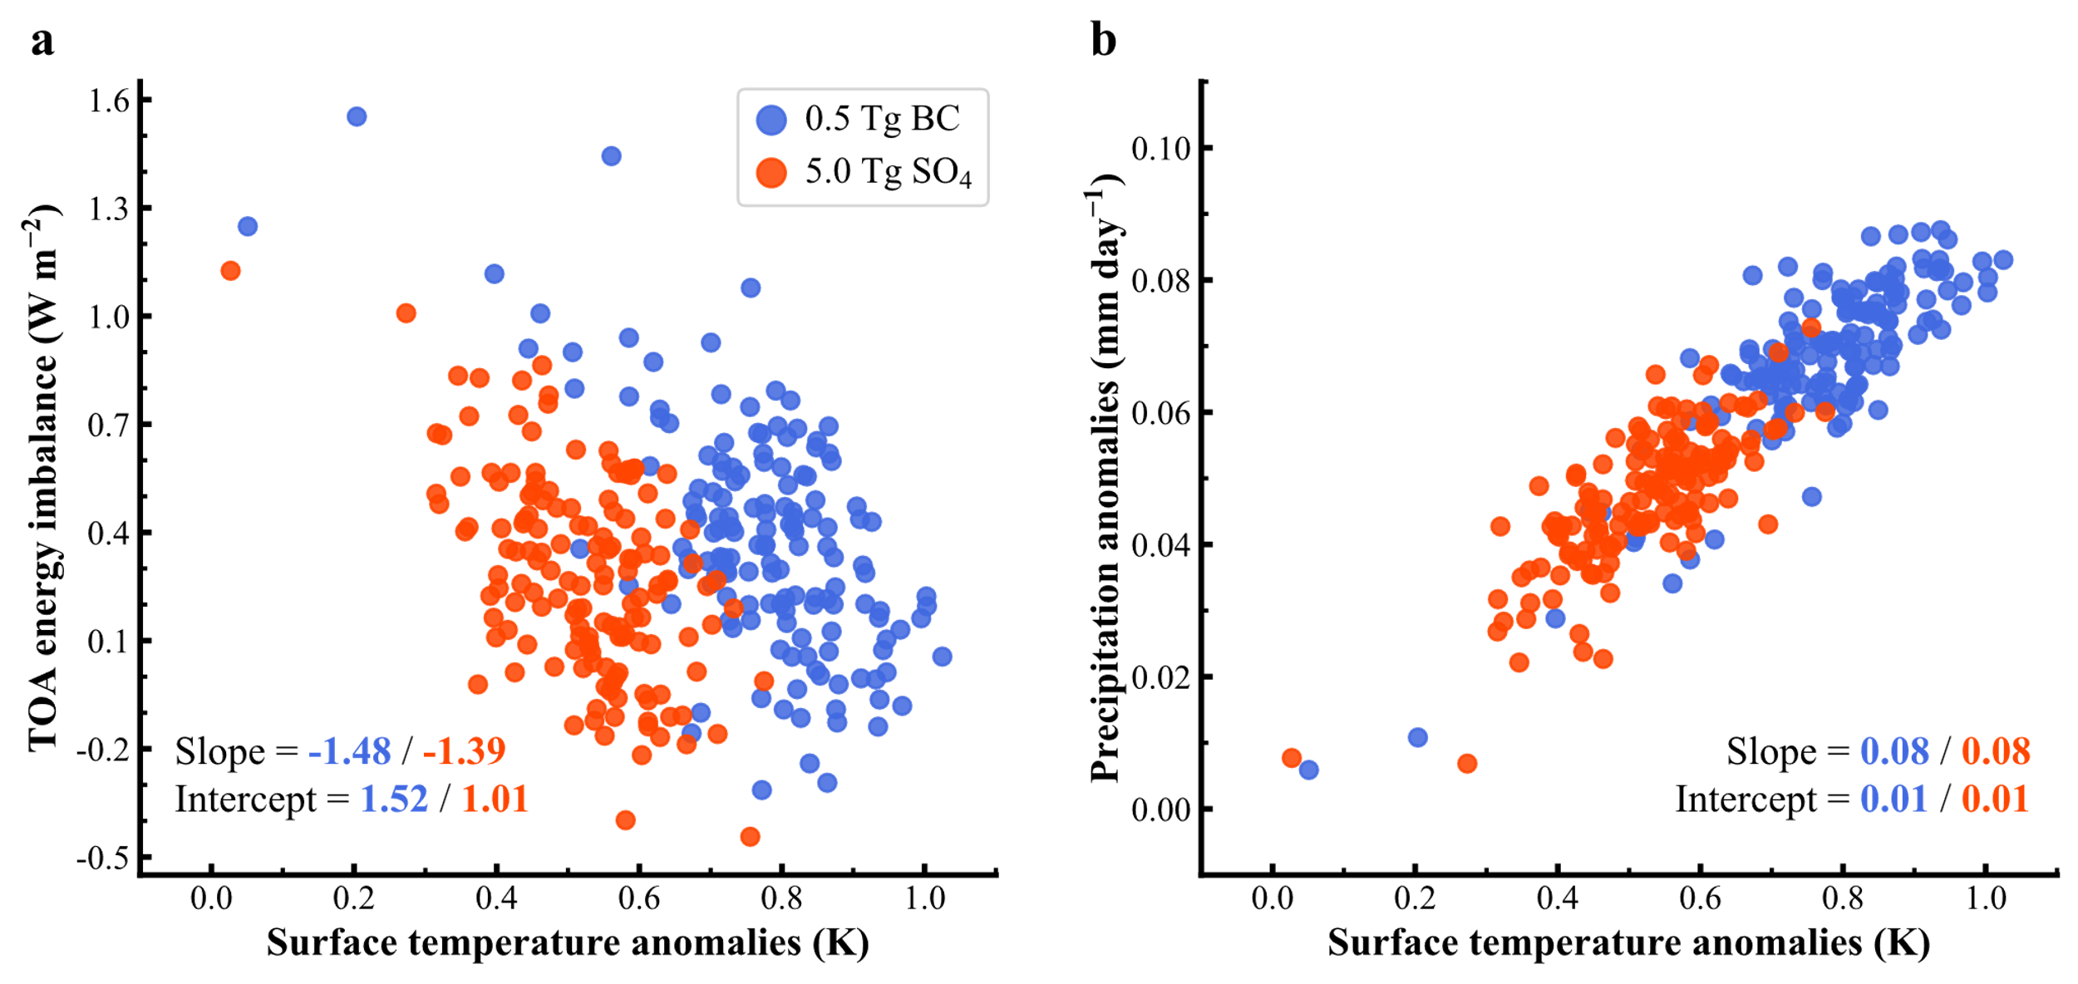
Extended Data Fig. 4. Scatter plots of flipped ensemble-mean surface air temperature anomalies versus (a) flipped TOA energy imbalance and (b) flipped precipitation anomalies, for the GFDL-CM2.1 model simulations forced with 0.5 Tg BC and 5 Tg SO₄ aerosols separately, by horizontal-uniformly prescribing the targeted aerosols at the second highest sigma level of aerosol inputs, beginning from the pre-industrial control runs. The individual dots represent the ensemble mean of 3 members with different conditions taken from a pre-industrial control simulation by the GFDL-CM2.1 model. The anomalies are flipped to match the conventional Gregory plots, which are designed for global warming cases. Therefore, the y-intercepts noted in the plots need to be interpreted by reversing signs.

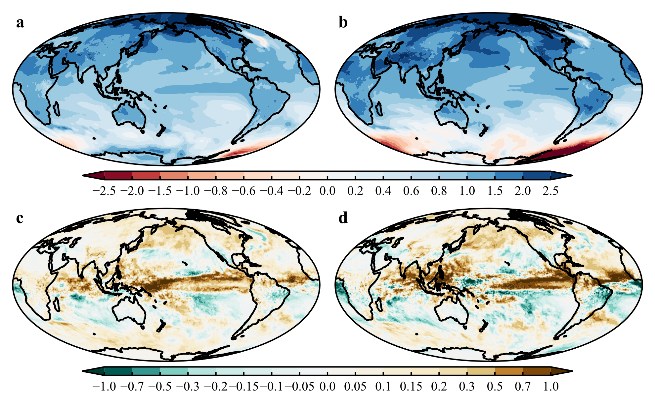
Extended Data Fig. 5. Same as Fig. 4, except for the results of the single realization of the GFDL-CM2.5-FLOR model.

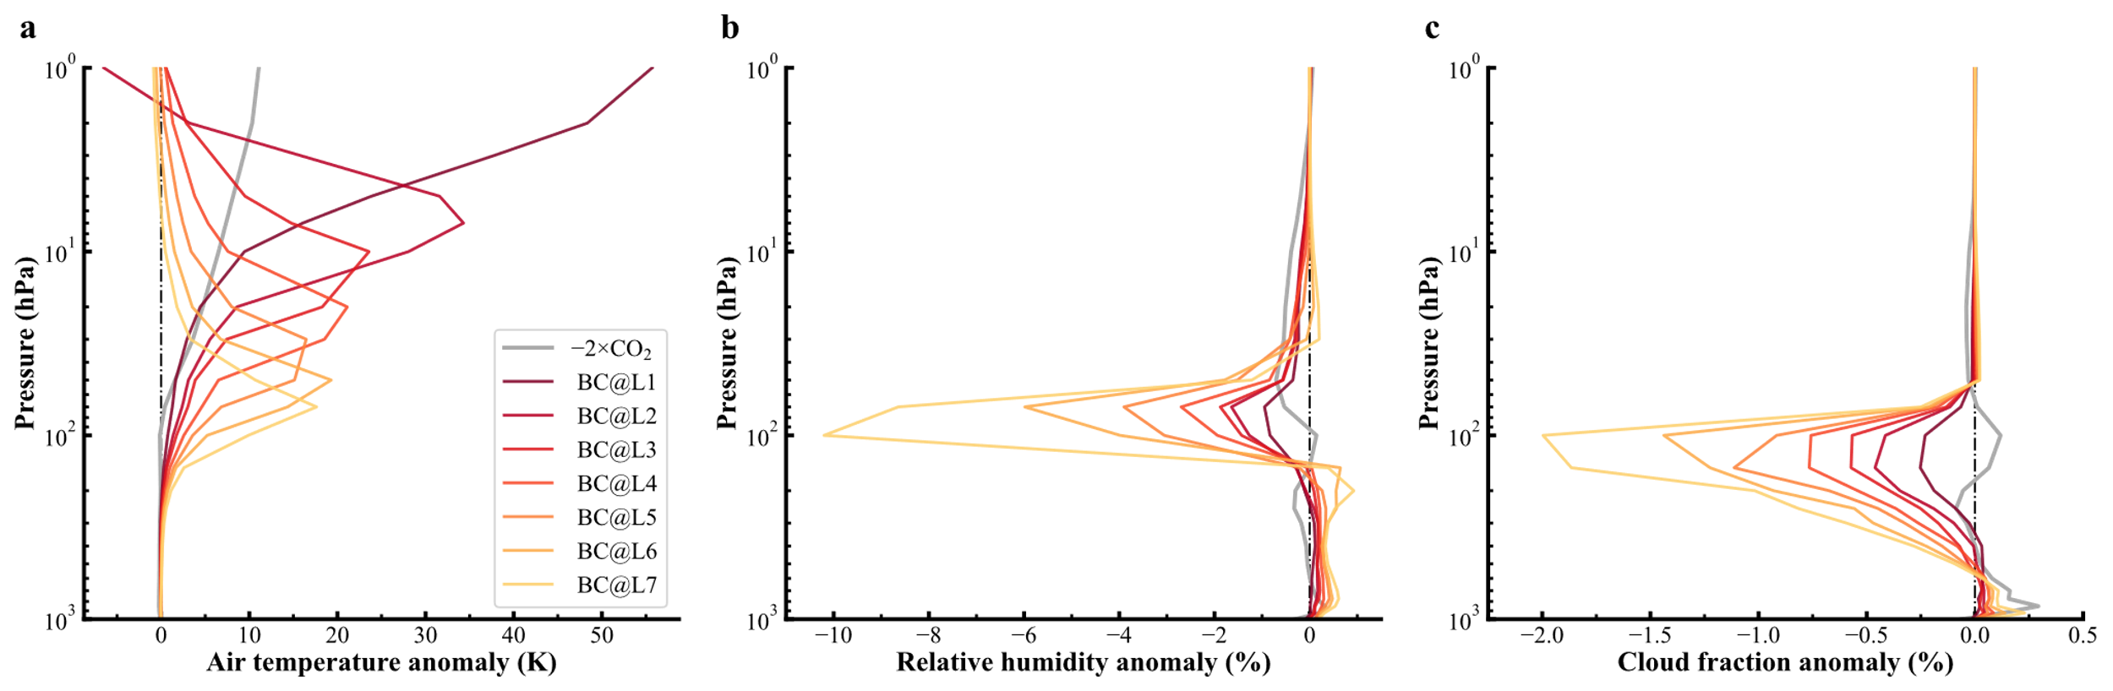
Extended Data Fig. 6. Profiles of GFDL-AM2.5 simulated (a) air temperature, (b) relative humidity, and (c) cloud fraction anomalies with horizontal-uniformly prescribed 0.5 Tg BC aerosols at each of the highest 7 sigma levels of aerosol inputs [the level number is defined with direction from top to bottom (or altitude from high to low)], respectively. Flipped profiles of air temperature, relative humidity, and cloud fraction responses to a doubling of CO₂ are also provided for reference.

