Supplementary

Supplementary Table 1: Adverse Events
A. Summary of number of patients with AEs ≥ grade 3 by terms
CTCAE 4.03 | Grade | Count
Anemia | 3 | 2
Dysphagia | 3 | 2
Lymphocyte count decreased | 3 | 2
Anorexia | 3 | 1
Ascites | 3 | 1
Aspartate aminotransferase increased | 3 | 1
Blood bilirubin increased | 3 | 1
Fatigue | 3 | 1
Hyperglycemia | 3 | 1
Hypertension | 3 | 1
Hypoalbuminemia | 3 | 1
Hypokalemia | 3 | 1
Hyponatremia | 3 | 1
Lung infection | 3 | 1
Serum amylase increased | 3 | 1
Serum amylase increased | 4 | 1
Thromboembolic event | 3 | 1
Upper gastrointestinal hemorrhage | 3 | 1
Urinary tract infection | 3 | 1
B. Summary of number of AEs ≥ grade 3
CTCAE 4.03 | Grade | Count
Anemia | 3 | 4
Serum amylase increased | 3 | 4
Dysphagia | 3 | 2
Lymphocyte count decreased | 3 | 2
Anorexia | 3 | 1
Ascites | 3 | 1
Aspartate aminotransferase increased | 3 | 1
Blood bilirubin increased | 3 | 1
Fatigue | 3 | 1
Hyperglycemia | 3 | 1
Hypertension | 3 | 1
Hypoalbuminemia | 3 | 1
Hypokalemia | 3 | 1
Hyponatremia | 3 | 1
Lung infection | 3 | 1
Serum amylase increased | 4 | 1
Thromboembolic event | 3 | 1
Upper gastrointestinal hemorrhage | 3 | 1
Urinary tract infection | 3 | 1

Supplementary Figure 1

CALIBRATION Trial protocol version 7.1 (08/08/2022). Patient identification, recruitment and trial interventions. 2 patients continued to have Durvalumab treatment beyond the 6 months originally stipulated on trial, as they continued to derive clinical benefit.

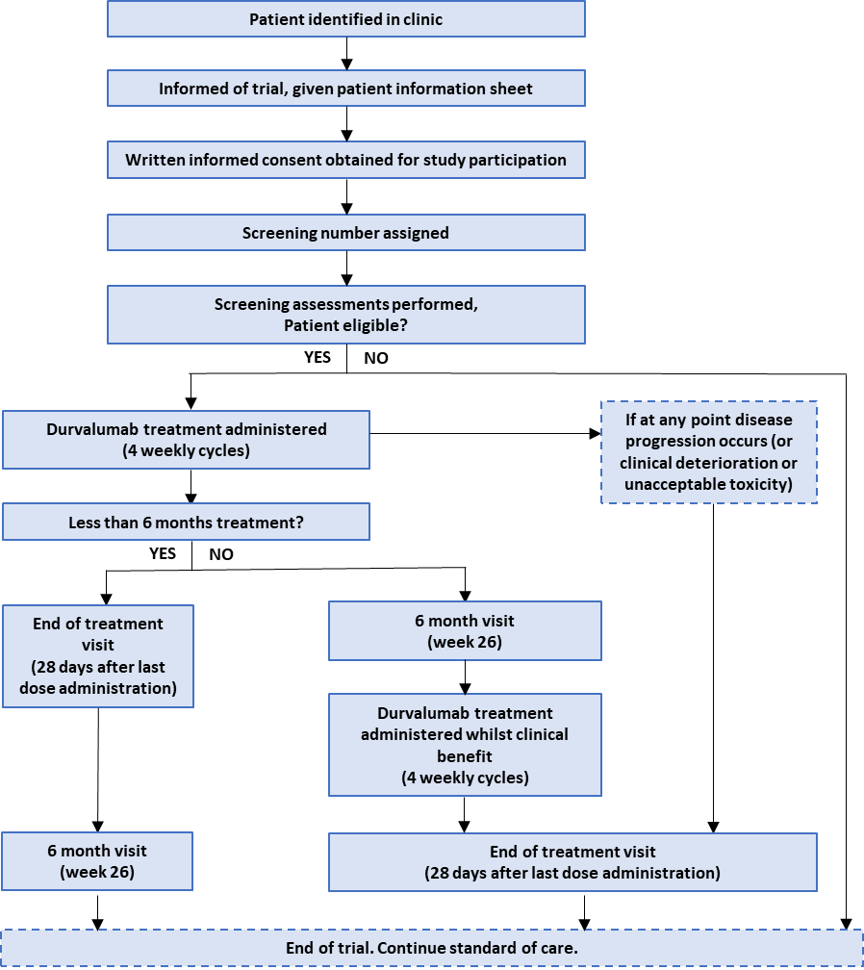

Supplementary Figure 2
Venn diagram showing relationship between different patient groups described in Table 1. Overall cohort = 23 patients, Evaluable cohort = 18 patients, patients with week 4 ctDNA = 17, patients with week 7 ctDNA = 12, patients with both week 4 and week 7 ctDNA = 11.
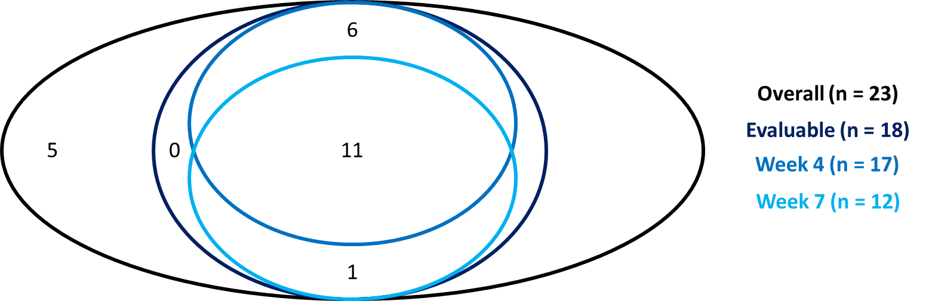

Supplementary Figure 3
Concordance of additional ctDNA and radiological outcomes. Please see in conjunction with Main Figure 3. (a) Waterfall plot with change in ctDNA mVAF at week 4 measured with Guardant 360 CDx panel against 26 week CT RECIST status. Increase of any change (≥1%) ctDNA vMAF concordant if PD, decrease of any change (≤1%) ctDNA mVAF concordant if PR, and no change in ctDNA (between +1% to -1%) ctDNA mVAF concordant if SD (8/17 patients concordant). (b) Waterfall plot with change in ctDNA mVAF at week 7 measured against 26 week CT RECIST status. Pre-defined increase in ctDNA mVAF of ≥+50% corresponding to PD and decrease of ≥-50% concordant with PR (6/12 patients concordant). (c-f) Plot with relative changes in Week 9 (c, d) and Week 26 (e, f) CT RECIST sum of diameters plotted against ctDNA concordance status with Week 4 ctDNA (c, e) and Week 7 ctDNA (d, f) with predefined categories at ±50% as above. (4/17, 6/12, 1/6 and 3/5 patients concordant respectively).

Supplementary Spreadsheet 1
All ctDNA variants detected using Guardant Health 360 CDx panel from all plasma timepoints.

Supplementary Spreadsheet 2
ctDNA somatic variants tracked over time (SNVs) using Guardant Health 360 CDx panel applied to plasma, including mean variant allele fractions (mVAF) at each time point.

