Table 1 Nomenclature
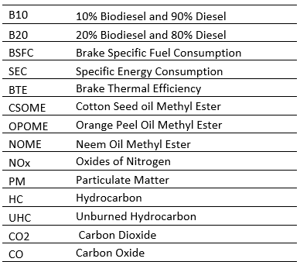

Table 2 Different nanoparticles affect the characteristics of diesel engines
Nanoparticle | Quantity | Base fuel | Preparation method | Diesel Engine Attributes | ref
CeO₂ | 10, 20,30 ppm | Diesel, Sorbitan oleate | Ultrasonication | Break power, slight decrease in fuel consumption, NOx and PM reduction takes place, CO Increased, HC | [39]
Multiwalled Carbon nanotubes | 50 mg/l | Jojoba Biodiesel | Ultrasonication | 16% BTE improves, and 15% BSFC-lowers, pressure rise-7%, heat rate rise-4%, at 20 mg/l decline in NOx-35, CO-50%, UHC-60% | [40]
Aluminium oxide | 0.25, 0.5, 0.75 and 1in g/l | Diesel, Jathropha oil (B20) | Ultrasonication | Break power, Break Thermal Efficiency BTE improved, Emission Not studies [36] | [41]
Al₂O₃, CeO₂ | each 30 ppm | Diesel, Jathropha oil | Ultrasonication | BTE-12% rise, NO-30% decline, CO2, HC, and smoke by30%, 60%, 44% and 38% respectively.[37] | [42]
Zink Oxide, Titanium Oxide | 50 and 100 ppm | Calophyllum Inophyllum biodiesel | Ultrasonication | BP, improve by 15%, heat rise and pressure rise by 5-17% improvement in BTE, CO and HC reduced, NOx is lower than biodiesel but higher than Diesel, smoke emission reduced [38] | [43]
cerium oxide with EGR | Not mentioned | lemongrass oil, diethyl ether, diesel Water emulsion | Ultrasonication | Cylinder pressure-4.46% and 3.29%-heat release rate increase, BTE 2.4% and BSFC-10.8% increased, 30.72% reduction in NOx, 11.2 % Smoke emission decrease, HC-18.18% and CO-33.31% reduced [39] | [44]
ferric chloride (FeCl3), Diethyl ether additive | 15% | Diesel | Ultrasonication | BTE enhanced by 8%, BSFC lowered up to 9%, Diesel + DEE15 combination, NO increased by 35%, 2% reduction of smoke opacity [40] | [45]
Cerium oxide (CeO₂) | 20 ppm | Cymbopogon flexuous biofuel with four different combustion bowls | Ultrasonication | Peak pressure rise by 10.08% Break power, MF, Break Thermal Efficiency, NOx, Smoke emission decrease of 17% of HC, 43.66% of CO, smoke- 12.28% | [46]
Cerium oxide (CeO₂) | 30 ppm | Cymbopogon flexuous biofuel (lemongrass oil emulsion) | Ultrasonication | Break power, MF, Break Thermal Efficiency, decrease in UHC, CO by 35.5%, 16.03%, 24.80% BTE, NOx -24.8% reduction and 6.4% Smoke emission decrease | [47]
zinc oxide (ZnO) | 250 ppm | Palm oil methyl ester, Diesel + ethanol | Ultrasonication | Reduced BTE-21% and 9%., increase in BSFC- 39% and 14%., Maximum pressure- 8% and 13%. HRR-118% and 129%., Reduced-CO- 62% and 92%. NOx -35% and 16%. Smoke-54% and 82%. HC rise by 21% and lowered by 9%. | [48]
ZnO | 50 ppm | waste cooking vegetable oil | Ultrasonication | At different speed (1700, 2000, 2300, 2600, 2900) RPM, Torque enhance by 6.74, 4.9 and 3.69% reduction in BSFC by 5.6, 6.44 and 2.5% | [31]
Al₂O₃, CUO₂ | 0.5 wt.% Less than 100 nm | Diesel | Ultrasonication | Lower BSFC is 0.65% for CUO2 diesel. The reductions in HC, CO, and NOx are 6.3%, 7.11%, and 2.6%, respectively for CUO2 and for Al2O3 it is 13.3%,12.17% and 8.75%, respectively | [49]
Aluminium oxide hydroxide (AlO (OH)) | 25, 50 and 100 ppm | Jatropha oil | Surfactant and Ultrasonication | Compared to plain diesel, biodiesel had a lower brake thermal efficiency, for every BD10W100er, there is CO-50%, UHC-39%, NO-37%, and smoke-25% reduction, reduces NO and smoke opacity by 42% and 18% | [50]
Cuprous Oxide CuO2 | Not mentioned | Diesel, rapeseed methyl ester (RME) | Ultrasonication | Improved Pressure and Rate of Heat rise by 4% and 11%, BTE improved by 3.64%, 7.36%, 9.28% and 12.43% with CuO, BSFC lowered by 5.26%, 7.47%, 9.68% and 12.73% with 25,50,75 and 100% loading, NOX emissions by 29.64% with 20% EGR and CuO, soot particle concentration lower, PM by 26.37% | [24]
Al₂O₃ | 30, 50, and 100 mg/l | butanol-diesel | Ultrasonication | Thermophysical properties tested, PM emission tested, BSFC decreased by 7.3%, BTE 4.7% improved, PM 30.5% lowered, reduction in CO-42.71%, HC-37.46%, and NOX-12.37% for 100 mg/l | [51]
Magnalium and cobalt oxide (Co3O4) | 100 mg/l | Diesel, Jathropha | Sol-Gel, ball mill, ultrasonication, surfactant | Cobalt oxide- Reduction in SEC, 60%-UBHC, 50%-CO, 45%-NOx, HC -70% and 41 % in CO, 30%-NOx for magnalium | [32]
Al₂O₃ | 50 ppm 100 ppm | Mahua biodiesel | ultrasonication and a homogenizer | 7.66% reduction in SFC, gain of 1.58% and 7.34% in BTE, reduction of 26.04% HC, 26% and 48% CO, NOx increment of around 4.8% and 7.95% | [52]
ZNO, Ethanox | ZNO-50, 100 ppm  Ethanox- 200ppm and 500ppm | Calophyllum Inophyllum | ultrasonication | Enhanced efficiency-4.7%, lower NO_{x} 12.6% for ZNO 100 ppm, NOx-17.8% reduced at 500 ppm Ethanox, HC and CO increased | [53]

Table 3 Properties of Combined Biodiesel (CSOME+NOME+OPOME)
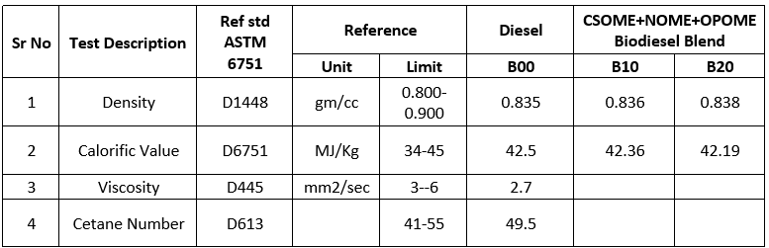
Table 4 Fuel details
Sr No | Short Name | Details
1 | DIESEL | Diesel
2 | B10ZN30 | B10 (10% Biodiesel, 90%Diesel), 30ppm ZNO
3 | B10ZN50 | B10 (10% Biodiesel, 90%Diesel), 50ppm ZNO
4 | B20ZN30 | B20 (20% Biodiesel, 80%Diesel), 30ppm ZNO
5 | B20ZN50 | B20 (20% Biodiesel, 80%Diesel), 50ppm ZNO

Table 5 Properties of Combined Biodiesel (CSOME+NOME+OPOME) with ZNO
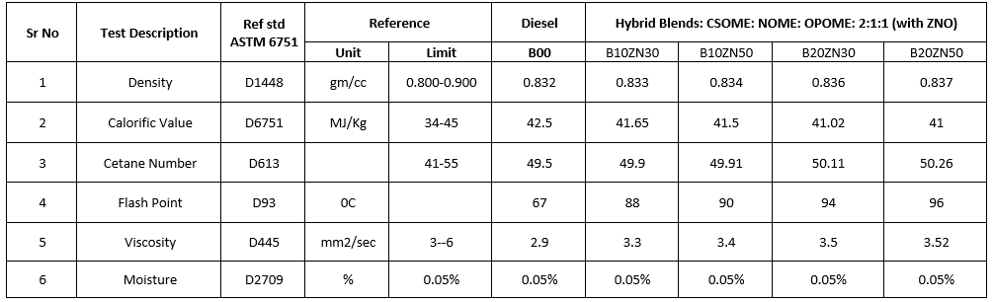

Table 6 Properties of ZNO [51]
