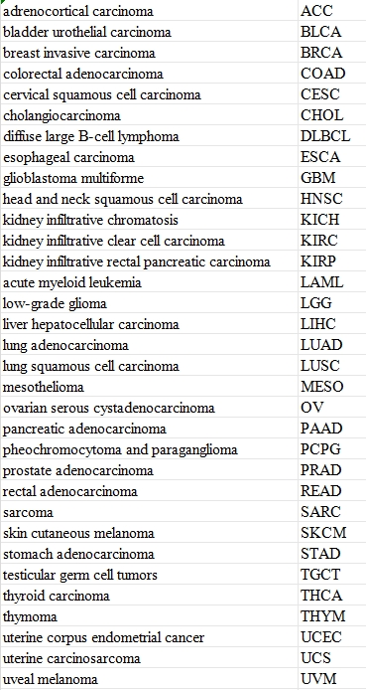
Table1.List of 33 types of tumors.

