Supplementary information

Table S1 Results of Blast

Description | Scientific Name | Coverage | Max Score | Acc. Len | E-value | % Ident
QSZ40499.1 | sp|P19068.2 | 97.872 | 235 | 235 | 1.72e-176 | 100.00
QSZ40499.1 | AUX79023.1 | 97.447 | 235 | 235 | 1.35e-175 | 99.57
QSZ40499.1 | ACE82208.1 | 97.447 | 235 | 235 | 4.32e-175 | 99.57
QSZ40499.1 | ABG74605.1 | 97.021 | 235 | 235 | 7.55e-175 | 99.57
QSZ40499.1 | ADI72792.1 | 97.845 | 232 | 232 | 4.23e-174 | 100.00
QSZ40499.1 | AHL17213.1 | 97.845 | 232 | 232 | 4.98e-174 | 100.00
QSZ40499.1 | ADZ23542.1 | 97.845 | 232 | 232 | 5.21e-174 | 100.00
QSZ40499.1 | ADZ23545.1 | 97.845 | 232 | 232 | 5.54e-174 | 100.00
QSZ40499.1 | ADZ23546.1 | 97.845 | 232 | 232 | 5.55e-174 | 100.00
QSZ40499.1 | ADZ23544.1 | 97.845 | 232 | 232 | 5.77e-174 | 100.00
QSZ40499.1 | ADZ23560.1 | 97.845 | 232 | 232 | 5.77e-174 | 100.00
QSZ40499.1 | SCN47971.1 | 98.268 | 231 | 231 | 1.52e-173 | 100.00
QSZ40499.1 | ADZ23553.1 | 97.835 | 231 | 231 | 4.30e-173 | 100.00
QSZ40499.1 | ADZ23568.1 | 97.835 | 231 | 231 | 4.31e-173 | 100.00
QSZ40499.1 | ADZ23535.1 | 97.835 | 231 | 231 | 5.70e-173 | 100.00
QSZ40499.1 | AAK53549.1 | 97.403 | 231 | 231 | 1.06e-172 | 99.57
QSZ40499.1 | ADZ23556.1 | 97.817 | 229 | 234 | 1.19e-171 | 100.00
QSZ40499.1 | ADZ23543.1 | 97.380 | 229 | 234 | 4.94e-171 | 100.00
QSZ40499.1 | ACO90391.1 | 98.214 | 224 | 224 | 1.43e-167 | 100.00
QSZ40499.1 | AHL17212.1 | 84.255 | 235 | 235 | 2.82e-154 | 94.47
QSZ40499.1 | ABG74606.1 | 82.979 | 235 | 235 | 1.02e-152 | 94.47

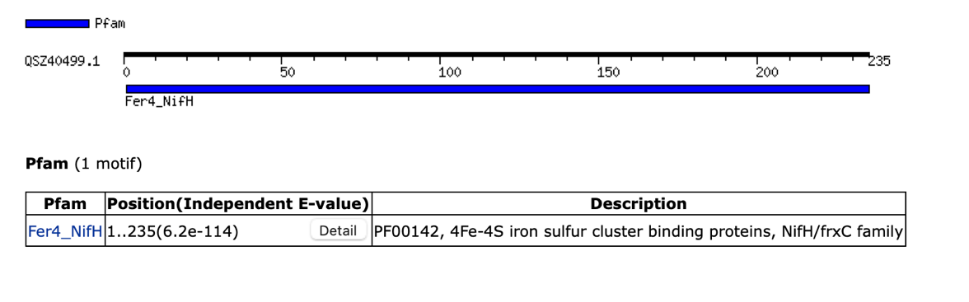
Fig. S1 Motif predicted in our query protein sequence of Nitrogenase from Ensifer fredii
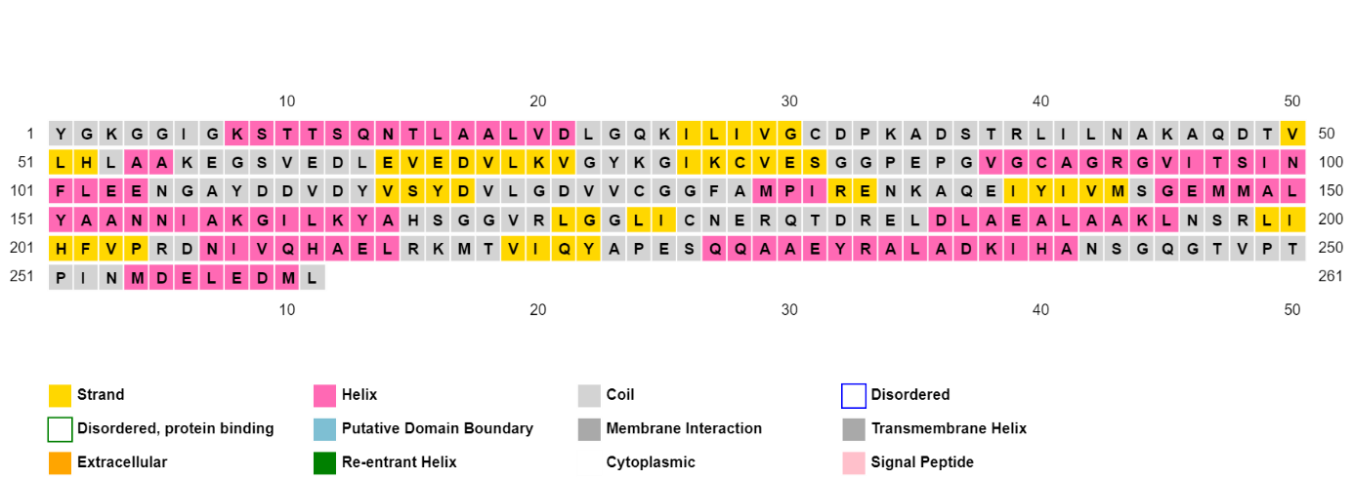
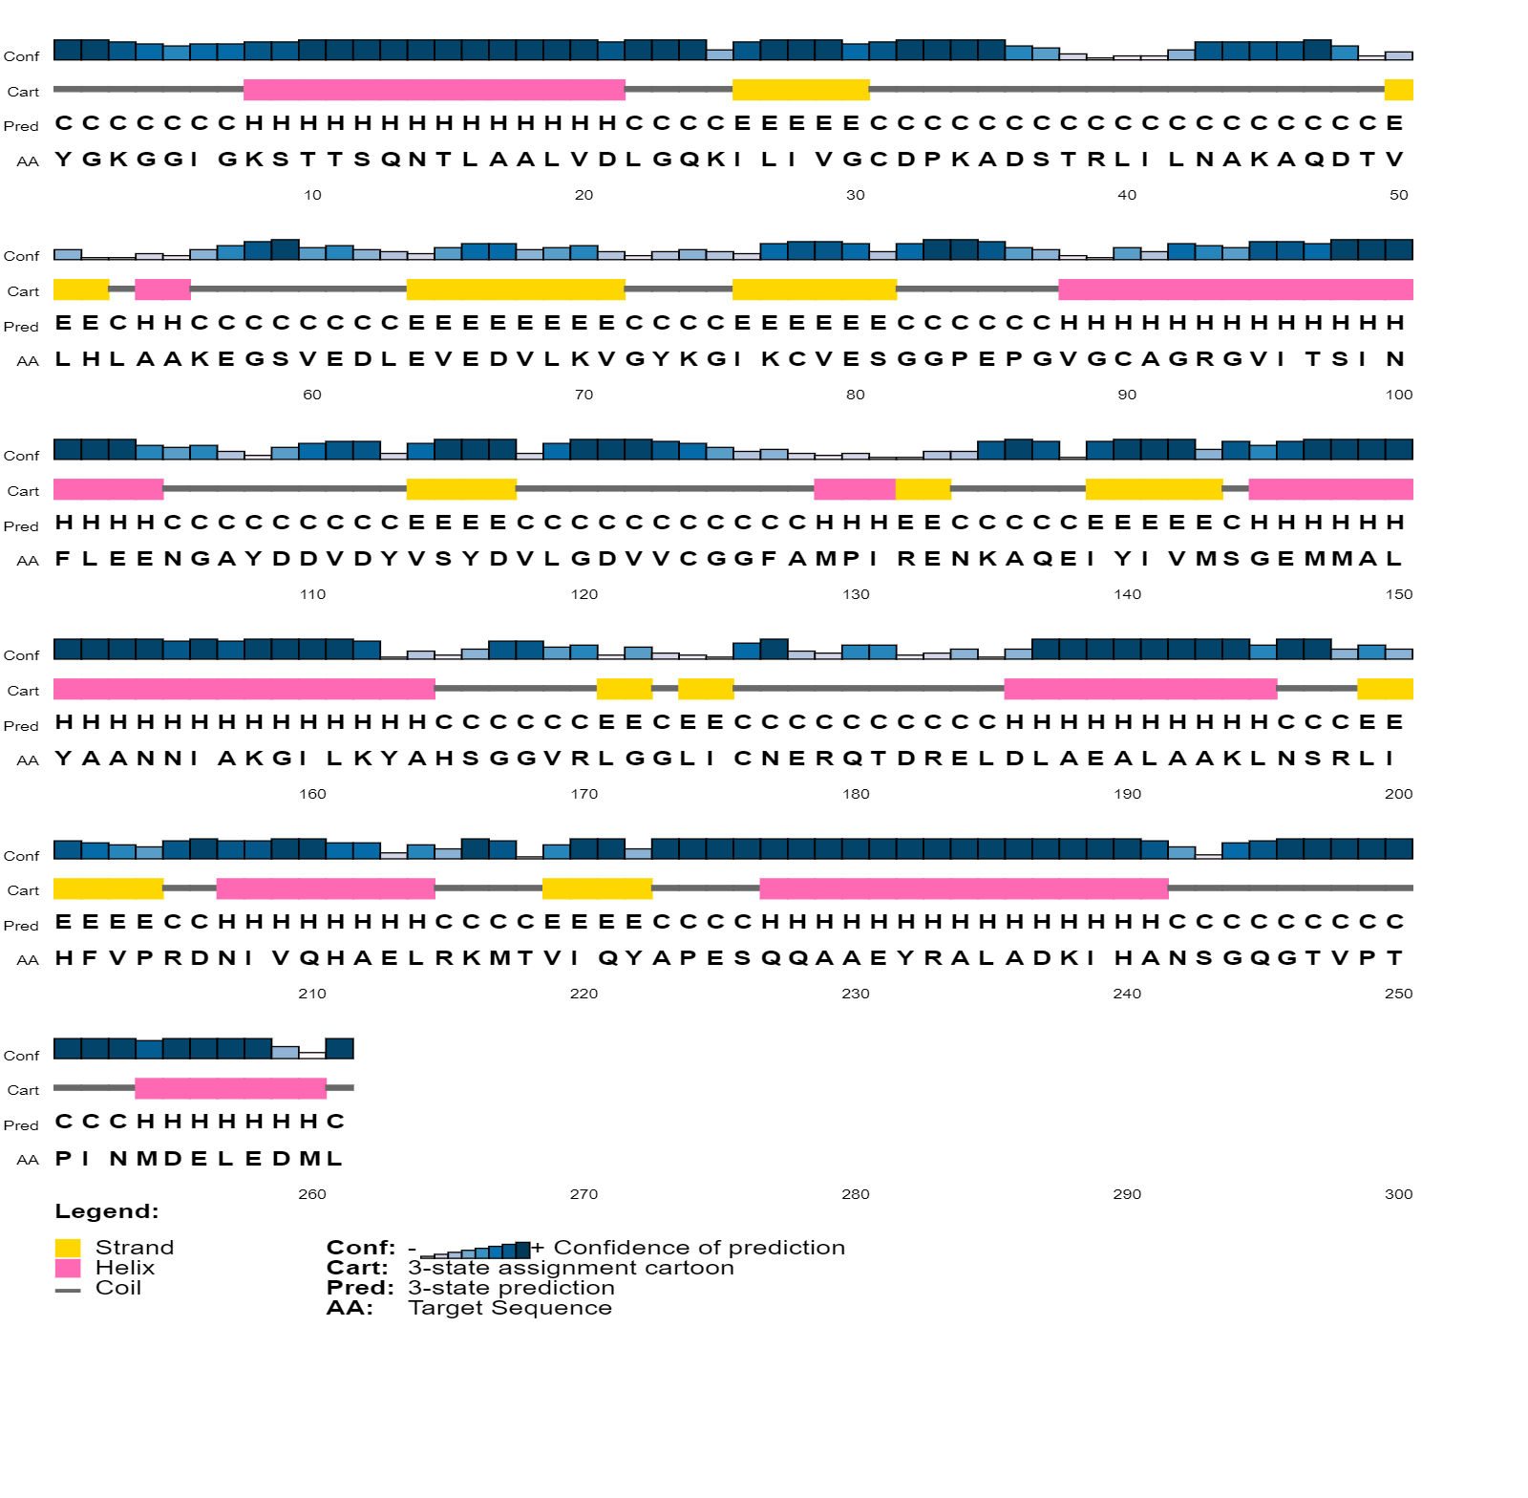
Fig. S2 Secondary Structure Map and graphical representation (PSIPRED)

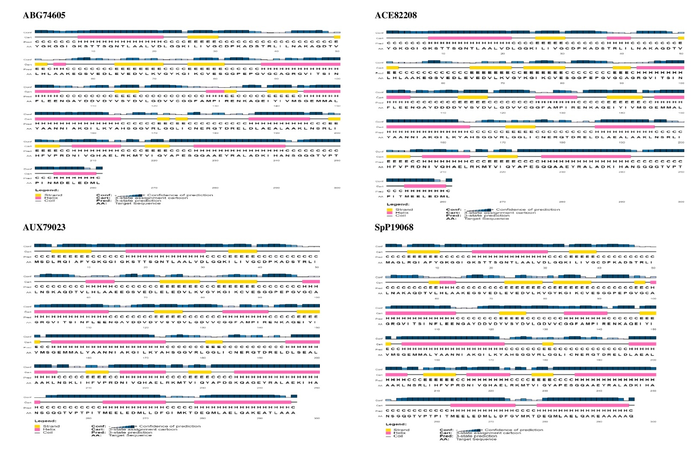
Fig. S3 Secondary structure map, and graphical representation of the predicted secondary structures present within the proteins used in this study attained by PSIPRED (The pink blocks represent the alpha helices; the yellow blocks represent beta strands, and the black thread-like structures were the coils.

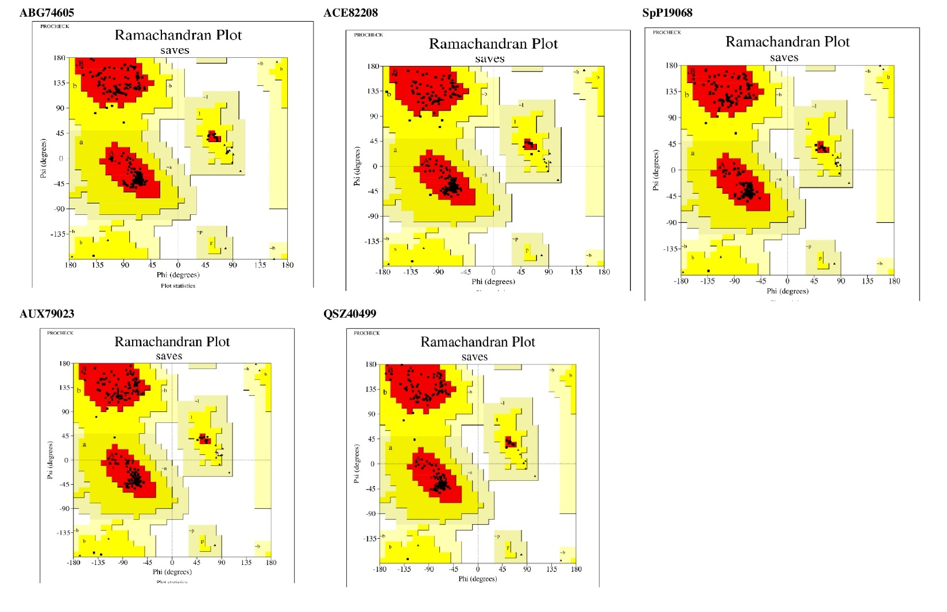
Fig. S4 Ramachandran plot of refined Nitrogenase model as analyzed by RAMPAGE.
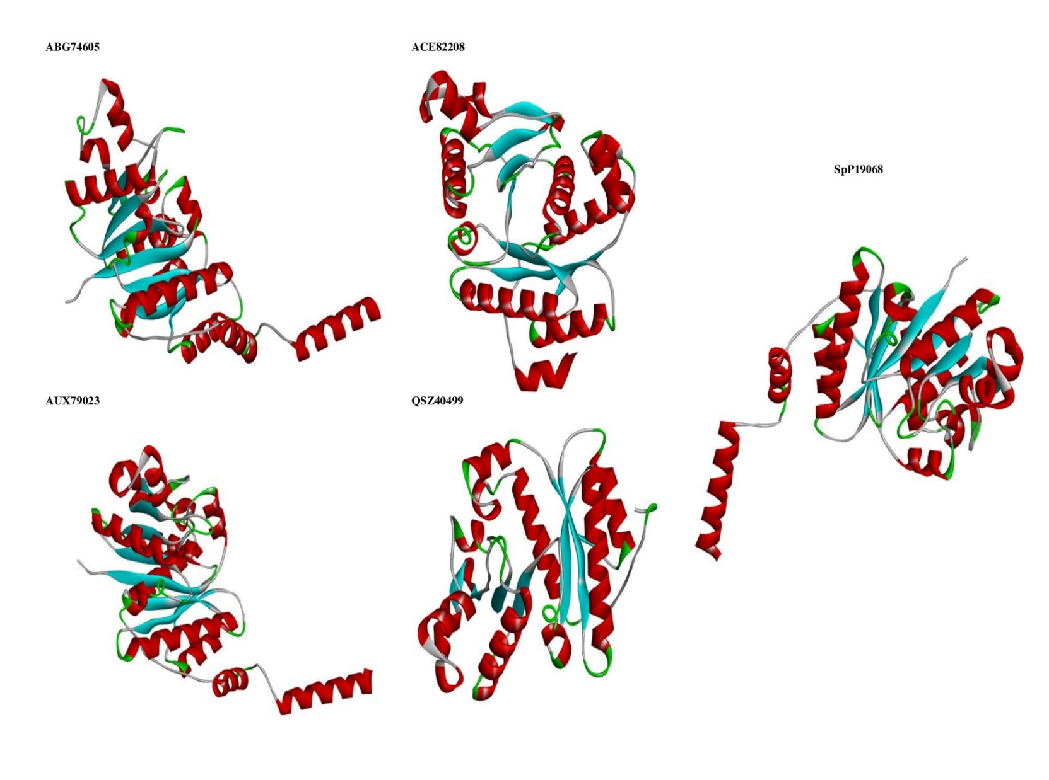
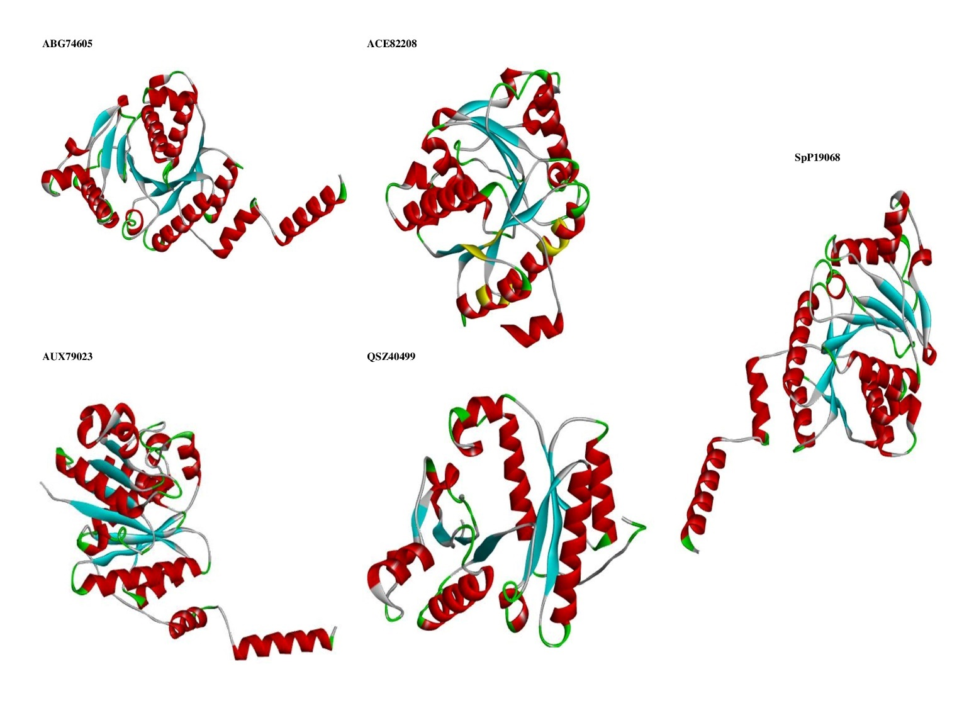
Fig. S5 AlphaFold predicted 3D model structure of all proteins used in this study viewed by Discovery studio
Fig. S6 3D predicted models after refinement

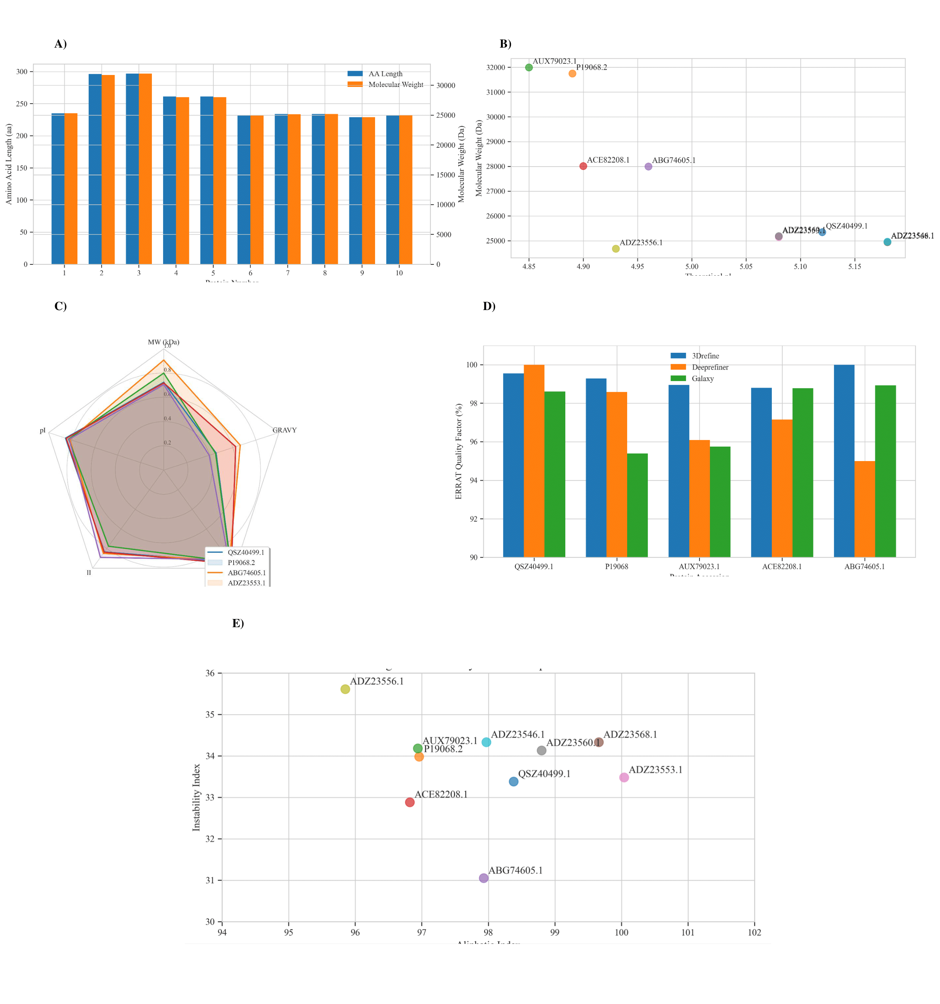
Fig. S7. Physicochemical Properties and Model Refinement Scores for Nitrogenase Fe Protein from Ensifer fredii Strains. A) Molecular weight vs amino acid length, B) Theoretical pI vs molecular weight scatter plot, C) Radar chart of key physicochemical proprieties, D) ERRAT quality factor across rafinement servers, E) Instability index vs Aliphatic index

