Table S1. Overview of 16S rRNA sequencing results from 12 rumen fluid samples.
Sample | Raw PE | Combined | Qualified | Nochime | Q20(%) | Q30(%) | GC Content(%)
CON1 | 74849 | 73,646 | 73,056 | 63,292 | 98.75 | 95.88 | 53.86
CON2 | 78,260 | 77,174 | 76,376 | 54,298 | 98.70 | 95.71 | 53.3
CON3 | 83,687 | 83,131 | 82,515 | 67,437 | 98.72 | 95.78 | 53.95
CON4 | 77,316 | 76,201 | 75,644 | 62,538 | 98.71 | 95.79 | 54.4
CON5 | 76,208 | 74,890 | 74,278 | 64,897 | 98.69 | 95.7 | 53.5
CON6 | 77,915 | 77,554 | 76,887 | 65,463 | 98.19 | 94.04 | 55.36
E1 | 85,203 | 84,810 | 84,309 | 65,353 | 98.84 | 96.03 | 54.14
E2 | 82,681 | 82,467 | 81,990 | 64,353 | 98.71 | 95.71 | 54.08
E3 | 78,214 | 77,440 | 76,904 | 62,366 | 98.65 | 95.54 | 53.46
E4 | 83,483 | 83,309 | 82,807 | 67,557 | 98.76 | 95.85 | 53.49
E5 | 78,498 | 77,958 | 77,540 | 64,367 | 98.72 | 95.72 | 53.01
E6 | 76,571 | 76,259 | 75,631 | 61,890 | 98.37 | 95.18 | 56.6

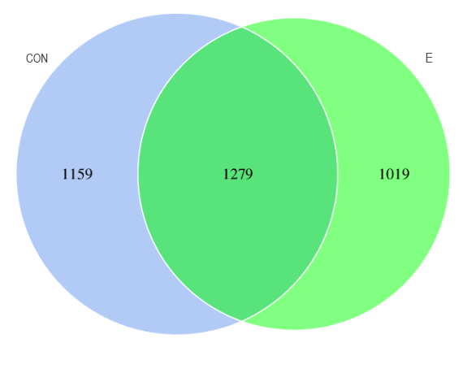
Fig. S1. Venn diagram of actionable taxonomic units in the rumen microbiota of goats fed NSP enzyme in high-concentrate diets (HCD). CON: basal diet without NSP enzyme; E: basal diet + 500 mg/kg NSP enzyme.
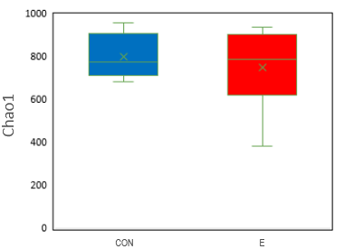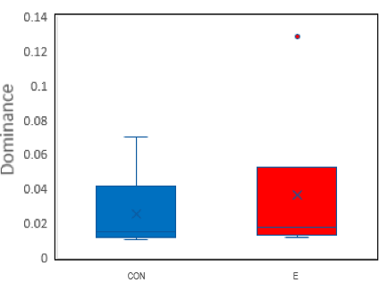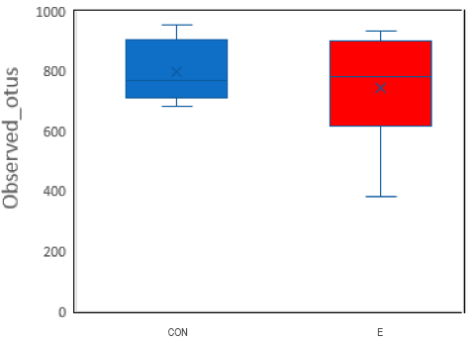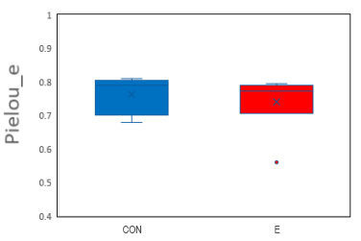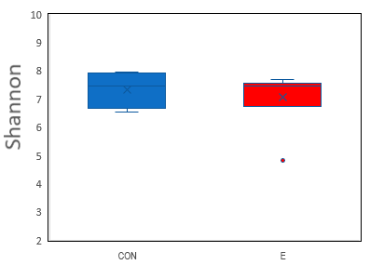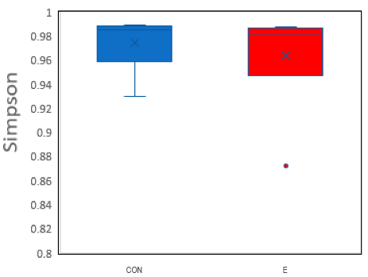
Fig. S2. Alfa diversity indices of the rumen microbiota of NSP enzyme enriched high-concentrate diets (HCD), including Chao1, Dominance, Observed_outs, Pielou_e, Shannon and Simpson. CON: basal diet without NSP enzyme; E: basal diet + 500 mg/kg NSP enzyme.

