Supporting Information

Tuning aromaticity of cyclocarbons by heteroatom doping
Luye Sun^{1,6}, Yuan Guo^{1,6}, Ihor Sahalianov^{2,3,6}, Zheng Zhou^{1,6}, Wei Zheng^{1,6}, Wenzhi Xiang¹, Yumeng Guo¹, Yuanhao Feng¹, Rashid Valiev⁴, Artem Kuklin⁵, Hans Ågren⁵, Glib V. Baryshnikov^{2,3,}*, Wei Xu^{1,}*
¹Interdisciplinary Materials Research Center, School of Materials Science and Engineering, Tongji University, Shanghai 201804, People’s Republic of China.
²Laboratory of Organic Electronics, Department of Science and Technology, Linköping University, 60174 Norrköping, Sweden.
³Wallenberg Initiative Materials Science for Sustainability, Department of Science and Technology, Linköping University, 60174 Norrköping, Sweden.
⁴Department of Chemistry, University of Helsinki, FI-00014 Helsinki, Finland.
⁵Department of Physics and Astronomy, Uppsala University Box 516, SE-75120 Uppsala, Sweden.
⁶These authors contributed equally: Luye Sun, Yuan Guo, Ihor Sahalianov, Zheng Zhou, Wei Zheng
*Corresponding authors. Email: glib.baryshnikov@liu.se, xuwei@tongji.edu.cn

Table of Contents
Materials and Methods
Table S1
Figs. S1 to S11
References

Materials and Methods

Solution synthesis of perchlorodibenzo[b,d]thiophene (C₁₂SCl₈)

Preparation of C₁₂SCl₈
To a suspension of AlCl₃ (850 mg, 6.38 mmol) in SO₂Cl₂ (75 mL) was added a solution of dibenzothiophene (74 mg, 0.4 mmol) in S₂Cl₂ (2.0 mL, 25 mmol) and SO₂Cl₂ (30 mL) over 30 min via a syringe pump. In the meantime, the solution was stirred at 65 °C. After the completion of the addition, the solution was stirred at 65 °C for 24 h. After cooling to room temperature, CH₂Cl₂ (30 mL) was added. The mixture was slowly added into water at 0 °C, followed by quenching with an aqueous saturated Na₂CO₃ solution. The layers were separated, and the aqueous phase was extracted with CH₂Cl₂. The organic phases were combined, washed with brine, dried and filtered. Solvent removal and washing with CH₂Cl₂ afforded decachlorofluorene as a white powder (90 mg, 0.2 mmol, 50 %). No signals from the product were observed.

Synthesis of perchloro-1H-cyclopenta[b]quinoline (C₁₂NCl₉)

Chemicals and Materials
PCl₅ (99.0%) and acridine (98.0%) were purchased from Adamas and used as received.
Preparation of C₁₂NCl₉
A custom-made autoclave with Hastelloy alloy (150 mL) was charged with acridine (0.932 g, 0.0052 mol) and PCl₅ (40 g, 0.192 mol), which was heated rapidly to 300° C (1.5 hours) and then maintained at this temp for a further 16 hours. The autoclave was allowed to cool to room temperature and vented to release the HCl formed during the reaction before the vessel was opened. The product was then hydrolyzed by the slow addition of ice. When this was complete, the chlorinated product was filtered off and dried.
The mixture was purified by dynamic sublimation at 130 ℃ for 1 h to obtain a yellow solid, and the yellow solid was sublimated in a glass ampule (O.D. 1 cm, L. 15 cm) at 130–135 ℃ for 5 days, giving colorless block crystals suitable for single crystal X-ray diffraction in good yield (Yield: 90%).
Structure Solution and Refinement Details
Data collection of C₁₂NCl₉ was performed on a Bruker VENTURE system equipped with a PHOTON III C14 detector, a Cu-target iμs 3.0 microfocus X-ray source (λ = 1.54178 Å), and a graphite monochromator. The data were collected at T = 150(2) K (Oxford Cryosystems CRYOSTREAM 1000). Data reduction and integration were performed with the Bruker APEX5 software package SAINT (version 8.40B)¹. Data were corrected for absorption effects using the empirical methods as implemented in SADABS (version 2016/2)². The structures were solved by SHELXT (version 2018/2)³ and refined by full-matrix least-squares procedures using the Bruker SHELXTL (version 2019/2)⁴ software package through the OLEX2 graphical interface⁵. All non-hydrogen atoms, including those in disordered parts, were refined anisotropically. Hydrogen atoms were included in idealized positions for structure factor calculations with U_{iso}(H) = 1.2 U_{eq}(C). Crystallographic data and details of the data collection and structure refinement are listed in Table S1. The crystal structure is shown in Fig. S1.

Table S1. Crystal data and structure refinement parameters for C₁₂NCl₉.
Compound | C₁₂NCl₉
CCDC Number | 2387696
Empirical formula | C₁₂NCl₉
Formula weight | 477.18
Temperature (K) | 150(2)
Wavelength (Ǻ) | 1.54178
Crystal system | Orthorhombic
Space group | Pnma
a (Å) | 38.1882(18)
b (Å) | 6.7886(3)
c (Å) | 19.7046(6)
α (°) | 90
β (°) | 90
γ (°) | 90
V (Å³) | 3156.6(3)
Z | 8
ρ_{calcd} (g·cm⁻³) | 2.008
μ (mm⁻¹) | 14.550
F(000) | 1856
Crystal size (mm) | 0.05×0.06×0.20
θ range for data collection (°) | 3.810-71.995
Reflections collected | 14823
Independent reflections | 3318  [R_{int} = 0.0308]
Transmission factors (min/max) | 0.3411/0.7536
Data/restraints/params. | 3318/0/259
R1,ª wR2^{b} (I > 2σ(I)) | 0.0326, 0.0838
R1,ª wR2^{b} (all data) | 0.0328, 0.0839
Quality-of-fit^{c} | 1.150
R_{int} = Σ|F_{o}²-<F_{o}²>|/Σ|F_{o}²|
ªR1 = Σ||F_{o}|-|F_{c}||/Σ|F_{o}|. ^{b}wR2 = [Σ[w(F_{o}²-F_{c}²)²]/Σ[w(F_{o}²)²]].
^{c}Quality-of-fit = [Σ[w(F_{o}²-F_{c}²)²]/(N_{obs}-N_{params})]^{½}, based on all data.

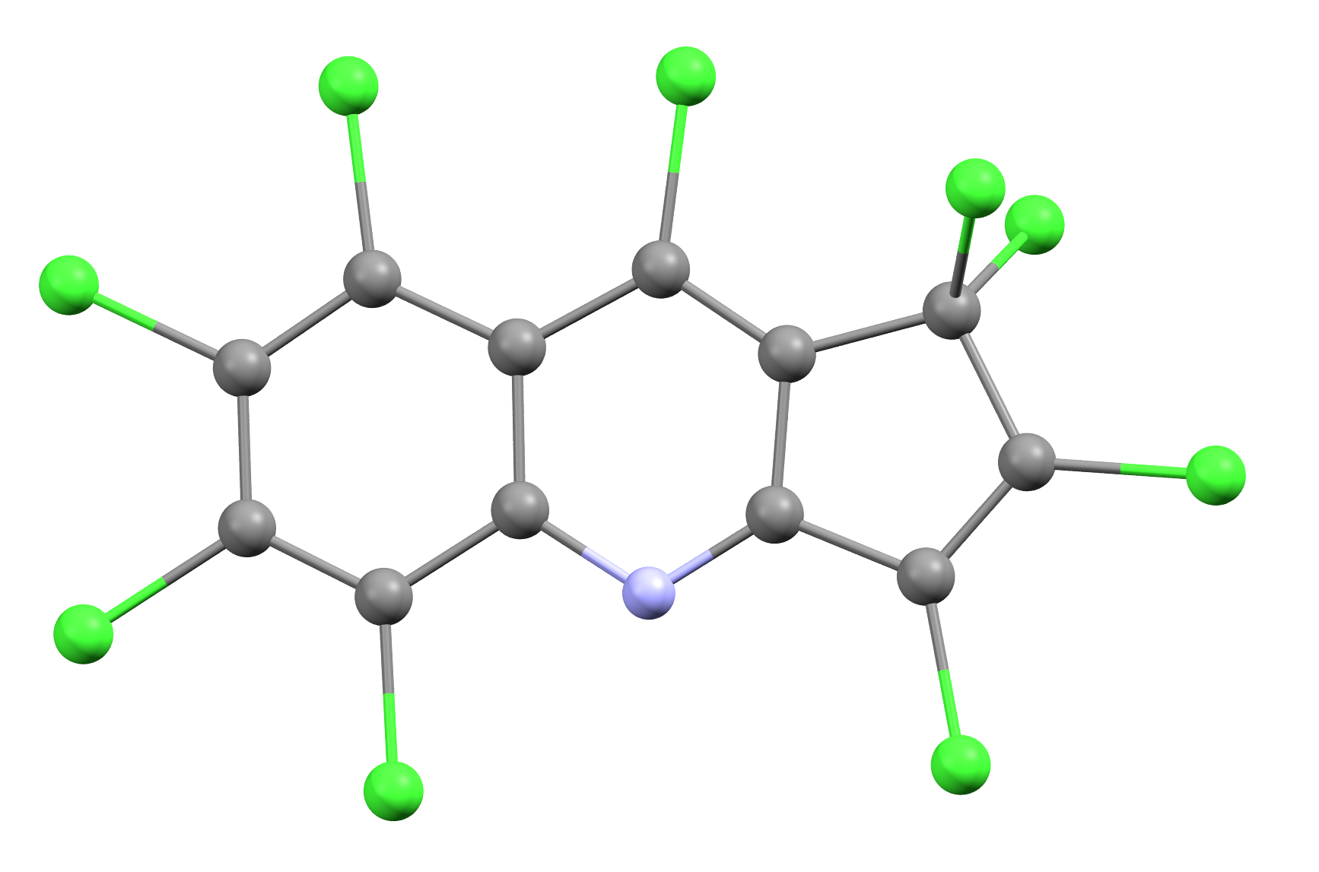
Fig. S1. Molecular structure of C₁₂NCl₉ obtained from SC-XRD experiment in ball and stick model.

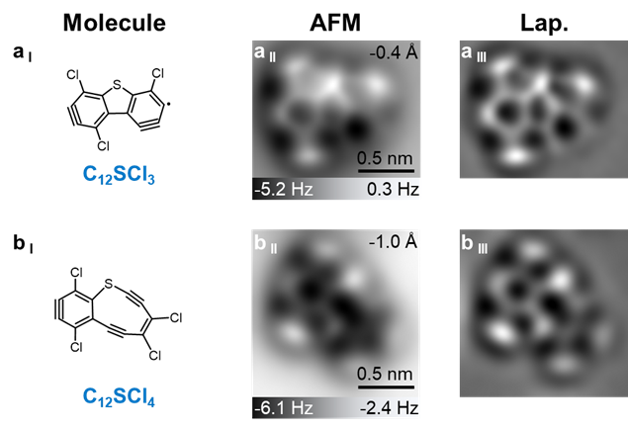
Fig. S2. Molecular structures, AFM images and Laplace-filtered AFM images of other observed intermediates. (a _{I} to a _{III}) C₁₂SCl₃, (b _{I} to b _{III}) C₁₂SCl₄. Reference set point of Δz: I = 4 pA, V = 0.3 V.
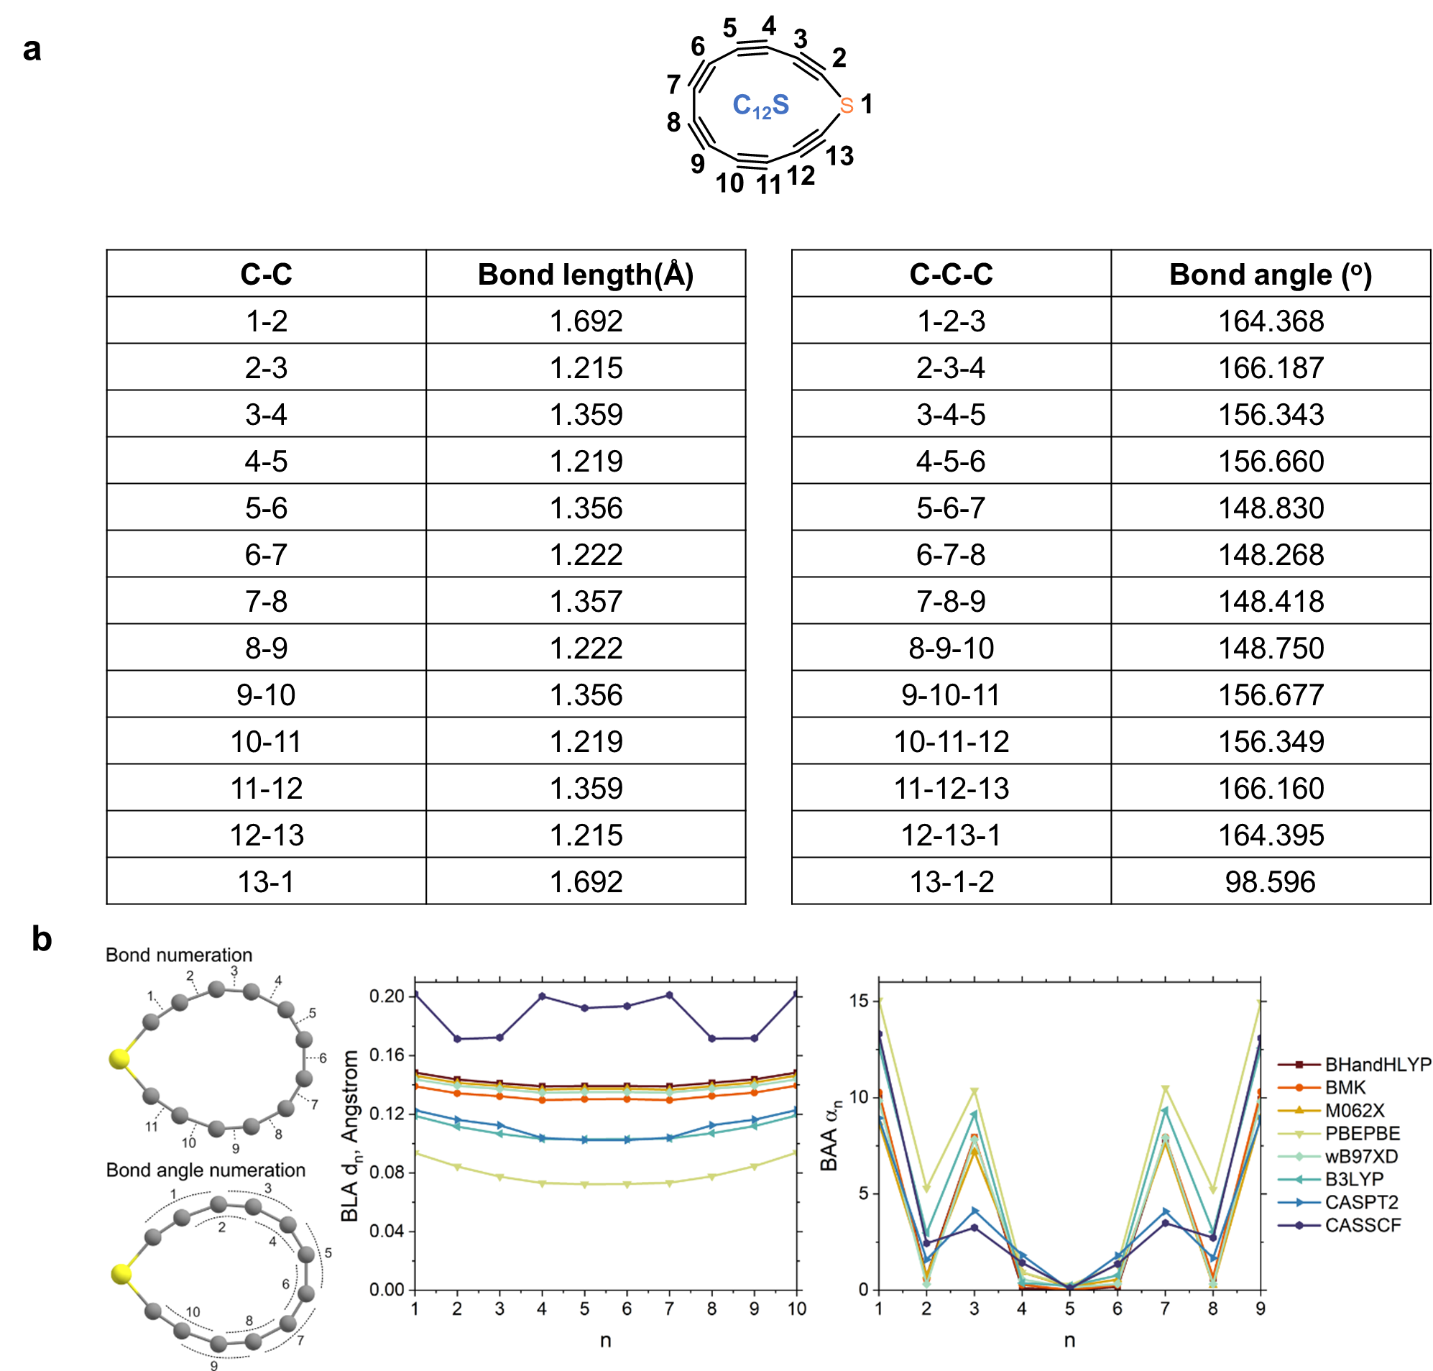
Fig. S3. Structural characterization of C₁₂S. (a) The bond lengths and bond angles in C₁₂S. Calculations were conducted at the ωB97XD/6-311++G(d,p) level. (b) Bond length alternation (BLA) and bond angle alternation (BAA) descriptors calculated at different levels of theory.

Optimization of C₁₂S structure with different levels of theory always leads to the structure with clear bond length alternation (BLA d_{n}) between adjacent CC bonds l_{n+1} and l_{n} (d_{n} = |l_{n+1} – l_{n}|). There is a clear trend that the BLA parameter increases with the rise of HF exchange within the functional starting from 0.08-0.10 Å for the pure PBEPBE functional until approximately 0.15 Å for BHandHLYP functional (Fig. S3b). CASSCF(8x8) level of theory overestimates the BLA in C₁₂S at the level 0.17-0.20 Å due to the lack of accounting of dynamic correlation effects. At the same time XMC-CASPT2 simulations provide a the reasonable BLA in line with DFT results and most closely relate to the optimization with the B3LYP functional. In contrast to BLA, the bond angle alternation BAA (α_{n} = |L_{n+1} – L_{n}|) only slightly varies among different functionals (7.5º-10º), while CASSCF and XMC-CASPT2 methods result in much smaller BAA deviation at the level of 3-4º (Fig. S3b).

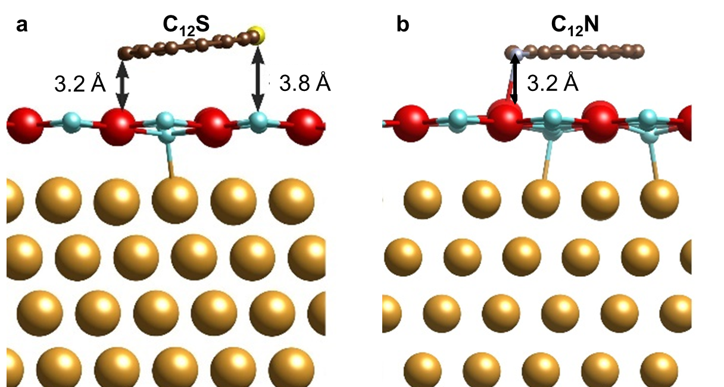
Fig. S4. Optimized equilibrium geometry of C₁₂S (a) and C₁₂N (b) adsorbed on NaCl/Au(111).

To accurately model the real experimental conditions, it is essential to use periodic boundary conditions and take into account substrate effects. Therefore, we performed calculations on the adsorption of C₁₂S adsorbed on NaCl/Au(111) using the periodic boundary PBC approximation. The initial model of the interface consisted of a five-layer Au (111) surface with deposited NaCl (001) monolayer which was matched and created using the Virtual NanoLab (VNL) tool^{6,7} to minimize mutual structural stress. We determined that the unit cell is large enough (23.93× 19.94 Å) to simulate C₁₂S adsorption on the NaCl/Au(111) while avoiding spurious interactions between the molecules, maintaining an effective separation distance of 14.5 Å between neighboring molecules. The simulated C₁₂S/NaCl/Au(111) heterostructure is shown in Fig. S4a. In contrast to cyclo[18]carbon, which reveals cumulene type when the PBE functional with 0% HFE was used⁸, the present C₁₂S molecule demonstrates bond length alternation (BLA) with short and long bond lengths of 1.256 and 1.329 Å, respectively. Therefore, we believe that the PBE functional can qualitatively describe the adsorption properties of C₁₂S. We found that the adsorption energy is ~ -0.03 eV and varies depending on the position. The global energy minimum was found when the S atom is ~3.8 Å above Cl, while two carbon atoms on the opposite side of the molecule are ~3.2 Å above Na. Therefore, the molecule is not parallel to the surface.

Similarly to C₁₂S, we performed calculations on the adsorption of C₁₂N on NaCl/Au(111) using the periodic boundary (PBC) approximation. The simulated C₁₂N/NaCl/Au(111) heterostructure is shown in Fig. S4b. In contrast to the C₁₂S molecule which demonstrates bond length alternation (BLA) with short and long bond lengths of 1.256 and 1.329 Å, the present C₁₂N radical reveals a much smaller BLA varying between 1.278 and 1.309 Å at the PBE level of theory. We found that the ground state adsorption energy is very low (~ -0.36 eV) and varies depending on the position. The global energy minimum was found when the N atom is ~3.2 Å above Na. It is also found that the molecule is located parallel to the surface.

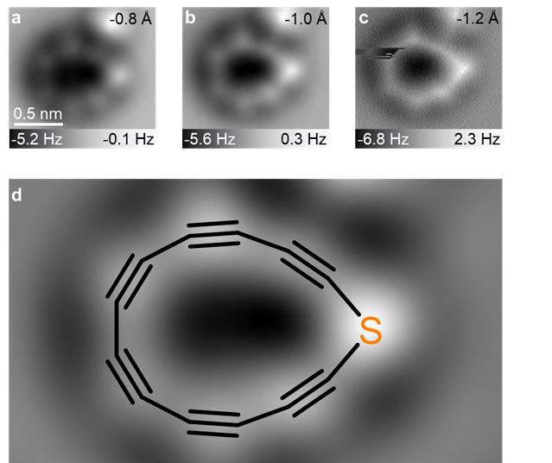
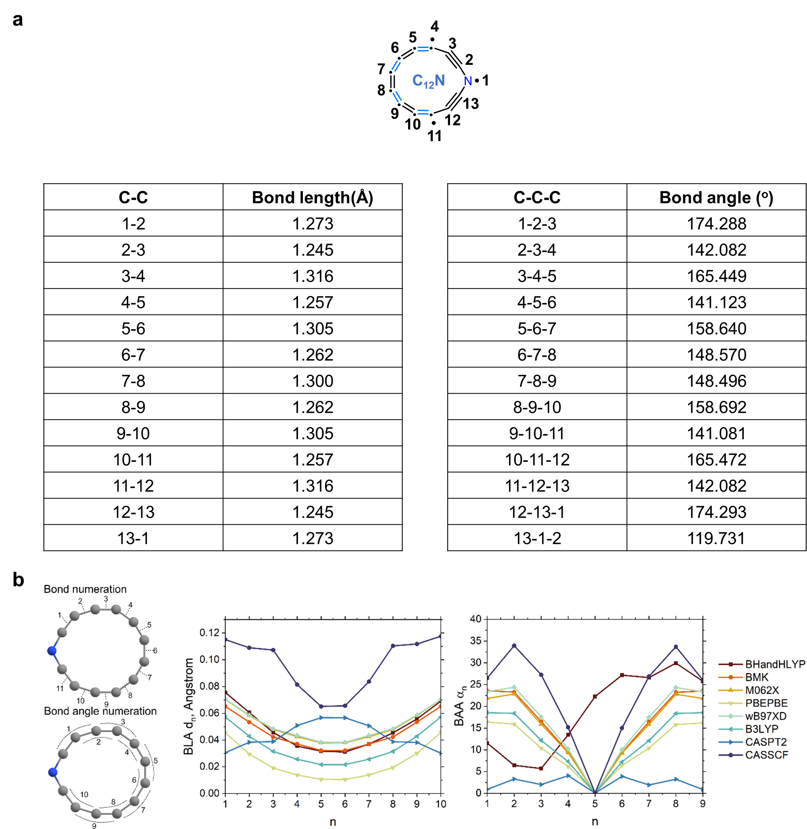
Fig. S5. AFM images of C₁₂S at different tip heights. AFM images (a to c) of C₁₂S at different tip heights (Δz) acquired with a CO-terminated tip. (d) Laplace-filtered AFM image of C₁₂S superimposed with molecular model. Reference set point of Δz: I = 0.5 pA, V = 0.3 V.
Fig. S6. Structural characterization of C₁₂N. (a) The bond lengths and bond angles in C₁₂N. Calculations were conducted at the ωB97XD/6-311++G(d,p) level. (b) Bond length alternation (BLA) and bond angle alternation (BAA) descriptors calculated at different levels of theory.

We have considered the structure of C₁₂N in its ground state by using DFT and ab initio calculations. We have found that the C₁₂N radical sustains the round-shaped form with a slight kink at the CNC centre. This is the sequence of delocalization of the unpaired electron over the whole C₁₂N ring but not localizing on the N atom. The trends in BLA are closely similar between all the DFT methods which predict it in the range 0.01-0.08 Å. CASSCF(8x8) optimized structure shows a the similar BLA trend to DFT with a more pronounced magnitude (Fig. S6b), while the CASPT2 method predicts the other trend of BLA which approximately corresponds to the inversion of bond orders in the ring (co-called bond shift). At the same time the BAA descriptor (Fig. S6b) demonstrates basically the same trend with all employed methods, while the only the BHandHLYP functional predicts a distorted geometry of C₁₂N which is probably the impact of the high percentage of HF exchange in the functional.

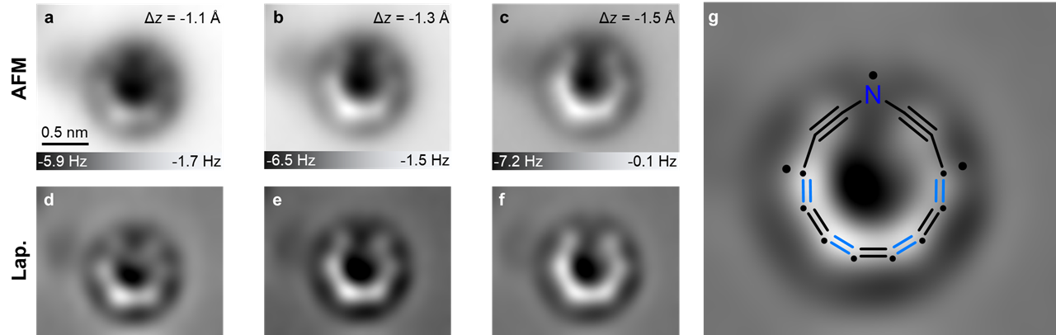

Fig. S7. AFM images of C₁₂N at different tip heights. AFM images (a to c) and Laplace-filtered AFM images (d to f) of C₁₂N at different tip heights (Δz) acquired with a CO-terminated tip. (g) Laplace-filtered AFM image of C₁₂N superimposed with molecular model. Reference set point of Δz: I = 0.5 pA, V = 0.3 V.
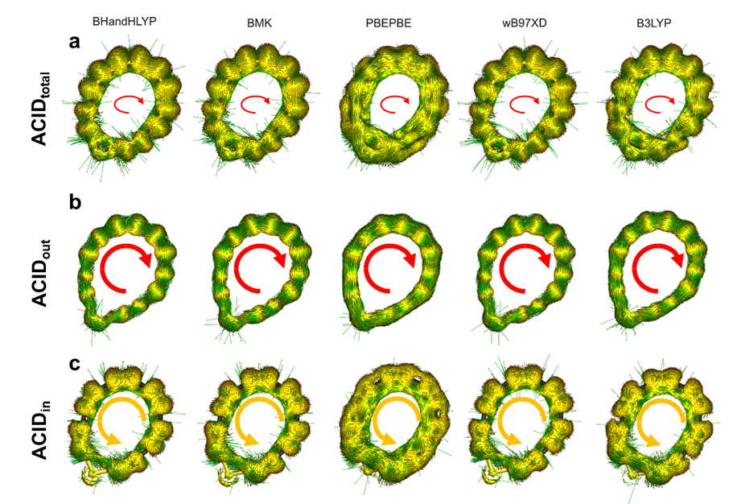

Fig. S8. ACID plots for C₁₂S calculated at different levels of DFT. (a) ACID_{total}. (b) ACID_{out}. (c) ACID_{in}. The external magnetic field B is perpendicular to the ring plane and points upward.

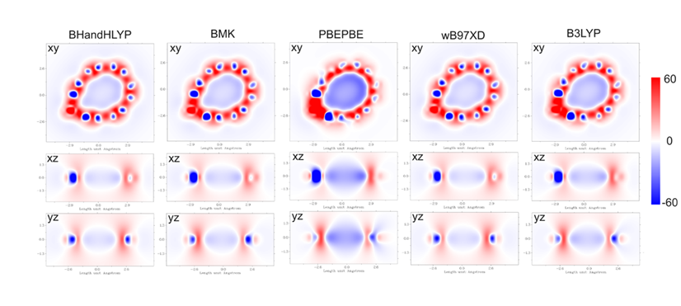Fig. S9. 2D ICSSzz plots for C₁₂S molecule calculated by different DFT methods and presented in different projections. The external magnetic field B is perpendicular to the ring plane and points upward.

ICSSzz plots (Fig. S9) confirms the presence of diatropic out-of-plane and paratropic in-plane induced currents–there is clear area inside the ring (xy projections) characterized by negative values of the magnetic shielding tensor (zz-component) indicating the antiaromaticity and out-of-plane area (xz and yz projections) characterized by positive values of magnetic shielding tensor (zz-component) indicating the aromaticity. It is also clearly seen from the xz and yz projections in the ICSS plots that the negative shielding area (blue colour) is limited in space only by the area inside the ring, while the positive shielding area is localized up and down with respect to the molecular plane and envelop the negative shielding area.
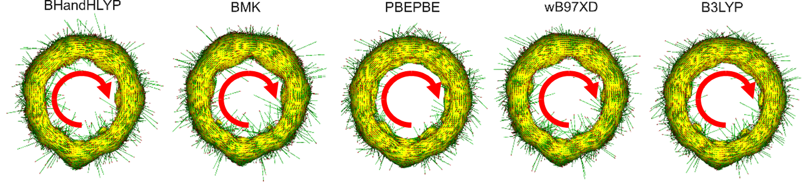
Fig. S10. Total ACID plots for C₁₂N calculated at different levels of DFT.

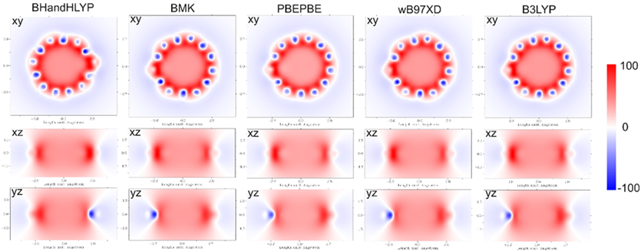

Fig. S11. 2D ICSS_{zz} plots for C₁₂N molecule calculated at different DFT methods and presented in different projections.

References
1 SAINT; part of Bruker APEX5 software package (version 2023.9-2): Bruker AXS. (2023).
2 SADABS; part of Bruker APEX5 software package (version 2023.9-2): Bruker AXS. (2023).
3 Sheldrick, G. SHELXT - Integrated space-group and crystal-structure determination. Acta Cryst. A 71, 3-8 (2015).
4 Sheldrick, G. Crystal structure refinement with SHELXL. Acta Cryst. C 71, 3-8 (2015).
5 Dolomanov, O. V., Bourhis, L. J., Gildea, R. J., Howard, J. A. K. & Puschmann, H. OLEX2: A complete structure solution, refinement and analysis program. J. Appl. Crystallogr. 42, 339-341 (2009).
6 Stradi, D., Jelver, L., Smidstrup, S. & Stokbro, K. Method for determining optimal supercell representation of interfaces. J. Phys.: Condens. Matter 29 (2017).
7 Jelver, L., Larsen, P. M., Stradi, D., Stokbro, K. & Jacobsen, K. W. Determination of low-strain interfaces via geometric matching. Phys. Rev. B 96, 085306 (2017).
8 Baryshnikov, G. V., Valiev, R. R., Kuklin, A. V., Sundholm, D. & Ågren, H. Cyclo[18]carbon: Insight into electronic structure, aromaticity, and surface coupling. J. Phys. Chem. Lett. 10, 6701-6705 (2019).

