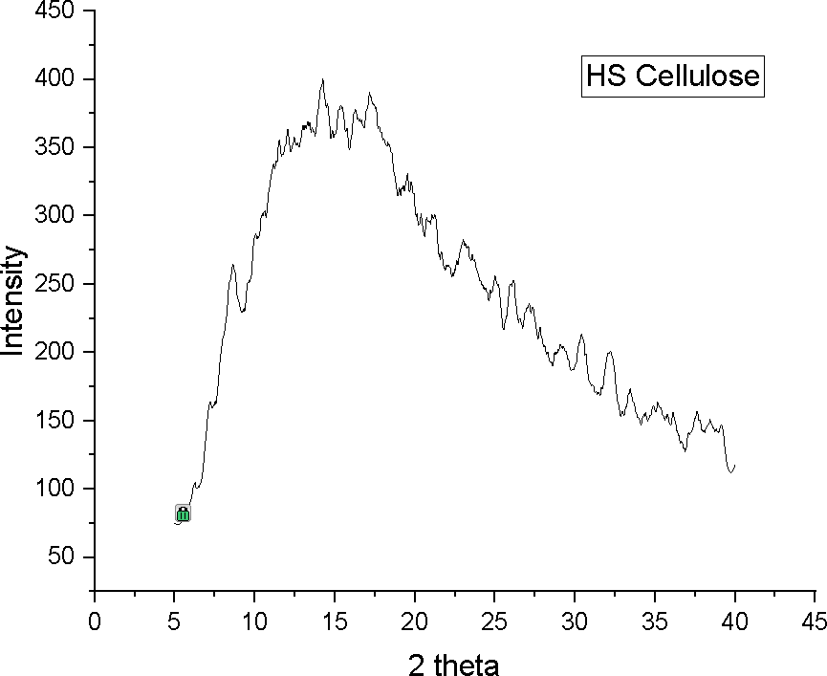
Figure 1: XRD graph of bacterial cellulose produced using HS media.

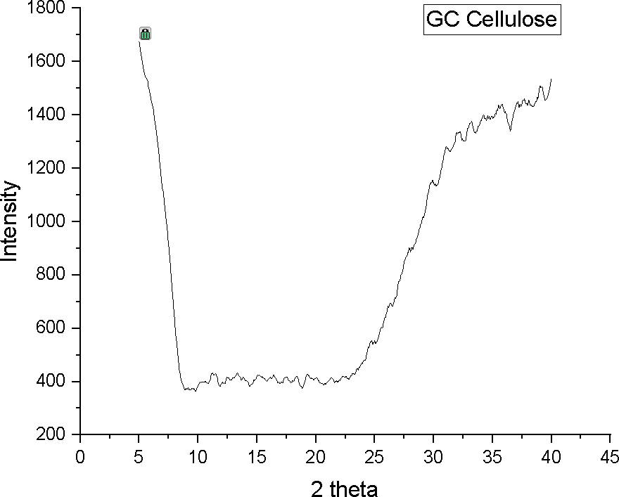
Figure 2: XRD graph of glucose cellulose.
Table 4: FTIR-ATR spectrum of Bacterial cellulose production through utilizing different culture mediums.

Bond | Wavelength  cm-1 | Standard HS Media | Glucose and utilized tea | Bagasse and utilized tea
O-H bond stretch | 3340 | `3343.22 | 3343.10 | 3343.90
C=O bond stretch | 1630-1690 | 1637.38 | 1638.30 | 1635.54
C ≡C bond stretch | 2100-2250 | 2161.70 | 2161.70 | 2162.42
C-N bond stretch | 1316 | - | 1315.55 | -
C-O-C bond stretch | 1109 | 1109.78 | 1109.33 | 1107.64
C-O bond stretch secondary alcohol | 1085-1050 | 1057.96 | 1057.45 | 1056.08
C-O bond stretch | 1030 | - | 1033.55 | 1032.65

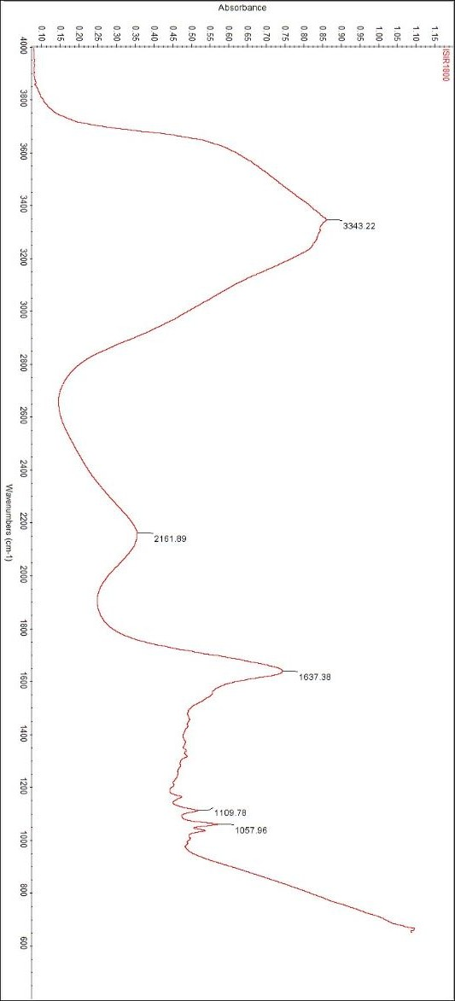
Figure 1: FTIR-ATR
spectrum of Bacterial cellulose produced by HS media
.

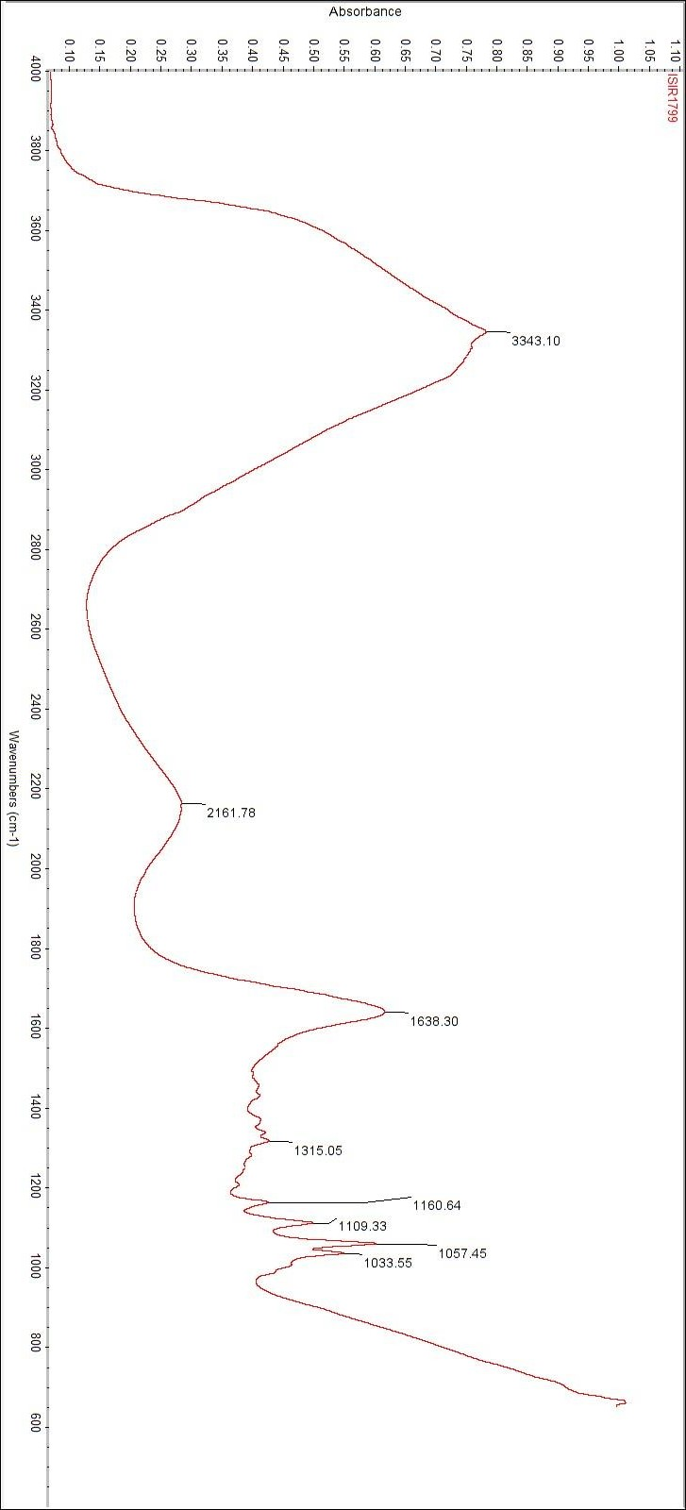
Figure 2: FTIR-ATR spectrum of Bacterial cellulose produced by Glucose and Utilized tea.

Table 3: pH measurements of different culture mediums before and after the addition of SCOBY.
Substrate | pH before the addition of SCOBY | pH after the addition of SCOBY
Standard HS media | 6 | 4.5
100ml Bagasse and utilized tea | 5 | 4
300ml Bagasse and utilized tea | 5 | 4
300ml Bagasse and utilized tea | 5 | 4
Glucose and utilized tea | 6 | 4

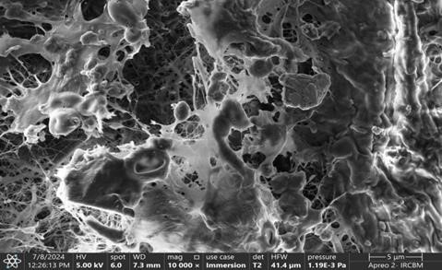

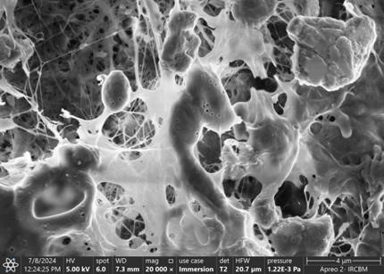

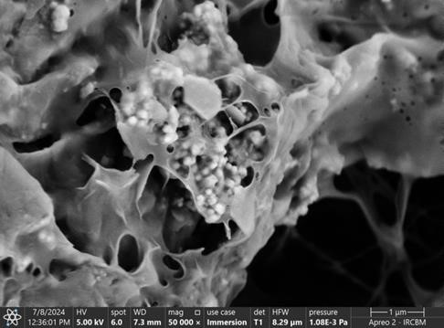

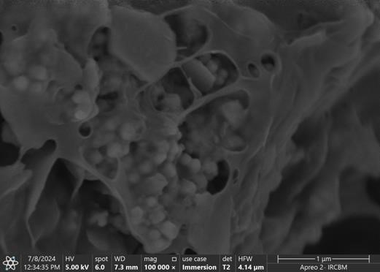

Figure 6: FE-SEM analysis of sugarcane bagasse bacterial cellulose at a magnification range of 5000X, 8000X, 10,000X, 20,000X, 50,000X and 100,000X.

