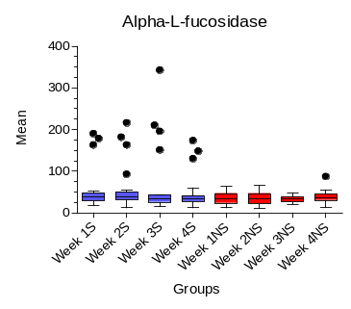
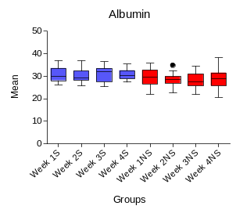
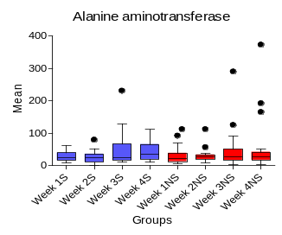
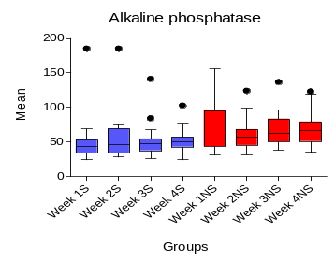
A
C
B
D

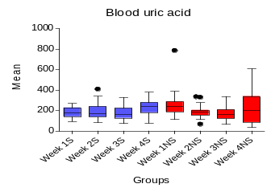
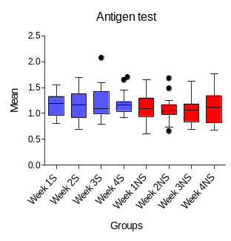
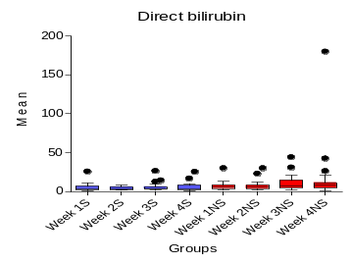
G
E
H
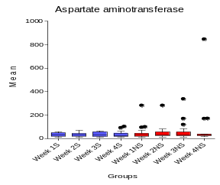
F

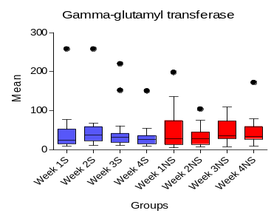
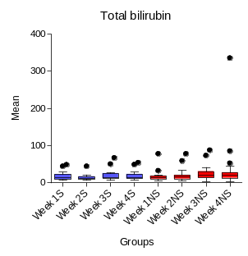
I
L
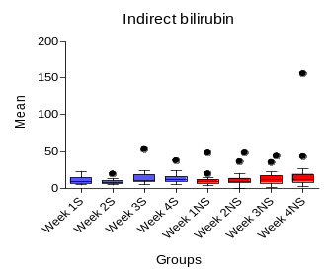
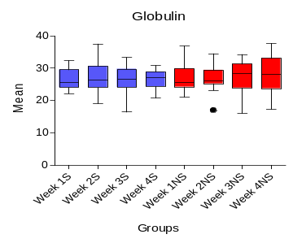
K
J000000

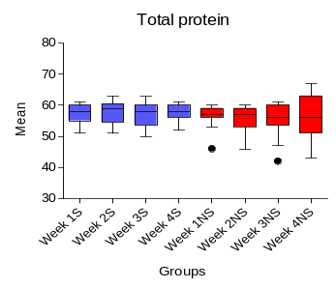
M

Supplementary figure 1. The non-significant results of biochemical blood tests in survivors (S) and non-survivors (NS) groups during the four weeks. A) Alpha-L-fucosidase. B) Alanine aminotransferase. C) Albumin. D) Alkaline phosphatase. E) Antigen test. F) Aspartate aminotransferase. G) Blood uric acid. H) Direct bilirubin. I) Gamma-glutamyl transferase. J) Globulin. K) Indirect bilirubin. L) Total bilirubin. M) Total protein.

Supp. Fig. 1

