Supplementary Materials for

Two-step grain boundary diffusion mechanism of a dopant accompanied by structural transformation

Chuchu Yang¹, Bin Feng^{1,2}*, Toshihiro Futazuka¹, Naoya Shibata^{1,3}, Yuichi Ikuhara^{1,3,4}*

*Corresponding author. Email: feng@sigma.t.u-tokyo.ac.jp, ikuhara@sigma.t.u-tokyo.ac.jp

This file includes:

Supplementary Note 1-5
Supplementary Figs. 1-8
Supplementary Tables 1-2
References

Supplementary Note 1: Calculation of GB energies of Ti-segregated GBs.
In the supercell approach, we can calculate the GB energy $σ_{GB}$ using the following equation,
$σ_{GB}=\left(E_{tot}^{GB}-\sum_{i}{n_{i}μ_{i}}\right)/\text{2}S$ (1)
$E_{tot}^{GB}$ is the total energy of the supercell including two GBs, $n_{i}$ is the number of constituent atoms (i = Al, O, Ti), $μ_{i}$ is the chemical potential of element i, and S is the GB area. The GB energy of the pristine GB can be expressed as
$σ_{GB,pri}=\left(E_{tot}^{GB,pri}-n_{Al}^{GB,pri}μ_{Al}-n_{O}^{GB,pri}μ_{O}\right)/\text{2}S$ (2)
Here we construct the Ti-segregated GB from the pristine GB as shown in Supplementary Fig. 6. If we introduce n Ti atoms in Al-substitutional form in the bulk region (Supplementary Fig. 6b) and assume that the interactions between Ti atoms in the bulk are negligible, the sum of defect formation energies of Al-substitutional Ti in bulk can be evaluated using the bulk supercell¹:
$nE_{f}^{bulk}=n\left(E_{tot}^{bulk,Ti(1)}-E_{tot}^{GB,pri}-μ_{Ti}+μ_{Al}\right)$ (3)
where $E_{tot}^{ bulk,Ti(1)}$ is the total energy of the GB supercell including one Ti atom in Al-substitutional form in the bulk region.
Then, we can form the Ti-doped GB by moving each Ti atom to the GB core (Supplementary Fig. 6c). Assuming that the interactions between Ti atoms in the GB core are negligible, the total energy difference can be approximated as the sum of segregation energies $E_{seg}$ of the most stable segregation site, which can be expressed as
$nE_{seg}$= $n\left(E_{tot}^{GB,Ti(1)}-E_{tot}^{ bulk,Ti(1)}\right)$ (4)
where $E_{tot}^{GB.Ti(1)}$ is the total energy of the supercell including two GBs with one segregated Ti atom in the GB, and $n$ is the number of Ti atoms in the Ti-segregated GB.
As described in Eq. 1, the GB energy of the Ti-segregated GB $σ_{GB,seg}$ can be expresses as
$σ_{GB,seg}=\left(E_{tot}^{GB,Ti(n)}-(n_{Al}^{GB,pri}{-n) μ}_{Al}-n_{O}^{GB,pri}μ_{O}-nμ_{Ti}\right)/\text{2}S$ (5)
Here, $E_{tot}^{GB,Ti(n)}$ is the total energy of the supercell including two GBs with n segregated Ti atoms in the GB. If the interactions between segregated Ti atoms are negligible, $E_{tot}^{GB,Ti(n)}$ can be expressed as
$$E_{tot}^{GB,Ti\left(n\right)}=\left(E_{tot}^{GB,Ti\left(n\right)}-E_{tot}^{bulk,Ti\left(n\right)}\right)+\left(E_{tot}^{bulk,Ti\left(n\right)}-E_{tot}^{GB,pri}\right)+E_{tot}^{GB,pri}$$$=n\left(E_{tot}^{GB,Ti\left(1\right)}-E_{tot}^{bulk,Ti\left(1\right)}\right)+n\left(E_{tot}^{bulk,Ti\left(1\right)}-E_{tot}^{GB,pri}\right)+E_{tot}^{GB,pri}$ (6)
Using Eq. 3 and Eq. 4, this $E_{tot}^{GB,Ti\left(n\right)}$ can be expressed as
$E_{tot}^{GB,Ti\left(n\right)}=nE_{seg}+n\left(E_{f}^{bulk}+μ_{Ti}-μ_{Al}\right)+E_{tot}^{GB,pri}$ (7)
Inserting Eq. 7 into Eq. 5, and using Eq. 2, we obtain
$$σ_{GB,seg}=\left(E_{tot}^{GB,pri}-n_{Al}^{GB,pri}μ_{Al}-n_{O}^{GB,pri}μ_{o}+nE_{f}^{bulk}+nE_{seg}\right)/\text{2}S$$
$=σ_{GB,pri}+\frac{n}{\text{2}S}\left(E_{f}^{bulk}+E_{seg}\right)$ (8)
Therefore, by using $E_{f}^{bulk}$ and $E_{seg}$, the GB energy of the Ti-segregated GB can be determined from the following equation:
$σ_{GB,seg}=σ_{GB,pri}+Γ_{Ti}(E_{f}^{bulk}+E_{seg})$ (9)
where $Γ_{Ti}=n/\text{2}S$ is defined as Ti segregation amount. Eq. 9 shows the approximate formula for evaluating the GB energy of Ti-doped GB as a function of the amount of Ti excess.

Supplementary Note 2: Diffusion kinetics in this study
To calculate the GB diffusion coefficient $D_{b}$, the type of GB diffusion kinetic is first determined according to Harrison’s classification²⁻⁴, by comparing parameters of $sδ$, $\sqrt{D_{v}t}$, $d$. Here $s$ is the segregation factor, $δ$ is the GB width. $D_{v}$ is the volume diffusion coefficient, which is $\text{2.2}×{10}^{-19}$ m²/s for Ti diffusion in Al₂O₃ according to the previous study⁵. $t$ is the diffusion time, which is 7200 s in this study. $d$ is the spacing between adjacent GBs, which should be infinite in the case of a bicrystal.
To determine $δ$ and $s$, we extracted Ti concentration profiles based on the STEM EDS maps at different diffusion depth positions (see Supplementary Fig. 4). An example in Supplementary Fig. 5 shows the details. From the Ti averaged concentration profile across the GB, we define $δ$ as full width at half maximum (FWHM) of the peak. The volume concentration next to the GB and the average GB segregation concentration can be obtained as$c_{v}=f\left(-δ/2\right)= f(δ/2)$ and $c_{b}=\int_{ -δ/2}^{δ/2}{f(x)dx/δ}$, respectively. Then, we can deduce the solute segregation factor s, which is determined as $s=c_{b}/c_{v}$. The results are summarized in Supplementary Table 1.
Taking these parameters into account, the present study meets the condition of

$sδ≪\sqrt{D_{v}t}≪ d$ (10)
Therefore, the GB diffusion behavior of Ti can be classified as type B kinetics according to the Harrison classification².

Supplementary Note 3: Calculation of GB diffusion coefficients for Ti diffusion along asymmetric Al₂O₃ Σ7 GB.
For Type B kinetics, GB diffusion product $P=sδD_{b}$ can be determined by the following equation for constant-source conditions⁶⁻⁷, if we assume the GB diffusion along asymmetric GB satisfies such condition during the whole diffusion process:

$P= sδD_{b}=\text{1.322}{\left(D_{v}/t\right)}^{\text{1}/\text{2}}{\left(-∂lnc_{Ti}/{∂y}^{\text{6}/\text{5}}\right)}^{-\text{5}/\text{3}}$ (11)
The $∂lnc_{Ti}/{∂y}^{\text{6/5}}$ term can be obtained from the experimental diffusion profiles (Fig. 4 in the main text), where $c_{Ti}$ is the GB concentration of Ti, y is the Ti diffusion depth. Therefore, $D_{b}$ can be obtained by $D_{b}=P/sδ$, where averaged GB width and average segregation factor were used for the calculation (Supplementary Table 1).
As for the Ti diffusion time $t(A)$ in the asymmetric GB, it is equivalent to the total annealing time of 7200 s. According to Eq. 11, the range of $D_{b}(A)$ can be calculated which is shown in Extended Data Table 1.

Supplementary Note 4: Calculation of GB diffusion coefficients for Ti diffusion along symmetric Al₂O₃ Σ7 GB.
To calculate the GB diffusion coefficient D_{b}(S) in the symmetric GB, it is necessary to determine the diffusion time t(S) in the symmetric GB. However, as Ti diffusion in the symmetric GB begins with the initiation of GB structural transformation, t(S) cannot be precisely determined. Therefore, we have approximately estimated t(S) to calculate the D_{b}(S).
Supplementary Fig. 7a-c illustrates the entire diffusion process. Initially, Ti diffuses along the asymmetric GB. At time t₁, the GB structure undergoes a transformation due to Ti accumulation reaching a critical threshold. The total diffusion length in the asymmetric GB at this point is L₁. Following t₁, Ti starts diffusing along both symmetric and asymmetric GBs for time t₂, which corresponds to t(S). During t₂, Ti continues to diffuse in the asymmetric GB, extending the diffusion length of asymmetric GB from L₁ to L₂ (where L₂> L₁). The total diffusion time is t_{total} = t₁+t₂ = 7200 s.
Although t₂ cannot be precisely determined, we can estimate a range for t₂ and consequently calculate a range of D_{b}(S) as described follows.
First, t₂ must satisfy t₂ < t_{total}. By calculating diffusion coefficient using t_{total}, we get D_{b}(S)’ which satisfies D_{b}(S)’< D_{b}(S). In addition, we can also estimate t₂ if t₁ is known, which can be obtained by L₁ and D_{b}(A) (determined in Supplementary Note 3). Since L₁ can not be measured, we use the dataset of L₂ instead of L₁ to approximate t₁, denoted as t₁’. This approximation is justified because both L₁ and L₂ corresponds to the diffusion in the asymmetric GB, and it is technically feasible by re-plotting $lnc_{Ti}$ vs $y^{\text{6}/\text{5}}$ curve using a modified data from Supplementary Table 2, where the depth position (y) of the asymmetric GB in Supplementary Table 1 was modified to fit the case of Supplementary Fig. 7d. Given that L₂> L₁, we have t₁’>t₁, implying t₂’< t₂. Using t₂’, the GB diffusion coefficient can be calculated as D_{b}(S)’’, which satisfies D_{b}(S)’’> D_{b}(S).
Consequently, we conclude the value of D_{b}(S) lies within the range
D_{b}(S)’ < D_{b}(S) < D_{b}(S)’’
and the results are shown in Extended Data Table 1 in the main text.

Supplementary Note 5: Estimation of the Ti segregation amount in structural transition region from STEM EDS analysis.
To directly compare the Ti concentration between the calculation and experimental results, the Ti segregation amount $Γ_{Ti}$ were determined by STEM EDS analysis from the following equation⁸⁻⁹:
$Γ_{Ti}=\frac{n_{Ti}}{S}=\frac{ρ_{{Al}_{2}O_{3}} V}{A_{{Al}_{2}O_{3}}}∙\frac{2A_{Al}}{C_{Al}}∙\frac{C_{Ti}}{A_{Ti}}∙\frac{N_{A}}{S}=\frac{V}{S}∙\frac{ρ_{{Al}_{2}O_{3}} }{A_{{Al}_{2}O_{3}}}∙\frac{{\text{2}A}_{Al}}{A_{Ti}}∙\frac{C_{Ti}}{C_{Al}}∙N_{A}$ (12)
where $n_{Ti}$ is the number of Ti atoms, $V$ and $S$ are the volume measured by STEM EDS and the area of the GB plane, respectively. $ρ_{{Al}_{2}O_{3}}$ is the matrix density (kg/m³). $A_{{Al}_{2}O_{3}}$ is the atomic mass of Al₂O₃ (kg/mol). $c_{Al}$ and $c_{Ti}$ are the weight fraction (wt.%) of Al and Ti, respectively. $N_{A}$ is Avogadro’s number.
From STEM EDS analysis, we can determine the weight fraction of Al and Ti in the structural transition region. The weight fraction of Ti in a wide region across the GB (7.5 nm * 1.2 nm, shown in Supplementary Fig. 8) is 1.2 $±$ 0.1 wt.%. Therefore, the excess of Ti at this region was determined to be 2.4 $±$ 0.2 nm⁻² using Eq. 12.

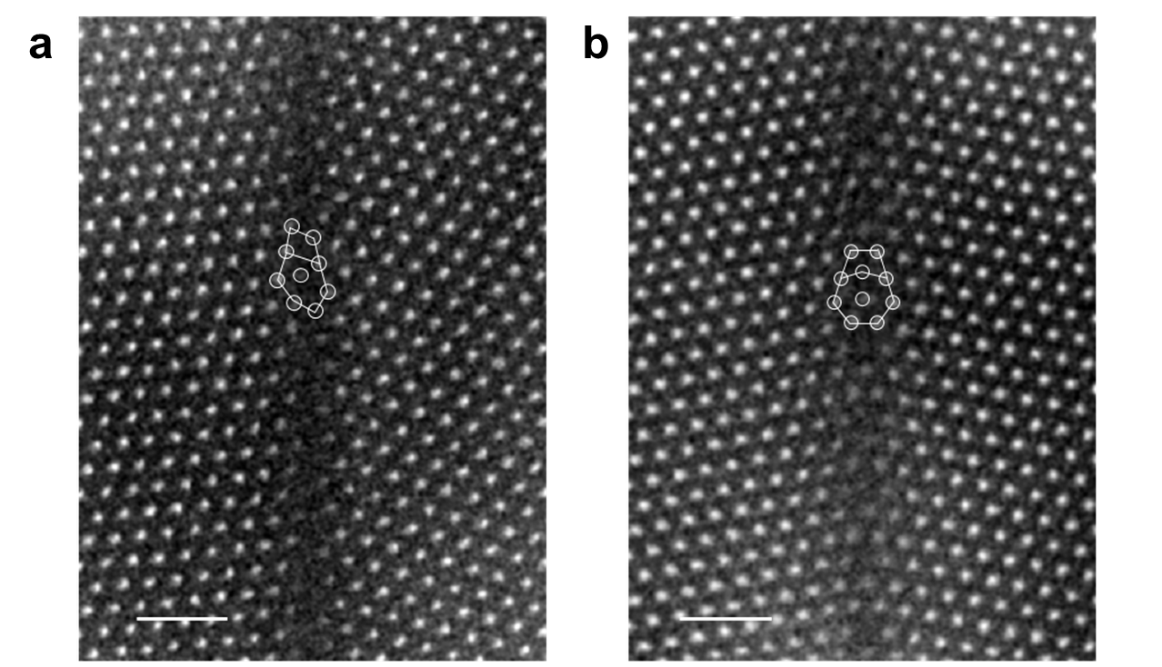
Supplementary Fig. 1 Atomic structures of the undiffused and Ti-diffused GBs observed at 1300ºC. a, HAADF STEM image of the undiffused GB. b, HAADF STEM image of the Ti-diffused GB. The white circles and lines illustrate GB structural units.

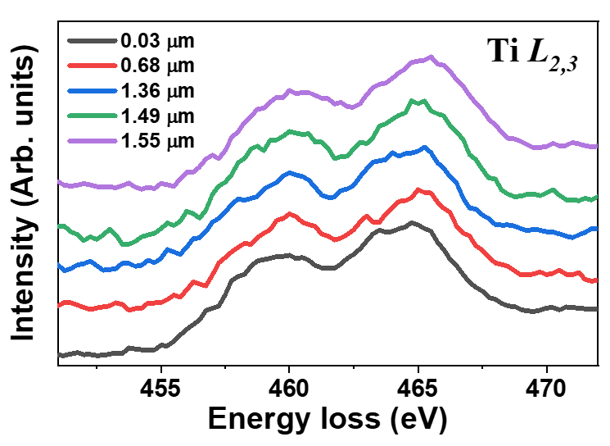
Supplementary Fig. 2 EELS spectra of Ti L_{2,3} edges recorded in the GBs of different diffusion depths (see Fig. 2 in the main text). The two prominent peaks indicate that the valence state of Ti in the GB is trivalent.
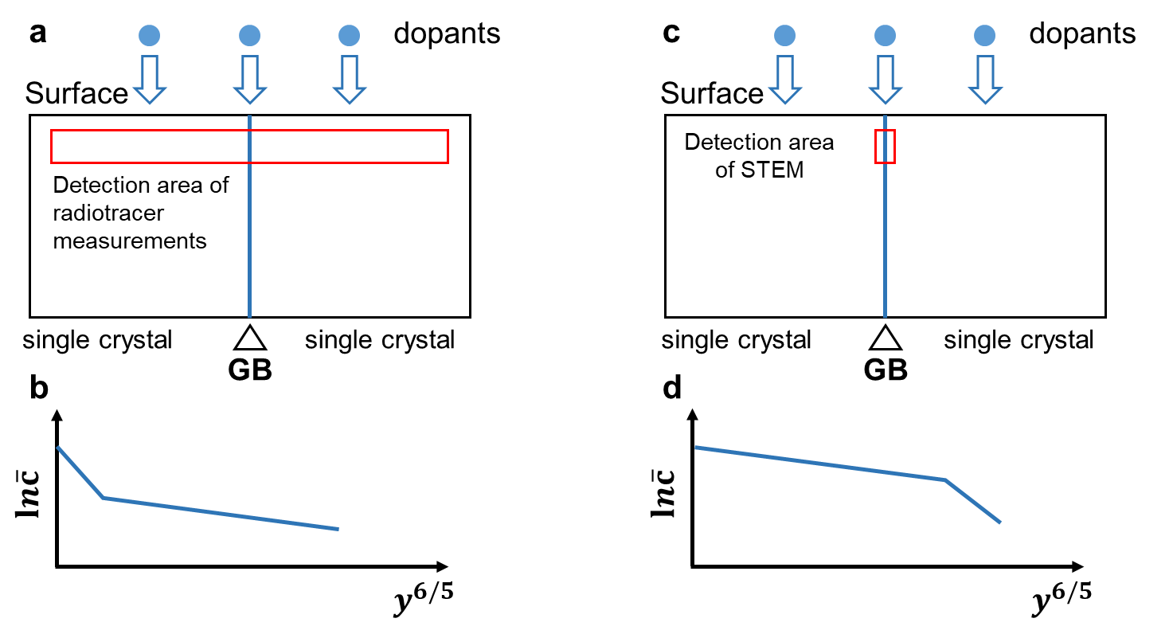Supplementary Fig. 3 Schematics of detection area used in in different experimental setups. The red box represents the detection area. a, Detection area for conventional experimental approaches such as radiotracer measurement or secondary ion mass spectrometry, with its typical diffusion profile shown in b. c, Detection area for STEM, with the diffusion profile obtained from this study shown in d.

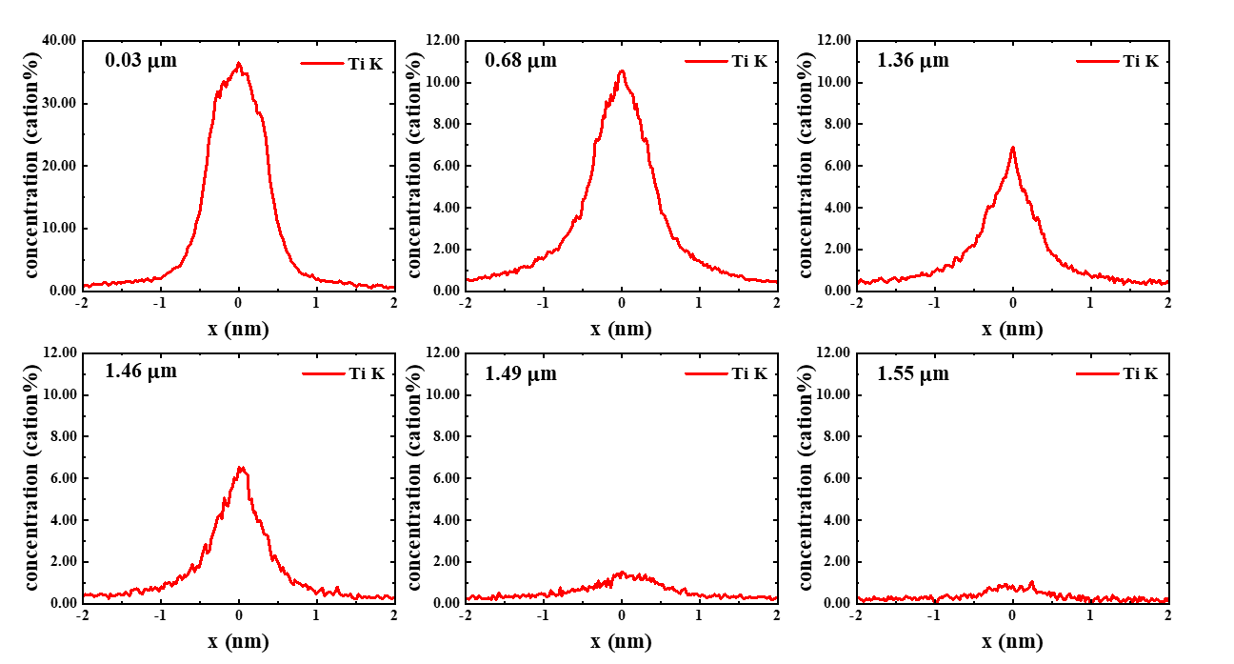
Supplementary Fig. 4 Ti concentration profiles based on the STEM EDS maps at different diffusion depths (see Fig. 2 in the main text).
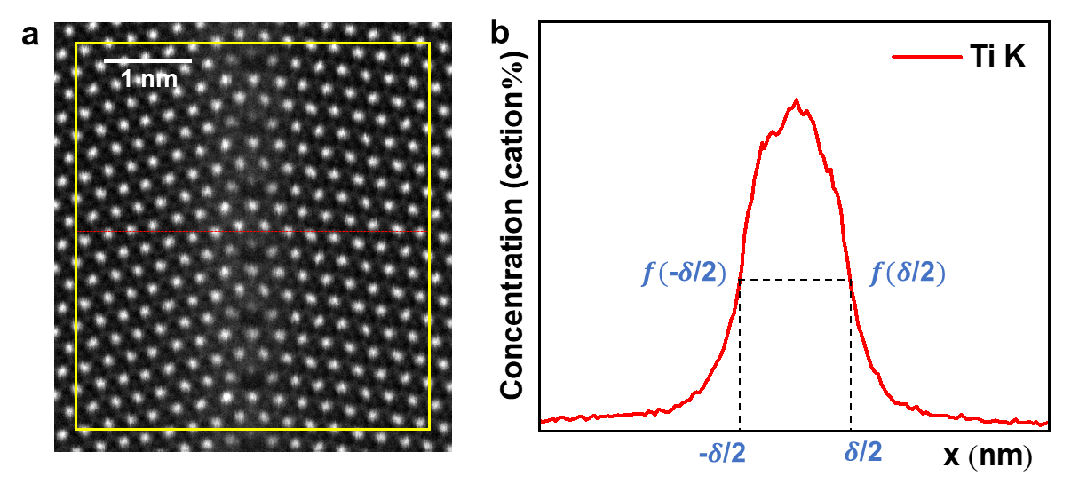
Supplementary Fig. 5 An example of determining the solute segregation factor s based on the Ti concentration profile. a, A representative HAADF STEM image with averaged line scan along the direction perpendicular to the GB, as shown by the red dotted line. The area for extracting spectral data is within the yellow rectangle and the GB length covers six structural units. b, Ti concentration profile from the line scan. $δ$ is the effective GB width. The volume concentration next to the GB is defined as$c_{v}=f\left(-δ/2\right)= f(δ/2)$, and the average GB concentration is $c_{b}=\int_{ -δ/2 }^{δ/2 }{f(x)dx/δ}$. Therefore, the solute segregation factor $s=c_{b}/c_{v}$ can be deduced.

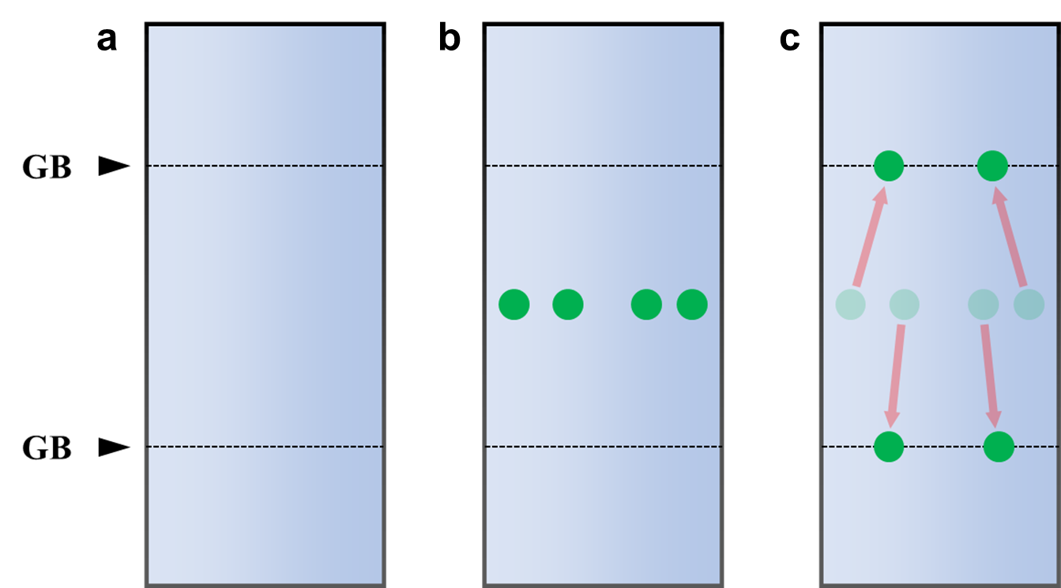
Supplementary Fig. 6 Schematics of the construction of Ti-segregated GB from pristine GB. a, The schematics of the supercell with two equivalent pristine GBs. b, The introduction of n Ti atoms into the bulk. c, Moving n Ti atoms to the GB.

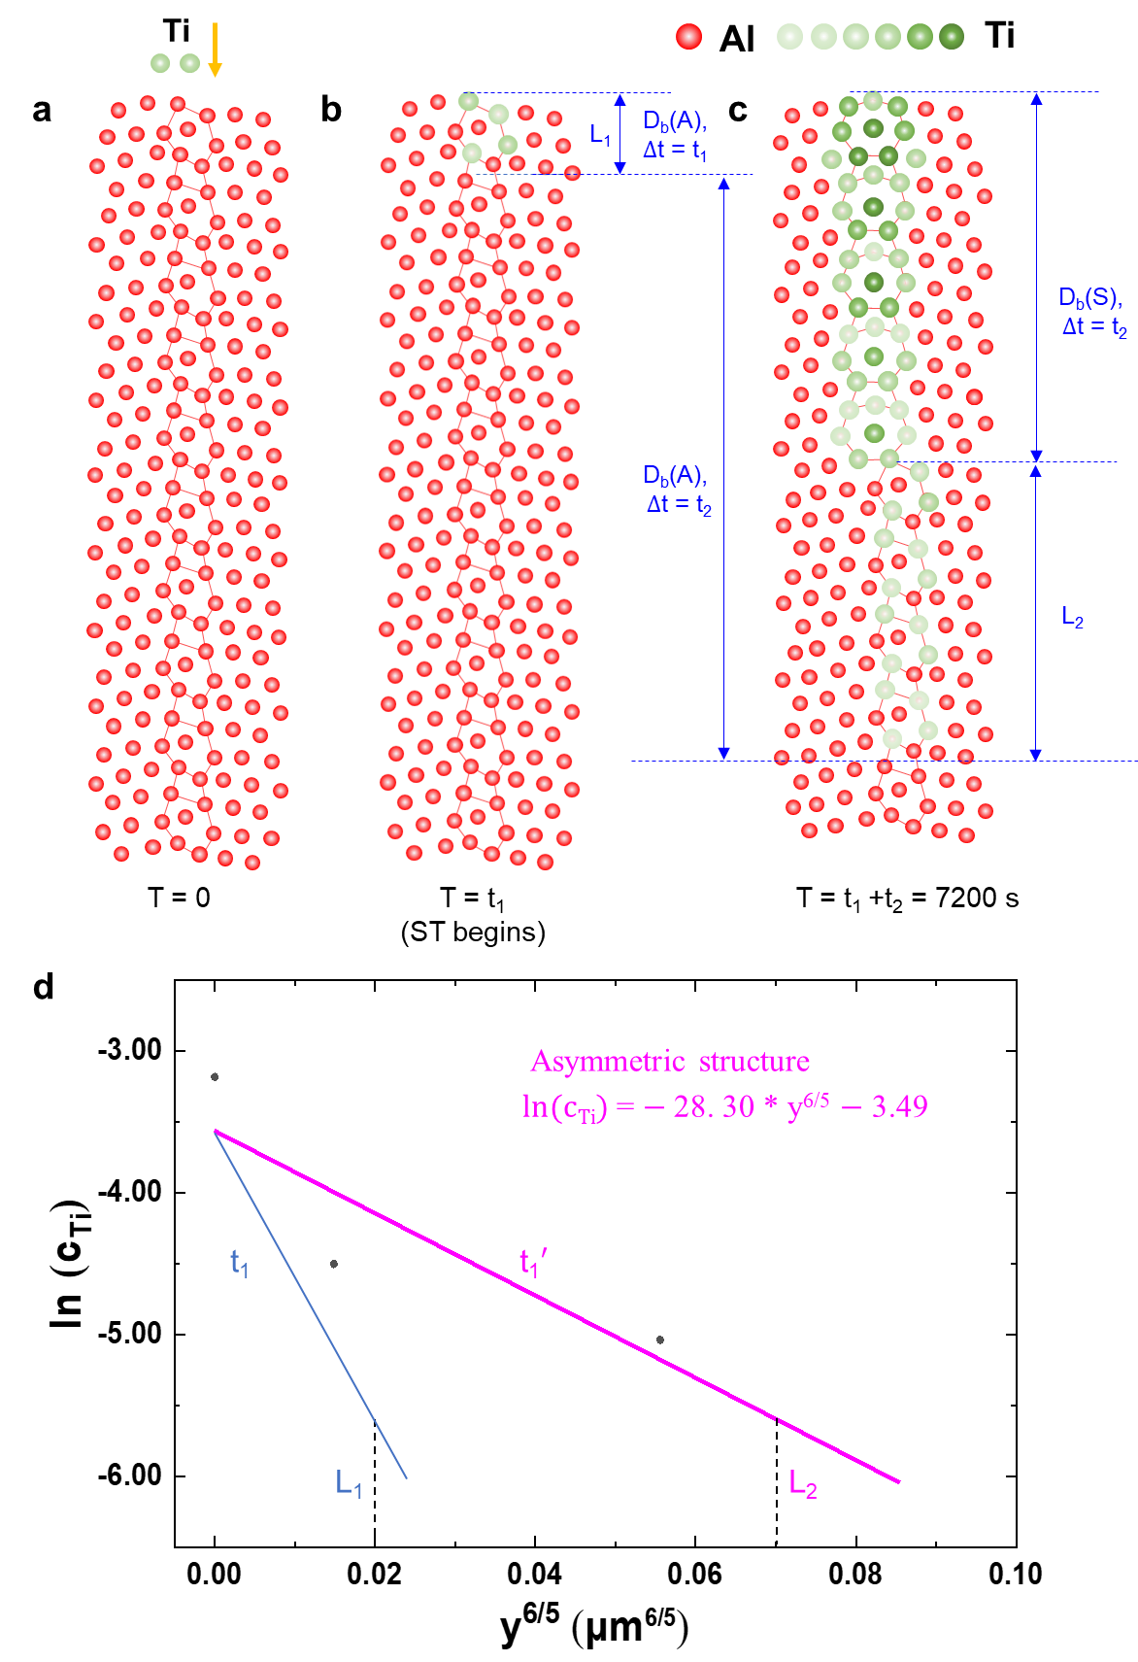
Supplementary Fig. 7 Estimation of Ti diffusion time in the symmetric Al₂O₃ Σ7 GB. a-c, Schematic diagram showing the Ti diffusion process. t₁ and t₂ are the duration from a to b and b to c, respectively. L₁ and L₂ are Ti segregation depths in the asymmetric GB at t₁ and at t₁+t₂, respectively. d, $lnc_{Ti}$ vs $y^{\text{6}/\text{5}}$ plot for Ti diffusion in the asymmetric Al₂O₃ Σ7 GB. The solid circles indicate data based on EDS quantitative analysis (see Supplementary Table 2). The magenta solid line represents the corresponding fit. The blue solid line indicates the possible real plot.
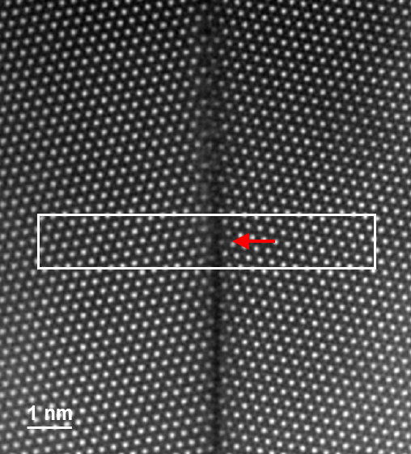
Supplementary Fig. 8 The HAADF STEM image of the structural transition region. The horizontal red arrow indicates the position of structural transition, where a step was formed. The white rectangle of 7.5 nm * 1.2 nm shows the region for estimation of the amount of Ti excess.

Supplementary Table 1 Analysis results of the GB width and the Ti segregation factor based on Supplementary Fig. 2.
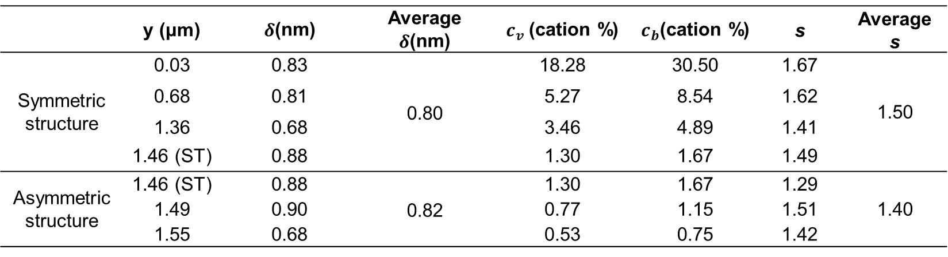

Supplementary Table 2 Modified quantitative STEM EDS data for the asymmetric GB structure in Supplementary Table 1. The depth position (y) is modified according to Supplementary Fig. 7b.
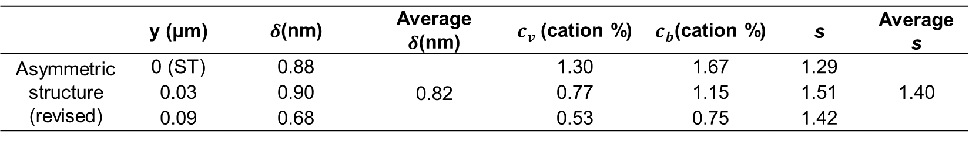

Supplementary references
1. Freysoldt, C. et al. First-principles calculations for point defects in solids. Rev. Mod. Phys. 86, 253–305 (2014).
2. L. G. Harrison, Influence of dislocations on diffusion kinetics in solids with particular reference to the alkali halides. Trans. Faraday Soc. 57, 1191–1199 (1961).
3. A. D. Le Claire, The analysis of grain boundary diffusion measurements. Br. J. Appl. Phys. 14, 351–356 (1963).
4. Y. Mishin, C. Herzig, Grain boundary diffusion: Recent progress and future research. Mater. Sci. Eng. A 260, 55–71 (1999).
5. T. Nakagawa, A. Nakamura, I. Sakaguchi, N. Shibata, T. Mizoguchi, T. Yamamoto, H. Haneda, N. Ohashi, Y. Ikuhara, Cation diffusion along basal dislocations in sapphire. Acta Mater. 59, 1105–1111 (2011).
6. H. Mehrer, Diffusion in Solids: Fundamentals, Methods, Materials, Diffusion-Controlled Processes (Springer Science & Business Media, 2007).
7. I. Kaur., Y. Mishin, W. Gust, Fundamentals of Grain and Interphase Boundary Diffusion (Wiley, 1995).
8. V. Keast, D. Williams. Quantification of boundary segregation in the analytical electron microscope. J. Microsc. 199, 45–55 (2000).
9. R. Akiva, A. Berner, W. D. Kaplan. The solubility limit of CaO in α-alumina at 1600 ºC. J. Am. Ceram. Soc. 96, 3258–3264 (2013).

