Extended Data Figures

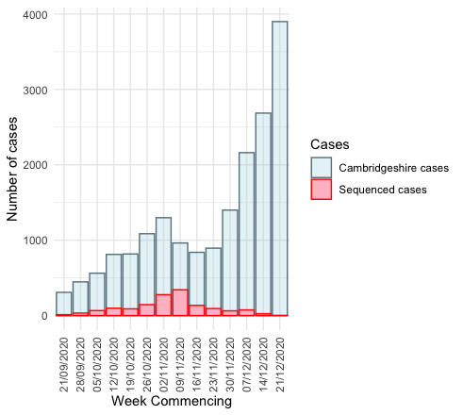

Extended Data Figure 1: Bar chart demonstrating the total number of Cambridgeshire cases including local community, university and hospital (light blue) and corresponding numbers of high-quality sequences available for the study.

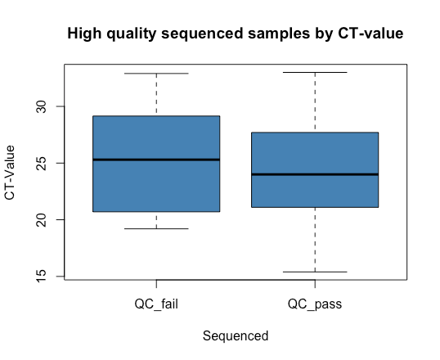

Extended Data Figure 2: Box plot to demonstrate difference in cycle threshold (Ct) values of those samples passing quality control (QC) thresholds to meet sequence inclusion criteria (<5% ‘N’ count and > 29000Kb file size) and those that did not. The difference between the Ct values of samples that passed QC versus those that did not was not significant (two-sample t-test, p = 0.27)

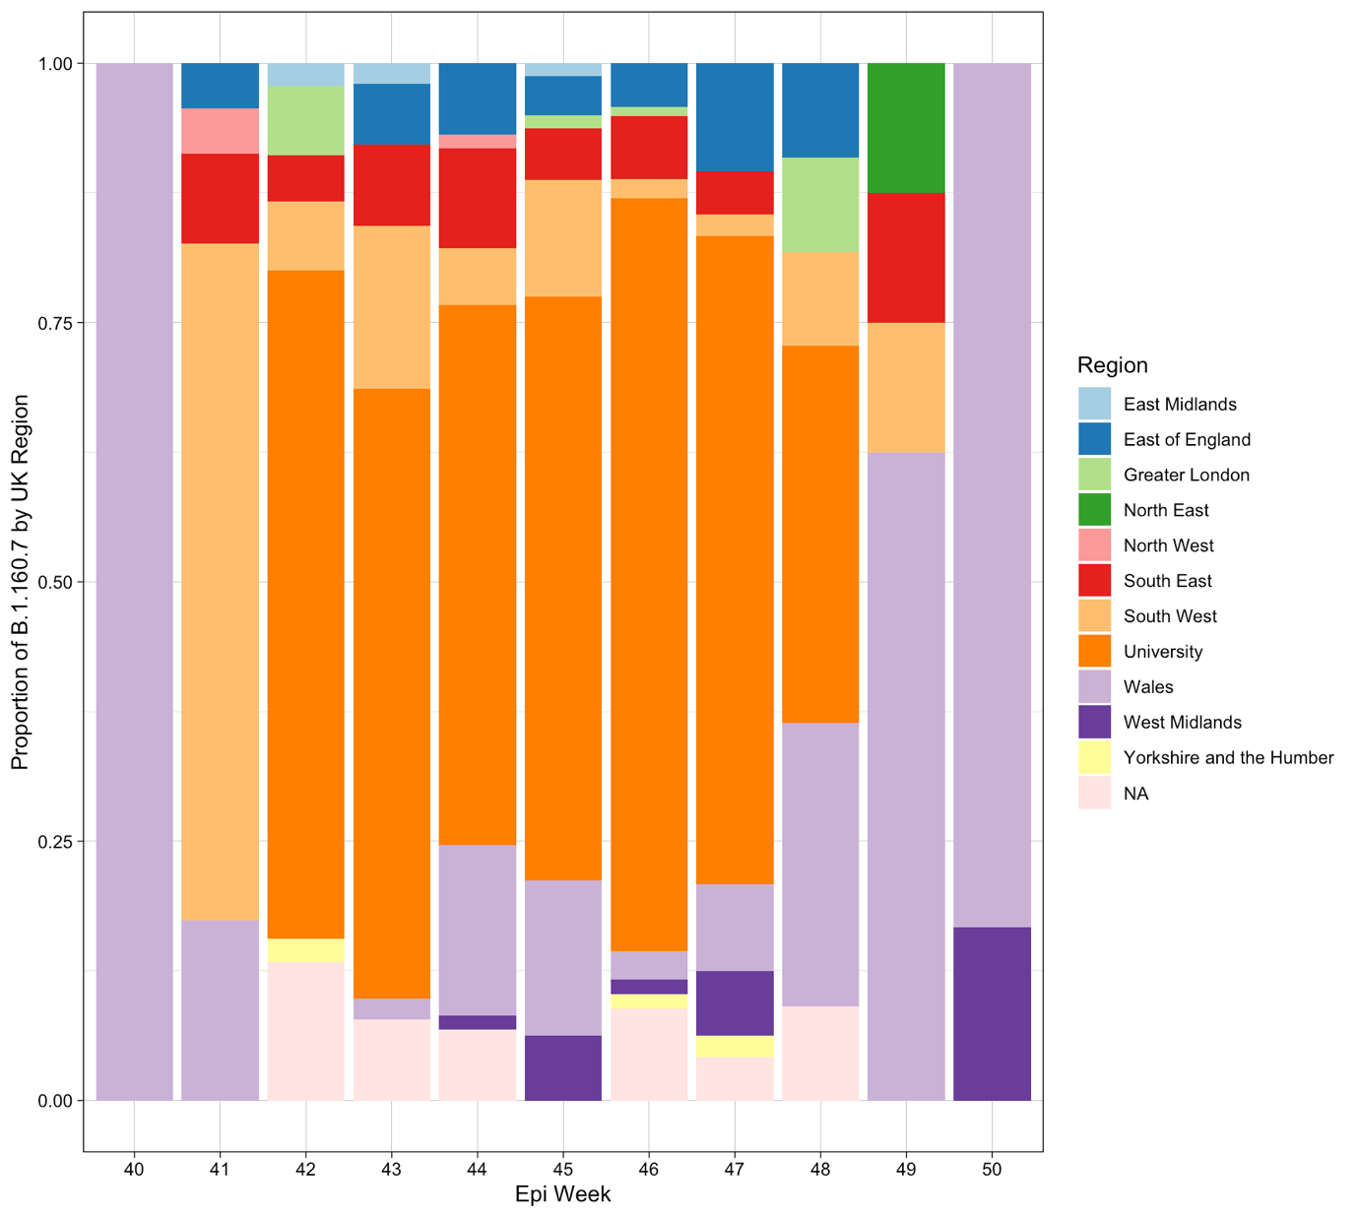
Extended Data Figure 3: Proportion of Lineage B.1.160.7 (to which cluster 1 belongs) sequences in each region of the UK. Regions are defined as ‘Nomenclature of territorial units for statistics’ (NUTS) regions, where the UK has 9 regions. Lineage B.1.160.7 was first sequenced in Wales, and then in the neighbouring South West of England, before the greatest proportion are found to be within the University of Cambridge.

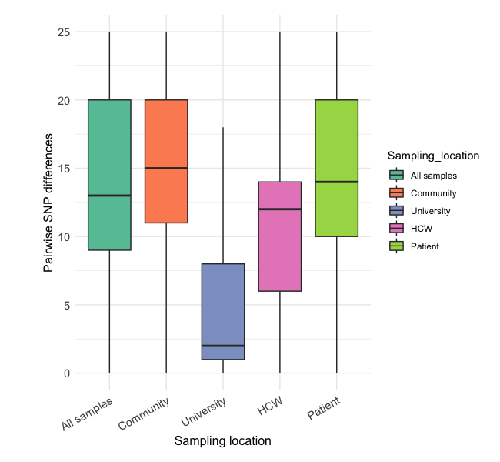
Extended Data Figure 4: The SNP difference among university students was much lower (Wilcoxon signed-rank test, p-value < 2.2e-16) than among the rest of the Cambridgeshire community, reflecting the establishment of fewer persistently transmitting lineages.

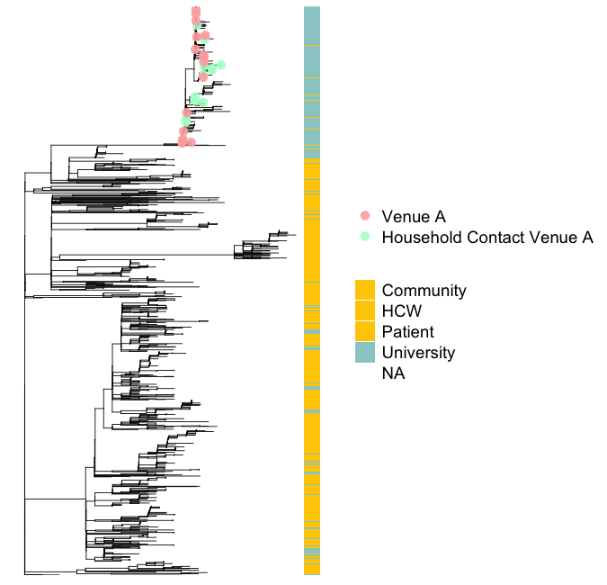
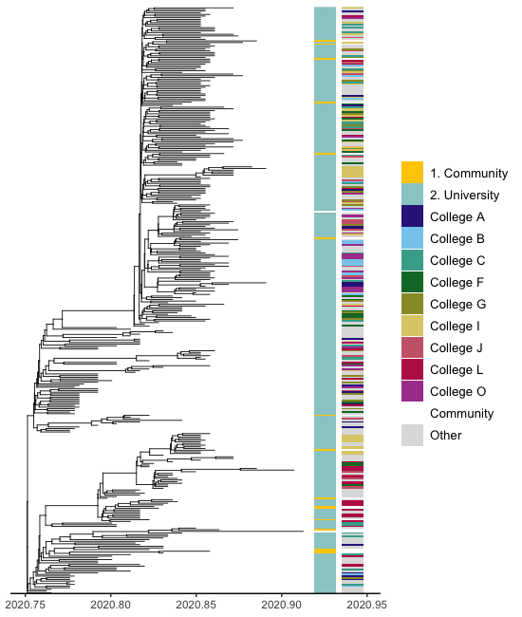

CLUSTER 1

Extended Data Figure 5: Maximum Likelihood Tree of all isolates in the study demonstrating phylogenetic association of positive SARS-CoV-2 cases associated with Venue A. Venue A attendees (pink node leaves/tree tips) and household contacts of individuals who visited Venue A (green node leaves/tree tips) but were not sequenced are highlighted on the tree, located on Cluster 1. This venue was implicated as a possible source for the dispersion of SARS-CoV-2 across the university and increased transmission in the weeks around national lockdown. The vertical panel represents cases by location (general community and university affiliated members).

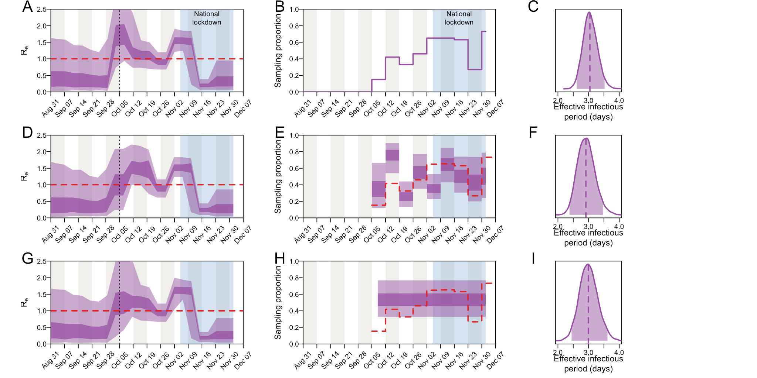
Extended Data Figure 6: Parameter estimates of cluster 1 with the birth-death skyline model when R_{e} is parameterised into 20 equidistantly spaced epochs, under different parameterisations of the sampling proportion: (A-C) fixed to the empirical estimates (number of sequenced genomes from all University clusters divided by the number of positive tests among University staff and students), (D-F) fixed to 0 before the start of term and estimated for each week thereafter, and (G-I) fixed to 0 before the first week of term and assumed to be constant thereafter. See the caption of figure 5 for further details.

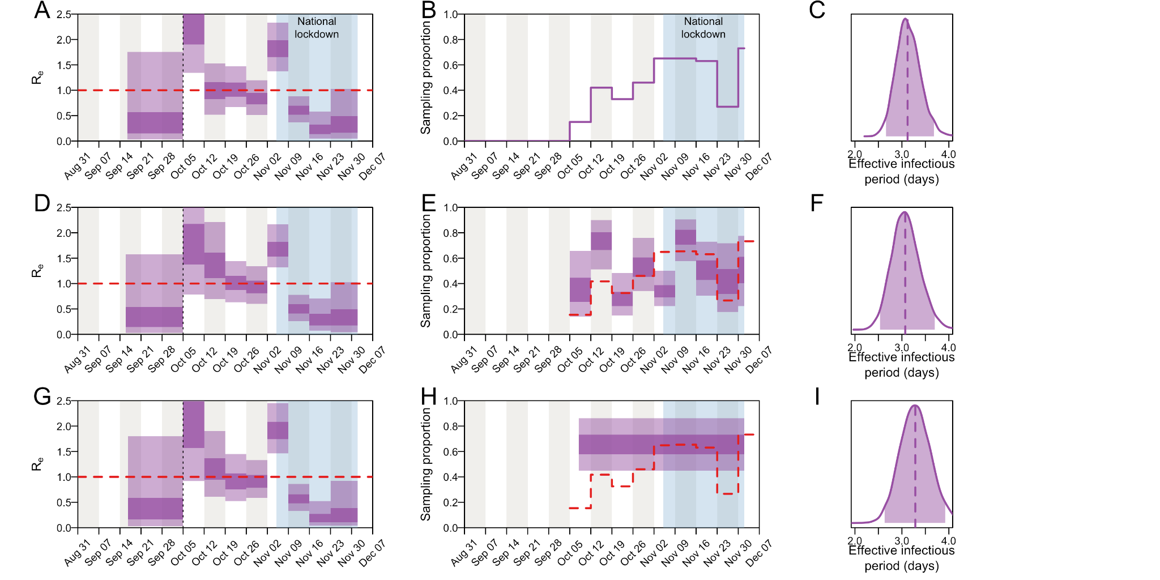
Extended Data Figure 7: Parameter estimates of cluster 1 with the birth-death skyline model when R_{e} is estimated for each week of term, under different parameterisations of the sampling proportion: (A-C) fixed to the empirical estimates (number of sequenced genomes from all University clusters divided by the number of positive tests among University staff and students), (D-F) fixed to 0 before the start of term and estimated for each week thereafter, and (G-I) fixed to 0 before the first week of term and assumed to be constant thereafter. See the caption of figure 5 for further details.

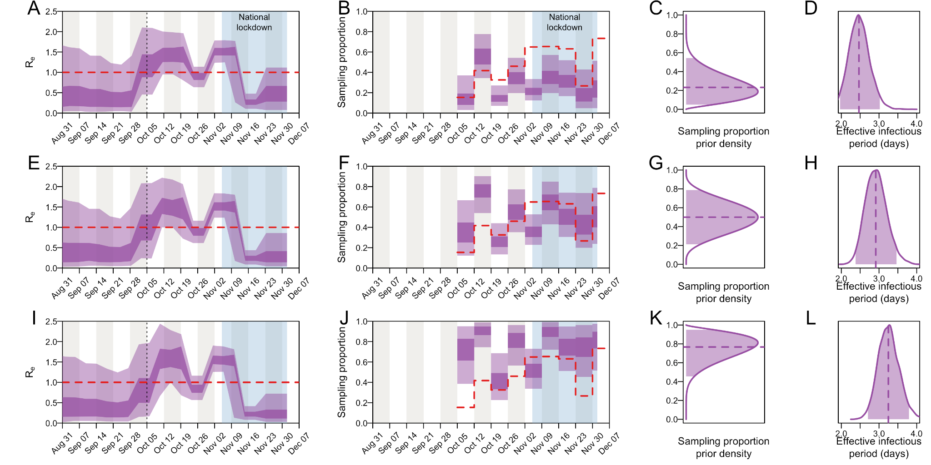

Extended Data Figure 8: Parameter estimates of cluster 1 with the birth-death skyline model when the sampling proportion prior is varied: (A-D) Beta(2.5, 7.5), (E-H) Beta(5,5), and (I-L) Beta(7.5, 2.5). See the caption of figure 5 for further details.

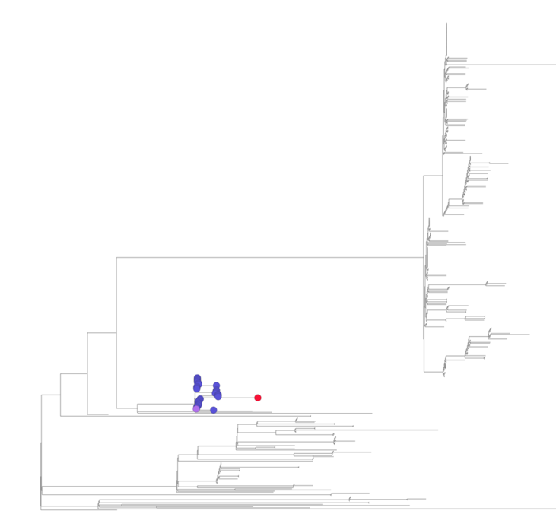
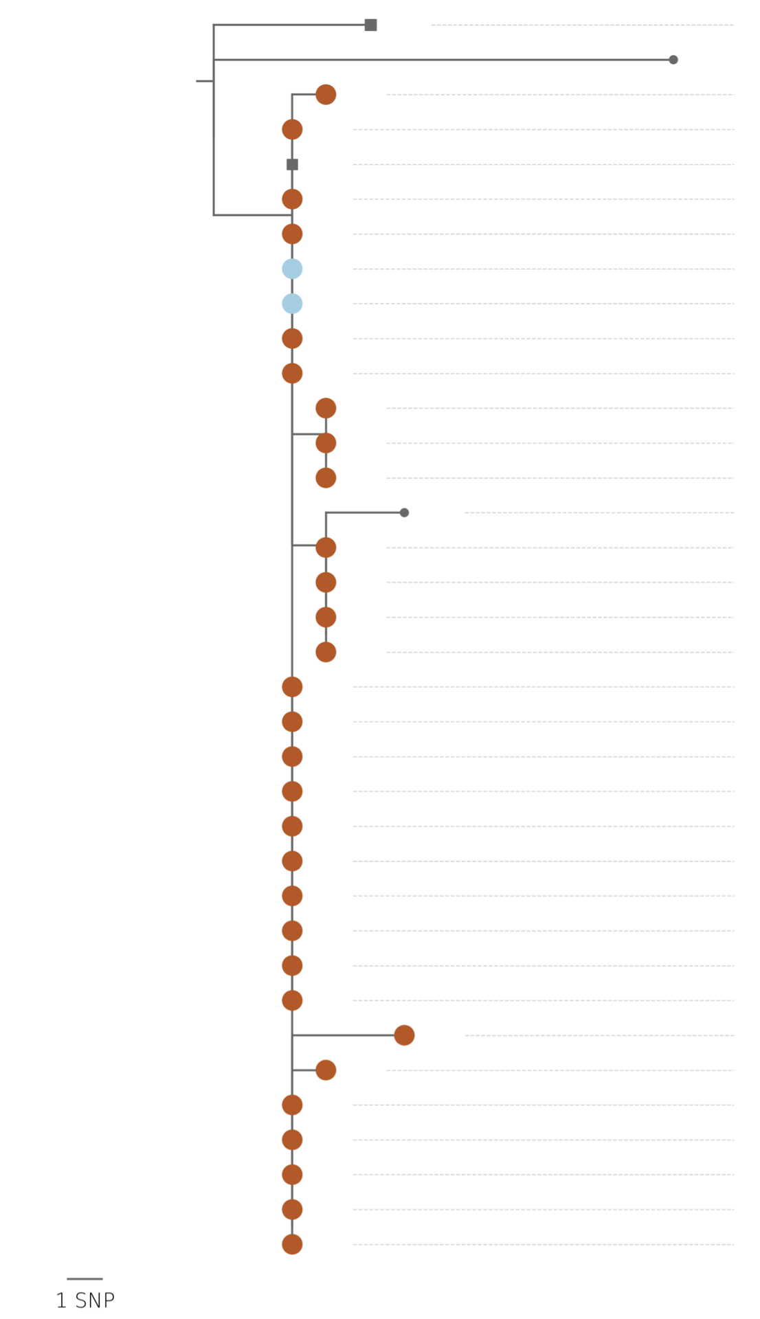

Extended Data Figure 9: Cluster 2 highlighted on a maximum likelihood tree of university cases, with associated CIVET cluster output demonstrating close phylogenetic relatedness

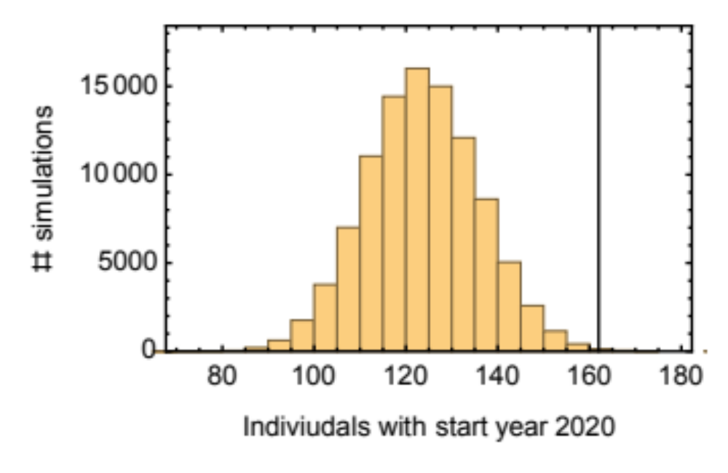

Extended Data Figure 10: Simulation of number of 1st year cases expected to be seen by random chance in the large University Cluster (cluster 1). The data shows an over-representation of individuals with start year 2020 in the data (vertical black line) compared to the neutral expectation (histogram) (p-value 0.998).

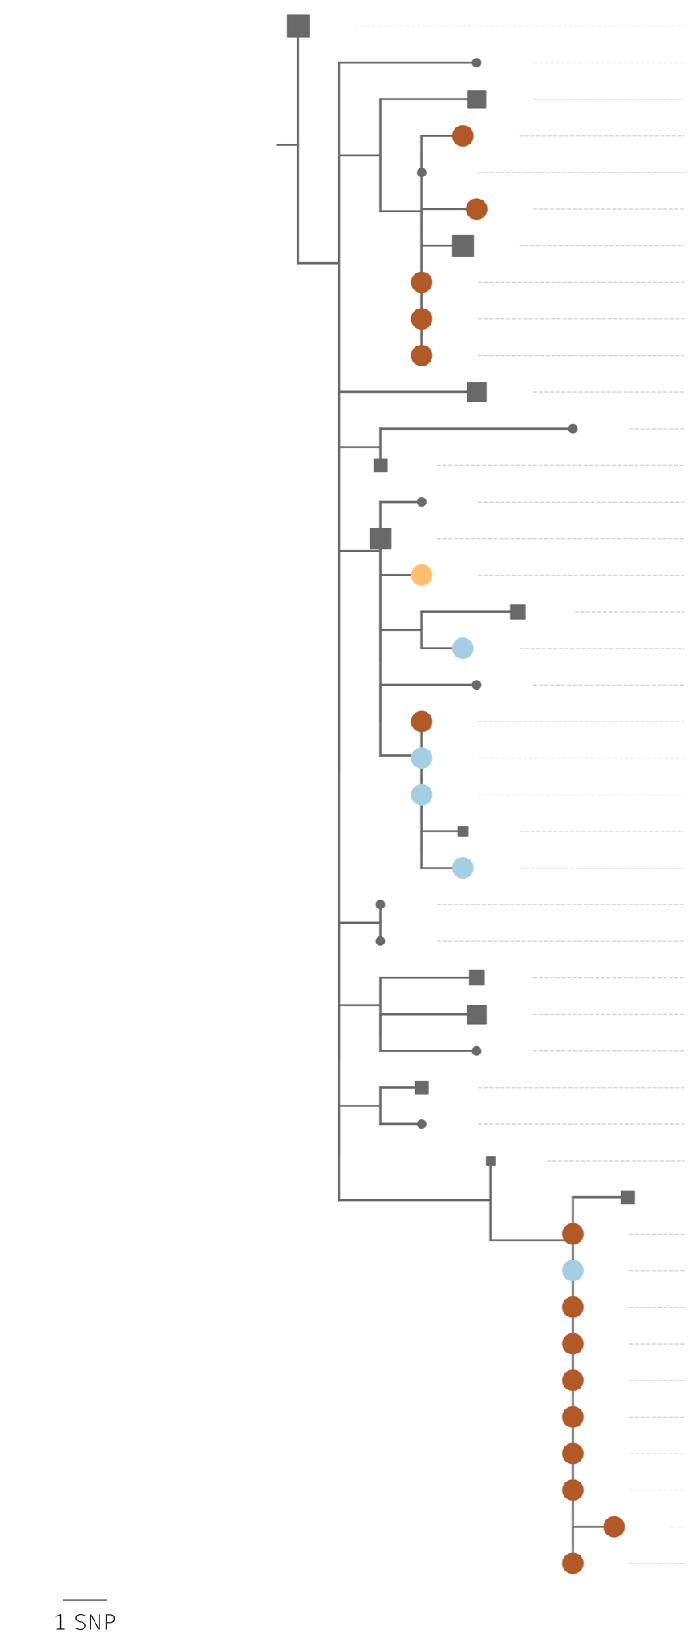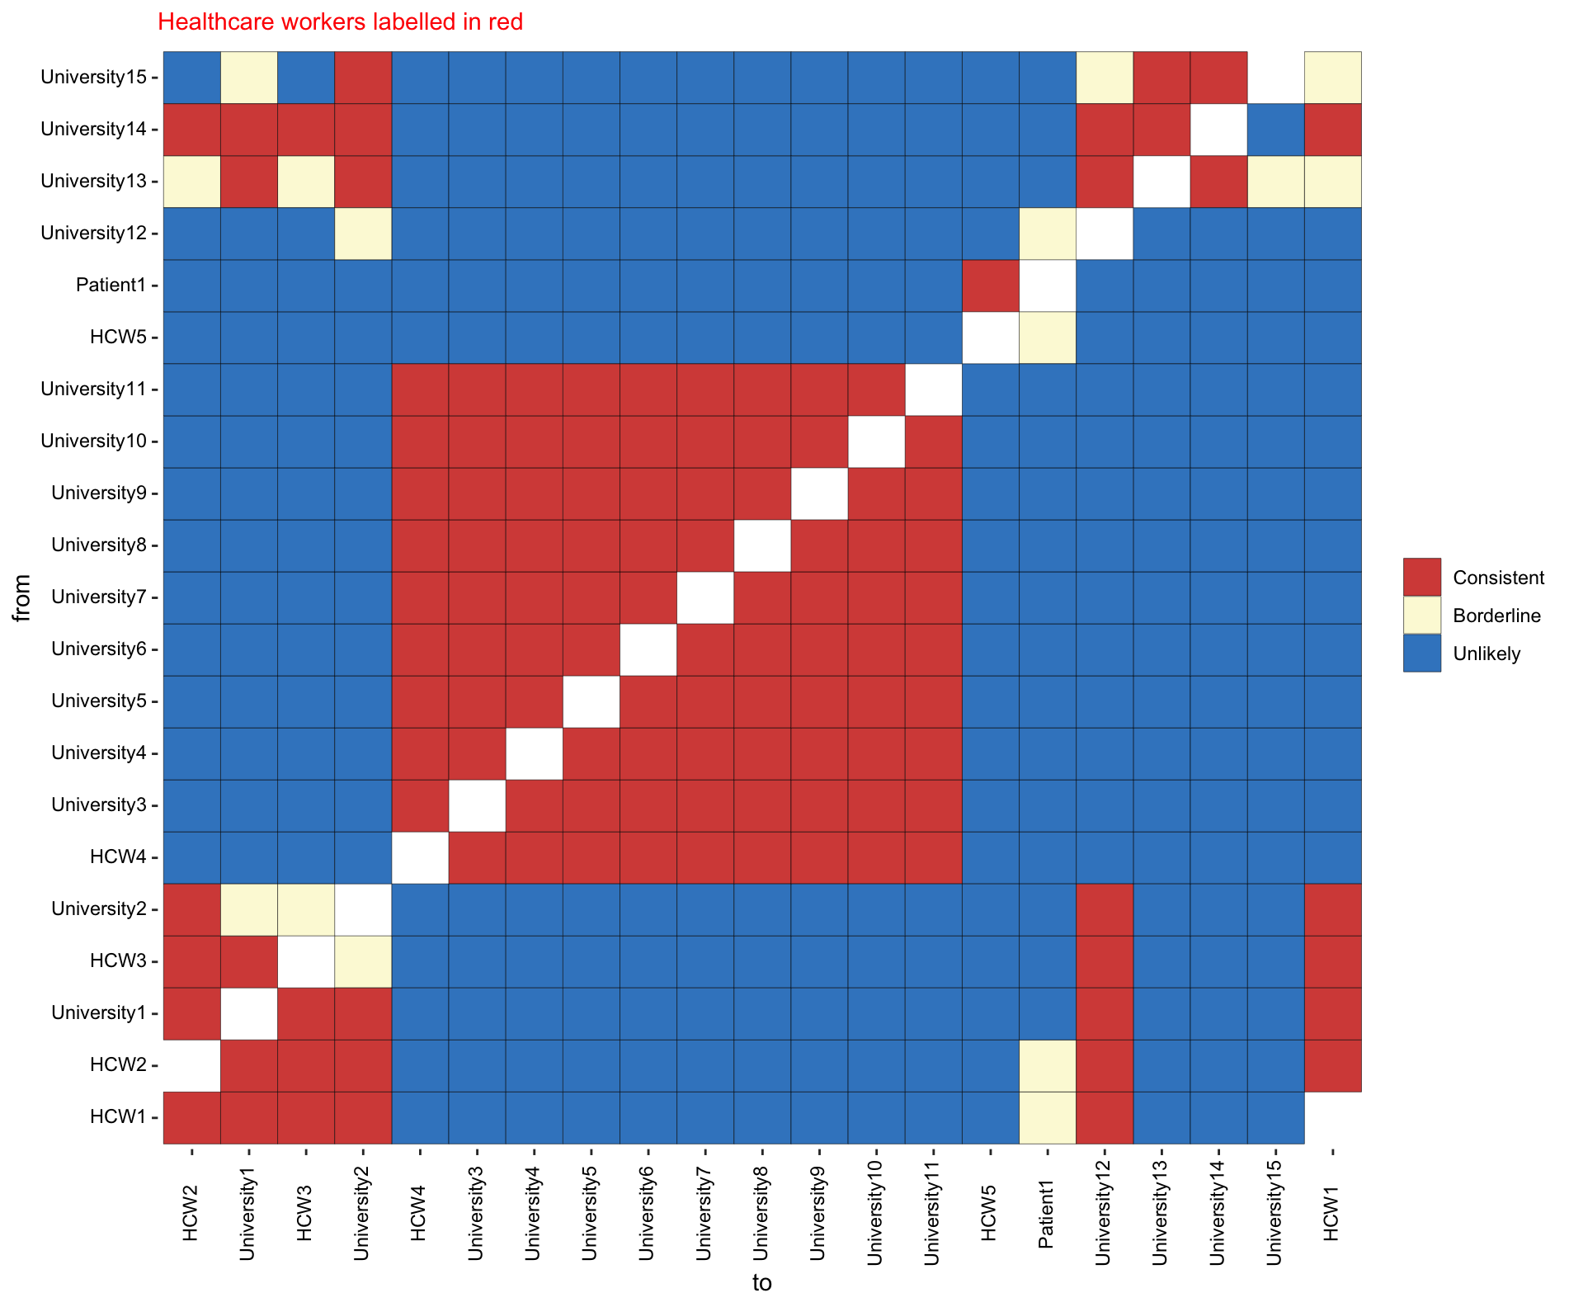

Extended Data Figure 11: CIVET phylogenetic tree of a Cambridge Universities Hospital (CUH) cluster amongst healthcare workers (HCW) and medical students, with associated A2B-COVID output. Both demonstrate a large cluster of individuals linked to the hospital setting, with consistent transmission seen between multiple medical students and a HCW and separately between a group of patients and HCWs.

