SUPPLEMENTAL DATA
Clustering of >145,000 Symptom Logs Reveals Distinct Pre, Peri, and Post Menopausal Phenotypes

Shravan G. Aras^{1,2,#}, Azure D. Grant^{3,#}, John P. Konhilas^{2,4,*}

¹Center for Biomedical Informatics and Biostatistics, University of Arizona Health Sciences, Tucson, AZ, 85750; ²Opensci, LLC, Tucson, AZ, 85750; ³People Science Inc., LA, CA, 90291; ⁴Department of Physiology, University of Arizona College of Medicine, Tucson, AZ, 85750.
#Authors contributed equally to this work.
Keywords: Symptom clustering, climacteric symptoms, premenstrual syndrome, PMS, VMS, reproductive health, fertility
*Corresponding Author: Address for reprint requests and other correspondence: John P. Konhilas, Ph.D., Univ. of Arizona, Dept. of Physiology, Biomedical Engineering, Molecular and Cellular Biology, Cellular and Molecular Medicine, Nutritional Sciences, Sarver Molecular Cardiovascular Research Program (e-mail: konhilas@arizona.edu).

Supplemental Figures & Tables
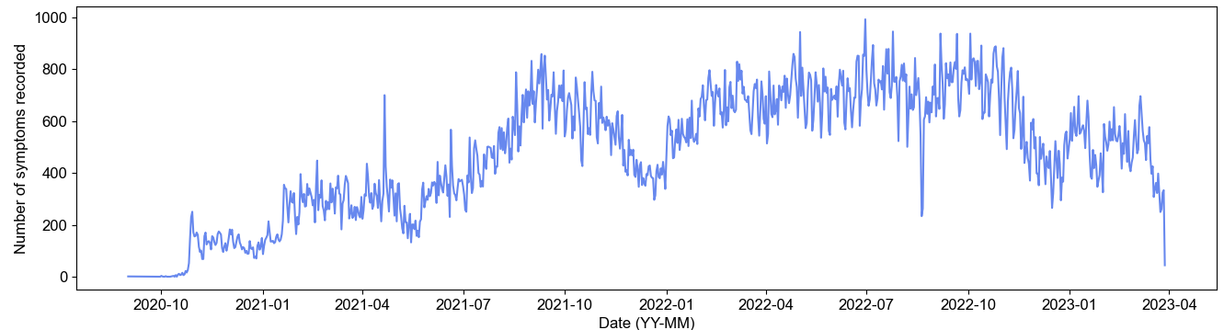
Symptom Group | Included Symptoms
Menstrual Cycle-Associated (PMS and Ovulation)^{36,44,45} | breast pain, breast swelling, ovulation, ovulation pain, cramps, spotting. May also include bloating, fatigue, headache, anxiety, mood swings, diarrhea.
Mood | fatigue, anxiety, depression, mood swings
Cognitive | brain fog, memory lapse, headache
Digestive (Flu-Like) | bloating, diarrhea, incontinence, chills, heartburn, nausea, vomiting
Integumentary | brittle nails, dry eyes, dry skin, facial hair, hair loss, itchy skin
Sexual | painful intercourse, reduced sex drive, vaginal dryness
Vasomotor Symptoms (VMS)⁴⁶ | hot flashes, night sweats, chills
Nervous | dizzy, nausea, tinnitus, tingling extremities, vertigo
Sleep | insomnia
Cardiac^{47,48} | irregular heartbeat
Musculoskeletal | joint pain, muscle tension
Infection | nipple discharge, UTI, yeast infection
Other | allergies, odor
Supplemental Figure 1. Number of symptoms collected through the app over the years. We used symptoms from Fall 2021 to Spring 2023 in our analysis. We see a seasonal trend in symptom recording, with compliance dropping near the end of the year.
Supplemental Table 1. Symptom Group Descriptions.

name
- allergies (all)
- anxiety (anx)
- bloating (blo)
- brain_fog (bra)
- breast_pain (bre)
- breast_swelling (bre)
- brittle_nails (bri)
- chills (chi)
- constipation (con)
- cramps (cra)
- depression (dep)
- diarrhea (dia)
- dizzy (diz)
- dry_eyes (dry)
- dry_skin (dry)
- facial_hair (fac)
- fatigue (fat)
- hair_loss (hai)
- headaches (hea)
- heartburn (head)
- hot _flashes (hot)
- incontinence (inc)
- insomnia (ins)
- irregular_beat (irr)
- itchy_skin (itc)
- joint_pain (joi)
- memory_lapse (mem)
- mood_swings (moo)
- muscle_tension (mus)
- nausea (nau)
- night_sweats (nig)
- nipple_discharge (nip)
- odor (odo)
- ovulation (ovu)
- ovulation_pain (ovu)
- painful_intercourse (pai)
- ringing_ears (rin)
- sex_drive (sex)
- spotting (spo)
- tingling_extremeties (tin)
- uti (uti)
- vaginal_dryness (vag)
- vertigo (ver)
- vomiting (vom)
- yeast _infection (yea)

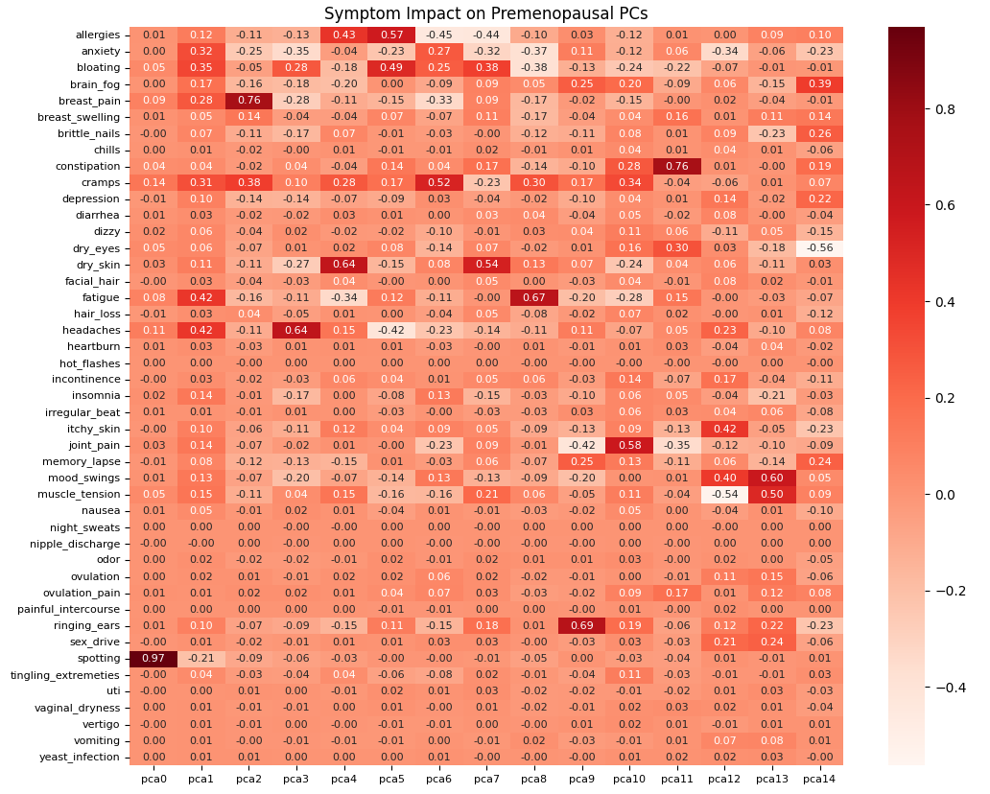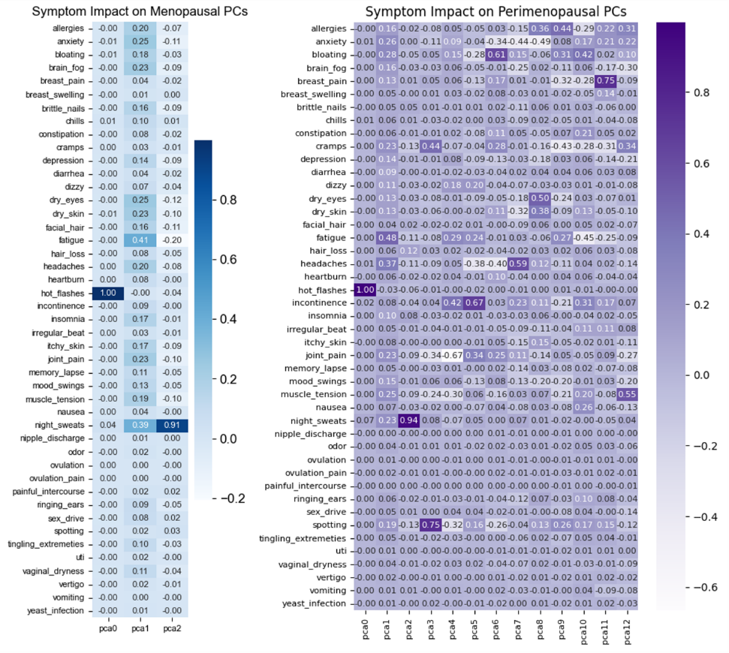
Supplemental Figure 2. Impact of each symptom on principal components in pre-(red), peri-(purple), and menopausal (blue) women.

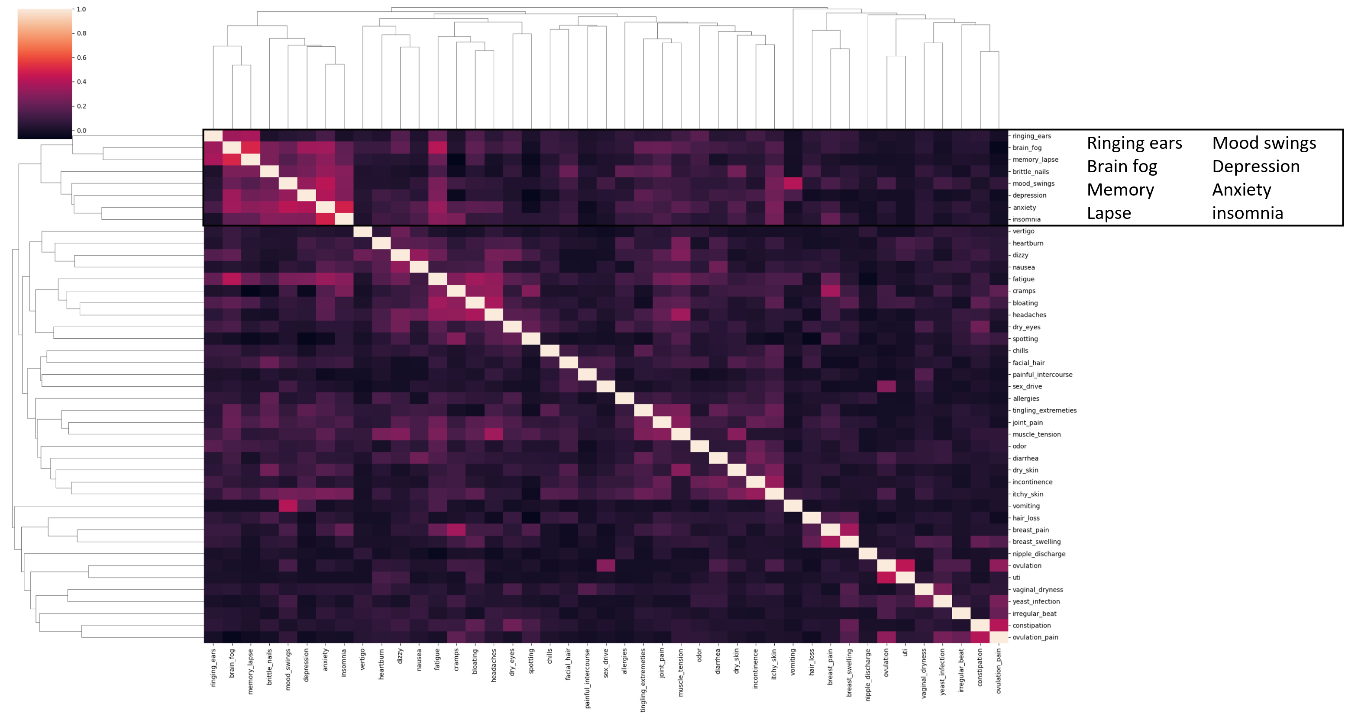
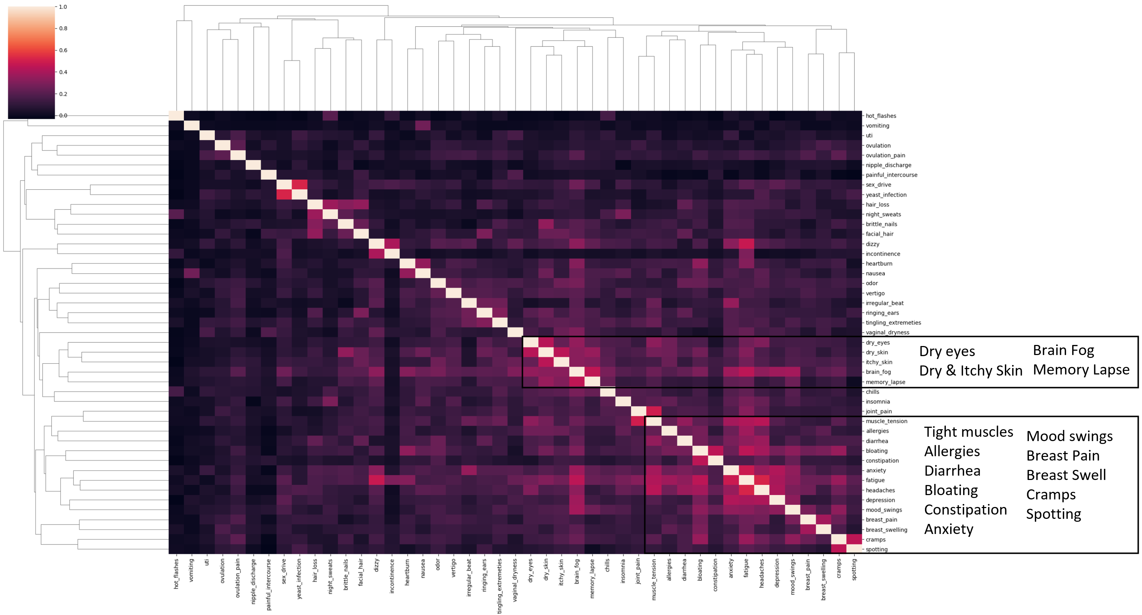
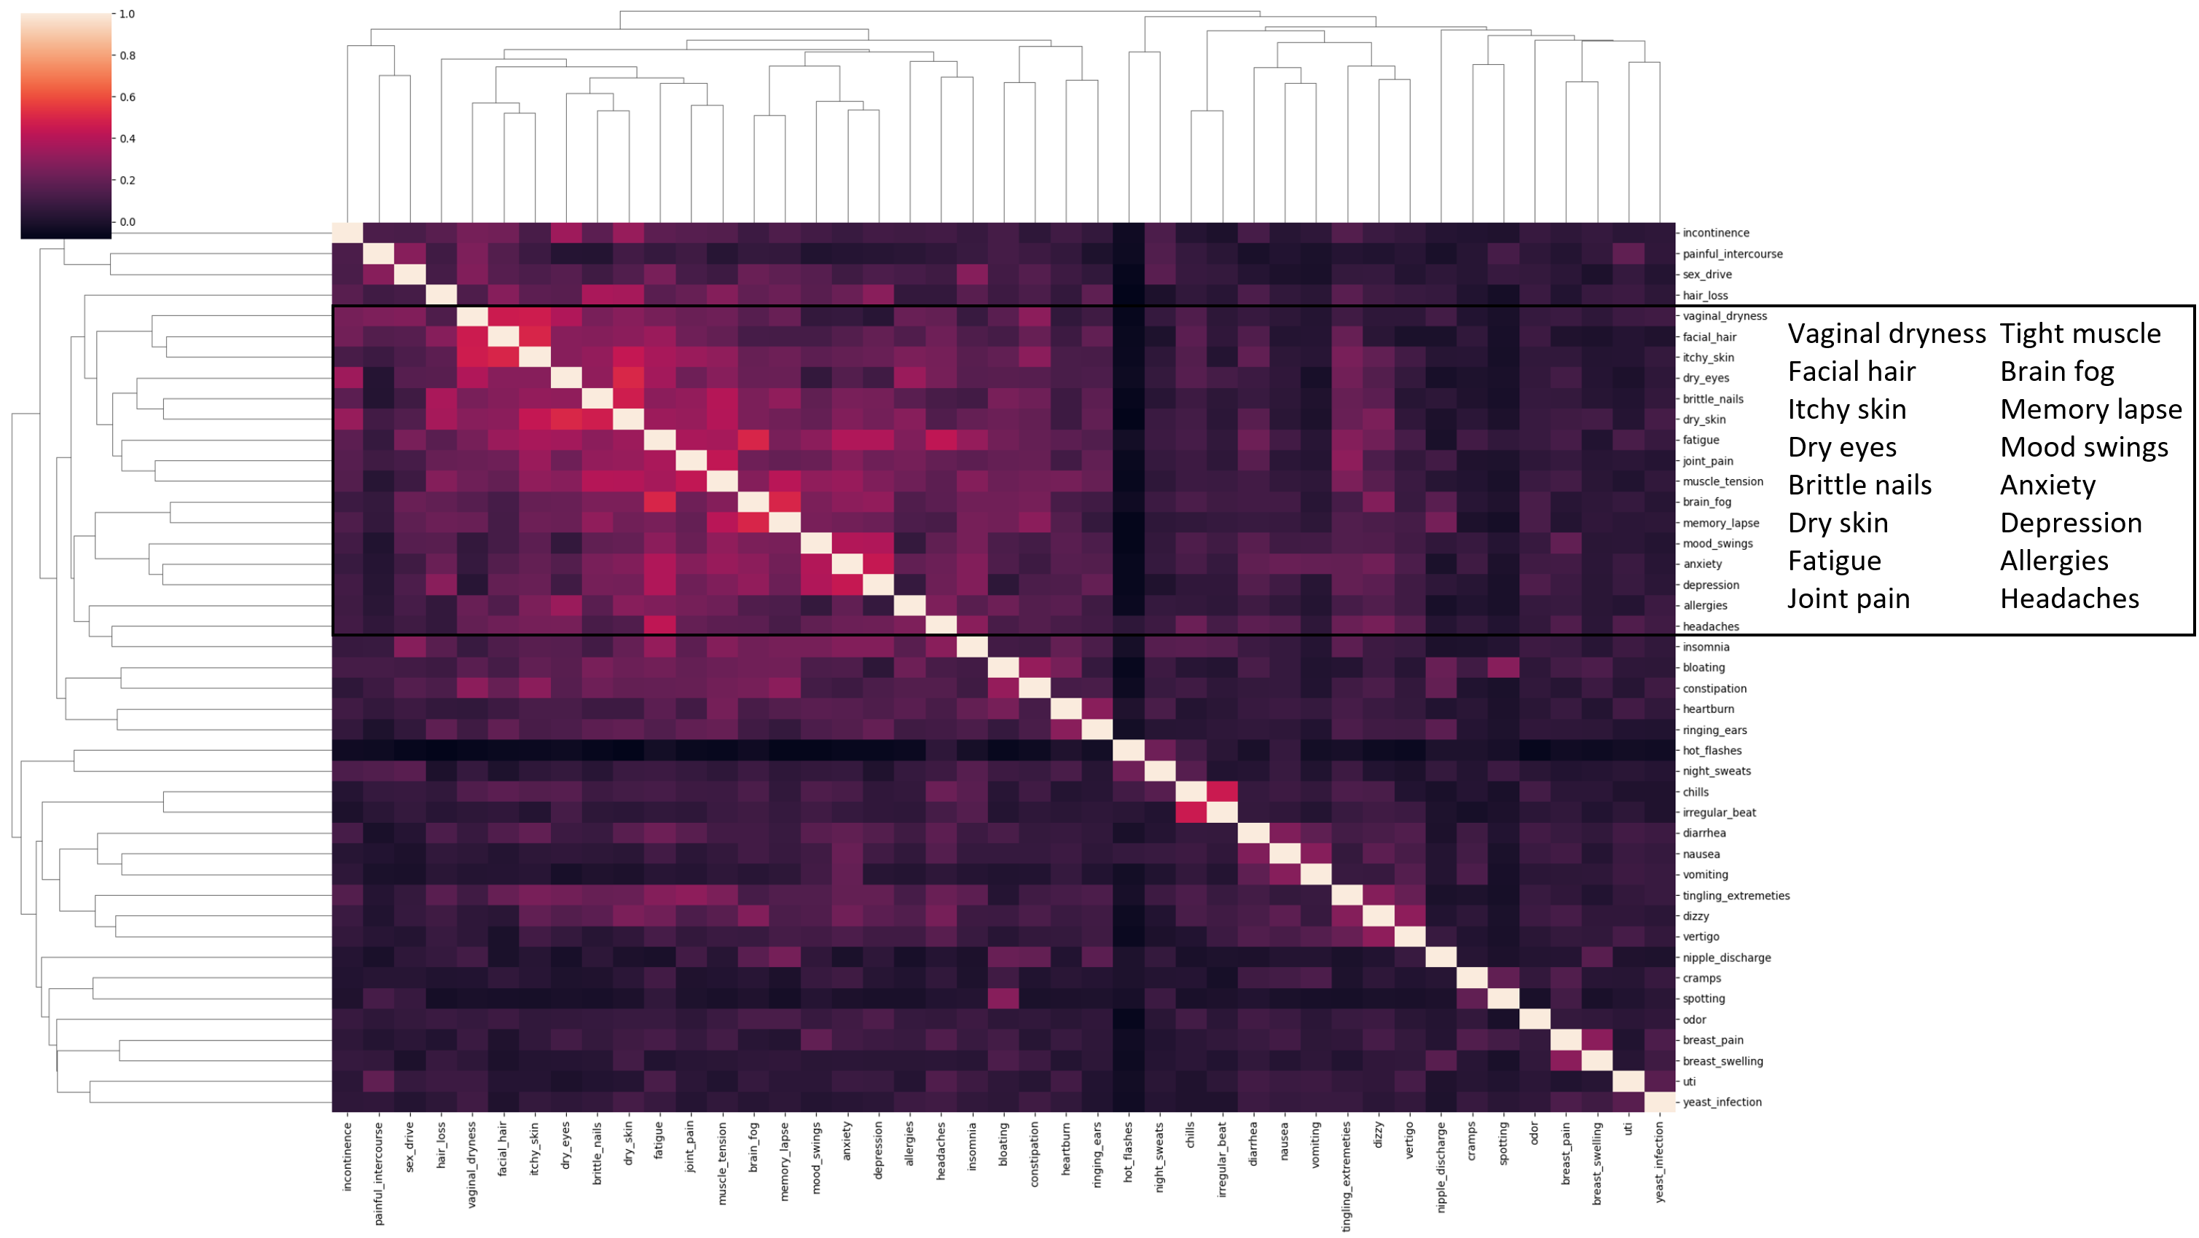
Supplemental Figure 3. Hierarchical cluster maps in premenopausal (top), perimenopausal (middle), and menopausal (bottom) participants.
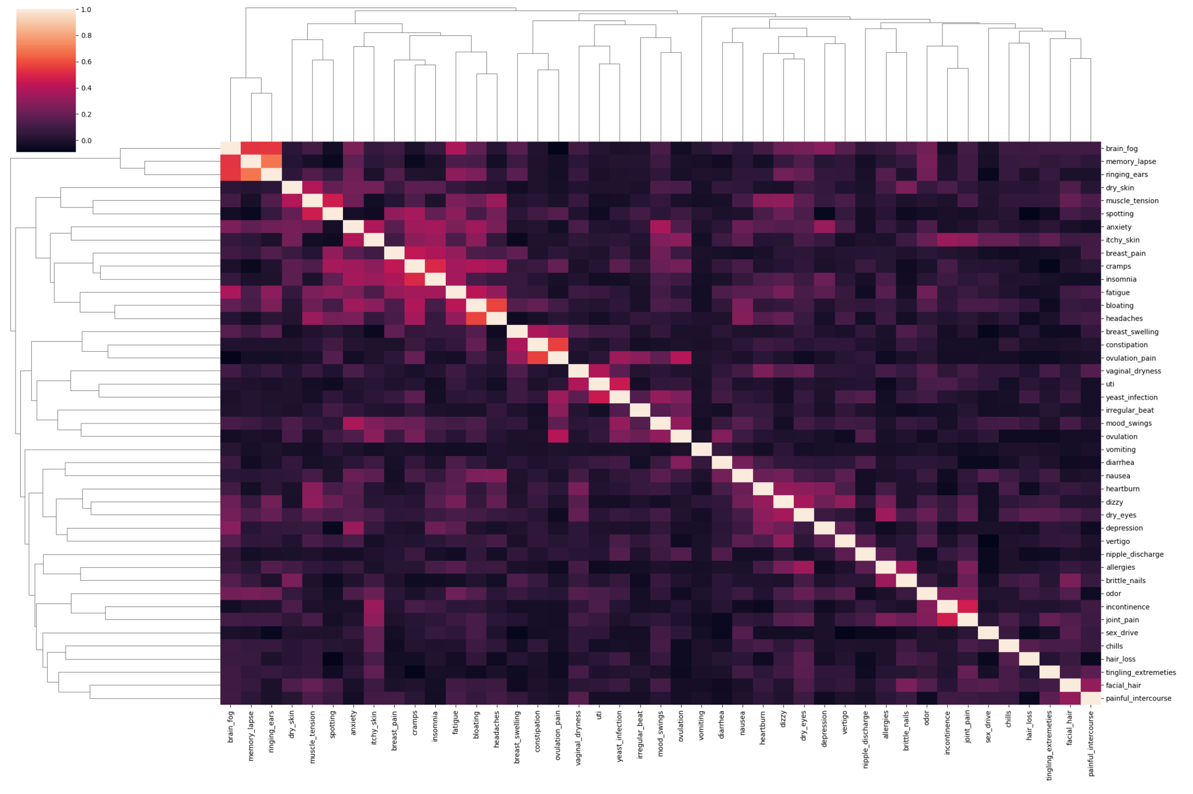
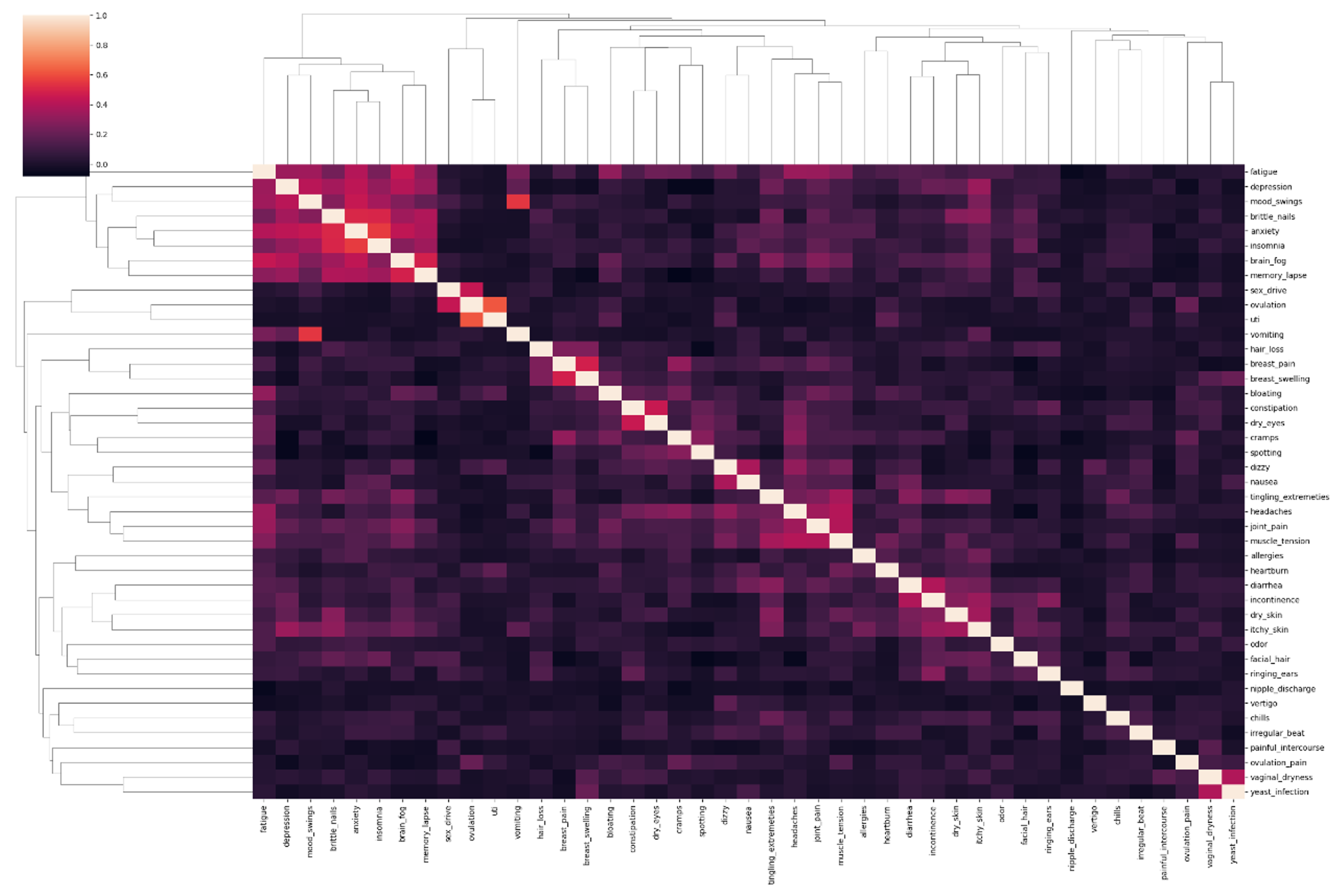
Supplemental Figure 4. Hierarchical cluster maps in regular cyclers (top) and irregular cyclers (bottom).
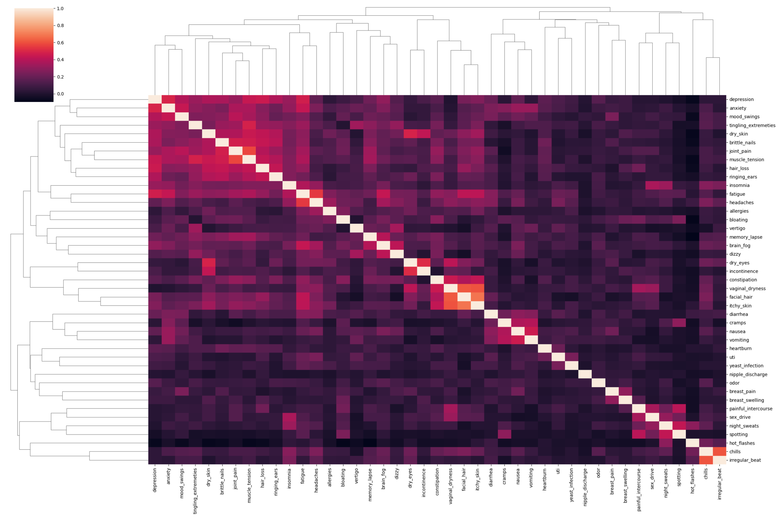
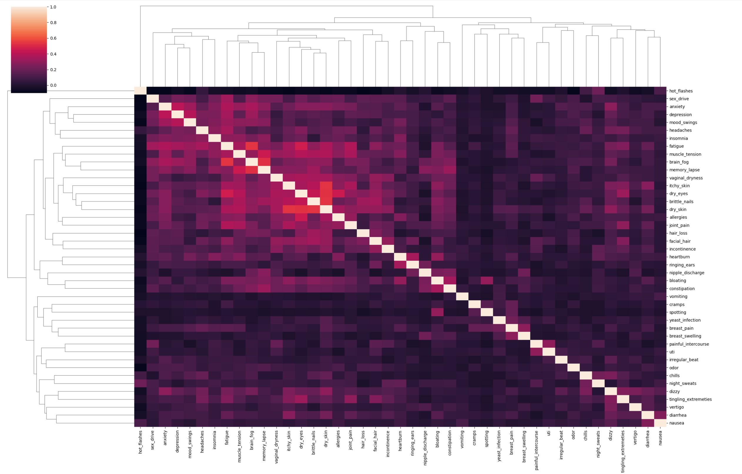
Supplemental Figure 5. Hierarchical cluster maps in medical/surgical menopause (top) and natural menopause (bottom).

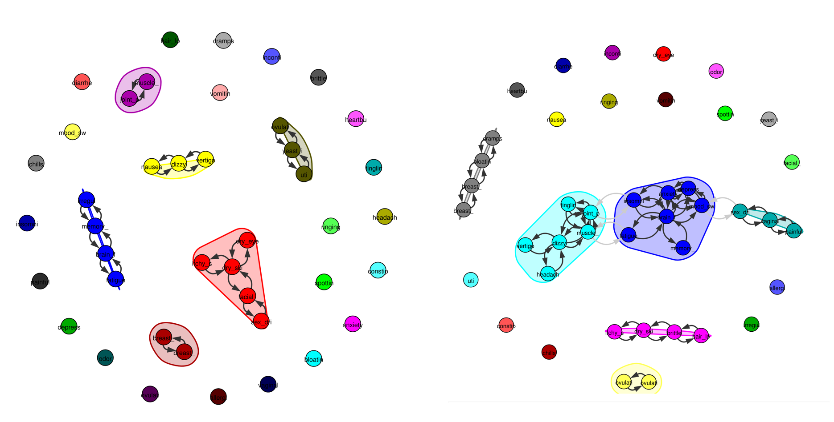
Supplemental Figure 6 -- Regular (left) and irregular (right) cyclers’ symptom networks. Symptom groups were more related in irregular cyclers, with pain/nervous, mood/cognitive, and sexual clusters linked.
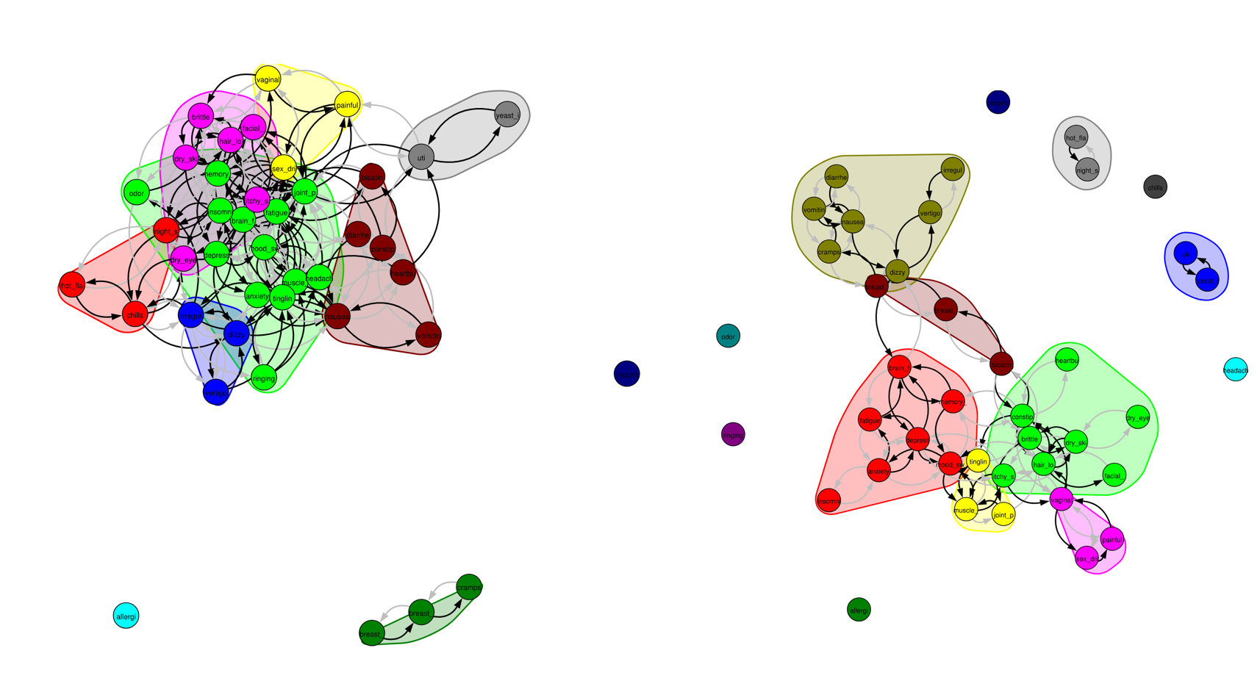
Supplemental Figure 7 -- Natural menopausal users (left) exhibited a more connected symptom network than did medical/surgical. Notably, hot flashes and night sweats were not connected to any additional symptoms in medical/surgical hysterectomy but were connected to a variety of mood and nervous symptoms in natural menopause.

