Table 2. Symptom Clustering Summary 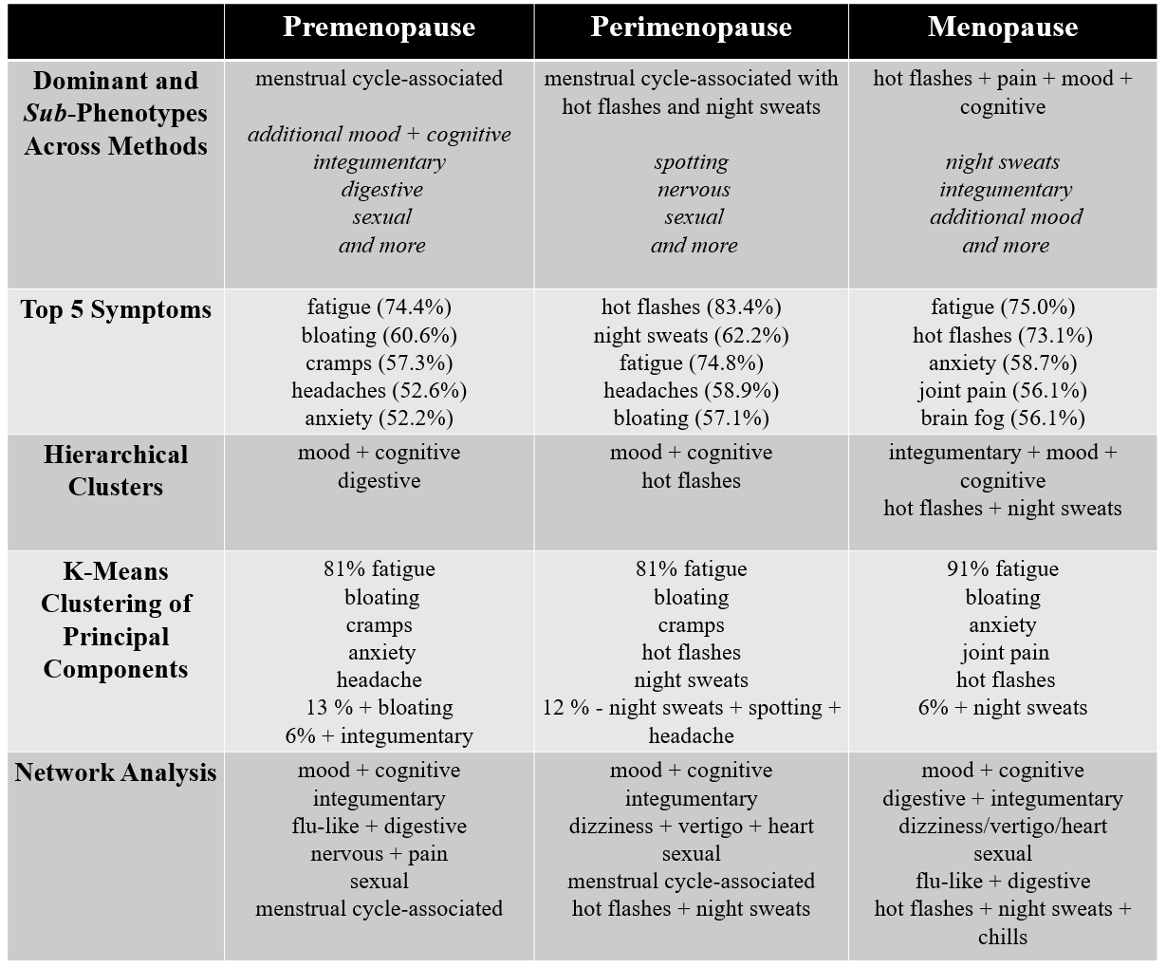
Table 2. Summary of symptom clusters across methods. Blue indicates shared symptom clusters or rankings across life stages, whereas red indicates differentiating symptoms and clusters.

