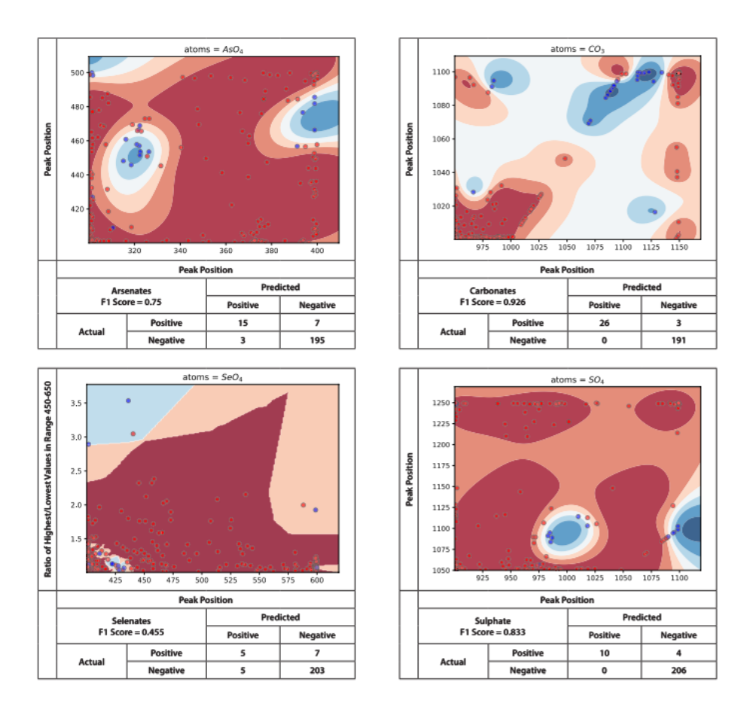
Supporting Information Figure 1. Clockwise from top left: arsenates, carbonates, sulfates, and selenites.
Classification by crystal system and structure type difficult due to small dataset
The remaining nine classifiers were part of two separate one-vs-all strategies to classify crystal system and structure type. The crystal system classifier (SI Table 1) showed good ability to find the correct class, with only trigonal crystal systems incorrectly predicted in 50% or more instances. Structure type classifier (SI Table 2) predicted nearly every dataset as possessing a sheet structure. This is due to the highly imbalanced distribution of classes in the training data. Sheet structure types dominate U(VI) minerals. CURIES has 163 instances of sheet structure types, while the next highest structure type, frameworks, had only eighteen instances, leading to much lower confidence values assigned to the other classifiers on average ³¹. This limited data also caused problems for the crystal system classifier, where only four examples of the trigonal class lead to a classifier that was underconfident in its predictions, causing the highest proportion of misclassifications. Note that the number of points for these two problems in SI Table 1 and SI Table 2 are different despite both using CURIES as training data due to removal of data points which did not have a crystal system/structure type defined in the database.
SI Table 1: Confusion matrix and F1 scores for the crystal system multi-class problem. The true class is the class for the sample from CURIES, while the predicted class is the class whose model returned the highest confidence for class membership for the sample.
True class | Predicted class |  |  |  |  | F1 Score
 | Monoclinic | Orthorhombic | Tetragonal | Triclinic | Trigonal
Monoclinic | 41 | 14 | 1 | 1 | 0 | 0.79
Orthorhombic | 2 | 73 | 0 | 0 | 0 | 0.82
Tetragonal | 1 | 5 | 26 | 1 | 0 | 0.83
Triclinic | 3 | 9 | 4 | 33 | 0 | 0.79
Trigonal | 0 | 2 | 0 | 0 | 2 | 0.67

SI Table 2: Confusion matrix for the structure type multi-class problem. The true class is the class for the sample from CURIES, while the predicted class is the class whose model returned the highest confidence for class membership for the sample.
True class | Predicted class |  |  |  | F1 Score
 | Chains | Cluster | Framework | Sheet
Chains | 5 | 0 | 0 | 11 | 0.48
Cluster | 0 | 6 | 0 | 0 | 0.86
Framework | 0 | 2 | 7 | 9 | 0.56
Sheet | 0 | 0 | 0 | 163 | 0.94

SI Table 3: List of models and the final, highest-performing classification algorithm selected for each.
Classifier | Algorithm
AsO₄ | Gaussian Process
CO₃ | Gaussian Process
Cu | Nearest Neighbors
H₂O | Gaussian Process
PO₄ | Nearest Neighbors
SeO₄ | Nearest Neighbors
SiO | Gaussian Process
SO₄ | Gaussian Process
V₂O₈ | Gaussian Process
hexagonal | Nearest Neighbors
pentagonal | Nearest Neighbors
square bipyramidal | Nearest Neighbors
monoclinic | Gaussian Process
orthorhombic | Nearest Neighbors
tetragonal | Nearest Neighbors
triclinic | Gaussian Process
trigonal | Nearest Neighbors
chains | Gaussian Process
cluster | Gaussian Process
framework | Nearest Neighbors
sheet | Gaussian Process

