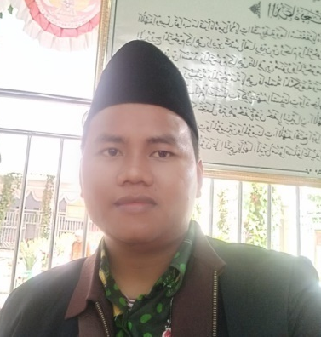
Author Biography
Hosaini S.PdI, M.Pd was born in Arjasa Sumenep Madura 26 December 1990, after attending elementary school, he continued his education at Madrasah Tsanawiyah in 2004-2007, then continued his education at Ibrahimy Sukorejo High School in 2007-2010. After that he continued to Higher Education (UNIB) Ibrahimy University, Faculty of Islamic Religion in 2010-2014, after being appointed as a teaching staff, he had the opportunity to continue his education at Masters level at the same campus (Ibrahimy University) Study Program, Islamic Religious Education in 2014-2016, in under the auspices of the Sukorejo Situbondo Salafiyah Syafi'iyah Islamic Boarding School. Creative works produced in the form of written works consist of scientific works in the form of books, international articles, accredited national articles, proceedings, international books and national books. The works in the form of books are: 1. Ethics and the Teaching Profession 2. Educational Leadership 3. Hadith studies 4. Qur'an Study (Captivating the heart with the Al Qur'an" Ma'naAyat-selected verses) 5. Madrasah Education Management 6. Ethics and the Teaching Profession II 7. Discourse on the Ma'na of the Hijab in Surah Al-Ahzab Verse 59 (Study Comparison between the opinions of Ibn Kathir and M. Quraish Shihab). 8. SILAT QU Method (One day, five verses, 3 months can read the Qur'an and memorize it) 9. Qualitative Research Methods and Techniques for Writing Proposals and Secretions 10. Qur'an Study Era 4.0 11. Introduction to Participatory Action Research Methodology ( Par) 12. Islamic boarding school chaplain 13. Project Management 14. Tough Warrior 16. Philosophy of Islamic Education 17 Development of Islamic Education Teaching Materials Using the Inquiry Model 18. Learning Moral Creeds 19. Verses of struggle 20. Islamic Religious Education 21. Sociology of Islamic Education 22 Principles of Management. 23. Educational Evaluation 24. PAI Learning Using the CTL Method 25 Moderate Islamic Paradigm Building peaceful Islam,
Meanwhile, written work in the form of national journal articles is not accredited and national journals are accredited 41 articles 4 Proceedings of international journals https://scholar.google.co.id/citations?user=2812y8sAAAAJ&hl=id Sinta account https://sinta.kemdikbud.go .id/profile Currently, the author is active as a teaching staff on the Bondowoso University campus as well as a reviewer in various accredited national journals, a reviewer for the Indonesian Ministry of Religion's LITABDIMAS and a writer for the Indonesian Ministry of Religion's National PKB Module
The position that has been in power and is still running continuously today is, BP Coordinator. Ma'had at the Salafiyah Syafi'iyah Sukorejo Islamic Boarding School, Deputy Chair III for student affairs at the Situbondo Intellectual Islamic High School, Chair of the Islamic Education Department and Deputy Dean of the Faculty of Islamic Religion, Bondowoso University, Secretary of Internal Quality AUDIT at Bondowoso University. And LPMI secretary. Bondowoso University journal management. Currently, he acts as Head of the Interanal Quality Assurance Center at Bondowoso University, apart from being a formal office holder, he also acts as a public leader in organizational experience. 1. Horseshoe Coordinator of the Research Lecturer Communication Forum (FKDP) Kepertais Region IV. 2 Republic of Indonesia Lecturers Association 3. Management of the Association of College Book Writers 3. Management of the Association of College Book Writers. 4. National and International Annual Conference On Islamic Education (Ancoms and Icon Use) speaker. 5 Chair of the Indonesian PTKIS Lecturer Association (Adpetikisindo) DPW East Java. 6. HR Secretary of the Association of Experts and Lecturers of the Republic of Indonesia (ADRI). 7. 2020 PAR Ambassador for the Ministry of Religion Program. 8 Deputy General Chairperson of the Indonesian Higher Education Association. 9. National Reviewer for Research & Community Service for the Republic of Indonesia Ministry of Religion Lecturer Grant Fund Program. 10 Professional Organization Administrators (PERMAPENDIS) 11. Head of APTIKIS Indonesia Division 12. Reviewer in various national and international journals. We hope that this book, being blessed and useful, can provide a positive contribution to every reader wherever they are.

