Mapping Global Cereal Flow at Subnational Scales Unveils Key Insights for Food Systems Resilience
Supplementary Information

Supplementary Figures
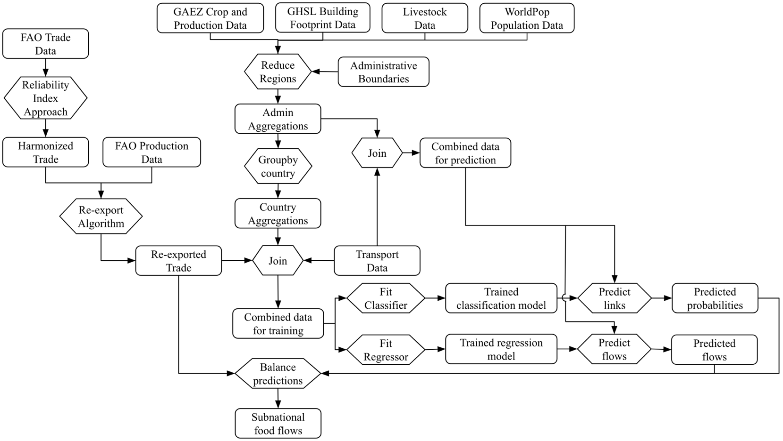
Additional Trade Data
Supplementary Figure 1. Modelling pipeline.

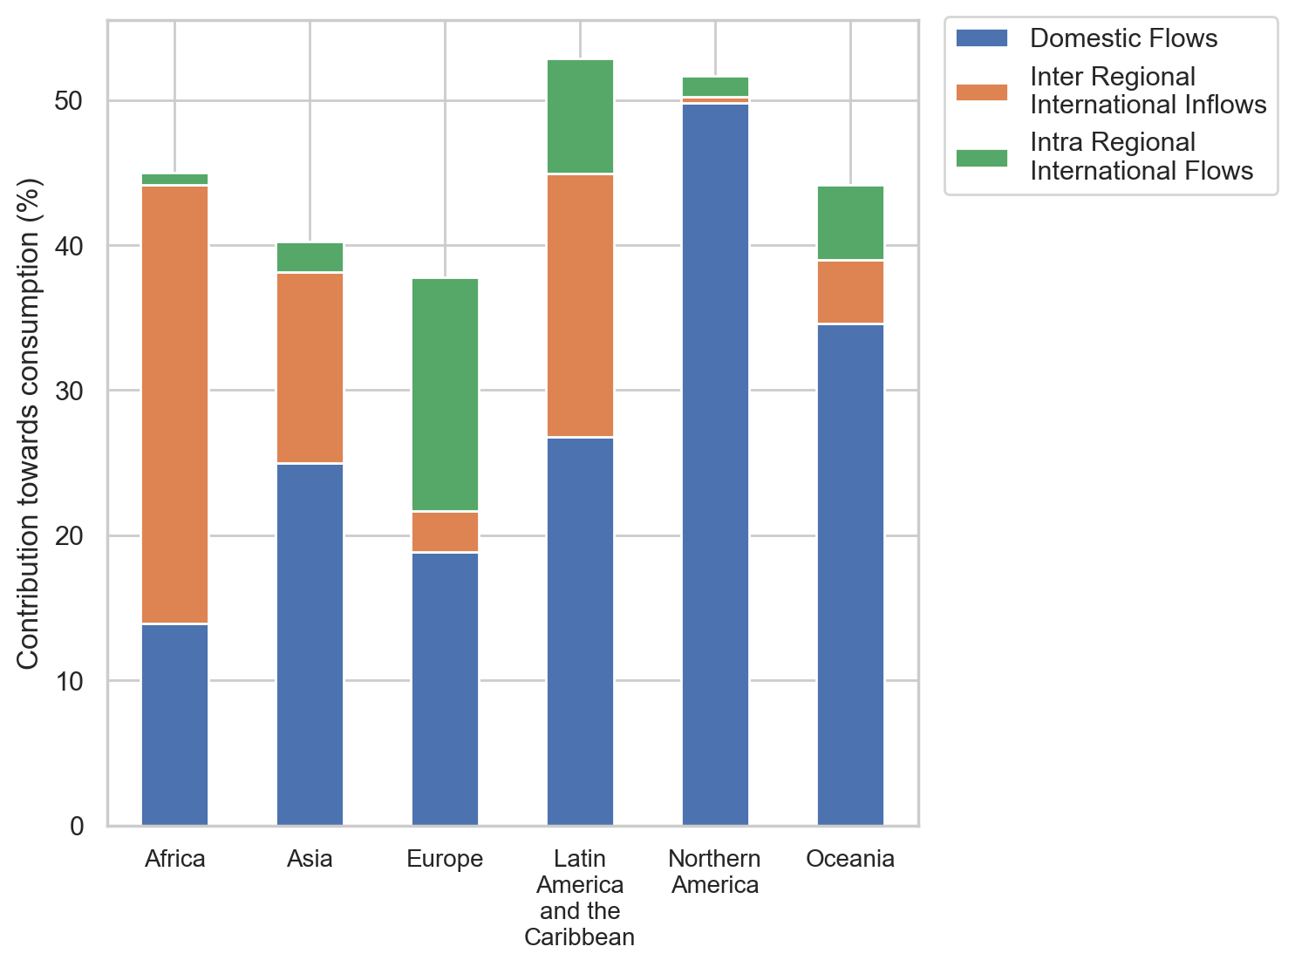
Supplementary Figure 2. Contribution of cereal flows to consumption, by continent (2017-2021).
Note that continental groupings differ widely in country count and scale; these bars are descriptive and should not be read as strictly comparable efficiency metrics.

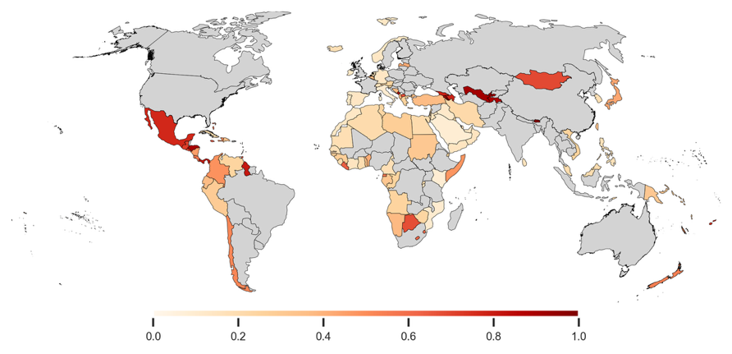
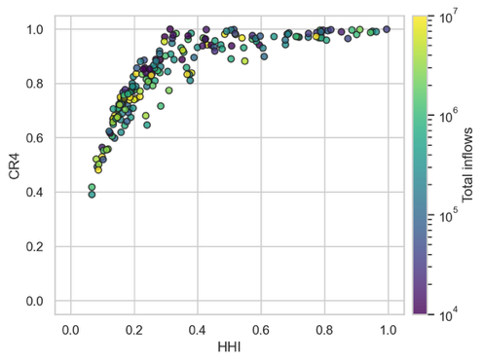
a b

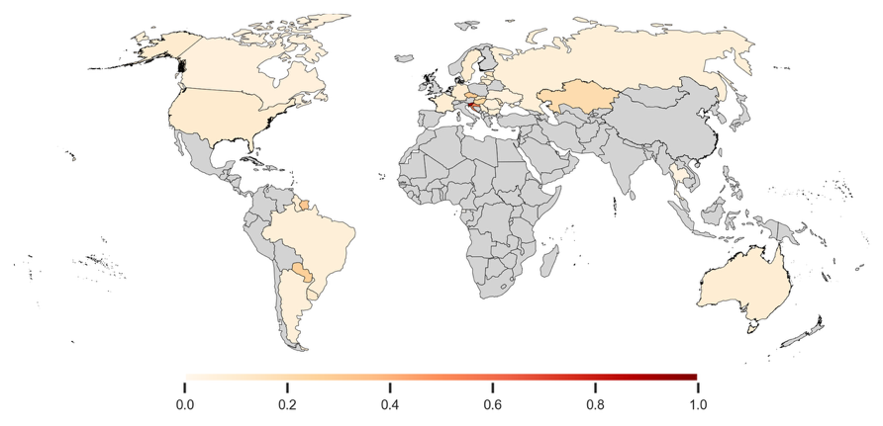
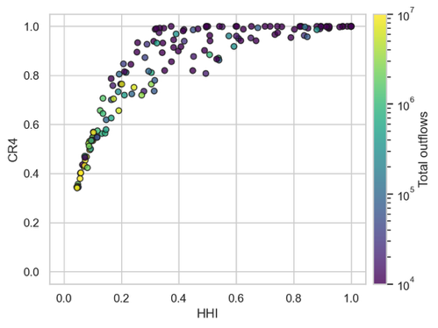
c d

Supplementary Figure 3. Concentration of national scale international cereal flows. a Comparison of HHI and CR4 for cereal inflows, by importing country. b HHI over inflows, by importing country (showing only countries where international inflows exceed 20% of national consumption). c Comparison of HHI and CR4 for cereal outflows, by exporting country. d HHI over outflows, by exporting country (showing only countries where international outflows exceed 20% of national production).

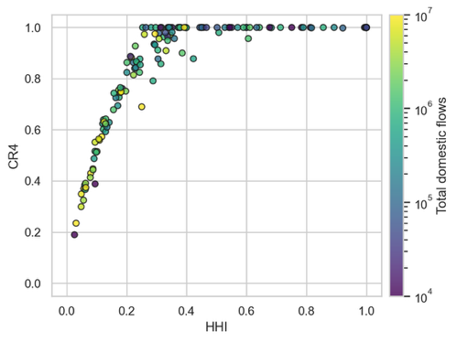
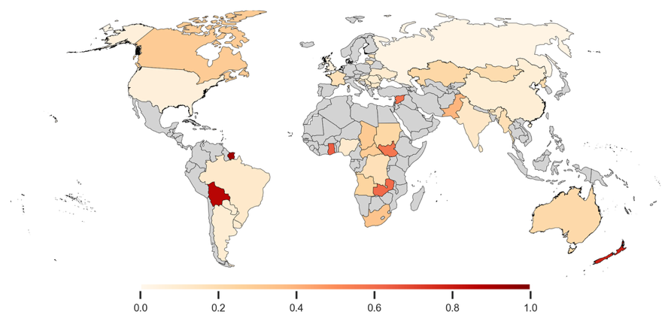
a b

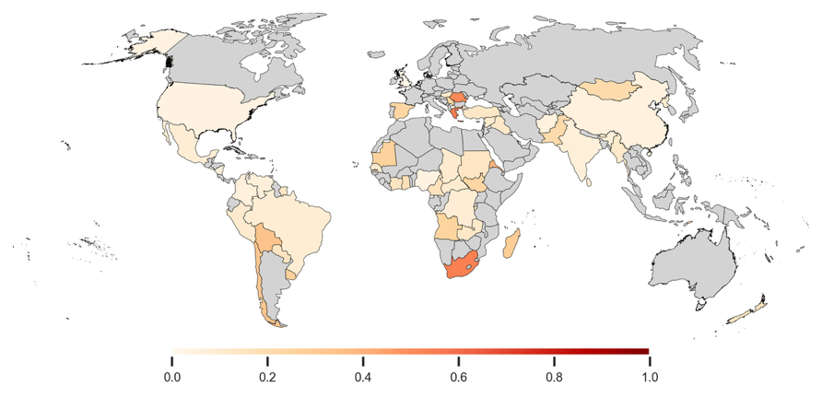
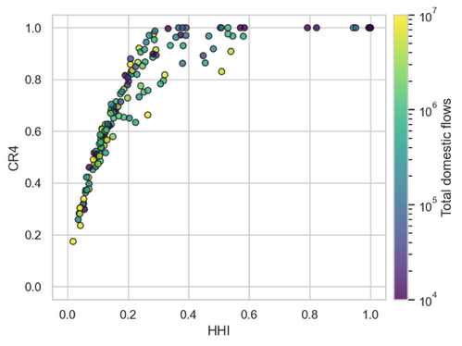
c d

Supplementary Figure 4. Concentration of subnational scale domestic cereal flows. a Comparison of HHI and CR4 for cereal exporters, by country. b HHI over exporters, by country (showing only countries where domestic flows exceed 20% of national consumption). c Comparison of HHI and CR4 for cereal importers, by country. d HHI over importers, by country (showing only countries where domestic exceed 20% of national production).

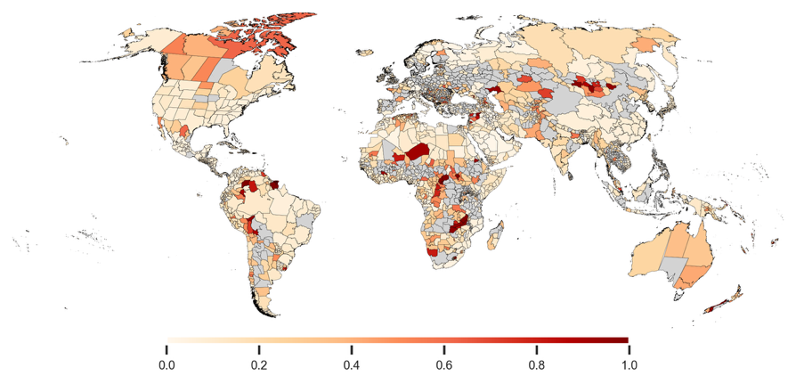
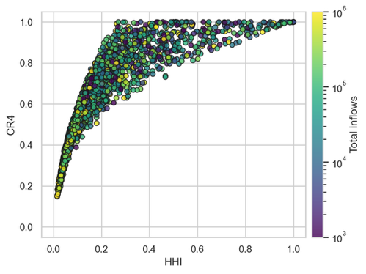
a b

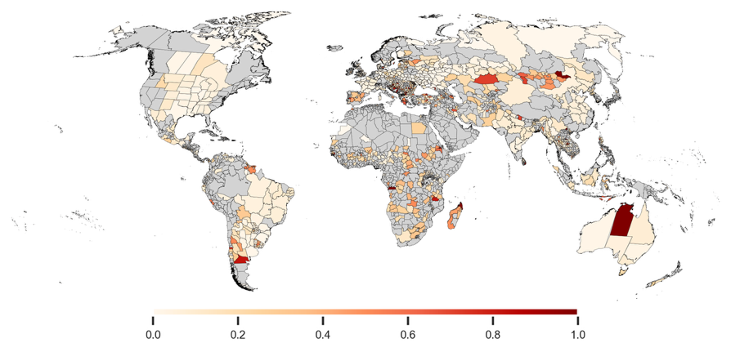
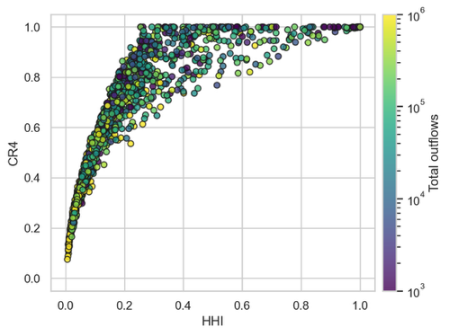
c d

Supplementary Figure 5. Concentration of subnational scale cereal flows (both domestic and international). a Comparison of HHI and CR4 for cereal inflows, by importing administrative region. b HHI over inflows, by importing administrative region (showing only regions where total inflows exceed 20% of regional consumption). c Comparison of HHI and CR4 for cereal outflows, by exporting administrative region. d HHI over outflows, by exporting administrative region (showing only regions where international outflows exceed 20% of regional production).

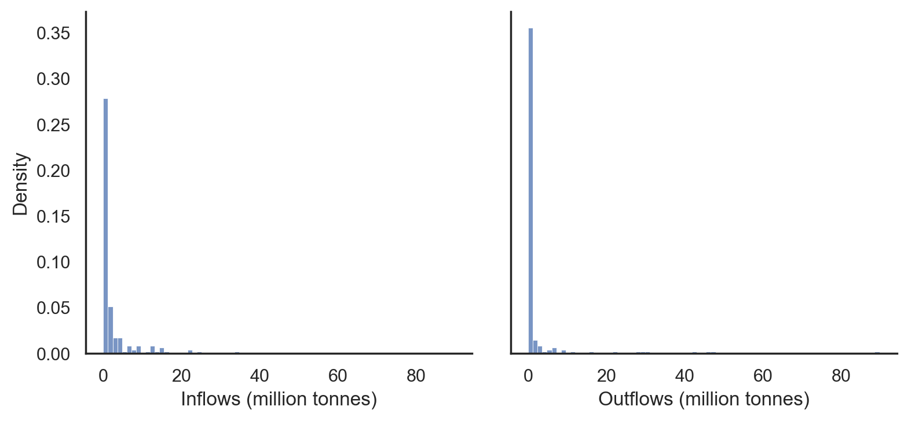
Supplementary Figure 6. Distribution of country-level total inflows and total outflows.

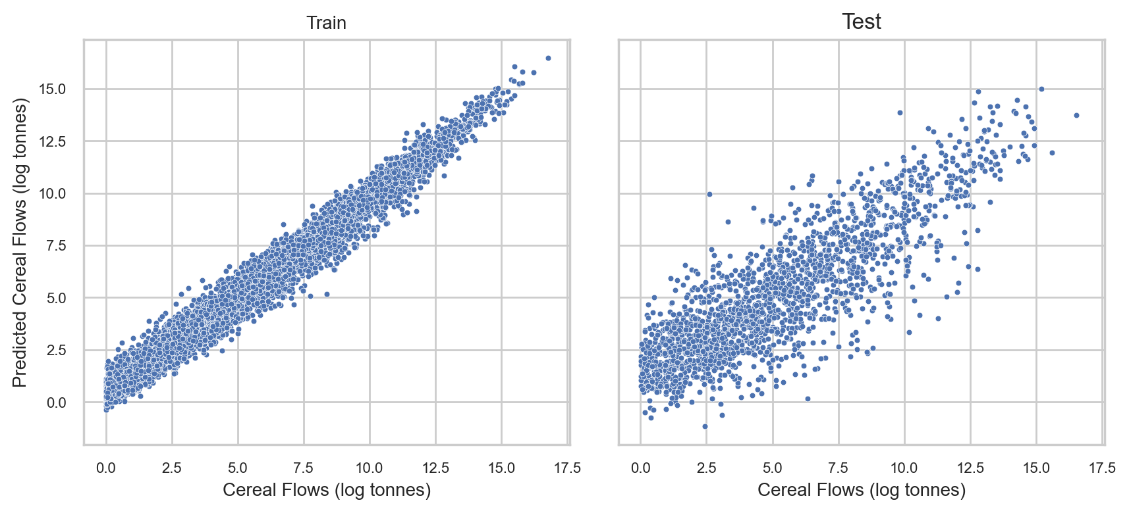
Supplementary Figure 7. Predicted vs observed national-scale cereal flows in log tonnes for train ($n=7,959$) and test sets ($n=2026$).

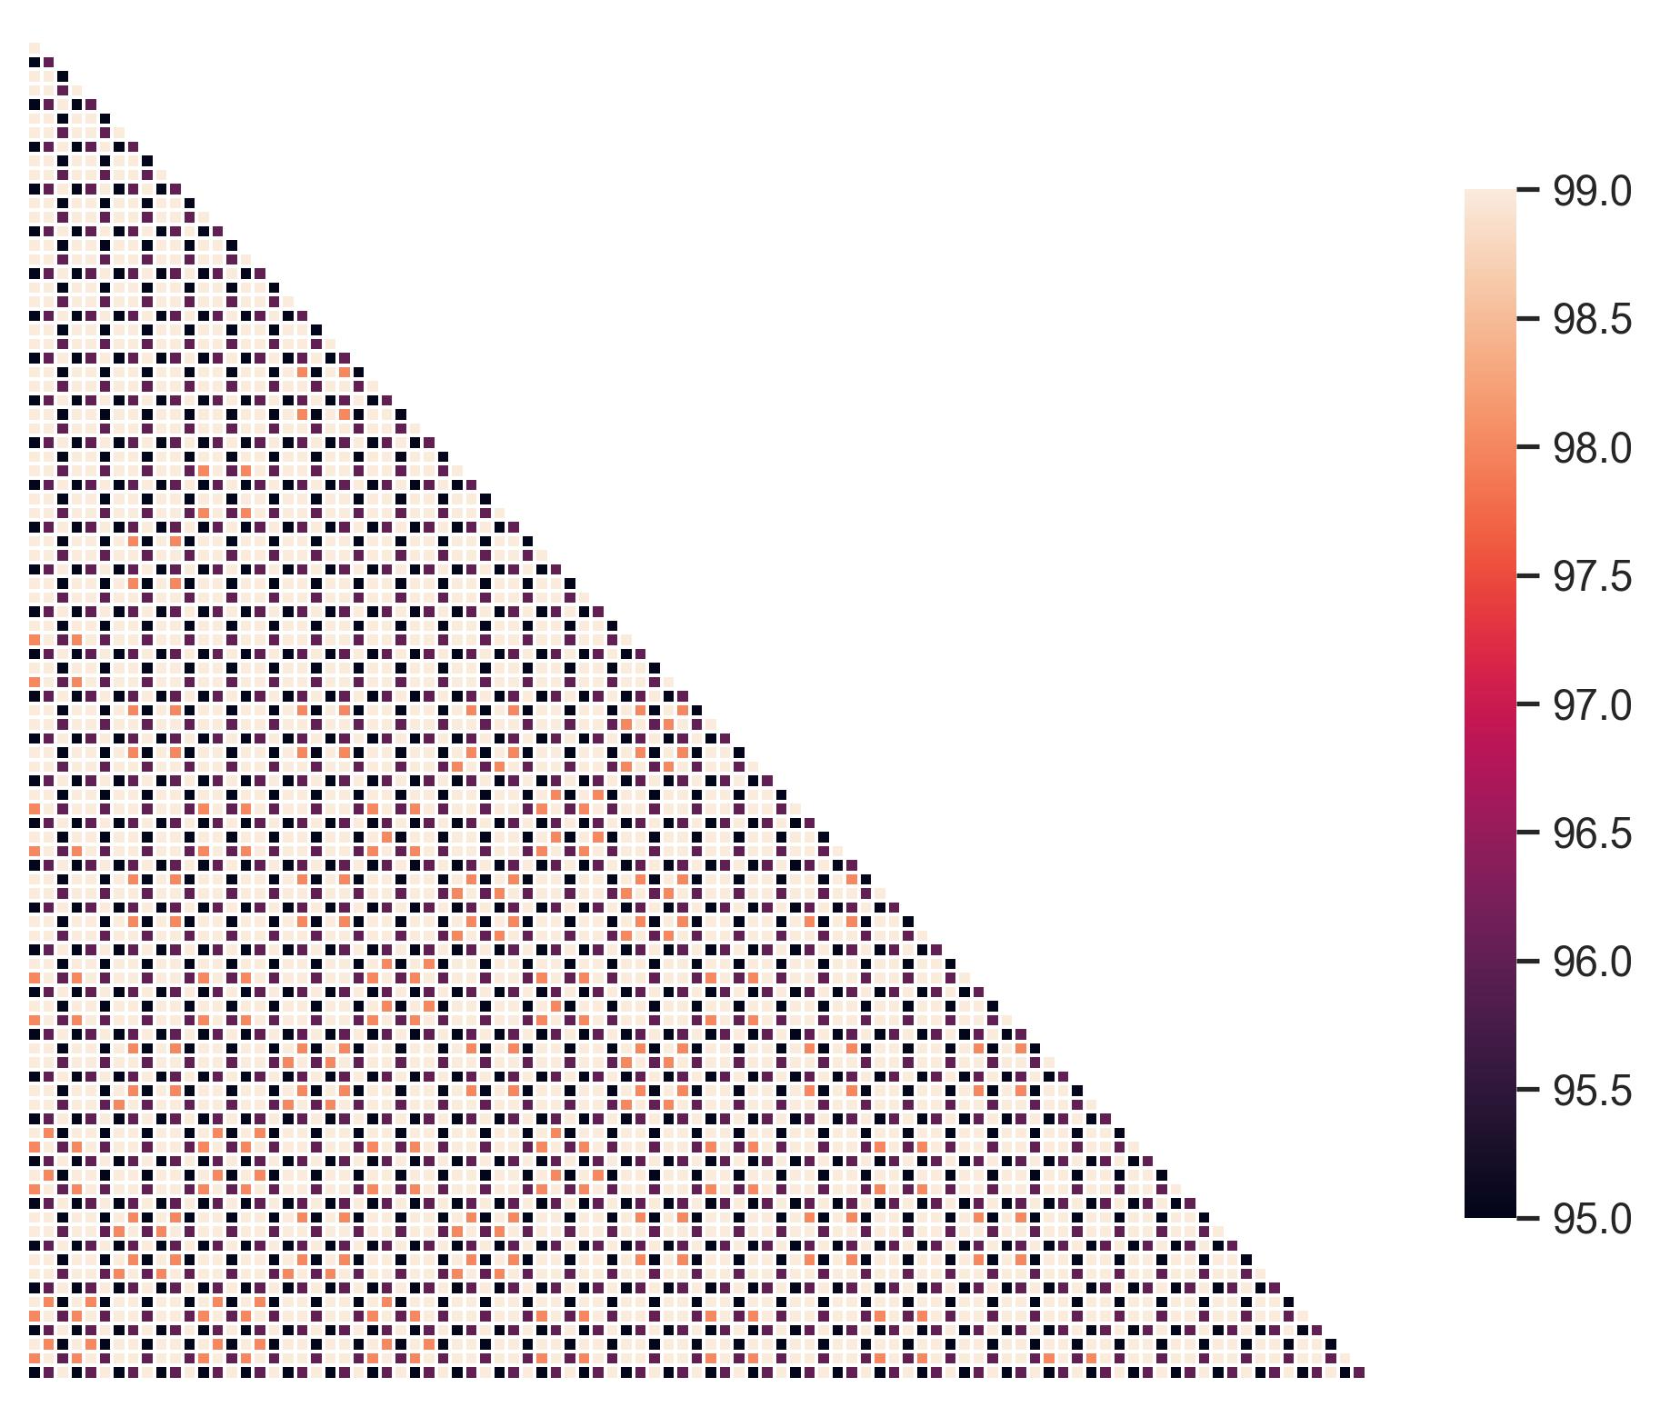
Supplementary Figure 8. Pairwise Pearson correlations among subnational cereal flow estimates generated under 96 different harmonization‐parameter settings.

Supplementary Tables
Supplementary Table 1. Datasets used in the modelling pipeline
Data | Database | Year(s) | Details
Political boundaries | Global Administrative Areas Database (GADM) |  | 195 countries, 3,536 subnational administrative regions
Production | FAOSTAT¹ | 2012 | Crops included: barley, buckwheat, canary seed, fonio, maize, millet, mixed grain, oatsª, quinoa, rye, rice^{b}, sorghum, triticale, wheat, other cereals^{c}  Spatial resolution: National scale
Production | FAOSTAT¹ | 2017
Production | FAOSTAT¹ | 2017-21
Producer prices | FAOSTAT¹ | 2010-21
Yield | FAOSTAT¹ | 2010-21
Bilateral trade | FAOSTAT¹ | 2017-21
Bilateral trade | Harris et al.² | 2012 | Domestic cereal flow in India
Bilateral trade | Pandit et al.³ | 2017 | Subnational international flows between USA and China
Global gridded crop areas | Global Agro-Ecological Zones (GAEZ) + 2015 Annual Crop Harvest Area and Production^{4,5} | 2015 | Crops included: barley, maize, millet, rice, sorghum, wheat, other cereals  Spatial resolution: ~10 km
Global gridded crop production |  | 2015
Gridded livestock counts | Gridded Livestock of the World 2015⁶⁻¹³ | 2015 | Animals included: buffaloes, cattle, chickens, ducks, goats, horses, pigs, sheep  Spatial resolution: ~10 km
Global gridded building footprint | Global Human Settlement Layer (GHSL) Built-up Volume¹⁴ | 2020 | Spatial resolution: 100 m
Global gridded population | WorldPop¹⁵ | 2020 | Spatial resolution: 1 km
Global gridded GDP | Wang & Sun¹⁶ | 2005 | Spatial resolution: 1 km
Transport | Guimbard et al.¹⁷ |  | Includes cost, distance, and time variables for transporting commodities between any two subnational regions
Tariff | MAc-MAP-HS6¹⁸ | 2019 | Bilateral tariff data
ª Oats trade includes rolled oats as well.
^{b} For rice, bilateral trade for the ‘milled equivalent’ category was used. For consistency, the rice production data from FAO was scaled by a factor of 0.7, to estimate the milled equivalent rice production¹⁹.
^{c} ‘other cereals’ corresponds to FAOSTAT’s ‘Cereals, n.e.c.’ (not elsewhere classified)

Supplementary Table 2. Global production, country-to-country trade, and flows for 11 cereal commodities. Production data comes from the FAO, trade data is obtained after harmonizing the FAO bilateral trade data²⁰, and flows data is the output of the re-export algorithm²¹.
Commodity | Global Production  (million tonnes) | Global Trade  (million tonnes) | Global Flows  (million tonnes) | Correlation between country -to-country trade and flows
 |  |  |  | Linear scale | Log scale
Barley | 150.34 | 37.74 | 36.35 | 0.99 | 0.89
Buckwheat | 2.01 | 0.18 | 0.12 | 0.94 | 0.69
Canary seed | 0.25 | 0.20 | 0.17 | 0.99 | 0.68
Fonio | 0.65 | 0.00 | 0.00 | 0.99 | 0.87
Maize | 1154.94 | 183.23 | 177.31 | 0.99 | 0.89
Millet | 29.91 | 0.47 | 0.38 | 0.96 | 0.82
Mixed grain | 3.36 | 0.07 | 0.01 | 0.27 | 0.59
Oats | 23.80 | 4.45 | 4.06 | 0.99 | 0.84
Quinoa | 0.16 | 0.10 | 0.08 | 0.98 | 0.62
Rice | 535.07 | 44.96 | 42.56 | 0.99 | 0.84
Rye | 12.96 | 1.63 | 1.49 | 0.99 | 0.89
Sorghum | 58.92 | 7.23 | 7.16 | 0.99 | 0.89
Triticale | 14.17 | 0.81 | 0.78 | 0.99 | 0.97
Wheat | 759.29 | 191.62 | 184.11 | 0.99 | 0.86
Other | 7.82 | 0.37 | 0.11 | 0.44 | 0.51
Total | 2754.09 | 471.44 | 455.92 | 0.99 | 0.89

Supplementary Table 4. Hyperparameter settings for all cereal flow link classification models evaluated
Model | Hyperparameters
Logistic regression | maximum iterations: 500
Random forest classifier | number of trees: 200  maximum tree depth: 15  minimum number of samples required to split a node: 4  weights associated with classes: ‘balanced’
Gradient boosting classifier | maximum iterations: 5000  minimum number of samples per leaf: 100  proportion of features chose in each node split: 0.8  weights associated with classes: ‘balanced’
Neural network | learning rate: 0.001  number of hidden layers: 2  dropout: 0.2  dense neurons: 512  batch size: 512  epochs: 300  hidden layer activation function: ‘relu’  output layer activation function: ‘sigmoid’  loss function: ‘binary cross entropy’  optimizer: ‘RMSprop’

Supplementary Table 5. Out-of-sample performance of cereal flow link classification models by dataset type. Metrics are averaged over five model runs with distinct train-test splits to account for sampling variation.
Model | Dataset* | Accuracy | Precision | Recall | MCC
Logistic regression | faostat | 0.89 | 0.82 | 0.77 | 0.72
Logistic regression | india | 0.72 | 0.74 | 0.83 | 0.38
Logistic regression | us-china | 0.80 | 0.53 | 0.33 | 0.30
Logistic regression | overall | 0.88 | 0.80 | 0.75 | 0.69
Random forest classifier | faostat | 0.93 | 0.84 | 0.91 | 0.82
Random forest classifier | india | 0.87 | 0.83 | 0.99 | 0.73
Random forest classifier | us-china | 0.97 | 0.94 | 0.91 | 0.90
Random forest classifier | overall | 0.93 | 0.84 | 0.92 | 0.83
Gradient boosting classifier | faostat | 0.94 | 0.85 | 0.93 | 0.84
Gradient boosting classifier | india | 0.90 | 0.88 | 0.97 | 0.78
Gradient boosting classifier | us-china | 0.97 | 0.93 | 0.95 | 0.92
Gradient boosting classifier | overall | 0.94 | 0.85 | 0.93 | 0.85
Neural network | faostat | 0.93 | 0.86 | 0.87 | 0.81
Neural network | india | 0.87 | 0.88 | 0.92 | 0.73
Neural network | us-china | 0.95 | 0.89 | 0.86 | 0.84
Neural network | overall | 0.93 | 0.86 | 0.87 | 0.81
* test-split only. ‘faostat’: national-scale international flows (2017-2021); ‘india’: domestic cereal flows within India (2012); ‘us-china’: subnational-scale international flows between USA and China (2017); ‘overall’: all datasets combined
Accuracy measures the proportion of correct predictions over all predictions. Precision measures the proportion of true positives over all predicted positives. Recall measures the proportion of all positives that are identified by the model. The MCC score provides the most balanced estimate of performance by assessing all 4 elements of the 2x2 confusion matrix, and can take values between -1 and +1, where +1 indicates perfect agreement.

Supplementary Table 6. Hyperparameter settings for all cereal flow prediction regression models evaluated
Model | Hyperparameters | Details
Linear regression | - | Target: log (flow volume)  Loss: mean squared error on log scale
Random forest regressor | number of trees: 500  maximum tree depth: 10 | Target: log (flow volume)  Loss: mean squared error on log scale
Gradient boosting regressor | maximum iterations: 1000  minimum number of samples per leaf: 100  proportion of features chose in each node split: 0.4  maximum tree depth: 8  L2 regularization: 100  loss function: ‘gamma’ | Target: flow volume (linear)  Loss: gamma loss, which internally uses a log-link.
Neural network | learning rate: 0.01  number of hidden layers: 2  dropout: 0.2  dense neurons: 256  batch size: 512  epochs: 400  hidden layer activation function: ‘relu’  output layer activation function: ‘softplus’  optimizer: ‘RMSprop’ | Target: flow volume (linear)  Loss:  $L\left(y,\hat{y}\right)=α L_{q}\left(y,\hat{y}\right)×0.01$ $+\left(1-α\right) L_{l}\left(y,\hat{y}\right)×100$,  where $α=$ 0.5,  $y=$ observed flows, $\hat{y}=$ predicted flows,  $L_{q}\left(y,\hat{y}\right)=$ quantile loss between observed and predicted flows with a quantile weight of 0.6,  $L_{l}\left(y,\hat{y}\right)=$ mean squared error between log (observed) and log (predicted) flows

Supplementary Table 7. Out-of-sample performance of cereal flow prediction regression models by dataset type. Metrics are averaged over five model runs with distinct train-test splits to account for sampling variation.
Model | Dataset* | R2 (cereal flows)
Model | Dataset* | Linear scale | Log scale
Linear regression | faostat | 0.02 | 0.47
Linear regression | india | 0.04 | 0.46
Linear regression | us-china | -0.04 | 0.34
Linear regression | overall | 0.03 | 0.48
Random forest regressor | faostat | 0.09 | 0.64
Random forest regressor | india | 0.23 | 0.78
Random forest regressor | us-china | 0.18 | 0.86
Random forest regressor | overall | 0.11 | 0.67
Gradient boosting regressor | faostat | 0.39 | 0.70
Gradient boosting regressor | india | 0.52 | 0.83
Gradient boosting regressor | us-china | 0.79 | 0.95
Gradient boosting regressor | overall | 0.42 | 0.73
Neural network | faostat | 0.52 | 0.65
Neural network | india | 0.35 | 0.75
Neural network | us-china | 0.54 | 0.88
Neural network | overall | 0.52 | 0.68
* test-split only. ‘faostat’: national-scale international flows (2017-2021); ‘india’: domestic cereal flows within India (2012); ‘us-china’: subnational-scale international flows between USA and China (2017); ‘overall’: all datasets combined
Supplementary Table 8. Out-of-sample performance of the best performing link classification models for different cereals, by dataset type. Metrics are averaged over five model runs with distinct train-test splits to account for sampling variation.
Crop (Model) | Dataset* | Accuracy | Precision | Recall | MCC
wheat (Neural network) | faostat | 0.96 | 0.84 | 0.86 | 0.83
wheat (Neural network) | india | 0.96 | 0.85 | 0.97 | 0.88
wheat (Neural network) | overall | 0.96 | 0.84 | 0.86 | 0.83
rice (Gradient boosting classifier) | faostat | 0.95 | 0.75 | 0.94 | 0.82
rice (Gradient boosting classifier) | india | 0.94 | 0.92 | 0.99 | 0.88
rice (Gradient boosting classifier) | overall | 0.95 | 0.77 | 0.95 | 0.83
maize (Random Forest) | faostat | 0.95 | 0.73 | 0.85 | 0.76
maize (Random Forest) | india | 0.97 | 0.00 | 0.00 | -0.01
maize (Random Forest) | overall | 0.95 | 0.73 | 0.84 | 0.75
other cereals (Random Forest) | faostat | 0.94 | 0.72 | 0.86 | 0.75
other cereals (Random Forest) | india | 0.94 | 0.64 | 0.28 | 0.39
other cereals (Random Forest) | overall | 0.94 | 0.72 | 0.85 | 0.75
all cereals (Gradient boosting classifier) | faostat | 0.94 | 0.85 | 0.93 | 0.84
all cereals (Gradient boosting classifier) | india | 0.90 | 0.88 | 0.97 | 0.78
all cereals (Gradient boosting classifier) | us-china | 0.97 | 0.93 | 0.95 | 0.92
all cereals (Gradient boosting classifier) | overall | 0.94 | 0.85 | 0.93 | 0.85
* test-split only. ‘faostat’: national-scale international flows (2017-2021); ‘india’: domestic cereal flows within India (2012); ‘us-china’: subnational-scale international flows between USA and China (2017); ‘overall’: all datasets combined. The ‘us-china’ dataset is excluded from individual-cereal models because it lacks disaggregated flows by cereal type.
Accuracy measures the proportion of correct predictions over all predictions. Precision measures the proportion of true positives over all predicted positives. Recall measures the proportion of all positives that are identified by the model. The MCC score provides the most balanced estimate of performance by assessing all 4 elements of the 2x2 confusion matrix, and can take values between -1 and +1, where +1 indicates perfect agreement.

Supplementary Table 9. Out-of-sample performance of the best performing flow prediction regression models for different cereals, by dataset type. Metrics are averaged over five model runs with distinct train-test splits to account for sampling variation.
Crop (Model) | Dataset* | R2 (cereal flows)
Crop (Model) | Dataset* | Linear scale | Log scale
wheat (Neural network) | faostat | 0.45 | 0.64
wheat (Neural network) | india | 0.36 | 0.70
wheat (Neural network) | overall | 0.45 | 0.65
rice (Neural network) | faostat | 0.33 | 0.61
rice (Neural network) | india | 0.44 | 0.87
rice (Neural network) | overall | 0.36 | 0.67
maize (Neural network) | faostat | 0.29 | 0.59
maize (Neural network) | india | -0.02 | -0.47
maize (Neural network) | overall | 0.29 | 0.60
other cereals (Neural network) | faostat | 0.27 | 0.60
other cereals (Neural network) | india | -0.11 | -0.07
other cereals (Neural network) | overall | 0.26 | 0.60
all cereals (Neural network) | faostat | 0.52 | 0.65
all cereals (Neural network) | india | 0.35 | 0.75
all cereals (Neural network) | us-china | 0.54 | 0.88
all cereals (Neural network) | overall | 0.52 | 0.68
* test-split only. ‘faostat’: national-scale international flows (2017-2021); ‘india’: domestic cereal flows within India (2012); ‘us-china’: subnational-scale international flows between USA and China (2017); ‘overall’: all datasets combined. The ‘us-china’ dataset is excluded from individual-cereal models because it lacks disaggregated flows by cereal type.
Supplementary Table 10. Goodness of fit for regression models estimating consumption for different cereals
Crop | R-squared between true and fitted country level consumption |  | R2 between true country level consumption and totalled admin level consumption (estimated)
Crop | Linear scale | Log scale | Linear scale | Log scale
wheat | 0.89 | 0.52 | 0.93 | 0.47
rice | 0.85 | 0.76 | 0.94 | 0.68
maize | 0.63 | 0.74 | 0.69 | 0.72
other cereals | 0.57 | 0.75 | 0.52 | 0.65
all cereals | 0.90 | 0.87 | 0.89 | 0.87

Supplementary Table 11. Out-of-sample Pearson correlations of observed and predicted total cereal flows with observed disaggregated cereal flows. Metrics are averaged over five model runs with distinct train-test splits to account for sampling variation.
Model | Dataset* | Correlation between total and disaggregated cereal flows
Model | Dataset* | wheat |  | rice |  | maize |  | other cereals
Model | Dataset* | obs | pred | obs | pred | obs | pred | obs | pred
Neural network | faostat | 0.71 | 0.59 | 0.20 | 0.11 | 0.82 | 0.57 | 0.57 | 0.52
Neural network | india | 0.84 | 0.56 | 0.75 | 0.47 | 0.07 | 0.16 | 0.23 | 0.22
Neural network | us-china | - | - | - | - | - | - | - | -
Neural network | overall | 0.74 | 0.56 | 0.31 | 0.15 | 0.76 | 0.56 | 0.54 | 0.51
* test-split only. ‘faostat’: national-scale international flows (2017-2021); ‘india’: domestic cereal flows within India (2012); ‘us-china’: subnational-scale international flows between USA and China (2017); ‘overall’: all datasets combined. Correlations for the ‘us-china’ dataset are not provided because it lacks disaggregated flows by cereal type.

Supplementary Table 12. Parameter grid used for sensitivity analysis of the harmonization algorithm
Parameter | Description | Test values
Link probability threshold | Classification probability cutoff for retaining a predicted link. | 0.40, 0.50, 0.60
Domestic quantile fallback | If no domestic link in a country exceeds the threshold, retain top X% of links by probability. | 0.75, 0.80
International quantile fallback | If no international link between a trading country pair exceeds the threshold, retain top X% of links by probability. | 0.75, 0.80
Iteration limit | Maximum passes in Phase I (Phase II uses twice this value). | 40, 50
Scaling factor $α$ | In Phase I, upward nudges go from $α$ to $2α$ and downward nudges go from $0.5α$ to $1.5α$; in Phase II, $α$ denotes the fraction of total deficit (or surplus) to reallocate. | 0.10, 0.20
Export cap $β$ | Maximum share of production allowed for export in Phase I. | 0.90, 0.95

Supplementary Methods
Supplementary Methods 1: Reliability index approach
The reliability index approach outlined by Gehlhar²⁰ is used to resolve discrepancies between the volume of cereal trade reported by the importer and exporter in the bilateral trade dataset. An accuracy level (Supplementary Equation 1) is computed for each bilateral trading pair, and this captures the quality of match between the importer and exporter reported quantities. The value of $AL$ should be closer to 0 for the match to be more accurate, and a threshold of 0.2 is used to separate accurate from non-accurate matches, i.e. a match is accurate only if the difference between the reported imports and exports is less than 20%. Then, for each country, it becomes possible to construct an importer reliability index ($RIM$), and an exporter reliability index ($RIX$), which are given by Supplementary Equations 2 and 3 respectively. An importer’s reliability is measured by the proportion of total imports it reports accurately, and similarly an exporter’s reliability is measured by the proportion of its total exports it reports reliably. Finally, for each bilateral trading pair, the value reported by the more reliable partner is accepted as the trade flow between those countries.
Equation 1 calculates the accuracy level ($AL$) of a transaction from region $r$ to region $s$, for which the value of trade reported by the importer is $M_{r,s}$ and that reported by the exporter is $X_{r,s}$:
$AL_{r,s}=2×\frac{\left|M_{r,s}-X_{r,s}\right|}{M_{r,s}+X_{r,s}}$
Equation 2 calculates the reliability index of import region $s$ as:
$RIM{}_{s}=\frac{M_{s}^{A}}{M_{s}^{T}}$ , where
$M_{s}^{T}=\sum_{r}{M_{r,s}}$ $∀s$, and
$M_{s}^{A}=\sum_{r}{M_{r,s}}$ $∀s$where $AL_{r,s}≤0.2$
Equation 3 calculates the reliability index of import region $r$ as:
$RIX{}_{s}=\frac{X_{r}^{A}}{X_{r}^{T}}$ , where
$X_{r}^{T}=\sum_{s}{X_{r,s}}$ $∀r$, and
$X_{r}^{A}=\sum_{s}{X_{r,s}}$ $∀r$where $AL_{r,s}≤0.2$

Supplementary Methods 2: Re-export algorithm
The bilateral trade dataset harmonized using the reliability index approach is fed into a re-export algorithm along with the production dataset from FAO. The re-export algorithm proposed by Croft et al.²¹ ensures that the total exports from a country never exceed its production and total imports; and it also links the source of production with the destination of import. The algorithm uses the production and export matrices $P$ and $E$, and applies an iterative approach to produce a domestic supply matrix $D$. In this study, the dimensions of $P$, $E$, and $D$ are $195×1$, $195×195$, and $195×195$ respectively. The non-diagonal elements of the computed domestic supply matrix $D$ and the export matrix $E$ were highly correlated (Supplementary Table 2).
$P=\left[\begin{matrix}p_{1} \\ p_{2} \\ ⋮ \\ p_{n}\end{matrix}\right]$
$E=\left[\begin{matrix}0 & e_{12} & … & e_{1n} \\ e_{21} & 0 & … & e_{2n} \\ ⋮ & ⋮ & ⋱ & ⋮ \\ e_{n1} & e_{n2} & … & 0\end{matrix}\right]$

$D=\left[\begin{matrix}d_{11} & d_{12} & … & d_{1n} \\ d_{21} & d_{22} & … & d_{2n} \\ ⋮ & ⋮ & ⋱ & ⋮ \\ d_{n1} & d_{n2} & … & d_{nn}\end{matrix}\right]$

where, $p_{i}$ is the production in country $i$; $e_{ij}$ are the exports from country $i$ to $j$; and $d_{ij}$ is the quantity of country $j$’s domestic supply that originates from country $i$. The sum of rows of matrix $D$ equals the countries’ production, and the sum of columns equals the countries’ domestic supply (or consumption). The diagonal elements correspond to the produce that stays within the countries. The non-diagonal elements of matrix $D$ are referred to as ‘flows’ in this study, i.e., $d_{ij|ij}$ gives the food flow from $i$ to $j$. Croft et al.²¹ list all the algorithm steps and also provide MATLAB code for implementing it to obtain the domestic supply matrix $D$.

Supplementary Methods 3: Producer prices
FAO‐reported producer prices (USD/tonne) reflect farm‐gate receipts and exclude post–farm‐gate costs such as transport to market, storage, processing, and marketing fees. When available, prices from the three most recent years since 2010 were averaged for each crop and country. Missing values were imputed via a linear regression (Supplementary Equation 4), with prices first converted from per hectare to per tonne by multiplying by yields to improve model fit.
Equation 4:
$\log{price=β_{0}+β_{1}\log{GDP}}+β_{2}\log{production}+β_{3}\log{yield}+region FE$,
with regions: Africa, Americas, Asia, Europe, Oceania
The primary regression was fitted using data from the 25 largest producers with available price information, to minimize noise from smaller producers. Where countries fell outside the regions covered by these top 25, a secondary regression was applied using all nations with price data. In regions lacking any observations, global averages were substituted. When fewer than 25 observations existed for a given crop, subregional, regional, and then global means were used in sequence to impute missing values, instead of the regression approach.
Finally, aggregated cereal producer prices were computed as production‐weighted averages of individual commodity prices. In the absence of any subnational data on producer prices, country level price data was used all subnational regions.

Supplementary Methods 4: Estimating regional production and consumption
The 2015 global gridded crop‐production data⁴ were first aggregated to administrative boundaries to yield baseline estimates of regional cereal production. To account for change (growth) in overall output between 2015 and the study period (2017–2021), these values were scaled using country‐specific factors equal to the ratio of FAO’s national production totals to the 2015 gridded production estimates aggregated by country.
Subnational cereal consumption was then estimated via a log-linear gamma regression fitted at the national scale (Supplementary Equation 5). Observed national consumption was defined as $production + inflows - outflows$, and this quantity was regressed against log-transformed regional covariates, including livestock counts (buffaloes, cattle, chickens, ducks, goats, horses), population, GDP, and cereal production. The log-linear specification was
Equation 5
$ln\left(E\left(consumption_{i}\right)\right)=β_{1} ln\left(buffaloes_{i}\right)+β_{2} ln\left(cattle_{i}\right)+β_{3} ln\left(chicken_{i}\right)+β_{4} ln\left(ducks_{i}\right)+β_{5} ln\left(goats_{i}\right)+β_{6} ln\left(horses_{i}\right)+β_{7} ln\left(pop_{i}\right)+β_{8} ln\left(gdp_{i}\right)+β_{9} ln\left(production_{i}\right)$
Livestock and population capture combined food and feed demand, GDP serves as a proxy for dietary preferences, and regional production serves as an indirect indicator of both local availability and unobserved industrial processing. Processing plants are frequently co-located with primary grain production areas to minimize inbound transport costs for bulky cereals^{22,23}. Hence, the covariate for regional cereal production can proxy for this hidden component of demand, in the absence of a direct measure of processing at subnational scales. Pigs and sheep were omitted from the regression specification due to multicollinearity. Also note that stock variation was not accounted for while estimating production or consumption even though stocks can affect total supply. Global stock variation amounted to only ~1% of annual production over 2017-2021 (and remained below 5% for nearly all countries), making it a very small component of total supply.
The R-squared between estimated and observed consumption at national scales was 0.90. The fitted model was used to estimate consumption at subnational scales. The estimated subnational-scale consumption, when aggregated at national level, also matched well with observed national level consumption (R²=0.89). The resulting subnational consumption estimates were also scaled so that, within each country, their sum exactly matched the FAO’s reported consumption total.

Supplementary Notes
Pseudocode for modelling pipeline

Input:
`D_fao_trade`: FAO national bilateral trade data (reporter, partner, commodity, year, volume)
`D_fao_prod`: FAO national production data (country, commodity, year, volume)
`D_subnat_flows_known`: Available subnational flow data (e.g., India domestic, US-China international)
`C_gridded`: Gridded covariate datasets (crop area/production, livestock, population, GDP, building footprint etc.)
`A_boundaries`: Administrative boundaries (national and subnational)
`P_prices`: Producer price data
`T_tariffs`: Tariff data
`T_transport`: Transport data

Output:
`F_subnational`: Matrix of harmonized cereal flows between all subnational administrative units (origin_admin_unit, destination_admin_unit, flow_volume, flow_type: {domestic, international})

BEGIN PIPELINE

Phase 1: Data Pre-processing and Covariate Preparation

1. Process National Trade Data (`D_fao_trade`):
a. FOR EACH commodity, year:
i. Resolve Reporter Discrepancies:
1. Calculate accuracy level for each bilateral trade pair (importer vs. exporter reported values).
2. Compute importer and exporter reliability indices.
3. `D_harmonized_trade` = Accept value reported by the more 0reliable partner for each bilateral pair.
ii. Apply Re-export Algorithm:
1. Input: `D_harmonized_trade`, `D_fao_prod`.
2. Output: `D_national_flows` (links production source country to final import destination country, minimizes re-exports, ensures country exports <= production + imports).
b. Aggregate `D_national_flows` across all cereal commodities, and average over 2017-2021.

2. Process and Integrate Known Subnational Flows (`D_subnat_flows_known`):
a. Aggregate individual commodity flows to total cereal flows.
b. Standardize format to match (origin_admin_unit, destination_admin_unit, volume).

3. Prepare Covariates:
a. FOR EACH gridded covariate dataset in `C_gridded`:
i. Aggregate gridded data to `A_subnational` (subnational administrative units).
ii. Aggregate gridded data to `A_national` (national units).
b. Process `P_prices`, `T_tariffs`, and `T_transport`, aligning them with national/subnational units.
c. Create origin-destination pair features for all potential national-national and subnational-subnational links. Features include:
- Origin characteristics (production of specific cereals, livestock counts, population, GDP, area, region, etc.).
- Destination characteristics (similar to origin).
- Pairwise characteristics (transport cost/time/distance, border compliance costs, tariffs, etc.).
d. `X_features_links` = Combined feature set for all potential links.

Phase 2: Machine Learning Prediction of Subnational Flows

1. Prepare Training Data for ML:
a. `Data_ML_train` = Combine `D_national_flows` and `D_subnat_flows_known`.
b. Associate each flow in `Data_ML_train` with its corresponding features from `X_features_links`.

2. Link Prediction (Classification Model):
a. Define `y_link_presence` = 1 if flow_volume > threshold (i.e., 1 tonne), else 0.
b. Train `Classifier_model` (e.g., Gradient Boosting Classifier, Random Forest) on `Data_ML_train` (features: `X_features_links` for training pairs, target: `y_link_presence`). Use cross-validation for hyperparameter tuning.
c. `P_link_probabilities` = `Classifier_model`.predict_proba(`X_features_links` for all potential subnational-subnational pairs).

3. Volume Prediction (Regression Model):
a. `Data_ML_regression_train` = Subset of `Data_ML_train` where `y_link_presence` = 1.
b. Train `Regressor_model` (e.g., Neural Network, Gradient Boosting Regressor) on `Data_ML_regression_train` (features: `X_features_links` for training pairs with links, target: `log(flow_volume)` or `flow_volume` with appropriate loss function). Use cross-validation.
c. `V_predicted_volumes_raw` = `Regressor_model`.predict(`X_features_links` for all potential subnational-subnational pairs).

Phase 3: Harmonization of Predicted Subnational Flows

1. Initialize Subnational Flow Network:
a. Filter `P_link_probabilities`: Retain links if probability > `prob_threshold` (e.g., 0.5).
- IF for a given national trade pair (CountryX -> CountryY), no subnational links (AdminX_i -> AdminY_j) exceed `prob_threshold`, THEN retain top `k%` of links by probability for that national pair.
- Apply similar logic for domestic links within a country.
b. `F_subnational_initial` = For retained links, assign flow volume from `V_predicted_volumes_raw`.

2. Estimate Subnational Consumption (`C_subnational_demand`):
a. Estimate subnational production (`P_subnational_supply`) using subnational production covariates/proxies scaled to match national production when aggregated.
b. Regress national consumption (Production + Imports - Exports) against national-level covariates (livestock, population, GDP, production).
c. Use the fitted regression model with subnational covariates to predict `C_subnational_demand_raw`.
d. Scale `C_subnational_demand_raw` within each country so that sum of subnational consumption equals national consumption.

3. Iterative Harmonization - Phase I: Global Adjustment (International & Domestic Focus)
a. `F_subnational_current` = `F_subnational_initial`.
b. FOR `iter_global` FROM 1 TO `MAX_GLOBAL_ITERATIONS`:
i. Realign with National Totals:
1. FOR EACH national bilateral trade pair (CountryX -> CountryY) in `D_national_flows`:
- `Sum_current_sub_intl_flow` = SUM(`F_subnational_current` for all AdminX_i -> AdminY_j).
- `Scale_factor` = `D_national_flows(CountryX -> CountryY)` / `Sum_current_sub_intl_flow`.
- Multiply `F_subnational_current` for all AdminX_i -> AdminY_j by `Scale_factor`.
ii. Rebalance Regional Supply/Demand:
1. FOR EACH subnational region `r`:
- Calculate `NetSupply_r` = `P_subnational_supply_r` + TotalInflows_r(`F_subnational_current`) - TotalOutflows_r(`F_subnational_current`).
- `Deficit_r` = `C_subnational_demand_r` - `NetSupply_r`.
- IF `Deficit_r` > `consumption_deficit_threshold` * `C_subnational_demand_r`:
- Increase incoming flows to `r` in `F_subnational_current` (by `adj_factor_inflow`, possibly increasing with `iter_global`).
- Decrease outgoing flows from `r` in `F_subnational_current` (by `adj_factor_outflow`, possibly increasing with `iter_global`).
- ELSE IF `NetSupply_r` > `C_subnational_demand_r` (Surplus):
- Decrease incoming flows to `r`.
- Increase outgoing flows from `r` (if `P_subnational_supply_r` allows after existing exports).
iii. Enforce Production-Based Export Cap:
1. FOR EACH subnational region `r`:
- `MaxExport_r` = MIN( `export_prod_cap_factor` * `P_subnational_supply_r`, `P_subnational_supply_r` - `self_consumption_factor` * `C_subnational_demand_r` (if `P_subnational_supply_r` > `self_consumption_factor` * `C_subnational_demand_r`), else 0).
- IF TotalOutflows_r(`F_subnational_current`) > `MaxExport_r`:
- Proportionally scale down all outgoing flows from `r` in `F_subnational_current`.
iv. IF convergence criteria met (e.g., small changes in flows), BREAK.
c. Perform final realignment of international subnational flows to `D_national_flows` country totals.
d. `F_subnational_after_global` = `F_subnational_current`.

4. Iterative Harmonization - Phase II: Domestic Adjustment (Within-Country Focus)
a. `F_subnational_current` = `F_subnational_after_global`.
b. FOR `iter_domestic` FROM 1 TO `MAX_DOMESTIC_ITERATIONS`:
i. FOR EACH Country `C`:
1. Identify `DeficitRegions_C` and `SurplusRegions_C` within `C` based on current balances (`P_subnational_supply` + Inflows - Outflows vs. `C_subnational_demand`).
2. `TotalDeficit_C` = SUM of deficits in `DeficitRegions_C`.
3. `TotalAvailableSurplus_C` = SUM of available surpluses in `SurplusRegions_C` (production not yet committed to export or local consumption).
4. `ReallocationBudget_C` = `realloc_factor` * MIN(`TotalDeficit_C`, `TotalAvailableSurplus_C`).
5. FOR EACH `deficit_region_r` in `DeficitRegions_C`:
- `ShareToReceive` = `Deficit_r` / `TotalDeficit_C` * `ReallocationBudget_C`.
- Allocate `ShareToReceive` by creating/increasing domestic flows from `SurplusRegions_C` (proportional to their available surplus) to `deficit_region_r`. Update `F_subnational_current`.
6. Ensure no region exports more than its production (relaxed constraints might be used here compared to Phase I export cap for domestic balancing).
ii. IF convergence criteria met (e.g., regional deficits < `final_deficit_threshold`), BREAK.
c. `F_subnational_final` = `F_subnational_current`.

5. Return `F_subnational_final`

END PIPELINE

Supplementary References
1. FAO. (2023). FAOSTAT.
2. Harris, F., Dalin, C., Cuevas, S., NR, L., Adhya, T., Joy, E. J., Scheelbeek, P. F., Kayatz, B., Nicholas, O., & Shankar, B. (2020). Trading water: virtual water flows through interstate cereal trade in India. Environmental Research Letters, 15(12), 125005.
3. Pandit, A., Karakoc, D. B., & Konar, M. (2023). Spatially detailed agricultural and food trade between China and the United States. Environmental Research Letters, 18(8), 084031.
4. Frolking, S., Wisser, D., Grogan, D., Proussevitch, A., & Glidden, S. (2020). GAEZ+_2015 Crop Production Version V2) Harvard Dataverse. https://doi.org/doi/10.7910/DVN/KJFUO1
5. Frolking, S., Wisser, D., Grogan, D., Proussevitch, A., & Glidden, S. (2020). GAEZ+_2015 Crop Harvest Area Version V4) Harvard Dataverse. https://doi.org/doi/10.7910/DVN/KAGRFI
6. Gilbert, M., Cinardi, G., Da Re, D., Wint, W. G. R., Wisser, D., & Robinson, T. P. (2022). Global sheep distribution in 2015 (5 minutes of arc) Version V1) [GIS Geotiff file]. Harvard Dataverse. https://doi.org/doi/10.7910/DVN/VZOYHM
7. Gilbert, M., Cinardi, G., Da Re, D., Wint, W. G. R., Wisser, D., & Robinson, T. P. (2022). Global chickens distribution in 2015 (5 minutes of arc) Version V1) Harvard Dataverse. https://doi.org/doi/10.7910/DVN/SXHLF3
8. Gilbert, M., Cinardi, G., Da Re, D., Wint, W. G. R., Wisser, D., & Robinson, T. P. (2022). Global ducks distribution in 2015 (5 minutes of arc) Version V1) Harvard Dataverse. https://doi.org/doi/10.7910/DVN/S9ONXV
9. Gilbert, M., Cinardi, G., Da Re, D., Wint, W. G. R., Wisser, D., & Robinson, T. P. (2022). Global cattle distribution in 2015 (5 minutes of arc) Version V1) Harvard Dataverse. https://doi.org/doi/10.7910/DVN/LHBICE
10. Gilbert, M., Cinardi, G., Da Re, D., Wint, W. G. R., Wisser, D., & Robinson, T. P. (2022). Global pigs distribution in 2015 (5 minutes of arc) Version V1) Harvard Dataverse. https://doi.org/doi/10.7910/DVN/CIVCPB
11. Gilbert, M., Cinardi, G., Da Re, D., Wint, W. G. R., Wisser, D., & Robinson, T. P. (2022). Global buffaloes distribution in 2015 (5 minutes of arc) Version V1) Harvard Dataverse. https://doi.org/doi/10.7910/DVN/I1WCAB
12. Gilbert, M., Cinardi, G., Da Re, D., Wint, W. G. R., Wisser, D., & Robinson, T. P. (2022). Global horses distribution in 2015 (5 minutes of arc) Version V1) Harvard Dataverse. https://doi.org/doi/10.7910/DVN/JJGCTX
13. Gilbert, M., Cinardi, G., Da Re, D., Wint, W. G. R., Wisser, D., & Robinson, T. P. (2022). Global goats distribution in 2015 (5 minutes of arc) Version V1) Harvard Dataverse. https://doi.org/doi/10.7910/DVN/YYG6ET
14. Schiavina, M., Melchiorri, M., Pesaresi, M., Politis, P., Freire, S., Maffenini, L., Florio, P., Ehrlich, D., Goch, K., & Tommasi, P. (2022). GHSL data package 2022. Publications Office of the European Union: Luxembourg.
15. WorldPop. (n.d.). The spatial distribution of population in 2020. Retrieved April 5, 2024 from https://hub.worldpop.org/geodata/summary?id=24777
16. Wang, T., & Sun, F. (2022). Global gridded GDP data set consistent with the shared socioeconomic pathways, Sci. Data, 9, 221. In.
17. Verschuur, J., Vittis, Y., Obersteiner, M., & Hall, J. (2023). Cost drivers of international grains and oilseeds trade.
18. Guimbard, H., Jean, S., Mimouni, M., & Pichot, X. (2012). MAcMap-HS6 2007, an exhaustive and consistent measure of applied protection in 2007. International Economics, 130, 99-121.
19. Bodie, A. R., Micciche, A. C., Atungulu, G. G., Rothrock Jr, M. J., & Ricke, S. C. (2019). Current trends of rice milling byproducts for agricultural applications and alternative food production systems. Frontiers in Sustainable Food Systems, 3, 47.
20. Gehlhar, M. (1996). Reconciling bilateral trade data for use in GTAP. GTAP Technical papers, 11.
21. Croft, S. A., West, C. D., & Green, J. M. (2018). Capturing the heterogeneity of sub-national production in global trade flows. Journal of Cleaner Production, 203, 1106-1118.
22. Denicoff, M., Jessup, E., Taylor, A., & Nibarger, D. (2010). Chapter 2: The importance of freight transportation to agriculture. Study of rural transportation issues, 110-246.
23. Westlake, M. J. (2005). Addressing marketing and processing constraints that inhibit agrifood exports: A guide for policy analysts and planners. Food & Agriculture Org.

