Supplemental Material

Deep learning reveals shifting precipitation patterns on the Qinghai-Tibetan Plateau (1980-2020) linked to Southwest Asian monsoon

Duoping Zhu^{1,2,3}, Junbang Wang^{1,*}, Hao Li^{4,5}, Bin Yao^{2,3}, Alan E. Watson¹

¹ National Ecosystem Science Data Center, Key Laboratory of Ecosystem Network Observation and Modeling, Institute of Geographic Sciences and Natural Resources Research, Chinese Academy of Sciences, Beijing 100101, China
² Institute of Ecological Conservation and Restoration, Chinese Academy of Forestry, Beijing 100091, China
³ Institute of Desertification Studies, Chinese Academy of Forestry, Beijing 100091, China
⁴ Xiongan Institute of Innovation, Hebei Key Laboratory of Cognitive Intelligence, Xiongan 071700, China
⁵ College of Materials Science and Opto-Electronic Technology, University of Chinese Academy of Sciences, 101408, China

* Corresponding author at: National Ecosystem Science Data Center, Key Laboratory of Ecosystem Network Observation and Modeling, Institute of Geographic Sciences and Natural Resources Research, Chinese Academy of Sciences, Beijing 100101, China
E-mail address: jbwang@igsnrr.ac.cn (J.B. Wang).

Texts

S1 Cross-validation
The newly developed algorithm, A-GCN, was evaluated through cross-validation with observations from meteorological stations, independent validation with observations from ecological stations, and comparing with available datasets until the present for the QTP. According to cross-validation, the A-GCN showed higher accuracy than the machine learning-based KNN model-based precipitation data. The A-GCN had a higher R² of 0.95 (p<0.001), and a lower RRMSE 0.30 (Fig. S3a), while the KNN model had the R² and RRMSE of 0.84 and 0.51, respectively (Fig. S3b), that is, A-GCN algorithm had an R² 13.10% higher and RRMSE lower by 41.18% than that of the KNN model.
The cross-validation for each model showed the A-GCN algorithm can explain 95% of the temporal variability (R² = 0.95), averaged for all stations with an average RRMSE of 0.28. Spatially, most stations (over 90%), and the A-GCN algorithm can explain over 90% of the temporal variability. Only a few stations (0.49% of the total station number) had a lower R² in the range of from 0.6 to 0.8, and those stations are mainly distributed in the extremely arid regions of the QTP (Fig. S4). Meanwhile, the RRMSE is mainly concentrated between 0.1 - 0.3 for most stations (75.86% of the total station number), and the stations with an RRMSE over 0.5 account for 6.37% of the total stations. Those stations with a higher RRMSE are mainly distributed in extremely arid regions of the QTP. Because the data used for the cross-validation was the time series data of all stations over the whole region, the cross-validation found the A-GCN algorithm had very good performance to produce accurate spatiotemporal variability estimates for monthly precipitation observations, especially for the observations for the extremely arid region of the QTP.
The A-GCN algorithm was further validated through independent observations from ecological stations to overcome possible autocorrelation in the cross validation. Results show monthly precipitation interpolated by the both A-GCN and KNN are significantly linearly correlated with the observed precipitation from the ecological stations (Fig. 2 and Table S2). The precipitation interpolated by the A-GCN algorithm can explain the monthly variability of 86% in the observed data for all four stations, while it was 84% for the KNN. Meanwhile, the A-GCN had smaller bias (RRMSE = 0.43) than for the KNN (RRMSE = 0.48). The A-GCN showed better performance with a higher R² by 2.34% and a lower RRMSE by 10.42% than the corresponding metrics from the KNN model.

S2 Influence from model structure
Ablation experiments were applied to the A-GCN algorithm to assess the influence of the gated convolution (GCN) and the attentive mechanism (AGC) in terms of the converging speed and efficiency when training the model and the accuracy to predict precipitation with sparse observations. The training speed and efficiency was quantified by the residual loss for training steps and showed in Figure S2. The A-GCN more quickly converges to a residual loss lower by 10 mm and 20 mm, that is lower by 40.0% and 57.14%, than that from AGC and GCN, respectively (Fig. S2). Based on the further cross validation, the introduction of the attention mechanism, AGC, could improve its accuracy by about 14.63% and constrain its error by about 41.51% in terms of R² and RRMSE than that the GCN. The corresponding evaluation metrics were 1.06% higher for the R² and lower by 3.22% for the RRMSE than that of the AGC and were higher by 43.40% in the R² and lower by 15.85% for the RRMSE than that of GCN if introducing relief amplitude data as inputs in the final version, A-GCN (Fig. S2, Table S1).

S3 Influence from model inputs
The model was influenced by not only its algorithm structures but also its inputs on its accuracy and its error size. Among the inputs, the number and amount of observations was found having a major influence on the accuracy of the A-GCN to interpolate precipitation with sparse observations. As shown in Figure S6b, when more observations were used to predict precipitation by the A-GCN algorithm, the accuracy showed a gradual increasing R² along with a decreasing RRMSE. When the sampling rate, defined as the percent of the number of observations used in the interpolation to the total number of the available observations, is more than 40%, the prediction could explain over 80% of spatial-temporal variability with an RMMSE of less than 0.2. When the sampling rate is 80%, the accuracy loss was only 1.00% with the error increasing by 4.47% in terms of R² and RRMSE, respectively, if compared to the corresponding values with a 100% sampling rate. It is very interesting that the model still demonstrated a higher accuracy (R² = 0.70) with lower error (RRMSE = 0.26) if the sampling rate decreased to 20%, and the prediction even can explain the variability of 46.07%with the error of 34.99% if the sampling rate was set at 10% for the whole study area with the sparse observations (Fig S6b).
The influence of precipitation amount was limited on accuracy for the A-GCN algorithm (Fig S6a). On the whole, the accuracy of the A-GCN algorithm was correlative with the monthly precipitation amount (Pre) and the nonlinear functions with the Pre as independent variable can explain the changes of 51% and 71% in the R² and RRMSE from the cross-validations. However, if the Pre was more than 20 mm, the model showed a higher accuracy with R² above 0.96 and RRMSE below 0.26. Only if the Pre was less than 20 mm, the A-GCN algorithm showed a very lower accuracy, which meant the model was more suitable for conditions where the monthly precipitation is more than 20 mm.

References
Chen, D. L., Xu,B. Q., Yao,T. D., Guo, Z. T., Cui, P., & Chen, F. H., et al. (2015). Assessment of past, present and future environmental changes on the Tibetan Plateau. Chinese Science Bulletin, 60(32), 3025-3037. https://doi.org/10.1360/N972014-01370.
Chen, F. H., Wang, Y. F., Zhen, X. L., & Sun, J. (2021). Environmental Impacts and Response Strategies on the Tibetan Plateau under Global Change. Chinese Tibetology(4), 21-28.
Cuo, L., Zhang, Y. X., Wang, Q. C., Zhang, L. L., Zhou, B. R., & Hao, Z. C., et al. (2013). Climate Change on the Northern Tibetan Plateau during 1957-2009: Spatial Patterns and Possible Mechanisms. Journal Of Climate, 26(1), 85-109. https://doi.org/10.1175/JCLI-D-11-00738.1.
Fick, S. E., Hijmans,R. J. (2017). WorldClim 2: new 1km spatial resolution climate surfaces for global land areas. International Journal of Climatology, 37(12), 4302-4315.
Harini, S., Mulyanto, A. D., Iriany, A., & Astuti, C. C. (2019). Interpolation methods of spatial distribution salt price during scarcity period in malang raya using geographic information system. International Journal of Advanced Trends in Computer Science and Engineering, 8(6), 3120-3123. https://doi:10.
30534/ijatcse/2019/73862019.
Harris, I., Osborn, T. J., Jones, P., & Lister, D. (2020). Version 4 of the CRU TS monthly high-resolution gridded multivariate climate dataset. Scientific Data, 7(1), 109. https://doi.org/10.1038/s41597-020-0453-3.
Jiang, Y. Z., Yang, K., Qi, Y. C., Zhou, X., He, J., & Lu, H., et al. (2022). TPHiPr: a long-term (1979–2020) high-accuracy precipitation dataset (1∕30°, daily) for the Third Pole region based on high-resolution atmospheric modeling and dense observations. Earth Syst. Sci. Data, 15, 621-638 https://
doi.org/10.5194/essd-15-621-2023.
Ma, Z. Q., Xu, Y. P., Peng, J., & Chen, Q. X. (2018). Spatial and temporal precipitation patterns characterized by TRMM TMPA over the Qinghai-Tibetan plateau and surroundings. International Journal of Remote Sensing, 39(12), 3891-3907. https://doi:10.1080/01431161.2018.1441565.
Peng, S. Z. (2020). 1 km monthly precipitation dataset for China (1901-2017). National Tibetan Plateau / Third Pole Environment Data Center. https://doi.org/10.5281/zenodo.3114194.
Save, H., Bettadpur, S., & Tapley, B.D. (2016). High resolution CSR GRACE RL05 mascons, J. Geophys. Res. Solid Earth, 121(1). https://doi.org/10.1002/2016JB013007.
Shen, S. S. P., Clarke, G., Shen, B. W., & Yao, T. D. (2019). Spatiotemporal variations of the twentieth century Tibetan Plateau precipitation based on the monthly 2.5° reconstructed data. State Key Lab of Resources and Environmental Information System. Theoretical and Applied Climatology, 135(1-2): 71-83. https://doi.org/10.1007/s00704-017-2357-5.
Tong, K., Su, F. G., Yang, D. Q., Zhang, L. L., & Hao, Z. C. (2014). Tibetan Plateau precipitation as depicted by gauge observations, reanalyses and satellite retrievals. International Journal of Climatology, 34(2), 265-285. https://doi.org/10.1002/joc.3682.
Wan, G. N., Yang, M. X., Liu, Z. C., Wang, X. J.,& Liang, X. W. (2017). The Precipitation Variations in the Qinghai-Xizang (Tibetan) Plateau during 1961-2015. Atmosphere, 8(5), 80. https://doi.org/10.3
390/atmos8050080.
Wang, J. W., Ye, H ., Liu, Y., & He, H.L. (2017). Spatially interpolated dataset of national temperature and precipitation on 1 km grid from 2000 to 2012. China Science Data, 2(1).
Yao, T. D., Bolch, T., Chen, D. L., & Gao, J. (2022). The imbalance of the Asian water tower. Nature Reviews Earth & Environment, 3(10), 618-632. https://doi:10.1038/s43017-022-00299-4.
You, Q. L., Fraedrich, K., Ran, G., Ye, B. S., Meng, X. H., & Kang, S. H. (2012). Inconsistencies of precipitation in the eastern and central Tibetan Plateau between surface adjusted data and reanalysis. Theoretical and Applied Climatology, 109(3-4),485-496 https://doi:10.1007/s00704-012-0594-1.
You, Q. L., Min, J. Z., Zhang, W., Pepin, N., & Kang, S. C. (2015). Comparison of multiple datasets with gridded precipitation observations over the Tibetan Plateau. Climate Dynamics, 45(3-4), 791-806. https://doi:10.1007/s00382-014-2310-6.
Zhong, Y., Feng, W., Zhong, M., & Ming, Z. (2020). Dataset of reconstructed terrestrial water storage in China based on precipitation (2002-2019). A Big Earth Data Platform for Three Poles. https://doi: 10.11888/Hydro.tpdc.270990
Zhang, X. L., Wang, S. J., Zhang, J. M., Wang, G., & Tang, X. Y. (2015). Temporal and spatial variability in precipitation trends in the Southeast Tibetan Plateau during 1961-2012. Clim. Past Discuss,11(1), 447-487. https://doi:10.5194/cpd-11-447-2015.

Figures

Figure S1 Spatial distribution of meteorological stations and flux tower stations in the Qing-Tibetan Plateau, of these, TI includes the Tarim and Inner basins; BS includes the Brahmaputra and Salween basins; MY includes the Mekong and Yangtze basins; YQH includes the Yellow, Qaidam and Hexi basins.

Figure S2 Convergence loss comparison of three network structure ablation experiments for (1) GCN, (2) AGC, and (3) A-GCN and two similarity modules ablation experiments of dot product similarity and distance similarity in the attention mechanism.
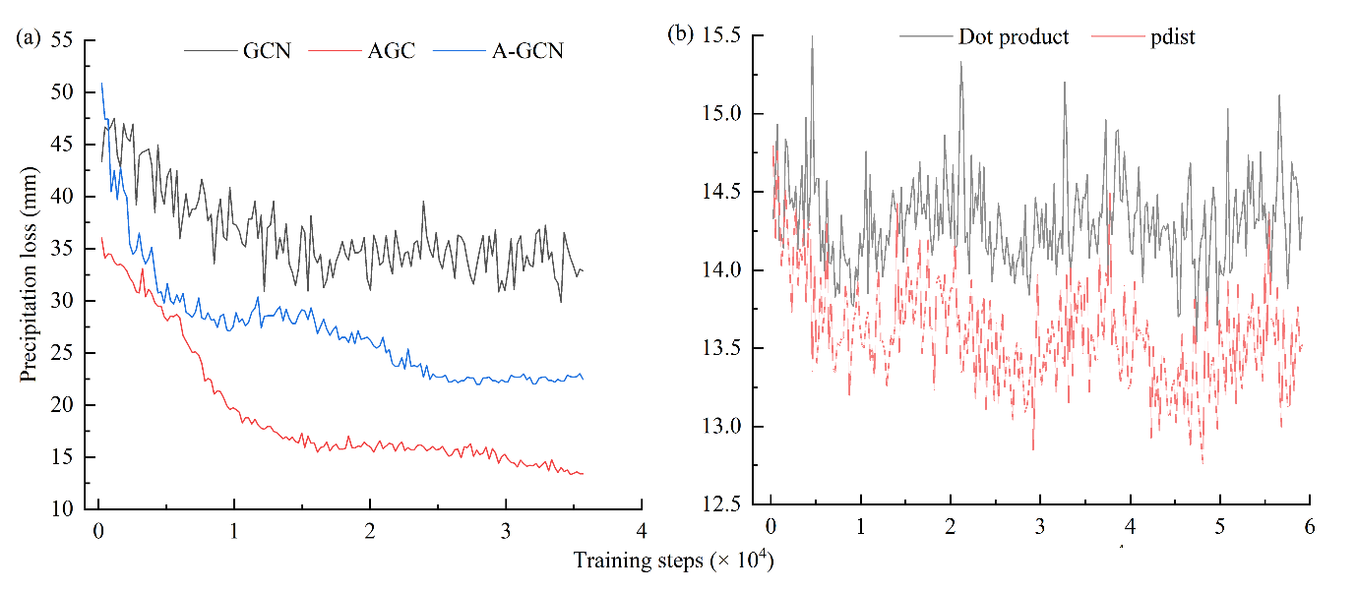

Figure S3 Cross-validation predicted monthly precipitation values with meteorological station observed values: (a) A-GCN, and (b) KNN. The dashed line is the line with a slope of 1, and the red line is the fit between the estimates and the observations. (monthly data in 41 years at about 215 stations)

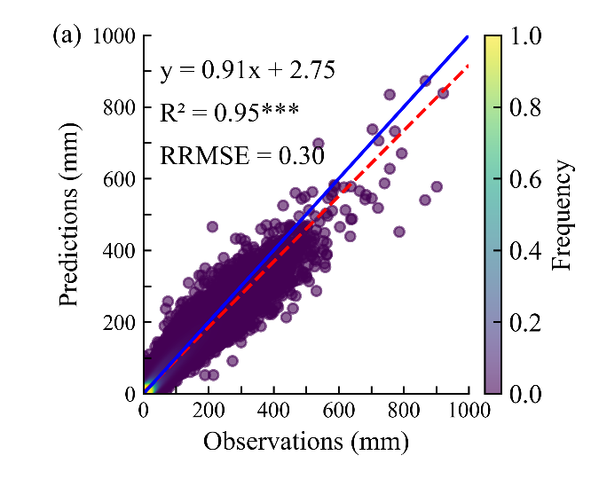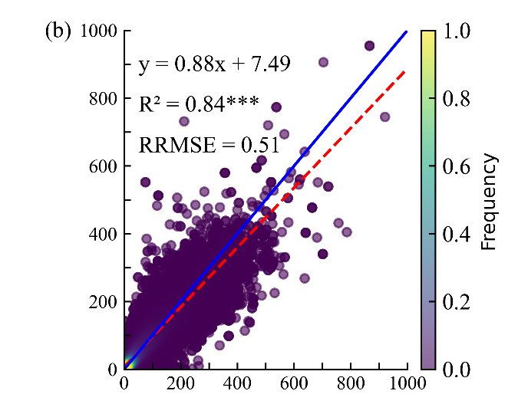

Figure S4 Spatial distributions of R² and RRMSE between meteorological station observed values and predicted values by A-GCN for monthly precipitation from1980 to 2020. (monthly data in 1980 to 2020 for each station)
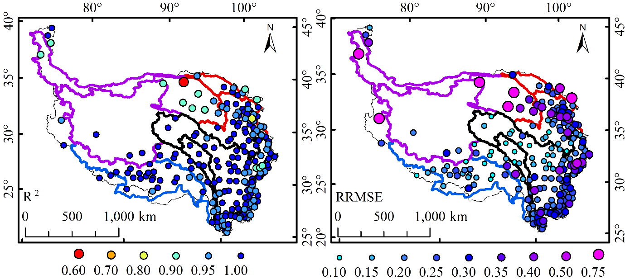

Figure S5 The performance indicated by R² (a) and RRMSE (b) of the A-GCN along the station number proportion.
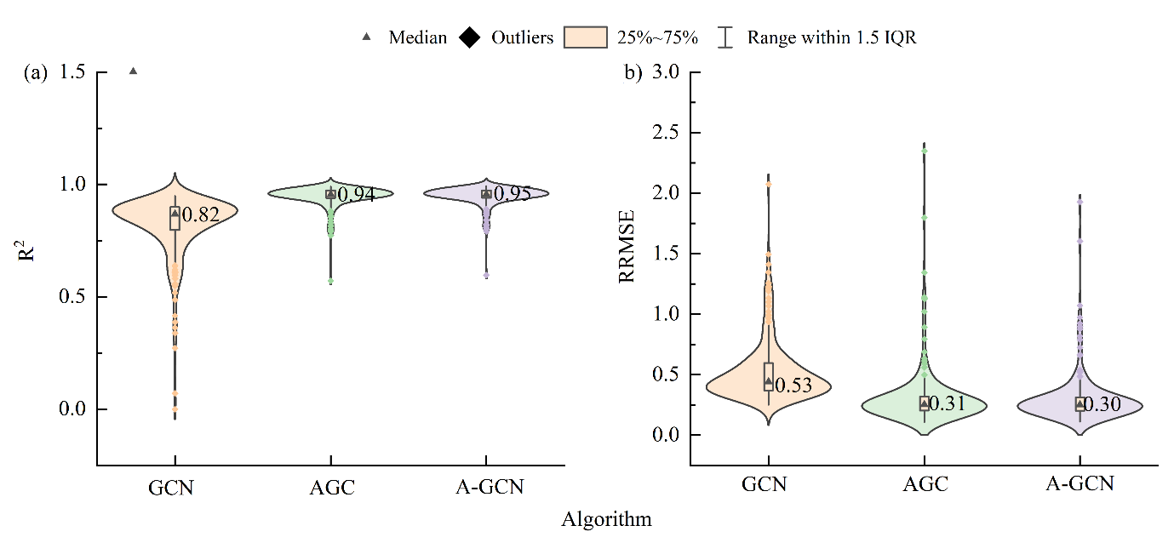

Figure S6 The influence of precipitation amounts on the accuracy and the error for the A-GCN algorithm and the influence of the station number on prediction. The station number was quantified by its percentage of in the total number for each station R² and RRMSE between meteorological station observation value and the predicted value by the A-GCN algorithm,
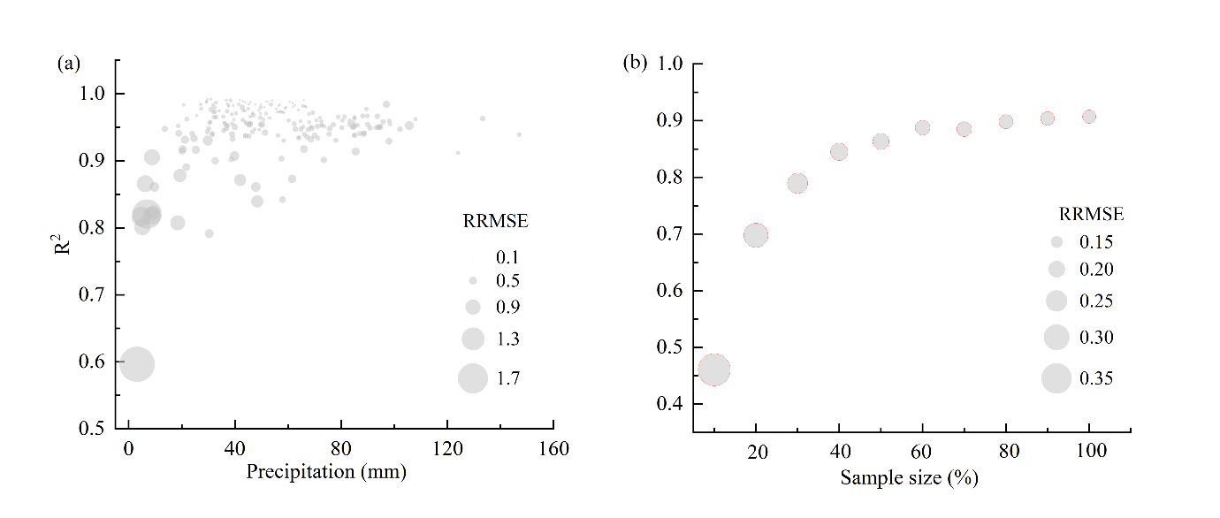

Figure S7 Weights of the attention mechanism in the Attention Mechanism-Gated Convolutional Neural Network (A-GCN) for predicted values and surrounding all meteorological stations observed values (plus sign) in different sparse station areas (the larger the dot, the larger the weight contribution)
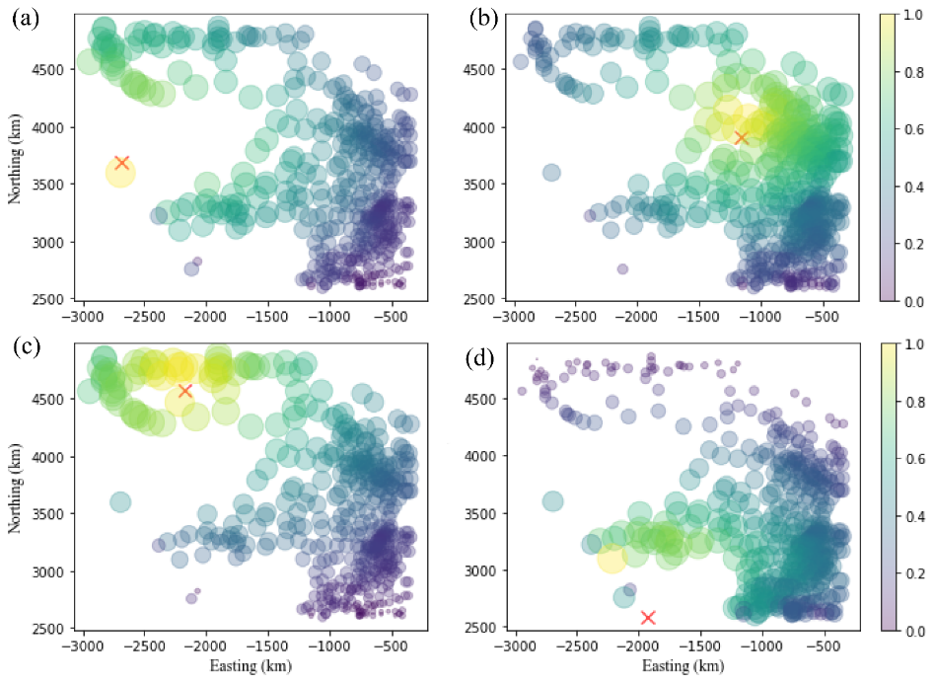

Figure S8 Linear regression of meteorological stations observed values versus the estimated for Worldclim, PRCP_{CRU}, REA5, PRE_{DS}, MeteoGrid weekly dataset and PRCP_{A-GCN} dataset from 1980 to 2018. The dashed line is a straight line with a slope of 1, and the red line is the fit between estimates and observations and significant p < 0.001 for all data sets.

Figure S9 Spatial distribution and statistical histograms of precipitation at surface sites on the QTP in years of abrupt change.

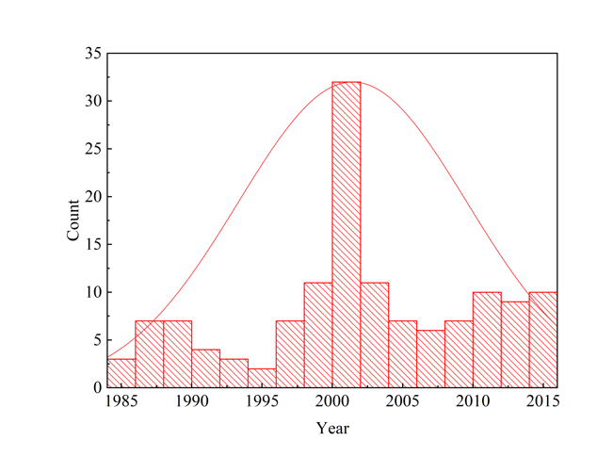

Tables

Table S1 average error between meteorological station observation values and the predicted values by three different network structures spatial interpolations and between precipitation and the accuracy.
Network Structures | GCN | AGC | A-GCN
RRMSE | 0.53 | 0.31 | 0.30
R² | 0.82 | 0.94 | 0.95
Sample size | 215 | 215 | 215

Table S2 Comparison of monthly variations of predicted precipitation values by A-GCN and KNN models with those from meteorological stations in Dangxiong, Haibei, Gonggashan, Linzhi and all flux stations values.
 |  | Dangxiong | Haibei | Gonggashan | Linzhi | All station
A-GCN | R² | 0.92 | 0.84 | 0.85 | 0.82 | 0.86
A-GCN | RRMSE | 0.43 | 0.47 | 0.38 | 0.46 | 0.43
KNN | R² | 0.88 | 0.81 | 0.80 | 0.77 | 0.84
KNN | RRMSE | 0.54 | 0.48 | 0.40 | 0.55 | 0.48

Table S3 Comparison of accuracies of Worldclim, PRCP_{CRU}, REA5, PRE_{DE}, MeteoGrid and PRCP_{AGCN} datasets using data from the meteorological stations observed values.
Dataset | R² | RRMSE | Period | Data Reference | Data sources
Worldclim | 0.69 | 0.71 | 1980-2018, monthly | Harris, I. et.al (2020). | https://worldclim.org/
PRCP_{CRU} | 0.73 | 0.66 | 1980-2018, monthly | (Harris et al., 2020) | https://crudata.uea.ac.uk/cru/data/hrg/cru_ts_4.00/
ERA5 | 0.66 | 1.10 | 1980-2018, monthly | Jiang, Q, et al. (2020). | https://developers.google.com/earth-engine/datasets/catalog/
PRE_{DE} | 0.71 | 0.69 | 1980-2018, monthly | Peng, S. (2020). | https://data.tpdc.ac.cn/zh-hans/data
MeteoGrid | 0.56 | 1.14 | 1980-2018, weekly | WANG J B, et al.(2017) | http://www.nesdc.org.cn
PRCP_{A-GCN} | 0.95 | 0.30 | 1980-2018.monthly | This study

Table S4 The spatiotemporal change of the precipitation over the QTP in 1980 to 2020
Regions | Mean  (mm) | Std  (mm) | Slope  (mm 10a-1) | R² | Sig. level | Area with sig. increasing (%) | Area with sig. decreasing (%)
 |  |  |  |  | 1980-2020
TI | 379.40 | 52.76 | -3.15 | 0.01 | 0.56 | 0.00 | 1.38
BS | 570.02 | 86.67 | -8.41 | 0.03 | 0.30 | 0.00 | 15.05
MY | 650.13 | 78.07 | -14.06 | 0.13 | 0.02 | 0.23 | 22.36
HOY | 331.74 | 45.89 | 3.68 | 0.02 | 0.37 | 3.14 | 0.00
QTP | 473.44 | 66.16 | -5.40 | 0.04 | 0.21 | 1.76 | 7.78
 |  |  |  |  | 1980-2000
TI | 381.16 | 49.23 | 31.13 | 0.23 | 0.03 | 36.80 | 0.00
BS | 592.81 | 84.10 | 40.26 | 0.14 | 0.10 | 28.64 | 0.01
MY | 664.73 | 72.96 | -8.66 | 0.01 | 0.62 | 0.64 | 7.15
HOY | 326.24 | 45.59 | -13.01 | 0.06 | 0.29 | 0.00 | 9.97
QTP | 326.07 | 45.58 | 17.09 | 0.10 | 0.17 | 21.71 | 3.91
 |  |  |  |  | 2000-2020
TI | 378.97 | 55.84 | -48.52 | 0.53 | 0.00 | 0.00 | 64.73
BS | 562.89 | 87.11 | -51.68 | 0.31 | 0.01 | 0.00 | 41.88
MY | 636.83 | 78.50 | -20.05 | 0.09 | 0.19 | 6.41 | 26.04
HOY | 334.66 | 46.69 | 17.52 | 0.14 | 0.10 | 12.77 | 0.0
QTP | 468.82 | 67.23 | -29.18 | 0.39 | 0.00 | 4.18 | 37.34

Table S5. The trends and its significant level (P) in precipitation in the different periods for the QTP and its sub-regions
Period | Trends (mm 10a⁻¹) | P | Areas | Data | Data sources | Reference
1980-2018 | 3.4 | 0.3 | Tibetan Plateau and surrounding Hindu Kush, Karakoram and Himalayan mountain ranges | 3 station-based and 4 atmospheric rea-  nalysis datasets |  | (Yao et al., 2022)
1998-2013 | Increase | >0.05 | QTP |  | https://mirador.gsfc.nasa.gov | (Ma et al., 2018)
1998-2013 | -33.6 | 0.059 | The central part of the QTP |  | https://mirador.gsfc.nasa.gov | (Ma et al., 2018)
1998-2013 | -146.2 | 0.003 | Southern part of the QTP |  | https://mirador.gsfc.nasa.gov | (Ma et al., 2018)
1998-2013 | -367.9 | < 0.001 | Southern Malayas to southeastern TP (Hengduan Mountains) |  | https://mirador.gsfc.nasa.gov | (Ma et al., 2018)
1998-2013 | 267.5 | < 0.001 | Along the west coast of India to the Himalayas, the eastern Pamirs and parts of the eastern part of the Pamirs |  | https://mirador.gsfc.nasa.gov | (Ma et al., 2018)
1998-2013 | 143.8 | 0.009 | A transition zone in the central part of the Tibetan Plateau |  | https://mirador.gsfc.nasa.gov | (Ma et al., 2018)
1961-2007 | 5.13 | 0.14 | QTP | Stations | https://data.cma.cn/ | (You et al., 2012)
1961-2007 | -46.62 | <0.001 | QTP | NCEP/NCAR | http://www.cdc.noaa.gov/ | (You et al., 2012)
1961-2001 | -49.21 | 0.003 | QTP | EAR-40 | http:// www.ecmwf.int/ | (You et al., 2012)
1961-2015 | 3.87 | > 0.05 | QTP |  | https://www.cma.gov.cn/ | (Wan et al., 2017)
1979-2001 | 3.99 |  | Northwest of the QTP |  | https://data.cma.cn/ | (You et al., 2015)
1979-2001 | 16.84 |  | The southeast of the QTP |  | https://data.cma.cn/ | (You et al., 2015)
1979-2001 | negative | < 0.05 |  |  | http://www.esrl.noaa.gov  http://cfs.ncep.noaa.gov | (You et al., 2015)
1957-2009 | 3.9 | > 0.05 | Qinghai |  | SYMAP interpolation | (Cuo et al., 2013)
1961-2007 | 9.1 | < 0.01 | QTP | Stations | http://cdc.cma.gov.cn/home.do | (Li et al. 2010)
1961-2012 | 10 | < 0.01 | The southeast of the QTP |  | http://cdc.cma.gov.cn/home.do | (Zhang et al., 2015)
1971-2000 | 2.55 |  | QTP | GPCP/GPCC | http://precipgsfc.nasa.gov | (Shen et al., 2019)
1961-2007 | 3.7 | p> 0.05 | QTP | APHRODITE | http://www.chikyu.ac.jp/precip/ | (Tong et al., 2014)
1961-2007 | 7.6 | p< 0.05 | QTP | Corr. CMA | http://ncc-cma.net/cn/ | (Tong et al., 2014)
1961-2020 | 7.9 | P < 0.05 | QTP |  | Yao et al | (Chen et al., 2021)
Recent | 2.2 |  | QTP |  |  | (Chen D L, 2015)
1980-2020 | -5.40 | 0.19 | QTP |  | AGCN interpolation | This study
1980-2020 | 0 | 0.99 | QTP |  | ERA5-Land Monthly | (Harini et al., 2019)
1980-2020 | 10.9 | 0.003 | QTP |  | https://poles.tpdc.ac.cn/zh-hans/ | (Peng et al., 2019)
1980-2020 | -1.0 | 0.82 | QTP |  | 10.11922/csdata.170.2016.0112 | (Wang, 2017)
1980-2020 | -3.5 | 0.041 | QTP |  | https://worldclim.org/ | (Fick, 2017)
2002-2020 | -3.4 | 0.57 | QTP |  | https://www2.csr.utexas.edu/grace/RL06_mascons.html | (Save, 2016)
2002-2020 | 2.0 | 0.02 | The eastern part of the QTP |  | https://www2.csr.utexas.edu/grace/RL06_mascons.html | (Save, 2016)
2002-2020 | 11.3 | 0.002 | The western part of the QTP |  | https://www2.csr.utexas.edu/grace/RL06_mascons.html | (Save, 2016)
2002-2020 | -34.5 | 0.000 | Southern part of the QTP |  | https://www2.csr.utexas.edu/grace/RL06_mascons.html | (Save, 2016)
2002-2020 | 15.6 | 0.78 | The northern part of the QTP |  | https://www2.csr.utexas.edu/grace/RL06_mascons.html | (Save, 2016)
2002-2019 | -4.3 | 0.0002 | QTP |  | https://poles.tpdc.ac.cn/zh-hans/data/  71cf70ec-0858-499d-b7f2-63319e1087fc/ | (Yulong et al., 2020)
2002-2019 | 0.07 | 0.93 | The eastern part of the QTP |  |  | (Yulong et al., 2020)
2002-2019 | 12.6 | 0.000 | The western part of the QTP |  |  | (Yulong et al., 2020)
2002-2019 | -37.1 | 0.000 | Southern part of the QTP |  |  | (Yulong et al., 2020)
2002-2019 | 16.0 | 0.00 | The northern part of the QTP |  |  | (Yulong et al., 2020)
1980-2020 | 10.88 | 0.008 | QTP |  | https://data.tpdc.ac.cn/en/data | (Kun and Yaozhi, 2022)
1980-2000 | 5.77 | 0.62 | QTP |  | https://data.tpdc.ac.cn/en/data | (Kun and Yaozhi, 2022)
2000-2020 | 16.70 | 0.11 | QTP |  | https://data.tpdc.ac.cn/en/data | (Kun and Yaozhi, 2022)

