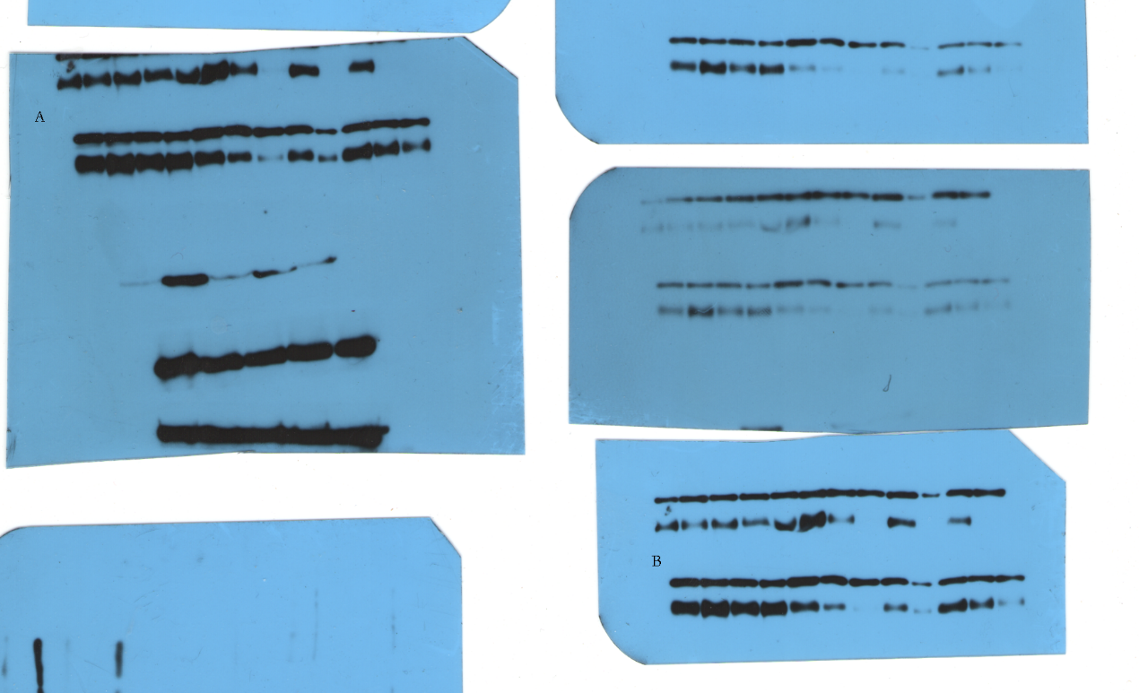
A and B images are the uncropped blots images conducting in twice different time. The second to sixth gels bands counted from the left side are the results of the experiment.

