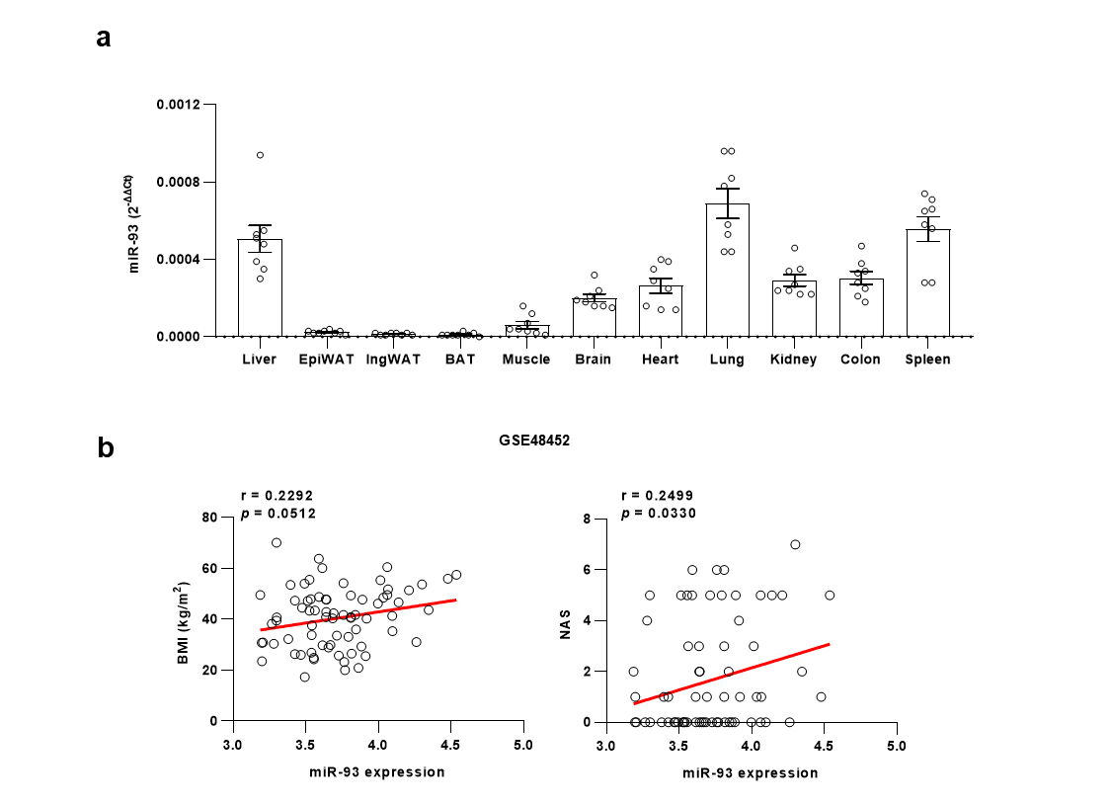
Extended Data Fig. 1. miR-93 expression is upregulated in the liver.
a, Differential expression of miR-93 (2^{−ΔΔCt}) across various tissues in mice (n = 8). b, Correlation analysis of human hepatic miR-93 levels with BMI or NAS using the GSE48452 database. Data presented as means ± SEM.

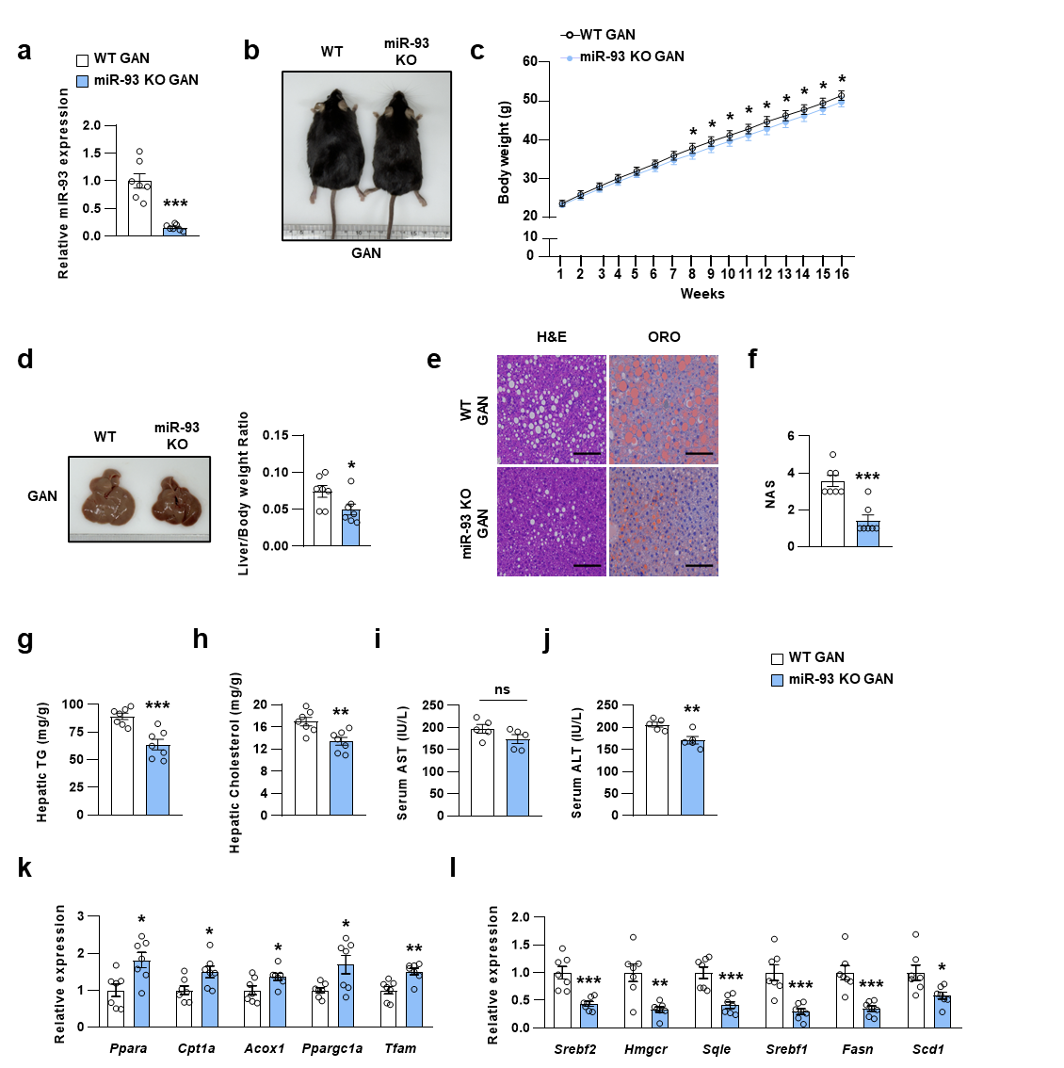
Extended Data Fig. 2. Inhibition of miR-93 alleviates hepatic steatosis in GAN diet-fed mice.
WT and miR-93 KO mice were fed a GAN diet for 16 weeks (n = 7 per group). a, Hepatic expression of miR-93. b, Representative images of mice. c, Body weight. d, Representative liver images and liver-to-body weight ratio. e, Representative H&E and ORO staining of liver sections (scale bar, 100 μm). f, NAS, g, hepatic TG, h, hepatic cholesterol, i, serum AST, and j, serum ALT level. k,l, Relative expression of genes related to fatty acid oxidation (k); cholesterol biosynthesis and de novo lipogenesis (l). Data presented as means ± SEM. Statistical analysis: two-tailed Student’s t-test. *p < 0.05, **p < 0.01, ***p < 0.001, ns indicates not significant.

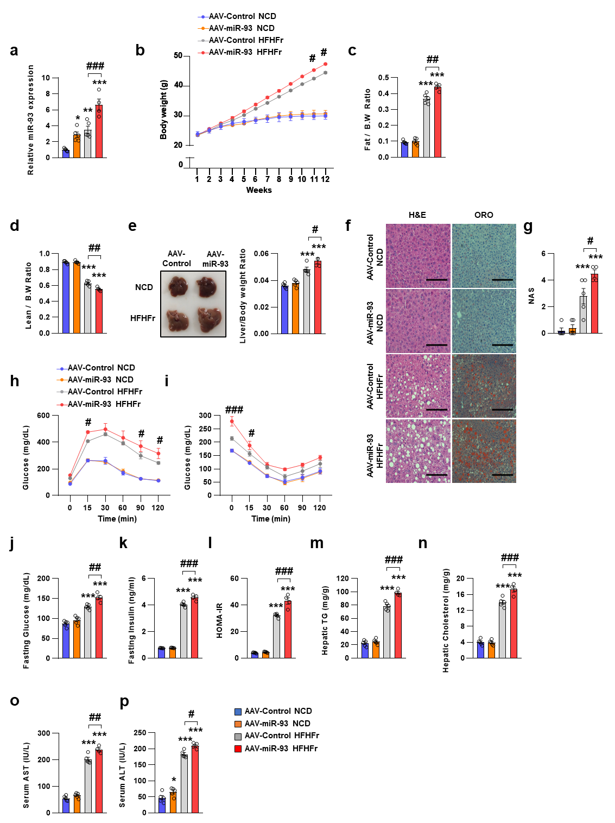
Extended Data Fig. 3. miR-93 promotes hepatic steatosis.
C57BL/6J mice were fed NCD (n = 5 per group) or HFHFr diet (AAV-Control, n = 5; AAV-miR-93, n = 4) for 12 weeks and administered the indicated AAVs. a, Relative liver expression levels of miR-93. b, Body weight. c, Fat mass ratio. d, Lean mass-to-body weight ratio. e, Representative liver images and liver-to-body weight ratio. f, Representative H&E and ORO staining of liver sections (scale bar, 100 μm). g, NAS, h, GTT, i, ITT, j, fasting glucose, k, fasting insulin, l, HOMA-IR, m, hepatic TG, n, hepatic cholesterol, o, serum AST, p, serum ALT level. Data presented as means ± SEM. (B, H, I) Two-way ANOVA followed by Tukey’s multiple comparisons test; for other data, one-way ANOVA followed by Tukey’s multiple comparison test. *p < 0.05, **p < 0.01, ***p < 0.001 vs AAV-Control NCD; #p < 0.05, ##p < 0.01, ###p < 0.001 vs AAV-Control HFHFr.

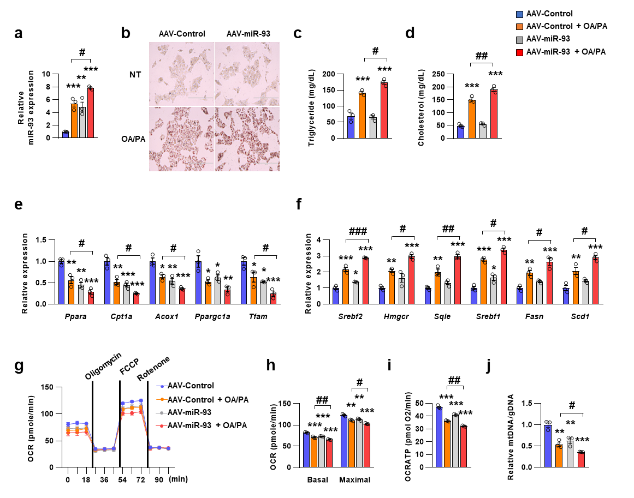
Extended Data Fig. 4. Overexpression of miR-93 exacerbates dysregulated lipid metabolism in hepatocytes.
Primary hepatocytes were transduced with the indicated AAVs and treated with OA/PA for 24 hours (n = 3 per group). a, Relative expression of miR-93. b, Representative images of lipid accumulation. c, TG levels. d, Cholesterol levels. e,f, Expression of genes involved in fatty acid oxidation (e); cholesterol biosynthesis and de novo lipogenesis (f). g, OCR. h, Basal and maximal OCR. i, ATP levels. j, Mitochondrial copy number of Nd1 in indicated hepatocytes. Data presented as means ± SEM. Statistical analysis was performed using one-way ANOVA followed by Tukey’s multiple comparison test. *p < 0.05, **p < 0.01, ***p < 0.001 vs AAV-Control; #p < 0.05, ##p < 0.01, ###p < 0.001 vs AAV-Control + OA/PA.
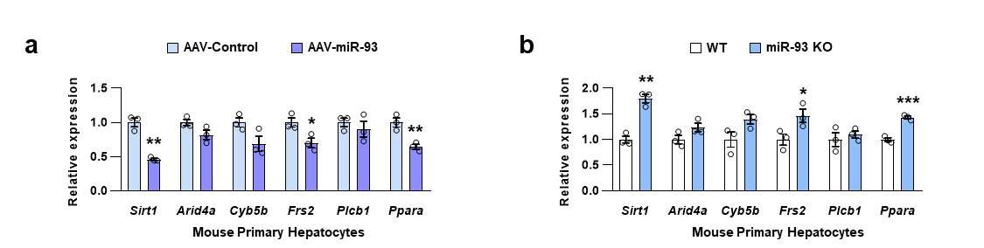
Extended Data Fig. 5. miR-93 regulates predicted target candidates in mouse primary hepatocytes.
a,b, Relative expression of predicted target candidates in AAV-infected cells (n = 3 per group) (a) and cells isolated from WT or miR-93 KO mice (n = 3 per group) (b). Data presented as means ± SEM. Statistical analysis: two-tailed Student’s t-test. *p < 0.05, **p < 0.01, ***p < 0.001.

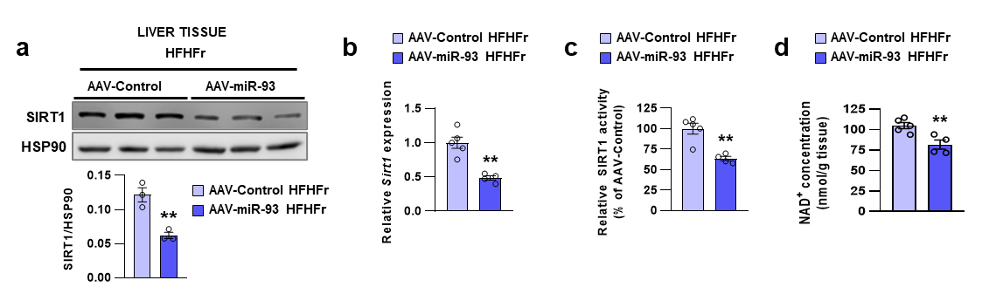
Extended Data Fig. 6. miR-93 overexpression regulates SIRT1 expression in HFHFr-fed mice.
C57BL/6J mice were fed NCD (n = 5 per group) or HFHFr diet (AAV-Control, n = 5; AAV-miR-93, n = 4) for 12 weeks and administered the indicated AAVs. a, Protein levels and normalized intensities of SIRT1 relative to HSP90. b, mRNA expression of Sirt1. c, SIRT1 activity and d, NAD⁺ level. Data presented as means ± SEM. Statistical analysis was performed using a two-tailed Student’s t-test. **p < 0.01.

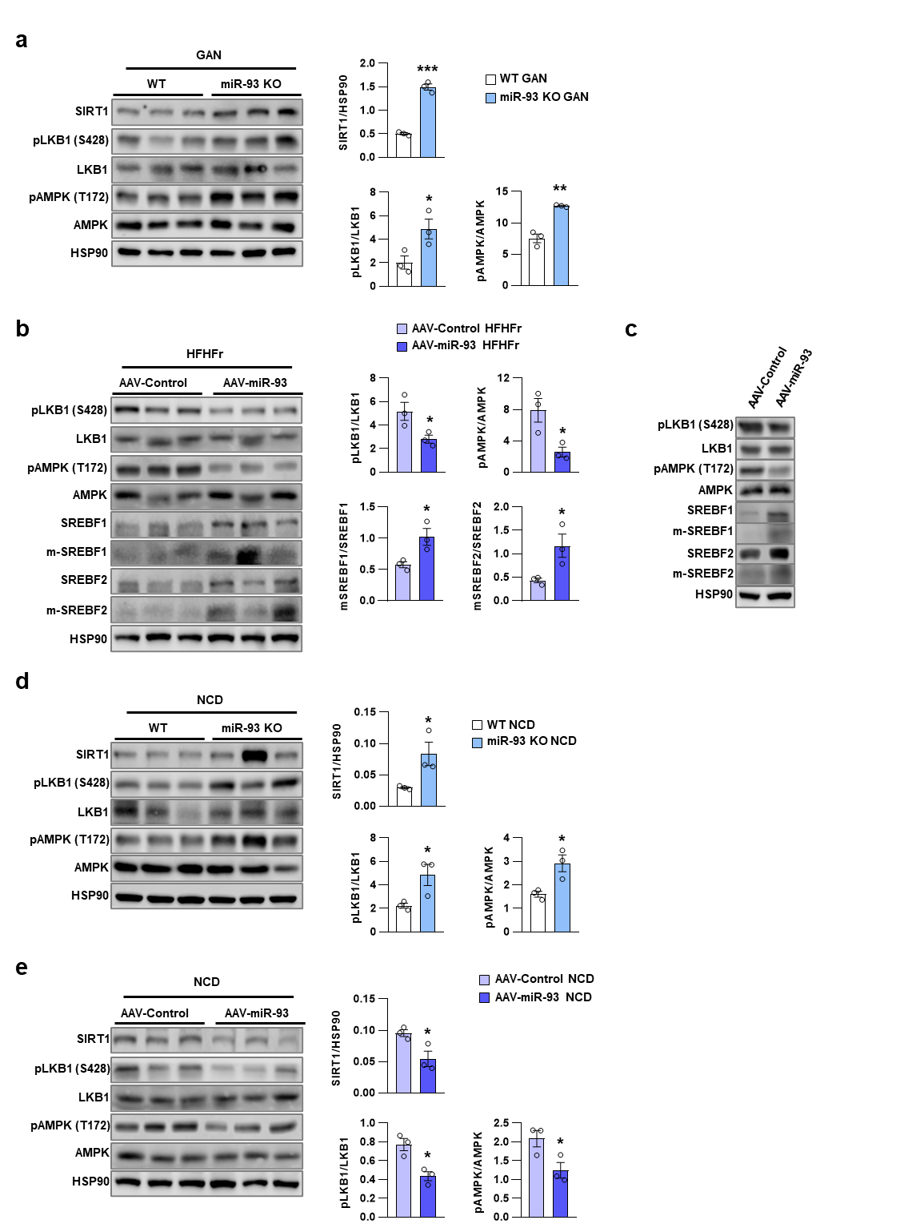
Extended Data Fig. 7. miR-93 regulates SIRT1/LKB1/AMPK signaling axis in both NCD- and DIO mice.
a–e, Immunoblot analysis of the indicated proteins from the livers of mice were fed with GAN diet (n = 7 per group) for 16 weeks (a), HFHFr diet (AAV-Control, n = 5; AAV-miR-93, n = 4) for 12 weeks (b), NCD (WT, n = 7; KO, n = 10) for 16 weeks (d), NCD (n= 5 per group) for 12 weeks and administered the indicated AAVs (e), and primary hepatocytes (c). Quantitative analysis of SIRT1, pLKB1, pAMPK, and m-SREBF1/2 normalized to HSP90 or total protein levels. Data presented as means ± SEM. Statistical analysis conducted using a two-tailed Student’s t-test. *p < 0.05, **p < 0.01, ***p < 0.001.

Extended Data Table 1. Histologic parameters of study participants
No. | Steatosis | Fibrosis | Fibrosis  (MASH) | Ballooning change | Lobular inflammation | Portal inflammation | NAS | MASH score* | CAP (dB/m) | Elasticity (kPa) | Diagnosis
1 | 2 | 0 | 0 | 2 | 1 | 1 | 5 | 6 | 360 | 7.7 | MASH
2 | 1 | 1 | 1c | 1 | 1 | 0 | 3 | 3 | 336 | 8.8 | Not-MASH
3 | 1 | 1 | 1c | 0 | 1 | 2 | 2 | 1 | 302 | 7.2 | Not-MASH
4 | 2 | 3 | 3 | 0 | 1 | 2 | 3 | 7 | 301 | 11.1 | MASH
5 | 1 | 1 | 2 | 1 | 1 | 2 | 3 | 7 | 282 | 6.7 | MASH
6 | 2 | 2 | 2 | 0 | 2 | 1 | 4 | 7 | 285 | 10.1 | MASH
7 | 1 | 4 | 4 | 1 | 1 | 2 | 3 | 8 | 307 | 21.3 | MASH
8 | 2 | 1 | 1c | 0 | 2 | 0 | 4 | 3 | 346 | 4.7 | Not-MASH
9 | 1 | 1 | 1c | 0 | 1 | 1 | 2 | 2 | 290 | 8.5 | Not-MASH
10 | 3 | 1 | 1c | 1 | 1 | 1 | 5 | 3 | 331 | 6.8 | Not-MASH
11 | 1 | 2 | 3 | 1 | 1 | 2 | 3 | 8 | 324 | 14.0 | MASH

Steatosis was graded as follows: 0% = no steatosis, 1 = 5-33%, 2 = 34-66%, 3 = >66%; Fibrosis was classified according to the METAVIR system; Fibrosis (MASH) stages were defined as: 0 = none; 1A = mild, perisinusoidal fibrosis in zone 3; 1B = moderate, perisinusoidal fibrosis in zone 3; 1C = fibrosis limited to the portal/periportal region; 2 = combined perisinusoidal and portal/periportal fibrosis; 3 = bridging fibrosis; 4 = cirrhosis; Ballooning change was categorized as: 0 = none, 1 = few, 2 = many. Lobular inflammation was scored as: 0 = absent, 1 = one focus/200x field, 2 = two to four foci/200x field, 3 = more than five foci/200x field. Portal inflammation was graded as: 0 = none, 1 = mild (some portal areas), 2 = moderate (some or all portal areas), 3 = moderate to marked (all portal areas), 4 = marked (all portal areas); NAS, NAFLD Activity Score.
* MASH score refers to a recently recommended scoring system for diagnosing metabolic-associated steatohepatitis (MASH), as endorsed by the Korean Society of Pathology; Diagnosis was made based on a recently recommended scoring system by the Korean Society of Pathology for diagnosing MASH.
* CAP, Controlled Attenuation Parameter

