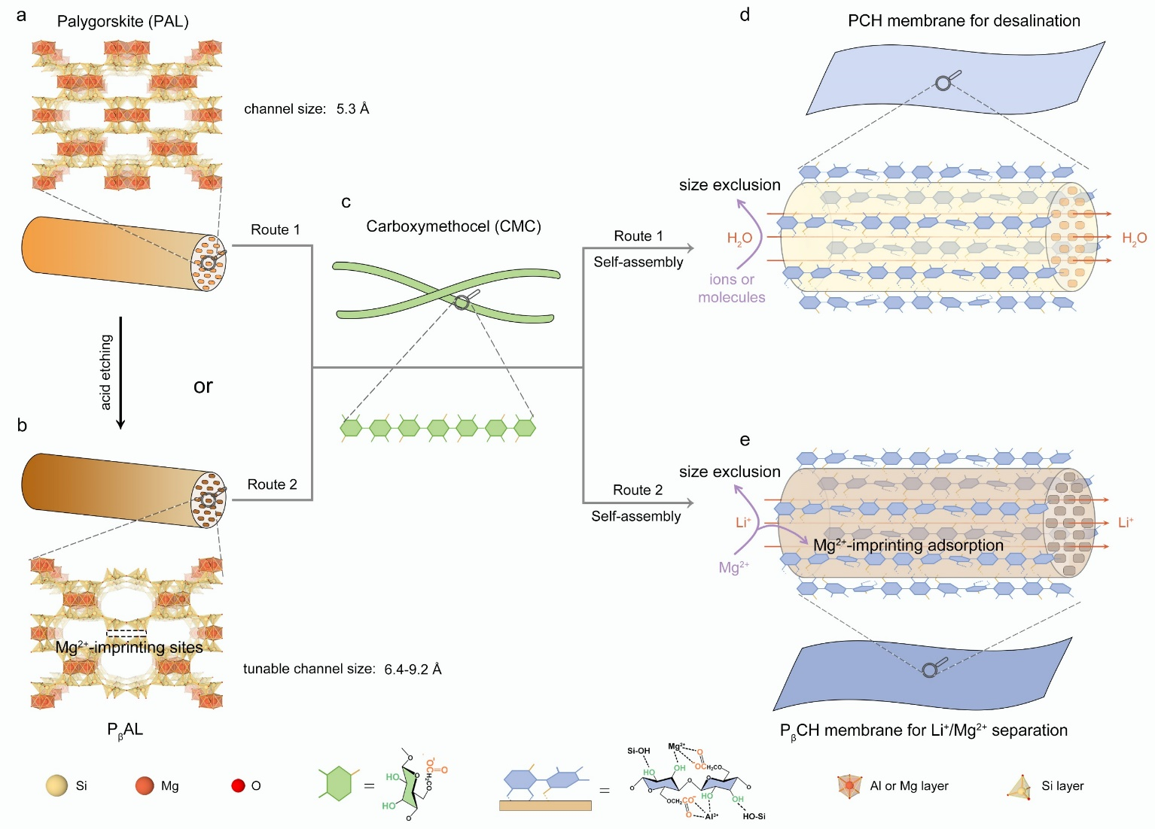
Scheme 1. Schematic illustration of membrane preparation by coordination self-assembly between PAL nanorods and CMC chains for fast water and lithium-ion transport. Structure model of (a) natural PAL and (b) P_{β}AL nanorods. (c) CMC structure with a high density of carboxyl and hydroxy groups which was employed as the cross-linked component. (d) PCH membranes for high-efficiency desalination. (e) P_{β}CH membranes for Li⁺/Mg²⁺ separation.

