Supplementary Information

Tailoring sub-nanochannels and ion-imprinted functionality of palygorskite nanofiltration membranes for desalination and lithium-ion transport
Liping Zhen^{[a], [b], [c] #}, Genping Meng^{[a] #}, Xisheng Zhao^{[b], [d]}, Wenting Guo^{[a]} *, Dina Sun^{[a]}, Yonghui Chen^{[c]}, Shuai Wei^{[a]}, Guowen Hu^{[a]}, Aiqin Wang^{[e]} *, and Baodui Wang^{[a], [b]} *
[a] College of Chemistry and Chemical Engineering, Lanzhou University, Gansu, Lanzhou, 730000. P. R. China.
[b] College of Earth and Environmental Sciences, Lanzhou University, Gansu, Lanzhou, 730000, P. R. China.
[c] Advanced Energy Science and Technology Guangdong Laboratory, Guangdong, Huizhou, 516000. P. R. China.
[b] Baotou Iron and Steel (Group) Co. Ltd., Baotou, 014010, P. R. China.
[e] Key Laboratory of Clay Mineral Applied Research of Gansu Province, Lanzhou Institute of Chemical Physics, Chinese Academy of Sciences, Lanzhou, Gansu 730000, P. R. China.
#These authors contributed equally to this work.
Email: guowenting@mail.lzjtu.cn; *aqwang@licp.cas.cn; *wangbd@lzu.edu.cn

Table of Contents
Experimental Procedures 3

Materials 3

Membrane Characterization 3

Purification of PAL 3

Ion imprinting treatment of PAL nanorods 4

Preparation of PCH-α and P_{β}CH-α membranes 4

Membrane Filtration Performance. 4

Antifouling experiments 4

Density functional theory simulations 5

Langevin dynamics simulations 5
Results and Discussion 7

Supplementary Figures 7

Supplementary Tables 25
References 31

Experimental Procedures

Materials
Palygorskite (PAL) was supplied by Lanzhou Institute of Chemical Physics, Chinese Academy of Sciences. Commercially available polyethersulfone (PES) ultrafiltration membranes (mean pore size: 0.22 μm) used as the substrate were purchased from Dongguan Pinggen Experimental Equipment Co. Ltd. (Guangdong, China). Oxalic acid (H₂C₂O₄) was obtained from Shanghai Macklin Biochemical Technology Co., Ltd. Hydrochloric acid (HCl) was provided by Lianlong Bohua Pharmaceutical & Chemical Co., Ltd. Sodium Carboxymethyl cellulose (CMC) and the six types of salts containing sodium chloride (NaCl), calcium chloride (CaCl₂) sodium sulfate (Na₂SO₄), lithium chloride (LiCl) magnesium chloride (MgCl₂) and magnesium sulfate (MgSO₄) were acquired from Kelong chemical reagent Co. Ltd. (Chengdu, China). Congo red (GR), Rhodamine 6G (Rh6G), Methyl blue (MB), and Crystal violet (CV) were provided by Dingguo Biological Technology Co. Ltd. (Beijing, China). The actual water samples are collected from the Yellow Sea. Bovine serum albumin (BSA) was obtained from Shanghai Aladdin Biochemical Technology Co., Ltd. Unless specified, deionized (DI) water was used throughout this work. All chemicals were used as received without any further purification.

Membrane Characterization
The morphologies of the PAL, the substrate PES membrane, and the PCH membranes were characterized via a field emission scanning electron microscope at 10 kV (FESEM, Apreo S, Thermo Fisher). The chemical composition was obtained by energy-dispersive spectrometry (EDS). The transmission electron microscope (TEM, Tecnai F30, FEI) was used to measure PAL's structural performance. The crystallization property of the PAL and PCH membranes was measured by Rigaku D/Max-2400 Powder X-ray diffractometer (XRD) that works under 40 kV and 30 mA with a diffraction angle from 5⁰ to 90⁰ in a fixed time mode and step interval of about 0.167°. The superficial properties of PCH membranes, including chemical ingredient, coordination, hydrophilicity, and zeta potential, were recorded by Fourier transform infrared (FTIR, Nicolet 560) spectrometer, X-ray Photoelectron Spectroscopy (XPS, PHI-5702 multifunctional spectrometer with AlKa radiation), contact angle goniometer (JC2000C, China), and Sur PASS Electrokinetic Analyzer (Anton Paar KG, Austria), respectively. The nitrogen adsorption-desorption isotherms were acquired through a high-precision Autosorb apparatus (ASAP2020M&TriStar3020) at 77.35 K, and the Non-Local Density Functional Theory (NLDFT) method was applied to the adsorption branch to calculate the pore size distribution of samples. Room temperature UV-visible absorption spectroscopy was conducted to obtain the concentration of dyes on an Agilent Cary 5000 UV-Vis-NIR Spectrophotometer across the range of 200-800 nm. The concentration of metal ions was quantitatively analyzed by inductively coupled plasma atomic emission spectrometry (ICP-OES). The concentration of heavy metal ions was quantitatively analyzed by inductively coupled plasma mass spectrometry (ICP-MS). All the solid-state NMR experiments were performed on a 400 MHz spectrometer equipped with a MAS probe (AVANCE NEO, Bruker, Germany). The ²⁷Al MAS NMR spectra of the PAL and PCH-7 membrane were recorded.

Purification of PAL
The PAL was purified via sedimentation methodology, and the obtained purified PAL was marked as PAL nanorods. In a typical procedure, 1.0 g PAL was suspended in 100 mL of DI water and ultrasound at 25 °C for 2 h. After that, the mixture was collected via centrifugation at 4000 rpm for 5 min, and washed with DI water three times. Finally, the samples were dried at 50 °C.

Ion imprinting treatment of PAL nanorods
A series of ion-imprinted PAL nanorods were performed as follows: 1.0 g PAL nanorods were immersed in 25 ml H₂C₂O₄/HCl solution with various concentrations (0.2, 0.35, 0.5, and 1.0 mol/L) at 20 °C for 0.5 h under mechanical stirring at 1250 rpm, and then washed with DI water for many times until the supernatant was free of Cl⁻ (determined by AgNO₃ solution). The resulting sample was dried at 100 °C. The obtained ion-imprinted PAL nanorods were marked as P_{β}AL nanorods (where β corresponds to H₂C₂O₄/HCl solution concentration). To identify the presence of Mg²⁺-imprinted sites in P_{β}AL nanorods, 100 mg of P_{0.35}AL was immersed in 50 ml of MgCl₂ (2000 ppm) for 30 minutes.

Preparation of PCH-α and P_{β}CH-α membranes
The membranes were fabricated by a coordination self-assembly method. Briefly, the mixtures (a total of 0.5 g) of PAL or P_{β}AL nanorods and CMC chains were evenly dispersed into 100 mL DI water, followed by a stir at 45 °C for 12 h in a water bath. It was subsequently concentrated to ~10 ml by a decompression distillation process. The resulting slurry was coated with a Mayer rod to fabricate PAL-CMC hybrid (PCH) membranes. Meanwhile, the as-prepared PCH membranes were dried at 60 °C for 2 hours to be exfoliated easily from the substrate membrane and then were presented as PCH-α and P_{β}CH-α (α = 3, 5, 7, and 9, where α represents the mass percent of CMC). For example, PCH-7 represents the membrane doped with 7 wt % CMC chains.

Membrane Filtration Performance.
The permeation and separation performances of the synthesized PCH-α and P_{β}CH-α membranes were evaluated using a lab-scale crossflow filtration system at room temperature (flow rate: 0.5 L min⁻¹). The membranes were pre-compacted and washed with DI water for at least 0.5 h at a constant pressure of 6.0 bar before nanofiltration tests. If not mentioned otherwise, during the nanofiltration testing process the salt concentration is 2000 ppm, and the operating pressure is 6.0 bar. The permeance (P, L m⁻² h⁻¹ bar⁻¹), solute rejection (R, %), and Li⁺/Mg²⁺ selectivity (S) were calculated by the following equations:
 | $$P= \frac{V}{S × ∆t × ∆P}$$ | (1)
 | $$R=\left(1- \frac{C_{a}}{C_{b}}\right)×100\%$$ | (2)
 | $$S=\frac{C_{f, {Mg}^{2+}} /{ C}_{f, {Li}^{+}} }{C_{p, {Mg}^{2+}} /{ C}_{p, {Li}^{+}}}$$ | (3)

V is the volume of the permeation collected within the time Δt. S (m²) and ΔP (bar) are the effective membrane area (3.14 cm²) and working pressure, respectively. $C_{f }$ and $C_{p }$ are the ion concentrations in the feed and permeate, respectively.

Antifouling experiments
The antifouling feature of the PCH membranes was evaluated by a filtration measurement using BSA as the representative foulant. Before the measurements, all the membranes were pretreated at 0.8 bar for 0.5 h by deionized (DI) water until the permeance reached a stable value. In detail, the DI water permeation (P_{w1}) of the membrane was tested first at 0.8 bar. Subsequently, the DI water was replaced by a foulant aqueous solution (0.1 wt.%). The fouling test was carried out for 5 h and the permeation (P_{f}) was recorded again. Then the fouled membrane was cleaned with DI water for 1 h. At last, the filtration cell was refilled with the DI water to obtain water permeation (P_{w2}). After antifouling tests, four parameters including total flux decline ratio (DR_{t}), irreversible flux decline ratio (DR_{ir}), reversible flux decline ratio (DR_{r}), and flux recovery ratio (FRR) were introduced to evaluate the antifouling features of the membrane and were calculated with the equations below.
 | $${DR}_{t}=1- \frac{P_{f}}{P_{w1}}$$ | (4)
 | $${DR}_{ir}=1- \frac{P_{w2}}{P_{w1}}$$ | (5)
 | $${DR}_{r}= \frac{P_{w2}- P_{f}}{P_{w1}}$$ | (6)
 | $$FRR= \frac{P_{w2}}{P_{w1}}$$ | (7)

The higher FRR and lower DR_{t} values indicate the better antifouling property of the membrane.

Density functional theory simulations
We have employed the first principles to perform all density functional theory (DFT) calculations within the generalized gradient approximation (GGA) using the Perdew-Burke-Ernzerhof (PBE) formulation. The projected augmented wave (PAW) potentials were chosen to describe the ionic cores and take valence electrons into account using a plane wave basis set with a kinetic energy cutoff of 520 eV. Partial occupancies of the Kohn−Sham orbitals were allowed using the Gaussian smearing method with a width of 0.05 eV. The electronic energy was considered self-consistent when the energy change was smaller than 10⁻⁵ eV. A geometry optimization was considered convergent when the energy change was smaller than 0.05 eV Å⁻¹. The vacuum spacing in a direction perpendicular to the plane of the structure is 18 Å for the surfaces. The Brillouin zone integration is performed using 2×2×1 Monkhorst-Pack k-point sampling for a structure. Finally, the adsorption energies (E_{ads}) were calculated as E_{ads}= E_{ad/sub} -E_{ad} -E_{sub}, where E_{ad/sub}, E_{ad}, and E_{sub} are the total energies of the optimized adsorbate/substrate system, the adsorbate in the structure, and the clean substrate, respectively. The free energy was calculated using the equation:
 | G=E_{ads} + ZPE - TS | (8)

where G, E_{ads}, ZPE, and TS are the free energy, total energy from DFT calculations, zero point energy, and entropic contributions, respectively.

Langevin dynamics simulations
Ab initio molecular dynamics (AIMD) simulation was carried out to study structures with H₂O. respectively. During geometry optimization, the cut-off energy was set as 450eV for structures, respectively. The Brillouin zone was sampled by a Monkhorst-Pack (MP) k-point grid of 1× 1 × 1 for geometry optimizations. The PBE-D3 dispersion term was introduced to correct the van der Waals interactions. The conjugated gradient method was applied with a smearing width of 0.15 eV, and the convergence criteria for the energy and force were 10-4 eV/cell and 0.05 eV/Å, respectively. AIMD simulations were run for 100 ps as equilibration with time steps of 1 fs, performing a constant temperature of 300 K in the Nosé -Hoover isokinetic ensemble. Grimme’s DFT-D3 methodology was used to describe the dispersion interactions. Finally, the binding energies (E_{b}) were calculated as E_{b}= E_{ad/sub} -E_{ad} -E_{sub}, where E_{ad/sub}, E_{ad}, and E_{sub} are the total energies of the optimized adsorbate/substrate system, the adsorbate in the structure, and the clean substrate, respectively.

Results and Discussion

Supplementary Figures
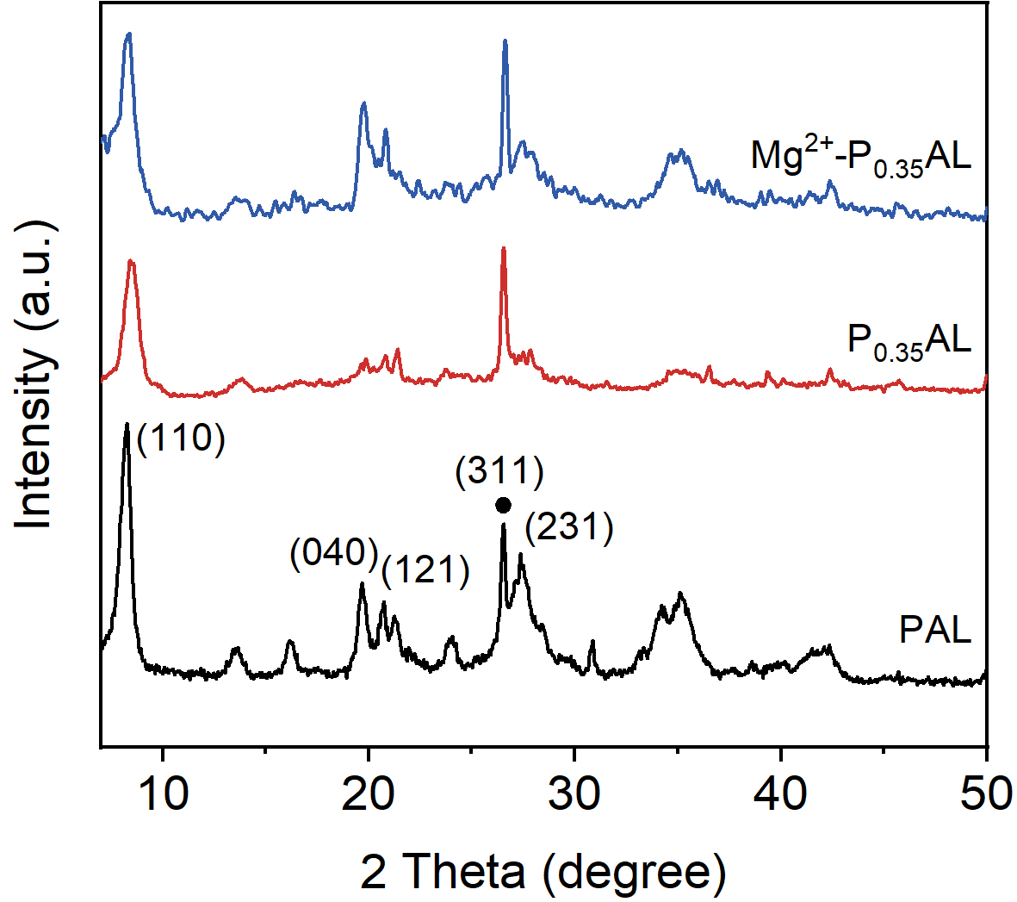
Figure S1. XRD patterns of the PAL, P_{0.35}AL, and Mg²⁺-P_{0.35}AL nanorods.

Note: The diffraction peaks labeled with dots are affiliated with the (311) crystal plane of impurity Quartz in PAL nanorods.¹

Discussion: PAL nanorods show four characteristic crystal peaks, belonging to the (110), (040), (121), and (231) crystal planes, respectively. After PAL nanorods were treated with acid etching, the characteristic peaks changed significantly. The intensity of the crystallization peaks on the (040), (121), and (231) crystal planes is reduced considerably or even disappeared. The position of the crystallization peaks on the (110) crystal face also shifted to a high degree (Figure 2f). These changes indicate that acid etching affects the crystalline structure of PAL due to the leaching of some metal oxides (e.g., MgO). Surprisingly, after P_{0.35}AL nanorods adsorbed Mg²⁺ again, the intensity and position of the above characteristic diffraction peaks were largely recovered. This suggests that Mg²⁺ can return to the ion-imprinted adsorption sites in the P_{0.35}AL skeleton.

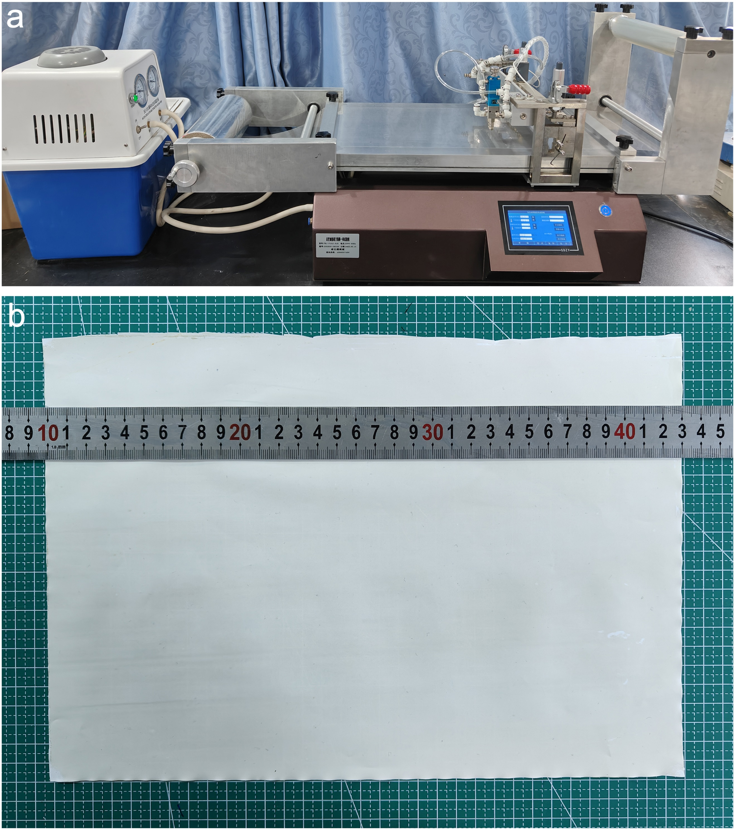
Figure S2. Photographs of (a) K control coater and (b) the large-area PCH-7 membrane.

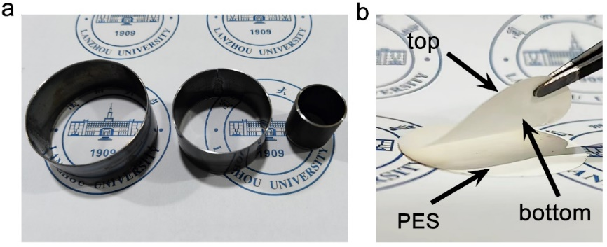
Figure S3. Photos of molds and membranes. (a) Molds for cutting large-area membrane, (b) Exfoliation process of the PCH membrane from the PES substrate. A circular membrane was obtained by cutting the large-area membrane with a mold.

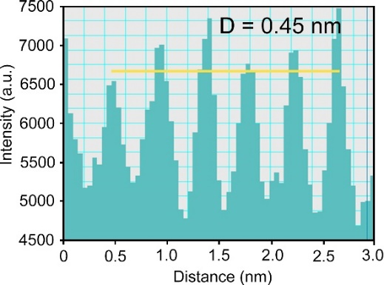
Figure S4. d-spacing of PAL nanorods in membrane calculated from the DigitalMicrograph software.

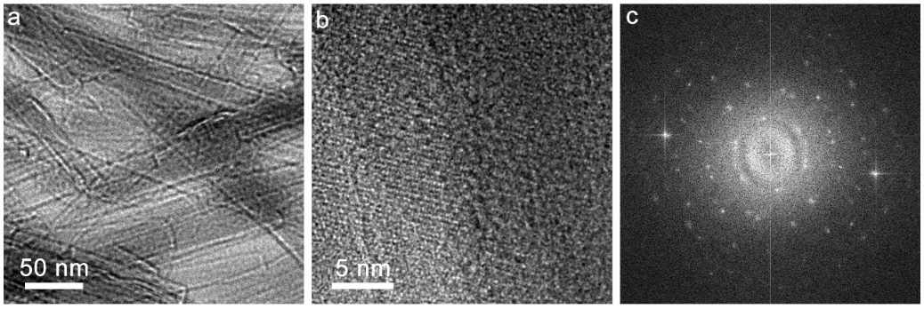
Figure S5. TEM characterizations of the PCH-7 membrane. (a) and (b) TEM images with different magnifications. The HRTEM image of the lattice spacing of the PAL nanorod in the PCH-7 assembly. (c) The electron diffraction pattern of PAL nanorods in the PCH-7 membrane.

Discussion: The PCH-7 membrane preserves the high crystallinity of the PAL nanorods, indicating the assembly process has a negligible impact on the crystallization of PAL nanorods.

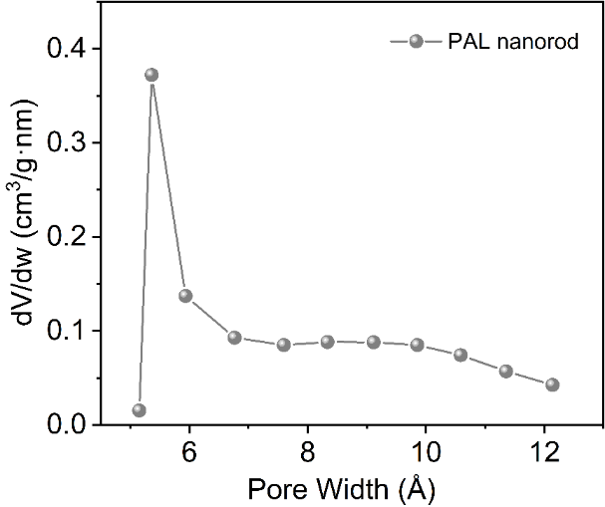
Figure S6. Pore size distribution of PAL nanorods.

Discussion: PAL nanorods exhibit a pore size of ~5.5 Å, which matches the theoretical size of 3.7 Å × 6.4 Å and the data from TEM calculation (Figure 1a).

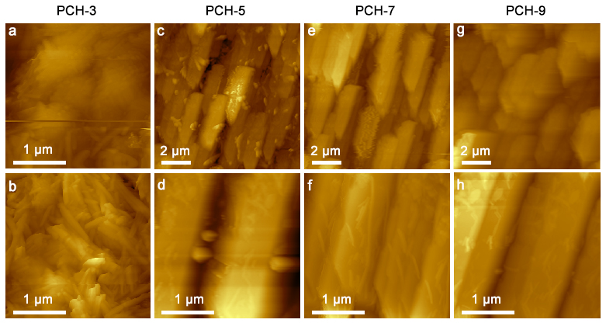
Figure S7. AFM images of PCH membranes.

Discussion: Laminated assemblies gradually form with increasing content of CMC. Concretely, when the content of CMC is no more than 3%, there is almost no assembly but a random arrangement of PAL nanorods and large gaps are observed between the nanorods. when the CMC content reaches 5%, despite the formation of the PCH-5 membrane we also observe the unassembled PAL nanorods intercalated in the assemblies. Exhilaratingly, the assemblies are regularly and tightly arranged when the content of CMC reaches 7%. With the CMC content in PCH membranes increased to 9%, debris consisting of CMC agglomerates adheres to the surface of the laminated assemblies, which perhaps blocks a part of the 1D channels of PAL nanorods.² Thus a CMC doping of 7% is optimal, as it ensures that the PAL nanorods are tightly assembled without blocking its intrinsic pores.

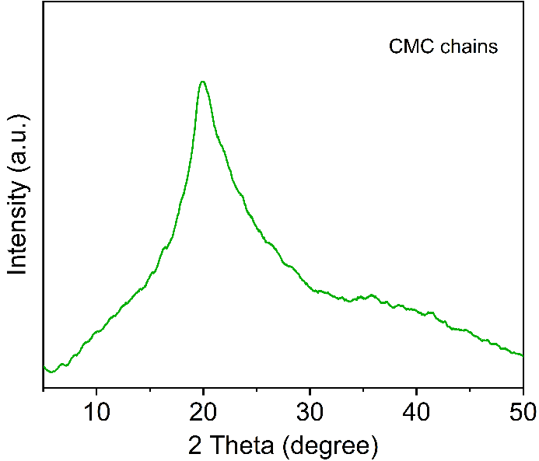
Figure S8. XRD pattern of CMC chains.

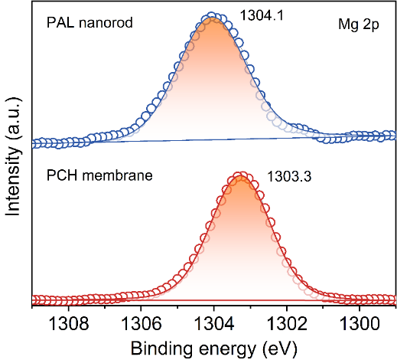
Figure S9. XPS high-resolution scans for Mg 2p.

Discussion: The binding energy of Mg 2p for PAL nanorods is 1304.1 eV. After assembling PAL into the PCH membrane, this value becomes lower and moves to 1303.3 eV.

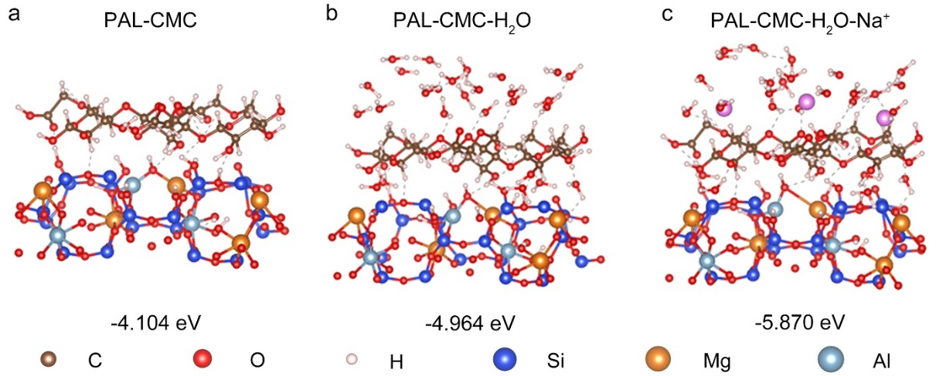
Figure S10. Energy-optimized geometry of bonding between a PAL nanorod and a CMC chain by theoretical calculation with DFT. The interaction between a PAL nanorod and a CMC chain under different conditions: (a) in a dry state, (b) in pure water, and (c) in water under the presence of Na⁺. The gray dotted line represents hydrogen bonding interactions formed between PAL and the CMC chain.

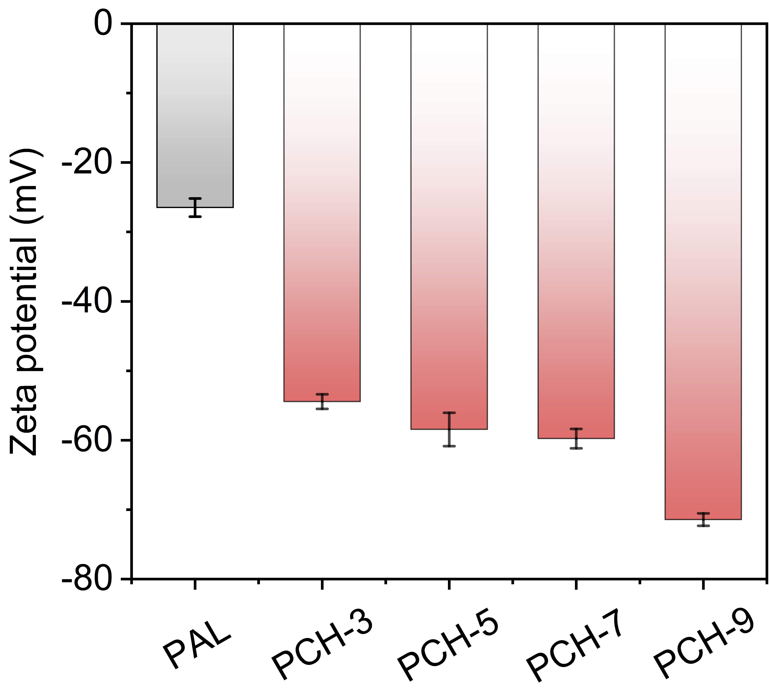
Figure S11. Zeta potential of the PCH membranes.

Discussion: PAL nanorods are inherently negatively charged and the Zeta potential is -26.6 mV. As the content of CMC chains with affluent -COO⁻ groups increases, the value of zeta potential is gradually enhanced up to -71.3 mV.

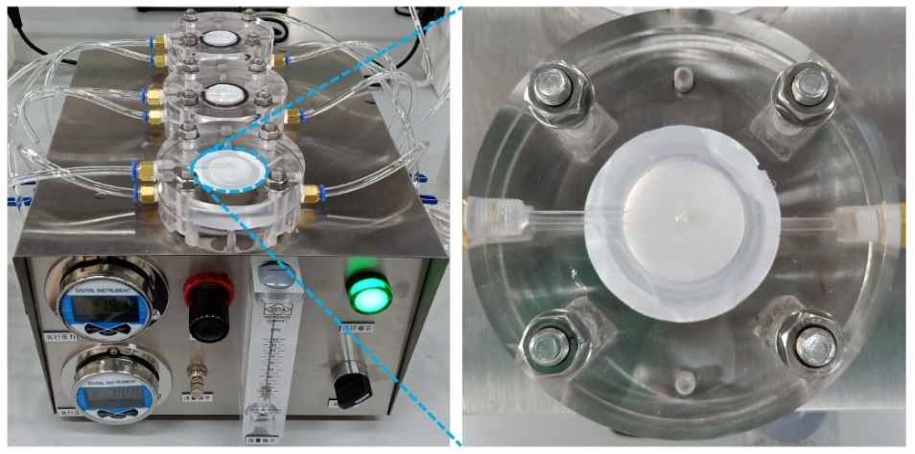
Figure S12. A commercial RO cross-flow filtration system.

Note: The working principle of the system is schematically illustrated in Figure 4b. The PCH membrane suspended on a PES substrate separates the chamber into two, the lower one filled with salt solutions which permeate through the membrane to the upper one. The RO pressure difference induced by applied pressure serves as the driving force for water transport.

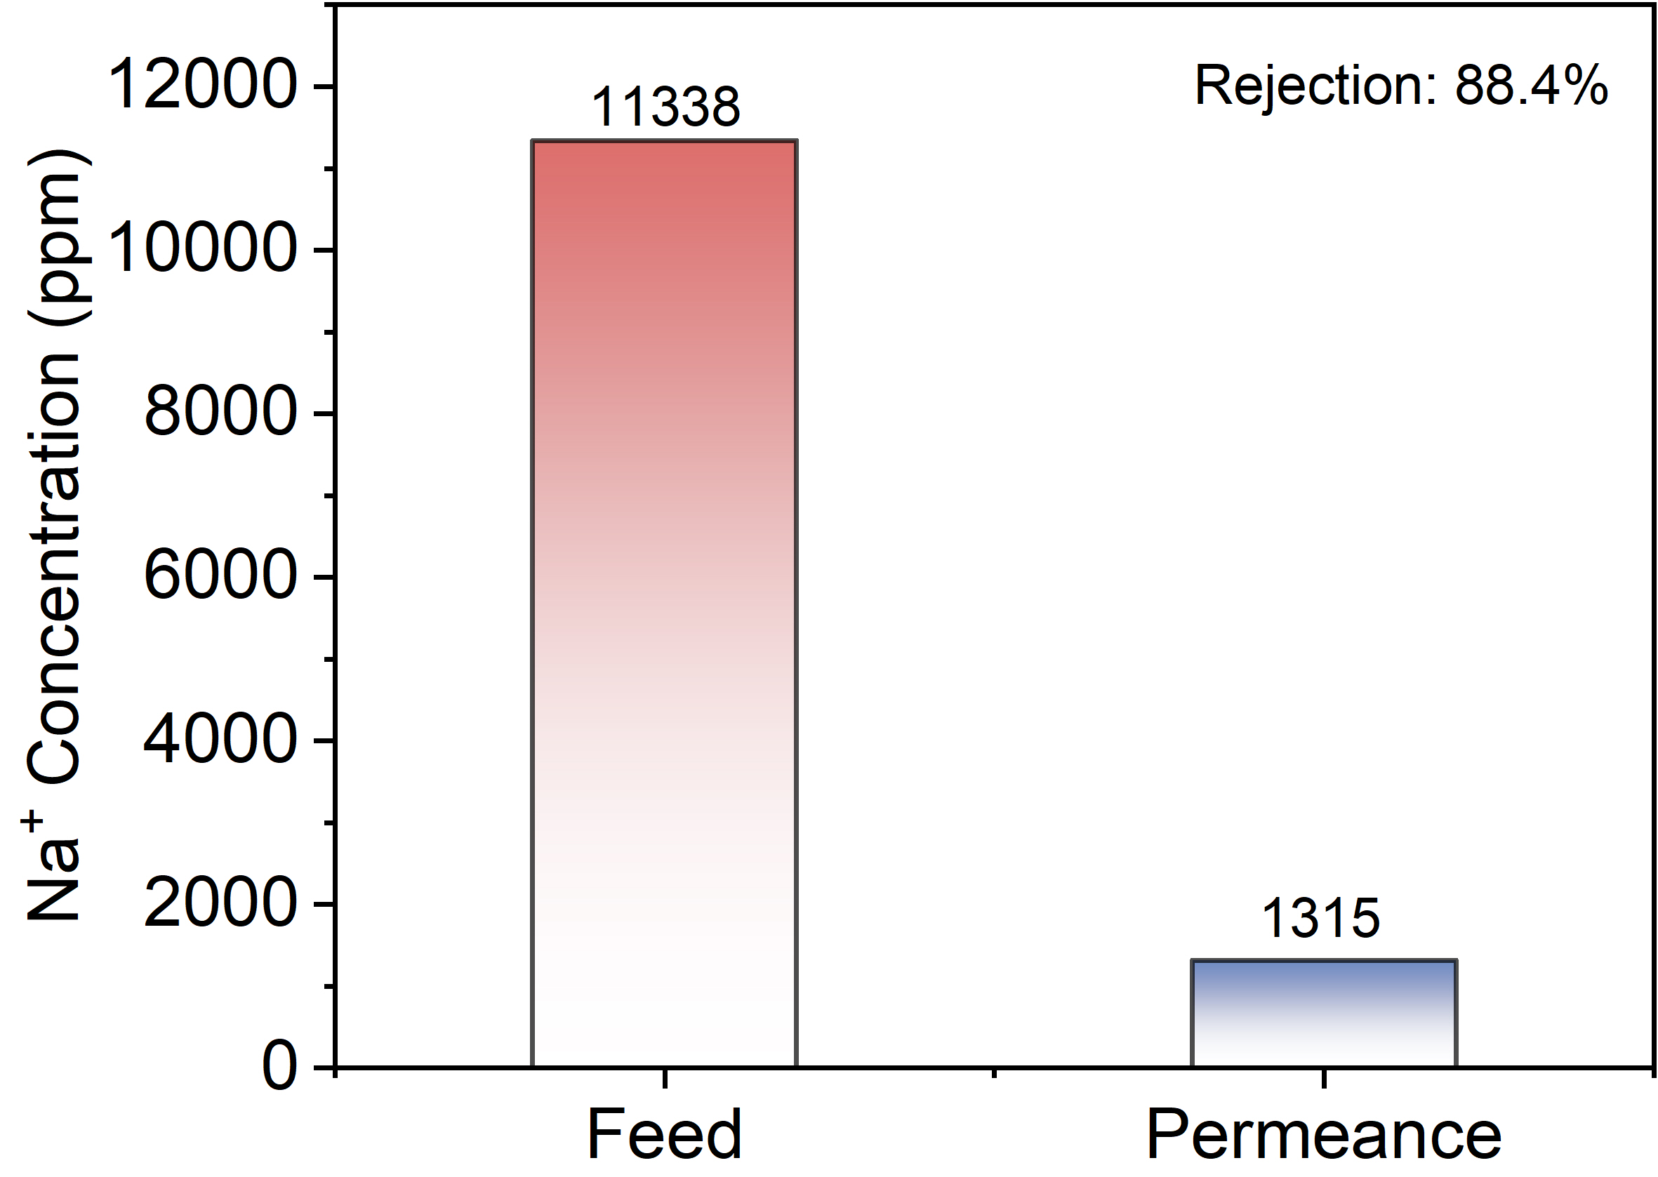
Figure S13. NF performance of the PCH-7 membrane for an ultrahigh concentration of Na₂SO₄ (35000 ppm).

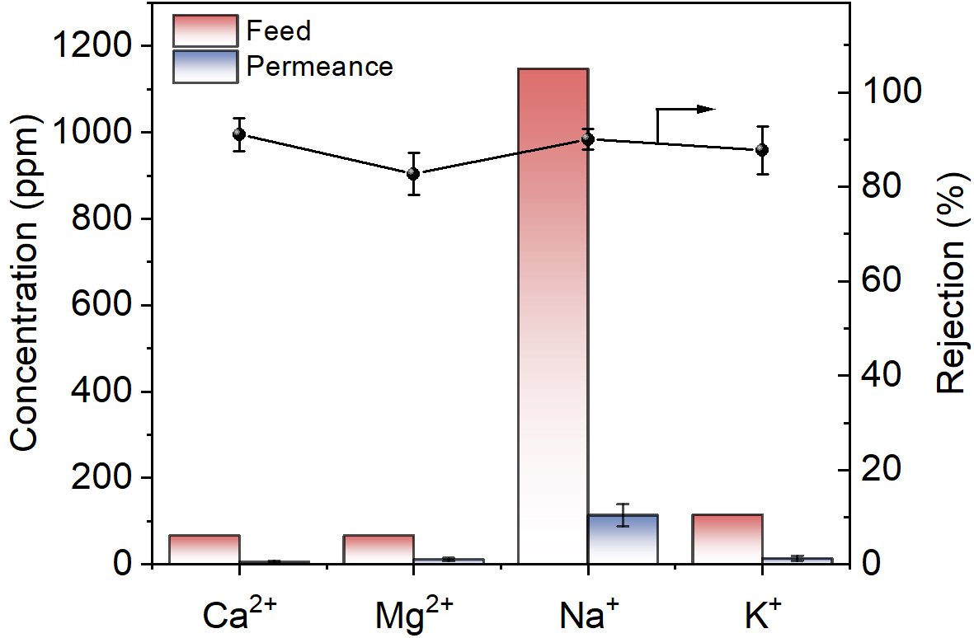
Figure S14. Filtration performance of the PCH-7 membrane on actual Yellow Sea water samples.

Discussion: The concentrations of the four most common cations (including Ca²⁺, Mg²⁺, Na⁺, and K⁺) in the Yellow Sea were determined and the retention performance of the PCH-7 membrane for these four ions was investigated. The ion concentrations in the actual water samples are 67.0 ppm for Ca²⁺, 66.8 ppm for Mg²⁺, 1148 ppm for Na⁺, and 115.4 ppm for K⁺. There was an order-of-magnitude reduction in permeance ion concentration compared to that in the feed, with the rejection for all kinds of ions above 80%.

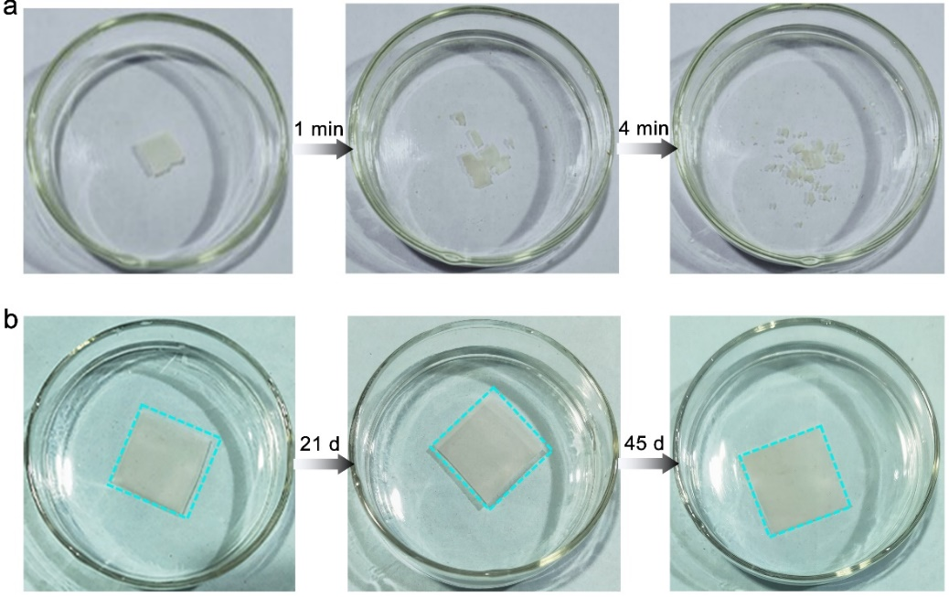
Figure S15. Stability of the PAL nanorod membrane (a) and (b) PCH-7 membrane in water.

Discussion: In the absence of CMC, the bare PAL nanorod membrane readily disintegrates in water within 4 min. In contrast, the PCH-7 membrane retains structural integrity even if soaked in water for 45 days due to the strong interactions between PAL nanorods and CMC chains.

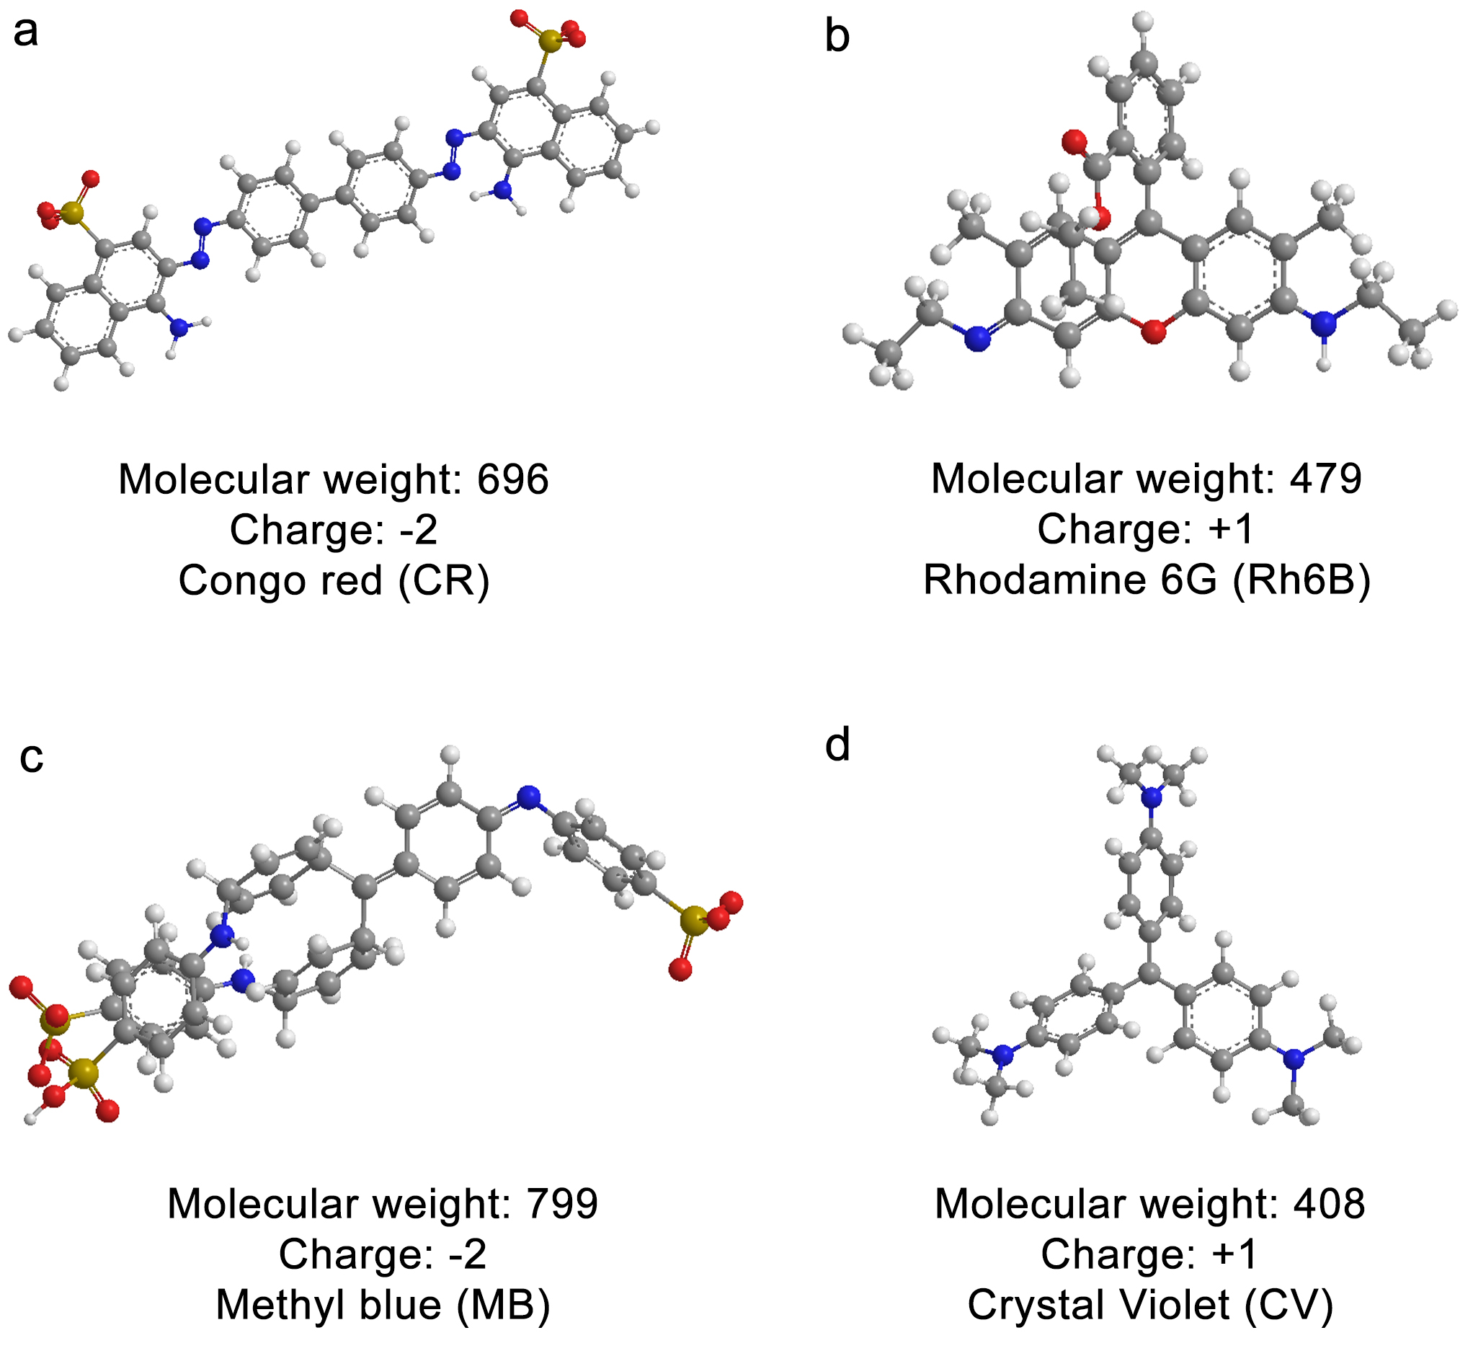
Figure S16 The characteristics of the organic dyes used in this work.

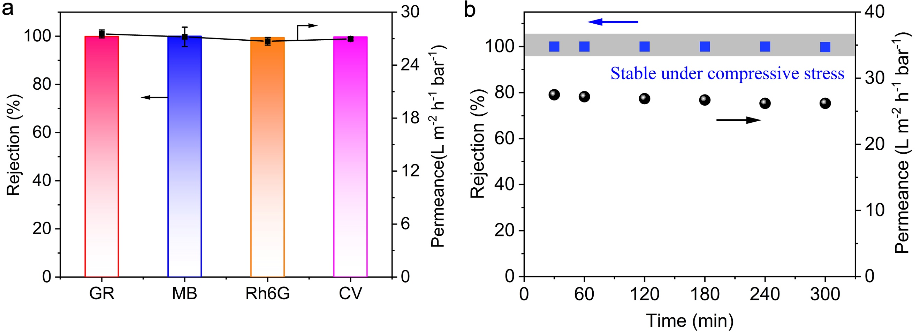
Figure S17. Dye rejection performance of the PCH-7 membrane. (a) Permeability and selectivity of the PCH-7 membrane for the nanofiltration of different dye solutions (dye concentration: 20 ppm). b) Long-term stability of the PCH-7 membrane for rejecting MB.

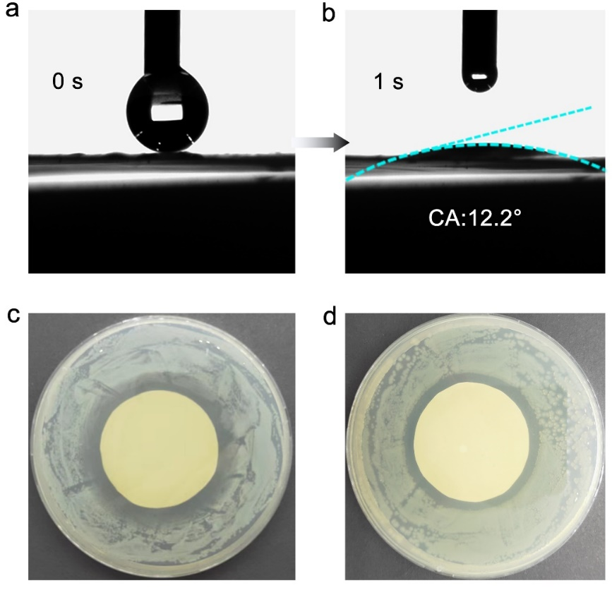
Figure S18. Antifouling performance of P_{0.35}CH-7 membrane. a, b) The Surface wettability of the P_{0.35}CH-7 membrane. c, d) The inhibition zone of P_{0.35}CH-7 membrane against S. aureus and E.coli.

Supplementary Tables

Table S1. Atomic percentage of elements in the PAL obtained from EDS mapping

 | O (%) | Mg (%) | Al (%) | Si (%) | Fe (%)
PAL | 64.43 | 7.70 | 4.00 | 22.79 | 1.08
P_{0.2}AL | 67.75 | 7.01 | 4.05 | 20.08 | 1.11
P_{0.35}AL | 66.33 | 6.56 | 3.78 | 22.10 | 1.22
P_{0.5}AL | 67.01 | 6.49 | 4.24 | 20.95 | 1.31
P_{1.0}AL | 67.55 | 5.32 | 6.25 | 19.22 | 1.66
Mg²⁺-P_{0.35}AL | 67.21 | 7.87 | 4.00 | 19.80 | 1.13

Discussion: After PAL nanorods were treated with H₂C₂O₄/HCl solution, the Mg content decreased significantly from 7.70 % to 5.32% with the increase of acid concentration, indicating that Mg²⁺ can be easily leached from the skeleton by H⁺ exchange during the etching process. P_{β}AL nanorods obtained by the ion imprinting technique lay a foundation for selective adsorption of Mg²⁺. Specifically, when 100 mg of P_{0.35}AL nanorods was immersed in 50 ml of MgCl₂ solution (2000 ppm) for 30 minutes, the Mg content increased from 6.56 % to 7.87 %, consistent with the content in the original PAL without acid treatment. This result suggests that Mg²⁺ in solution can be recaptured again into the PAL skeleton by ion-imprinted adsorption mechanism.

Table S2. The CMC content in PCH membranes.

Membrane | PAL content (wt%) | CMC content (wt%)
PCH-3 | 97 | 3
PCH-5 | 95 | 5
PCH-7 | 93 | 7
PCH-9 | 91 | 9

Table S3. The species of oxygen-containing functional groups and their corresponding binding energy obtained by peak fitting to O 1s.

 | Functional groups | Binding energy（eV）
CMC chains | C-O-C | 533.4
CMC chains | O=C-O | 532.7
PCH membrane | Si-O-Mg | 530.5
PCH membrane | Si-O-Al | 531.0
PCH membrane | Si-O-Si | 531.6
PCH membrane | Si-OH | 532.4
PCH membrane | C-O-C | 534.2
PCH membrane | O=C-O | 535.8

Table S4. Some reported nanofiltration membranes as well as corresponding membrane parameters.

Membrane | Feed  solution | Salt  rejection  (%) | Salt water Hydraulic  Permeability  (L m⁻² h⁻¹ bar⁻¹) | Reference
PSBMA@MoS₂ | 1000 ppm  Na₂SO₄ | 94.8 | 7.8 | ³
PA-ATP(n)/PES | 1000 ppm  Na₂SO₄ | 92 | ~23 | ⁴
GO/MoS₂ | 0.01M Na₂SO₄ | 65.2 | 10.2 | ⁵
rGO membrane | 0.01M Na₂SO₄ | 90 | <0.5 | ⁶
MOF-303 membrane | 0.10 wt % Na₂SO₄ | 100 | 0.0396 | ⁷
PA/GO membrane | 1000 ppm  Na₂SO₄ | 94.8 | 15.5 | ⁸
ZIF-8/TA-PES | 2000 ppm  Na₂SO₄ | 92.2 | 3.6 | ⁹
NF270 | 1000 ppm  Na₂SO₄ | 96.1 | 10.3 | ¹⁰
PCH membrane | 2000 ppm  Na₂SO₄ | 97.3 | 26.4 | This work
Traditional PA | 2000 ppm  NaCl | 33.7 | 7.1 | ¹¹
Asymmetric PA | 2000 ppm  NaCl | 41.1 | 30.6 | ¹¹
PDA-2h-PA | 2000 ppm  NaCl | 99.4 | 1.46 | ¹²
PA-ATP(n)/PES | 1000 ppm  NaCl | 14.7 | ~23 | ⁴
ZIF-8/TA-PES | 2000 ppm  NaCl | 64.7 | ~2 | ⁹
ZIF-8/(TA-Zn²⁺)n/PES | 2000 ppm  NaCl | 55.2 | 5.1 | ¹³
GO/FLG | 0.2% NaCl | 85 | 0.46 | ¹⁴
NF270 | 1000 ppm  NaCl | 25.9 | 13.8 | ¹⁰
NF90 | 1000 ppm  NaCl | 80.3 | 8.7 | ¹⁰
TFN-Pal/TiO₂ | 2000 ppm NaCl | 98.0 | 2.5 | ¹⁵
CPF membrane | 584 ppm  NaCl | 83.0 | 9.5 | ¹⁶
PCH-7 membrane | 2000 ppm NaCl | 86.2 | 27.7 | This work

Table S5. Comparison of Li⁺/Mg²⁺ separation performance of P_{0.35}CH-7 with other separation membranes.

Membrane | Feed  Concentration  (ppm) | Mg²⁺/Li⁺ ratio in feed | Permeance  (L m⁻² h⁻¹ bar⁻¹) | Mg²⁺/Li⁺ selectivity | Reference
TET-TMC | 2000 | 50 | ~16.7 | 28 | ¹⁷
QSPIP-TMC | / | 100 | 22 | 8.7 | ¹⁸
PEI-TMC-QBPD | 2000 | 50 | 16.1 | 5.2 | ¹⁹
PEI(Cyclen)-TMC | 2000 | 20 | 14.0 | 8.7 | ²⁰
TMC  PEI(LDH)-GA | 1000 | 10 | 4.0 | 18.7 | ²¹
PEI@15C5-TMC | 2000 | 20 | 8.0 | 14.0 | ²²
PA/PE-TFC-IPA | 2000 | 20 | 4.8 | 18.0 | ²³
PA-g-AS-Fe | 2000 | 20 | 8.7 | 81.5 | ²⁴
PAA/TMC | 2000 | 20 | 7.39 | 31.6 | ²⁵
AIP-PA | 2000 | 30 | 12.3 | 78.3 | ²⁶
NF-HACC-0.3 | 2000 | 13.9 | 15.7 | 115 | ²⁷
DABIL-5 | 1050 | 20 | 16.8 | 26.5 | ²⁸
M-E₁₊₂ | 2000 | 100 | 34.3 | 23.2 | ²⁹
QEDTP NFM | 2000 | 120 | 21.2 | 15.6 | ³⁰
PSF(RIP) | 1000 | 20 | 10.5 | 40.8 | ³¹
IPC33 | 2000 | 20 | 9.3 | 117 | ³²
PEI-70000/ PA/PES | 2000 | 50 | 2.2 | 150 | ³³
LiOH-Am7CD- TMC | 2100 | 31 | 1.92 | 190 | ³⁴
PEI-TMC-QTHIM | 2000 | 50 | ~28.3 | 4.6 | ³⁵
TFC-2 | 2000 | 27.3 | 18.6 | 50.7 | ³⁶
PEI-TMC-DHTAB | 2000 | 61 | ~6.0 | 60.1 | ³⁷
P_{0.35}CH-7 membrane | 2000 | 100 | 27.7 | 175 | This work

Table S6. The antifouling indexes (DR_{t},DR_{r}, DR_{ir} and FRR) of the PCH-7 membrane for BSA feed solutions.

Antifouling Indexes | PCH-7 membrane
FRR | 94.6
DR_{t} | 18.5
DR_{r} | 13.1
DR_{ir} | 5.4

References
1. Han Y, et al. Marine sponge spicules-inspired magnesium oxychloride cement with both enhanced water resistance and compressive strength via incorporating acid-activated palygorskite. Appl Clay Sci 196, (2020).
2. Huang T, Alyami M, Kashab NM, Nunes SP. Engineering membranes with macrocycles for precise molecular separations. J Mater Chem A 9, 18102-18128 (2021).
3. Liang X, et al. Zwitterionic functionalized MoS₂ nanosheets for a novel composite membrane with effective salt/dye separation performance. J Membr Sci 573, 270-279 (2019).
4. Wu M, et al. Fabrication of composite nanofiltration membrane by incorporating attapulgite nanorods during interfacial polymerization for high water flux and antifouling property. J Membr Sci 544, 79-87 (2017).
5. Zhang P, et al. Novel “loose” GO/MoS₂ composites membranes with enhanced permeability for effective salts and dyes rejection at low pressure. J Membr Sci 574, 112-123 (2019).
6. Wang Z, Ma C, Xu C, Sinquefield SA, Shofner ML, Nair S. Graphene oxide nanofiltration membranes for desalination under realistic conditions. Nat Sustain 4, 402-408 (2021).
7. Jian M, et al. Ultrathin water-stable metal-organic framework membranes for ion separation. Sci Adv 6, eaay3998 (2020).
8. Wei X, et al. Preparation of graphene oxide/polyamide composite nanofiltration membranes for enhancing stability and separation efficiency. J Appl Polym Sci 138, (2021).
9. Xu Y, et al. Plant polyphenol intermediated metal-organic framework (MOF) membranes for efficient desalination. J Membr Sci 618, (2021).
10. Li Y, Wong E, Mai Z, Van der Bruggen B. Fabrication of composite polyamide/Kevlar aramid nanofiber nanofiltration membranes with high permselectivity in water desalination. J Membr Sci 592, (2019).
11. Yuan B, Zhao S, Hu P, Cui J, Niu QJ. Asymmetric polyamide nanofilms with highly ordered nanovoids for water purification. Nat Commun 11, (2020).
12. Song X, Li S, Zhang W, Liu H, Jiang J, Zhang C. Constructing semi-oriented single-walled carbon nanotubes artificial water channels for realized efficient desalination of nanocomposite RO membranes. J Membr Sci 663, (2022).
13. Xiao Y, Zhang W, Jiao Y, Xu Y, Lin H. Metal-phenolic network as precursor for fabrication of metal-organic framework (MOF) nanofiltration membrane for efficient desalination. J Membr Sci 624, (2021).
14. Morelos-Gomez A, et al. Effective NaCl and dye rejection of hybrid graphene oxide/graphene layered membranes. Nat Nanotechnol 12, 1083-1088 (2017).
15. Zhang T, Li Z, Wang W, Wang Y, Gao B, Wang Z. Enhanced antifouling and antimicrobial thin film nanocomposite membranes with incorporation of Palygorskite/titanium dioxide hybrid material. J Colloid Interface Sci 537, 1-10 (2019).
16. Shen J, et al. Fast water transport and molecular sieving through ultrathin ordered conjugated-polymer-framework membranes. Nat Mater 21, 1183-1190 (2022).
17. Li J, Peng H, Liu K, Zhao Q. Polyester Nanofiltration Membranes for Efficient Cations Separation. Adv Mater 36, (2023).
18. Peng H, Yu K, Liu X, Li J, Hu X, Zhao Q. Quaternization-spiro design of chlorine-resistant and high-permeance lithium separation membranes. Nat Commun 14, (2023).
19. Feng Y, Peng H, Zhao Q. Fabrication of high performance Mg²⁺/Li⁺ nanofiltration membranes by surface grafting of quaternized bipyridine. Sep Purif Technol 280, (2022).
20. Li T, Zhang X, Zhang Y, Wang J, Wang Z, Zhao S. Nanofiltration membrane comprising structural regulator Cyclen for efficient Li⁺/Mg²⁺ separation. Desalination 556, (2023).
21. Ni H, Wang N, Yang Y, Shen M, An Q-F. Positively-charged nanofiltration membrane constructed by polyethyleneimine/layered double hydroxide for Mg²⁺/Li⁺ separation. Desalination 548, (2023).
22. Li H, et al. Nanofiltration membrane with crown ether as exclusive Li⁺ transport channels achieving efficient extraction of lithium from salt lake brine. Chem Eng J 438, (2022).
23. Wang Q, et al. Polyamide/polyethylene thin film composite (PA/PE-TFC) NF membranes prepared from reverse-phase interface polymerization (RIP) for improved Mg(II)/Li(I) separation. Desalination 553, (2023).
24. Liu Y, et al. A nanofiltration membrane with positively and negatively charged groups by grafted p-aminosalicylic acid-Fe(III) chelation for Li⁺/Mg²⁺ efficient separation. Sep Purif Technol 308, (2023).
25. Xu P, et al. Fabrication of highly positively charged nanofiltration membranes by novel interfacial polymerization: Accelerating Mg²⁺ removal and Li⁺ enrichment. J Membr Sci 668, (2023).
26. Zhao G, Gao H, Qu Z, Fan H, Meng H. Anhydrous interfacial polymerization of sub-1 Å sieving polyamide membrane. Nat Commun 14, (2023).
27. Zhang T, et al. Advanced Mg²⁺/Li⁺ separation nanofiltration membranes by introducing hydroxypropyltrimethyl ammonium chloride chitosan as a co-monomer. Appl Surf Sci 616, (2023).
28. Soyekwo F, Wen H, Liao D, Liu C. Nanofiltration Membranes Modified with a Clustered Multiquaternary Ammonium-Based Ionic Liquid for Improved Magnesium/Lithium Separation. ACS Appl Mater Interfaces 14, 32420-32432 (2022).
29. Peng H, Liu X, Su Y, Li J, Zhao Q. Advanced Lithium Extraction Membranes Derived from Tagged‐Modification of Polyamide Networks. Angew Chem Int Ed 62, (2023).
30. Xu Y, Peng H, Luo H, Zhang Q, Liu Z, Zhao Q. High performance Mg²⁺/Li⁺ separation membranes modified by a bis-quaternary ammonium salt. Desalination 526, (2022).
31. Wang Q, et al. Polyethyleneimine (PEI) based positively charged thin film composite polyamide (TFC-PA) nanofiltration (NF) membranes for effective Mg²⁺/Li⁺ separation. Desalination 565, (2023).
32. Xu P, et al. Fine-tuning polyamide nanofiltration membrane for ultrahigh separation selectivity of Mg²⁺ and Li⁺. J Membr Sci 688, (2023).
33. Zhao P, et al. Nanofiltration membrane with modified nano-gradient structure and positive charge for Li separation from high Mg/Li ratio brine. Desalination 577, 117394 (2024).
34. Hong S, et al. Precision ion separation via self-assembled channels. Nat Commun 15, :3160 (2024).
35. Liu X, Feng Y, Ni Y, Peng H, Li S, Zhao Q. High-permeance Mg²⁺/Li⁺ separation nanofiltration membranes intensified by quadruple imidazolium salts. J Membr Sci 667, (2023).
36. Chen K, et al. Dual-electric layer nanofiltration membranes based on polyphenol/PEI interlayer for highly efficient Mg²⁺/Li⁺ separation. J Membr Sci 660, (2022).
37. Gu T, et al. Quaternary ammonium engineered polyamide membrane with high positive charge density for efficient Li⁺/Mg²⁺ separation. J Membr Sci 659, (2022).

