Supplementary material
Microbial Stimulation in Apple Orchards of Different Ages on the Loess Plateau: Poor Predictability of Increased Soil N₂O Emissions
Man Zhang^{a,b,c,1*}, Cui Li^{a,b,1}, Weixin Wang^{a,b}, Xin Tong^{a,b}, Kaixuan Wang^{a,b}, Minmin Qiang^{d}, Qiong Zhang^{a,b}
ª College of Soil and Water Conservation Science and Engineering, Northwest A&F University, Yangling, Shaanxi 712100, PR China
^{b} Institute of Soil and Water Conservation, Northwest A&F University, Yangling, Shaanxi 712100, PR China
^{c} Institute of Soil and Water Conservation, Chinese Academy of Sciences and Ministry of water Resources, Yangling, Shaanxi 712100, PR China
^{d} Northwest Engineering corporation limited, Xi’an, Shaanxi 710065, PR China

¹ These authors contributed equally to this work
* Corresponding author: Dr Man Zhang
Email: zmcocoo0203@nwafu.edu.cn
Supplementary Methods
Meta-analysis
Global in situ soil-atmosphere trace gas measurements
To provide a global context for detailed field measurements, we compiled 17 published studies that assess the impact of nitrogen (N) fertilizer addition on N₂O fluxes and mineralized N across various stages of fruit maturity (Table S2). Utilizing these datasets, we estimated the average effect size of N fertilizer addition on soil-atmosphere N₂O fluxes at different stand ages.
Criteria for data collection
We conducted a screening of N adjustment experiments involving added N fertilizer to obtain in situ data on soil-atmosphere N₂O flux in orchards of different ages. We reviewed 16 peer-reviewed journal articles published before May 2024 that met our criteria, sourced from the China National Knowledge Infrastructure (https://www.cnki.net) and Web of Science (http://apps.webofknowledge.com). The search terms employed were "nitrogen fertilizer" or "N₂O" or "ammonium nitrogen" or "nitrate nitrogen" and "orchard".
To reduce publication bias, all observations met the following criteria.
- All data were collected from field measurements and laboratory culture data were deleted.
- The treatment area and the control area were studied under the same natural environmental conditions. Nitrogen fertilizer increases of different magnitude were considered independent and included in this meta-analysis.
- Only articles containing N₂O are included.
- Sample sizes, means and standard deviations of both treatments and controls were obtained directly or were calculated from other data (standard errors, 95% bootstrap confidence interval (CI)) presented in the articles.
- When the data were presented as figures, we used ENGAUGE DIGITIZER 4.1 (Free Software Foundation Inc., Boston, MA, USA) to extract the data.
Before data analysis, the validity of each group of data was tested using the Kolmogorov-Smirnov (K-S) test. The normal distribution of the data was estimated using the non-parametric method (Bootstrap) to generate combined effect values () and conduct data analysis with a 95% CI (Wang et al., 2019). The means ( for treatments and for controls), sample sizes (n_{t} for treatments and n_{c} for controls) and standard deviations (s_{t} for treatments and s_{c} for controls) of both the treatment and control were provided directly or were calculated using the SE or 95% CI from the studies. These values were employed to calculate the individual effect size (lnR; Eq. 1), variance (v; Eq. 2) and weighting factor (w; Eq. 3) via meta-analysis (Hedges et al., 1999).
(1)
(2)
(3)
We calculated the weighted effect size (lnEE, Eq. 4) and the associated 95% bootstrap CI (Eq. 6 based on Eq. 5) from individual (i=1, 2, 3…, n) values by assigning a greater weight to the entries with a lower variance to improve the precision of our analysis as the mean effect size using a mixed model. Here, n is the number of entries in a certain category (see Categories for data collection), and i is the ith entry. If the number of entries used to calculate the weighted effect size is <20, the 95% CI will be narrow (Hedges et al., 1999); we conducted a resampling test with 4999 interactions to assess the 95% bootstrap CI and statistical significance. The response of the variable to different stand ages was considered significant if the 95% CI did not overlap with zero. If the weighted effect size of a variable in response to different stand ages was greater than zero, it was identified as a “positive” effect; otherwise, it was designated “negative”. MetaWin 2.0 (Rosenberg et al., 2000) was used to calculate the weighted effect size and 95% bootstrap CI.
(4)
(5)
(6)
We also calculated the percentage change (P, Eq. 7; Lu et al. 2013) of each category based on the weighted effect size.
(7)
Table S1 Time and amount of fertilizer applied.
Fertilization time | Fertilizer types | N kg ha^{–1} |  | P₂O₅ kg ha^{–1} |  | K₂O kg ha^{–1}
Fertilization time | Fertilizer types | 5yr | 25yr | 5yr | 25yr | 5yr | 25yr
2017.11.04 | Compound fertilizer | 321.78 | 321.78 | 128.71 | 128.71 | 321.78 | 321.78
2018.04.08 | Urea | 172.28 | 287.13 | — | — | — | —
2018.07.14 | Compound fertilizer | 222.77 | 222.77 | 61.88 | 61.88 | 272.28 | 272.28
2018.10.01 | Compound fertilizer | 346.53 | 346.53 | 396.04 | 396.04 | 284.65 | 284.65
2019.04.11 | Urea | 227.72 | 227.72 | — | — | — | —
2019.07.21 | Compound fertilizer | 89.11 | 89.11 | 19.80 | 19.80 | 118.81 | 118.81

Table S2 Data matrix used in the meta-analysis.
Study | Site name | Longitude | Latitude | MAT | MAP | climatic zone | age
(Liu et al., 2016) | Jiangxi Province | 115°04′E | 26°44′N | 18 | 1509 | subtropical | 0
(Tu and Zhang, 2018) | Zhejiang Province | 120°40′12″E | 30°40′12″N | 15.9 | 1200 | subtropical | 6
(Ma, 2022) | Shaanxi Province | 109°35′14″W | 35°10′37″N | 11.4 | 550 | template | 12
(He, 2022) | Shaanxi Province | 108°40′E | 34°18′N | 12.9 | 635.1 | template | 3
(Zhu, 2019) | Shaanxi province | 109°21′36″E | 35°46′48″N | 10.7 | 512 | template | 5
(Ma et al., 2021) | Shaanxi Province | 109°34′58″E | 35°12′15″N | 11.4 | 550 | template | 15
(Han et al., 2019) | Shaanxi Province | 107°41'E | 35°14'N | 9.1 | 582 | template | 15
(Xu et al., 2024) | Jiangsu Province | 119°14′E | 31°97′N | 16.2 | 1192 | subtropical | 5
(Oo et al., 2018) | Ibaraki, Japan | 140°26′E | 36°16′N | 13.3 | 1349 | template | 25
(Wu et al., 2017a) | Jiangxi Province | 115°04′E | 26°44′N | 18 | 1509 | subtropical | 1
(Xie et al., 2017) | Shandong province | 120°45′E | 37°490 N | 11.9 | 664 | template | 8
(Cheng et al., 2017) | Jiangsu Province | 119° 59′E | 31° 28′N | 15.7 | 1177 | subtropical | 6
Marques et al., 2018 | Nelas, Portugal | 7°51′W | 40°31′N | 14.15 | 1170 | template | 15
(Rowlings et al., 2013) | Brisbane, Australia | 152°W | 26°N | 19.9 | 1709 | subtropical | 20
(Wang et al., 2018) | The Xinjiang Uygur  Autonomous Region | 86°04′22″ E | 41°48′21″ N | 11.15 | 55 | template | 6
(Zhu et al., 2015) | Hainan Province | 109°29' E | 19° 30′ N | 23.5 | 1815 | tropical | 0
(Wu et al., 2017b) | Jiangxi Province | 115°04′E | 26°44′N | 18 | 1509 | subtropical | 1

Fig. S1 Daily precipitation, maximum temperature and minimum temperature during experiment period.
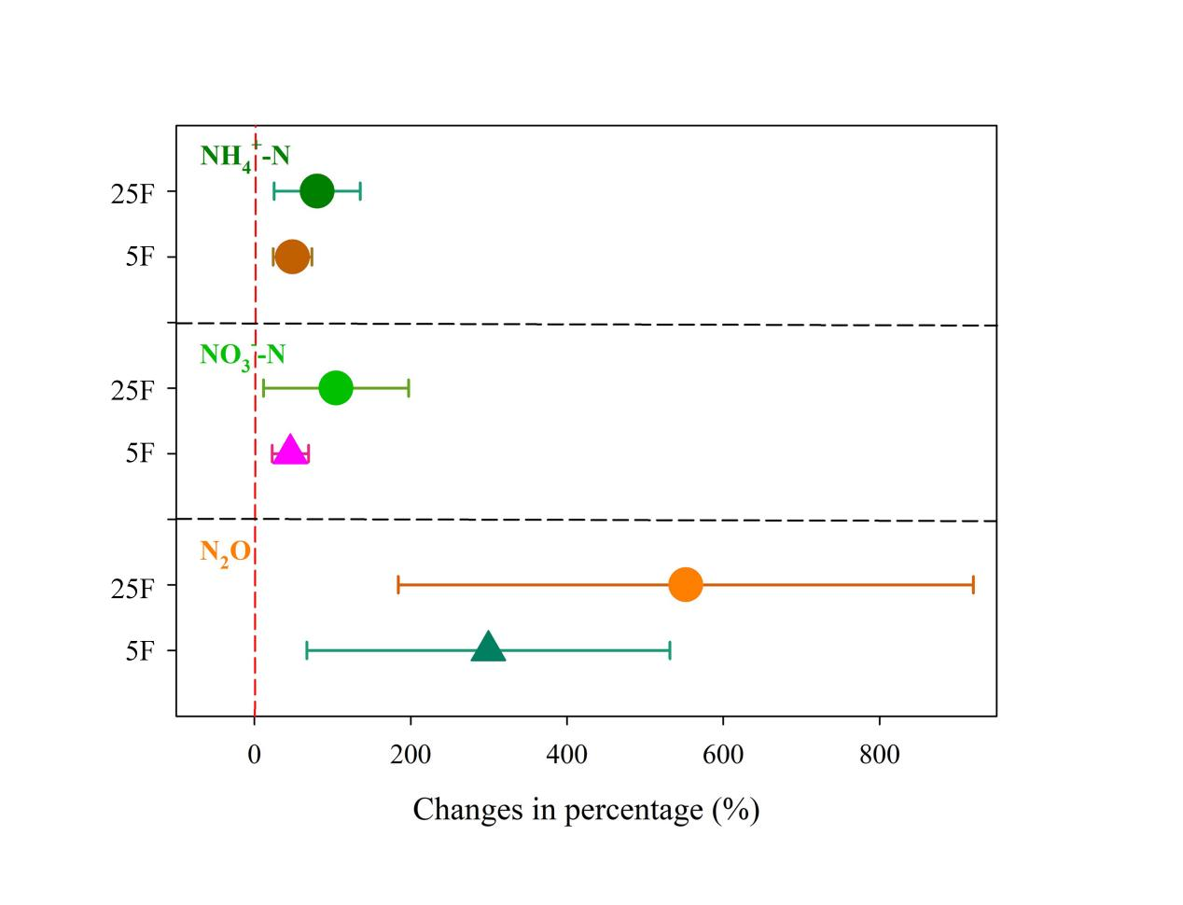
Fig. S2 Effects of nitrogen fertilizer on soil NH₄⁺-N, NO₃⁻-N and N₂O in orchards of different ages. The error bar represents a 95% confidence interval (CI). The number of observations is shown next to the right Y-axis. a, age.
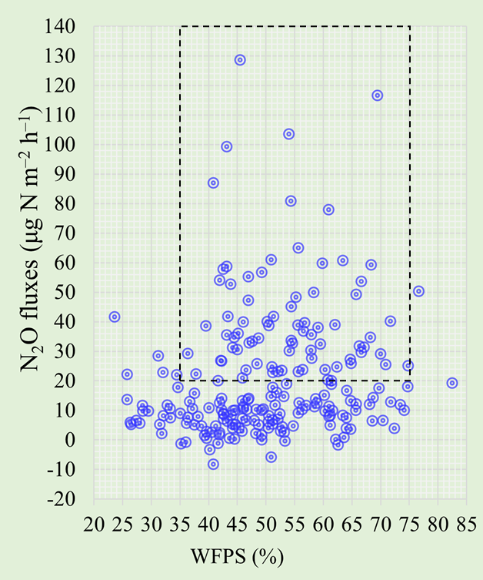
Fig. S3 Soil N₂O fluxes and WFPS of non-fertilized plots in young and old apple orchards, black dotted box indicates the range of WFPS that produced higher N₂O emissions (n = 210).
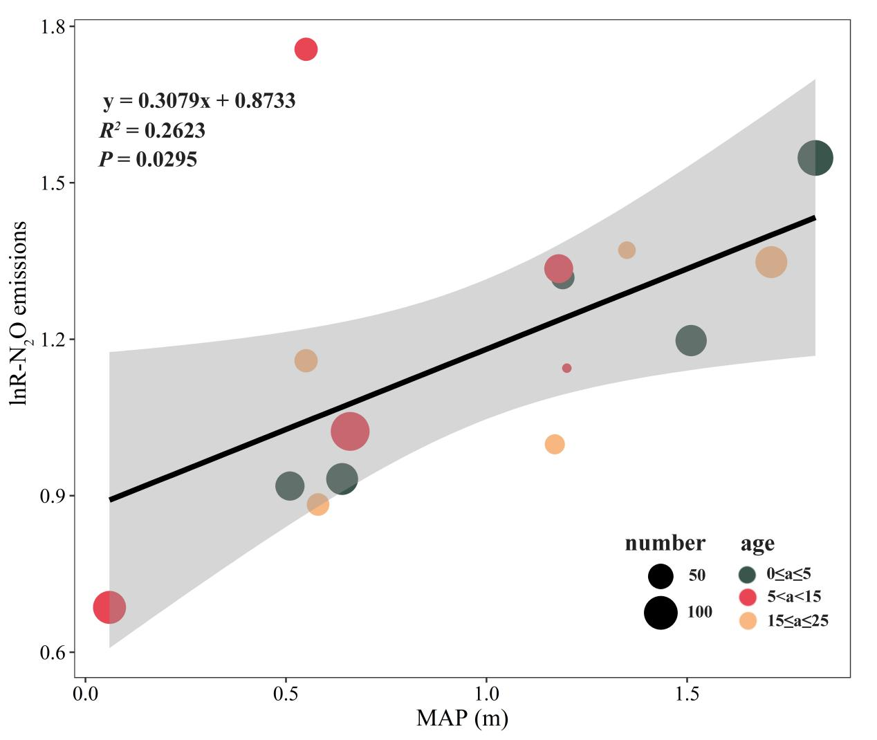
Fig. S4 The relationships between the lnR of soil N₂O emission and MAP. MAP, mean annual precipitation.

References
Cheng, Y., Xie, W., Huang, R., Yan, X., and Wang, S. (2017). Extremely high N₂O but unexpectedly low NO emissions from a highly organic and chemical fertilized peach orchard system in China. Agriculture, Ecosystems & Environment 246, 202–209. doi: 10.1016/j.agee.2017.06.015
Han J., Hao S., Liu Z., Zhang M., and Zhang A. (2019). Characteristics of CO₂ and N₂O Emissions Under Two Land Use Types in the Loess Plateau of China. Environmental Science 40, 5164–5172. doi: 10.13227/j.hjkx.201904206
He X. (2022). Effect of Drip-irrigation and Fertilization on Greenhouse Gas Emission of Vineyards and its Simulation in Semi-humid Area. Dissertation of Master Degree, Northwest Agricultural & Forestry University, Xianyang, China. doi: 10.27409/d.cnki.gxbnu.2021.000728
Hedges, L. V., Gurevitch, J., and Curtis, P. S. (1999). The Meta-Analysis of Response Ratios in Experimental Ecology. Ecology 80, 1150–1156. doi: 10.1890/0012-9658(1999)080[1150:TMAORR]2.0.CO;2
Liu, H., Liu, G., Li, Y., Wu, X., Liu, D., Dai, X., et al. (2016). Effects of land use conversion and fertilization on CH₄ and N₂O fluxes from typical hilly red soil. Environ Sci Pollut Res 23, 20269–20280. doi: 10.1007/s11356-016-7239-3
Ma Y. (2022). Effects of different water and fertilizer management on greenhouse gas emissions in apple orchard in Weibei dryland. Dissertation of Master Degree, Northwest Agricultural & Forestry University, Xianyang, China. doi: 10.27409/d.cnki.gxbnu.2021.000951
Ma Y., Zhao Z., Feng T., Thongsouk S., Kong X., Zhai B., et al. (2021). Effects of combined application of organic and inorganic fertilizers on greenhouse gas emissions in apple orchard. Journal of Agricultural and Environmental Sciences 40, 2039–2048.
Oo, A., Gonai, T., Sudo, S., Win, K., and Shibata, A. (2018). Surface application of fertilizers and residue biochar on N₂O emission from Japanese pear orchard soil. Plant, Soil and Environment 64. doi: 10.17221/114/2018-PSE
Rosenberg, M., Adams, D., and Gurevitch, J. (2000). MetaWin: Statistical software for meta-analysis. Version 2.0. Sinauer Associates.
Rowlings, D. W., Grace, P. R., Scheer, C., and Kiese, R. (2013). Influence of nitrogen fertiliser application and timing on greenhouse gas emissions from a lychee (Litchi chinensis) orchard in humid subtropical Australia. Agriculture, Ecosystems & Environment 179, 168–178. doi: 10.1016/j.agee.2013.08.013
Tu J., and Zhang C. (2018). Effects of different fertilization on soil greenhouse gas emissions in peach orchard. Modern Horticulture, 7–9. doi: 10.14051/j.cnki.xdyy.2018.01.004
Wang C., Chen B., Yusufujiang Y., Wang Q., Chai Z., and Liu X. (2018). Effects of different nitrogen application levels on nitrous oxide emission from the soil of a‘Kuerlexiangli’ pear orchard. Journal of Fruit Science 35, 1353–1362. doi: 10.13925/j.cnki.gsxb.20180167
Wang, L., Coulter, J. A., Palta, J. A., Xie, J., Luo, Z., Li, L., et al. (2019). Mulching-Induced Changes in Tuber Yield and Nitrogen Use Efficiency in Potato in China: A Meta-Analysis. Agronomy 9, 793. doi: 10.3390/agronomy9120793
Wu, X., Liu, H., Fu, B., Wang, Q., Xu, M., Wang, H., et al. (2017a). Effects of land-use change and fertilization on N₂O and NO fluxes, the abundance of nitrifying and denitrifying microbial communities in a hilly red soil region of southern China. Applied Soil Ecology 120, 111–120. doi: 10.1016/j.apsoil.2017.08.004
Wu, X., Liu, H., Zheng, X., Lu, F., Wang, S., Li, Z., et al. (2017b). Responses of CH₄ and N₂O fluxes to land-use conversion and fertilization in a typical red soil region of southern China. Sci Rep 7, 10571. doi: 10.1038/s41598-017-10806-z
Xie, B., Gu, J., Yu, J., Han, G., Zheng, X., Xu, Y., et al. (2017). Effects of N Fertilizer Application on Soil N₂O Emissions and CH₄ Uptake: A Two-Year Study in an Apple Orchard in Eastern China. Atmosphere 8, 181. doi: 10.3390/atmos8100181
Xu P., Guo S., Zheng H., Wang J., and Zou J. (2024). Effect of Partial Substitution of Chemical Fertilizers with Organic Fertilizers on N₂O and NO Emissions from a Peach Orchard. Environmental Science 45, 3725–3733. doi: 10.13227/j.hjkx.202306036
Zhu, T., Zhang, J., Huang, P., Suo, L., Wang, C., Ding, W., et al. (2015). N₂O emissions from banana plantations in tropical China as affected by the application rates of urea and a urease/nitrification inhibitor. Biol Fertil Soils 51, 673–683. doi: 10.1007/s00374-015-1018-z
Zhu Z. (2019). Effects of Fertilization System on Ammonia Volatilization and Greenhouse Gas Emission in Weibei Apple Orchard. Northwest Agricultural & Forestry University, Xianyang, China.

