Streptococcus vaginalis sp. nov., a novel bacterial species isolated from vaginal swabs of a pregnant woman with diabetes

An-Shine Chao^{1,2,3}, Chiao-Yun Lin^{2,3}, Angel Chao^{2,3}, Yun-Shien Lee^{4,5}, Yu-Chung Chang⁵, Hui-Chung Wu⁵, Yu-Jie Dai⁵, Wei-Qi Liao⁵, Fan-Ching Kao⁵, and Yi-Sheng Chen^{5,*}

¹Department of Obstetrics and Gynecology, New Taipei City Municipal Tu Cheng Hospital, New Taipei City, Taiwan
²Department of Obstetrics and Gynecology, Linkou Chang Gung Memorial Hospital, Tao-Yuan, Taiwan
³Gynecologic Cancer Research Center, Linkou Chang Gung Memorial Hospital, Taoyuan, Taiwan
⁴Genomic Medicine Research Core Laboratory, Chang Gung Memorial Hospital, Taoyuan, Taiwan
⁵Department of Biotechnology, Ming Chuan University, No. 5, De-Ming Rd., Guishan Dist., Taoyuan City 333, Taiwan

*Corresponding author
Fax: +886 3-3507001 #3540; Tel: +886 3-3593878
E-mail address: yisheng@mail.mcu.edu.tw

Supplementary Table 1. Comparative fatty acid compositions of Streptococcus vaginalis sp. nov. P1L01^{T} and the closely related species.
Strains: 1, Streptococcus vaginalis sp. nov. P1L01^{T}; 2, Streptococcus periodonticum KCOM 2412^{T}; 3, Streptococcus anginosus subsp. anginosus NCTC 10713^{T}; 4, Streptococcus anginosus subsp. whileyi CCUG 39159^{T}. Values are percentages of total fatty acids. Fatty acids amounting to less than 0.5% of the total fatty acids are not shown. -: Not detected. NA: Data not available. The major components of cellular fatty acid (≥ 10%) are highlighted in bold.

Fatty acid | 1 | 2* | 3* | 4*
12:0 | 2.0 | NA | NA | NA
14:1 ω7c | 3.0 | NA | NA | NA
14:0 | 14.7 | 32.8 | 13-20 | 6-8
16:0 | 40.7 | 35.0 | 36-42 | 34-39
16:1 ω9c | 6.4 | NA | NA | NA
16:1 ω7c | 4.0 | NA | NA | NA
16:1 ω5c | 2.5 | NA | NA | NA
18:0 | 3.0 | 1.9 | 5-9 | 12-13
18:1 ω9c | 1.8 | 2.4 | 7-13 | 9-12
18:1ω7c | 18.0 | NA | NA | NA
18:1ω7c/ω9t/ω12t | - | 4.9 | 7-11 | 11-16
18:2 ω6,9c/18:0 ante | - | 1 | 7-10 | 8-12
* Data obtained from study of Lim et al., 2019.

Supplementary Fig. S1. Phylogenetic tree based on 16S rRNA gene sequences showing the relationship of S. vaginalis sp. nov. (strain P1L01^{T}) with closely related species of the genus Streptococcus. The tree was reconstructed by the neighbour-joining method with Kimura’s two-parameter model on the basis of a comparison of 1304 bp, and Enterococcus faecalis ATCC 19433^{T} was used as an outgroup. Bootstrap values based on 1000 replications are indicated at branch nodes. Bar, 1% sequence divergence.

Supplementary Fig. S2. Phylogenetic tree based on 16S rRNA gene sequences showing the relationship of S. vaginalis sp. nov. (strain P1L01^{T}) with closely related species of the genus Streptococcus. The tree was reconstructed by the minimum-evolution method with Kimura’s two-parameter model on the basis of a comparison of 1304 bp, and Enterococcus faecalis ATCC 19433^{T} was used as an outgroup. Bootstrap values based on 1000 replications are indicated at branch nodes. Bar, 1% sequence divergence.

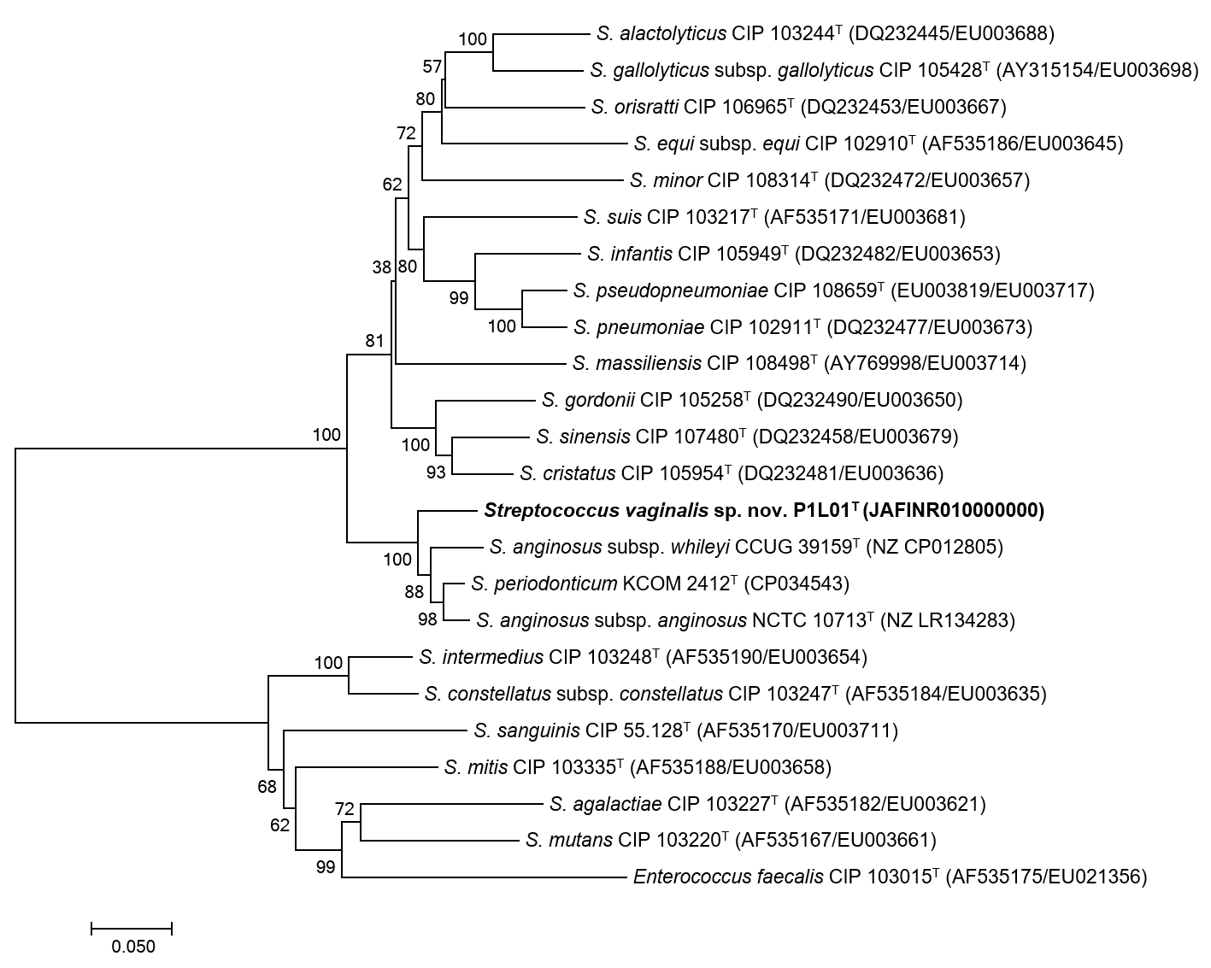

Supplementary Fig. S3. Phylogenetic tree based on the concatenated rpoB and groEL sequences showing the relationship of S. vaginalis sp. nov. (strain P1L01^{T}) with closely related species of the genus Streptococcus. The tree was reconstructed by the neighbour-joining method with Kimura’s two-parameter model on the basis of a comparison of 1430 bp, and Enterococcus faecalis CIP 103015^{T} was used as an outgroup. Bootstrap values based on 1000 replications are indicated at branch nodes. Bar, 5% sequence divergence.

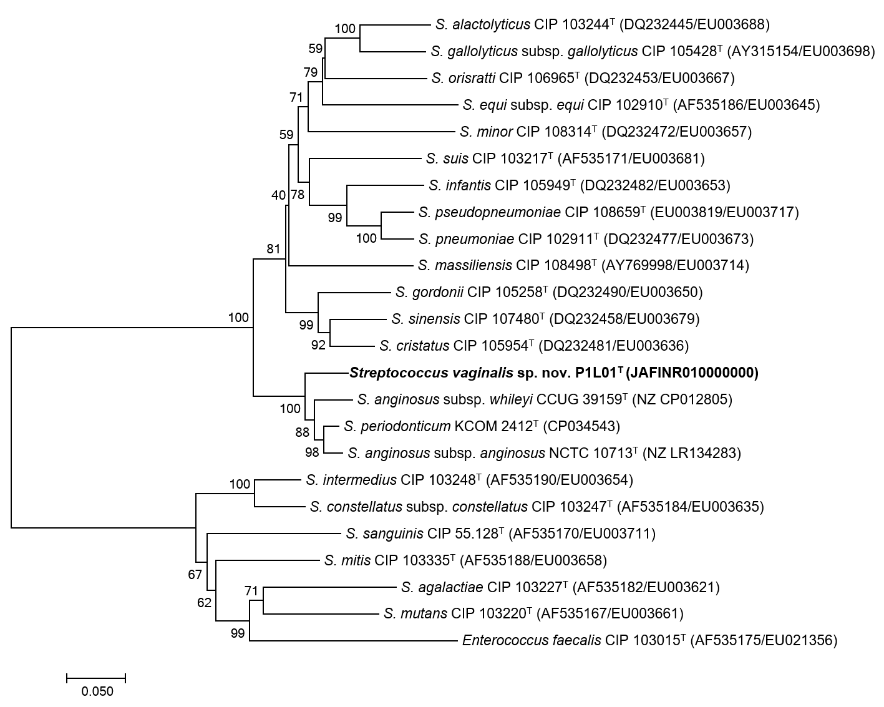

Supplementary Fig. S4. Phylogenetic tree based on the concatenated rpoB and groEL sequences showing the relationship of S. vaginalis sp. nov. (strain P1L01^{T}) with closely related species of the genus Streptococcus. The tree was reconstructed by the minimum-evolution method with Kimura’s two-parameter model on the basis of a comparison of 1430 bp, and Enterococcus faecalis CIP 103015^{T} was used as an outgroup. Bootstrap values based on 1000 replications are indicated at branch nodes. Bar, 5% sequence divergence.

