Supplementary Methods: The interplay between genomic copy number variants, sleep, and cognition in the general population.

Cognition measures

General cognitive ability

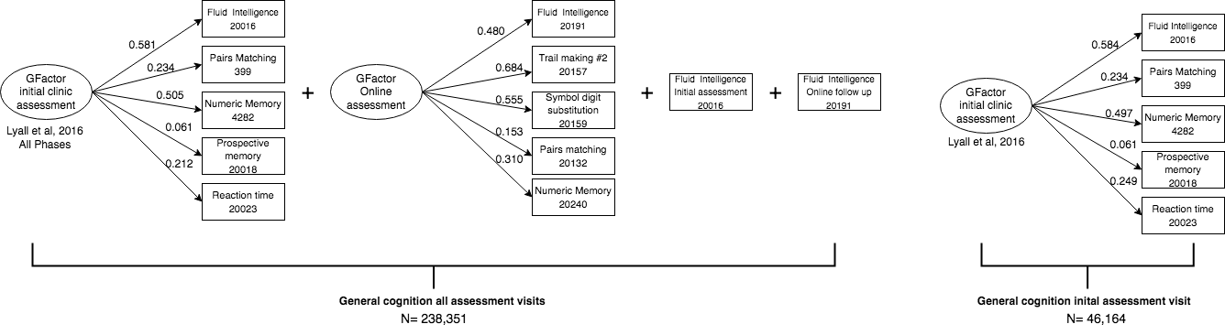
As depicted above, general cognitive ability was computed based on tasks from all assessment points. We first computed a gfactor using a PCA (‘factoextra’ r package) outlined in Lyall et al., 2016¹. The first available time-point for each task score was used. If scores were not available from clinic assessment visits (initial or follow-up), we computed a g factor score based on completed tasks from participant’s online assessment. If participants did not have enough completed tasks to compute either g factor, scores from their first completed fluid intelligence (FI) task (initial assessment in clinic or online) were used. The above information was pooled to represent general cognitive ability in the UkBiobank. For analyses restricted to the initial assessment visit we used the Lyall et al., 2016 gfactor score composed of five tasks completed at the initial assessment.

For a breakdown of individuals per cognitive assessment, see figure below:

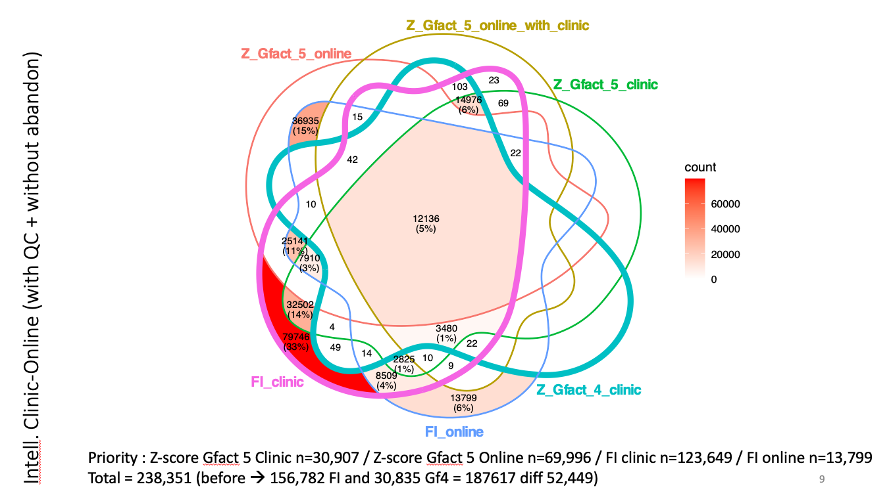

The executive functioning tasks used are described below and further detailed in the UK Biobank documentation. https://biobank.ndph.ox.ac.uk/ukb/search.cgi

Fluid intelligence (20016) :
Participants responded to a series of logic and reasoning questions within a two-minute time limit. In the versions presented in clinic the maximum score was 13, in the online follow-up version (20191) the maximum score was 14.

Pairs Matching (20132) :
Participants memorized the positions of matching card pairs. They were then asked to match the card pairs from memory with the fewest tries possible. Higher scores reflect more errors on the task, hence worst cognitive performance. There were two versions of the Pairs Matching Task using 3-pairs and 6-pairs of matching cards. The 6-pairs version was selected for this study.

Prospective Memory (20018):
Prior to starting their cognitive assessments, participants read: ‘At the end of the games we will show you four coloured symbols and ask you to touch the blue square. However, to test your memory, we want you to actually touch the Orange Circle instead’
Participants had a score of one if they pressed the orange circle and 0 if not.

Numeric Memory (‘Maximum digits remembered’; 4828) :
Participants were shown a two-digit number, following a brief pause they were asked to recall the digits. The digits’ participants were asked to recall increased by one until an error was made or all 12 digits were recalled correctly (maximum score).

Reaction time (20023) :
Participants were asked to press a button when both cards on screen matched. A mean response time in milliseconds was derived from multiple matching rounds.

Symbol digit substitution (20159) :
Participants were shown one grid linking symbols to single-digit integers at the bottom. A second grid containing only the symbols (same as the first grid) was also shown. Participants were then asked to identify the numbers corresponding to symbols in the second grid using the first grid one as a reference.

Trail Making # 2 (alphanumeric version B; 20157) :
Participants were asked to link letters and numbers sequentially. Their completion time was measured in milliseconds.

Executive Functioning Tasks :

The Trail Making Task: Participants were asked to link consecutive numbers (numeric version A), then link letters and numbers sequentially (alphanumeric version B). The difference in completion time (milliseconds) between version B and A was computed to account for motor ability². Zscore directions were reversed to indicate lower scores correspond with worst performance. Performance scores were obtained from initial visit assessments (20157), and pooled with online follow-up scores (20157) if initial scores were not available.

Tower Rearranging Task (21004): For 18 rounds participants were shown three pegs (“towers”) with three differently colored hoops, then asked to indicate how many moves were required to re-arrange the hoops to a specified reference location. Participants’ score based on the number of correct responses (maximum 18).

All tasks scores were z-scored. After final scores were combined, both age and sex were controlled for in using a residuals approach:

Linear Regression = glm(Cognitive ability ZScore ~ age + sex, data= Cognitive Data)
Cognitive Data $residual_CognitiveZscore = residuals(Linear Regression)

Genetics
CNV calling and quality controls.
For all selected SNP array data, we called CNVs with PennCNV² and QuantiSNP³ using previously published methods ^{4,5}. CNVs were called using both algorithms with the following parameters: number of consecutive probes for CNV detection ≥3, CNV size ≥1Kb, confidence scores ≥15. CNVs detected by both algorithms were combined (CNVision)⁶ to minimize the number of potential false discoveries. After this merging step, the CNV inheritance analysis algorithm (in-house algorithm), was applied to concatenate adjacent CNVs (same type) into one, according to the following criteria: a) gap between CNVs ≤150 kb; b) size of the CNVs ≥ 1000 bp; and c) number of probes ≥ 3. CNV filtering steps were previously published. After filtering array according to their quality, we applied filtering for CNVs. The CNVs with the following criteria were selected for analysis: confidence score ≥ 30 (with at least one of both detection algorithms), size ≥ 50 kb, unambiguous type (deletions or duplications). Every recurrent CNV was manually visualized by at least one individual.

Annotation of CNVs.
We used bedtools suite (https://bedtools.readthedocs.io/en/latest/) to compare the different elements of the genes that overlap CNVs (UTRs, start and stop codons, exons and introns). Thus, for each CNV, we obtained its proportion of overlap with each gene as well as with each gene component (UTR, Coding exons, start and stop codons, introns).

