Supplementary data: The interplay between genomic copy number variants, sleep, and cognition in the general population.

List of supplementary tables and figures:

Supplementary tables 1
eTable1. Sleep related medication in the UkBiobank 3
eTable2. CNVs and genes previously associated with neurodevelopmental or neuropsychiatric conditions 5
eTable3. Associations between sleep duration and cognition in the UkBiobank 7
eTable4. Associations between insomnia, sleep efficiency and cognition 8
eTable5. Associations between CNVs, sleep, and cognitive measures 9
eTable6. Association between LOEUF, insomnia, sleep efficiency and cognition measures 9
eTable7. Quadratic Associations between LOEUF and sleep duration 9
eTable8. Mediation analysis 9
Supplementary figures 10
eFigure 1. GAM smooth associations between sleep duration and cognition in the UkBiobank 10
eFigure 2. U-shape/quadratic associations between sleep duration and cognition performance showing data point distributions 11
eFigure 3. Associations between haploinsufficiency and sleep and cognition measures stratified by LOEUF score 12
eFigure 4. Mediation analyses between LOEUF, sleep duration and cognitive ability 13

Supplementary tables
Category | Drug | Code | Category | Drug | Code
Antidepressants | chlordiazepoxide | 1140863328 | Antidepressants | tranylcypromine+trifluoperazine 10mg/1mg tablet | 1140867944
Antidepressants | cipralex 5mg tablet | 1141190158 | Antidepressants | trazodone | 1140879634
Antidepressants | cipramil 10mg tablet | 1141151946 | Antidepressants | trimipramine | 1140867756
Antidepressants | citalopram | 1140921600 | Antidepressants | triptafen tablet | 1140867934
Antidepressants | clomipramine | 1140879620 | Antidepressants | tryptizol 10mg tablet | 1140867668
Antidepressants | cymbalta 30mg gastro-resistant capsule | 1141201834 | Antidepressants | venlafaxine | 1140916282
Antidepressants | dosulepin | 1140909806 | Antidepressants | yentreve 20mg gastro-resistant capsule | 1141200570
Antidepressants | dothiepin | 1140879628 | Antidepressants | zispin 30mg tablet | 1141152736
Antidepressants | doxepin | 1140867640 | Antidepressants | anafranil 10mg capsule | 1140867690
Antidepressants | duloxetine | 1141200564 | Antidepressants | allegron 10mg tablet | 1140867820
Antidepressants | edronax 4mg tablet | 1141151982 | Antipsychotics | clopixol 2mg tablet | 1140867342
Antidepressants | escitalopram | 1141180212 | Antipsychotics | clozapine | 1140867420
Antidepressants | faverin 50mg tablet | 1140867860 | Antipsychotics | clozaril 25mg tablet | 1140882320
Antidepressants | fluoxetine | 1140879540 | Antipsychotics | cpz - chlorpromazine | 1140910358
Antidepressants | fluphenazine hydrochloride+nortriptyline 1.5mg/30mg tablet | 1140867940 | Antipsychotics | denzapine 25mg tablet | 1141200458
Antidepressants | fluvoxamine | 1140879544 | Antipsychotics | depixol 3mg tablet | 1140867152
Antidepressants | imipramine | 1140879630 | Antipsychotics | dolmatil 200mg tablet | 1140867306
Antidepressants | isocarboxazid | 1140867856 | Antipsychotics | dozic 1mg/ml oral liquid | 1140867180
Antidepressants | lofepramine | 1140867726 | Antipsychotics | fentazin 2mg tablet | 1140867210
Antidepressants | ludiomil 10mg tablet | 1140867784 | Antipsychotics | fluanxol 500micrograms tablet | 1140867952
Antidepressants | lustral 50mg tablet | 1140867884 | Antipsychotics | flupenthixol | 1140867150
Antidepressants | manerix 150mg tablet | 1140867922 | Antipsychotics | flupentixol | 1140909800
Antidepressants | maoi - isocarboxazid | 1140910504 | Antipsychotics | fluphenazine | 1140882098
Antidepressants | maoi - phenelzine | 1140910704 | Antipsychotics | fluphenazine | 1140882098
Antidepressants | maoi - tranylcypromine | 1140910820 | Antipsychotics | fluspirilene | 1140867546
Antidepressants | mianserin | 1140879556 | Antipsychotics | haldol 5mg tablet | 1140867184
Antidepressants | mirtazapine | 1141152732 | Antipsychotics | haloperidol | 1140867168
Antidepressants | moclobemide | 1140867920 | Antipsychotics | largactil 10mg tablet | 1140863416
Antidepressants | molipaxin 50mg capsule | 1140882244 | Antipsychotics | levomepromazine | 1140909802
Antidepressants | nardil 15mg tablet | 1140867852 | Antipsychotics | modecate 12.5mg/0.5ml oily injection | 1140867456
Antidepressants | nefazodone | 1140917460 | Antipsychotics | neulactil 2.5mg tablet | 1140867136
Antidepressants | nortriptyline | 1140867818 | Antipsychotics | olanzapine | 1140928916
Antidepressants | norval 10mg tablet | 1140867812 | Antipsychotics | panadeine co tablet | 1140928260
Antidepressants | paroxetine | 1140867888 | Antipsychotics | panadeine forte tablet | 1140856418
Antidepressants | phenelzine | 1140867850 | Antipsychotics | panadeine tablet | 1140856416
Antidepressants | prothiaden 25mg capsule | 1140867624 | Antipsychotics | pericyazine | 1140867134
Antidepressants | prozac 20mg capsule | 1140867876 | Antipsychotics | perphenazine | 1140867208
Antidepressants | reboxetine | 1141151978 | Antipsychotics | pimozide | 1140867218
Antidepressants | seroxat 20mg tablet | 1140882236 | Antipsychotics | prochlorperazine | 1140868170
Antidepressants | sertraline | 1140867878 | Antipsychotics | promazine | 1140879746
Antidepressants | sinequan 10mg capsule | 1140882312 | Antipsychotics | quetiapine | 1141152848
Antidepressants | surmontil 10mg tablet | 1140867758 | Antipsychotics | risperdal 0.5mg tablet | 1141177762
Antidepressants | tranylcypromine | 1140867914 | Antipsychotics | risperidone | 1140867444
Antipsychotics | thioridazine | 1140879750 | Antipsychotics | serenace 500micrograms capsule | 1140867092
Antipsychotics | trifluoperazine | 1140868120 | Antipsychotics | seroquel 25mg tablet | 1141152860
Antipsychotics | zaponex 25mg tablet | 1141201792 | Antipsychotics | sertindole | 1140927956
Antipsychotics | zuclopenthixol | 1140882100 | Antipsychotics | stelazine 1mg tablet | 1140867244
Antipsychotics | zyprexa 2.5mg tablet | 1141167976 | Antipsychotics | sulpiride | 1140867304
Antipsychotics | chloractil 25mg tablet | 1140863410 | Anxiolytics | tryptizol 10mg tablet | 1140867668
Antipsychotics | amisulpride | 1141153490 | Anxiolytics | ucerax 25mg tablet | 1140863292
Antipsychotics | aripiprazole | 1141195974 | Anxiolytics | welldorm tablet | 1140863028
Anxiolytics | chlordiazepoxide | 1140863328 | Anxiolytics | xanax 250mcg tablet | 1140863310
Anxiolytics | chlordiazepoxide | 1140863328 | Anxiolytics | zimovane ls 3.75mg tablet | 1140928004
Anxiolytics | clomethiazole | 1140909798 | Anxiolytics | zolpidem | 1140865016
Anxiolytics | dalmane 15mg capsule | 1140863112 | Anxiolytics | zopiclone | 1140863144
Anxiolytics | diazepam | 1140863152 | Anxiolytics | abilify 5mg tablet | 1141202024
Anxiolytics | diazepam | 1140863152 | Anxiolytics | buspirone | 1140879730
Anxiolytics | dichloralphenazone | 1140855824 | Anxiolytics | atarax 10mg tablet | 1140863286
Anxiolytics | dormonoct 1mg tablet | 1140855890 | sleep | chlormezanone | 1140863262
Anxiolytics | flurazepam | 1140863110 | sleep | clobazam | 1140863268
Anxiolytics | heminevrin 192mg capsule | 1140863036 | sleep | clomethiazole | 1140909798
Anxiolytics | hydroxyzine | 1140883656 | sleep | diazepam | 1140863152
Anxiolytics | librium 5mg tablet | 1140863350 | sleep | dichloralphenazone | 1140855824
Anxiolytics | loprazolam | 1140863120 | sleep | diphenhydramine product | 1140883600
Anxiolytics | lorazepam | 1140863302 | sleep | ketazolam | 1140855860
Anxiolytics | lormetazepam | 1140863176 | sleep | lorazepam | 1140863302
Anxiolytics | medazepam | 1140863372 | sleep | lormetazepam | 1140863176
Anxiolytics | meprate 400mg tablet | 1140863440 | sleep | medazepam | 1140863372
Anxiolytics | meprobamate | 1140863378 | sleep | meprobamate | 1140863378
Anxiolytics | methyprylone | 1140856040 | sleep | methyprylone | 1140856040
Anxiolytics | mogadon 5mg tablet | 1140863194 | sleep | nitrazepam | 1140863182
Anxiolytics | neulactil 2.5mg tablet | 1140867136 | sleep | nytol 25mg tablet | 1140862722
Anxiolytics | nitrazepam | 1140863182 | sleep | oxazepam | 1140863442
Anxiolytics | oxazepam | 1140863442 | sleep | prazepam | 1140855944
Anxiolytics | phenergan 10mg tablet | 1140862810 | sleep | sonata 5mg capsule | 1141171410
Anxiolytics | phenergan comp expect linctus | 1140855722 | sleep | temazepam | 1140863202
Anxiolytics | promethazine product | 1140882082 | sleep | triazolam | 1140855914
Anxiolytics | rohypnol 1mg tablet | 1140863106 | sleep | triclofos sodium | 1140863140
Anxiolytics | sinequan 10mg capsule | 1140882312 | sleep | zaleplon | 1141171404
Anxiolytics | stilnoct 5mg tablet | 1140864916 | sleep | zopiclone | 1140863144
Anxiolytics | temazepam | 1140863202 | sleep | bromazepam | 1140863318
A list of medications known to impact/or likely impact natural sleep rhythms, as previously provided³.

eTable1. Sleep related medication in the UkBiobank

Locus  (Main gene) | Start-Stop  (Mb, hg19)​ | N genes | Risk​ (Reference) | Type | N carriers
 |  |  |  |  | Sleep Questionnaire​ | Actigraphy​ | General Cognition​ | Trail Making​ | Tower Task​
1q21.1 Distal (BCL9) | 146.52-147.39​ | 7 | risk ^{​a} | DEL | 107 | 20​ | 38 | 24​ | 8
 |  |  |  | DUP | 165 | 28​ | 77​ | 33​ | 13
1q21.1 TAR (ANKRD34A) | 145.39-145.80​ | 15 | risk​^{​​ a} | DEL | 151 | 22 | 68​ | 36​ | 11​
 |  |  |  | DUP | 440​ | 73​ | 181​ | 97​ | 29​
NRXN1​ – 2p16.3 | 50.15-51.26​ | 1 | risk​​​ ​^{​b} | DEL | 281 | 59 | 107 | 68​ | 15​
 |  |  |  | DUP | 2 | -- | --​ | 1 | --​
2q11.2  (SNRNP200)​ | 96.74-97.67​ | 17 | risk ​^{​a} | DEL | 34​ | 5 | 14 | 11​ | 6
 |  |  |  | DUP | 31 | 5 | 11​ | 6 | 1
NPHP1 – 2q13 | 110.86-110.98​ | 1 | risk​​ ​^{​a} | DEL | 2,597​ | 443 | 1,076​ | 653 | 188
 |  |  |  | DUP | 1,111 | 195 | 490 | 267 | 69​
2q13  (BUB1)​ | 111.39-112.01​ | 3 | risk​ ​^{​a} | DEL | 60​ | 10 | 28​ | 15​ | 3
 |  |  |  | DUP | 73 | 18​ | 31 | 18​ | 9
4p16.3​  (WHSC1) | 1.55-2.09​ | 10 | risk​ ​^{​a} | DEL | 6 | 2 | 2​ | 3 | 1
 |  |  |  | DUP | 11​ | -- | 3 | 1 | 1
ZNF92​ ​– 7q11.21 | 64839-64866​ | 1 | protective ^{​c} | DEL | 3,255​ | 647 | 1,368​ | 815 | 229
 |  |  |  | DUP | 235 | 478 | 96 | 61​ | 13​
7q11.23​ WBS (BAZ1B) | 72.74-74.14​ | 21 | risk​ ​^{​d} | DEL | 1 | -- | --​ | --​ | --​
 |  |  |  | DUP | 17​ | -- | 7 | 2 | 2
VPS13B​ ​– 8q22.2 | 100.02-100.89​ | 1 | risk ​^{​c} | DEL | 38 | 4 | 15 | 6 | 3
 |  |  |  | DUP | 6 | --​ | --​ | 1 | 1
DMRT1 ​– 9p24.3 | 0.84-0.96​ | 1 | risk​ ^{c} | DEL | 16 | 2 | 8 | 4 | --​
 |  |  |  | DUP | 59 | 10 | 10 | 12​ | 2
10q11.21-q11.23  (MAPK8) | 49.39-51.06 | 16 | risk​ ​^{​a} | DEL | 57​ | 5 | 19 | 9 | 1
 |  |  |  | DUP | 44​ | 8 | 27 | 8 | 2
ZMYM5​ – 13q12.11 | 20.41-20.44​ | 1 | protective​ ^{c} | DEL | 6 | 0 | 5 | 1 | --​
 |  |  |  | DUP | 80 | 17 | 38 | 17​ | 7
CRYL1 – 13q12 | 20.98-21.10 | 1 | risk​ ​^{​a} | DEL | 397 | 64 | 174 | 103 | 20
 |  |  |  | DUP | 8 | 1 | 2 | 2 | 1
13q12.12​ (SPATA13) | 23.55-24.88​ | 6 | risk​ ​^{​a} | DEL | 812 | 17​ | 28 | 16​ | ​3
 |  |  |  | DUP | 251 | 45 | 107 | 61 | 15​
15q11.2  (CYFIP1) | 22.80-23.09 | 4 | risk​ ​^{​d} | DEL | 1,723​ | 290 | 662 | 379 | 109
 |  |  |  | DUP | 2,250​ | 361​ | 892 | 450 | 133
15q11.2-q13.1 PWS/AS (UBE3A) | 22.80-28.39​ | 20 | risk​ ​^{​d} ​ | DEL | 1 | --​ | 0 | --​ | --​
 |  |  |  | DUP | 18​ | 1 | 3 | 2 | --​
15q13.1-q13.3  BP3-5 (OTUD7A)​ | 29.16-32.46 | 15 | risk​ ​^{​d} | DEL | 56​ | 4 | 17 | 5 | --​
 |  |  |  | DUP | 245 | 36​ | 102 | 51​ | 12​
15q13.3 (CHRNA7)​ | 31.08-32.47​ | 6 | risk​ ª | DEL | 1 | 1 | --​ | --​ | --​
 |  |  |  | DUP | 65​ | 7 | 24 | 7 | --​
16p13.11​  (KIAA0430) | 15.51-16.29​ | 6 | risk​​ ​^{​d} | DEL | 135​ | 12​ | 43​ | 16​ | 4
 |  |  |  | DUP | 886 | 159 | 336 | 177 | 44​
16p12.1​  (POLR3E) | 21.95-22.43​ | 7 | risk​​ ​^{​a} | DEL | 249 | 22 | 80 | 35​ | 14​
 |  |  |  | DUP | 194 | 41​ | 72 | 51​ | 15​
16p11.2 Proximal​ (TAOK2) | 29.65-30.20​ | 26 | risk​​ ​^{​d} | DEL | 121​ | 9 | 43 | 12​ | --​
 |  |  |  | DUP | 145 | 15​ | 53 | 21​ | 7
16p11.2 Distal​ (SH2B1) | 28.82-29.05​ | 9 | risk​​ ​^{​d} | DEL | 59​ | 6 | 18 | 8 | --​
 |  |  |  | DUP | 128​ | 16​ | 41 | 20​ | 3
CDH13 - 16q23.3 | 82.66-83.83​ | 1 | risk^{e}​ | DEL | 18​ | 4 | 7 | 4 | --​
 |  |  |  | DUP | 62 | 12 | 26 | 20 | 1
17p12  (HNPP/PMP22)​ | 14.14-15.43​ | 4 | protective​ ​^{​f} ​ | DEL | 263 | 53​ | 96 | 63 | 14
 |  |  |  | DUP | 136​ | 27​ | 59 | 41​ | 11​
17q11.2​  (NF1) | 29.11-30.26​ | 13 | risk​​​ ​^{​a} | DEL | 12​ | 3 | 8 | 8 | 2
 |  |  |  | DUP | 5 | 1 | 1 | 1 | --​
17q12  (HNF1B)​ | 34.81-36.22​ | 15 | risk​​ ​^{​d} | DEL | 9 | 3​ | 5 | 1 | --​
 |  |  |  | DUP | 102​ | 10 | 33 | 14​ | 1
22q11.2 Distal​ (MAPK1) | 21.92-23.65​ | 18 | risk​​​ ​^{​a} | DEL | 106 | 16​ | 29 | 24​ | 6
 |  |  |  | DUP | 302 | 52​ | 125 | 55 | 21
22q11.2 Proximal​ (HIRA) | 19.04-21.47 | 44 | risk​​​ ​^{​d} | DEL | 9​ | --​ | 3 | --​ | --​
 |  |  |  | DUP | 282 | 52​ | 101 | 56 | 12

eTable2. CNVs and genes previously associated with neurodevelopmental or neuropsychiatric conditions
List of recurrent loci and genes previously associated with neuropsychiatric disorders in Coe et al. 2014ª, Satterstrom et al. 2020^{b}, Marshall et al. 2017^{c}, Sanders et al. 2019^{d}, Issoifov et al., 2014e, and Stefansson et al. 2014^{f}. Coordinates are presented in megabase (Mb) with the hg19 positions (Homo sapiens (human) genome assembly GRCh37) from Genome Reference Consortium. The number of genes indicated are the ones that are completely encompassed in each region. N: number; DEL: deletion; DUP: duplication; TAR: thrombocytopenia-absent radii; WBS: William-Beuren syndrome; PWS/AS: Prader-Willi syndrome/Angelman syndrome; BP: break points.
Cognitive variable | Sleep Duration  measure | Analysis | N | Model variables | Linear |  |  |  | Quadratic
 |  |  |  |  | Beta | SD | p | AdjR | Beta | SD | p | Adj R | ANOVA  p-value
General cognitive ability  (z-score) | Self-Report | Main | 237,015 | Sleep duration  Sleep duration²  Sleep duration age | -0.0132  --  -0.0079 | 0.0019  --  0.0002 | 1.03⁻¹²  --  1.80⁻²²⁴ | 0.0513 | 0.6135  -0.0436  -0.0074 | 0.0146  0.0010  0.0002 | <2.20⁻¹⁶  <2.20⁻¹⁶  1.36⁻¹⁹ | 0.0588 | <2.20⁻¹⁶
General cognitive ability  (z-score) | Self-Report | Sensitivity1 | 182,095 | Sleep duration  Sleep duration²  Sleep duration age | -0.0135  --  -0.0058 | 0.0022  --  0.0003 | 1.51⁻⁰⁹  --  2.43⁻⁷⁴ | 0.0567 | 0.6449  -0.0464  -0.0053 | 0.0185  0.0013  0.0003 | <2.20⁻¹⁶  <2.20⁻¹⁶  5.54⁻⁶² | 0.0634 | <2.20⁻¹⁶
General cognitive ability  (z-score) | Self-Report | Sensitivity2 | 45,873 | Sleep duration  Sleep duration²  Sleep duration age | -0.0098  --  -0.0033 | 0.0041  --  0,0005 | 1.73⁻⁰²  --  6.88⁻¹⁰ | 0.0555 | 0.6645  -0.047  -0.0029 | 0.0313  0.0022  0.0005 | 1.80⁻⁹⁹  4.27⁻¹⁰⁴  5.81⁻⁰¹ | 0.0651 | 4.27⁻¹⁰⁴
General cognitive ability  (z-score) | Accelerometer | Main | 69,249 | Sleep duration  Sleep duration²  Sleep duration age | -0.0079  --  -0.0063 | 0.0041  --  0.0004 | 5.66⁻⁰²  --  1.83⁻⁴⁴ | 0.0262 | 0.3192  -0.023  -0.0062 | 0.0411  0.0029  0.0005 | 8.72⁻¹⁵  1.37⁻¹⁵  3.80⁴³ | 0.0271 | 3.37⁻¹⁵
General cognitive ability  (z-score) | Accelerometer | Sensitivity1 | 36,572 | Sleep duration  Sleep duration²  Sleep duration age | 0,0005  --  -0.005 | 0.0058  --  0.0009 | 9.03⁻⁰¹  --  2.75⁻⁰⁸ | 0.0336 | 0.2597  -0.0185  -0.0049 | 0.057  0.004  0.0009 | 5.29⁻⁰⁶  4.93⁻⁰⁶  4.72⁻⁰⁸ | 0.0341 | 4.93⁻⁰⁶
Trail Making Task  (z-score) | Self-Report | Main | 117,765 | Sleep duration  Sleep duration²  Sleep duration age | -0.011  --  -0.0083 | 0.0026  --  0.0003 | 2.88⁻⁰⁵  --  3.86⁻¹³⁹ | 0.0142 | 0.2898  -0.0209  -0.0082 | 0.0221  0.0015  0.0003 | 3.92⁻³⁹  1.40⁻⁴²  2.04⁻¹³³ | 0.0157 | 1.46⁻⁴²
Trail Making Task  (z-score) | Self-Report | Sensitivity1 | 95, 698 | Sleep duration  Sleep duration²  Sleep duration age | -0.0104  --  -0.0055 | 0.0029  --  0.0004 | 2.64⁻⁰⁴  --  1.20⁻⁴⁴ | 0.0129 | 0.2754  -0.0201  -0.0053 | 0.0257  0.0018  0.0004 | 8.84⁻²⁷  4.68⁻²⁹  6.85⁻⁴² | 0.0142 | 6.68⁻²⁹
Trail Making Task  (z-score) | Self-Report | Sensitivity2 | 30,104 | Sleep duration  Sleep duration²  Sleep duration age | -0.0189  --  -0.0148 | 0.0052  --  0.0007 | 2.95⁻⁰⁴  --  3.30⁻¹⁰⁹ | 0.0227 | 0.3443  -0.0254  -0.0146 | 0.046  0.0032  0.0007 | 7.11⁻¹⁴  1.89⁻¹⁵  2.96⁻¹⁰⁶ | 0.0247 | 1.89⁻¹⁵
Trail Making Task  (z-score) | Accelerometer | Main | 53,018 | Sleep duration  Sleep duration²  Sleep duration age | 0.0046  --  -0.0087 | 0.0044  --  0.0005 | 3.02⁻⁰¹  --  9.19⁻⁷¹ | 0.0129 | 0.1673  -0.0115  -0.0087 | 0.0446  0.0031  0.0005 | 1.78⁻⁰⁴  2.49⁻⁰⁴  7.04⁻⁷⁰ | 0.0131 | 2.49⁻⁰⁴
Trail Making Task  (z-score) | Accelerometer | Sensitivity1 | 28,836 | Sleep duration  Sleep duration²  Sleep duration age | 0.0100  --  -0.0018 | 0.0053  --  0.0008 | 6.01⁻⁰²  --  3.18⁻⁰² | 0.0124 | 0.0889  -0.0056  -0.0017 | 0.053  0.0037  0.0008 | 9.33⁻⁰²  1.34⁻⁰¹  3.50⁻⁰² | 0.0124 | 1.34⁻⁰¹
Tower Rearranging Task  (z-score) | Self-Report | Main | 31,849 | Sleep duration  Sleep duration²  Sleep duration age | -0,0008  --  -0.002 | 0.0057  --  0.0007 | 8.86⁻⁰¹  --  6.65⁻⁰¹ | 0.0193 | 0.2991  -0.0209  -0.0018 | 0.0502  0.0035  0.0007 | 2.54⁻⁰⁹  1.81⁻⁰⁹  1.40⁻⁰² | 0.0203 | 1.81⁻⁰⁹
Tower Rearranging Task  (z-score) | Self-Report | Sensitivity1 | 27,137 | Sleep duration  Sleep duration²  Sleep duration age | 0,0004  --  0.0014 | 0.0065  --  0.0009 | 9.46⁻⁰¹  1.21⁻⁰¹ | 0.0212 | 0.2948  -0.0207  0.0016 | 0.0607  0.0042  0.0009 | 1.22⁻¹⁶  1.10⁻⁰⁶  7.18⁻⁰² | 0.0220 | 1.10⁻⁰⁶
Tower Rearranging Task  (z-score) | Accelerometer | Main | 11,994 | Sleep duration  Sleep duration²  Sleep duration age | 0.0021  --  -0.003 | 0.0106  --  0.0012 | 8.43⁻⁰¹  --  9.81⁻⁰³ | 0.0118 | 0.1552  -0.0108  -0.0029 | 0.1066  0.0075  0.0012 | 1.45⁻⁰¹  1.49⁻⁰¹  1.16⁻⁰² | 0.0119 | 1.49⁻⁰¹
Tower Rearranging Task  (z-score) | Accelerometer | Sensitivity1 | 6,948 | Sleep duration  Sleep duration²  Sleep duration age | 0.0026  --  0.0066 | 0.0144  --  0.0022 | 8.58⁻⁰¹  --  2.29⁻⁰³ | 0.0159 | 0.0642  -0.0044  0.0066 | 0.1448  0.0103  0.0022 | 6.57⁻⁰¹  6.69⁻⁰¹ | 0.0158 | 6.69⁻⁰¹

eTable3. Associations between sleep duration and cognition in the UkBiobank
Sleep duration²= quadratic term; Sensitivity 1= removing medication and individuals > 65 years;Sensitivity 2= restricting analyses to only the initial assessment point.

Model | Sleep Measure | Analysis | Variables | General cognition  (z-score) |  |  |  | Trail Making Task  (z-score) |  |  |  | Tower Rearranging Task  (z-score)
 |  |  |  | N | Beta | SD | P | N | Beta | SD | P | N | Beta | SD | P
Probable  insomnia | Self-report | Main | Probable Insomnia  Probable Insomnia age | 237,021 | -0.0504  -0.0077 | 0.0044  0.0002 | 7.70⁻³¹  6.83⁻²¹⁷ | 118,230 | -0.0141  -0.0105 | 0.0065  0.0004 | 2.96⁻⁰²  1.27⁻¹⁷¹ | 31,849 | 0.0031  -0.002 | 0.0126  0.0007 | 8.07⁻⁰¹  6.32⁻⁰³
Probable  insomnia | Self-report | Sensitivity 1 | Probable Insomnia  Probable Insomnia age | 124,571 | -0.0421  -0.008 | 0.0062  0,0004 | 1.24⁻¹¹  6.54⁻⁹⁴ | 72,367 | -0.0052  -0.0163 | 0.0079  0,0006 | 5.12⁻⁰¹  7.67⁻¹⁸⁶ | 26,394 | 0.0088  0.0014 | 0.0141  0,0009 | 5.32⁻⁰¹  1.12⁻⁰¹
Probable  insomnia | Self-report | Sensitivity 2 | Probable Insomnia  Probable Insomnia age | 45,875 | -0.036  -0.0032 | 0.0098  0,0005 | 2.27⁻⁰⁴  2.77⁻⁰⁹ | 30,361 | -0.0159  -0.0202 | 0.0143  0,0008 | 2.66⁻⁰¹  1.60⁻¹³¹ | – | – | – | –
Sleep Efficiency | Accelerometer | Main | Sleep efficiency  Sleep efficiency age | 69,251 | 0.0605  -0.0064 | 0.0489  0,0005 | 2.16⁻⁰¹  1.39⁻⁴⁵ | 53,183 | 0.2034  -0.0104 | 0.058  0.0005 | 4.60⁻⁰⁴  2.07⁻⁸³ | 11,994 | 0.0978  -0.0029 | 0.1246  0.0011 | 4.32⁻⁰¹  1.03⁻⁰²
Sleep Efficiency | Accelerometer | Sensitivity 1 | Sleep efficiency  Sleep efficiency age | 22,510 | 0.1002  -0.0065 | 0.0852  0.0011 | 2.39⁻⁰¹  5.03⁻⁰⁹ | 32,198 | 0.1379  -0.0146 | 0.0675  0.0008 | 4.10⁻⁰²  1.63⁻⁷⁵ | 6,986 | 0.0817  0.0063 | 0.1649  0.0022 | 6.20⁰¹  3.33⁰³

eTable4. Associations between insomnia, sleep efficiency and cognition
Sensitivity 1= removing medication and individuals > 65 years;Sensitivity 2= restricting analyses to only the initial assessment point.

eTable5. Associations between CNVs, sleep, and cognitive measures
The table can be found in 'Supplementary_tables.xlsx"

eTable6. Association between LOEUF, insomnia, sleep efficiency and cognition measures
The table can be found in 'Supplementary_tables.xlsx"

eTable7. Quadratic Associations between LOEUF and sleep duration
The table can be found in 'Supplementary_tables.xlsx"

Type | Variable | Estimate | 95% C.I |  | p-value
Type | Variable | Estimate | Lower | Upper | p-value
Duplication | ACME | -0,0003 | -0,0005 | -0,0001 | p < 2e⁻¹⁶
Duplication | ADE | -0.006 | -0.0085 | -0.0037 | p < 2e⁻¹⁶
Duplication | Total Effect | -0.0063 | -0.0089 | -0.004 | p < 2e⁻¹⁶
Duplication | Proportion Mediated | 0.0476 | 0.022 | 0.083 | p < 2e⁻¹⁶
Deletions | ACME | -0,0008 | -0.0013 | -0,0005 | p < 2e⁻¹⁶
Deletions | ADE | -0.0173 | -0.0210 | -0.0135 | p < 2e⁻¹⁶
Deletions | Total Effect | -0.0181 | -0.022 | -0.0143 | p < 2e⁻¹⁶
Deletions | Proportion Mediated | 0.0456 | 0.0262 | 0.0714 | p < 2e⁻¹⁶

eTable8. Mediation analysis
Mediation analysis between the sum of LOEUF (independent variable), cognitive ability (dependent variable) and sleep duration. ACME = Average Causal Mediation Effect ; ADE = Average Direct Effect

Supplementary figures

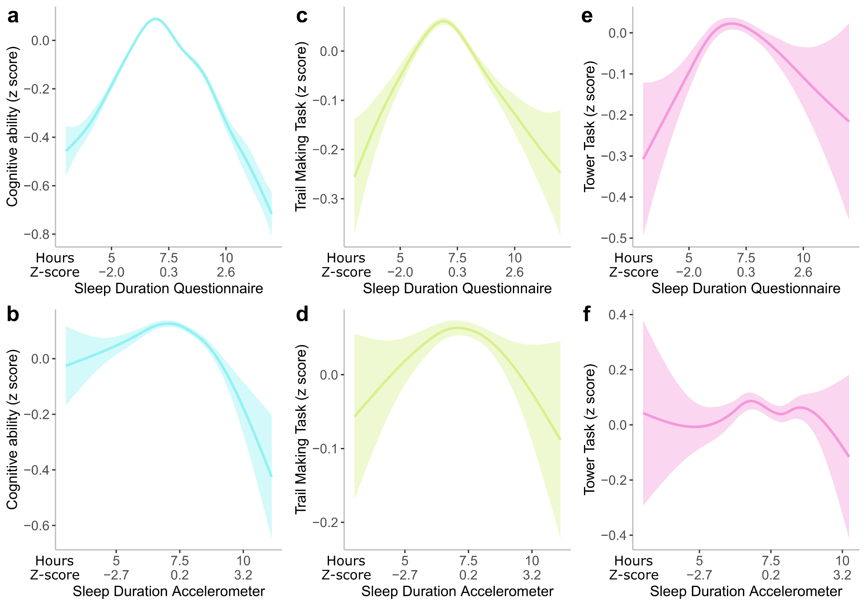

eFigure 1. GAM smooth associations between sleep duration and cognition in the UkBiobank
Plots represent the relationship between cognition (adjusted for age and sex) and sleep duration with a GAM smooth line applied.a) The relationship between general cognition aggregated across visits and self-reported sleep duration. b) The relationship between executive functioning measured by the trail making task administered in clinic and online and self-reported sleep duration. c) The relationship between executive functioning measured by the tower rearranging task administered in clinic and self-reported sleep duration. d) The relationship between general cognition aggregated across visits and accelerometer derived sleep duration. e) The relationship between executive functioning measured by the trail making task administered in clinic and online and accelerometer derived sleep duration. F) The relationship between executive functioning measured by the tower rearranging task administered in clinic and accelerometer derived sleep duration.
Note: Blue=General cognitive ability, Green= Trail making task, Purple=Tower task

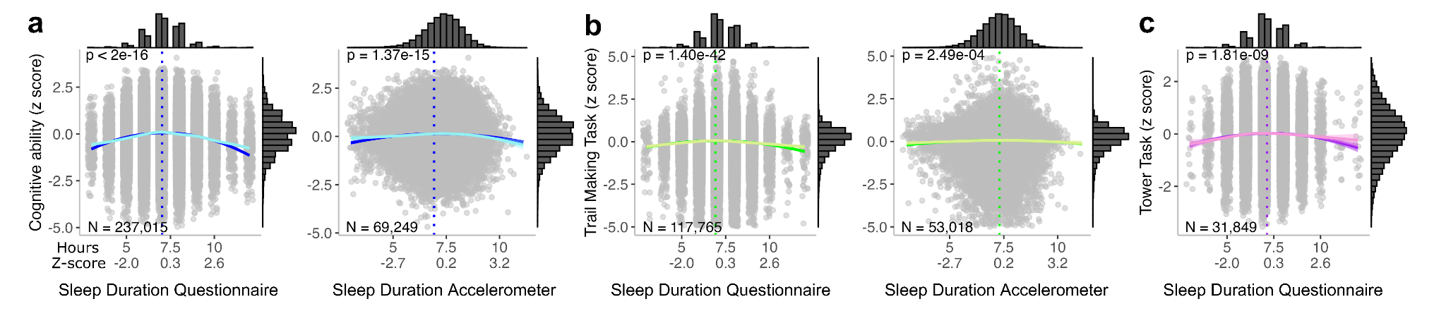

eFigure 2. U-shape/quadratic associations between sleep duration and cognition performance showing data point distributions
Quadratic model predictions associating cognition and sleep duration (dark line). The light line represents the GAM model. The dotted vertical line indicates the vertex of the parabola. a) The relationship between general cognition aggregated across visits and sleep duration (self-reported on the left and accelerometer on the right). b) The relationship between executive functioning measured by the trail making task administered in person and online and self-reported sleep duration (self-reported on the left and accelerometer on the right). c) Relationship between executive functioning measured by the tower rearranging task administered in person and self-reported sleep duration (Note: this relationship was not significant with accelerometer-derived sleep duration).
Note: Blue=General cognitive ability, Green= Trail making task, Purple=Tower task. X-axis : durations are in hours (first line) and z-scored duration (second line). Y-axis : z-scored cognitive ability.

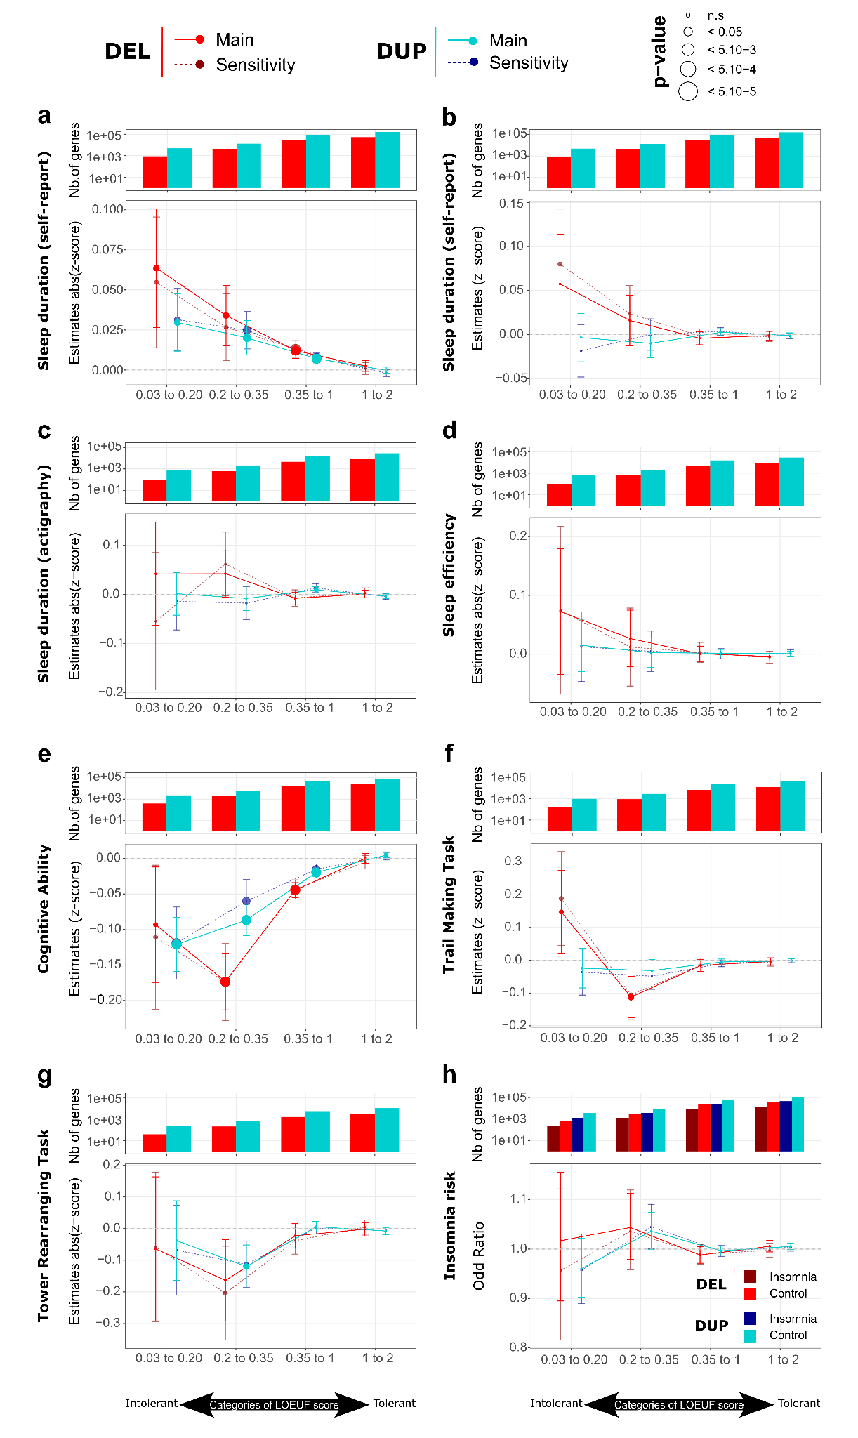

eFigure 3. Associations between haploinsufficiency and sleep and cognition measures stratified by LOEUF score
The effect-size of genes deleted (red) and duplicated (blue) were estimated for a) absolute z-scored measure of self-reported sleep duration, b) z-scored sleep duration of self-reported sleep duration c) absolute z-scored sleep duration measured by actigraphy
d) absolute z-scored sleep efficiency measured by actigraphy e) z-scored measure of general cognition e) z-scored measure of trail making task (TMT) task, e) z-scored measure of the tower rearranging task and f) self-reported insomnia.
Genes (and corresponding estimates) were stratified in four categories of intolerance to LoF variants: highly intolerant genes (LOEUF < 0.2), moderately intolerant genes (0.2 ≤ LOEUF < 0.35), tolerant genes (0.35 ≤ LOEUF < 1) and genes highly tolerant to LoF variants (LOEUF ≥ 1). The histograms represent the number of deleted or duplicated genes in function of their LOEUF score for individuals with the corresponding phenotype. The dots and lines represent the estimates for deleted or duplicated genes in each category of LOEUF score. Solid lines represent the main analyses including the whole sample with the corresponding phenotype. Dashed lines represent sensitivity analyses after removing individuals with medications or with an age over 65 years old. Size of the points represent the range of p-value associated with each estimate. All models were adjusted for age and sex and the first 10 principal components.

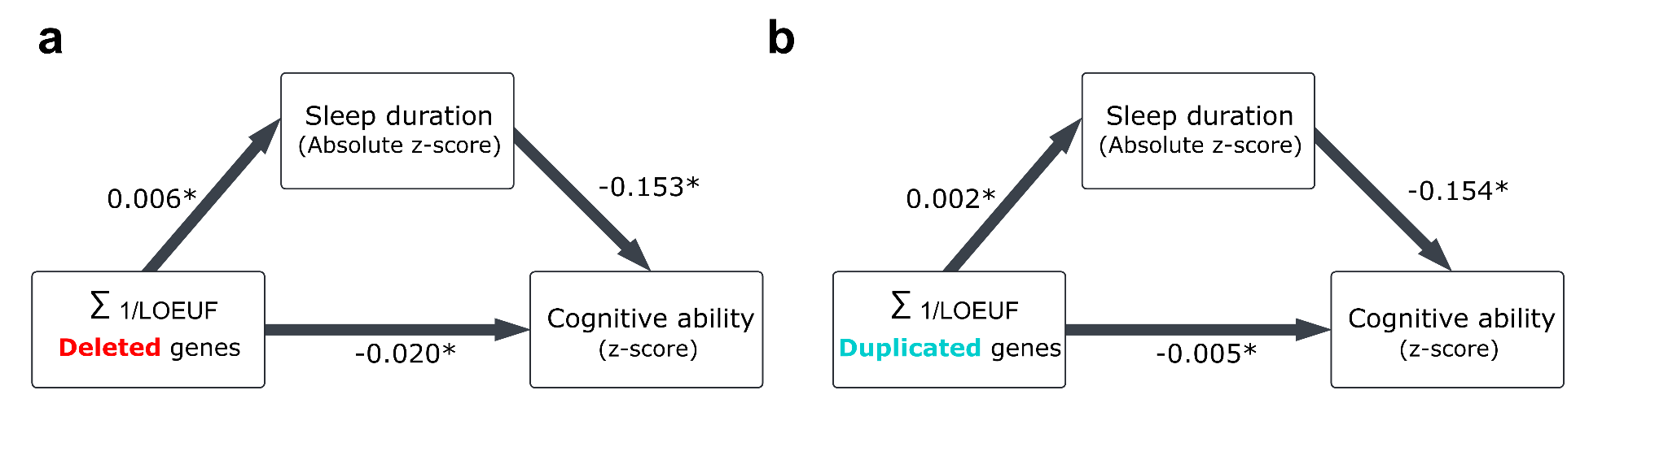

eFigure 4. Mediation analyses between LOEUF, sleep duration and cognitive ability
Figures a and b represent mediation analyses removing individuals taking medication and above 65 years of age.

