Supplementary Information to
Jueterbock et al. -
Roadmap to sustainably develop the European seaweed industry

Supplementary Files

File A.1 – Interview guide
Interview guide:
iSEA – Initiative towards sustainable algae farming in Europe
Aim of the interview guide:
Gain an understanding of
1. What aspects of sustainability in algae farming are in particular crucial?
2. What challenges regarding sustainable algae farming do the producers face?
3. What kind of knowledge and methods do the algae farmers lack, but would need to move towards sustainable algae farming?
4. What are the most relevant innovation and development projects?

Interview guide
Introduction
- Presentation of the project, interview design, and data processing (permission for audio recording).
- Any other questions from the participant.
Interview participant information
- Can you tell us a little about your background?
- Can you describe what function and work tasks you have in your organization/company/ institution?
- How long have you been working on this?
Sustainability in the organization
- What does sustainability mean to you and your organization? Do you think that your organization is sustainable?
- Can you describe the organization's work with sustainability (in different parts of the value chain)?
  - Do you have any concrete examples?
  - In what way must the company follow (public/ state/industry) regulations in the work with sustainability?
- What ambitions do you have to ensure sustainable development in the organization?
  - Does the organization have specific sustainability goals, or what goals?
  - How do you identify specific goals, and how do you work towards these?
  - Do you have systems for registering and reporting goals?
  - Do you have sustainability reports on your company?
Sustainability in the macroalgae industry
- How do you think macroalgae nutrition in Portugal should develop sustainably?
  - What drives the work on sustainability? Social and state requirements?
- Environment - What environmental aspects do you think macroalgae production affects (positively and/or negatively), and to what extent?
  - In which parts of the value chain do the biggest challenges related to the environment arise?
  - How to address these challenges, at what level (company, industry, local, national, global)?
- Society - What social aspects do you think are affected by macroalgae production in a positive and/or negative way, and to what extent? (Effect on the community, environmental education, etc.)
  - In which parts of the value chain do the biggest challenges associated with this arise?
  - How to address these challenges, at what level (company, industry, local, national, global)?
- Economy - What economic aspects do you think macroalgae production affects (positively and/or negatively), and to what extent?
  - In which parts of the value chain do the biggest challenges associated with this arise? (How do these small farms use and collect investment to produce and profit?)
  - How to address these challenges, at what level (company, industry, local, national, global)?
  - Do you think accounting for the ecosystem services provided by macroalgae farming (e.g., carbon sequestration) could be important for the growth of the industry? In which way could these be accountable?
Innovation and development
- What goals do you think are important for development and value creation in this industry?
  - Why are these important?
- What do you consider to be the most important challenges to highlight at the moment, and why?
  - How do you think these challenges can be solved/explored?
- How does your organization work with innovation?
  - Do you have any concrete examples? (Products, processes, sales and marketing, communication)
  - What improvements has your organization been working on lately?
  - What ambitions does the organization have for further development and innovation? And how your organization can work with that?
- In what way is research useful for sustainable development and innovation?
  - In what areas does research contribute? Knowledge development, competitiveness?
  - In what way academic researchers can further help for the sustainable development and innovation of the macroalgae industry?
End
- Do you think that a national aggregation of the algae farms could increase the positive social, environmental, and economic impacts of the industry? And would this help to achieve more sustainable development?
- Summary of the interview – Do you have anything more to add?
- Can you be contacted again if there is a need for a follow-up?
- Do you have any questions at the end?

File A.2
Registration of processing of personal data for interviews in Norway
https://figshare.com/s/cd22978768a991579f57

File A.3
Registration of processing of personal data for interviews in Portugal
https://figshare.com/s/90b6e41135902a1d853d

Supplementary Tables

Table A.1
Code and code categories. Listed are codings in the second column along with the code categories in column 3 and the concepts they belong to in column 1. The fourth column indicates to which files the respective coding has been applied.
https://figshare.com/s/f40b41ccc49619b998ec

Table A.2
Cross-dimensional connections between the WOS codes were supported by >3 independent statements from the workshop or interviews. Intra-dimensional connections, like between code G5 and G6, are only shown if the statements are also connected across the dimensions, G, C, E, or EC. For each connection, the table shows the code numbers (columns A,B) and IDs (columns J,K), the file where the statements (columns H,I) were extracted from, based on the index locations in the text (columns D-G), and the number of statements that connect these codes (column L).
https://figshare.com/s/5b5fd28ec936c78c475d

Table A.3
Strengths, Weaknesses, Opportunities, and Threats. Statements from the Workshop SWOT analysis (column E), that identify Strengths, Weaknesses, Opportunities, and Threats (column AD) of the current state two the future development of a sustainable seaweed industry. Each statement is associated with codes (cid) and categories (catIDs) in the WOS (Wheel of Sustainability) dimensions, the Technology push / Market pull concepts, and the Roadmap categories. The indexes refer to the locations in the respective file (column B) where the statement originates from. Statements that overlap with cross-dimensional connections between the WOS codes that were supported by >3 independent statements from the workshop or interviews, are indicated by value 1 in column AD.
https://figshare.com/s/30609ab4af67df4038ae

Table A.4
Statements that represent the connecting lines in the roadmap plot (Fig. 4). Each statement is associated with codes (cid) and categories (catIDs) in the WOS (Wheel of Sustainability) dimensions, the Technology push / Market pull concepts, and the Roadmap categories. The indexes refer to the locations in the respective file (column C) where the statement originates from. All statements represent such that were coded in at least two of the WOS dimensions and this connection was supported by >3 independent statements from the workshop or interviews.
https://figshare.com/s/fff5bedc031e3a7d629c

Supplementary Figures
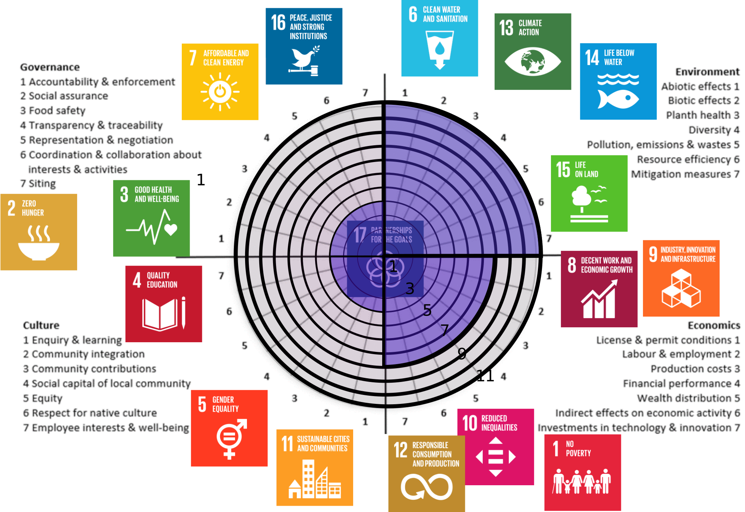

Fig. A.1
Representation of the four categories of the Wheel of Sustainability (Environment, Economics, Culture, Governance) in the expertise of workshop participants. Numbers from the innermost circle (1) to the outermost circle (11) represent the number of participants that had assigned themselves to the respective category. Assignments to more than one category are all fully counted. Thus, the total number of representatives here exceeds the number of workshop participants. Subcategories, represented by numbers around the circle (1-7) for each of the four dimensions, are not discriminated. Figure adapted from Godal (2020).

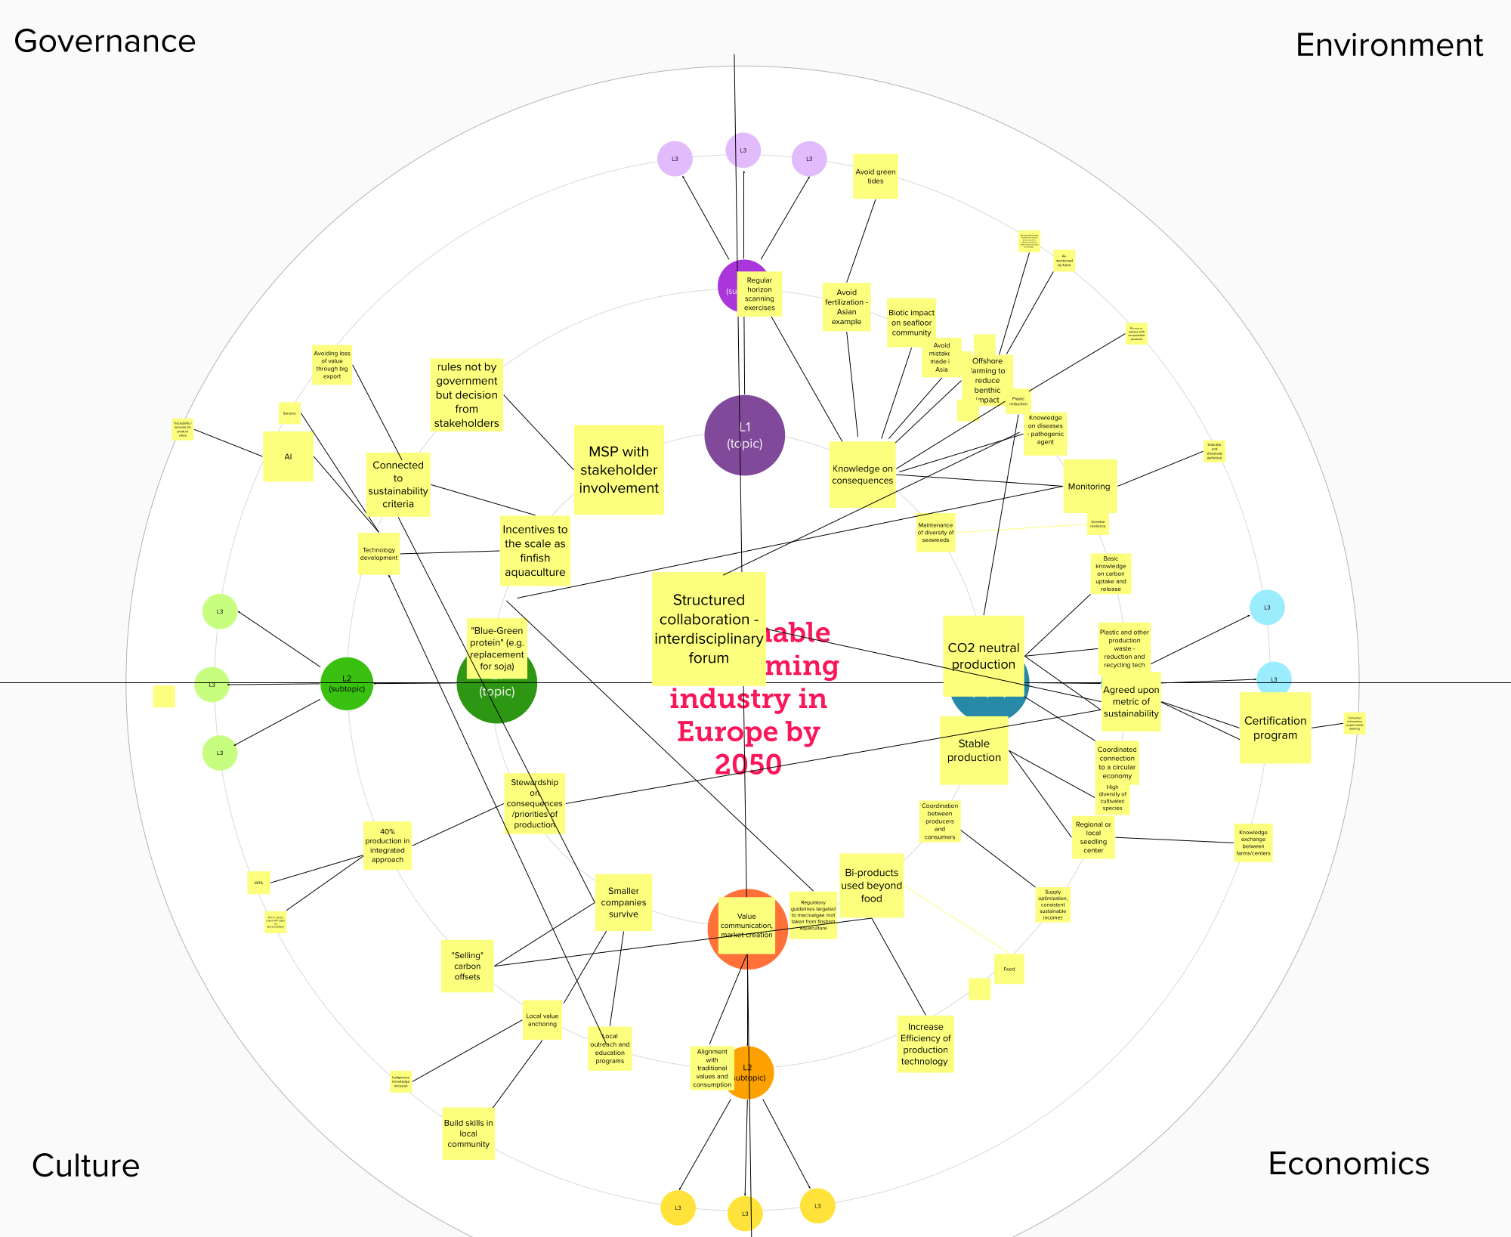
Fig. A.2
Futures Wheel focusing on the vision of a sustainable seaweed farming industry by 2050 with four sustainability dimensions: Environment, Economics, Culture, Governance.
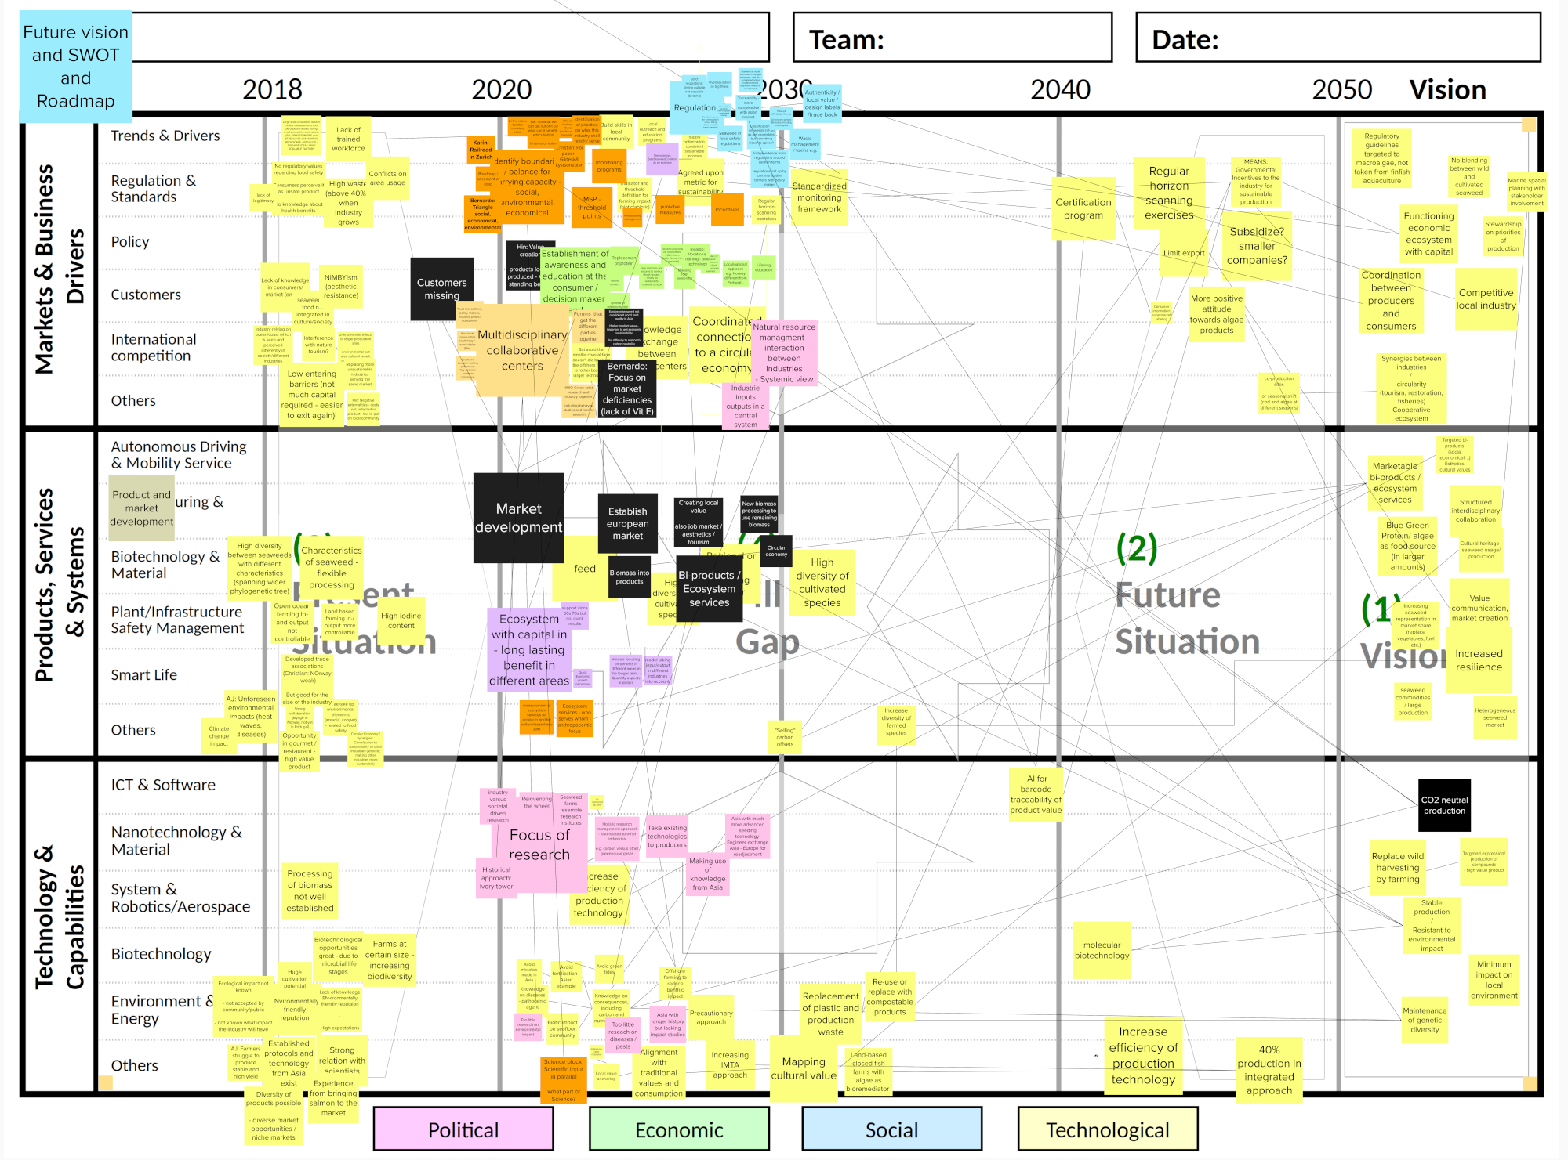

Fig. A.3
Compilation of roadmap ideas into seven topics along the four-arrow back-casting model of Okada et al. (2022).
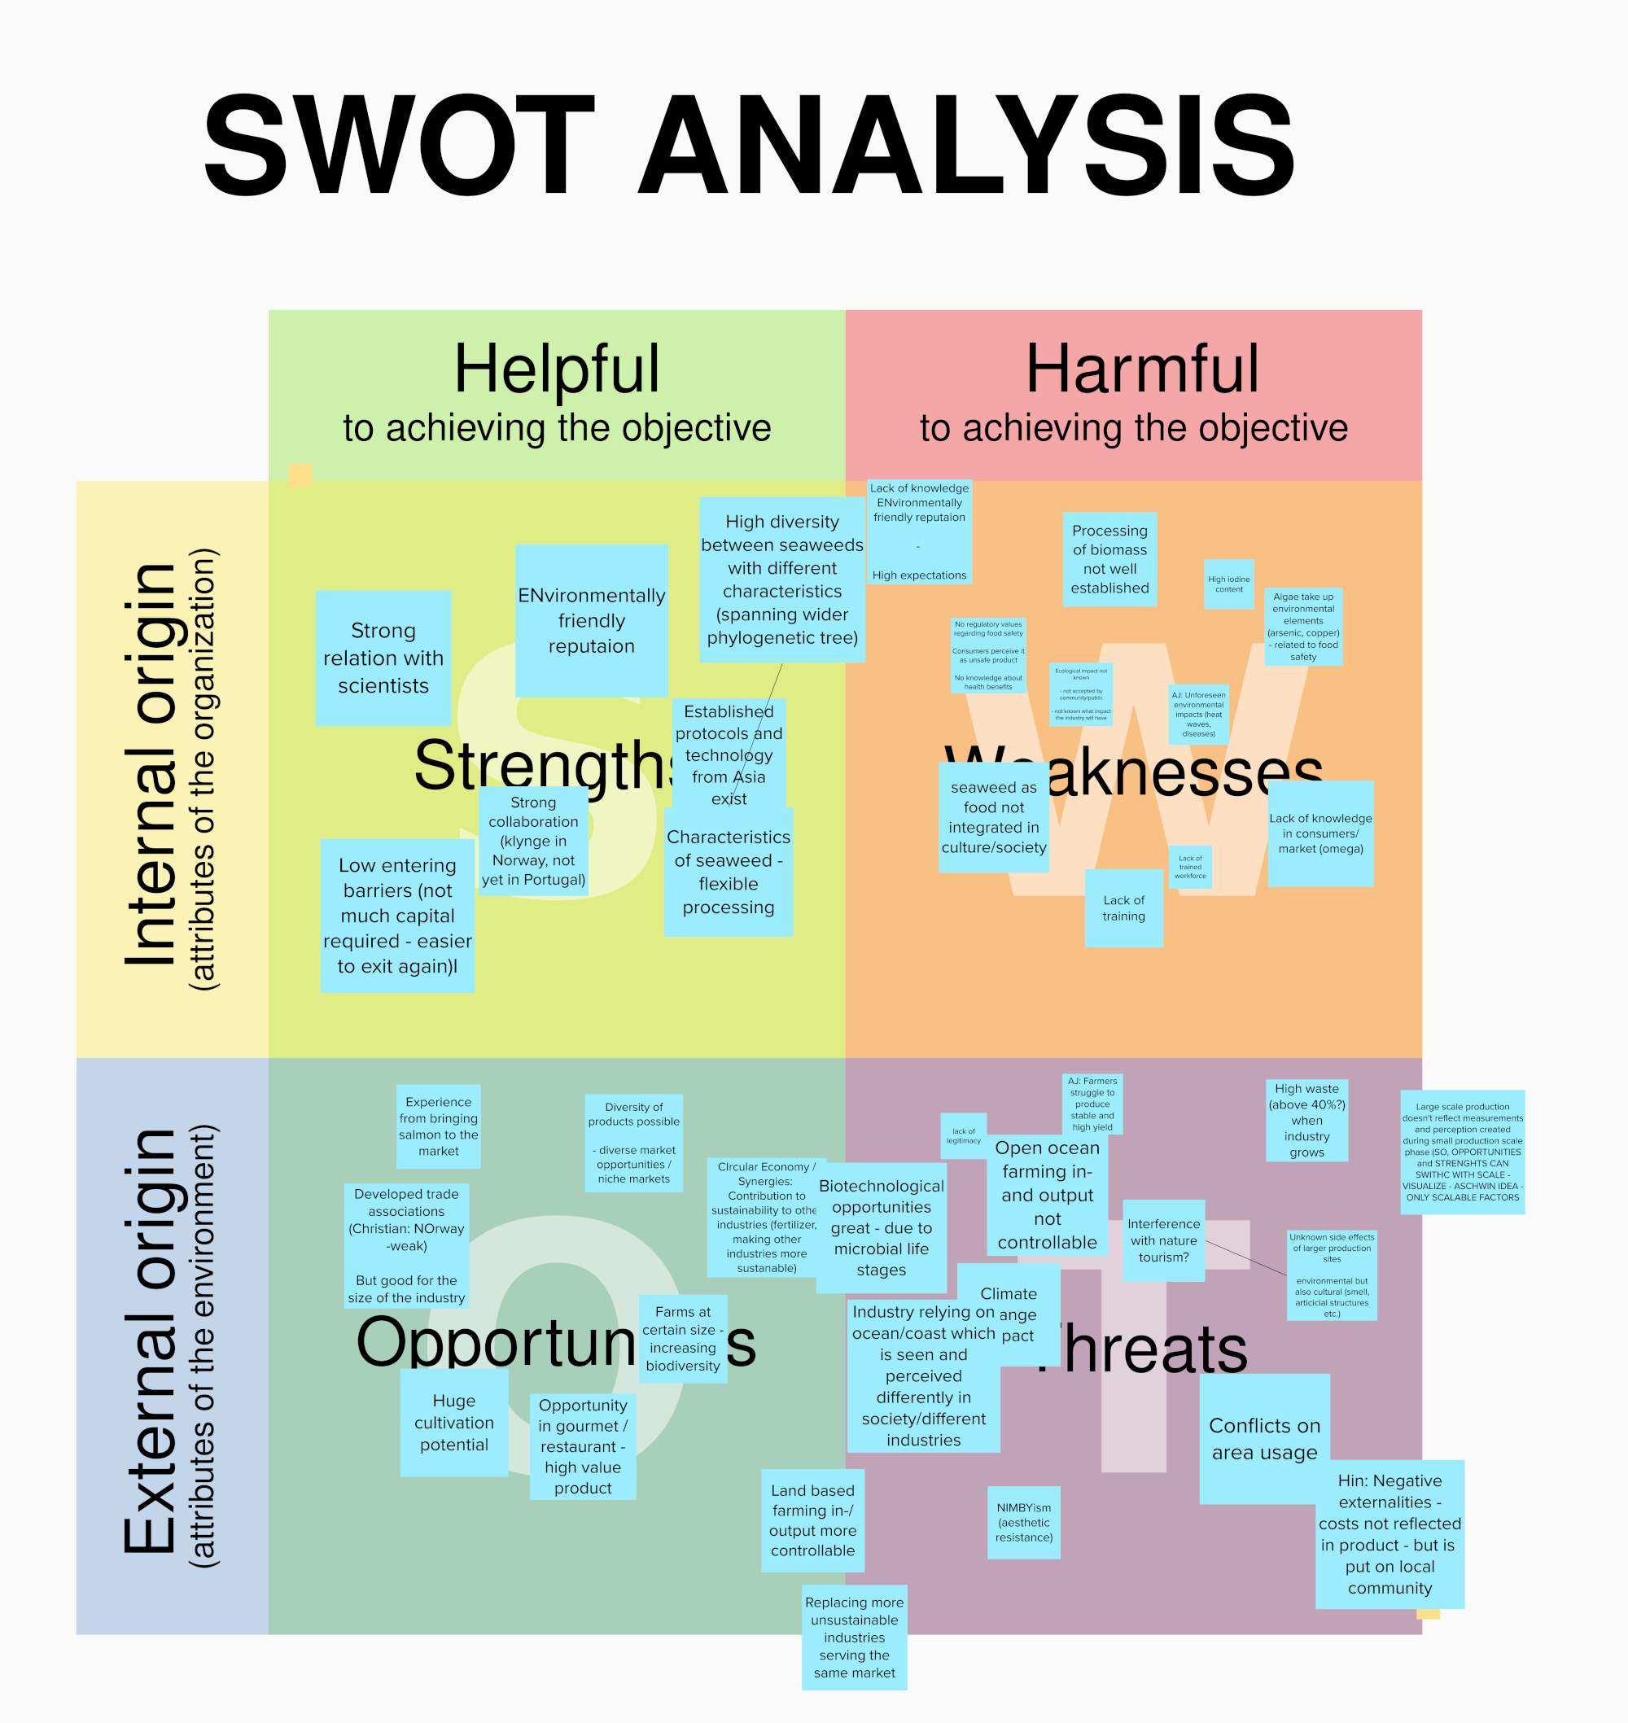

Fig. A.4
Strengths, Weaknesses, Opportunities, and Threats of the sustainable development of the European seaweed industry. The points listed represent a summary of all workshop participants. Figure adapted from https://commons.wikimedia.org/wiki/File:SWOT_en.svg.

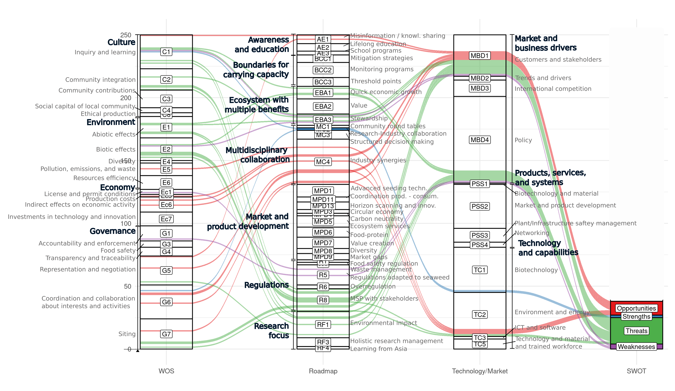

Fig. A.5
SWOT results. Strengths, weaknesses, opportunities, and threats for the sustainable development of the seaweed industry in Europe are linked to specific codings in the dimensions of the Wheel of sustainability (WOS), the Technology push / Market pull concept, and the Roadmap we built during our workshop.
Godal, M.S., 2020. Operationalisation of sustainability of the Norwegian macroalgae aquaculture industry.
Okada, Y., Kishita, Y., Nomaguchi, Y., Yano, T., Ohtomi, K., 2022. Backcasting-Based Method for Designing Roadmaps to Achieve a Sustainable Future. IEEE Transactions on Engineering Management 69, 168–178. https://doi.org/10.1109/TEM.2020.3008444

