Supplementary Information for
Single-cell imaging reveals efficient nutrient uptake and growth of microalgae that darken the Greenland Ice Sheet

Content:
Supplementary Figures 1-6
Supplementary Notes 1-2
Supplementary Tables 1-3
Supplementary References

Supplementary Figures
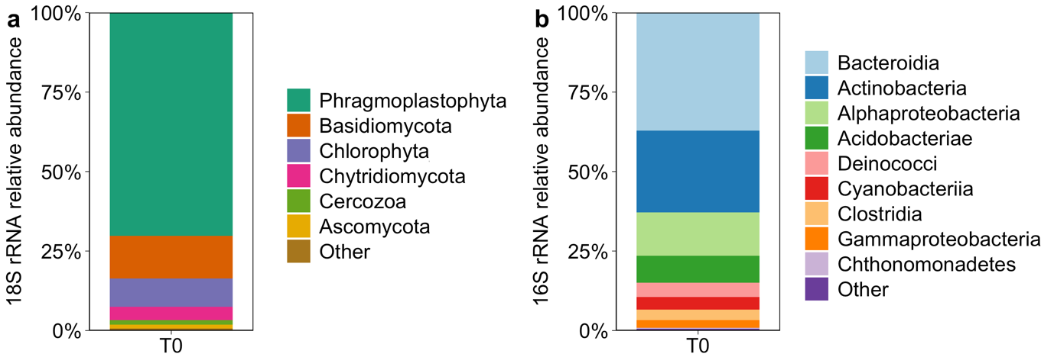
Supplementary Figure 1. Supraglacial community composition (T0) based on rRNA gene amplicon sequencing. (a) Eukaryotic community composition at the phylum level based on 18S rRNA gene relative abundance. Note that the phylum Phragmoplastophyta was comprised solely of Mesotaeniaceae, to which glacier ice algae belong. (b) Bacterial community composition at the class level based on 16S rRNA gene relative abundance.

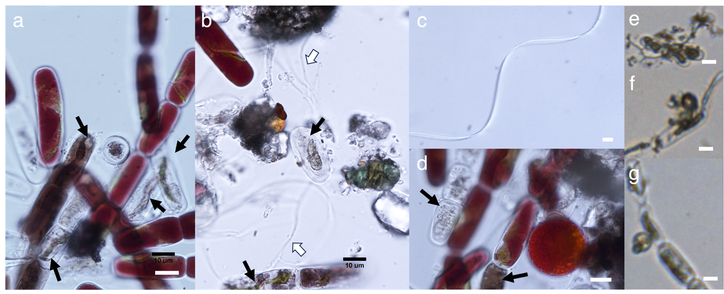
Supplementary Figure 2. (a-d) Microscopic pictures of the incubated glacial community from the start of the experiment (T0). (a, b, d) Microscope pictures of unfixed sample show phenotypic heterogeneity of Ancylonema nordenskiöldii. Black arrows point to assumingly dead cells (where the pigmentation was fully lost) or cells showing signs of degradation or infection. White arrows point to fungal hyphae. (c) Putative cyanobacteria. (e-g) FlowCam microscope pictures of fixed sample, showing examples for signs of infections in A. nordenskiöldii cells by chytrid fungi. Scale bar shows 10 µm.
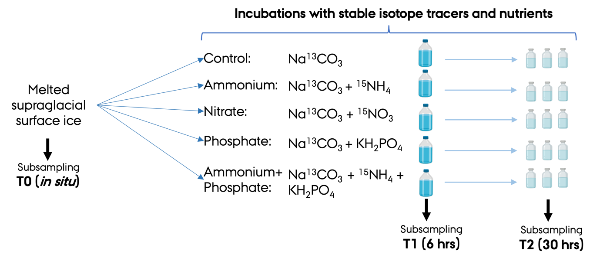
Supplementary Figure 3. Overview of samples used in this study: unmanipulated melted surface ice was subsampled, representing the “in situ” conditions and the T0 time point of the incubation experiment. Stable isotope tracers and nutrients were added to this melted glacier ice and incubated. The incubations were subsampled at T1 (after 6 hrs) from the blue cap bottles (1 only) and at T2 (after 30 hrs) from serum bottles (3 replicates each). Created with BioRender.com.

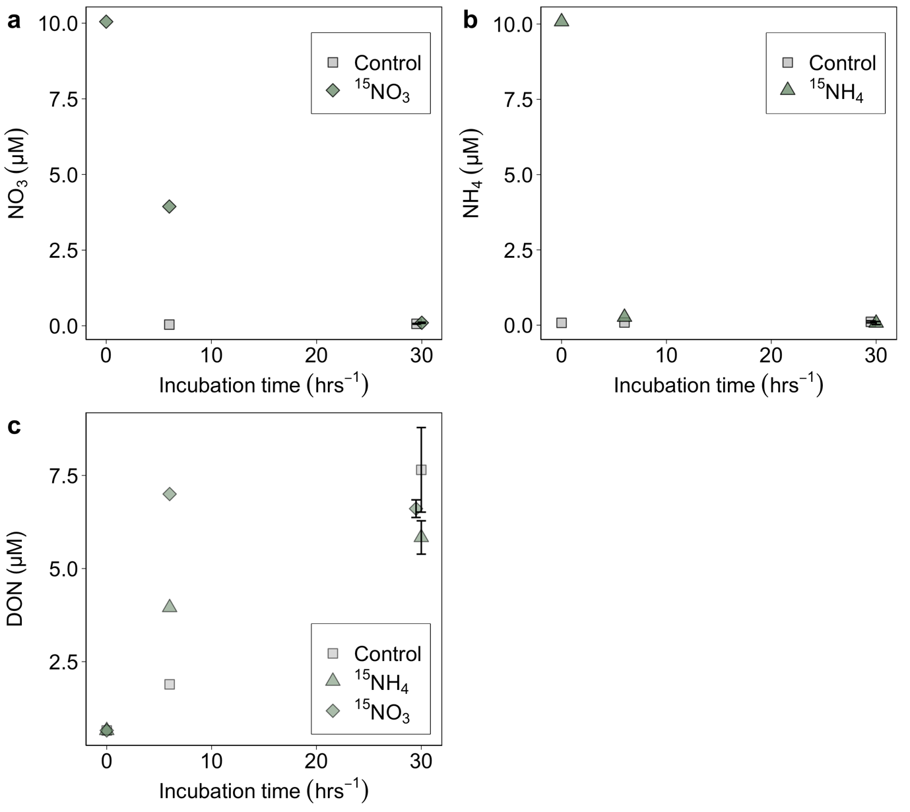
Supplementary Figure 4. Changes in NO₃, NH₄ and dissolved organic nitrogen (DON) concentrations during incubation (T0, T1: 6 hrs and T2: 30 hrs). (a) NO₃⁻ in the ¹⁵N-NO₃⁻ amended treatment and the control. (b) NH₄ in the ¹⁵N-NH₄ amended treatment and the control. (c) DON concentrations in the control and ¹⁵N-NH₄ and ¹⁵N-NO₃ treatments. Error bars represent the range of the standard error at T2 (n=3).

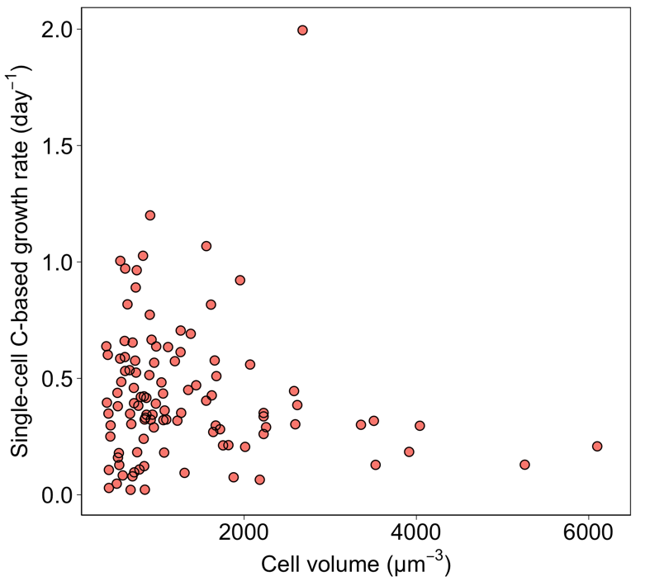
Supplementary Figure 5. Correlation between the cell specific C-based growth rates from the HR-SIMS measurements and cell volume of glacier ice algae from the Control, and NO₃⁻ and NH₄⁺ treatments (n=125).

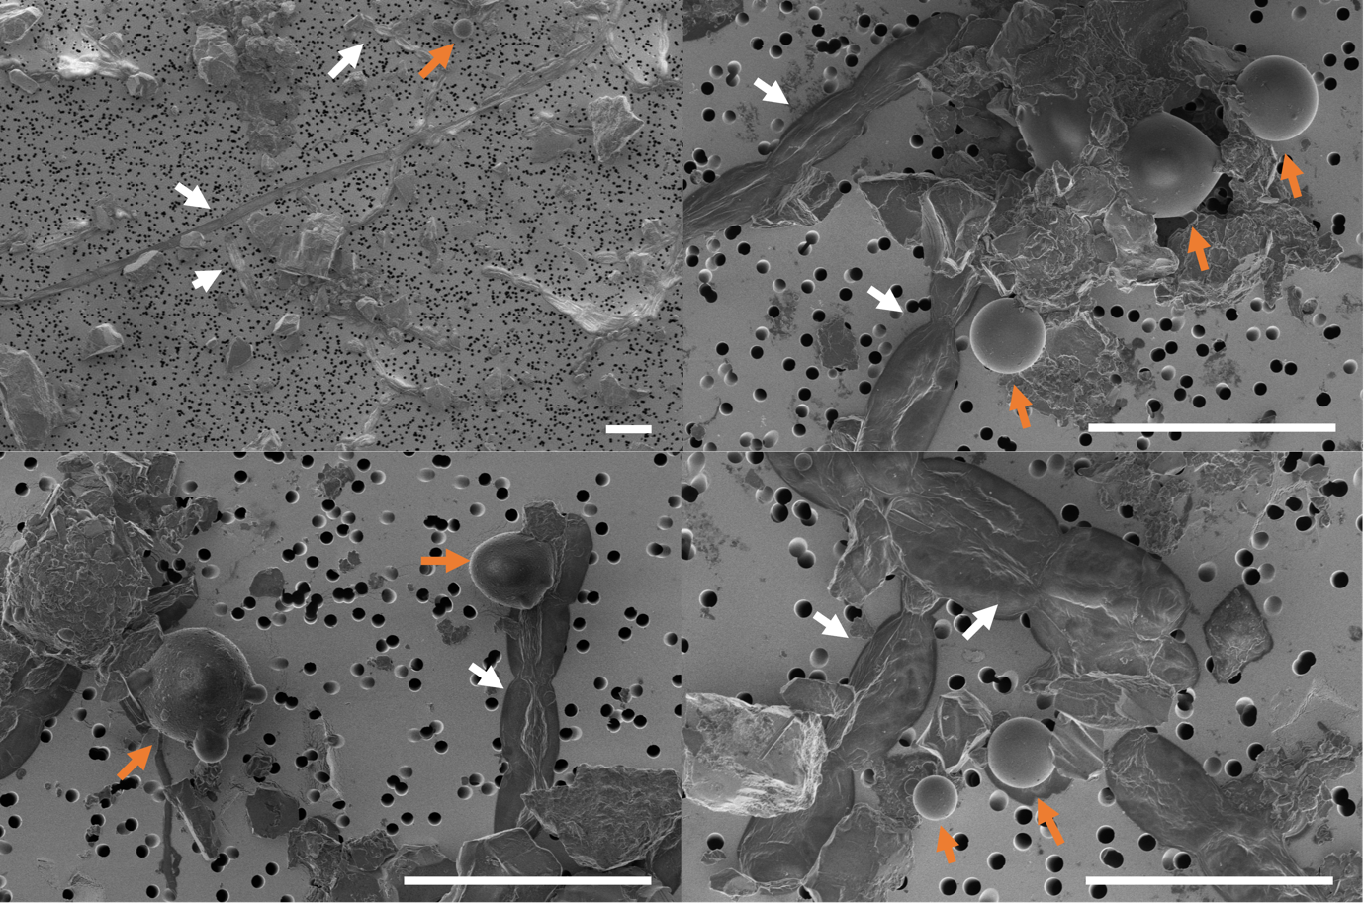
Supplementary Figure 6. SEM-images of the bulk POM after the incubations, fixed and dried on 3 µm pore size filters. Images show glacier ice algae (white arrows) along with other organisms, likely mainly snow algal cysts (orange arrows), inorganic particles and organic matter. Scale bars are 50 µm.

Supplementary Notes
Supplementary Note 1: ¹³C-DIC labelling percentage
We determined the DIC concentrations of ¹³C-DIC and ¹²C-DIC in the melted glacier ice of T1 and T2 of the incubation experiment using GC-IRMS. In the control treatment, the total DIC (¹²C-DIC+¹³C-DIC) concentration measured at T1 was 283 µM. The ¹³C-DIC concentration was 8 µM, thus implying that the DIC concentration of the melted glacier ice used for the experiment was 275 µM. This DIC concentration is much higher than the 15 µM previously measured in melted surface ice in Yallop et al.[¹] or 44-70 µM in supraglacial streams in Andrews et al.[²]. This could be due to, to net heterotrophic activity and/or photooxidation. Carbonates were not present in the sample. Simple PHREEQ[³] modelling shows the pH, the partial pressure of dissolved CO₂ and the conductivity of the solution (Supplementary Table 6).

Supplementary Note 2: Uncertainty propagation
The uncertainties (σ) of the relative contribution of glacier ice algae to the bulk C and N uptake (Supplementary Tables 2 and 3) were determined by propagating the individual standard deviations associated with cell abundance (N _{cell}), single-cell assimilation rates (assimilation_{cell}) and bulk rates (assimilation_{bulk}) for the timepoints T1 and T2, respectively.
-σ_{N cell}; determined by the standard deviation of duplicate cell counts at T0 (n=2); or the standard deviation of the corrected algal abundance based on the biomass variation between the individual bottles (n=3 at T2, see description below)
-σ_{assimilation cell}; determined by the standard deviation of the single-cell measurements for the specific timepoint (for DIC at T1: n=11 and at T2: n=37; for NH₄⁺ at T1: n=19 and at T2: n=26)
-σ_{assimilation bulk}; determined by the standard deviation of the bulk C or N uptake measurements for each individual timepoint (T1: n=1; T2: n=3)

Based on equation 4 in the main manuscript, the uncertainties in the relative contribution of glacier ice algae (σ_{Contr cell}) to bulk C and N uptake were calculated following the laws of error propagation for the different timepoints as follows:
$$σ_{Contr cell}={\overline{Contr cell}×\sqrt{ {\left(\frac{∂_{N cell}}{\overline{N cell}}\right)}^{2}+ {\left(\frac{∂_{assimilation cell}}{\overline{assimilation cell}}\right)}^{2}+ {\left(\frac{∂_{assimilation bulk}}{\overline{assimilation bulk}}\right)}^{2}} }^{}$$

Additionally, to account for potential differences in algal abundance between bottles and timepoints, we calculated the contribution by the glacier ice algal population to bulk C and N uptake by correcting the algal abundance based on the fractional change in measured POC concentrations between T0 and T1, as well as between T0 and T2 (Supplementary Table 4).
Variable biomass distributions between the bottles could be a consequence of (i) the rapid sinking out of paticles and/or (ii) heterogenous biomass distribution on the filter used for the bulk measurements – even despite carefully and thoroughly homogenising the melted glacier ice during the set-up of the experiment and prior to samplings. Using the corrected potential change in glacier ice algal abundance, we found that the estimated contribution of glacier ice algae to the bulk C and N uptake remained low (7-12% for C from DIC and 3-4% for N from NH₄⁺; Supplementary Table 2 and 3).

Supplementary Tables
Supplementary Table 1. Overview of HR-SIMS-based measurements of single glacier ice algal cells. Estimates are presented as means with standard deviations.
Treatments | Sampling time | Incubation time | n | C-based growth |  |  | N-based growth |  |  | C-assimilation |  |  | N-assimilation
 |  | hrs | (number of cells) | (day⁻¹) |  |  | (day⁻¹) |  |  | (pmol C cell⁻¹ day⁻¹) |  |  | (fmol N cell⁻¹ day⁻¹)
Active population
Control | T1 | 6 | 11 | 0.66 | ± | 0.37 |  |  |  | 9.72 | ± | 5.45
Control | T2 | 30 | 37 | 0.47 | ± | 0.24 |  |  |  | 4.64 | ± | 3.46
NH₄⁺ | T1 | 6 | 19 | 0.19 | ± | 0.11 | 0.18 | ± | 0.05 | 4.31 | ± | 4.20 | 183 | ± | 137
NH₄⁺ | T2 | 30 | 26 | 0.40 | ± | 0.37 | 0.07 | ± | 0.03 | 4.27 | ± | 6.97 | 37.7 | ± | 23.2
NH₄⁺+PO₄³⁻ | T2 | 30 | 39 | 0.23 | ± | 0.16 | 0.07 | ± | 0.02 | 4.86 | ± | 2.93 | 86.3 | ± | 23.9
NO₃⁻ | T2 | 30 | 32 | 0.41 | ± | 0.24 | 0.07 | ± | 0.03 | 5.31 | ± | 4.31 | 63.5 | ± | 64.1
PO₄³⁻ | T2 | 30 | 56 | 0.20 | ± | 0.11 |  |  |  | 4.38 | ± | 2.25
Whole population (including nonactive cells)
Control | T1 | 6 | 15 | 0.48 | ± | 0.44 |  |  |  | 7.06 | ± | 6.49
Control | T2 | 30 | 45 | 0.38 | ± | 0.28 |  |  |  | 3.81 | ± | 3.61
NH₄⁺ | T1 | 6 | 20 | 0.18 | ± | 0.11 | 0.17 | ± | 0.06 | 4.09 | ± | 4.20 | 177 | ± | 136
NH₄⁺ | T2 | 30 | 28 | 0.37 | ± | 0.37 | 0.07 | ± | 0.03 | 3.97 | ± | 6.80 | 35.1 | ± | 24.2
NH₄⁺+PO₄³⁻ | T2 | 30 | 41 | 0.22 | ± | 0.16 | 0.07 | ± | 0.02 | 4.63 | ± | 3.04 | 82.4 | ± | 29.1
NO₃⁻ | T2 | 30 | 39 | 0.33 | ± | 0.27 | 0.06 | ± | 0.04 | 4.36 | ± | 4.40 | 52.5 | ± | 62.6
PO₄³⁻ | T2 | 30 | 56 | 0.20 | ± | 0.11 |  |  |  | 4.38 | ± | 2.25

Supplementary Table 2. Relative contribution by glacier ice algal DIC assimilation to POM-based C uptake (from ¹³C-DIC). Values are also presented in Table 2 in the main manuscript and are given as means ± standard deviation. Single-cell rates correspond to the rates of the active algal population fraction. The algal abundance at T0 was corrected for number of active cells within the population; i.e. 90% of the total cells, 1.46x10⁷ ± 0.11 cells L⁻¹). Bulk and single-cell rates are derived from the same replicate bottle for T1; for T2, single cell rates are derived from one replicate bottle, bulk rates from triplicate bottles. See Supplementary Note 2 for further details.
Parameter | GA abundance active |  | Single cell DIC assimilation GA | Total GA C assimilation (from ¹³C-DIC) | Bulk C uptake (from ¹³C-DIC) | Est. contribution of GA to bulk C uptake
Unit | (cells L⁻¹) |  | (pmol C cell⁻¹ day⁻¹) | (µg C L⁻¹ day⁻¹) | (µg C L⁻¹ day⁻¹) | (%)
T1 | T0 cell abundance | 1.46± 0.1x10⁷ | 9.7±5.5 _{T1} | 1700±970 _{T1} | 22540 _{T1} | 8±4 for T1
 | Est. T1 abundance* | 2.37±0.18x10⁷ | 9.7±5.5 _{T1} | 2770±1570 | 22540 _{T1} | 12±7 for T1
T2 | T0 cell abundance | 1.46± 0.11x10⁷ | 4.6±3.5 _{T2} | 820±610 _{T2} | 5380±1210 _{T2} | 15±12 for T2
 | Est. T2 abundance* | 0.68±0.19x10⁷ | 4.6±3.5 _{T2} | 380±310 _{T2} | 5380±1210 _{T2} | 7±6 for T2
*based on the fractional change in POC concentrations between T0 and T1, as well as, T0 and T2.

Supplementary Table 3. Relative contribution by glacier ice algal (GA) NH₄⁺ assimilation to POM-based N uptake (from ¹⁵N-NH₄⁺). Values are also presented in Table 2 in the main manuscript and are given as means ± standard deviation. Single-cell rates correspond to the rates of the active/alive algal population fraction. The algal abundance at T0 was corrected for number of active cells within the population; i.e. 90% of the total cells, 1.46x10⁷ ± 0.11 cells L⁻¹). Bulk and single-cell rates are derived from the same replicate bottle for T1; For T2, single cell rates are derived from one replicate bottle, bulk rates from triplicate bottles. See Supplementary Note 2 for further details.
Parameter | GA abundance active |  | Single cell NH₄⁺ assimilation GA | Total GA NH₄⁺ assimilation | Bulk N uptake (from ¹⁵N-NH₄⁺) | Est. contribution of GA to bulk N uptake
Parameter |  |  | Single cell NH₄⁺ assimilation GA | (from ¹⁵N-NH₄⁺) | Bulk N uptake (from ¹⁵N-NH₄⁺) | Est. contribution of GA to bulk N uptake
Unit | (cells L⁻¹) |  | (fmol N cell⁻¹ day⁻¹) | (µg N L⁻¹ day⁻¹) | (µg N L⁻¹ day⁻¹) | (%)
T1 | T0 cell abundance | 1.46± 0.11x10⁷ | 183±137 _{T1} | 37±28 _{T1} | 450 _{T1} | 8±6 for T1
 | Est. T1 abundance* | 0.76±0.06x10⁷ | 183±137 _{T1} | 19±15 _{T1} | 450 _{T1} | 4±3 for T1
T2 | T0 cell counts | 1.46± 0.11x10⁷ | 38±23 _{T2} | 7.7±4.8 _{T2} | 127±14 _{T2} | 6±4 for T2
 | Est. T2 abundance* | 0.84±0.06x10⁷ | 38±23 _{T2} | 4±2.7 _{T2} | 127±14 _{T2} | 3±2 for T2
*based on the fractional change in POC concentration between T0 and T1, as well as, T0 and T2.

Supplementary Table 4. Variation in POC concentrations in the Control and ¹⁵N-NH₄⁺ treatments between the timepoints, used to estimate the algal abundance (Supplementary Note 2).
 | POC in Control |  | POC in ¹⁵N-NH₄⁺ treatment
 | (µmol C mL⁻¹) |  | (µmol C mL⁻¹)
T0 | 2.9 |  | 2.9
T1 | 4.6 | 0.5±0.1x of T0 POC | 1.5 | 0.5 x of T0 POC
T2 | 1.3±0.38 | 0.5x of T0 POC | 1.5±0.11 | 0.6±0.04 x of T0 POC

Supplementary Table 5. Elemental composition of glacier ice algal cells given in atom% and mass%, derived by SEM-EDS.
 | C | O | N | Na | S | Si | P | Al | Mg | K | Ca | Cl
mean (atom%) | 78.8 | 14.4 | 4.2 | 1.2 | 1.0 | 0.3 | 0.2 | 0.1 | <0.05 | <0.05 | <0.05 | <0.05
SD | 1.4 | 1.3 | 0.6 | 0.4 | 0.2 | 0.2 | 0.0 | 0.1
mean (mass%) | 71.5 | 17.3 | 4.4 | 2.0 | 2.4 | 0.5 | 0.4 | 0.1 | <0.05 | 0.1 | 0.1 | <0.05
SD | 6.1 | 1.9 | 0.8 | 0.6 | 0.5 | 0.4 | 0.1 | 0.1 |  | <0.05 | 0.1
n | 48 | 48 | 48 | 48 | 48 | 48 | 48 | 48 | 48 | 48 | 48 | 48

Supplementary Table 6. Chemical parameters to characterise the melted glacier ice prior to the start of the incubation experiments (T0) and after 6 hrs of the incubation experiment (T1). * denotes calculated parameters.
Parameter | Value | Unit | Sampling time
DIC | 275 | µM | T1
pH | 5.18-5.62 |  | T0
Conductivity | 4.6 | µS/cm | T0
log₁₀ p(CO₂)* | -2.47 | atms | calculated

Supplementary References
1. Yallop, M. L. et al. Photophysiology and albedo-changing potential of the ice algal community on the surface of the Greenland ice sheet. ISME J 6, 2302–2313 (2012).
2. Andrews, M. G., Jacobson, A. D., Osburn, M. R. & Flynn, T. M. Dissolved Carbon Dynamics in Meltwaters From the Russell Glacier, Greenland Ice Sheet. J Geophys Res Biogeosci 123, 2922–2940 (2018).
3. Parkhurst, D. L. & Appelo, C. A. J. Description of input and examples for PHREEQC version 3 - A computer program for speciation, batch-reaction, one-dimensional transport, and inverse geochemical calculations. in U.S. Geological Survey Techniques and Methods, book 6, 497 (2013).

