Extended Data
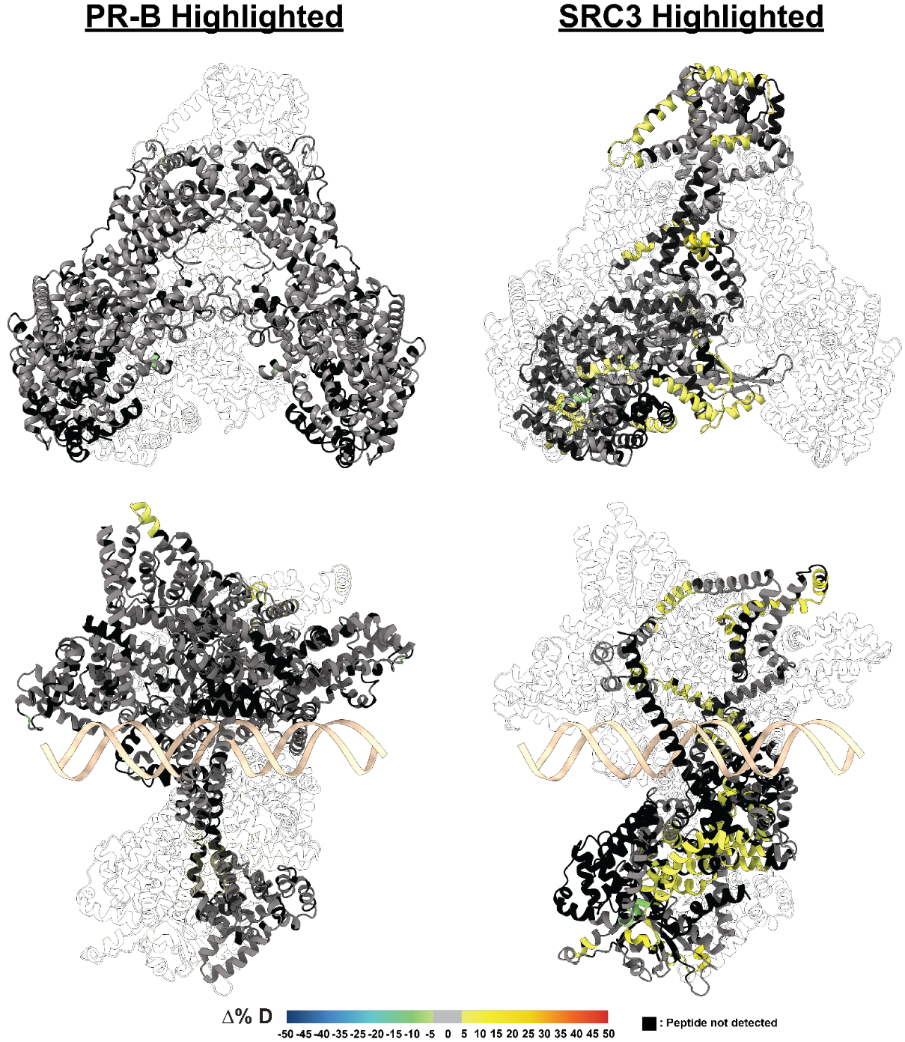
Extended Data Fig. 1 HDX overlays on best HDXer models of PR-B:SRC3 complexes. HDX-MS overlays on best selected model of PR-B:SRC3 complex in both non-DNA-bound (top) and DNA-bound (bottom) states. Warmer colors (yellow, orange, red), indicate increased deuterium exchange, and cooler colors (green, blue) indicate decreased deuterium exchange. Black indicates the peptide was not found by HDX and gray indicates exchange within ±5%. Models selected by HDXer RMSE values, and visualizations made using ChimeraX 1.8.

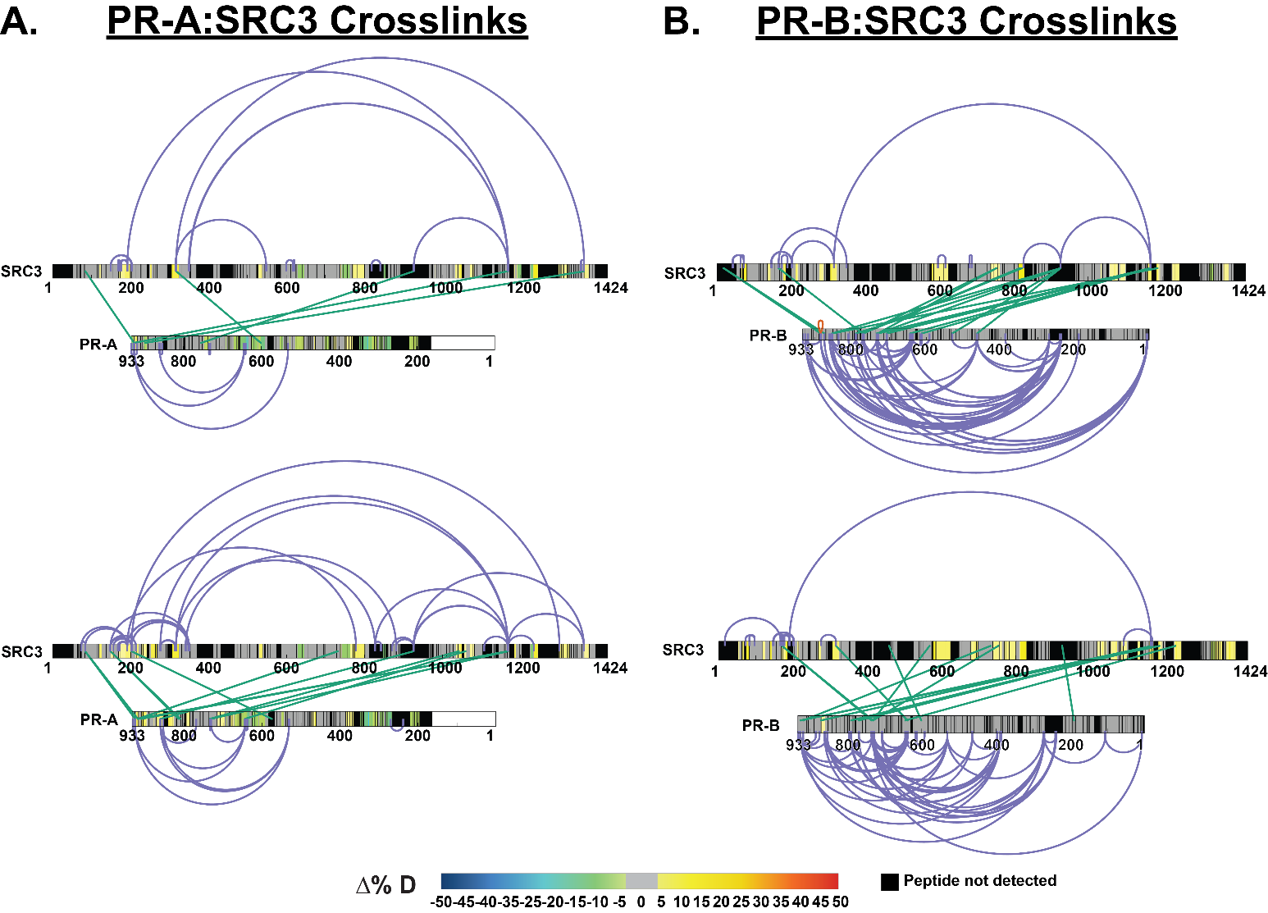
Extended Data Fig. 2 PR and SRC3 deuterium exchange differences align with crosslinking results. A. XiView images of differential XL-MS data for PR-A vs. PR-A:SRC3 experiments with crosslinks enriched in apo samples (top) and pre-bound samples (bottom) represented. HDX overlays are indicative of their comparable differential HDX-MS experiments. Top: SRC3 exchange - SRC3 vs. PR-A:SRC3 (non-DNA bound), PR exchange – PR-A vs. PR-A:SRC3. Bottom: SRC3 exchange – SRC3 vs. PR-A:SRC3:PRE, PR exchange – PR-A:SRC3 vs. PR-A:SRC3:PRE. B. XiView images of differential XL-MS data for PR-B vs. PR-B:SRC3 experiments with the same HDX overlays as shown in A. Intraprotein crosslinks are represented in purple, interprotein crosslinks are represented as green. Differential HDX-MS scale shows the % change in deuterium incorporation, where cooler colors represent reduced deuterium exchange, while warmer colors (yellow, orange, red) represent increased deuterium exchange. Black represents peptides not detected in HDX-MS experiments, and PR isoforms have numbering normalized to the B isoform.

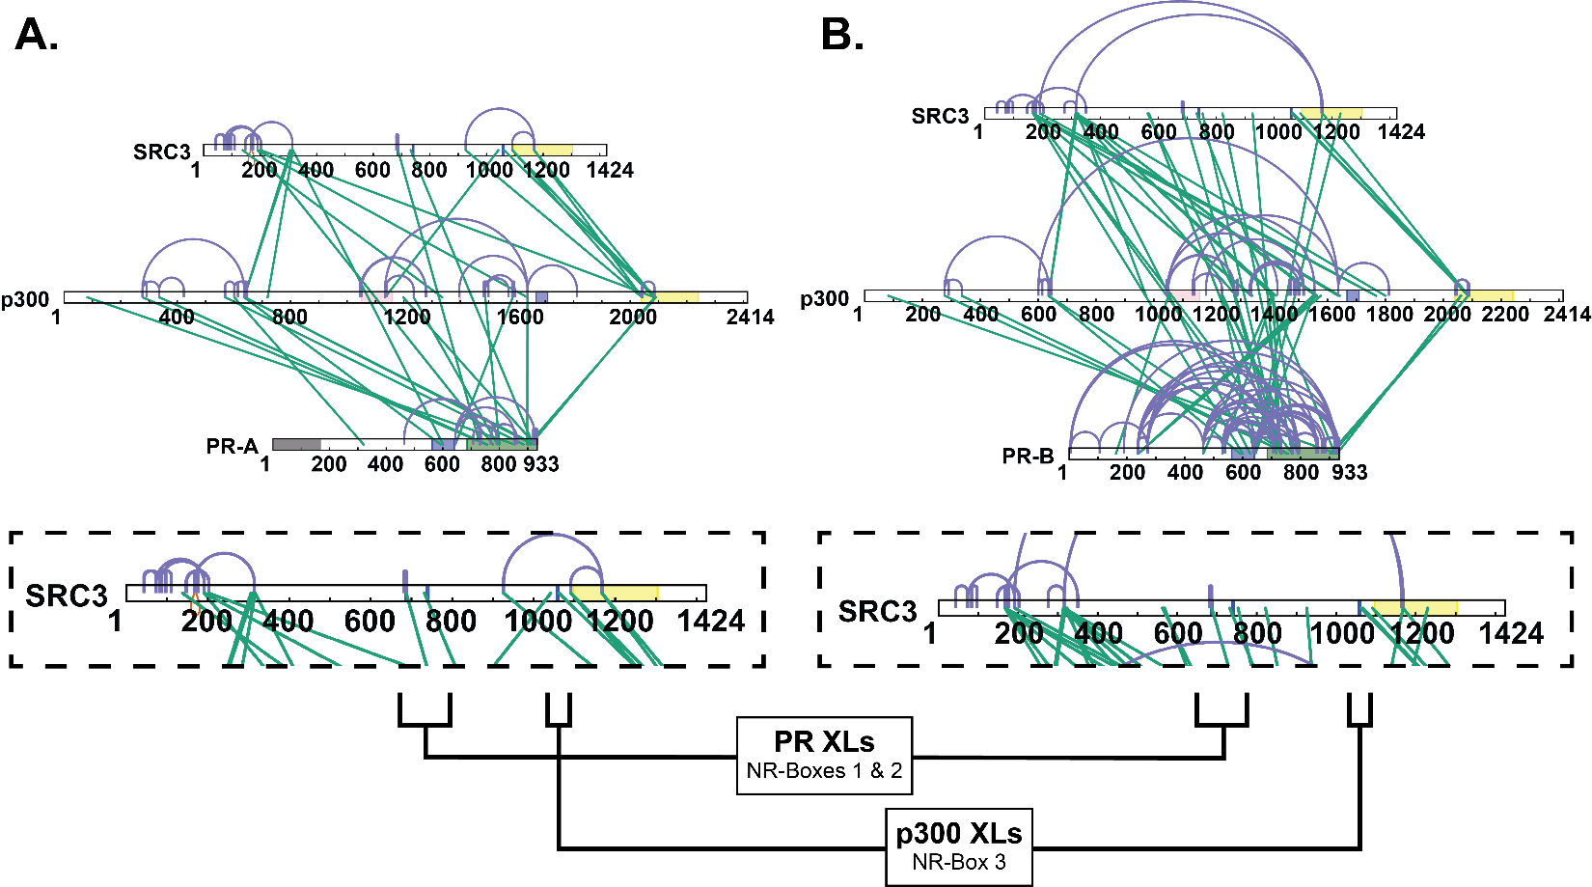

Extended Data Fig. 3 Crosslinking shows NR-Box 3 is exclusively used by p300. A. Top: All validated crosslinks from differential PR-A:SRC3:p300±PRE experiments. Bottom: Zoomed in view of SRC3 to show NR-Box crosslinks specific to the PR-A-containing complex. B. Top: All validated crosslinks from differential PR-B:SRC3:p300±PRE experiments. Bottom: Zoomed in view of SRC3 to show NR-Box crosslinks specific to the PR-B-containing complex. Defined domains are as follows: PR - DBD (purple) and LBD (green); SRC3 – NR-boxes (purple) and histone acetyltransferase domain (yellow); p300 - bromodomain (pink), zinc finger domain (green), and NCOA2-interaction domain (yellow).
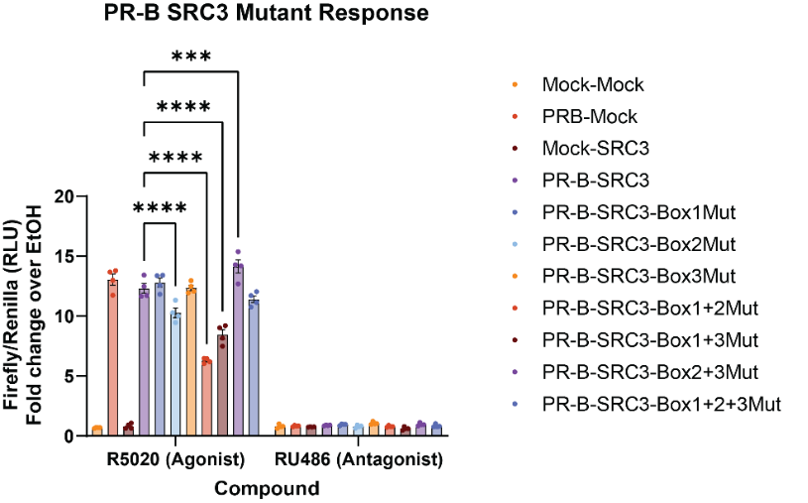
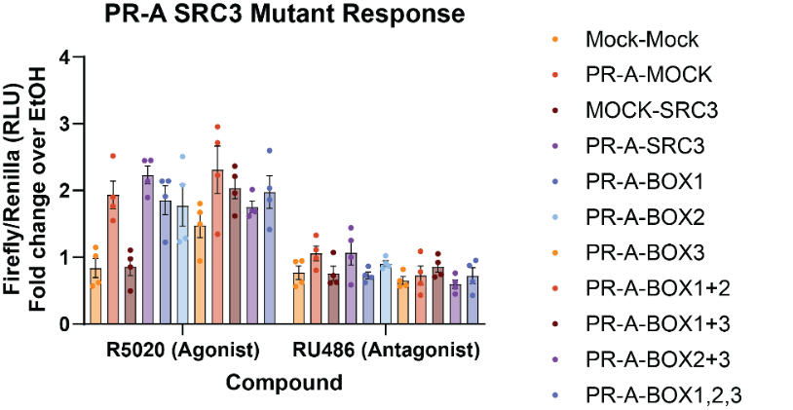

Extended Data Fig. 4 Mutation of NR-box 2 or multiple NR-boxes to LXXAA in SRC3 reduces PR activity. Bar graph showing the ratio of Firefly to Renilla luciferase normalized over the vehicle (ethanol) signal for both R5020 PR agonist and RU486 PR antagonist. Mock is indicative of base vector in the place of PR or SRC3 plasmid. ‘Mut’ in the legend indicates an LXXLL NR-Box mutated to LXXAA, validated by whole plasmid next-generation sequencing (Azenta). Similarly, ‘BOX’ denoted in the PR-A experiments indicates the mutated NR-Box(es). Points indicative of 4 replicates with SEM error bars. Two-way ANOVA was performed with Tukey correction for multiple comparisons, and asterisks indicate p<0.001 (***) and p<0.0001 (****).

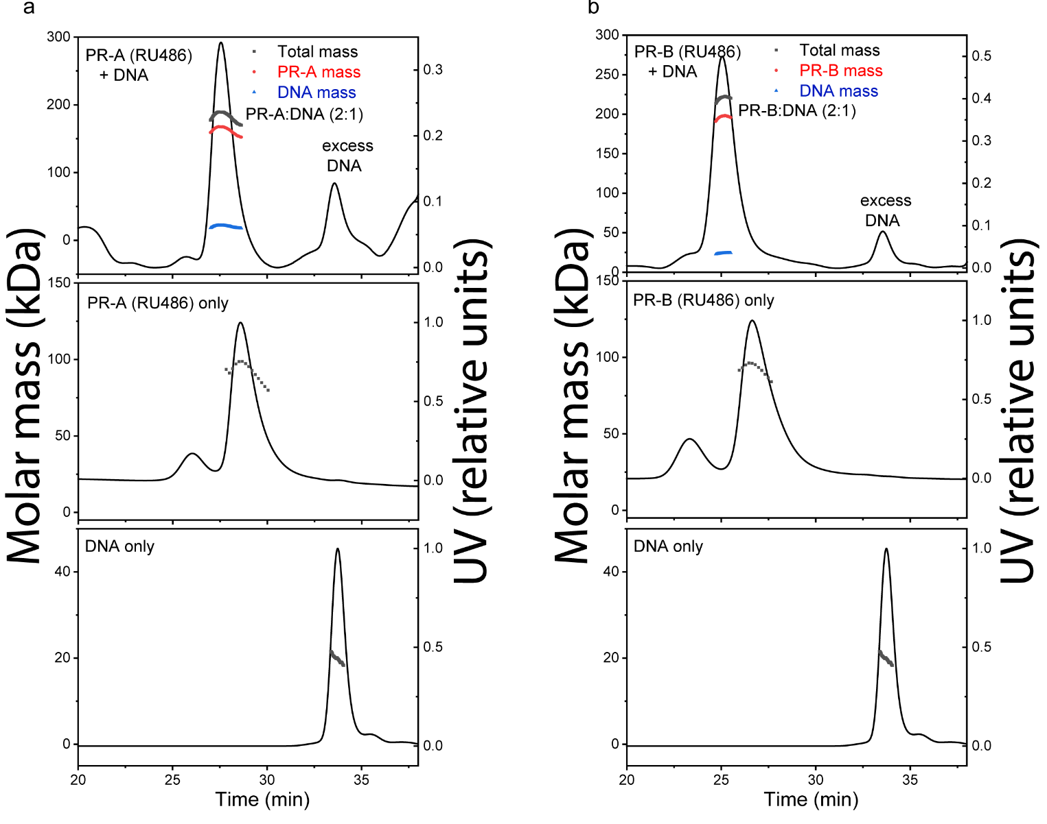
Extended Data Fig. 5 SEC-MALS of purified PR-A and PR-B bound to the progestin antagonist RU486 with and without DNA. DNA induces assembly of PR dimers A-B. SEC-MALS chromatograms of antagonist (RU486)- bound PR-A (A) and PR-B (B) with and without DNA. The molar mass of DNA and PR-A alone matches the monomeric molar mass (black line/dots across the peaks). DNA induces assembly of both PR-A and PR-B into a complex with 2:1 (protein:DNA) stoichiometry. The presence of DNA in the complexes were confirmed by deconvolution of the protein and DNA fractions in the peak (red and blue lines, respectively).

