Supplemental Material
Supplemental Material 1. Search algorithm
Cochrane Central Register of Controlled Trials
Trials matching esophageal cancer in All Text AND "recurrence" in All Text - with Publication Year from 2000 to 2023, with Cochrane Library publication date Between Jan 2000 and Dec 2023, in Trials (Word variations have been searched)
N = 763

Web of Science
((ALL=(Esophageal cancer)) AND ALL=(recurrence) AND ALL=(randomized trial) and Article (Document Types) and 1.95 Gastrointestinal & Esophageal Diseases (Citation Topics Meso) and 1.95.756 Esophageal Cancer (Citation Topics Micro) and English (Languages) and Gastroenterology Hepatology or Surgery or Oncology or Radiology Nuclear Medicine Medical Imaging (Web of Science Categories)
| Timespan: 2000-01-01 to 2023-12-31 (Publication Date)
N = 153

PubMed
("Esophageal Neoplasms"[MeSH Terms] AND "neoplasm recurrence, local"[MeSH Terms]) AND ((randomizedcontrolledtrial[Filter]) AND (2000/1/1:2023/12/31[pdat]))
N = 59

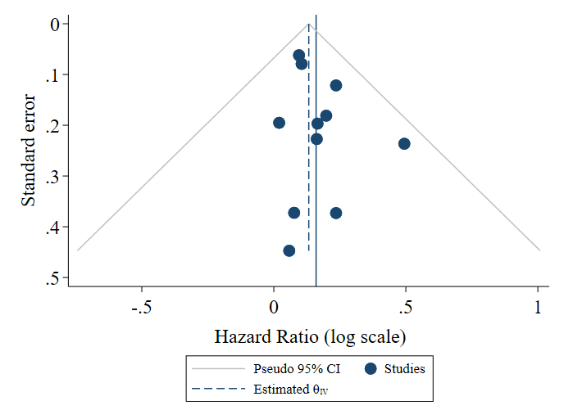Supplemental Figure 1. Symmetrical funnel plot of individual study overall survival hazard-ratio estimates.
Footnote: Triangular region within dashed line shows 95% confidence range of effect estimates adjusted for sample size of individual studies.

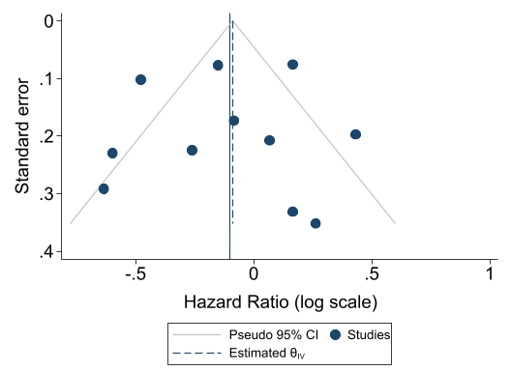
Supplemental Figure 2. Symmetrical funnel plot of individual study recurrence-/disease-free survival hazard-ratio estimates.
Footnote: Triangular region within dashed line shows 95% confidence range of effect estimates adjusted for sample size of individual studies.

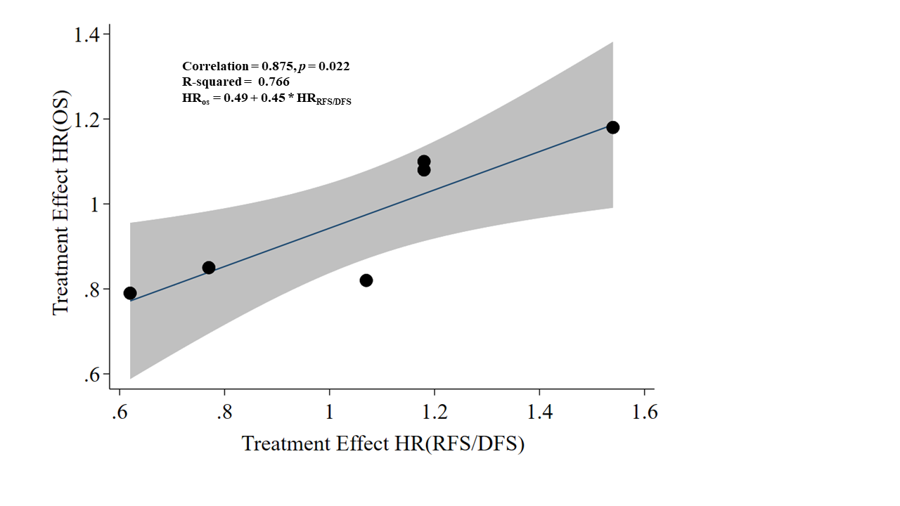
Supplemental Figure 3. Unweighted regression analysis of treatment effect on overall survival (OS) versus recurrence- or disease-free survival after removing four studies.
Footnote: In this sensitivity analysis, five of the selected studies from this analysis that were also included in the Ajani et al.(8) meta-analysis have been removed. Each point represents hazard ratios from each of the studies. The shaded area around the line of best fit represents the 95% confidence interval.

