Supporting information
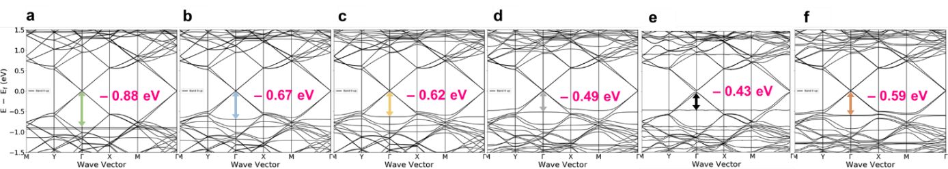
Figure S1: Band structures of (a) C₄₂/Gr, (b) C₅₄/Gr, (c) C₆₀/Gr, (d) C₇₈/Gr, (e) C_{96L}/Gr, (f) C_{96C}/Gr
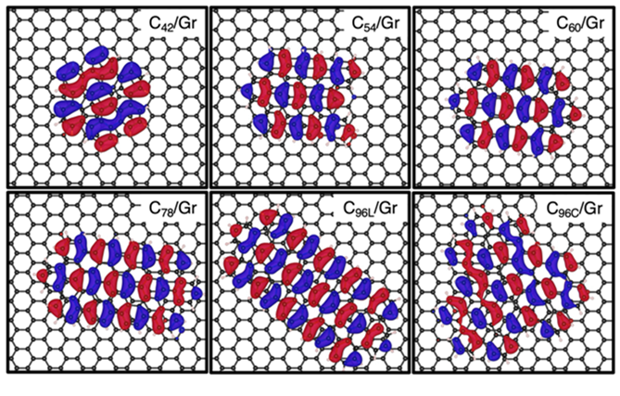
Figure S2: HOCO of the NG/Gr nanojunctions.
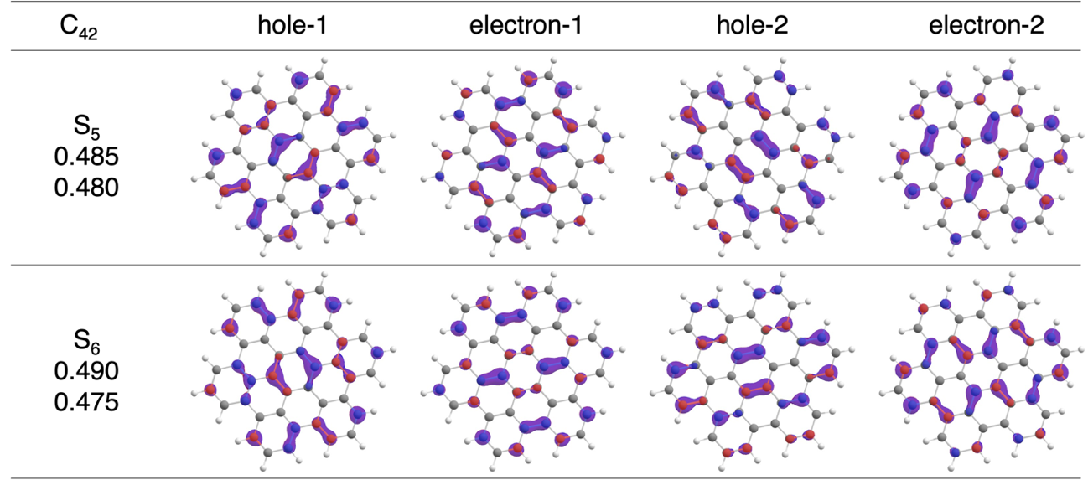
Figure S3. NTO for bright S₀ → S_{n} (n=1–6) vertical transitions of C₄₂ molecule.

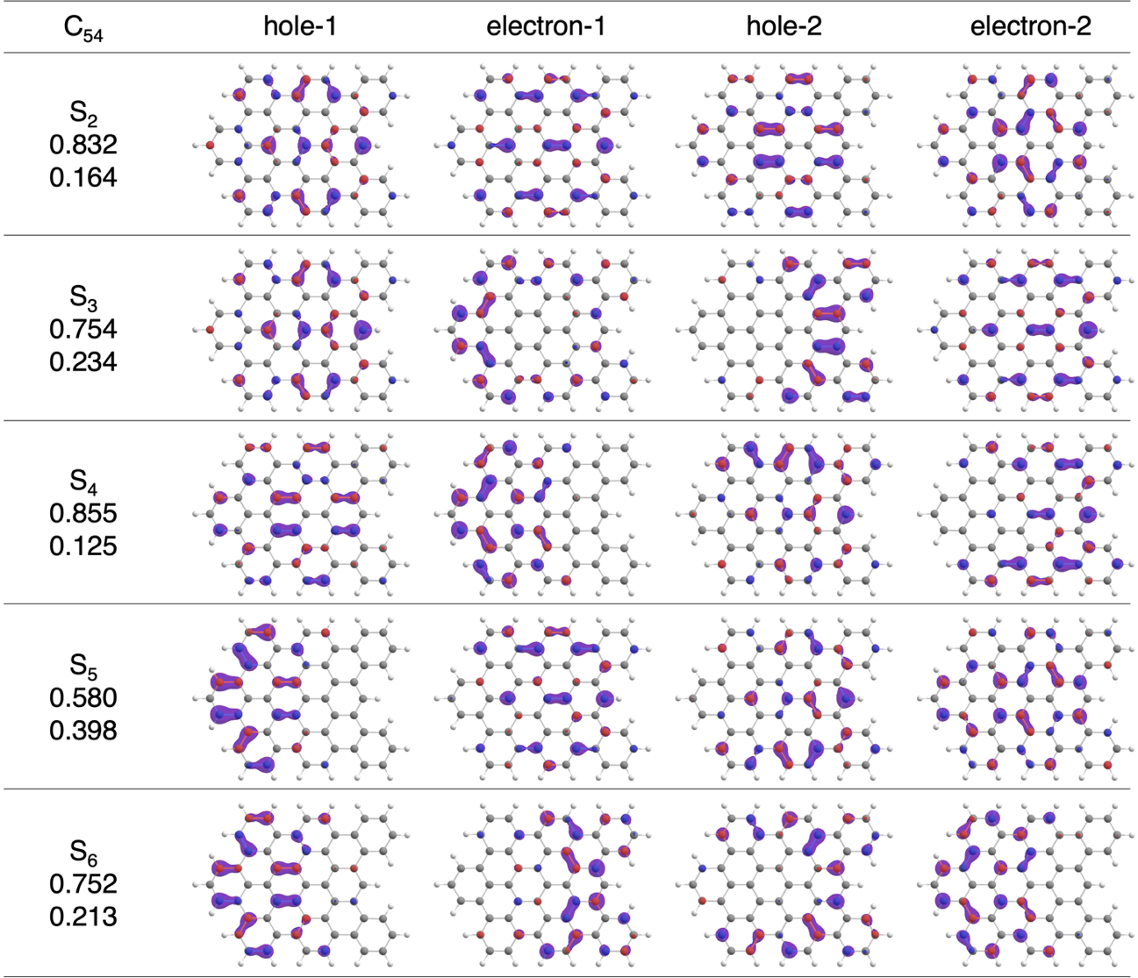
Figure S4. NTO for bright S₀ → S_{n} (n=1–6) vertical transitions of C₅₄ molecule.
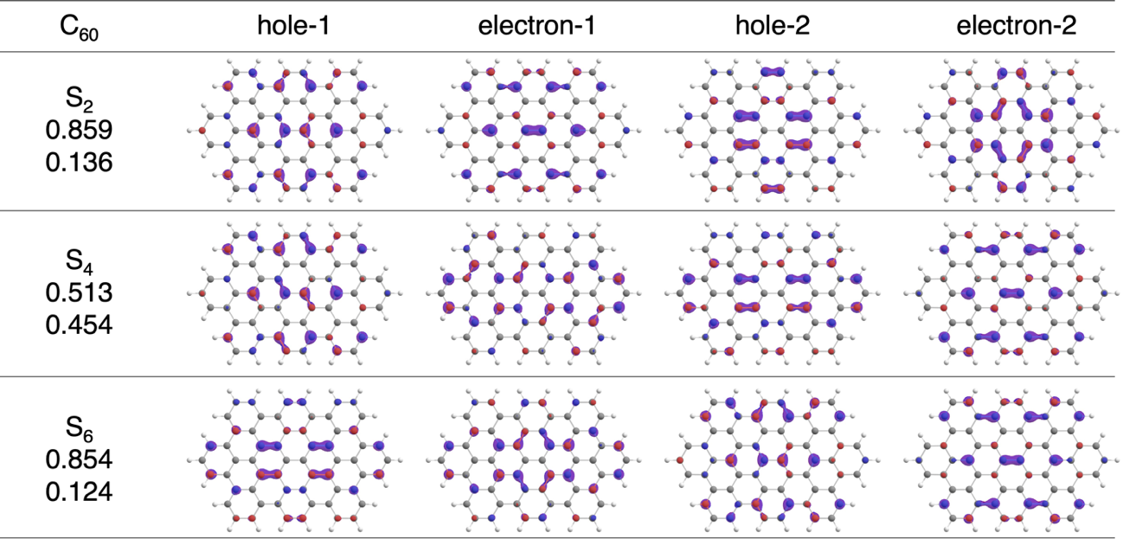
Figure S5. NTO for bright S₀ → S_{n} (n=1–6) vertical transitions of C₆₀ molecule.

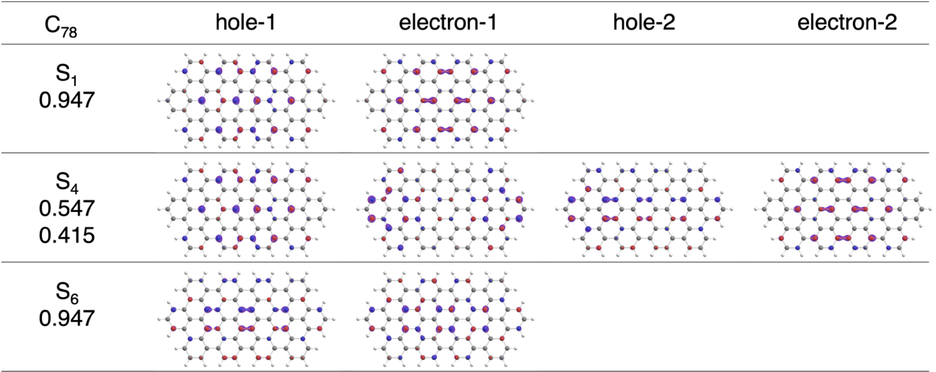
Figure S6. NTO for bright S₀ → S_{n} (n=1–6) vertical transitions of C₇₈ molecule.
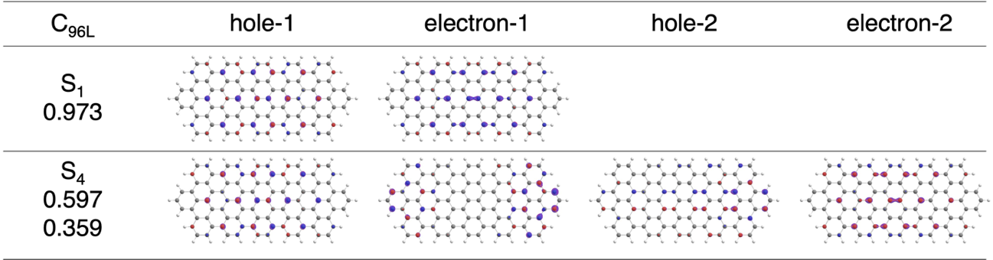
Figure S7. NTO for bright S₀ → S_{n} (n=1–6) vertical transitions of C_{96L} molecule.
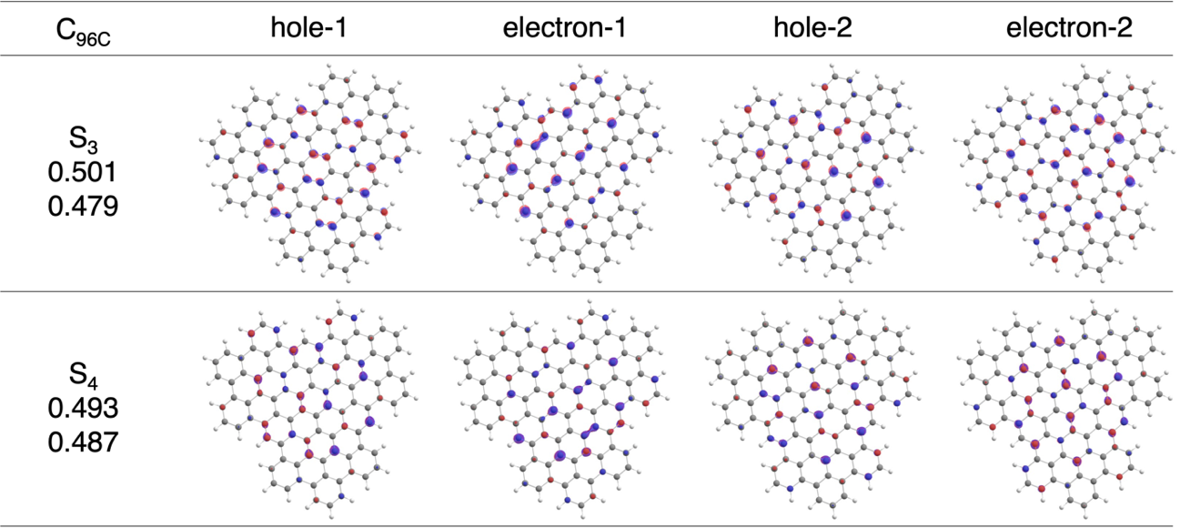
Figure S8. NTO for bright S₀ → S_{n} (n=1–6) vertical transitions of C_{96C} molecule.

Table S1: Excited state properties of the parent C₄₂ NG.
Excited state | Wavelength  (nm) | Osc. Strength  (a.u.) | E  (eV) | Transitions | dS²  (a.u.)
S₁ | 429.2 | 0.000 | 2.9 | H-1→LUMO (50%), HOMO→L+1 (49%) | 0.000
S₂ | 410.5 | 0.000 | 3.0 | H-1→L+1 (49%), HOMO→LUMO (50%) | 0.001
S₃ | 381.2 | 0.000 | 3.3 | H-2→LUMO (19%), HOMO→L+2 (79%) | 0.000
S₄ | 380.8 | 0.000 | 3.3 | H-2→L+1 (19%), H-1→L+2 (80%) | 0.000
S₅ | 358.0 | 0.724 | 3.5 | H-1→LUMO (42%), HOMO→L+1 (42%) | 8.535
S₆ | 358.0 | 0.726 | 3.5 | H-1→L+1 (43%), HOMO→LUMO (42%) | 8.554
S₇ | 343.8 | 0.000 | 3.6 | H-2→LUMO (78%), HOMO→L+2 (18%) | 0.000
S₈ | 343.5 | 0.000 | 3.6 | H-2→L+1 (78%), H-1→L+2 (18%) | 0.000
S₉ | 329.6 | 0.000 | 3.8 | H-2→L+2 (96%) | 0.000
S₁₀ | 311.2 | 0.001 | 4.0 | HOMO→L+3 (93%) | 0.0116

Table S2: Excited state properties of the parent C₅₄ NG.
Excited state | Wavelength  (nm) | Osc. Strength  (a.u.) | E  (eV) | Transitions | dS²  (a.u.)
S₁ | 468.8 | 0.000 | 2.6 | H-1→LUMO (50%), HOMO→L+1 (48%) | 0.004
S₂ | 459.3 | 0.159 | 2.7 | H-1→L+1 (14%), HOMO→LUMO (83%) | 2.407
S₃ | 406.9 | 0.034 | 3.0 | H-2→LUMO (20%), HOMO→L+1 (12%), HOMO→L+2 (63%) | 0.459
S₄ | 391.0 | 0.495 | 3.2 | H-1→L+1 (78%), HOMO→LUMO (11%) | 6.366
S₅ | 389.3 | 0.528 | 3.2 | H-2→LUMO (17%), H-1→LUMO (40%), HOMO→L+1 (35%) | 6.771
S₆ | 376.5 | 0.139 | 3.3 | H-2→L+1 (23%), H-1→L+2 (67%) | 1.719
S₇ | 365.0 | 0.269 | 3.4 | H-2→LUMO (59%), HOMO→L+2 (29%) | 3.231
S₈ | 351.3 | 0.113 | 3.5 | H-2→L+1 (65%), H-1→L+2 (19%) | 1.301
S₉ | 346.4 | 0.014 | 3.6 | HOMO→L+3 (93%) | 0.154
S₁₀ | 342.5 | 0.001 | 3.6 | HOMO→L+4 (85%) | 0.014
Table S3: Excited state properties of the parent C₆₀ NG.
Excited state | Wavelength  (nm) | Osc. Strength  (a.u.) | E  (eV) | Transitions | dS²  (a.u.)
S₁ | 491.4 | 0.000 | 2.5 | H-1→LUMO (51%), HOMO→L+1 (48%) | 0.005
S₂ | 486.6 | 0.257 | 2.5 | H-1→L+1 (13%), HOMO→LUMO (86%) | 4.118
S₃ | 444.5 | 0.000 | 2.8 | H-2→LUMO (27%), HOMO→L+2 (72%) | 0.000
S₄ | 408.1 | 0.662 | 3.0 | H-1→LUMO (45%), HOMO→L+1 (49%) | 8.889
S₅ | 407.5 | 0.000 | 3.0 | H-2→L+1 (14%), H-1→L+2 (84%) | 0.001
S₆ | 404.3 | 0.817 | 3.1 | H-1→L+1 (85%), HOMO→LUMO (12%) | 10.872
S₇ | 401.3 | 0.000 | 3.1 | H-2→LUMO (70%), HOMO→L+2 (26%) | 0.003
S₈ | 380.0 | 0.000 | 3.3 | H-2→L+1 (80%), H-1→L+2 (12%) | 0.000
S₉ | 365.6 | 0.017 | 3.4 | H-2→L+2 (95%) | 0.202
S₁₀ | 363.9 | 0.010 | 3.4 | H-3→LUMO (15%), HOMO→L+3 (82%) | 0.1181

Table S4: Excited state properties of the parent C₇₈ NG.
Excited state | Wavelength  (nm) | Osc. Strength  (a.u.) | E  (eV) | Transitions | dS²  (a.u.)
S₁ | 558.0 | 0.688 | 2.2 | HOMO→LUMO (95%) | 12.630
S₂ | 531.4 | 0.001 | 2.3 | H-1→LUMO (53%), HOMO→L+1 (46%) | 0.016
S₃ | 487.9 | 0.000 | 2.5 | H-2→LUMO (34%), HOMO→L+2 (64%) | 0.000
S₄ | 446.5 | 0.541 | 2.8 | H-1→LUMO (41%), HOMO→L+1 (49%) | 7.956
S₅ | 443.7 | 0.002 | 2.8 | H-2→LUMO (61%), HOMO→L+2 (32%) | 0.023
S₆ | 422.9 | 0.835 | 2.9 | H-1→L+1 (95%) | 11.626
S₇ | 420.4 | 0.001 | 2.9 | H-1→L+2 (86%) | 0.011
S₈ | 419.8 | 0.022 | 3.0 | H-4→LUMO (22%), HOMO→L+3 (73%) | 0.300
S₉ | 410.4 | 0.000 | 3.0 | H-3→LUMO (62%), H-2→L+1 (30%) | 0.000
S₁₀ | 405.9 | 0.000 | 3.1 | H-2→L+1 (38%), HOMO→L+4 (53%) | 0.0001

Table S5: Excited state properties of the parent C_{96L} NG.
Excited state | Wavelength  (nm) | Osc. Strength  (a.u.) | E  (eV) | Transitions | dS²  (a.u.)
S₁ | 619.3 | 1.140 | 2.0 | HOMO→LUMO (97%) | 23.238
S₂ | 557.8 | 0.002 | 2.2 | H-1→LUMO (54%), HOMO→L+1 (44%) | 0.029
S₃ | 518.3 | 0.000 | 2.4 | H-2→LUMO (41%), HOMO→L+2 (57%) | 0.000
S₄ | 476.4 | 0.418 | 2.6 | H-1→LUMO (35%), HOMO→L+1 (47%), HOMO→L+4 (13%) | 6.553
S₅ | 475.5 | 0.003 | 2.6 | H-2→LUMO (53%), HOMO→L+2 (39%) | 0.042
S₆ | 473.2 | 0.000 | 2.6 | H-3→LUMO (55%), HOMO→L+3 (44%) | 0.000
S₇ | 461.7 | 0.036 | 2.7 | H-4→LUMO (31%), HOMO→L+4 (60%) | 0.554
S₈ | 452.3 | 0.000 | 2.7 | H-3→LUMO (32%), H-1→L+2 (14%), HOMO→L+3 (41%) | 0.001
S₉ | 444.2 | 0.000 | 2.8 | HOMO→L+5 (93%) | 0.000
S₁₀ | 431.3 | 0.909 | 2.9 | H-1→L+1 (97%) | 12.9084

Table S6: Excited state properties of the parent C_{96C} NG.
Excited state | Wavelength  (nm) | Osc. Strength  (a.u.) | E  (eV) | Transitions | dS²  (a.u.)
S₁ | 591.2 | 0.000 | 2.1 | H-1→LUMO (49%), HOMO→L+1 (49%) | 0.000
S₂ | 570.4 | 0.000 | 2.2 | H-1→L+1 (49%), HOMO→LUMO (50%) | 0.002
S₃ | 488.4 | 1.263 | 2.5 | H-1→L+1 (44%), HOMO→LUMO (42%) | 20.310
S₄ | 488.3 | 1.271 | 2.5 | H-1→LUMO (43%), HOMO→L+1 (43%) | 20.432
S₅ | 476.9 | 0.007 | 2.6 | H-2→LUMO (27%), HOMO→L+2 (69%) | 0.110
S₆ | 476.3 | 0.007 | 2.6 | H-2→L+1 (27%), H-1→L+2 (69%) | 0.112
S₇ | 449.5 | 0.003 | 2.8 | H-2→LUMO (65%), HOMO→L+2 (23%) | 0.044
S₈ | 449.0 | 0.004 | 2.8 | H-2→L+1 (64%), H-1→L+2 (23%) | 0.059
S₉ | 422.8 | 0.000 | 2.9 | H-1→L+4 (34%), HOMO→L+3 (48%) | 0.004
S₁₀ | 422.7 | 0.000 | 2.9 | H-1→L+3 (35%), HOMO→L+4 (47%) | 0.0036

