Supplementary Material 2
Changes in Peak Torque of Knee Flexors Across Groups Before and After Intervention
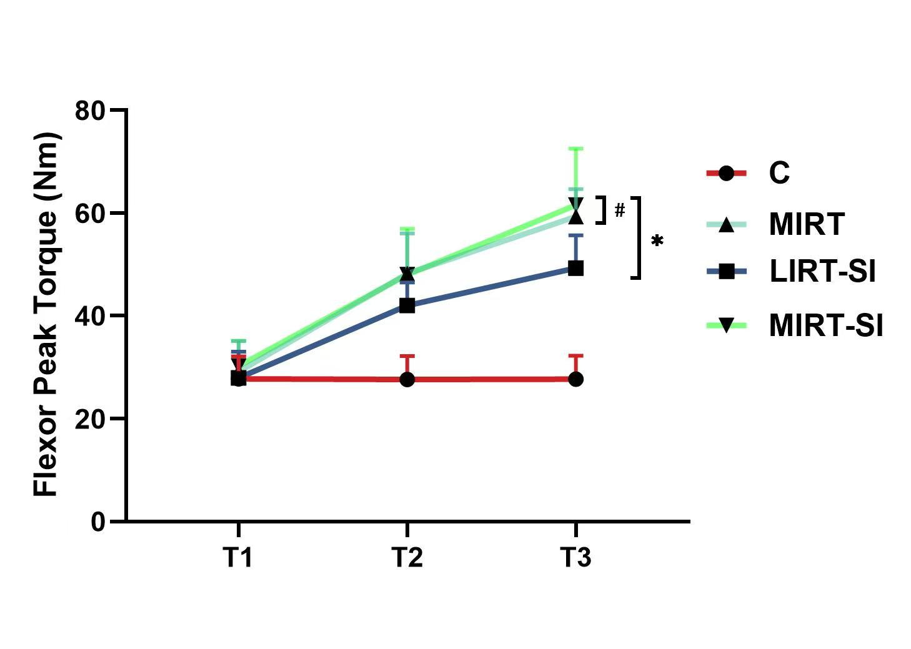
*P < 0.05 compared to Group C; #P < 0.05 compared to Group LIRT-SI. T1, 1 week before the intervention; T2, week 8 of the intervention; T3, week 16 of the intervention.

