Table S1: Primers
Gene(s) | Primer | Sequence | Reference
emm | 1b For | 5’-TATTCGCTTAGAAAATTAA-3’ | ¹
 | 2 Rev | 5’-AAACAAGCTAAAGAACTTGC-3’ | ¹
erm(T) | T For | 5’-CCGCCATTGAAATAGATCCT-3’ | ²
 | T Rev | 5’-GCTTGATAAAATTGGTTTTTGGA-3’ | ²
 | erm(T)reg For | 5’-TTGCAGTATAAATTTAACAGTCG-3’ | This paper
 | erm(T) qPCR For | 5’-TGAGATTGGTTCAGGGAAGG-3’ | This paper
 | erm(T) qPCR Rev | 5’-TAACCGCCATTGAAATAGATCCT-3’ | This paper
tuf(A) | For | 5’-CAACTCGTCACTATGCGCACAT-3’ | ³
 | Rev | 5’-GAGCGGCACCAGTGATCAT-3’ | ³

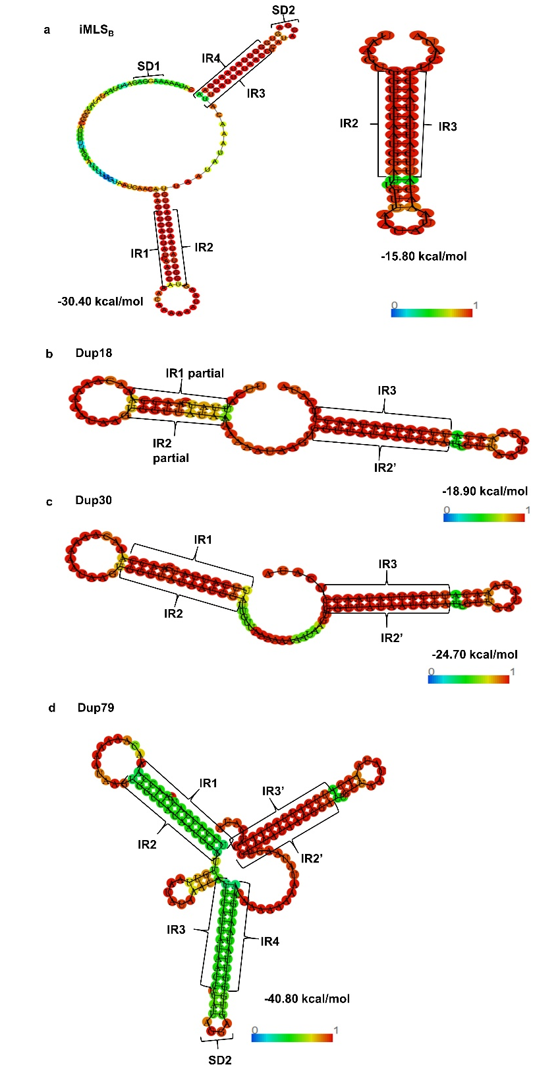
Fig. S1. Structural modeling and free energy calculations for mRNA hairpins predicted in iMLS_{B} and cMLS_{B} isolates. The sequenced erm(T) regulatory region for the iMLS_{B} (a), Dup18 (b), Dup30 (c), and Dup79 (d) isolates were used to assess the probability of mRNA hairpin formation based on analysis of segments corresponding to crucial IR regions. The secondary structures and free energy of mRNA from each isolate was predicted by the ViennaRNA tool. Predicted structures were visualized using the RNAFold Webserver tool. Colored bar represents base pair probabilities.
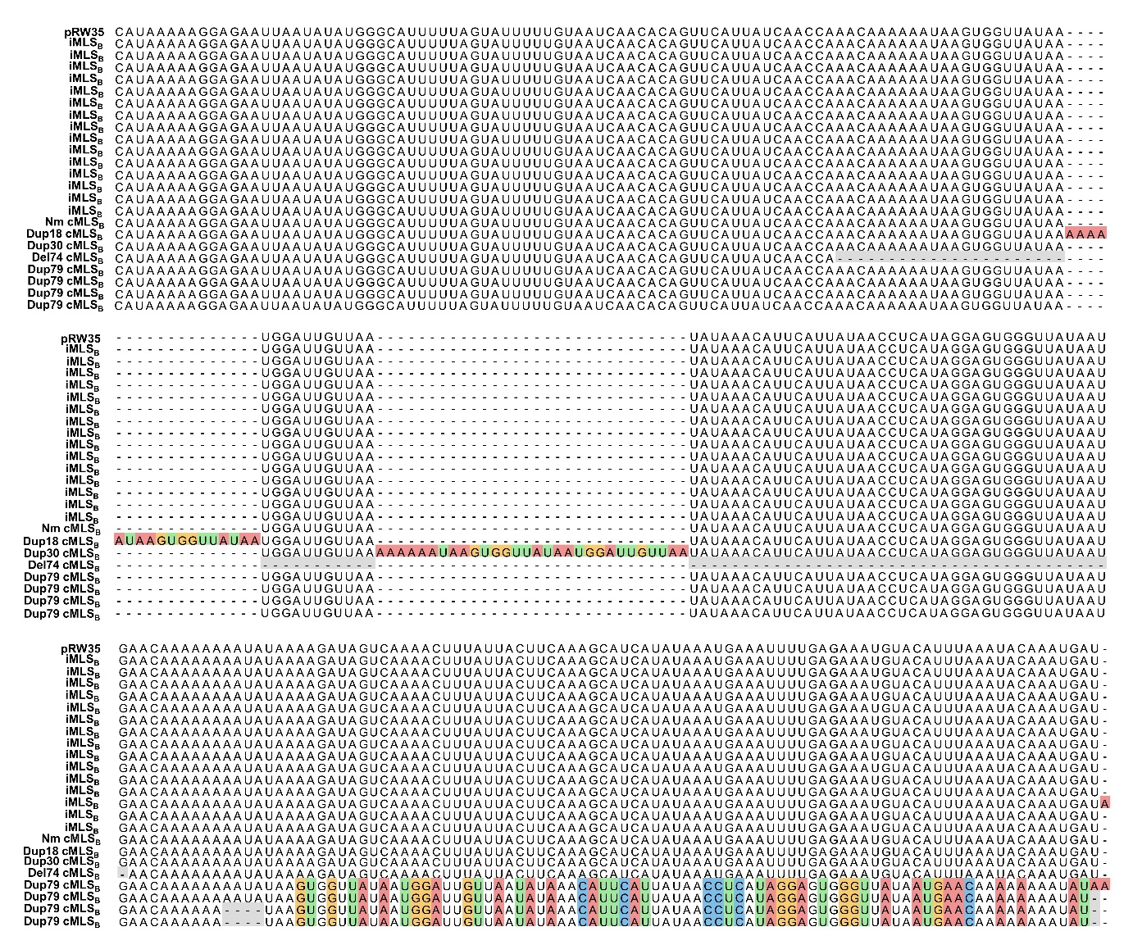
Fig. S2: Multiple sequence alignment of the erm(T) regulatory regions in emm92 isolates with iMLS_{B} and cMLS_{B} phenotypes. The region upstream of the erm(T) gene which regulates expression, is shown from all constitutive and a representative number of inducible emm92 isolates. Sequences are aligned with the pRW35 sequence reported by ². Alignment was generated with a MAFFT alignment in the MegAlign Pro (DNAstar) software.
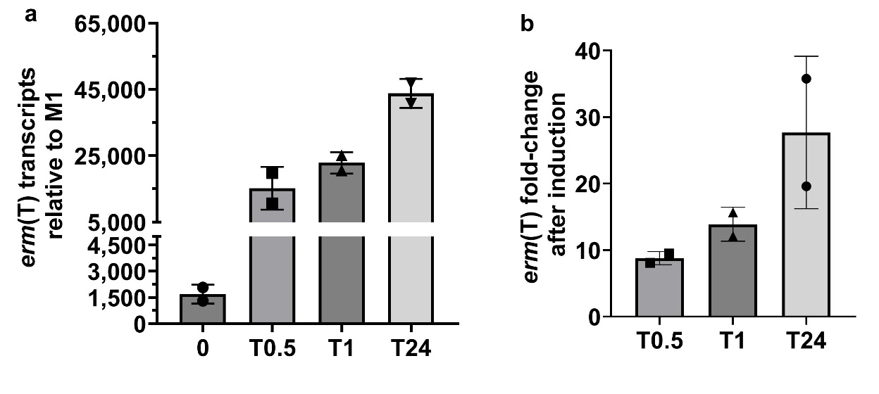
Fig. S3. RT-qPCR analysis of erm(T) expression in an iMLS_{B} isolate. An additional emm92 isolate with the iMLS_{B} phenotype was tested in addition to that used in main manuscript to confirm the RT-qPCR results. a) The number of erm(T) transcripts relative to the M1 control strain is shown after exposure to 10 µg/mL of erythromycin for 0.5, 1, or 24 hours. To assess statistical differences across the T0, T0.5, T1, and T24 time points a Brown-Forsythe ANOVA test (p=0.0188) was used. b) The fold-change in erm(T) transcripts after exposure to erythromycin for 0.5, 1, or 24 hours is shown relative to the untreated sample (T0). For all data, RNA was isolated from two independent experiments then converted to cDNA. RT-qPCR reactions were performed in triplicate wells per sample and results were normalized to the tuf(A) reference gene. Standard deviation was determined by the averaged log₂ ΔΔCT values for each biological replicate.
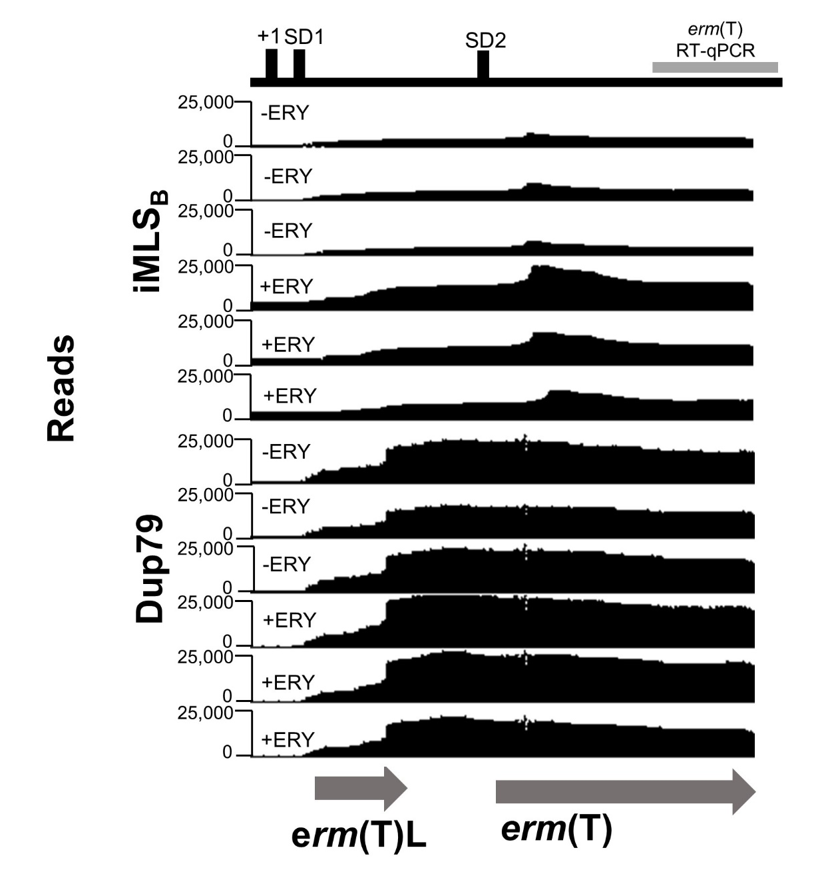
Fig. S4. RNAseq read mapping for replicate samples shown in Fig. 4. Sequences were aligned to the pRW35-like genome to determine plasmid-borne erm(T) expression at the transcriptional level (Accession #: CP032701), ⁴. Analysis of the erm(T) promoter and start of the erm(T) gene was assessed based on the number of mapped sequencing reads. Reads are shown for an iMLS_{B} isolate and cMLS_{B} isolate (Dup79) without erythromycin exposure for comparison to the number of reads after a 1-hour incubation period with 10 µg/mL erythromycin added at log-phase. The erm(T)L and erm(T) open reading frames are shown below (gray arrows), as predicted by SeqBuilder Pro (DNAstar). The section amplified in RT-qPCR experiments is indicated by the gray rectangle. The mapped reads are shown for 3 independent samples per isolate and condition.
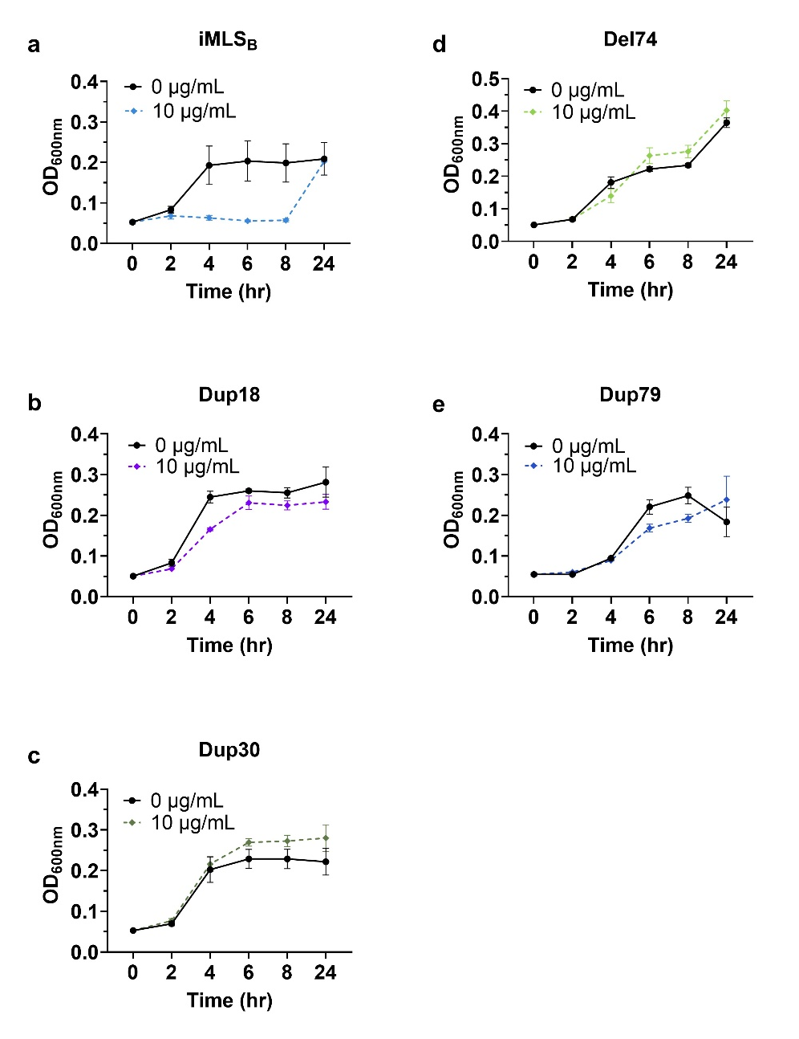
Fig. S5. Growth physiology of emm92 cMLS_{B} and iMLS_{B} isolates. Growth curves with the persistent presence of antibiotic in a 48-well plate. 10 µg/mL of erythromycin was added at the beginning of the assay at starting OD_{600nm} ~0.05 for the (a) iMLS_{B}, (b) Dup18, (c) Dup30, (d) Del74, and (e) Dup79 isolates. Data is from triplicate wells in 3 independent experiments.

References
1 Beall, B., Facklam, R. & Thompson, T. Sequencing emm-specific PCR products for routine and accurate typing of group A streptococci. Journal of Clinical Microbiology 34, 953-958 (1996).
2 Woodbury, R. L. et al. Plasmid-Borne erm(T) from invasive, macrolide-resistant Streptococcus pyogenes strains. Antimicrob Agents Chemother 52, 1140-1143, doi:10.1128/aac.01352-07 (2008).
3 Bachert, B. A. et al. Unique footprint in the scl1.3 locus affects adhesion and biofilm formation of the invasive M3-type group A Streptococcus. Front Cell Infect Microbiol 6, 90, doi:10.3389/fcimb.2016.00090 (2016).
4 Vega, L. A. et al. The integrative conjugative element ICESpyM92 contributes to pathogenicity of emergent antimicrobial-resistant emm92 group A Streptococcus. Infect Immun 90, e0008022, doi:10.1128/iai.00080-22 (2022).

