Supporting Information for
Effect of exhaust gas recirculation (EGR) on diesel engine carbonaceous PM emissions

Xinling Li^{a,b}, Pengcheng Zhao^{b}

ª College of Smart Energy, Shanghai Jiao Tong University, China
^{b} Institute of Eco-Chongming (IEC), Shanghai, 202162, China

Corresponding author. E-mail: lxl@sjtu.edu.cn (Xinling Li).

Number of figures: 1
Number of tables: 4

List of contents of the supporting information:

Figure
Fig. S1. Diagram of the system and instrumentation for the diesel engine combustion, particulate sampling and chemical analysis experiments

Tables
Table S1. Engine specifications
Table S2. Engine operation conditions
Table S3. Engine combustion, performance, and gaseous emission parameters
Table S4. Characteristic ions and retention time of target PAHs

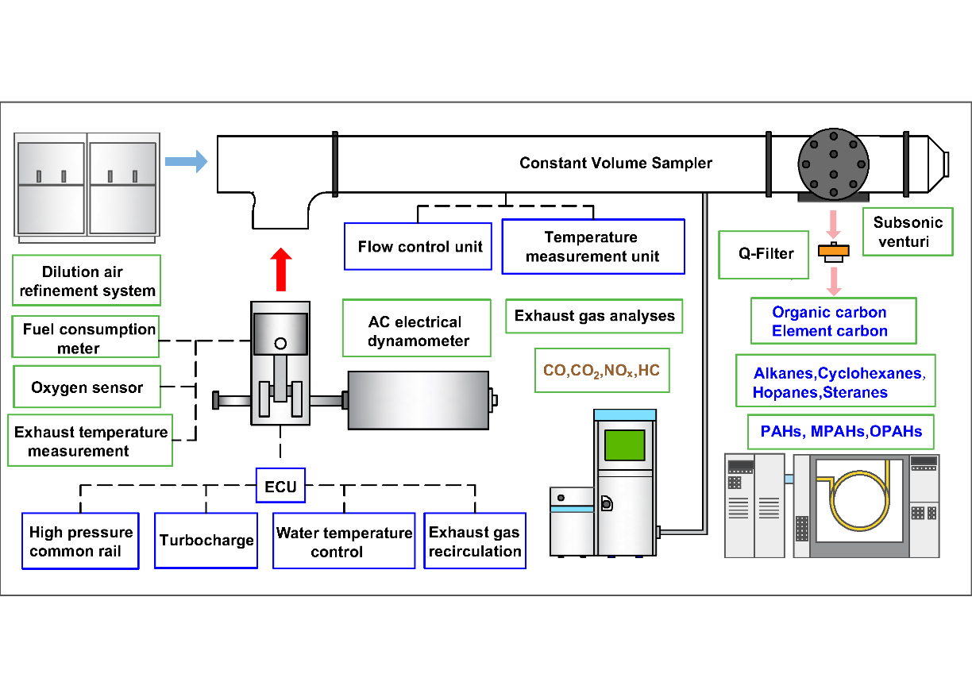
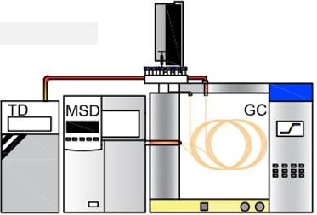

PAHs & n-alkanes
OC(OC₁-OC₄), EC(EC₁-EC₃)
EGR

Table S1. Engine specifications
Number of cylinders | 4
Fuel injection system | Common-rail injection system
Injection strategy | One main injection
Suction type | Turbo intercooler
Displacement | 2.8 L
Bore×stroke | 94 mm×100 mm
Maximum power | 110 kW/3000 rpm
Maximum torque | 360 N m/2200 rpm

Fig.S1 Diagram of the system and instrumentation for the diesel engine combustion, particulate sampling and chemical analysis experiments

Table S1. Engine specifications
Number of cylinders | 4
Fuel injection system | Common-rail injection system
Injection strategy | One main injection
Suction type | Turbo intercooler
Displacement | 2.8 L
Bore×stroke | 94 mm×100 mm
Maximum power | 110 kW/3000 rpm
Maximum torque | 360 N m/2200 rpm

Table S2. Engine operation conditions
Speed (rpm) | Load (%) | EGR rate (%) | Injection timing (°CA ATDC) | Injection pressure
1400 | 25 | 0, 10, 20, 30, 40, 45 | -6 | 120
1400 | 50 | 0, 8, 16, 22, 30 | -6 | 120
2200 | 25 | 0, 10, 20, 30, 40, 45 | -6 | 120
2200 | 50 | 0, 5, 10, 15, 20 | -6 | 120

Table S3. Engine combustion, performance, and gaseous emission parameters
Speed  (rpm) | Load  (%) | EGR  (%) | P_{max}  (MPa) | HRR_{max}  (kJ/m³ deg) | CD  (℃A) | T_{exh}  (K) | BSFC  (g/kWh) | Air-fuel  ratio | HC  (g/kWh) | CO  (g/kWh) | NO_{X}  (g/kWh)
1400 | 25 | 0 | 8.3 | 214 | 12 | 224 | 255 | 47.3 | 0.54 | 3.3 | 8.0
1400 | 25 | 10 | 7.7 | 228 | 10 | 232 | 256 | 39.4 | 0.51 | 2.9 | 5.2
1400 | 25 | 20 | 7.7 | 213 | 15 | 245 | 258 | 33.8 | 0.46 | 2.5 | 3.2
1400 | 25 | 30 | 7.3 | 230 | 17 | 259 | 254 | 29.0 | 0.44 | 2.5 | 1.6
1400 | 25 | 40 | 5.7 | 145 | 27 | 283 | 262 | 23.5 | 0.44 | 2.8 | 0.5
1400 | 25 | 45 | 5.8 | 146 | 32 | 316 | 269 | 19.7 | 0.49 | 6.6 | 0.9
1400 | 50 | 0 | 9.7 | 130 | 17 | 316 | 213 | 30.1 | 0.19 | 0.2 | 6.7
1400 | 50 | 8 | 9.7 | 133 | 23 | 335 | 212 | 25.6 | 0.14 | 0.2 | 2.2
1400 | 50 | 16 | 9.3 | 140 | 30 | 352 | 218 | 22.8 | 0.14 | 0.4 | 1.2
1400 | 50 | 22 | 9.5 | 133 | 32 | 364 | 218 | 20.9 | 0.15 | 0.5 | 1.5
1400 | 50 | 30 | 9.0 | 135 | 43 | 382 | 226 | 19.4 | 0.15 | 2.5 | 0.7
2200 | 25 | 0 | 8.0 | 177 | 13 | 223 | 259 | 50.4 | 0.53 | 3.1 | 4.4
2200 | 25 | 10 | 7.7 | 149 | 20 | 235 | 259 | 43.2 | 0.45 | 2.1 | 2.7
2200 | 25 | 20 | 7.8 | 127 | 23 | 250 | 258 | 37.5 | 0.39 | 1.7 | 1.7
2200 | 25 | 30 | 7.3 | 123 | 24 | 265 | 262 | 31.8 | 0.36 | 1.6 | 1.1
2200 | 25 | 40 | 6.8 | 131 | 27 | 272 | 272 | 25.4 | 0.33 | 2.1 | 0.5
2200 | 25 | 45 | 6.7 | 130 | 29 | 317 | 276 | 21.2 | 0.31 | 3.5 | 0.3
2200 | 50 | 0 | 9.1 | 118 | 18 | 310 | 214 | 35.7 | 0.23 | 0.4 | 4.1
2200 | 50 | 5 | 9.0 | 116 | 24 | 322 | 216 | 32.5 | 0.21 | 0.4 | 2.9
2200 | 50 | 10 | 8.9 | 108 | 30 | 317 | 215 | 30.4 | 0.22 | 0.4 | 2.7
2200 | 50 | 15 | 9.0 | 111 | 33 | 336 | 218 | 28.5 | 0.20 | 0.4 | 2.0
2200 | 50 | 20 | 9.2 | 109 | 45 | 346 | 218 | 27.5 | 0.20 | 0.4 | 1.6
EGR: Exhaust gas recirculation; P_{max}: Maximum in-cylinder pressure; HRR_{max}: Maximum heat release rate; CD: Combustion duration; T_{exh}: Exhaust temperature; BSFC: Brake specific fuel consumption

Table S4. Characteristic ions and retention time of target PAHs
Abbr. | Compounds | Ring number | Characteristic ions (m/z) | Retention time (min)
Nap | Naphthalene | 2 | 128 | 8.26
Acy | Acenaphthylene | 3 | 152 | 10.22
Ace | Acenaphthene | 3 | 154 | 10.44
Fl | Fluorene | 3 | 166 | 11.12
Phe | Phenanthrene | 3 | 178 | 12.90
Ant | Anthracene | 3 | 178 | 13.02
Flu | Fluoranthene | 4 | 202 | 15.95
Pyr | Pyrene | 4 | 202 | 16.56
BcP | Benzo[c]phenanthalene | 4 | 228 | 19.32
BaA | Benzo[a]anthracene | 4 | 228 | 20.06
Chr | Chrysene | 4 | 228 | 20.18
BbF | Benzo[b]fluoranthene | 5 | 252 | 23.03
BkF | Benzo[k]fluoranthene | 5 | 252 | 23.10
BeP | Benzo[e]pyrene | 5 | 252 | 23.58
Per | Perylene | 5 | 252 | 23.81
BaP | Benzo[a]pyrene | 5 | 252 | 23.82
IcdP | Indeno[1,2,3-cd] pyrene | 6 | 276 | 23.85
DBA | Dibenzo[a, h]anthracene | 5 | 278 | 24.34
BghiP | Benzo[g,h,i]perylene | 6 | 276 | 24.77
Cor | Coronene | 7 | 300 | 28.10

