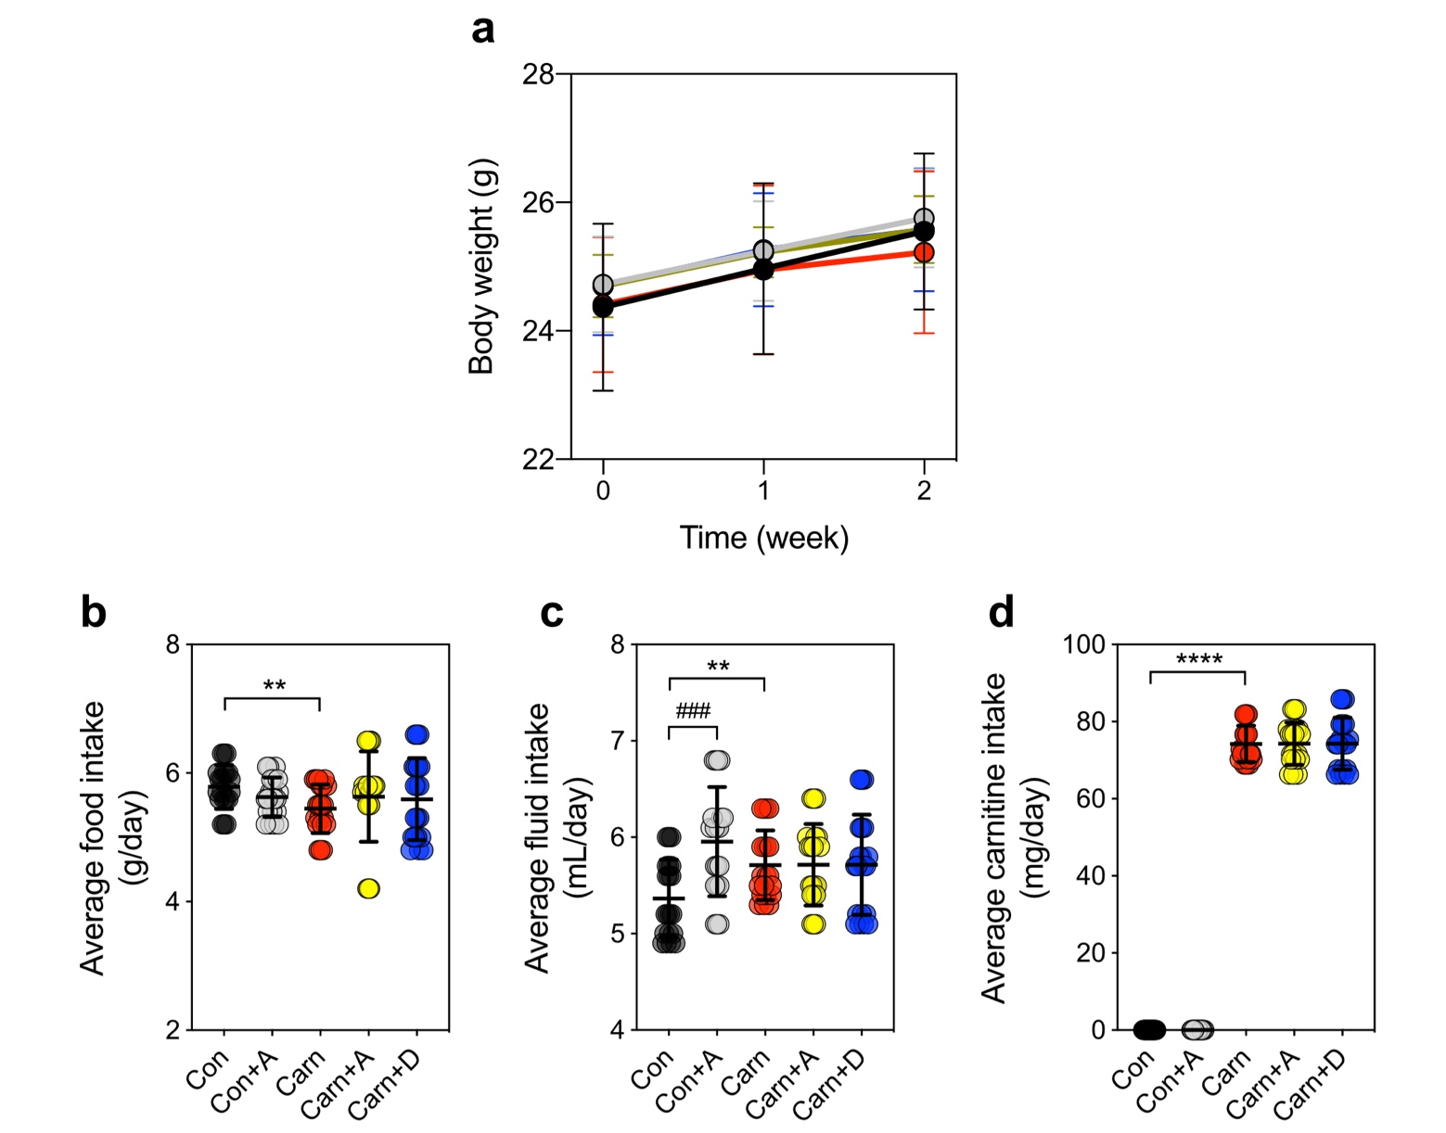
Supplementary Fig. 1 | Effect of allicin and carnitine in ʟ-carnitine-induced atherosclerosis male C57BL/6 mice. (a) Changes in body weight; (b) average food intake; (c) average fluid intake; and (d) average carnitine intake. Statistical analyses were performed using an unpaired two-tailed Student’s t-test control vs control + allicin group (###, p < 0.001), control vs carnitine group (**, p < 0.01; and ****, p < 0.0001); one-way ANOVA with Tukey’s range test for comparisons among the carnitine-intake groups.

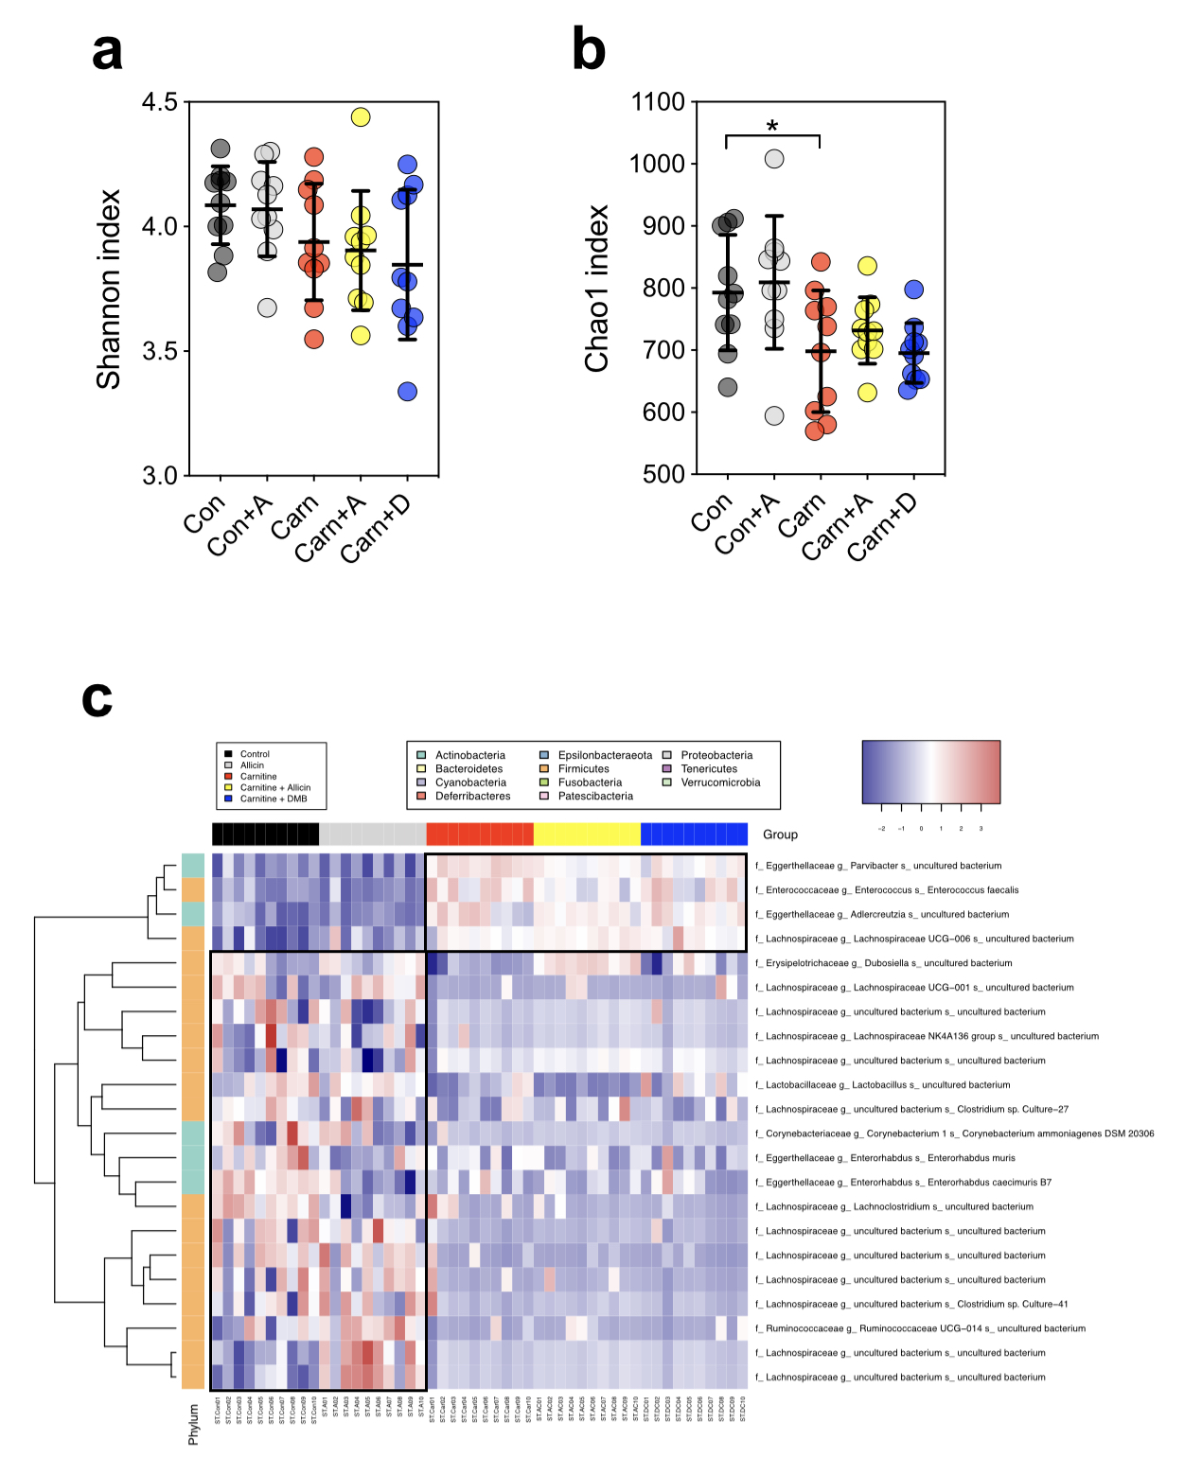
Supplementary Fig. 2 | ʟ-carnitine primarily affected the fecal microbiome composition in ʟ-carnitine-induced atherosclerosis male C57BL/6J mice. α-diversity indices, (a) Shannon index and (b) Chao1 index. (c) Heat map of the relative abundances at OTU level of fecal microbiota with a significant difference, as evaluated using the Kruskal–Wallis test with false discovery rate (FDR) (q < 0.01).

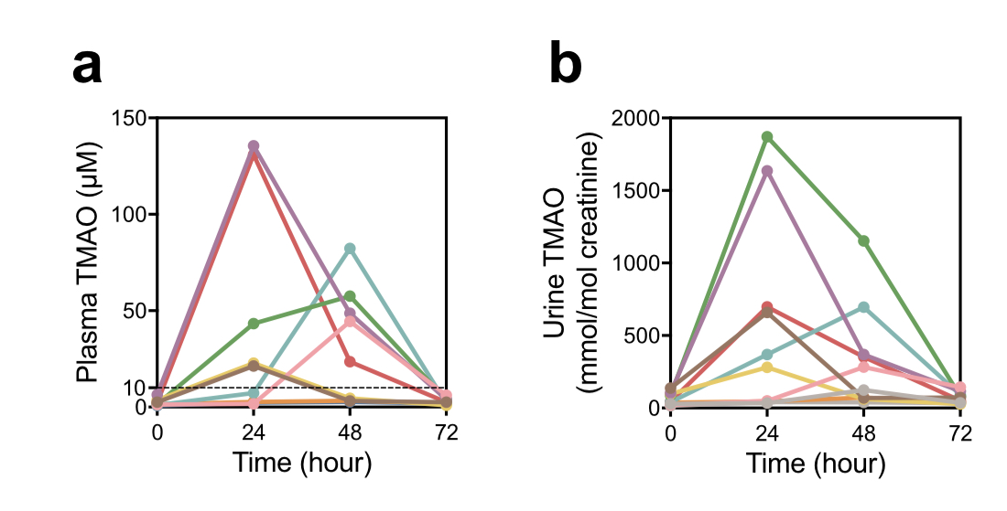
Supplementary Fig. 3 | Screening of high-TMAO producers using oral carnitine challenge test (OCCT) based on plasma TMAO level ≥ 10 μM in participants (n=9). (a) Plasma and (b) urine TMAO; OCCT was performed by collecting blood and urine as a baseline and subsequently administering 3 carnitine tablets (1,500 mg), followed by collection of blood/urine at 24, 48, and 72 h.

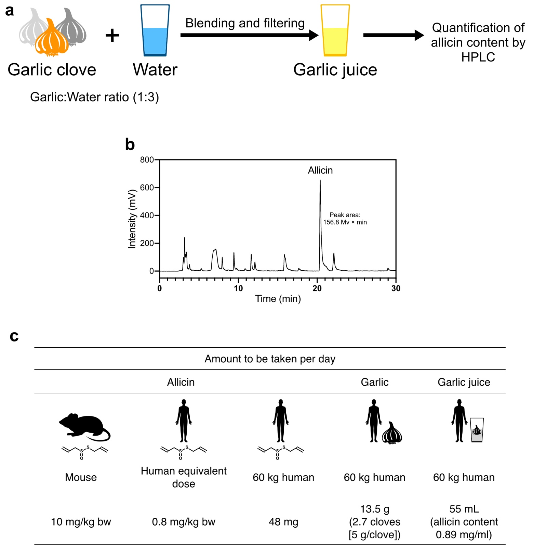
Supplementary Fig. 4 | Garlic juice preparation and mouse to human equivalent dose translation. (a) garlic juice preparation; (b) HPLC chromatogram indicates that the major component in garlic juice is allicin; (c) mouse to human equivalent dose translation of allicin and garlic juice.
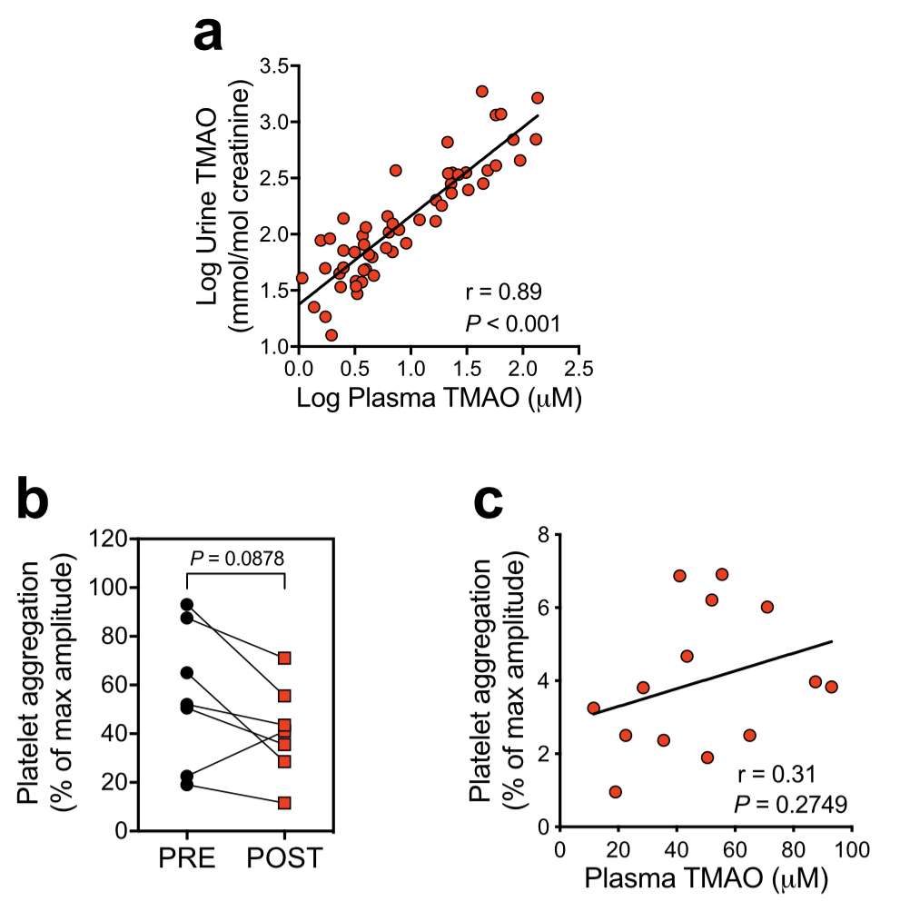
Supplementary Fig. 5 | Effect of raw garlic juice on plasma–urine TMAO correlation and platelet aggregation in TMAO producers (n = 7) who received an intervention of garlic juice (55 mL, equivalent to 48 mg of allicin/day) for 1 week, following which they were subjected to OCCT. (a) Pearson’s correlation of log plasma and urine TMAO, (b) platelet aggregation; and (c) Pearson’s correlation of plasma TMAO level and platelet aggregation. Statistical analysis was performed using two-tailed paired Student’s t-test.

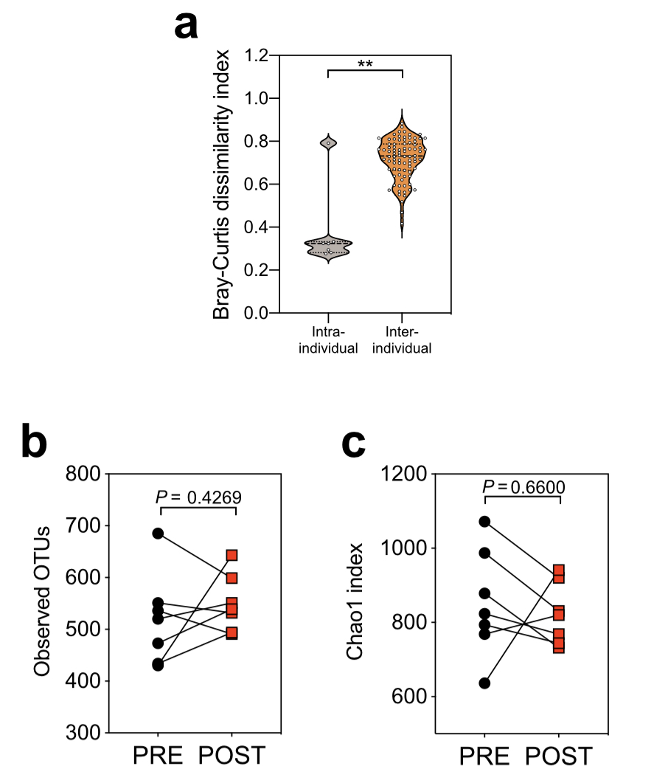
Supplementary Fig. 6 | Effect of raw garlic juice on fecal microbiota in healthy TMAO-producing participants (a) Bray-Curtis dissimilarity, α-diversity index (b) observed OTUs, and (c) Chao1 index. Statistical analysis was performed using Wilcoxon signed-rank test (**p<0.01) and two-tailed paired Student’s t-test with P-value.

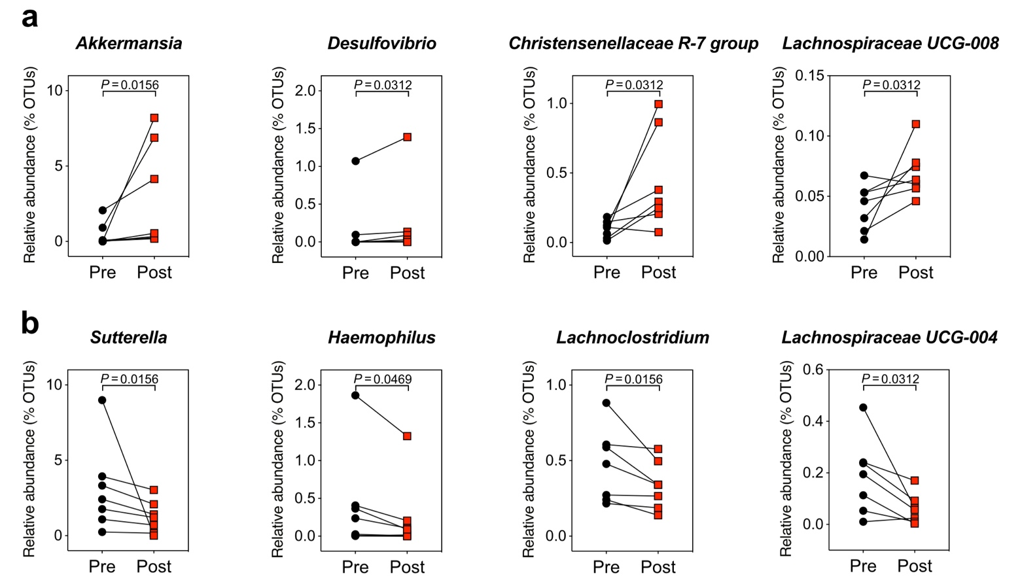
Supplementary Fig. 7 | Effect of fresh garlic juice on fecal microbiota at the genus level in TMAO producers (n = 7) who received an intervention of garlic juice (55 mL, equivalent to 48 mg of allicin/day) for 1 week, followed by OCCT. (a) Genera exhibiting increase in relative abundance, (b) Genera exhibiting decrease in relative abundance after intake of raw garlic juice for one week. Statistical analysis was perform using paired-Wilcoxon signed-rank test.

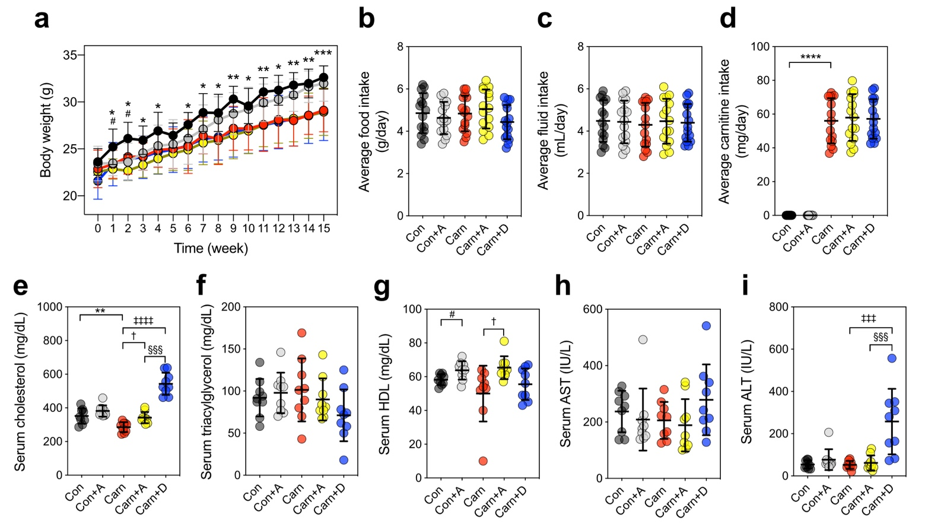
Supplementary Fig. 8 | Effect of allicin and carnitine on ʟ-carnitine-induced atherosclerosis ApoE^{−/−} mice. (a) Changes in body weight; (b) average food intake; (c) average fluid intake; (d) average carnitine intake; (e) serum cholesterol; (f) triacylglycerol; (g) high-density lipoprotein (HDL); (h) aspartate aminotransferase (AST); and (i) alanine aminotransferase (ALT). Statistical analyses were performed using an unpaired two-tailed Student’s t-test control vs control + allicin group (#, p < 0.05), control vs carnitine group (*, p < 0.05; **, p < 0.01; ***, p < 0.001; and ****, p < 0.0001); one-way ANOVA with Tukey’s range test for comparisons, carnitine vs carnitine + allicin group (†, p < 0.05), carnitine vs carnitine + DMB group (‡‡‡, p < 0.001; and ‡‡‡‡, p < 0.0001), carnitine + allicin vs carnitine + DMB group (§§§, p < 0.001).

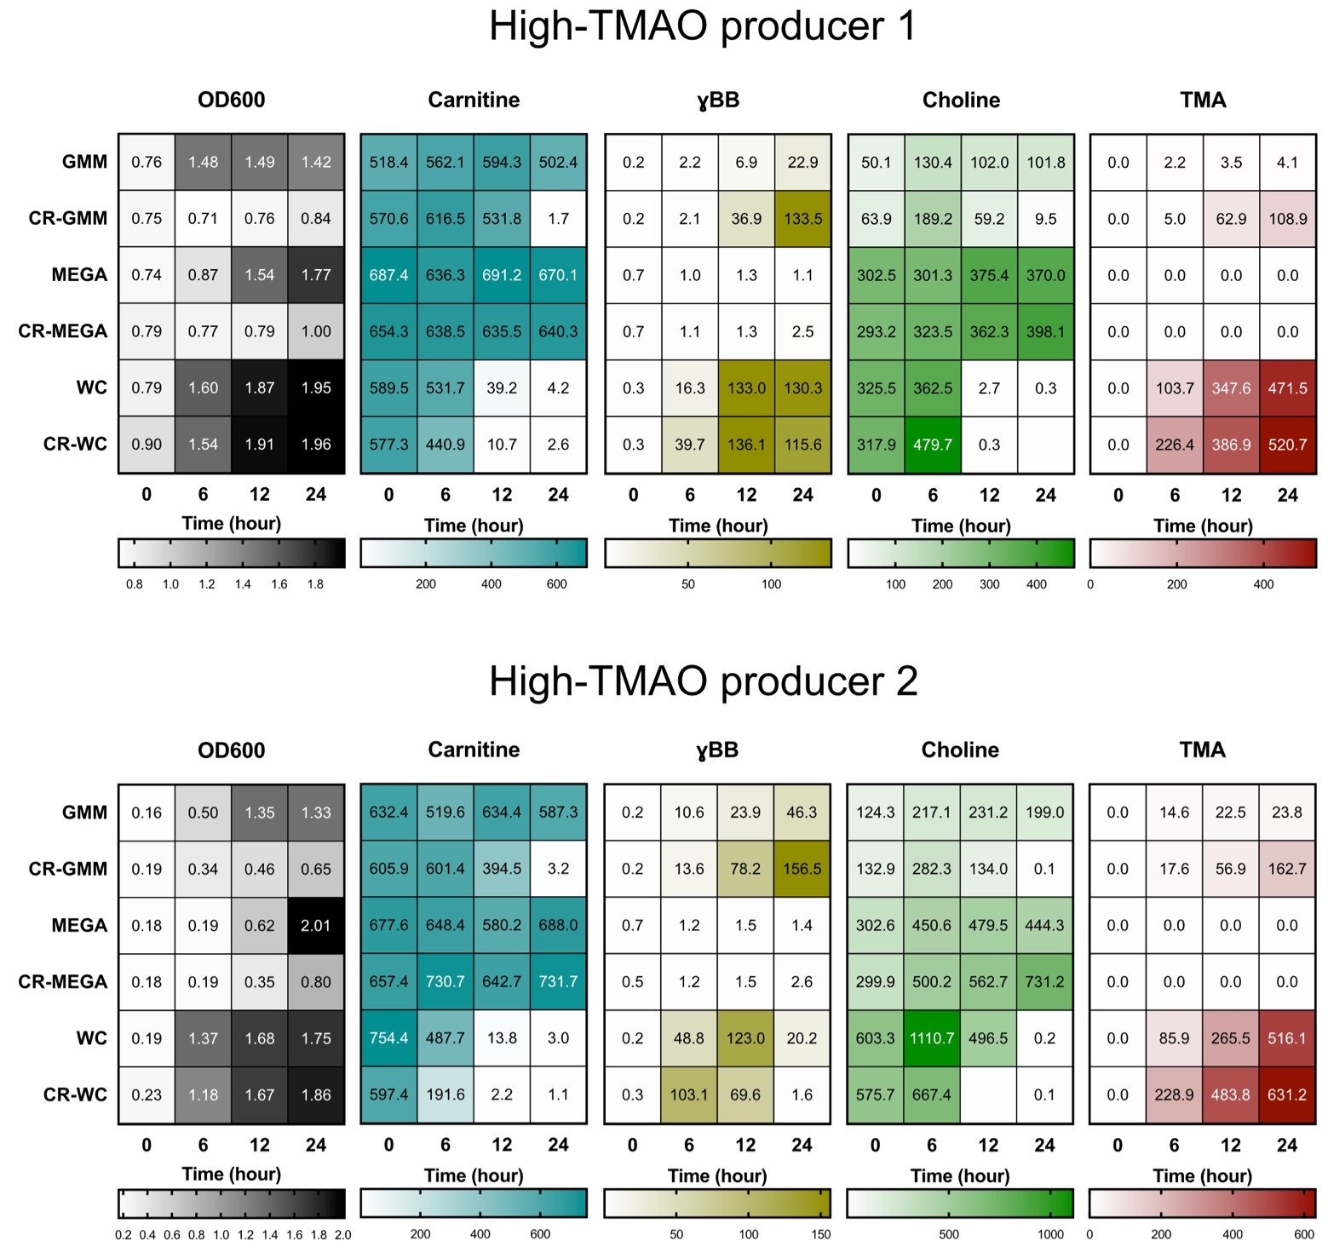
Supplementary Fig. 9 | Comparison of the TMA-producing ability in different media and its carbon-reduced media supplemented with ʟ-carnitine and inoculated with feces from two high-TMAO producer. The Wilkins–Chalgren (WC) medium and its carbon-reduced medium exhibited the highest concentration of TMA after 24 h of culture. GMM: gut microbiota medium; MEGA: mega medium; WC: Wilkins–Chalgren medium; CR-GMM: carbon-reduced gut microbiota medium; CR-MEGA: carbon-reduced MEGA medium; CR-WC: carbon-reduced Wilkins–Chalgren medium.

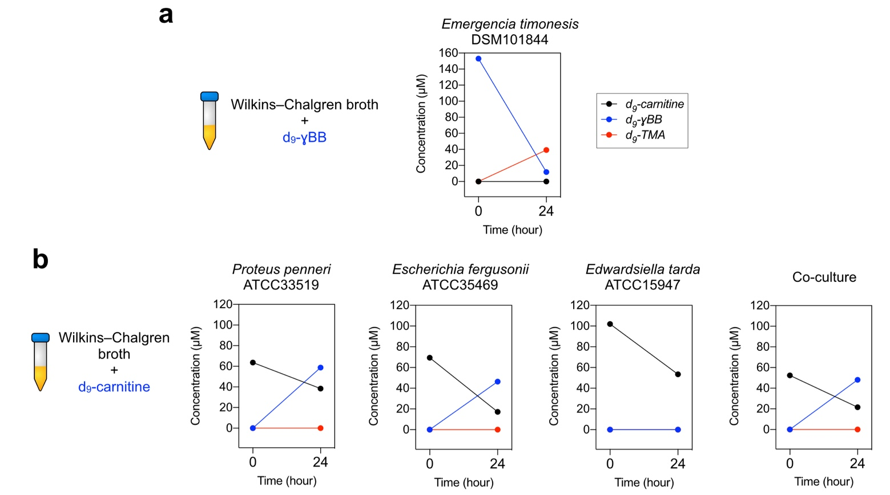
Supplementary Fig. 10 | The utilization of (a) d9-ɣBB by Emergencia timonensis DSM101844 for production of d9-TMA in Wilkins–Chalgren (WC) broth supplemented with d9-γBB; and the utilization of (b) d9-carnitine by Proteus penneri ATCC33519, Escherichia fergusonii ATCC35469, Edwardsiella tarda ATCC15947, and their co-culture in WC supplemented with d9-carnitine.

Supplementary Table 1. | Effect of raw garlic juice on plasma biochemistry of TMAO producers (n = 7) who received an intervention of garlic juice (55 mL, equivalent to 48 mg of allicin/day) for 1 week.

Blood biochemistry ª | Garlic Juice Intervention ^{b} |  | P-value ^{c} | Normal ranges
Blood biochemistry ª | PRE (n = 7) | POST (n = 7) | P-value ^{c} | Normal ranges
Glucose-AC (mg/dL) | 78.0 ± 12.4 | 80.1 ± 6.9 | 0.5757 | 65-100 (mg/dL)
AST (U/L) | 16.9 ± 3.4 | 21.1 ± 5.6 | 0.0105 | <40 (U/L)
ALT (U/L) | 9.6 ± 8.6 | 13.4 ± 9.4 | 0.0012 | <41 (U/L)
BUN (mg/dL) | 12.9 ± 3.3 | 11.2 ± 1.0 | 0.2615 | 6-20 (mg/dL)
Creatinine (mg/dL) | 0.8 ± 0.2 | 0.8 ± 0.1 | 0.1723 | 0.7-1.2 (mg/dL)
T-Cholesterol (mg/dL) | 176.6 ± 33.5 | 189.4 ± 50.0 | 0.3430 | <200 (mg/dL)
Triglyceride (mg/dL) | 78.9 ± 20.7 | 71.6 ± 24.5 | 0.2846 | <150 (mg/dL)
HDL-C (mg/dL) | 64.1 ± 16.3 | 66.4 ± 17.1 | 0.0703 | >40 (mg/dL)
LDL-C (mg/dL) | 106.6 ± 29.9 | 122.1 ± 49.4 | 0.2511 | <100 (mg/dL)
CRP-C (mg/dL) | 0.04 ± 0.03 | 0.05 ± 0.05 | 0.3559 | <0.50 (mg/dL)
ª Abbreviation: AST, Aspartate Aminotransferase; ALT, Alanine Aminotransferase; BUN, Blood Urea Nitrogen; HDL-C, High Density Lipoprotein Cholesterol; LDL-C, Low Density Lipoprotein Cholesterol, CRP-C, C Reactive Protein.
^{b} Blood biochemistry data of healthy subjects are shown above. All data are presented as mean ± SD.
^{c} P-value calculated using paired t-test comparing PRE and POST garlic juice intervention are shown.

Supplementary Table 2 | Gut microbiota medium (GMM) and its carbon-reduced medium recipe

Gut microbiota medium (GMM) | Regular medium | Carbon-reduced medium
 | (1 L) | (1 L)
Tryptone Peptone | 2 g | 2 g
Yeast Extract | 1 g | 1 g
ᴅ-glucose | 0.4 g | -
ʟ-cysteine | 0.5 g | 0.5 g
Cellobiose | 1 g | -
Maltose | 1 g | -
Fructose | 1 g | -
Meat Extract | 5 g | 5 g
KH₂PO4 | 100 mL | 100 mL
MgSO₄-7H₂0 | 0.002 g | 0.002 g
NaHCO₃ | 0.4 g | 0.4 g
NaCl₂ | 0.08 g | 0.08 g
CaCl₂ | 1 mL | 1 mL
Vitamin K (menadione) | 1 mL | 1 mL
FeSO₄ | 1 mL | 1 mL
Histidine Hematin Solution | 1 mL | 1 mL
Tween 80 | 2 mL | 2 mL
ATCC Vitamin Mix | 10 mL | 10 mL
ATCC Trace Mineral Mix | 10 mL | 10 mL
Acetic acid | 1.7 mL | 1.7 mL
Isovaleric acid | 0.1 mL | 0.1 mL
Propionic acid | 2 mL | 2 mL
Butyric acid | 2 mL | 2 mL
Resazurin | 4 mL | 4 mL

Supplementary Table 3 | MEGA medium (MEGA) and its carbon-reduced medium recipe

MEGA medium (MEGA) | Regular medium | Carbon-reduced medium
 | (500 mL) | (500 mL)
Tryptone Peptone | 5 g | 5 g
Yeast Extract | 2.5 g | 2.5 g
ᴅ-(+)-Glucose | 1 g | -
ʟ-Cysteine HCl | 0.25 g | 0.25 g
1 M Potassium Phosphate Buffer, pH 7.2 | 50 mL | 50 mL
TYG Salt Solution | 20 mL | 20 mL
Vitamin K Solution | 500 μL of 1 mg/mL | 500 μL of 1 mg/mL
0.8 % CaCl₂ | 500 μL | 500 μL
FeSO₄·7H₂O | 500 μL of 0.4 mg/mL | 500 μL of 0.4 mg/mL
Resazurin | 2 mL of 0.25 mg/mL | 2 mL of 0.25 mg/mL
Histidine-Hematin | 500 μL | 500 μL
dH₂O | 150 mL | 150 mL
ᴅ-(+)-Cellobiose | 0.5 g | 0.5 g
ᴅ-(+)-Maltose | 0.5 g | 0.5 g
ᴅ-(-)-Fructose | 0.5 g | 0.5 g
Soluble Starch | 12.5 mL of 2 % | 12.5 mL of 2 %
Tween 80 | 1 mL of 25 % | 1 mL of 25 %
Meat Extract | 2.5 g | 2.5 g
Trace Mineral Supplement (ATCC) | 5 mL | 5 mL
Vitamin Supplement (ATCC) | 5 mL | 5 mL
SCFA Supplement (Modified Recipe) | 3.75 mL | 3.75 mL

Supplementary Table 4 | Wilkins–Chalgren medium (WC) and its carbon-reduced medium recipe

Wilkins-Chalgren medium (WC) | Regular medium | Carbon-reduced medium
 | (1 L) | (1 L)
Tryptone | 10 g | 10 g
Gelatin peptone | 10 g | 10 g
Yeast extract | 5 g | 5 g
Glucose | 1 g | -
Sodium chloride | 5 g | 5 g
ʟ-Arginine | 1 g | 1 g
Sodium pyruvate | 1 g | 1 g
Menadione | 0.0005 g | 0.0005 g
Hemin | 0.005 g | 0.005 g

