Supplementary information to paper

Geometry encoded molecular dynamics enables deep learning insights
into P450 regiospecificity control.

Denis POMPON*, Luis F. GARCIA-ALLES, Philippe URBAN,

Toulouse Biotechnology Institute, Université de Toulouse, CNRS, INRAE, INSA, 135 Avenue de Rangueil, Toulouse, France

* Corresponding author: dpompon@insa-toulouse.fr

Figure S1. Protein side chain envelopes at active sites and CAVER channel profile. a, protein envelopes at the productive and effector sites of P450. b, CAVER channel view in a near-perpendicular orientation to panel a. Calculated energy profile along the CAVER channel.

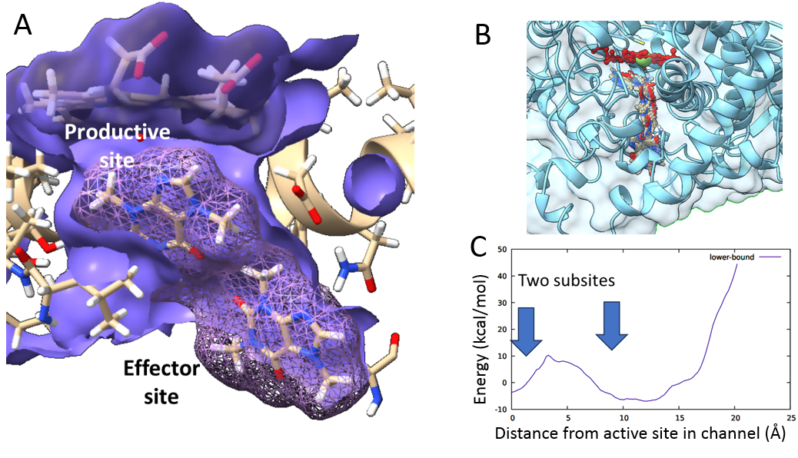

Figure S2. Processing flow for the conversion of geometric parameter distributions to sets of Gaussian components. a, MD trajectories involving presence of a single caffeine on the L or R face configuration (LN, RN), presence of two caffeine molecules all in the L (LL), all in the R (RR) or with mixed (LR) configurations, and rotamer involving a single substrate (LrN, NLr) or two substrates (LrL, LLr) were considered. Lr stand for a set of 12 rotations and N to the absence of substrate at producer (N-) or effector (-N) subsite. See supplementary tables for complete descriptions. b, for each condition, individual MD trajectories were sampled at 40 ps intervals and pooled. Time series of coordinates were converted into sets of geometrical descriptors prior to automated decomposition of each descriptor course into sets of Gaussian distributions. c, typical cases of conversion of time series of descriptors to Gaussian distributions are illustrated.

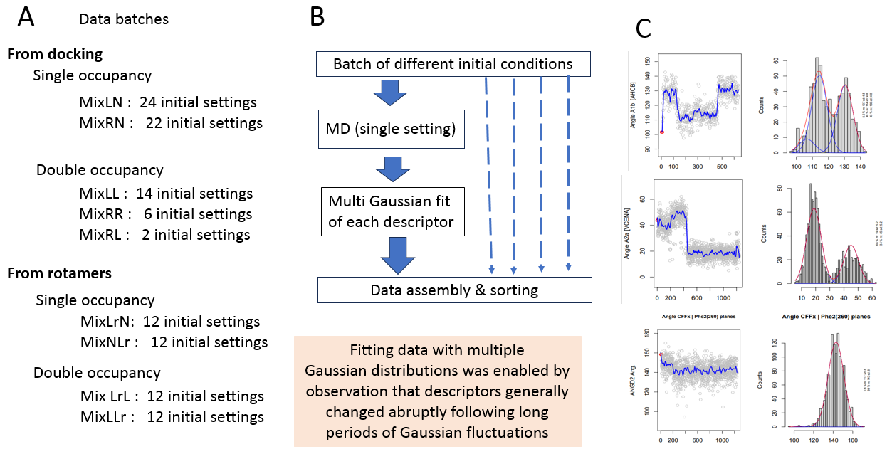

Figure S3. Gaussian components of the distributions of geometric descriptors corresponding to MD trajectories observed for a single caffeine in the L face configuration. For each trajectory, MD poses were sampled, converted into geometrical descriptors and their distributions fitted by sets of Gaussian distributions. The means for the major (black points), the secondary (green) and eventually the minor (yellow) distributions and the corresponding standard deviations (bars) were plotted for each considered descriptor. Each set of symbols on the vertical axis correspond to a unique MD trajectory. The order of MD trajectories on x-axis was identical for all panels and was defined to place the major component of the Imin descriptor (panel a) sorted by increasing values. For each panel (a-l) a different geometric parameter was considered. The Imin labels were repeated on the y-axis of panel a to avoid plot discontinuities due to the cyclic nature of orientations and improve readability. However, this ordering can for the same reasons introduce visual discontinuities (panel d for example) on angle representations for other panels (angle values defined are modulo 360°)
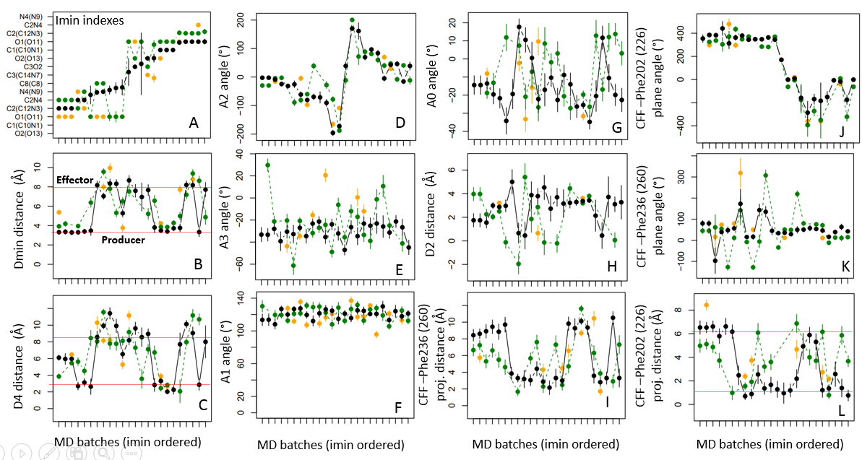

Figure S4. Relations between geometric parameters deduced from MD trajectories of caffeine at active site. A single caffeine on the L face configuration was considered. The D2 distance between the active oxygen and the closest caffeine methyl group was color-encoded. Each point corresponds to a recorded MD pose (40 ps intervals).
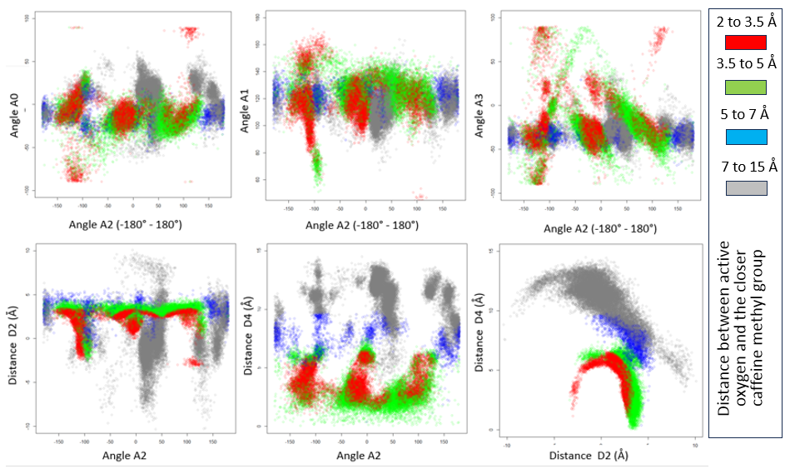

Figure S5. Examples of caffeine exchange between the producer and the effector sites. Corresponding events in a given time series were marked by red arrows and illustrated for different geometric descriptors as indicated in titles. Each panel pairs shows on its left part the time series (values of descriptor vs. times) and on its right part the distribution of the count of observed values (counts vs. values). Timescale is given as counts of 40 ps intervals. The figure related to events observed during the OMM37B MD runs (see supplementary material for details).
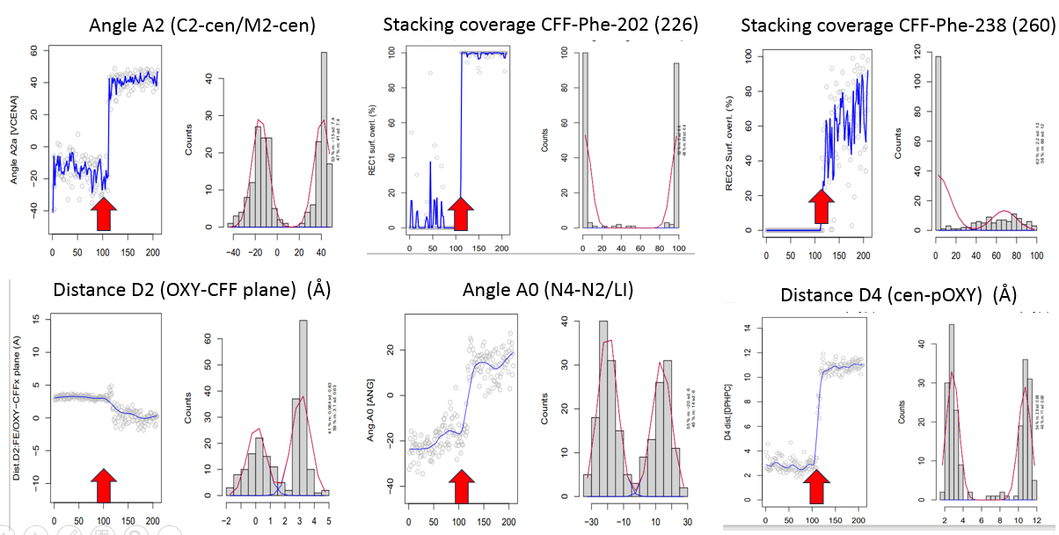

Figure S6. Time-shift sequences of conformational changes during caffeine exchanges between the producer and effector sites. Event 1: top panels (a-d): a, initial long-life configuration (0 to 16 ns) with caffeine methyl C1 (C10) at ~4 Å of active oxygen. The red, green, and blue areas represent, respectively, the C1, C2 and C3 methyl occupancy density during this period. b, rotation of Phe202 (226) and move of the substrate, initiating stacking panel c. the Phe202 (226) assisted transfer of caffeine to the effector site was achieved in d. Event 2: bottom panels (e-h). e, initial caffeine conformation with methyl C2 (C12) at 3.4Å of active oxygen. f, rotation of the phenylalanine, substrate capture by stacking (g), and new final stable configuration at the effector site (h). The frame intervals were 40 ps.
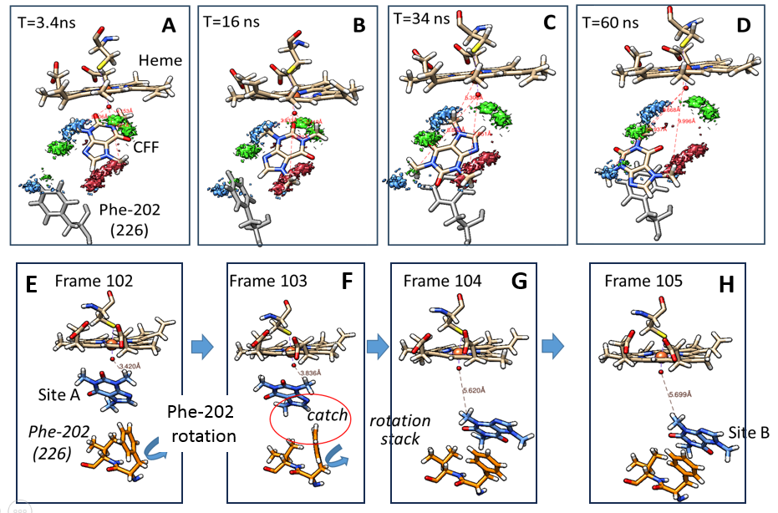

Figure S7. Rapid transition between a long-life caffeine geometry at the producer and effector sites. a, a rapid transition between alternate geometries at the producer site led to identical configurations of the C2 methyl group close to active oxygen (main metabolite forming) relative to active oxygen. The red and blue clouds represent the densities of presence of caffeine C2 and C3 methyl, respectively. During the transition, the density of the presence of C3 methyl suddenly shifts from the dop1 to the dop2 blue region, while that of C2 methyl (red color) remains unchanged, not affecting its distance from active oxygen (panel a, lower part). b, rapid conformational transitions at the effector site. The blue, red, and yellow clouds represented the densities of methyl groups C1, C2, and C3 before and after the event. The caffeine geometry was overlaid before (top) and after (bottom) the event. The time frame for pose sampling (dots) was 40 ps.
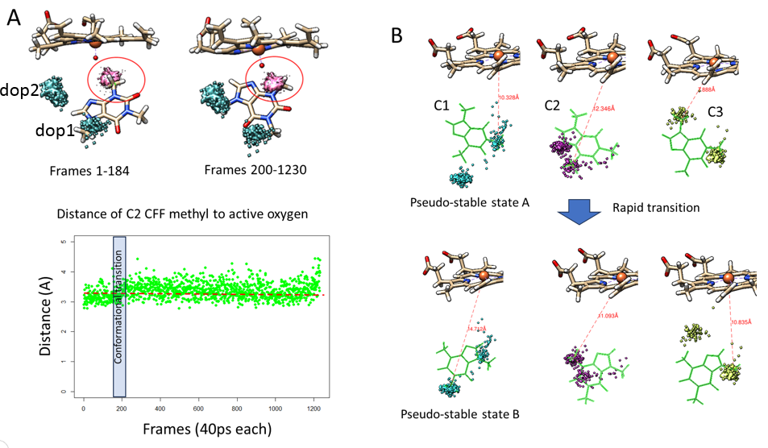
Figure S8. Rationally designed caffeine rotamers at the producer (a) and effector (b) sites. Rotamers consisted of regular rotations by 30° steps of caffeine around the geometric centroid of its three methyl groups, keeping the average plane of the substrate unchanged. The initial positions at the producer and effector sites were chosen based on those observed most frequently in MD trajectories. a, overlay (yellow) of all considered rotamers at the producer site viewed in orthogonal orientations. b, similar figure for rotamers at the effector site. Figures represent unrelaxed MD settings. For the sake of clarity, only amino acid numbering corresponding to the full-length sequence is given. Heme is represented in gray color on the top part of panels.
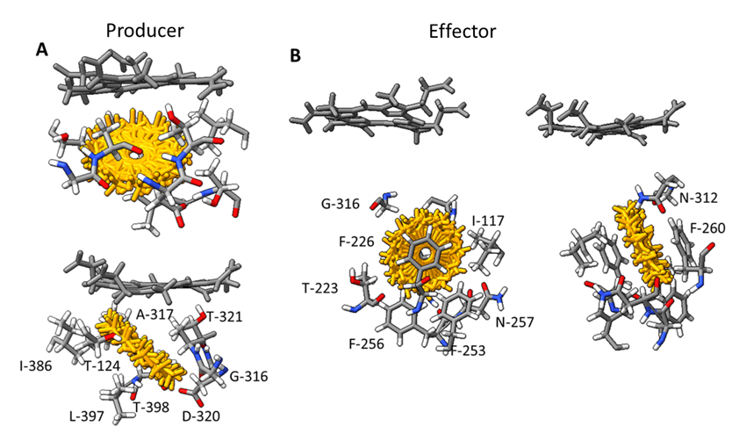

Figure S9. Progressive orientation of caffeine when approaching the producer site. MD trajectories considered correspond to a single caffeine on the L (left panel) or the R (right panel) face configurations. For each pose, the caffeine atom closest to active oxygen (Imin) was identified, and the resulting orientations counted by distance ranges as a function of the Dmin distance (x-axis on the figure). Pose counts (y-axis) were performed separately for each orientation and for each range of distance and plotted. MDS maps of geometric descriptors corresponding to the same set of data is visualized as insert. Distributions as a function of Dmin of the counts of C1, C1-O1 and C8 Imin values are overlaid illustrating for the L configuration a dominant C2 orientation leading to the main metabolite at proximity of active oxygen.

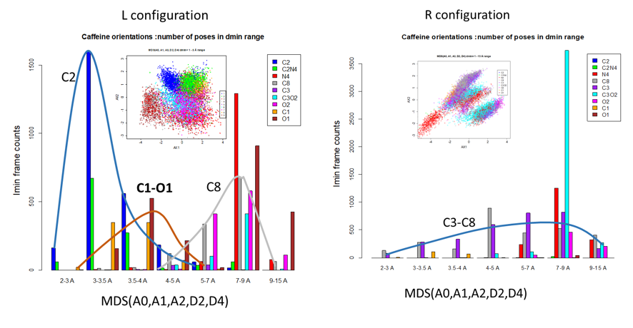
Figure S10. Deep learning model used. Computation was performed using a R code that connects the KERAS python layer and the TENSORFLOW (CUDA) models. The model involved five neuron layers (9, 128, 64, 12 and 2 neurons, respectively) and one dropout layer. All geometric parameters were variance normalized and centered, and angles were managed as cosine/sine pairs on both input and output. The learning sets involved 10,000 to 50.000 sets of MD poses.

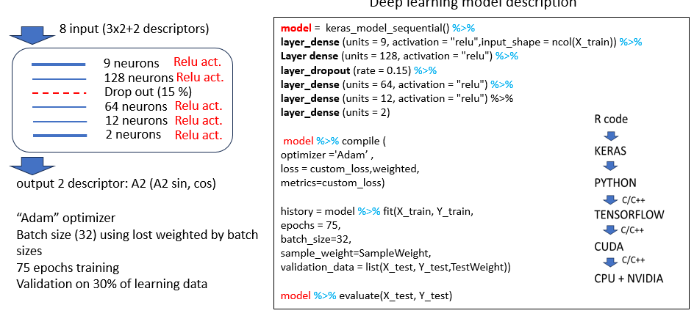

Figure S11. Evaluation of success score background during machine learning of geometrical descriptors. Potential background of false matches was evaluated for scoring defined as the proportion of matches between the expected (from MD trajectories) and the corresponding predicted (machine learning) A2 values assuming an error tolerance of 15 ° (visualized as rectangle on panels a1-d1). Maps of expected vs. predicted angle values (top panels), graphs of uncorrected scores (middle panels) and angle specific uncorrected scores (bottom panels) are illustrated. Panels a1-a3: proportions of A2 values matching within the tolerance two identical copies of the A2 dataset following randomization of their relative order. Other panels: maps and proportion of matches between MD determined and machine learning predicted A2 values. Panels b1-b3, the order of their geometric contexts but not of the corresponding A2 values was randomized before the learning phase. Panels c1-c3, the order the geometric contexts was kept unchanged but the order of the corresponding A2 values was shuffled before learning phase. d1-d3, correspondence of geometric contexts and A2 values was in contrast maintained. In each of a2-d2 panels, each bar (consistently colored between panels) corresponds to a distinct set of MD trajectories using the naming codes (in abscissa) defined in the supplementary tables. For panels a3- d3, all sets of MD trajectories were pooled and uncorrected prediction scores calculated for specific ranges of A2 values and Dmin distances. Angle ranges are given in panels abscissa and Dmin values were color-encoded: red (<3.5Å), green (3.5-5 Å), gray (>5Å).
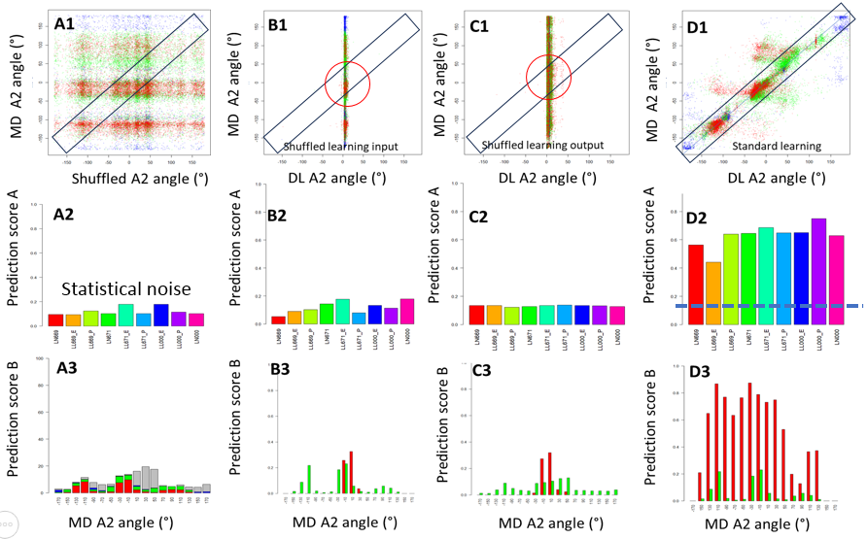
Figure S12. Effects on scoring quality of pondering success scores by learning efficiency. Panels a-d, unperturbed association of geometric descriptors and corresponding A2 angles was used during learning. Panels e-h the relative order of geometric descriptors and corresponding A2 angles was randomized prior to learning thus breaking association. Modules of the cosine/sine value pair corresponding to each A2 angle prediction were evaluated for each series of data and classified into ten ranges of values. For each trajectory (x-axis labels), uncorrected scores (b, f) and the count of sine/cosine modules falling into defined ranges (panels a, e) were plotted. Corrected scores were calculated by ponderation of raw scores using coefficients derived from these modules (c, g, see methods section) or using a threshold value for modules (d, h). The vertical red line indicates the chosen threshold used to filter out poorly learned samples during success scoring. Blue horizontal lines on b, c, f, g panels illustrate the maximum contributions on uncorrected scores that was estimated to possibly occur due to fortuitous matches.
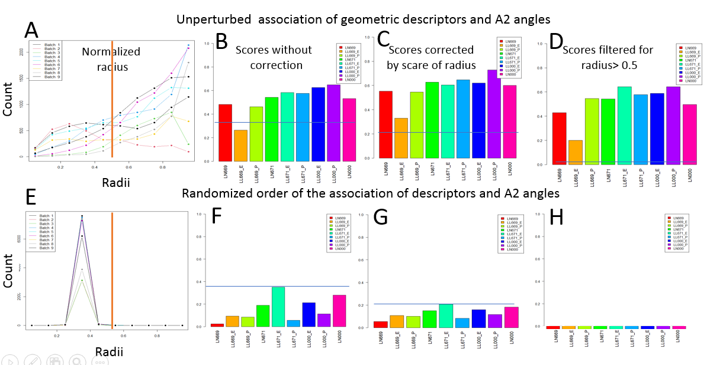

Figure S13. Global and angle-specific success scores as a function of the caffeine subsite considered and single or double substrate occupancy. MD poses involving both single and double substrate occupancies and caffeine in with the L face configuration were pooled and used as a global learning set. a, loss function calculated using a learning subset (blue) or an independent evaluation subset (green). b, plot of expected (MD trajectories) and predicted (machine learning) values for A2 angles using the Dmin values for color-encoding of points (red:1-3.5 Å, green: 3.5-5 Å, blue: 5-7 Å). c, corresponding corrected success scores (see supplementary tables for x-axis labelling of trajectories). d-f, corrected success scores dependence on Dmin distance and A2 angle ranges. Colors of bars on panels b, c, d, e, f are unrelated, but panel c colors correspond to bar colors on Fig. S12.

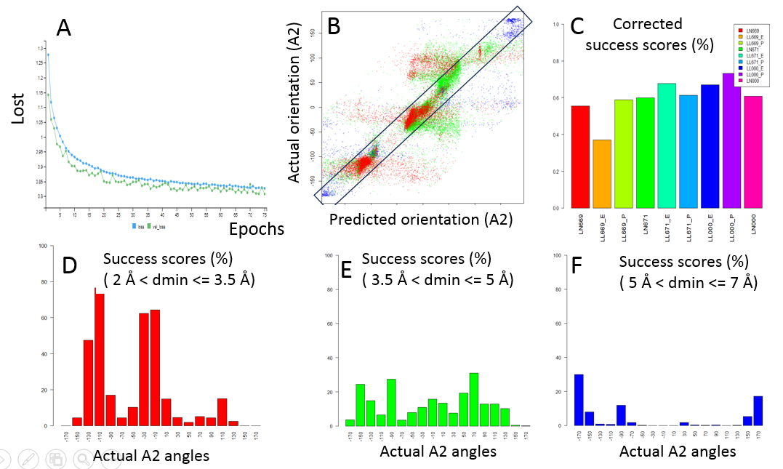
Figure S14. MDS maps correlating caffeine orientation to geometric descriptors differed between single and double occupancy conditions. Maps (panels a, b, c, d) were built from the two MDS components derived from geometric descriptors and corresponding color-coded substrate orientations similarly to Fig. 6. Single (c, d) and double (a, b) occupancy conditions were considered either at the producer (b, d) or at the effector (a, c) subsites. Data from panels a1, b1, c1, d1 corresponded to maps a, b, c, d, respectively, and represented event counts classified by caffeine orientations and Dmin distances as labeled in graphical legends.
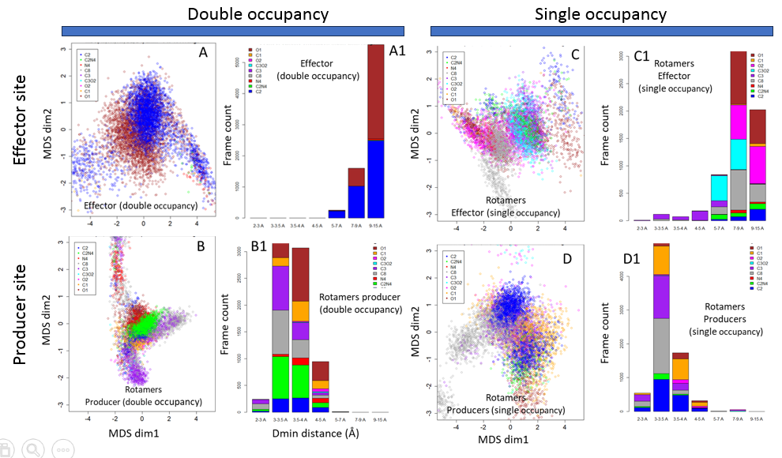
Figure S15. Set of complementary figures given as a downloadable zip file. This set includes 7056 additional figures in PDF format that were automatically generated by scripts and corresponding to analysis of all primary and derived geometric parameters and the statistics for each individual MD trajectory used in the presented work. Supplementary tables list metadata associated to these MD runs. The downloadable zip file includes nine folders. LL, RL, RR, LN, RN correspond to sets of MD trajectories with alternate occupancies and caffeine face configurations as discussed in the paper. “Serie669” corresponds to rotamers at the effector site in double occupancy, “serie671” to rotamers at the producer site in double occupancy, and “serie669_1CFF” and “serie671_1CFF” correspond to corresponding MD trajectories involving single occupancies. Each folder contains multiple PDF files, each corresponding to one particular run of MD, as indicated by their names. For each file, the first page gave a description of the corresponding MD run, followed by 48 figures summarizing the data. All data processing was performed with a unique R script and associated descriptor files that have been deposited on GitHub. Raw data files required to run scripts, and processed files can be downloaded at https://doi.org/10.57745/AEB7SV. Downloading of R-library dependencies of scripts, an operational Python implementation of Keras, TensorFlow, and CUDA software, as well as a Nvidia hardware accelerator, are required for execution.

Figures can be downloaded at https://doi.org/10.57745/AEB7SV in DataSet.zip file

Table S1. Definition of geometric parameters used in the figures.
Keywords
CAFFEINE, caffeine; cen, centroid i.e. center of the circle encompassing the three caffeine methyl groups; MDS: multidimensional scaling; DL, deep learning, MDs, molecular dynamics, SO, single occupancy, DO, double occupancy.
Geometric anchors
N1-N4 porphyrin nitrogen atoms.
M1: heme iron or active oxygen (depending on case)
M2, pOXY: projection of M1 on average caffeine plane
M3: centroid of caffeine methyl groups
M4: C2 (C12 methyl) of caffeine
MP1: projection of M1 on intersect line of average porphyrin and caffeine planes.

Primary geometric parameters (see also figures).
- A0, angle $between AX0=\vec{N2N4}$ (N2 and N4 of porphyrin nitrogen) and the intersect line (LI) between heme (P1) and caffeine (P2) average planes.
- A1, angle between the average heme and caffeine planes
- A2, oriented angle between the M2-M3 (AX3) and the M3-M4 (AX4) vectors.
- A3, oriented angle between the MP1-M2 (AX1) and the M2-M3 (AX4) vectors
- A4, oriented angle between the MP1-M2 (AX1) and the MP1-M3 (AX2) vectors
- D2: distance (M1-M2) of iron or active oxygen (depending on case) to caffeine plane.
- D4: distance (M2-M3) of caffeine centroid to iron or active oxygen (depending on case) projection on caffeine plane.
- The M3-M4 distance was not used as a parameter and was frozen to its average value in molecular dynamics.

Angle orientation rules.
The following conventions were used:
- The angles were primarily defined in the [-180° to +180 °], with an eventual offset in some figures by a multiple of 360 ° for readability (continuity of curves).
- A0 was taken positive when matching oriented rotation between N4, N1, N2 porphyrin nitrogens, negative in the contrary.
- A2, A3, A4 were taken positive when their orientations matched rotation between C1, C2, C3 caffeine methyl groups. Therefore, performing a 180° rotation of caffeine around its M3-C1 axis (mirroring) negated A3 and A4 but kept A2 unchanged.
- The distance D4 was taken as an algebraic value with a positive sign when M2 and M3 were on the same face of the P1-P2 dihedra, negative in the contrary. This rule allowed us to maintain continuity of A3 and A4 values when the M2 position on the caffeine plane crossed the porphyrin plane.
Due to previous conventions, geometric encoding was consistent and bijective for any conformation involving caffeine in the R or L face orientations. However, for the same relative positions between the caffeine centroid and the heme, A3 and A4 had opposite values depending on the orientation of the caffeine face in the channel. This was considered when comparing deep learning in these two situations.

Secondary geometrical parameters
Imin, caffeine orientation code was defined consistently with figure 270424-3 (Panel A). Values 1, 4, 5, 7, 8, 9 correspond to the orientation of caffeine that brings its atom C2(C12), C(C8), C3(C14), O2(O13), C1(C10), O1(O11) to the closer position compared to active oxygen, respectively. Values 2, 3, 6 correspond to intermediate orientations as described in the figure. The definition is independent of the orientation of the caffeine face.
Dmin, Distance from active oxygen to the projection of the caffeine atom defined by Imin on the circle encompassing C1, C2 and C3 methyl group carbons.
Meaning of geometrical parameters
D4 encodes the distance between the centroid of caffeine and the optimal expected position for the formation of metabolites in the current caffeine plane.
D2 encodes the minimal possible distance between active oxygen and a caffeine atom.
A2, Imin encodes the orientation of the caffeine atom relative to the optimal orientation for potential metabolism.
Dmin controls the potential for metabolism. A putative threshold at 3.5 Å was considered for productive events.

Table S2: MD batch naming used in figure labelling.

Mix LN: Pool of MDs with single occupancy, caffeine on L face, alternate settings
Mix RN: Pool of MDs with single occupancy, caffeine on R face, alternate settings
Mix LL: Pool of MDs with double occupancy, caffeine on L face, alternate settings
Mix RR: Pool of MDs with double occupancy, caffeine on R face, alternate settings
Mix RL: Pool of MDs with double occupancy, caffeine on R face at productive site and L face at effector site, alternate settings
Mix LrL: Pool of MDs with double occupancy, caffeine on L face, rotamer setting at producer site, fixed setting at effector site.
Mix LLr: Pool of MDs with double occupancy, caffeine on L face, fixed setting at the producer site, rotamer setting at the effector site.
Mix LrN: Pool of MDs with single occupancy, caffeine on L face, rotamer setting at producer site.
Mix NLr: Pool of MDs with single occupancy, caffeine on L face, rotamer setting at effector site.
'Alternate settings' means sampling the alternate position from the docking or the use of final or intermediate configurations of previous MDs to initiate a new MD with identical or different conditions.

Annotation equivalences between figures: LN669: NLr all sites; LL669_E: LLr effector site; LL669_P: LLr producer site; LN671: LrN all sites; LL671_E: LrL effector site; LL671_P: LrL producer site; LL000_E: LL effector site; LL000_P: LL producer site; LN000: LN all sites
Batches | Run ID | Faces* | Origin | P450 iron
MixLL | 1-12, 62, 63 | LL | Docking | OXO
MixLN-a | 15,17,18-20,22,49-55,57-60,70,75 | LX | Docking | OXO
MixLN-b | 25,26,30-32 | LX | Docking | OX
MixRN-a | 16,44-48, 71-74 | RX | Docking | OXO
MixRN-b | 24,33-38,36-41,43,61 | RX | Docking | OX
MixRR | 64-69. | RR | Docking | OXO
MixRL | 13,14 | RL | Docking | OXO
Set669_2 | 100-123 | LL | Rotamers | OXO
Set671_2 | 76-99 | LL | Rotamers | OXO
Set669_1 | 136-147 | LL | Rotamers | OXO
Set671_1 | 124-135 | LL | Rotamers | OXO
*Active site occupancy: double: LL, RR, RL; single: LX and RX. The first letter of pairs stands for the caffeine site proximal to heme. L and R represent the caffeine side facing the heme, X when not present.

Table S3. Atom abbreviations and parameter codes used (alternate codes used in R-routines are in brackets)
CFF, CFFx: selected caffeine (either effector or producer site, depending on context)
CFFa, CFFb: caffeine at effector (a) or producer (b) site, respectively
FE, OXY (activated oxygen), N1-N4: heme iron, active oxygen, and porphyrin nitrogen bound to iron, respectively.

Relative geometry of heme and caffeine sites (relative coordinate definitions)
- M1: FE, OXY, or centroid of N1-N4 atoms depending on context.
- M2: orthogonal projection of FE or OXY on target caffeine plane
- M3: (cenCFF, cenCFFa, cenCFFb): centres of circles circumscribed to C1(C10), C2(C12), C3(C14) caffeine atoms (selected, effector, producer sites)
- M4: C1 (C10), C2 (C12), and C3 (C14) CAFFEINE atoms depending on context.
- MP1: orthogonal projection of FE or OXY on the intersect line of porphyrin and considered caffeine planes.
- M3, M4: considered the cenCFF and C2 (C12) atom of caffeine, respectively.

Relative geometry of heme and caffeine sites (angle, distance definitions)
- A0: (ANG): angle between porphyrin N2-N4 axis and intersect line of porphyrin and caffeine planes.
- A1: (AHCA, AHBC): angles between the porphyrin plane and the caffeine plane considered.
- A2: (ANGC2, VCENA, VCENB): angles between the caffeine -C2 and caffeine -A2 vectors
- A3: angle between the MP1-M2 and the caffeine -M2 vectors
- A4: angle between the MP1-M2 and the MP1- caffeine vectors
- D2: (OPDC), D4 distances M1-M2 and M2-M3, respectively.
- D4: (DPCCO): distance cenCAFFEINEx-M2

Orientation of caffeine oxidizable atoms relative to active oxygen
- DCMO: Closest distance from oxidizable CFFx atom to OXY
- COC (COMP, IDENC, IDCMCF): Orientation code for the oxidizable CFFx atom closest to OXY
- COMP: Code for CFFx potential metabolite formation (combine COC and DCMO)

Relative geometries of caffeine and Phe 226 and 260
- CCTPP: distance from cenCFFEx to Phe1 (226) plane
- CCTPPb: similar to CCTPP but applied to Phe2 (260) plane.
- DPCPC: distance from Phe1 (226) cen to plane to projection of cenCFFEx on Phe1 plane
- DPCPCb: similar to DPCPC but applied to Phe2 (260)
- CPPA: Angle of the CFFEx and Phe1 (226) planes
- CPPAb: similar to CPPA but applied to Phe2 (260)
- SCM: % of surface overlap between the Phe1 (226) aromatic ring and the projection of CFFx C1, C2, C3 circle on Phe plane.
- SCMb: similar to SCM but applied to Phe2 (260)

Relative geometry of two caffeines when present at the active site.
- IDENA: Orientation code for theCFFa atom closest to cenCFFb
- IDENB: Orientation code for the CFFb atom closest to cenCFFa
- AHAB angle of CFFa and CFFb planes
- DCAB: Distance between cenCFFa and cenCFFb

Table S4. Index of molecular dynamic runs performed.

This is a list of tables requested to run scripts. The table encodes information required by scripts to recover the coordinates of specific elements in PDF files used in MDs. The column 'structure' encodes the nature and order of structural blocks of atoms present in PDF files: P: P450 protein; R: FMN domain of the reductase protein; H: heme; E: iron; O: active oxygen; C:caffeine(effector site);F: FMN; c: caffeine (producer site). Frames: number of recorded frames. N_P450d, C_P450d, N_FMNd: starting AA number of each element, respectively, SQN: semiquinone neutral flavin, FOX: oxidized flavin, HQA: hydroquinone flavin; OXY: oxidized heme; RED: reduced heme; FRO: ferrous dioxygen heme. Other columns are software utility codes.
Note that MDs involving alternate redox state of heme and flavin are not described nor used in this paper, but information required by scripts for extended analysis purposes.

ID Name Struct Frames N_P450d C_P450d N_FMNd C_FMNd FMN Heme SUPP
1 OMM01 PRHEOCFc 1232 1 495 496 665 SQN FRO 0
2 OMM1B PRHEOCFc 623 1 495 496 665 SQN FRO 0
3 OMM02 PRHEOCF 328 1 495 496 665 SQN FRO 0
4 OMM03 PRHEOCF 99 1 495 496 665 SQN FRO 0
5 OMM04 PRHEOCFc 89 1 495 496 665 SQN FRO 0
6 OMM05 PRHEOFC 765 1 495 496 665 SQN FRO 0
7 OMM06 PRHEOFC 534 1 495 496 665 SQN FRO 0
8 OMM07 PRHEOCFc 745 1 495 496 665 SQN FRO 0
9 OMM7B PRHEOCFc 745 1 495 496 665 SQN FRO 0
10 OMM08 PRHEOFC 351 1 495 496 665 SQN FRO 0
11 OMM09 PRHEOFC 765 1 495 496 665 SQN FRO 0
12 OMM10 PRHEOF 1259 1 495 496 665 SQN FRO 0
13 OMM11 PHEOC 859 1 495 496 665 VOD FRO 0
14 OMM12 PHEO 860 1 495 496 665 VOD FRO 0
15 OMM13 PRHEFC 218 1 495 496 665 FOX OXY 0
16 OMM14 PRHEFC 722 1 495 496 665 FOX OXY 0
17 OMM15 PRHEFC 562 1 495 496 665 FOX OXY 0
18 OMM16 PRHEF 785 1 495 496 665 FOX OXY 0
19 OMM16-2 PRHEF 653 1 495 496 665 FOX OXY 0
20 OMM17 PRHEF 653 1 495 496 665 FOX OXY 0
21 OMM18 PRHEFC 752 1 495 496 665 FOX OXY 0
22 OMM19 PRHEFC 750 1 495 496 665 FOX OXY 0
23 OMM20 PRHEFC 756 1 495 496 665 FOX OXY 0
24 OMM21 PRHEFC 822 1 495 496 665 HQA OXY 0
25 OMM22 PRHEFC 1271 1 495 496 665 FOX OXY 0
26 OMM23 PRHEFC 640 1 495 496 665 HQA OXY 0
27 OMM24 PRHEOCF 1271 1 495 496 665 FOX OXY 0
28 OMM25 PRHEFC 1509 1 495 496 665 HQA OXY 0
29 OMM26 PRHEFC 1099 1 495 496 665 SQN RED 0
30 OMM26B PRHEFC 608 1 495 496 665 SQN RED 0
31 OMM27 PRHEFC 254 1 495 496 665 FOX OXY 0
32 OMM28 PRHECF 1713 1 495 496 665 FRH OXY 0
33 OMM29 PHEC 800 1 495 496 665 VOD RED 0
34 OMM30 PHEC 131 1 495 496 665 VOD RED 0
35 OMM31 PRHEOFC 211 1 495 496 665 SQN FRO Ref O
36 OMM32 PRHEOFC 211 1 495 496 665 SQN FRO Ref O
37 OMM32B PRHEOFC 564 1 495 496 665 SQN FRO Ref O
38 OMM33 PRHEOFC 210 1 495 496 665 SQN FRO Ref O
39 OMM34 PRHEOFC 739 1 495 496 665 SQN FRO Ref O
40 OMM35 PRHEOFC 773 1 495 496 665 SQN FRO Ref O
41 OMM36 PRHEOFC 1461 1 495 496 665 SQN FRO Ref O
42 OMM37 PRHEOFC 44 1 495 496 665 SQN FRO Ref O
43 OMM37B PRHEOFC 209 1 495 496 665 SQN FRO Ref O
44 OMM37C PRHEOFC 44 1 495 496 665 SQN FRO Ref O
45 OMM38 PRHEOFC 43 1 495 496 665 SQN FRO Ref O
46 OMM39 PRHEOFC 43 1 495 496 665 SQN FRO Ref O
47 OMM40 PRHEOFCc 150 1 495 496 665 SQN FRO Ref O
48 OMM41 PRHEOCFc 284 1 495 496 665 SQN FRO Ref O
49 OMM42 PRHEOCFc 283 1 495 496 665 SQN FRO Ref O
50 OMM43 PRHEOFC 451 1 495 496 665 SQN FRO Ref O
51 OMM44 PRHEOFC 244 1 495 496 665 SQN FRO Ref O
52 OMM45 PRHEOFC 180 1 495 496 665 SQN FRO Ref O
53 OMM46 PRHEOFC 474 1 495 496 665 SQN FRO Ref O
54 OMM47 PRHEFC 466 1 495 496 665 SQN RED 0
55 OMM48 PRHEOCFc 493 1 495 496 665 SQN FRO Ref O
56 OMM49 PRHEOCFc 493 1 495 496 665 SQN FRO Ref O
57 OMM50 PRHEOCFc 207 1 495 496 665 SQN FRO Ref O
58 OMM51 PRHEOCFc 207 1 495 496 665 SQN FRO Ref O
59 OMM52 PRHEOCF 340 1 495 496 665 SQN FRO MM41
60 OMM53 PRHEOCF 338 1 495 496 665 SQN FRO MM42
61 OMM54 PRHEOCF 341 1 495 496 665 SQN FRO MM51
62 OMM55 PRHEOCF 341 1 495 496 665 SQN FRO MM50
63 OMM56 PRHEOCF 315 1 495 496 665 SQN FRO MM49
64 OMM57 PRHEOCF 315 1 495 496 665 SQN FRO MM48
65 OMM58 PRHEOCFc 1240 1 495 496 665 SQN FRO MM01 Pang 0
66 OMM59 PRHEOCFc 527 1 495 496 665 SQN FRO MM01 Pang 30
67 OMM60 PRHEOCFc 589 1 495 496 665 SQN FRO MM01 Pang 60
68 OMM61 PRHEOCFc 729 1 495 496 665 SQN FRO MM01 Pang 90
69 OMM62 PRHEOCFc 543 1 495 496 665 SQN FRO MM01 Pang 120
70 OMM63 PRHEOCFc 570 1 495 496 665 SQN FRO MM01 Pang 150
71 OMM64 PRHEOCFc 741 1 495 496 665 SQN FRO MM01 Pang 180
72 OMM65 PRHEOCFc 500 1 495 496 665 SQN FRO MM01 Pang 210
73 OMM66 PRHEOCFc 561 1 495 496 665 SQN FRO MM01 Pang 240
74 OMM67 PRHEOCFc 541 1 495 496 665 SQN FRO MM01 Pang 270
75 OMM68 PRHEOCFc 526 1 495 496 665 SQN FRO MM01 Pang 300
76 OMM69 PRHEOCFc 543 1 495 496 665 SQN FRO MM01 Pang 330
77 OMM70 PRHEOCFc 133 1 495 496 665 SQN FRO MM01 Eang 0
78 OMM71 PRHEOCFc 427 1 495 496 665 SQN FRO MM01 Eang 30
79 OMM72 PRHEOCFc 100 1 495 496 665 SQN FRO MM01 Eang 60
80 OMM73 PRHEOCFc 293 1 495 496 665 SQN FRO MM01 Eang 90
81 OMM74 PRHEOCFc 397 1 495 496 665 SQN FRO MM01 Eang 120
82 OMM75 PRHEOCFc 539 1 495 496 665 SQN FRO MM01 Eang 150
83 OMM76 PRHEOCFc 536 1 495 496 665 SQN FRO MM01 Eang 180
84 OMM77 PRHEOCFc 398 1 495 496 665 SQN FRO MM01 Eang 210
85 OMM78 PRHEOCFc 100 1 495 496 665 SQN FRO MM01 Eang 240
86 OMM79 PRHEOCFc 100 1 495 496 665 SQN FRO MM01 Eang 270
87 OMM80 PRHEOCFc 273 1 495 496 665 SQN FRO MM01 Eang 300
88 OMM81 PRHEOCFc 100 1 495 496 665 SQN FRO MM01 Eang 330
89 OMM82 PRHEOFc 677 1 495 496 665 SQN FRO MM01 Pang 0
90 OMM83 PRHEOFc 1521 1 495 496 665 SQN FRO MM01 Pang 30
91 OMM84 PRHEOFc 381 1 495 496 665 SQN FRO MM01 Pang 60
92 OMM85 PRHEOFc 349 1 495 496 665 SQN FRO MM01 Pang 90
93 OMM86 PRHEOFc 768 1 495 496 665 SQN FRO MM01 Pang 120
94 OMM87 PRHEOFc 384 1 495 496 665 SQN FRO MM01 Pang 150
95 OMM88 PRHEOFc 383 1 495 496 665 SQN FRO MM01 Pang 180
96 OMM89 PRHEOFc 439 1 495 496 665 SQN FRO MM01 Pang 210
97 OMM90 PRHEOFc 760 1 495 496 665 SQN FRO MM01 Pang 240
98 OMM91 PRHEOFc 439 1 495 496 665 SQN FRO MM01 Pang 270
99 OMM92 PRHEOFc 1091 1 495 496 665 SQN FRO MM01 Pang 300
100 OMM93 PRHEOFc 641 1 495 496 665 SQN FRO MM01 Pang 330
101 OMM94 PRHEOCF 770 1 495 496 665 SQN FRO MM01 Eang 0
102 OMM95 PRHEOCF 657 1 495 496 665 SQN FRO MM01 Eang 30
103 OMM96 PRHEOCF 319 1 495 496 665 SQN FRO MM01 Eang 60
104 OMM97 PRHEOCF 318 1 495 496 665 SQN FRO MM01 Eang 90
105 OMM98 PRHEOCF 539 1 495 496 665 SQN FRO MM01 Eang 120
106 OMM99 PRHEOCF 453 1 495 496 665 SQN FRO MM01 Eang 150
107 OMM100 PRHEOCF 1627 1 495 496 665 SQN FRO MM01 Eang 180
108 OMM101 PRHEOCF 308 1 495 496 665 SQN FRO MM01 Eang 210
109 OMM102 PRHEOCF 342 1 495 496 665 SQN FRO MM01 Eang 240
110 OMM103 PRHEOCF 308 1 495 496 665 SQN FRO MM01 Eang 270
111 OMM104 PRHEOCF 533 1 495 496 665 SQN FRO MM01 Eang 300
112 OMM105 PRHEOCF 355 1 495 496 665 SQN FRO MM01 Eang 330

Table S5. OMM worktables.

This table is part of required tables to run scripts.

Order Id OMM CAFFEINE mode Target P450 FMN Parent Desc
1 1 OMM01 1 25:9999 OXY FO SQN 0 2.90-o (L)
2 1 OMM01 2 25:9999 OXY FO SQN 1 2.90-o (L)
3 2 OMM1B 1 25:9999 OXY FO SQN 0 3.09-o (L)
4 2 OMM1B 2 25:9999 OXY FO SQN 1 3.09-o (L)
5 5 OMM04 1 25:9999 OXY FO SQN 0 3.06-o (L)
6 5 OMM04 2 25:9999 OXY FO SQN 1 3.06-o (L)
7 8 OMM07 1 25:9999 OXY FO SQN 0 3.57-o (L)
8 8 OMM07 2 25:9999 OXY FO SQN 1 3.57-o (L)
9 9 OMM7B 1 25:9999 OXY FO SQN 0 3.39-o (L-L)
10 9 OMM7B 2 25:9999 OXY FO SQN 0 3.39-o (L-L)
11 48 OMM41 1 25:9999 OXY FO SQN 0 3,95-o-(LL)
12 48 OMM41 2 25:9999 OXY FO SQN 0 3,95-o-(LL)
13 49 OMM42 1 25:9999 OXY FO SQN 0 3,73-o-(RL)
14 49 OMM42 2 25:9999 OXY FO SQN 0 3,73-o-(RL)
15 3 OMM02 1 25:9999 OXY FO SQN 0 7.02-0 (L)
16 4 OMM03 1 25:9999 OXY FO SQN 0 7.41-o (R)
17 6 OMM05 1 25:9999 OXY FO SQN 1 3.14-o (L)
18 7 OMM06 1 25:9999 OXY FO SQN 1 3.42-o (L)
19 10 OMM08 1 25:9999 OXY FO SQN 8 3.83-o (L)
20 11 OMM09 1 25:9999 OXY FO SQN 1 3.14-o (L)
21 12 OMM10 0 25:9999 OXY FO SQN 0 none
22 13 OMM11 1 25:9999 OXY FO NO 0 4.03-o (L)
23 14 OMM12 0 25:9999 OXY FO NO 0 none
24 15 OMM13 1 25:9999 FE Ox Ox 0 8,09-f (R)
25 16 OMM14 1 25:9999 FE Ox Ox 0 5.54-f (L)
26 17 OMM15 1 25:9999 FE Ox Ox 0 7.85-f (L)
27 18 OMM16 0 25:9999 FE Ox Ox 0 none
28 19 OMM16-2 0 25:9999 FE Ox Ox 0 none
29 20 OMM17 0 25:9999 FE Ox Ox 0 none
30 21 OMM18 1 25:9999 FE Ox Ox 0 8.07-f (L)
31 22 OMM19 1 25:9999 FE Ox Ox 0 6.84-f (L)
32 23 OMM20 1 25:9999 FE Ox Ox 0 7.21-f (L)
33 25 OMM22 1 25:9999 FE Ox Ox 0 9.0-f (R)
34 31 OMM27 1 25:9999 FE Ox Ox 29 9.0-f (R)
35 24 OMM21 1 25:9999 FE Ox Rd 0 7.31-f (R)
36 26 OMM23 1 25:9999 FE Ox Rd 0 6.99-f (R)
37 28 OMM25 1 25:9999 FE Ox Rd 0 8.71-f (R)
38 32 OMM28 1 25:9999 FE Ox Rd 0 8,44-f (R)
39 27 OMM24 1 25:9999 FE FO Ox 0 6.80-o (R)
40 29 OMM26 1 25:9999 FE Rd SQN 0 7.66-f (R)
41 30 OMM26B 1 25:9999 FE Rd SQN 0 8.9-f (R)
42 33 OMM29 0 25:9999 FE Rd NO 0 none
43 34 OMM30 1 25:9999 FE Rd NO 0 9.03-f (R)
44 35 OMM31 1 25:9999 OXY FO SQN 0 4,98-o-(R)
45 36 OMM32 1 25:9999 OXY FO SQN 0 4.19-o-(R)
46 37 OMM32B 1 25:9999 OXY FO SQN 0 3.22-o-(R)
47 38 OMM33 1 25:9999 OXY FO SQN 0 7.71-o-5R)
48 39 OMM34 1 25:9999 OXY FO SQN 0 3.65o(R)
49 40 OMM35 1 25:9999 OXY FO SQN 0 2.95-o(L)
50 41 OMM36 1 25:9999 OXY FO SQN 0 3.61-o(L)
51 42 OMM37 1 25:9999 OXY FO SQN 0 3.48-o-(L)
52 43 OMM37B 1 25:9999 OXY FO SQN 0 3.85-o-(L)
53 44 OMM37C 1 25:9999 OXY FO SQN 0 3.48-o-(L)
54 45 OMM38 1 25:9999 OXY FO SQN 0 3.33-o-(L)
55 46 OMM39 1 25:9999 OXY FO SQN 0 7.75-o-(L)
56 47 OMM40 0 25:9999 OXY FO SQ+F+F4:F50 0 special
57 50 OMM43 1 25:9999 OXY FO SQN 0 3,28-o-L
58 51 OMM44 1 25:9999 OXY FO SQN 0 5,97-o-L
59 52 OMM45 1 25:9999 OXY FO SQN 0 3,3-o-L
60 53 OMM46 1 25:9999 OXY FO SQN 0 3,36-o-L
61 54 OMM47 1 25:9999 FE Red SQN 0 8,15-F-R
62 55 OMM48 1 25:9999 OXY FO SQN 0 3.21-O-L
63 55 OMM48 2 25:9999 OXY FO SQN 0 3.21-O-L
64 56 OMM49 1 25:9999 OXY FO SQN 0 3.26-O-R
65 56 OMM49 2 25:9999 OXY FO SQN 0 3.26-O-R
66 57 OMM50 1 25:9999 OXY FO SQN 0 3.41-O-R
67 57 OMM50 2 25:9999 OXY FO SQN 0 3.41-O-R
68 58 OMM51 1 25:9999 OXY FO SQN 0 3.52-O-R
69 58 OMM51 2 25:9999 OXY FO SQN 0 3.52-O-R
70 59 OMM52 1 25:9999 OXY FO SQN 0 2.55-O-L
71 60 OMM53 1 25:9999 OXY FO SQN 0 2.61-O-R
72 61 OMM54 1 25:9999 OXY FO SQN 0 3.56-O-R
73 62 OMM55 1 25:9999 OXY FO SQN 0 2.05-O-R
74 63 OMM56 1 25:9999 OXY FO SQN 0 3.80-O-R
75 64 OMM57 1 25:9999 OXY FO SQN 0 4.23-O-L
76 65 OMM58 1 25:9999 OXY FO SQN 0 4,39-O-L-Rot0P
77 65 OMM58 2 25:9999 OXY FO SQN 0 9.3-O-L-Rot0P
78 66 OMM59 1 25:9999 OXY FO SQN 0 4,39-O-L-Rot30P
79 66 OMM59 2 25:9999 OXY FO SQN 0 9.3-O-L-Rot30P
80 67 OMM60 1 25:9999 OXY FO SQN 0 4,39-O-L-Rot60P
81 67 OMM60 2 25:9999 OXY FO SQN 0 9.3-O-L-Rot60P
82 68 OMM61 1 25:9999 OXY FO SQN 0 4,39-O-L-Rot90P
83 68 OMM61 2 25:9999 OXY FO SQN 0 9.3-O-L-Rot90P
84 69 OMM62 1 25:9999 OXY FO SQN 0 4,39-O-L-Rot120P
85 69 OMM62 2 25:9999 OXY FO SQN 0 9.3-O-L-Rot120P
86 70 OMM63 1 25:9999 OXY FO SQN 0 4,39-O-L-Rot150P
87 70 OMM63 2 25:9999 OXY FO SQN 0 9.3-O-L-Rot150P
88 71 OMM64 1 25:9999 OXY FO SQN 0 4,39-O-L-Rot180P
89 71 OMM64 2 25:9999 OXY FO SQN 0 9.3-O-L-Rot180P
90 72 OMM65 1 25:9999 OXY FO SQN 0 4,39-O-L-Rot210P
91 72 OMM65 2 25:9999 OXY FO SQN 0 9.3-O-L-Rot210P
92 73 OMM66 1 25:9999 OXY FO SQN 0 4,39-O-L-Rot240P
93 73 OMM66 2 25:9999 OXY FO SQN 0 9.3-O-L-Rot240
94 74 OMM67 1 25:9999 OXY FO SQN 0 4,39-O-L-Rot270P
95 74 OMM67 2 25:9999 OXY FO SQN 0 9.3-O-L-Rot270P
96 75 OMM68 1 25:9999 OXY FO SQN 0 4,39-O-L-Rot300P
97 75 OMM68 2 25:9999 OXY FO SQN 0 9.3-O-L-Rot300P
98 76 OMM69 1 25:9999 OXY FO SQN 0 4,39-O-L-Rot330P
99 76 OMM69 2 25:9999 OXY FO SQN 0 9.3-O-L-Rot330P
100 77 OMM70 1 25:9999 OXY FO SQN 0 4,39-O-L-Rot0E
101 77 OMM70 2 25:9999 OXY FO SQN 0 9.3-O-L-Rot0E
102 78 OMM71 1 25:9999 OXY FO SQN 0 4,39-O-L-Rot30E
103 78 OMM70 2 25:9999 OXY FO SQN 0 9.3-O-L-Rot30E
104 79 OMM72 1 25:9999 OXY FO SQN 0 4,39-O-L-Rot60E
105 79 OMM72 2 25:9999 OXY FO SQN 0 9.3-O-L-Ro6t60E
106 80 OMM73 1 25:9999 OXY FO SQN 0 4,39-O-L-Rot90E
107 80 OMM73 2 25:9999 OXY FO SQN 0 9.3-O-L-Rot90E
108 81 OMM74 1 25:9999 OXY FO SQN 0 4,39-O-L-Rot120E
109 81 OMM74 2 25:9999 OXY FO SQN 0 9.3-O-L-Rot120E
110 82 OMM75 1 25:9999 OXY FO SQN 0 4,39-O-L-Rot150E
111 82 OMM75 2 25:9999 OXY FO SQN 0 9.3-O-L-Rot150E
112 83 OMM76 1 25:9999 OXY FO SQN 0 4,39-O-L-Rot280E
113 83 OMM76 2 25:9999 OXY FO SQN 0 9.3-O-L-Rot180E
114 84 OMM77 1 25:9999 OXY FO SQN 0 4,39-O-L-Rot210E
115 84 OMM77 2 25:9999 OXY FO SQN 0 9.3-O-L-Rot210E
116 85 OMM78 1 25:9999 OXY FO SQN 0 4,39-O-L-Rot240E
117 85 OMM78 2 25:9999 OXY FO SQN 0 9.3-O-L-Rot240E
118 86 OMM79 1 25:9999 OXY FO SQN 0 4,39-O-L-Rot270E
119 86 OMM79 2 25:9999 OXY FO SQN 0 9.3-O-L-Rot270E
120 87 OMM80 1 25:9999 OXY FO SQN 0 4,39-O-L-Rot300E
121 87 OMM80 2 25:9999 OXY FO SQN 0 9.3-O-L-Rot300E
122 88 OMM81 1 25:9999 OXY FO SQN 0 4,39-O-L-Rot330E
123 88 OMM81 2 25:9999 OXY FO SQN 0 9.3-O-L-Rot330E
124 89 OMM82 2 25:9999 OXY FO SQN 0 9.3-O-L-Rot0P
125 90 OMM83 2 25:9999 OXY FO SQN 0 9.3-O-L-Rot30P
126 91 OMM84 2 25:9999 OXY FO SQN 0 9.3-O-L-Rot60P
127 92 OMM85 2 25:9999 OXY FO SQN 0 9.3-O-L-Rot90P
128 93 OMM86 2 25:9999 OXY FO SQN 0 9.3-O-L-Rot120P
129 94 OMM87 2 25:9999 OXY FO SQN 0 9.3-O-L-Rot150P
130 95 OMM88 2 25:9999 OXY FO SQN 0 9.3-O-L-Rot180P
131 96 OMM89 2 25:9999 OXY FO SQN 0 9.3-O-L-Rot210P
132 97 OMM90 2 25:9999 OXY FO SQN 0 9.3-O-L-Rot240
133 98 OMM91 2 25:9999 OXY FO SQN 0 9.3-O-L-Rot270P
134 99 OMM92 2 25:9999 OXY FO SQN 0 9.3-O-L-Rot300P
135 100 OMM93 2 25:9999 OXY FO SQN 0 9.3-O-L-Rot330P
136 101 OMM94 1 25:9999 OXY FO SQN 0 9.3-O-L-Rot0E
137 102 OMM95 1 25:9999 OXY FO SQN 0 9.3-O-L-Rot30E
138 103 OMM96 1 25:9999 OXY FO SQN 0 9.3-O-L-Ro6t60E
139 104 OMM97 1 25:9999 OXY FO SQN 0 9.3-O-L-Rot90E
140 105 OMM98 1 25:9999 OXY FO SQN 0 9.3-O-L-Rot120E
141 106 OMM99 1 25:9999 OXY FO SQN 0 9.3-O-L-Rot150E
142 107 OMM100 1 25:9999 OXY FO SQN 0 9.3-O-L-Rot180E
143 108 OMM101 1 25:9999 OXY FO SQN 0 9.3-O-L-Rot210E
144 109 OMM102 1 25:9999 OXY FO SQN 0 4,39-O-L-Rot240E
145 110 OMM103 1 25:9999 OXY FO SQN 0 4,39-O-L-Rot270E
146 111 OMM104 1 25:9999 OXY FO SQN 0 4,39-O-L-Rot300E
147 112 OMM105 1 25:9999 OXY FO SQN 0 4,39-O-L-Rot330E

